Application Template: GroupBoard Workspace 2007
Technical Overview for
IT Professionals
Microsoft® Windows® SharePoint® Services 3.0 is technology in Windows Server® that offers an integrated portfolio of collaboration and communication services designed to connect people, information, processes and systems both within and beyond the organizational firewall. Now available at no additional cost, Windows SharePoint Services makes it simpler for IT professionals to implement and manage a team collaboration infrastructure. Application Templates are tailored to address the needs and requirements for specific business processes or sets of tasks for organizations of any size. The templates provide out-of-the-box, customizable scenarios which solve business needs as well as providing a starting point for partners and developers looking to build more sophisticated Windows SharePoint Services solutions.

Description of Template
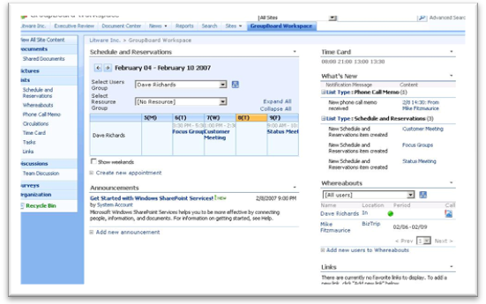
The GroupBoard Workspace 2007 application template for Windows SharePoint Services 3.0 creates a space for a group or team to connect and share information in a collaborative environment, improving team efficiency and productivity. The template helps track team member whereabouts and status, and includes a built-in timecard list and organization chart. Meetings can be scheduled with attendees, and meeting rooms and other resources can be reserved. It also enables members to share phone messages and circulate memos.
GroupBoard Workspace 2007 aids collaboration between group members, giving them immediate access to the information they need, when they need it. The lists in GroupBoard Workspace 2007 provide key information for everyone in the group, including group schedules, the movements of group members, equipment reservations and memos circulated to the group. The template creates powerful environments for sharing information within groups and provides immediate access to information via web browsers.

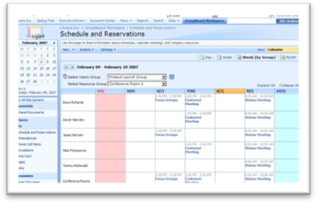
Activities Performed in this Application Template
- Schedule and Reservations: Manage reservations made by individual members and by the group as a whole. This feature can also be used to reserve conference rooms and equipment needed for meetings. The information can be accessed and edited directly from Microsoft Office Outlook® 2007, so you can manage reservations in relation to other reservations made by individual members and by the group as a whole.

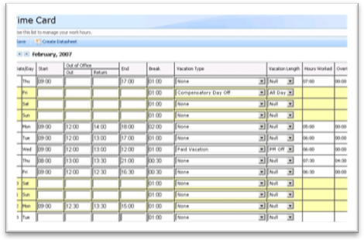
- Organization: The organizational chart is a quick and simple way to identify members' positions within the company and to select phone memo destinations and meeting participants. You can specify the order in which team leaders and members are displayed, and register the same user in multiple organizations.

- Time Card: Simply enter data from the top page on the team website in the time card to automatically calculate attendance records. This feature also provides ample support for flexible time systems, allowing you to customize the settings in line with the company's standard business hours and holidays.
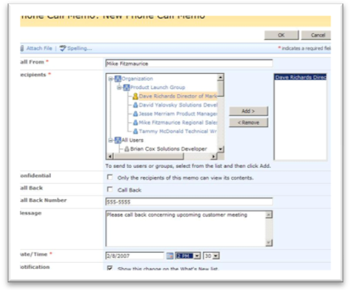

- Phone Memos: This feature records phone memos that arrive while group members are not available. When you enter details of a phone call that is to be returned, the information is displayed on the absent group member's home page. This provides a safe and secure way of passing on details of missed calls to group members who are out of the office.

- What’s New: This function allows you to quickly share new developments. It also lets you see the latest information at a glance, including requests to attend newly arranged meetings and memos addressed to you.

- Circulations: This feature simultaneously notifies group members of memos and other notices that they need to read. It also shows whether or not group members have opened and read their memos, helping to ensure that everyone is kept up to speed on important information.

- Whereabouts: This function allows you to quickly check on the whereabouts of group members. It tells you when they plan to be out of the office and how they can be reached. When the time card data is entered, members' "Out" and "Return" information is automatically updated. This information is then linked to phone memos, schedules and reservations, making the template even more user-friendly.

Access and Integration
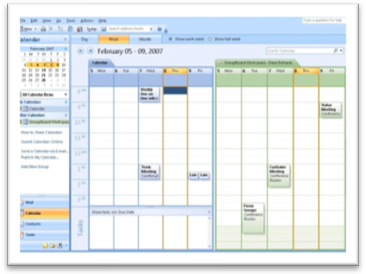
Access to team information from a range of devices, even when you're on the road.
The team site can be accessed by most web browsers, including Microsoft Internet Explorer. Users can also actively participate in information sharing from their mobile devices. Views designed specifically for mobile phones are available.

Direct access to team information via Office Outlook 2007.
Use Office Outlook 2007 to connect to the team website and access lists and libraries. You can even add scheduled team events and tasks to your own schedule simply by dragging and dropping them into your calendar. Team lists can be created and edited directly in Office Outlook 2007.

Provides access to updates and other information, even when you are out of the office.
You can now stay up to date even if you don't have full-time access. An RSS reader is all that is needed to keep up to date on the team's progress. You can use the Windows SharePoint Services integration with Office Outlook 2007 to view lists and documents even while offline.
Customizing SharePoint Sites and Templates
Microsoft Office SharePoint Designer 2007 is a Web site development and management program that provides powerful tools to build, customize, and contribute to Windows SharePoint Services sites using the latest Web design technologies and established standards in an IT-controlled environment.
Use Office SharePoint Designer 2007 to create and deploy interactive solutions without having to write code. Automate business processes, such as document approval, custom event notification and other collaboration tasks with the workflow designer. Create reporting and tracking applications using data views and forms to easily gather and aggregate data from outside your site and from lists and document libraries on the Web.
Extend your solution by building advanced interactive Microsoft ASP.NET pages. Insert and edit controls with the same powerful activity menus and control property grids previously found only in the Microsoft Visual Studio® development system.

Technical Dependencies
The GroupBoard Workspace 2007 application template has the following technical requirements:
- Microsoft Windows SharePoint Services 3.0*
- Microsoft Office Outlook 2007 (optional)

*Review Windows SharePoint Services 3.0 system requirements for additional information:
http://www.microsoft.com/technet/windowsserver/sharepoint/techinfo/sysreqs.mspx

More Information
For more information on the technologies described in this article, please visit:

Microsoft Windows SharePoint Services 3.0:
http://www.microsoft.com/sharepoint

Microsoft Office SharePoint Designer 2007:
http://office.microsoft.com/sharepointdesigner

Application Templates for Windows SharePoint Services:
http://www.microsoft.com/sharepointapps

