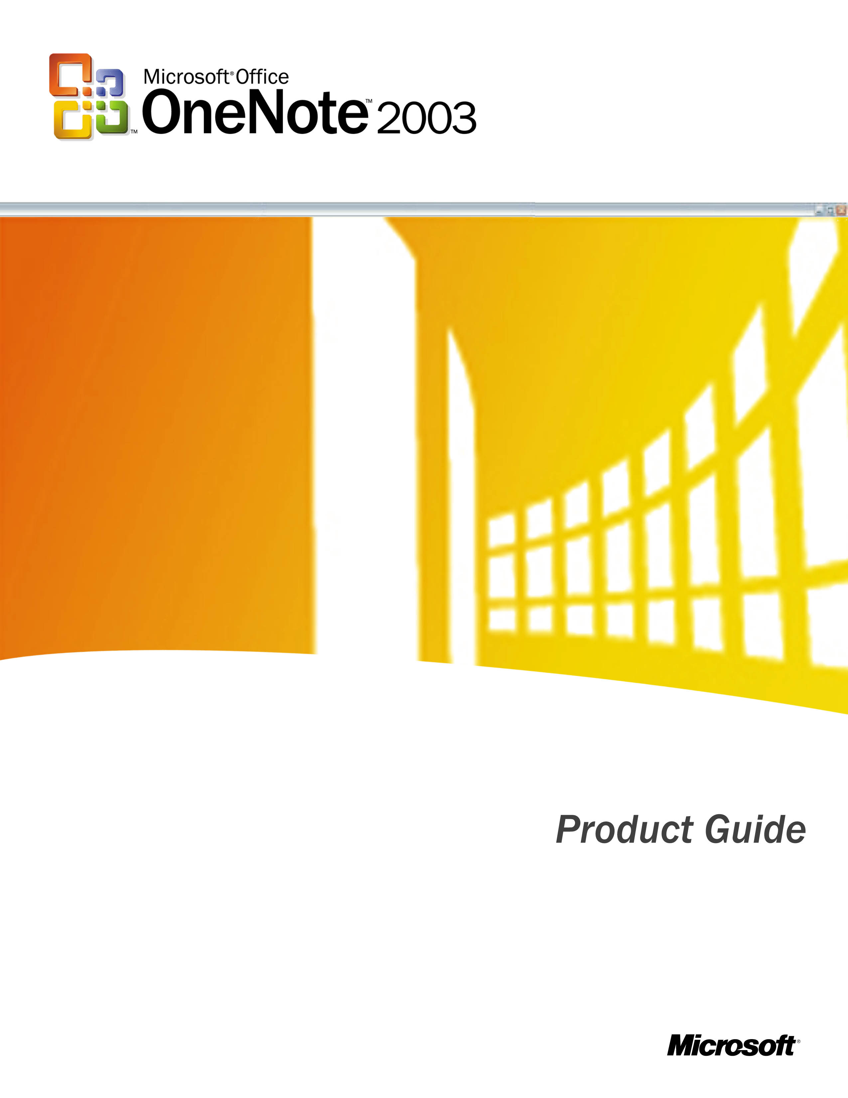

Contents

Introducing Microsoft® Office OneNote™ 2003 1
OneNote 2003 in Action 2
Easy and Efficient Organization 4
Access Notes 4
Intuitive User Interface 4
Notebook Sections 5
Page Tabs 6
Page Groups 6
Flexible 2-D Page Surface 7
Title Area 7
Organizing Notes 8
Outlining 8
Bullets and Numbering 9
Drag and Drop 9
Notes 9
Pages 9
Stationery 9
Note Flags 11
Find 12
History Navigation 12
Automatic Save 13
Work the Way You Want 14
Capture Notes 14
Digital Ink 14
Predefined Ink Styles 15
Writing Guides 15
Convert Ink to Text 16
Insert/Remove Space 16
Recording Linked Audio 17
Copy and Paste 18
Quick Pane 19
Research Library Task Pane 20
Keyboard Shortcuts 20
Rich Word-processing Experience 20
Share Notes 20
E-mail 21
Publish as HTML 21
Shared Workspace Pane 21
System Requirements 22

Introducing Microsoft® Office OneNote™ 2003
Microsoft® Office OneNote™ 2003, a new application in the Microsoft Office System of products, allows users to electronically capture, organize, and reuse notes typed or written on a laptop, desktop, or Tablet PC. OneNote 2003 provides a single place to collect and customize notes as you like—capturing information in multiple ways and organizing it according to your needs.
OneNote 2003 turns the act of note taking into a dynamic and integral part of every work day. OneNote allows you to:
- Take down notes as you like
- Organize information easily
- Access information quickly
- Reuse and share notes effectively
Microsoft Office OneNote 2003 helps make your notes more productive by transforming the note-taking process into an active and effective part of your day. Rather than transcribing paper-based notes into electronic form, the notes are already captured electronically, ready for distribution as soon as a meeting concludes. Add to that the ability to insert diagrams and Web research, and business notes transform from something that pile up, unused and forgotten, into a central part of your business process. OneNote 2003 helps you:
- Increase efficiency by centralizing all notes electronically
- Reduce downtime associated with note transcription
- Boost productivity by easily integrating OneNote content into other Microsoft Office applications
While OneNote 2003 can be used on a laptop, desktop, or Tablet PC, the pen input device on a Tablet PC enables additional capabilities in OneNote. For example, with Tablet PC, you can handwrite your notes (and convert them to text if desired) and draw diagrams or pictures as part of your notes. If you use OneNote with a laptop or desktop PC with a pen-input accessory, you can also write and draw in OneNote, but your handwriting is treated as picture files and cannot be converted to text as in a Tablet PC.
OneNote 2003 is expected to be available in mid-2003. In the meantime, visit www.microsoft.com/office/onenote for the latest information and updates.

OneNote in Action
Microsoft® Office OneNote™ 2003 is a versatile note-taking application that can help professionals in just about all walks of life. With OneNote 2003, you don't just take notes, you take action. Here are just a few fictitious examples of how OneNote can be used in the workplace:
 Jack—Project Manager
Jack is an example of a project manager for a large manufacturing company. He uses OneNote 2003 on his laptop to take notes during all of his meetings, both in-person and over the phone. Jack keeps his notes in a separate OneNote "notebook section" for each of his current projects, and he also keeps a special OneNote section for meetings. He appreciates the fact that OneNote keeps all this information in one place for him. He often uses OneNote to record the audio portion of meetings, which are automatically synchronized with his typed notes. After meetings, Jack will listen to parts of his audio recording again so that he can make sure he understands important customer comments and action items that he may have overlooked during the meeting.
 Scott—Engineer
Scott is an example of an engineer who designs circuits and chips for a high-tech company. He uses OneNote 2003 on his desktop PC along with a pen input accessory to take notes and draw diagrams for his various projects and meetings. Since all of Scott’s notebooks are in one place, it’s really easy for him to search his notes quickly to find information. For example, Scott’s manager just asked him for the price quote of a new alloy that he is currently investigating. Scott knows that he took down this quote for the alloy several weeks ago, but he doesn’t remember exactly where or when. By searching for the word “alloy” in his OneNote notes, Scott can find this information with a few clicks of his mouse.
 Abby—Consultant
Abby is an example of a consultant for a leading professional services firm. She uses OneNote 2003 on her notebook PC to keep track of her client notes, meetings, and phone calls. Abby particularly values the fact that OneNote makes it very easy to share her notes with her colleagues via e-mail or their team’s Microsoft® Windows® SharePoint™ Services site. This enables her entire team to share ideas and reuse each other’s notes and information much more easily.
 Walter—Journalist
Walter is a representative of a staff researcher for a major travel magazine. He uses OneNote 2003 on his desktop PC to take notes and gather information about new destinations for upcoming articles. He keeps a separate OneNote notebook section for each destination. Walter often uses the OneNote ability to simply drag pictures, text, or other information from a Web site directly into OneNote—and OneNote even conveniently notes the URL for him so that he can easily reference his sources later.
 Roxanne—Student
Roxanne is an example of a first-year student in college. She uses OneNote 2003 on her Tablet PC for typing notes to prepare for exams. She also uses the pen to handwrite notes while she’s in class. Roxanne keeps a separate notebook section for each of her classes, and when the semester ends, she starts a new folder to hold a new set of notes. She particularly likes the fact that OneNote enables her to find all of her Note Flags across every class notebook section, so she doesn’t forget about an assignment for other classes—or to call mom!

Easy and Efficient Organization
We all face challenges tracking the information we generate, the information we receive from others, and the information we share. People need to efficiently organize and access the right data at the right time so that they can create reports, prepare presentations, organize for important meetings, or study for tests.
With Microsoft® Office OneNote™ 2003, you can access powerful features that help organize your notes the way you want. The flexible interface gives you a digital notebook where you can create as many folders, sections, and pages as you need, while still keeping them all in one convenient place. And, no matter how you decide to organize information, you can easily search across all of your notes to quickly find the information you want.

Access Notes

Intuitive User Interface
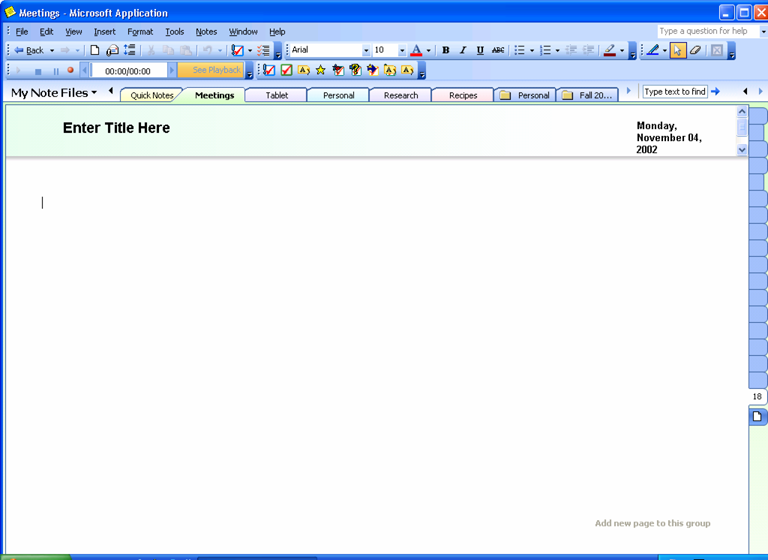
Figure 1 Organize your notes easily and efficiently within the intuitive interface.

OneNote gives you the freedom to organize information the way you want. With OneNote, you can create a digital note-taking and filing system that works best for you. OneNote gives you a "digital notebook" where you can create multiple folders to organize and file your information. Within these folders, you can create specific sections, with each section holding its own pages of notes.
Notebook folders and sections created in OneNote are automatically stored to a "My Notebook" folder found inside the "My Documents" folder. You can access all of the information saved to My Notebook through the intuitive interface of OneNote, making it easy for you to access information for multiple projects.

Notebook Sections
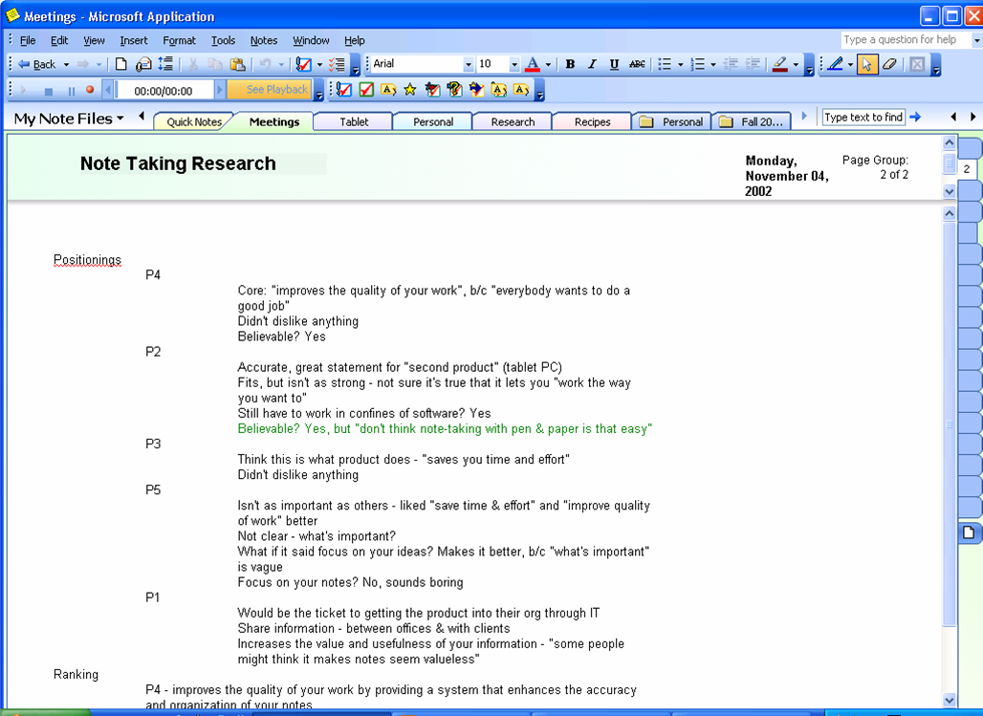
Figure 2 Organize different types of notes in notebook sections that you define.

A quick look at the interface shows an intuitive and user-friendly page surface. Near the top of the screen are tabs for each section of the notebook—much like tabs of hanging file folders. For example, a project manager might have a notebook for meeting notes and a section for each project that he is working on. Or, he might have a notebook folder for a particular project and a section for each component of the project (for example, vendor meetings, client meetings, and project timelines).
However you decide to organize your notes, each notebook section created represents a separate .one file, the binary file format for OneNote files, within the My Notebook folder.

Page Tabs
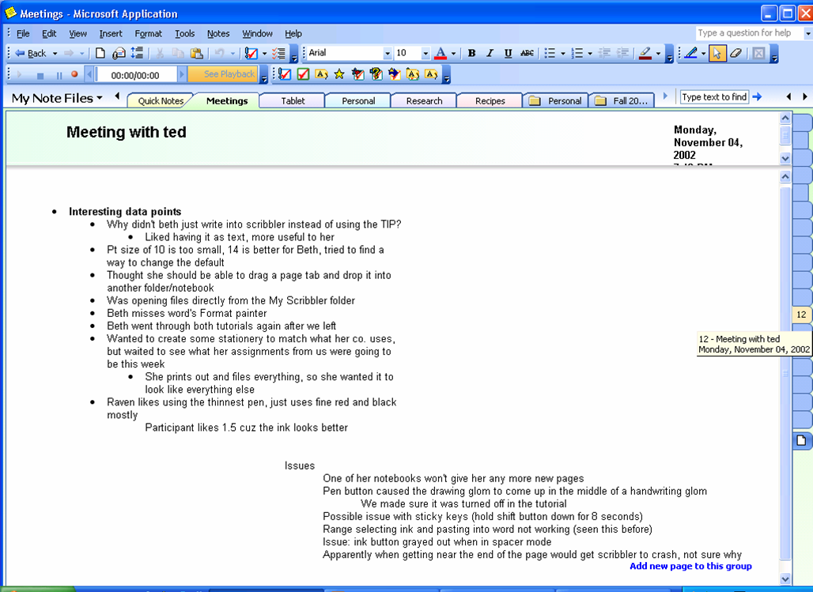
Figure 4 Find the correct page quickly with Page Tabs.

Along the right side of the screen, there is a separate set of tabs for the individual pages within each notebook. Clicking these tabs takes you to the corresponding page. When hovering the mouse or pen over these Page Tabs, you can quickly get information for each page, including the page title and date created. You can also select multiple pages using Page Tabs.
Just as you flip through (or "riffle through") paper notes to find the one page you are looking for, you can do the same with OneNote pages. This riffling action is recreated in OneNote when you hold down the mouse button and drag across all the Page Tabs.

Page Groups
You can also create a page group, which is a collection of pages with the same title area. A page group has a primary page and at least one sub-page. All pages within the group contain the same information in the title area as the original page. New sub-pages within a group appear as smaller Page Tabs on the right, directly after the normally sized tab that indicates the first primary page in the group. You can create as many new sub-pages within a group as you like.

Flexible 2-D Page Surface
Just as you would with paper, you can capture notes anywhere on the page in OneNote. So you can put the notes exactly where you want. Use the arrow keys to move around the page or click in the space where you want to take notes. People using a Tablet PC or a PC with a pen-input device can also write anywhere. (You can convert your handwritten notes to text with Tablet PCs, but with pen-input devices with laptops or PCs, you cannot do this). With OneNote, you can organize your thoughts and ideas the way you prefer.
Wherever you take notes within this page surface, you can take advantage of rich word-processing features as you type. (See page 21 for more information on rich word-processing features.)

Title Area
Figure 3 Keep important information visible at all times in the title area.

Sometimes, in long meetings or lectures, you may have a page of notes that extends beyond the available screen area. This makes it difficult to keep the information or notes visible that you want continuous access to, such as follow-up questions. OneNote overcomes this issue with the title area.
The title area of each page is a separate region that doesn’t scroll with the main page contents. It contains information such as date, time, the title of the page, and any notes you enter. All the content in that area remains visible at all times and can be resized to fit as much information as necessary.
The title area contains the same rich word-processing features (see page 21 for more information on these features) and the ability to write anywhere as in the rest of the OneNote page surface.

Organizing Notes
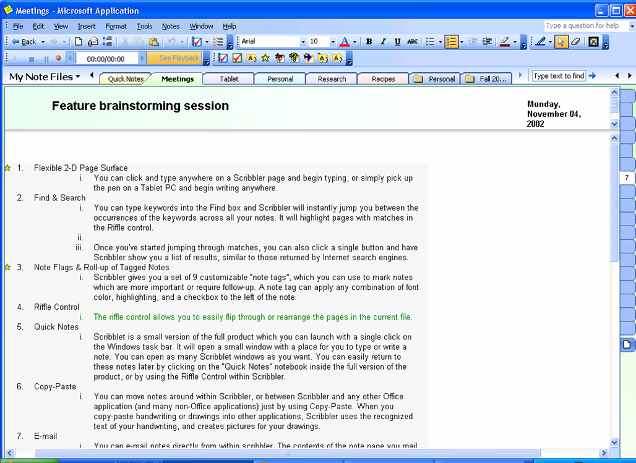
Figure 5 Outline your notes easily with OneNote.

OneNote 2003 also gives you the tools to better organize your notes, both while you're taking them and when reviewing them later.

Outlining
OneNote automatically recognizes a simple list of phrases, a series of bulleted paragraphs, or the traditional number and letter hierarchy of headings as types of outlines. Because this is automated, you can concentrate on the information you are taking down, rather than how to format it. OneNote also expands and contracts multiple levels of an outline, as well as customizes the number format of outlines.
In addition, the strict outline structure of OneNote ensures that sub-bullets are never indented more than one level underneath the preceding bullet. This makes dragging and dropping a paragraph into an outline easy, because that paragraph can only go in three possible positions: the same as the preceding bullet, one bullet point out from the preceding point, or one in from the preceding point. Again, this is an automatic process with OneNote, making simple organizational decisions for you so that you can concentrate on capturing and manipulating your ideas.

Bullets and Numbering
Easily add bullets to visually separate items in a list and draw attention to specific entries, or use numbers to show a sequence. With OneNote, you can even combine bullets and numbers within the same list.

Drag and Drop

Notes
Small icons called “note handles” appear next to your notes when you hover over your notes with a mouse or pen. Use these handles to move notes around easily on the page. Reorder items in a list with this feature (the numbers will adjust automatically) or combine notes on the same subjects that may be scattered across the page. Drop a list near another list, and OneNote automatically incorporates the dropped list into the original list. These handles can also be used to separate notes.

Pages
Reordering pages in a notebook is also easy—it’s just a matter of clicking the tab of the page to be moved and dragging it to the desired location. As the mouse is moved up and down the tabs, the screen shows the content of each page.

Stationery
When you launch OneNote, a blank page opens by default. However, there are also stationery styles, which are pages that have predefined looks. OneNote offers three basic kinds of stationery:
- Lined paper. Pages with various rule lines (for example, college ruled or graph paper).
- Lightweight forms. Pages that help organize your thoughts and information in various note-taking scenarios. You can specify a specific outline style for the note body.
- Designer paper. Stationery with pictures and coordinated fonts and font colors.
Once specific stationery is chosen in a notebook section, OneNote will use that as the default blank page for that section.
Stationery pages give you a consistent look in all note-taking sessions, help you avoid typing recurrent text (such as the word “Attendees” in every meeting note), and help you achieve visually pleasing notes without having to think about layout and font styles.
You can create your own stationery by formatting a page in your notebook, and then saving it as stationery in OneNote.
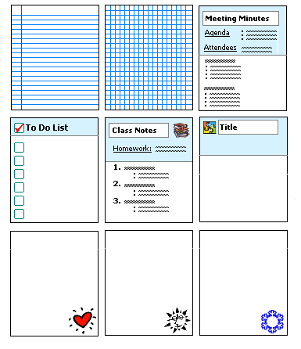
Figure 6 Stationery available to OneNote users.

Note Flags
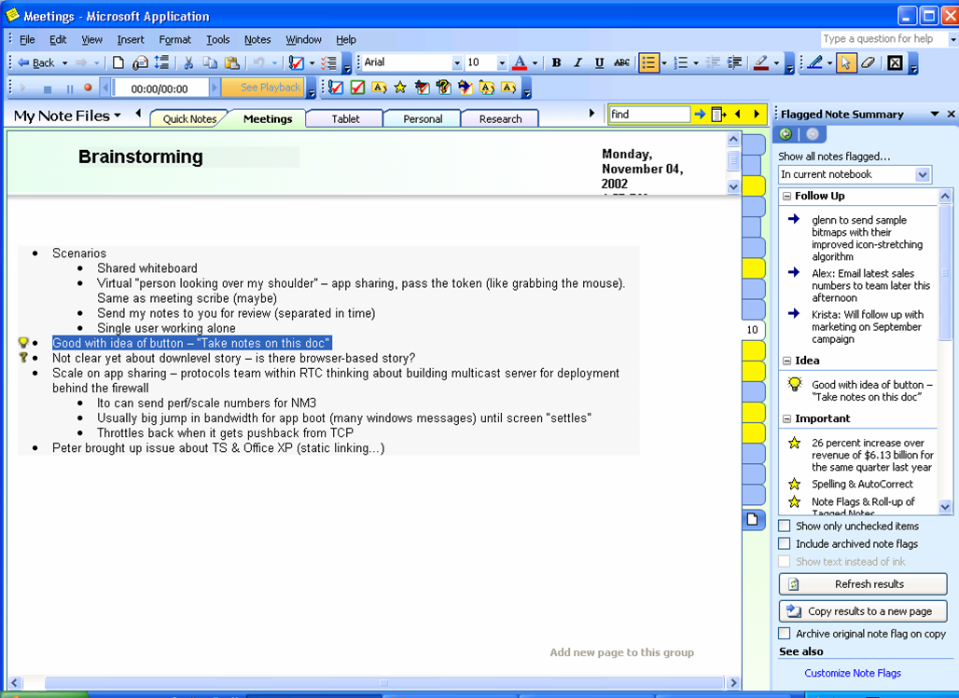
Figure 7 View important notes in one glance with Note Flags.

OneNote has a set of nine Note Flags that can be used to mark key items, urgent notes, or ones that require follow-up. You can customize icons and names for your Note Flags, and apply any combination of font color, highlighting, and check boxes next to the note. This feature ensures that important tasks and reminders are only one click away. Moreover, as an example of how OneNote and the other products in the latest version of the Microsoft® Office System work together to help you be more productive, the Note Flags in OneNote will integrate with the tasks and flags in Microsoft® Office Outlook® 2003.
In addition to providing a way to prioritize and mark notes, you can use Note Flags to organize your information. The Note Flags Summary pane makes it easy to manage and view flagged items, which can be viewed by page, notebook section, or across all notebook sections. This pane shows hyperlinks to all of the notes that you have marked with Note Flags on the page or notebook and presents management features needed to prioritize items and take necessary action. Clicking a flagged note in the summary pane takes you to that note in your notebook sections. In this way, you can navigate through notes according to the flags. For example, you could customize a Note Flag as a “supervisor” flag—and after a meeting call up all the action items your supervisor had mentioned.

Find
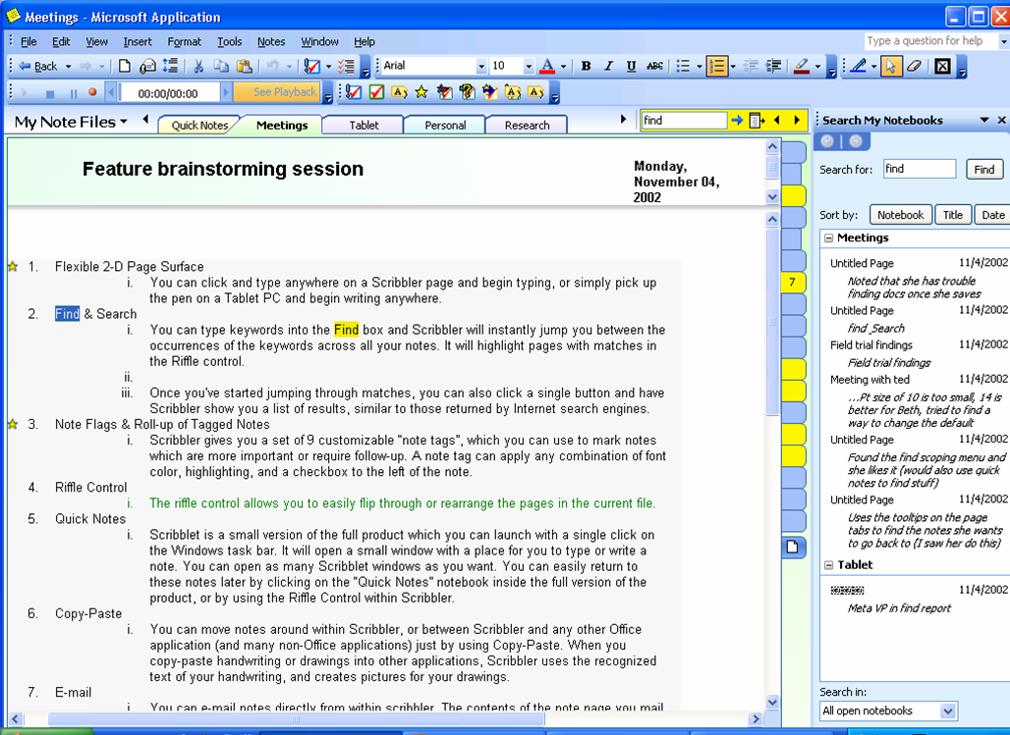
Figure 8 Find important information with just a few clicks.

Another capability for efficient note taking is the Find feature in OneNote, which searches notes by keywords.
When keywords are typed into the Find box, OneNote instantly finds those keywords across all notes in any notebook sections that are open. OneNote also highlights the pages that contain matches in the Page Tabs. When you press ENTER or click the “next match” arrow, OneNote jumps quickly to the next match in the notes, across any notebook section, making it easy to search across multiple sections at the same time.
In addition to jumping through the matches, you can click a single button, and OneNote then displays a list of results, similar to those returned by Internet search engines. By default, these results are grouped by section order, but they can be regrouped by date or title by clicking the Date or Title buttons in the page list pane.

History Navigation
With the many ways to navigate through OneNote and locate information, it’s important to have an easy way to get back to pages that have been viewed recently. OneNote tracks all of the pages visited across all notebooks—just as a Web browser tracks all of the Web pages that have been visited. And, just like in a browser, you can move back and forward through these pages by clicking Back and Forward in the upper-left corner of the application. The history is cleared each time the application is closed.

Automatic Save
One advantage of paper is that you never need to hit the “Save” button. Once you write it down, it’s there. OneNote 2003 offers the same kind of convenience. There is no Save button in OneNote—everything created in OneNote is automatically saved. So if it’s necessary to quickly turn off the computer or close the application, you don’t need to worry about losing important information. In addition, you never have to decide where to save a particular note—the notes are always saved within the My Notebook folder and are always easily accessible through the OneNote interface.
When OneNote is opened, it automatically returns to the last page that was modified before it was closed. This gives you quick access to the notes you were working on last.

Work the Way You Want
With Microsoft® Office OneNote™ 2003, you can flexibly and intuitively capture your notes—whether that’s typing anywhere on a page, recording audio, or handwriting your notes. You can also use OneNote to copy and paste information from various sources as well as easily share your notes with other people.

Capture Notes
With the application’s flexibility, you can capture information in a variety of ways and work with those formats easily.

Digital Ink
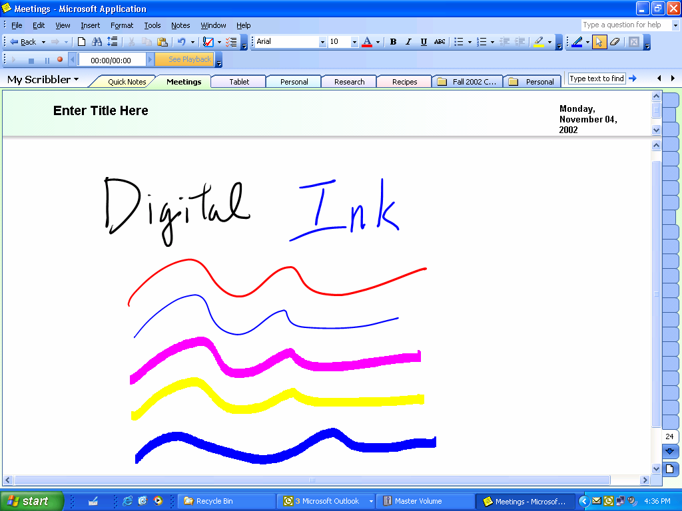
Figure 9 Hand write notes with digital ink, using a variety of colors and line thicknesses.

In meetings and lectures, you may draw a diagram to illustrate your point or brainstorm all over a whiteboard.
OneNote 2003 has enhanced capabilities for using Tablet PCs or pen-input devices with your desktop or laptop computers to handwrite notes or draw diagrams easily. You can both handwrite and type notes on the same page. If you don’t have a pen-input device, you can use your mouse to draw and sketch diagrams in OneNote.
With a Tablet PC, you can write and draw with digital ink—a new technology from Microsoft for working with handwriting as if it were text. The features of typed text notes in OneNote are also available with ink notes, such as bullets and numbering, drag and drop, and marking with Note Flags. The Find feature in OneNote also lets you search the ink notes that were written in your OneNote notebooks with the pen input device in a Tablet PC. And with OneNote, you can convert your digital ink notes to typed text if necessary.
If you are using pen-input devices with OneNote on your desktop or laptop, your handwritten notes are saved as picture files. While these notes appear as your own handwriting, they will not have the enhanced features of digital ink, such as bullets and numbering or being able to search them with the Find feature. These notes also cannot be converted to typed text.

Predefined Ink Styles
There are a variety of ink styles to choose from in OneNote, including different colors and thicknesses. You can also highlight sections of notes with the pen or use the pen as an eraser.

Writing Guides
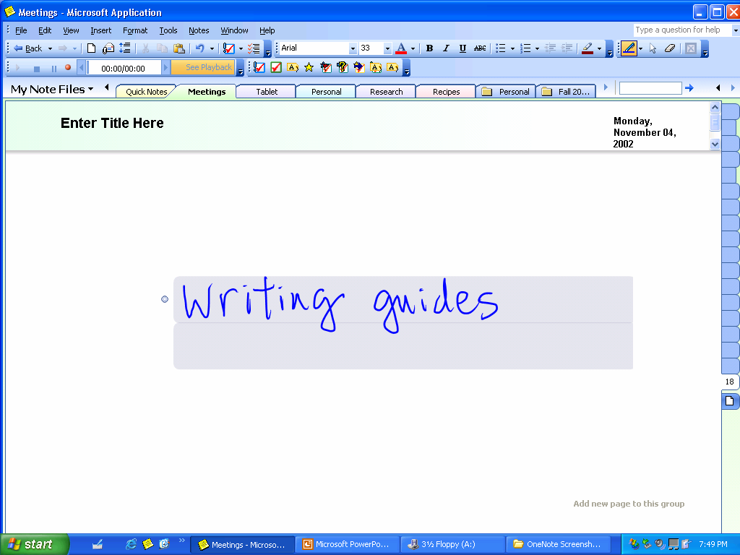
Figure 10 Define the boundaries of your handwritten notes with Writing Guides.

When you start writing on a OneNote page with a pen, lightly shaded boxes appear. These are Writing Guides that OneNote creates to help you define the boundaries of the particular notes or drawings you are creating. This is especially useful for creating a new item (such as a list or diagram) on a page instead of accidentally continuing an item you had previously created.
As you start writing, OneNote guesses what is being written and creates a Writing Guide accordingly to help you define where the paragraphs begin and end. Writing Guides expand and contract automatically, based on how OneNote interprets what you want. In addition, you can always manually adjust the dimensions of the Writing Guides to suit your needs.
When you draw a diagram or picture, Writing Guides show the rectangular extent of a drawing—like a canvas on which to draw. The guides expand and join together automatically as the drawings increase in size or become connected.

Convert Ink to Text
With OneNote, you can easily convert your Tablet PC handwritten digital ink notes to text. You can convert anything from just one word to a whole section at once by using your cursor to highlight the ink notes you want to convert. You then can choose the Convert option from the toolbar. If OneNote incorrectly converts a word, that word can be right-clicked to bring up a list of alternative words to choose from.

Insert/Remove Space
Sometimes conversations in a meeting or a discussion group veer off on tangents and then return to the original subject. When taking notes on paper in such a meeting, you can end up with notes on the same subject in more than one place. With OneNote, you can use the Insert/Remove Space tool to open up space on the page to add additional notes or drawings. Using a tool on the toolbar, you can drag open a vertical space and stretch the length of the page to create more space easily. You can use the same tool to remove excess space between notes or drawings.

Recording Linked Audio
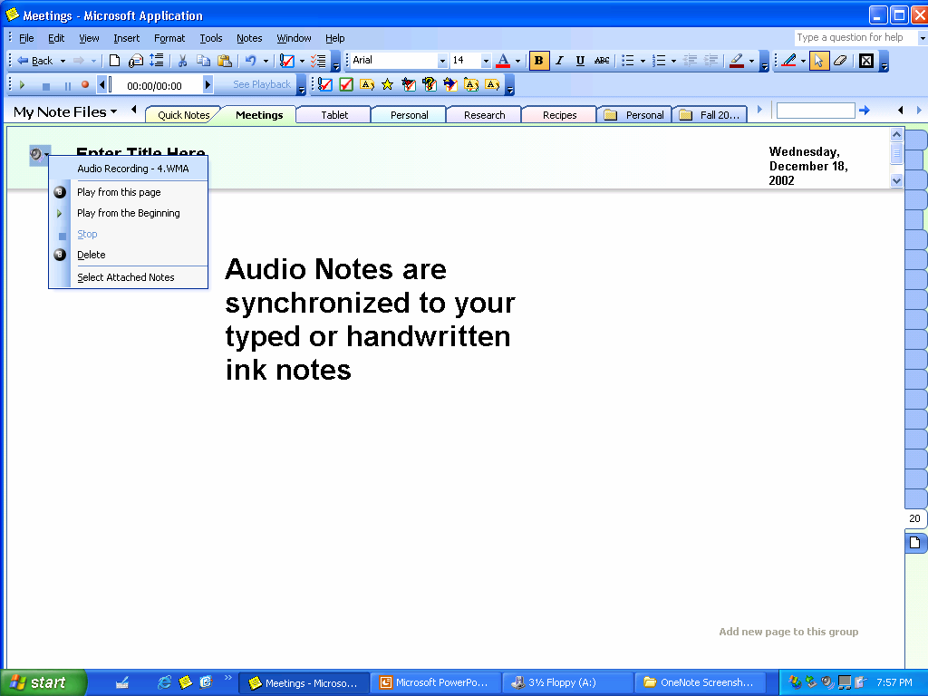
Figure 11 Recording linked Audio ensures that you won't miss important items.

The nature of notes is that they are brief summaries of ideas or discussions. However, sometimes brevity ends up being ambiguous, and you may not always remember what a particular word or phrase means. Or, if using pen input, you may have a difficult time deciphering a particular handwritten note. OneNote solves these problems by enabling you to record linked Audio.
If you have a microphone built-in or connected to your computer, click Record in OneNote to start recording audio. Then take notes with OneNote as usual. OneNote synchronizes the audio to the notes being written. By doing this, OneNote tracks the audio that occurred at the exact moment that each note was written.
Then, if you need to clarify a certain note, you can hover your mouse over the note in question and an audio icon appears. When the icon is clicked, OneNote plays back the audio that occurred exactly when that note was taken.
Alternatively, OneNote can play back all of the recorded audio while highlighting the note that was written at each point.

Copy and Paste
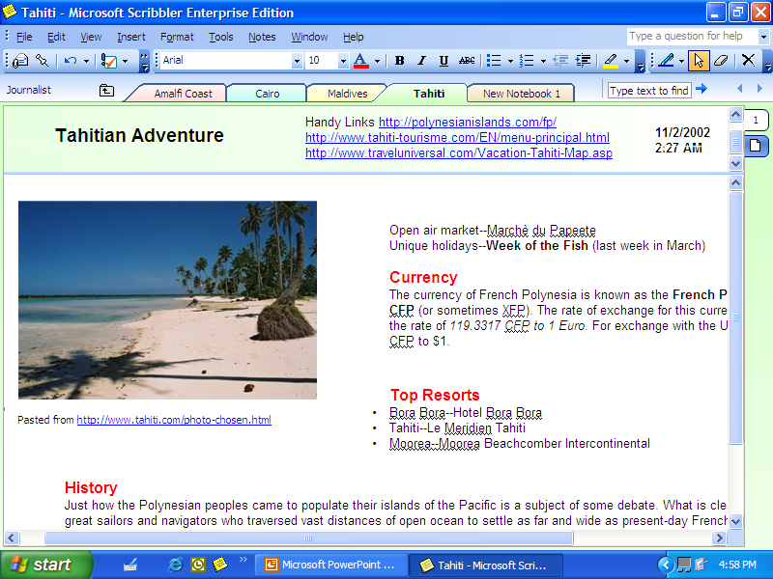
Figure 12 Copy and paste information from almost anywhere.

Microsoft Office users are used to copying and pasting within and among any Office applications. OneNote provides the same capability, and more.
With OneNote, you can copy and paste by using the drag-and-drop feature to move notes around within OneNote (as discussed on page 9) or between any other Office application and many non-Office applications. Simply point to or select the desired information with the cursor, and then move it to any page in your notes. Items that can be moved with the drag-and-drop feature into OneNote 2003 include pictures and text from Web sites and Microsoft Office Word documents, slides from Microsoft Office PowerPoint® presentations, and columns and rows of numbers from Microsoft Office Excel sheets.
When you copy and paste handwritten digital ink notes created in OneNote on a Tablet PC into other applications, the handwriting is automatically converted to text. Drawings are pasted as picture files.
Also, when you move information from Web sites, the source URL is automatically inserted with the information, so you can quickly return to the source of the information if you need to. This feature lets you do research more efficiently by capturing all of the information you need in one place.

Quick Pane
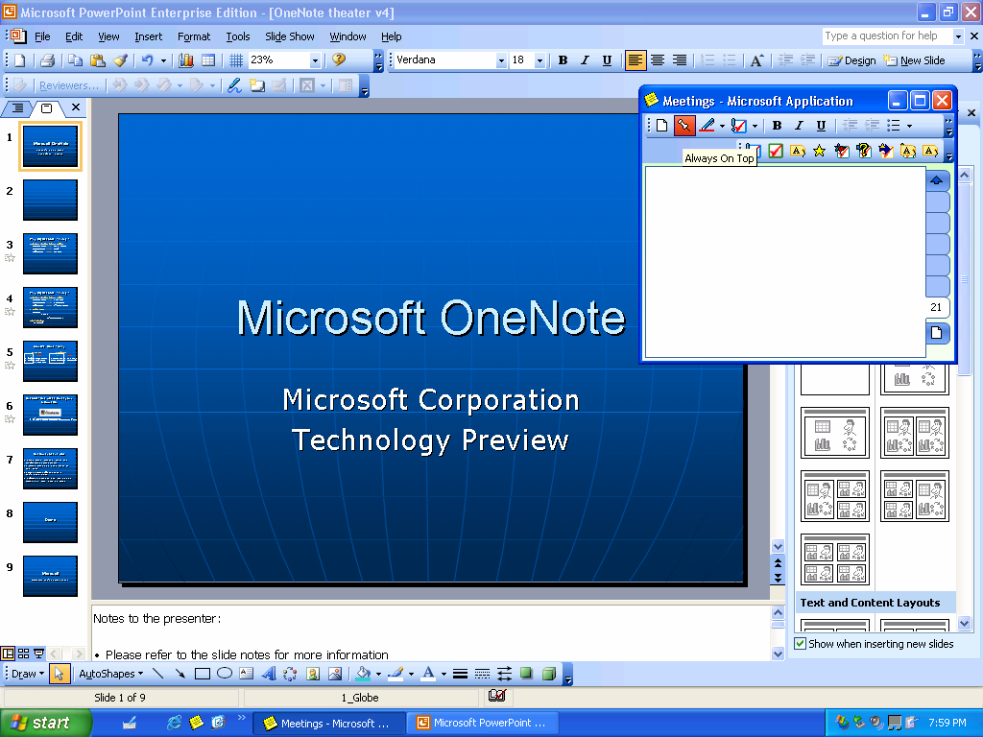
Figure 13 The quick pane interface makes it easy to jot down important information.

Sometimes you need to take short notes on the fly, such as when you are on the phone. The quick pane is a feature of OneNote that enables you to do just that.
You can access a streamlined, smaller view of OneNote through the OneNote quick pane icon in the Microsoft® Windows® taskbar. This small window of OneNote gives you access to all of the functionalities of OneNote, but in a smaller display called the quick pane. If you click the pushpin icon, you can “pin” the note to any part of the screen, and it will “float” or stay open on top of your other PC applications. This is a great way to keep pertinent information or reminders on hand—it’s like a “sticky note” for the PC with all the powerful features of OneNote. And you can open as many quick panes as you want.
This feature is also a convenient way to do research. For example, you might pin a quick pane to the top of the screen, open a Web browser, and drag information from a Web site into the quick pane. All notes taken in quick pane are automatically saved. In fact, they are saved right in OneNote. You can open OneNote and click the Quick pane tab to see all of the notes you created in the quick pane window.

Research Library Task Pane
OneNote hosts a Research Library Task Pane that you can use to look up information from your local network or the Web, as well as entries in dictionaries, encyclopedias, thesauruses, translation services, and more—all right from within OneNote. OneNote shares this feature with many other Microsoft® Office System applications. For more information about this feature, please see the product guide for the newest edition of the Microsoft Office System, available at www.microsoft.com/office.

Keyboard Shortcuts
Special consideration was put into making OneNote work well for people who prefer to work with the keyboard. Convenient keyboard shortcuts are available for all common operations. For example, each of the nine Note Flags can be inserted by entering Ctrl-1 through Ctrl-9.

Rich Word-processing Experience
OneNote combines the convenience of paper and the power of a digital software application. Similar to other Office applications, OneNote provides a rich authoring and word-processing experience. With OneNote, you can format text using colors, bold, italic, and underline, as well as benefit from features such as AutoCorrect and the spelling checker.

Share Notes
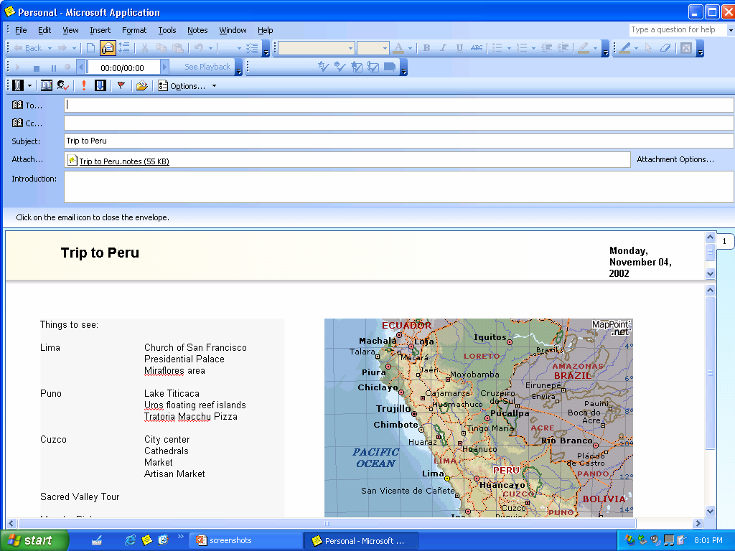
Figure 14 E-mail notes with one click of the mouse.

Too often, paper notes that you take just sit in stacks with all your other papers, because sharing them requires time and effort to retype them into another application. Now, with OneNote, you have several easy ways to share important information and ideas more effectively.

E-mail
By clicking the envelope icon on the toolbar, users with Microsoft® Office Outlook® 2003 can quickly e-mail any note you have taken in OneNote. OneNote automatically converts the notes to HTML and puts them into the message body so that even recipients who don’t have OneNote can read them. (Handwriting and drawings in the notes are converted into picture files.)
In addition, the application creates an attachment of the notes as an .one file so that if the recipients have OneNote, they can easily add that page to their own notebooks by simply double-clicking the attachment. Users with older versions of Outlook will also be able to e-mail OneNote notes as attachments as they would any other type of Microsoft Office document.

Publish as HTML
Another effective way to share information is on the Web. Easily save your notes as HTML and store them on a file share, a Web server, or a Microsoft® Windows® SharePoint™ Services (WSS) site. As with e-mail, handwriting and drawings are converted into pictures.

Shared Workspace Pane
OneNote also hosts a Shared Workspace task pane that you can use to create tasks, related documents and more in a shared OneNote notebook that is saved on a WSS site. Shared Workspaces provide intelligent document collaboration capabilities, improved version control and the ability to share documents in real time, assign tasks and deadlines, and easily review the status of a document project. OneNote 2003 shares this feature with many other Microsoft® Office System applications. For more information about this feature, see the product guide for the newest edition of the Microsoft Office System, available at www.microsoft.com/office.

System Requirements
Systems Requirements:
- PC with Pentium 133 MHz or higher processor; Pentium III recommended
- Microsoft Windows 2000 with Service Pack 3 or Windows XP or later operating system
For Windows 2000 and Windows XP:
- 64 MB of RAM (128 MB recommended) for the operating system plus an additional 8 MB of RAM for each application running simultaneously
- 245 MB of available hard-disk space with 115 MB on the hard disk where the operating system is installed (hard-disk use varies depending on configuration; custom installation choices may require more or less hard-disk space)
Other:
- CD-ROM drive
- Super VGA (800 x 600) or higher-resolution monitor with 256 colors
- Microsoft Mouse, Microsoft IntelliMouse®, or compatible pointing device
- Tablet PC pen-input required for capturing digital ink. Digital ink enables features such as numbering and bulleting handwritten notes, converting handwritten notes to text, and searching handwritten notes.

© 2003 Microsoft Corporation. All rights reserved.

This document is developed prior to the product's release to manufacturing, and as such, we cannot guarantee that all details included herein will be exactly as what is found in the shipping product. The information contained in this document represents the current view of Microsoft Corporation on the issues discussed as of the date of publication. Because Microsoft must respond to changing market conditions, it should not be interpreted to be a commitment on the part of Microsoft, and Microsoft cannot guarantee the accuracy of any information presented after the date of publication. The information represents the product at the time this document was printed and should be used for planning purposes only. Information subject to change at any time without prior notice.

This document is for informational purposes only. MICROSOFT MAKES NO WARRANTIES, EXPRESS OR IMPLIED, IN THIS DOCUMENT.

The example companies, organizations, products, domain names, e-mail addresses, logos, people, places, and events depicted herein are fictitious. No association with any real company, organization, product, domain name, e-mail address, logo, person, places, or events is intended or should be inferred.

Microsoft, IntelliMouse, the Office logo, OneNote, Outlook, PowerPoint, SharePoint, and Windows are either registered trademarks or trademarks of Microsoft Corporation in the United States and/or other countries. The names of actual companies and products mentioned herein may be the trademarks of their respective owners.

