

Starter Kit
Web Workflow Approvals

© Copyright Microsoft Corporation
Starter Kit: Web Workflow Approvals
Contents:
Introduction
Solution Structure
Dependencies and Prerequisites
Installing this Starter Kit
Known Issues
Your first Web Workflow Approvals project
- Creating a project in Visual Studio 2005
- Creating a project in Visual Studio 2008
Walkthrough – No Escalation
Walkthrough – With Escalation
Administrative Access

Introduction
The Web Workflow Approvals Starter Kit presents a developer-oriented sample for a simple introduction into the basics of real-world workflow and workflow tracking.
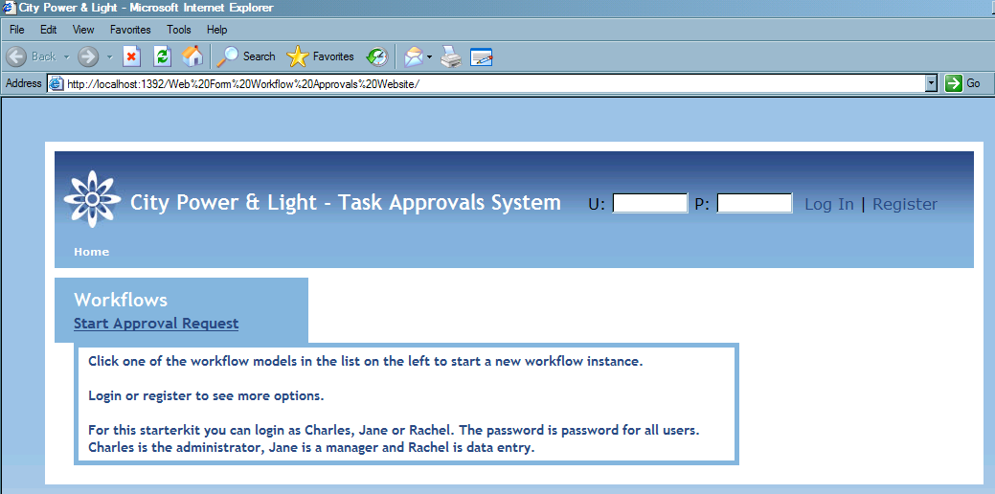
The sample has four projects, the web site, workflows, ASP.NET controls and workflow designer. The workflow builds a simple and obvious workflow business model with minimal code, making it a perfect place to demonstrate the workflow logic of an application. The web site provides implementations of the services the workflows interface to and presents information and a user interface to workflow data.
The workflows in this sample are pure business logic, stripped of any knowledge of the resource and IT infrastructure involved in implementing them. This is possible because communication with the outside world is handled via a construct called “User Activities”. These are IEventActivities with configurable data, typing, security roles and an external interface (implemented in the website) that manages their assignment to users and any progress made on them.
The user activities are a vessel for asking a user of a given role for data input to a given target. In the sample, work items are the data that the sample workflow needs. The user activities take a WorkItemDataSet as their data argument and send this to the ActivityDataInterface to be initialised for use with the user activity.
The website serves up the tasks to users and provides verification of user activity permissions and assignment. The interface it provides for entering the data tasks require is determined by the task type. Each type has a separate interface, all of which use a master page for common user activity/task oriented functions.
Workflow tracking information is also provided; Users may review progress and user activity data regarding workflows if they have been assigned to the workflow or have administrative privileges.
User Accounts
This sample uses a user / role system whereby different users are assigned different roles or even multiple roles. Below you will find a list of users, passwords and their assigned default roles.
User Name | Password | Assigned Role(s)
Charles | password | Administrator
Jane | password | Manager
Rachel | password | EnterResolution, RequestApproval

Description of Roles
- RequestApproval is able to enter the details of a given approval request instance. People within this role can enter the specifics about a given workflow instance, and hand over control of the workflow instance to a person within the Manager role.
- Manager is able to determine whether a given approval request can be approved or not. When people within this role complete this portion of the workflow instance, control of the workflow instance is handed over to a person within the EnterResolution role.
- EnterResolution is able to enter the results of the approval request. When people within this role complete this portion of the workflow instance, the workflow instance is complete and finishes.

Solution Structure
Web Form Workflow Approvals Website
The website hosts the workflows and WorkflowRuntime, tracks workflows and provides a user interface for users to interact with the user activities workflows create.
The UserActivities code folder provides the implementation of the workflow’s IUserActivityService that is used to create user activities. UserActivitiesDataSet is the corresponding data source for this service. The ActivityDataInterface is used by the rest of the website to save and load user activity data. Finally, the UserActivitiesHelper creates and configures the WorkflowRuntime, as well as providing helper methods for common user activity tasks.
Controls
FieldControl is a simple ASP.Net server control which produces the familiar label/field layout. Two important properties of the control are the DataSource and DataTextField, the DataSource is the DataRow that will be used to load and save the data, DataTextField is the name of the column that we wish to edit. Depending on the data type of the column the editable field rendered will be either a TextBox, CheckBox or Calendar. In the case when the field is flagged as a lookup a DropDownList will be used, values for the DropDownList are loaded from the OptionDataSource property.
Workflows
The main points of interest in this project are the sample workflow and the two activities that support its operation. UserActivity is the IEventActivity the workflow uses to drive user input. SaveWorkItems allows a workflow to save changes it makes internally to work items.
In addition to this, WorkItemsDataSet models the business data the workflows use, IUserActivityService is the contract workflows use to create user activities and Helper is an intermediary that hosts can use to pass the WorkflowRuntime and implementation of IUserActivityService to the workflows and their supporting classes.
WorkflowImageProvider
The main point of this library is to provide a class implementing a IHttpAsyncHandler to generate a image of the workflow highlighting the currently executing activity.

Dependencies and Prerequisites
Prerequisites
This starter kit has some pre-requisites. These are outlined below. When you install the starter kit, the installer will inform you if any of the prerequisites are missing, You will need to make sure that the prerequisites the installer informed you of are in fact installed on your machine before you attempt to launch this starter kit. Below is a list of the pre-requisites and their download links:
Prerequisite | Download link
Microsoft® Windows® Software Development Kit for Windows Vista™ and .NET Framework 3.0 Runtime Components | http://go.microsoft.com/?linkid=6405323
Microsoft .NET Framework 3.0 Redistributable Package | http://go.microsoft.com/?linkid=6405324
SQL Express (or any other edition of SQL 2005) | http://go.microsoft.com/?linkid=6405325
Visual Studio 2005 Workflow extensions for .NET Framework 3.0 (Windows Workflow Foundation) | http://go.microsoft.com/?linkid=6405326

Installing this Starter Kit
Note: This starter kit requires Microsoft Visual Studio 2005 Standard or higher.
To install this starter kit please extract the contents of the zip file to your hard drive and double click on setup.exe.
The installer will copy the starter kit to the 'Starter Kits' folder within Visual Studio. You can create a project based upon the starter kit by following the instructions outlined in the Your First Web Workflows Approvals project section.
The installer will also notify you of any dependencies that are not installed on your computer. Please ensure that these missing dependencies are installed on your machine before you create a project based upon the starter kit.

Known Issues
Start-Up Projects
Before you can use your Starter Kit to build your own applications, you must enter that you set the correct starter kit project start up order. Go to the 'Set Start-up Projects' section for more information on how to do this.
SQLExpress
This project will attempt to load a ‘User Instance’ of the database into SQLExpress. Please make sure SQLExpress is running prior to running the project. On occasion, the first time you run the application you will get an error similar to ‘Timeout expired. The timeout period elapsed prior to completion of the operation or the server is not responding.’. This is because SQLExpress is taking a while to load the User Instance database. Simply restart debugging and try again.

Remote Desktop
If you are running this starter kit on a computer through Remote Desktop you may encounter an error similar to ‘Failed to generate a user instance of SQL Server due to a failure in starting the process for the user instance. The connection will be closed.’. This is a known issue with Remote Desktop :
- http://support.microsoft.com/?id=896613
New workflow instances don’t show in administrative view
When you create a workflow instance (an instance without user assignment or data) and then login as a user with Administrative privileges to view Current Workflows the workflow you just created is not listed.
This is a known issue and will be addressed in a future build.

Can’t debug or set breakpoints in libraries
You need to prepare your solution for debugging, follow the instructions in the A note about project references and debugging the solution section.

Your first Web Workflow Approvals project
So you have created a project based upon the starter kit, what is next? To create a project based on the starter kit using Visual Studio 2005 see the instructions below. To create a project using Visual Studio 2008, see the section on the following page.
Creating a Project in Visual Studio 2005
In order to create a project based upon the Web Form Workflow Approvals Starter Kit you must go through the following steps. Note if you have already done this then you can move on to the next task.
- Open Visual Studio 2005 by going to Start Menu | Programs | Microsoft Visual Studio 2005 | Microsoft Visual Studio 2005
- In Visual Studio 2005, select the File | New | Project menu command.
- Select Visual C# | Starter Kits | Web Form Workflow Approvals Starter Kit
- Keep the rest of the defaults and click Ok to create a solution based on the starter kit template.
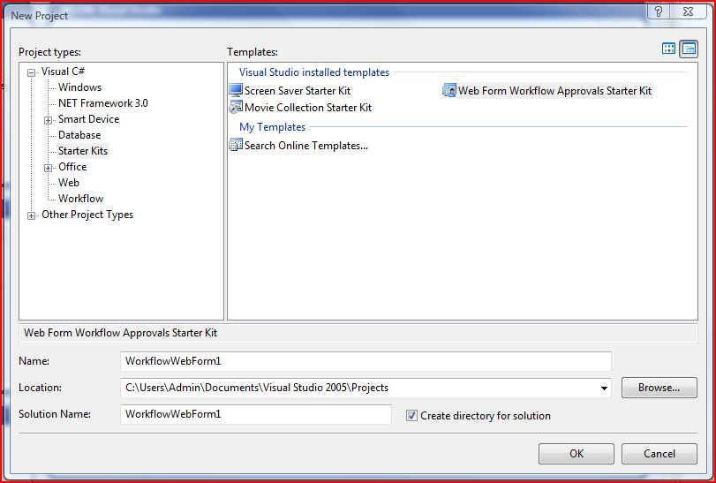

Creating a Project in Visual Studio 2008
In order to create a project based upon the Web Form Workflow Approvals Starter Kit you must go through the following steps. Note if you have already done this then you can move on to the next task.
- Open Visual Studio 2005 by going to Start Menu | Programs | Microsoft Visual Studio 2008 | Microsoft Visual Studio 2008
- In Visual Studio 2005, select the File | New | Project menu command.
- Select Visual C# | Workflow | Web Form Workflow Approvals Starter Kit
- Keep the rest of the defaults and click Ok to create a solution based on the starter kit template.

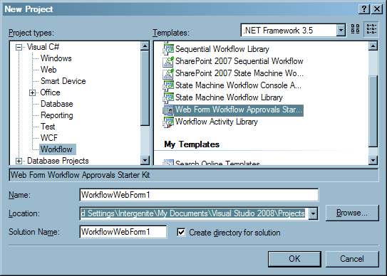
Set Start-up projects.
Before we can do anything else we must first define the start-up projects for the solution.
- Right Click on the Web Form Workflow Approvals Website project.
- Select Set As StartUp Project from the Context Menu.
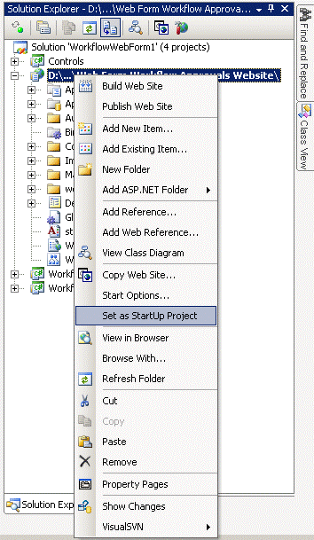
A note about project references and debugging the solution.
Before you can set breakpoints or step through calls to logic within any of the dependent libraries, you must first set the necessary project references.
This process involves two steps. First you must remove the dependent libraries binaries from the web-project bin folder; second you must set the necessary project references.
NOTE: It is not required for you to do this in order to continue with the walk through, however keep this in mind when you start digging deeper into how the starter kit is constructed by stepping through code.
Remove binary files.
- Open Solution Explorer.
- Expand the Web Project (by default this will be 'Web Form Workflow Approvals Website’).
- Expand the ‘Bin’ folder.
- Right-Click on each of the items in the bin folder, and select Delete.
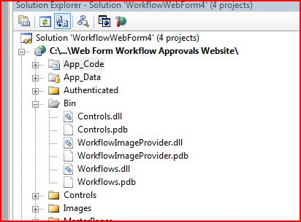
Set project references.
- Open Solution Explorer.
- Right-Click the Web Form Project (by default this will be 'Web Form Workflow Approvals Website')
- Select Add Reference.
- On the Projects tab select all projects listed and press Ok.
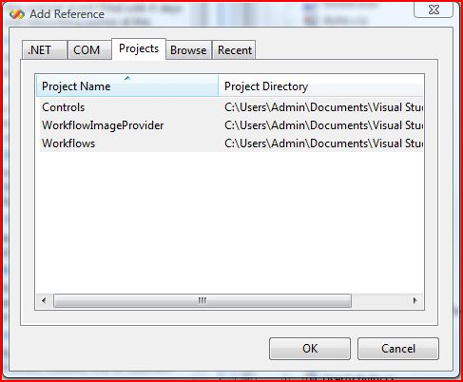
Make sure that you have SQLExpress running (by default it will be), hit F5 and run the solution.

Walkthrough – No Escalation
- Login as ‘Rachel’ (password = “password”).
- Start a new workflow: click Start Approval Request. This will start a new workflow, then take you to the first activity in the workflow where you will need to enter details of the work item request.
- At this point, clicking “Save” will simply save the current state of the workflow to the database. Clicking Submit will complete this phase of the workflow.
- Once the fields have been filled click Submit to move the workflow instance to its next phase ‘for Approval’, you will be notified that this phase of the workflow is complete.
- Login as ‘Jane’ (password = “password”), you will be able to see the work item Work Item Request for Approval. Click it and a page will load where you can approve or decline the approval request.
- Pressing Details (opens in a new browser window) will enable you to see the current executing part of the workflow, as you can see by the Sequential Workflow diagram that is displayed we are currently executing ApprovalForWorkItems (displayed with a box around it).
- Close the browser window that has the instance details within it.
- Tick Approved, and click Submit to move the workflow instance to its next phase of the workflow (‘await resolution’).
- Pressing Details (opens in a new browser window) will enable you to see the current executing part of the workflow. As you can see by the Sequential Workflow diagram that is displayed we are currently executing WaitForResolution (displayed with a box around it).
- Close the browser window that has the instance details within it, and click Logout on the Manager Approval page.
- Login as ‘Rachel’ (password = “password”), you will be able to see the work item Work Item Awaiting Resolution. Click it and a page will load where you can enter details about the resolution.
- Enter the resolution details and click Submit. This will complete this workflow instance.
- Clicking Details (opens in a new browser window) will enable you to see that there are no current executing portions of the workflow, as it is now complete.

Walkthrough – With Escalation
Complete steps 1 through 4. Leave the application running and wait 5 minutes while the workflow escalation process automatically declines the Approval Request.
When 5 minutes is up click Refresh Task List on the Home page. You will see a new Work Item Awaiting Resolution. Open it to enter a resolution. You can see that this work item was automatically declined by the workflow without any intervention.

Administrative Access
Login as ‘Charles’ (password = ‘password’), you will see a new button ‘Administration’ beside ‘Logout’. Click it and a page will load where you can view Current and Complete workflow instances. You also have a user interface to manage users and their roles.
Clicking on a Current workflow instance will display a page where you can see the current execution status plus execution history, and the ability to assign this workflow instance to a specific user or role.
Clicking on a Completed workflow will display a page where you can see the complete execution history of the workflow instance in question.

