Microsoft Office SharePoint Server 2007

Microsoft® Office SharePoint® Server 2007 is an integrated suite of server capabilities that can help improve organizational effectiveness by providing comprehensive content management and enterprise search, accelerating shared business processes, and facilitating information sharing across boundaries for better business insight.  Office SharePoint Server 2007 supports all intranet,  extranet, and Web applications across an enterprise within one integrated platform, instead of relying on separate fragmented systems. Additionally, this collaboration and content management server provides IT professionals and developers with the platform and tools they need for server administration, application extensibility, and  interoperability.  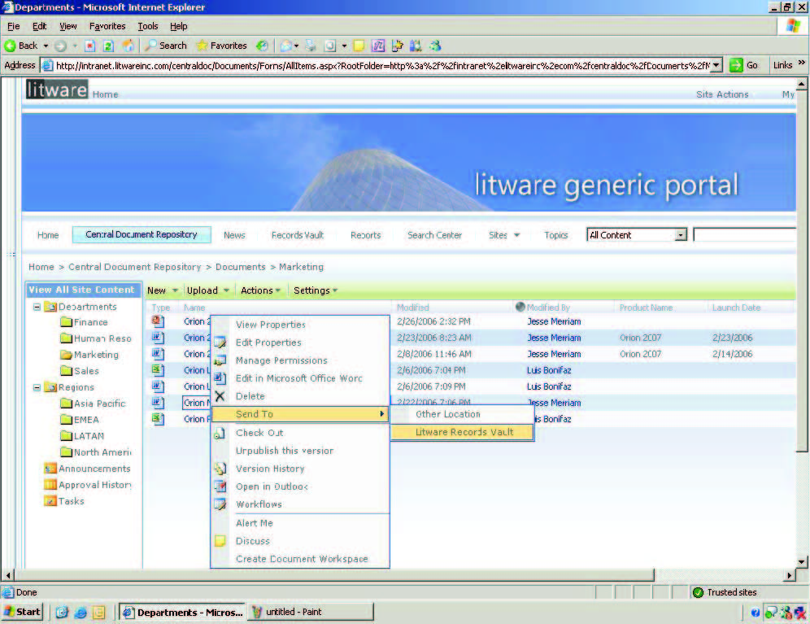  Managed enterprise content in a Web-based user interface.  www.microsoft.com/office/sharepointserver |  | Manage Content and Process  Derive more value from information assets and simplify  compliance by providing comprehensive control over the entire life cycle of electronic content, including documents, Web pages, PDF files, and e-mail messages. Streamline shared business processes through out-of-the-box workflows, easy-to-use electronic forms, and a simple, consistent user experience through familiar client applications.  Centrally store, manage, and access documents across the enterprise.  Organizations can store and organize all business documents and content in one central location, and users have a consistent mechanism to navigate and find relevant information. Default repository settings can be modified to add workflow, define retention policies, and add new templates and content types.  Help keep documents secure through detailed, extensible policy management.  Define customized document management policies to control access rights at a per-item level, specify retention period and expiration actions, and track content through document-auditing settings. Policy integration with familiar desktop client applications makes compliance transparent and easy for employees. Integration with information rights management enables persistent policies to be automatically embedded within documents, helping to ensure that confidential information is better protected even when the document is not connected to a server.  Simplify Web content management.  Provide easy-to-use functionality to create, approve, and  publish Web content. Master pages and page layouts provide reusable templates for a consistent look and feel. New functionality enables enterprises to publish content from one area to another (for example, from a collaborative site to a portal), or cost-effectively manage multilingual delivery of content on multiple intranet, extranet, and Internet sites.

Extend business processes across the organization.  Forms Services–driven solutions make it possible to accurately collect security-enhanced information inside and outside the organization without coding any custom applications. This information can then be integrated easily into line-of-business systems, stored in document libraries, used to start workflow processes, or submitted to Web services to help avoid duplicate efforts and costly errors resulting from manual data entry.  Streamline everyday business processes.  Out-of-the-box workflows enable initiation, participation,  tracking, and reporting for common business activities  such as document review and approval, issue tracking, and signature collection. Integration with browsers, e-mail, and familiar Microsoft Office system client programs simplifies the user experience. Organizations can easily define their own collaborative, user-driven business processes by capitalizing on the Windows Workflow Foundation services embedded in the Microsoft Windows® platform and using familiar Microsoft tools such as Microsoft Office SharePoint Designer 2007 (the next generation of the Microsoft Office FrontPage® tool) or the Microsoft Visual Studio® system.  Improve Business Insight  Make better-informed decisions at all levels of the  organization by efficiently finding, assembling, and  analyzing critical business information from disparate  sources such as documents, servers, databases, file shares, people, and SharePoint sites.  Provide centralized access to business-critical  information.  Create live, interactive business intelligence (BI) portals that assemble and display business information from disparate sources, using integrated BI capabilities such as dashboards, Web Parts, key performance indicators (KPIs), and business data connectivity technologies. Centralized Report Center sites give users a single place to find the latest spreadsheets, reports, or KPIs.  Share business data broadly while helping to protect sensitive information.  Excel Services enables you to broadly share spreadsheets and gives you improved manageability, security, and the ability to reuse models through a scalable, server-based calculation service and interactive Web-based user interface. Incorporate interactive spreadsheets into BI portals, dashboards, and scorecards. Help protect confidential information and maintain one up-to-date version by securing access at the server.  Unlock business data.  With the Business Data Catalog (BDC), IT can create a pool of connections to business systems such as SAP®1 and Siebel that can easily be reused to create personalized, interactive data views from browsers without writing code. Combine the BDC with SharePoint Enterprise Search to give users the ability to  search virtually any business system.  Capitalize on your unstructured business networks to drive better decisions.  Employees can use new knowledge management tools to get the most from unstructured business networks, both inside and outside their organizations, by connecting people more quickly and efficiently. By exploring these undocumented business relationships and finding subject matter experts, individuals can make better decisions more quickly.  Simplify Internal and External Collaboration  Find information and connect with subject matter experts,  regardless of where they are located. Share knowledge and simplify working with others within and across organizational boundaries.  Make it easier to search for information and people.  SharePoint Enterprise Search incorporates people and  business data along with documents and Web pages to  provide more comprehensive results. The Search Center  provides a single integrated location for employees to search for the organizational resources they need. Alerts on search results notify users when new query matches are discovered. Enterprise Search is ubiquitous in Office SharePoint Server 2007, with tight integration into SharePoint sites, Web Parts, SharePoint lists, people, profiles, and even business data.  Enhance customer and partner relationships.  With smart, standards-based, electronic forms–driven  solutions, you can collect business information from customers and partners through a Web browser. LDAP integration and support for other pluggable authentication providers make it  easier to work with sources other than the Active Directory® directory service, thereby simplifying extranet setups and facilitating tighter connectivity with customers, partners, suppliers, and more. Integration with information rights management enables content sharing with the confidence that information-use policies travel persistently with the content no matter where it goes.  Enhanced interoperability.  Office SharePoint Server 2007 is built on a scalable  architecture, with support for Web services and  interoperability standards including XML and SOAP. It has rich, open APIs and event handlers for lists and documents. This enables integration with existing systems and provides the flexibility to incorporate new IT investments. LDAP integration and support for other pluggable authentication providers make it easier to work with sources other than Active Directory. In addition, an out-of-the-box Web Services for Remote Portlets (WSRP) consumer Web Part enables you to integrate with other WSRP-compliant portal solutions.  Connectors and Web Parts for line-of-business systems  like SAP and Siebel simplify how business users can access data from these systems directly from within portal-based solutions.  Take advantage of the power of the integrated  platform.  Office SharePoint Server 2007 provides a unified architecture to support individuals, teams, and business units through intranet, extranet, and Internet sites. A unified architecture enables customers to take advantage of the Web Part framework, integrated search, integrated user management, and user rights, as well as a common store and security model.  Moreover, with this common architecture in place, customers can reuse applications, code, and site content and have a common development and deployment experience for developers and IT professionals. This amounts to easier content-sharing and knowledge-sharing among employees, customers, and partners, and lower hardware costs through server consolidation. It also means rapid time to deployment, low training costs, and a minimized need to deploy and maintain multiple solutions for different business functions.  Designed for extensibility.  Every industry and organization has unique needs, and we have devoted substantial efforts to understanding these needs and tailoring product extensibility to support them. With Office SharePoint Server 2007, extensibility is built right into the platform through Web services, RSS feeds, and a rich object model built on Microsoft .NET Framework 2.0. Next-generation features such as the BDC enable enterprise resource planning (ERP) systems to be indexed, making business data much more accessible. This approach enables the system to adapt to different needs across the organization and to changing requirements as the company grows. |  | 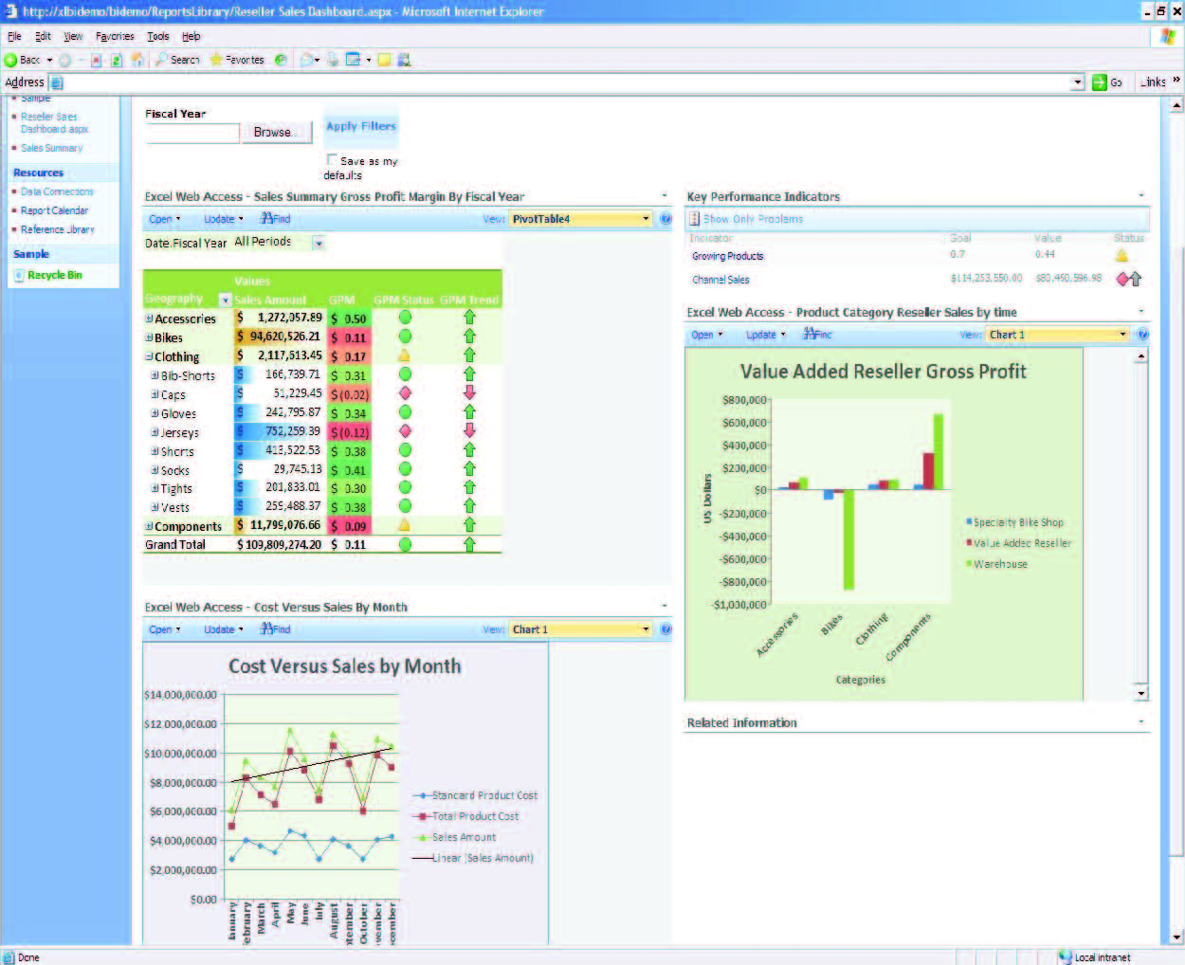  Sample Report Center dashboard using Excel Services, KPIs, and filtered Web Parts  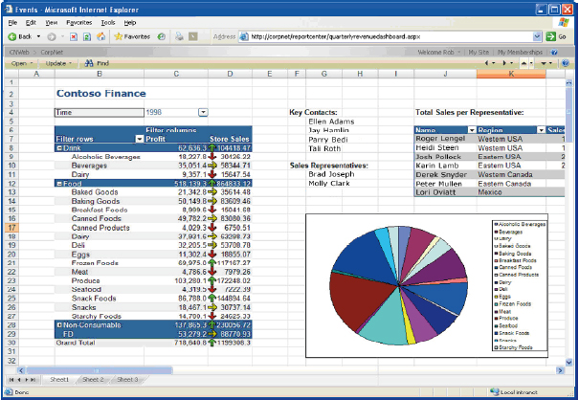  Viewing an Excel worksheet from a Web browser using Excel Services.  1 SAP is a trademark or registered trademark of SAP AG in Germany and in several other countries.  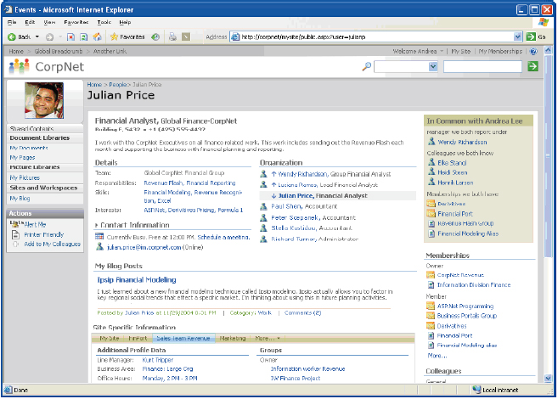  An example of a My Site with social network.  Personalize and customize the user experience.  My Sites gives users a dedicated site to store, present, view, and manage content, information, and applications in a controlled fashion. With My Sites, you can present information about the user, including information such as skills, colleagues or managers, groups and distribution lists (DLs), or active documents. Stringent privacy controls and enhanced security mechanisms enable each user to choose how much information to present, and to whom.  Work when and where you want.  With offline access to SharePoint lists and document libraries, you can free yourself from the limitations of corporate network connectivity. Tight integration with Microsoft Office Groove® 2007 further enhances the offline experience for users.  Use new knowledge management tools.  Empower employees to create and take advantage of people networks inside and outside their organizations, so they can connect and share knowledge with others more efficiently.  Use a Single Platform for Intranet, Internet, and Extranet Applications in the Enterprise  Increase responsiveness of IT to business needs and reduce the number of platforms to maintain by supporting all the intranets, extranets, and Web applications across the enterprise with one integrated platform. This reduces the need to rely on separate, fragmented systems.  Improved scalability.  Office SharePoint Server 2007 is more scalable and flexible than before. Organizations now have the flexibility, for example, to duplicate components, such as Web front-end servers to accommodate increasing user loads, or to add servers and services such as Microsoft Office Excel® 2007 or Search services. With its indexing enhancements, Office SharePoint Server 2007 is optimized to index only content that has changed. New change logs help indexers clearly identify which content has been modified and which has not. With the added end-user Recycle Bin, database restores are now greatly reduced. “Snapshot” support with Office SharePoint Server 2007 and Microsoft SQL Server™ 2005 means system backups can be completed within minutes.  Enable IT to focus on more strategic tasks.  Office SharePoint Server 2007 will provide IT professionals  with the tools and applications to simplify everyday tasks,  such as managing a Web server farm, deploying new pieces of content, or managing synchronization across those sites. Out-of-the-box, site starter templates for common Web sites, area and page layout templates, and preconfigured navigation simplify site staging. Enhanced backup and restore capabilities enable IT to schedule backups, back up multiple site collections, and then restore each site individually.  Moreover, users can now initiate workflows and self-provision applications, access data, define security permissions at a per-item level, and restore deleted items without involving IT. Reduced end-user dependence on IT improves productivity and enables the IT department to focus on providing value-added services to the organization.  For More Information  Learn more about Microsoft Office SharePoint Server 2007  and the Microsoft Office system at http://www.microsoft.com/office/sharepointserver.  This document is for informational purposes only. MICROSOFT MAKES NO WARRANTIES, EXPRESS OR IMPLIED, IN THIS SUMMARY.  The example companies, organizations, products, domain names, e-mail addresses, logos, people, places, and events depicted herein are fictitious. No association with any real company, organization, product, domain name, e-mail address, logo, person, place, or event is intended or should be inferred.  © 2006 Microsoft Corporation. All rights reserved. Microsoft, Active Directory, Excel, FrontPage, Groove, the Office logo, SharePoint, SQL Server, Visual Studio, Windows, and the Windows logo are either registered trademarks or trademarks of the Microsoft group of companies in the United States and/or other countries. All other trademarks are property of their respective owners.  

