Microsoft Office Excel 2007



**Microsoft® Office Excel® 2007 is a powerful tool to create and format spreadsheets and analyze and share information to make more informed decisions. With the Microsoft Office Fluent™ user interface, rich data visualization, and PivotTable® views, professional-looking charts are easier to create and use. Office Excel 2007, combined with Excel Services, a new technology that will ship with Microsoft Office SharePoint® Server 2007, provides significant improvements for sharing data with greater security. You can share sensitive business information more broadly and securely with your coworkers, customers, and business partners. By sharing a spreadsheet using Office Excel 2007 and Excel Services, you can navigate, sort, filter, input parameters, and interact with PivotTable views directly on the Web.**

Create Better Spreadsheets

Office Excel 2007 takes advantage of the Microsoft Office Fluent user interface to make powerful productivity tools easily accessible. It also offers more room to work and delivers faster performance than prior versions of Excel.

* **Get better results faster** with the Office Fluent user interface that presents the right tools when you need them most.
* **Increased spreadsheet row and column capacity** of 1 million rows by 16,000 columns enables you to import and work with massive amounts of data and achieve faster calculation performance with support for dual or multicore processors.
* **Quickly format cells and tables.** Use Cell Styles and Table Styles galleries to quickly format your spreadsheet the way you want it   
  to look. Tables include AutoFilters while column headers stay in view when you scroll through the data. AutoFill populates and expands any table automatically.

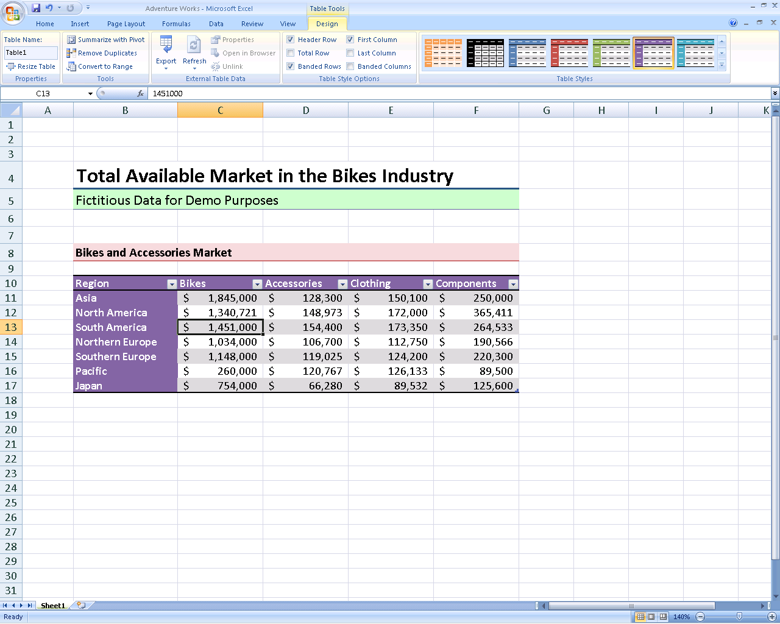

* **Formulas authoring experience** includes a resizable formula bar and context-based Formula AutoComplete—so that you can write the proper formula syntax the first time, every time. You can also refer to named ranges and tables within formulas and functions.
* **Create professional-looking charts** with few clicks and dramatic visual effects. Use predefined chart layout and chart styles or manually format each component, such as axes titles, and other chart labels. You can use stunning effects such as 3-D, soft shadowing, and antialiasing to help identify key data trends and create more compelling graphical summaries. Create and interact with charts the same way, regardless of the application you are using, because the Excel charting engine is consistent in Microsoft Office Word 2007 and Microsoft Office PowerPoint® 2007.

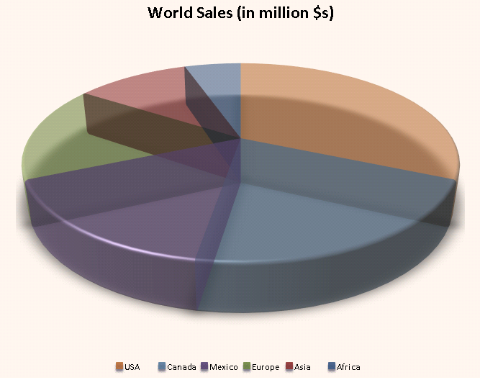

* **Use Page Layout View** to see exactly how your spreadsheet will print and to add or edit headers and footers. Adjust page margins with direct visual feedback where the page will truncate, and avoid multiple printing attempts.

Improve Spreadsheet Analysis

New data analysis and visualization tools help you analyze information, spot trends, and access your company information more easily.

* **Use conditional formatting with rich data visualization schemes.** You can now discover and illustrate important trends and highlight exceptions in your data by using conditional formatting with rich visualization schemes such as colored gradients (heat maps), data bars, and icons.

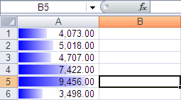

* **Sorting and filtering** are two of the most important types of basic analysis that you can do with data. New options for sorting and filtering, such as multiselect in AutoFilters, sort or filter by color, and quick filters for specific data types, make Office Excel 2007 the ideal tool for working with large amounts of complex data.

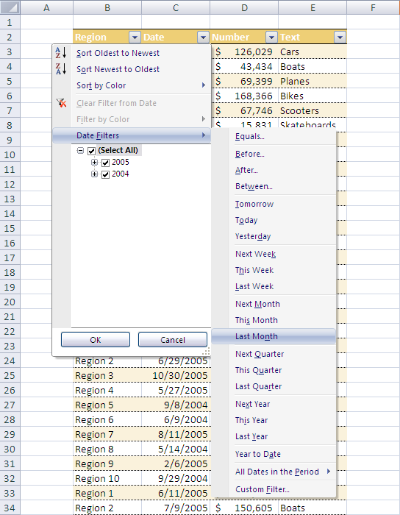

* **Create a PivotTable or PivotChart® view** more easily by using data fields to reorient data quickly to summarize and find the answers you need. Simply drag the fields where you want them to display.

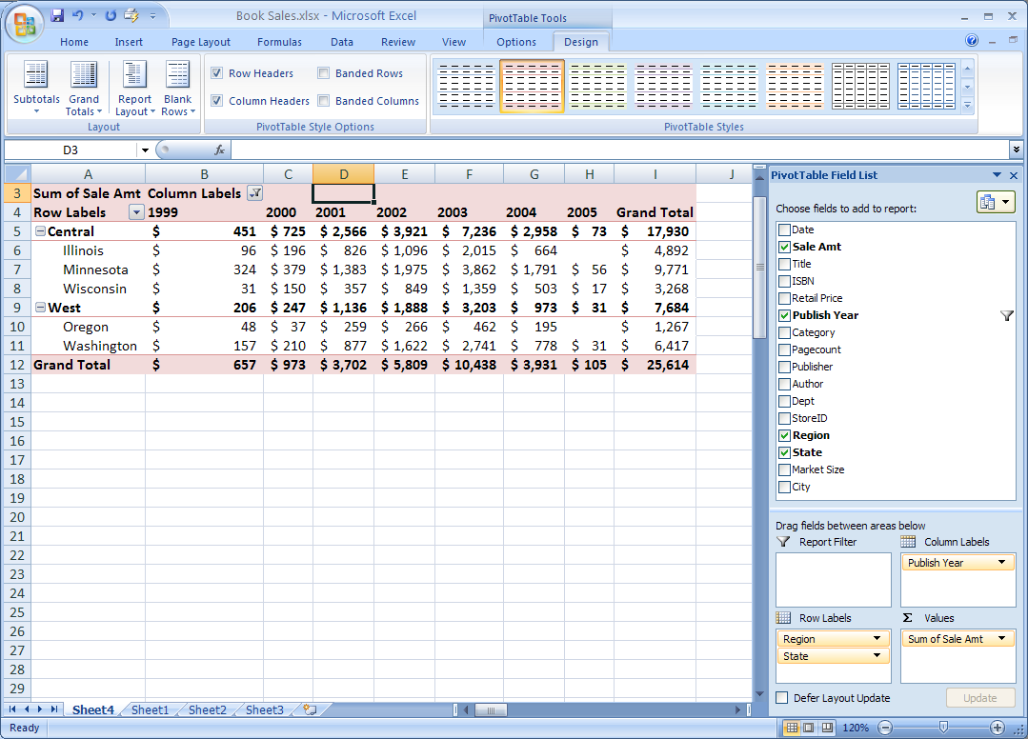

* **Full support for Microsoft SQL Server™ 2005 Analysis Services** enables you to query your most current business data by using the flexibility of Office Excel 2007. With the new cube functions, build a custom report from an Online Analytical Processing (OLAP) database.

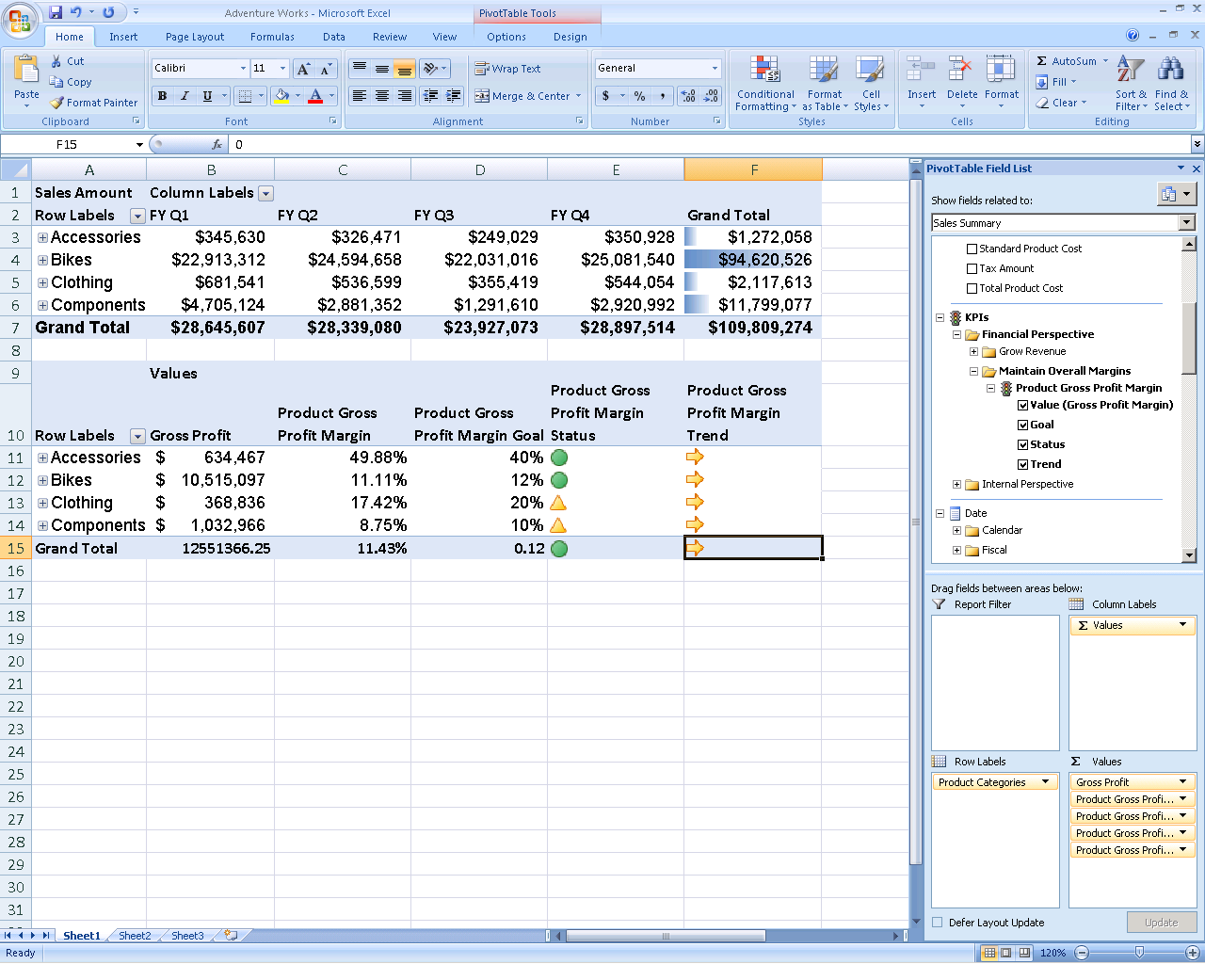

Share Information with Customers   
and Partners

Share sensitive business information in spreadsheets both broadly and more securely with coworkers, customers, and partners using Office Excel 2007 and Excel Services (which requires Office SharePoint Server 2007).[1]

* **Share a spreadsheet** using Office Excel 2007 and Excel Services, so you can navigate, sort, filter, input parameters, and interact with PivotTable views using the Web browser.
* **Create business dashboards** from spreadsheets and share within a portal. Track the key performance indicators of your business using browser-based dashboards that can be created from Excel spreadsheets, Excel Web Access, and Office SharePoint Server 2007.

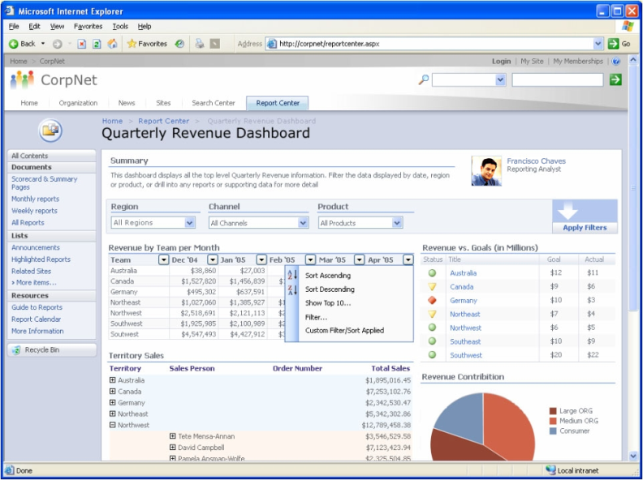

* **Improve** **interoperability** of spreadsheets with other data sources using Ecma Office Open XML Formats.
* **Convert your spreadsheet** to XML Paper Specification (XPS) or Portable Document Format (PDF) to create a fixed version of   
  your file for easier sharing.[2]

Manage Information More Effectively

Manage and control important business information using Office Excel 2007 and Excel Services.

* **Help prevent the spread of multiple copies** of business-critical spreadsheets throughout your organizationand help ensure people are working with the most current data by publishing them to Office SharePoint Server 2007.
* **Better protect confidential business information** while enabling people to view the data they need with report management features.
* **Create and manage trusted data connection libraries** that permit people to connect more safely to company data sources without assistance from IT.

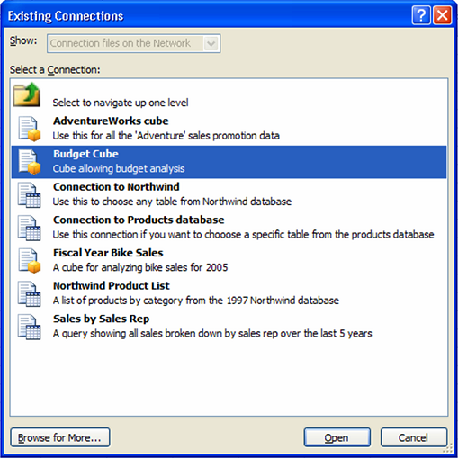

* **Excel Services application programming interface (API)** enables developers to use   
  the powerful Excel calculation engine in other applications, such as a Web-based mortgage calculator or an options pricing model.

For More Information

Learn more about Office Excel 2007 and the Microsoft Office system at [www.microsoft.com/office/excel](http://www.microsoft.com/office/excel).

For complete system requirements, visit [www.microsoft.com/office/excel](http://www.microsoft.com/office/excel).

This document is for informational purposes only. MICROSOFT MAKES NO WARRANTIES, EXPRESS OR IMPLIED, IN THIS SUMMARY.

The example companies, organizations, products, domain names, e-mail addresses, logos, people, places, and events depicted herein are fictitious. No association with any real company, organization, product, domain name, e-mail address, logo, person, place, or event is intended or should be inferred.

© 2006 Microsoft Corporation. All rights reserved. Microsoft, Excel, Internet Explorer, the Office logo, PivotChart, PivotTable, Fluent, PowerPoint, and SharePoint are either registered trademarks or trademarks of Microsoft Corporation in the United States and/or other countries. All other trademarks are property of their respective owners.



1. Excel Services requires Enterprise CAL.
2. You can save as a PDF or XPS file from a 2007 Microsoft Office system program only after you install an add-in. For more information, see [Install and use a PDF or XPS add-in.](http://r.office.microsoft.com/r/rlidOOPDFXPSAddin?clid=1033)