
Accounts Payable

Microsoft Dynamics™ SL

Benefits
- Work the way you want
Easily tailor Microsoft Dynamics SL Accounts Payable to suit the way you run your business, including taxes, aging, and fiscal period information
and the entry of as many expense accounts as needed.

- Enhance efficiency
Increase data entry effectiveness by using vendor classes to default several document options automatically, or locate a vendor by invoice or purchase order number. Then you can drill down from a check to the invoices it paid.

- Save valuable time
Use powerful tools to reduce the time spent entering and viewing vendor information. For example, distribute document amounts to multiple accounts or sub-accounts without manually breaking them into
separate documents.

- Streamline processes
Automate routine activities, such as
entering debit and credit adjustment
transactions that automatically update
vendor balances, to improve productivity, reduce cycle time, and gain control over accounts payable processes.

- Control cash flow and improve
business performance
Capitalize on vendor discount dates to
reduce payable liabilities. Easily select
“the right” vouchers for payment by
date, vendor, number, or a custom
query to control your cash outlay. Use
comprehensive reporting features to
present data in different ways, including many standard reports such as Aged Accounts Payables, Vendor Trial Balance, Check Register, and the Accounts Payable Batch Register.

Keep accurate information about money owed, due dates, and available discounts at your fingertips with a focused and flexible way to carefully track and take advantage of terms and discounts, predict cash requirements, and monitor payments so that they are made only once.

Increase
data entry effectiveness by
using vendor classes to default several document options automatically.

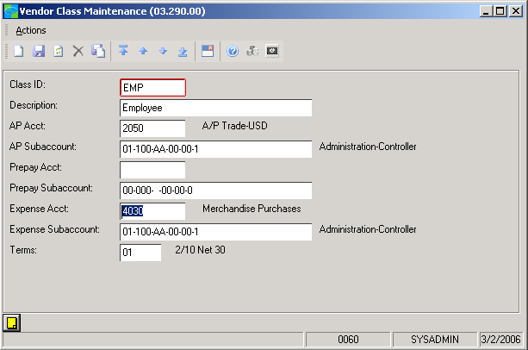

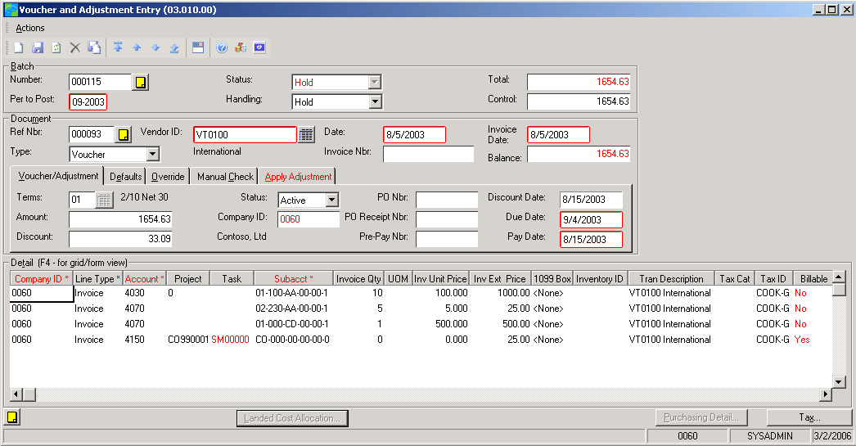

Distribute
document amounts to multiple amounts or sub-accounts.
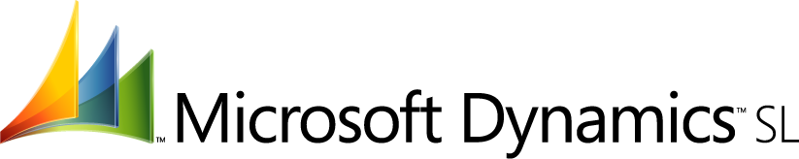

features

BENEFITS

Extended Reporting Options | Customize reports to provide the information your business needs.  Sort, select, and filter on any field in a report, and then export the data  to multiple formats, including Microsoft Office Excel, for further analysis.  With Microsoft portal solutions, provide managers and other users with  easy access to reports using a Web Browser.
Automated Recurring Processes | Automatically generate recurring vouchers, calculate sales and value-  added taxes, and automate activities for payment selection and scheduling,  recurring entries, and electronic payments.
Customizable Payment Selection | Select bills for payment based on your own unique criteria, including  options to select by company, vendor, or pay date.
Flexible Account Posting | Define accounts used to process transactions, including the vendor’s  default account. Split accounts among departments or divisions and  distribute expenses to any number of accounts. Post documents to  future or prior periods and exclude for current period reporting.
Easy Document Tracking | Find vendor information by using invoices or purchase orders and drill  down from checks to supporting documents quickly. Retain history of up  to 99 periods of transaction detail and 99 years of vendor information.
Adaptable Check Management | Manage pre-payment checks, void checks for current or prior periods,  print checks quickly, and pay separate vouchers for a vendor with  separate checks when needed. Enter manual check information at the  time of voucher entry and create checks for previously entered vouchers.
Tax Calculation and Reporting | Calculate, track and report sales, use, and value-added taxes. Vendor  Tax reporting, magnetic media, and IRS electronic filing are supported.
Flexible Vendor Management | Use flexible vendor ID structures for meaningful identification, group by  class for speedy data entry and useful reporting, and control vendor  status. Automatically remove one-time vendors when appropriate, and  use quick maintenance windows to add or change vendor information  during entry.
Flexible Purchasing | Record and maintain unlimited purchase order addresses per vendor,  with support for multiple purchase sites.
Multi-company Support | Work collaboratively with other businesses and automatically generate  inter-company entries.
For more information about Microsoft Dynamics™ SL, visit: http://www.microsoft.com/dynamics/sl

This document is for information purposes only.
MICROSOFT MAKES NO WARRANTIES, EXPRESS, IMPLIED, OR STATUTORY, AS TO THE INFORMATION IN THIS DOCUMENT.

© 2005 Microsoft Corporation. All rights reserved.
Microsoft, The Microsoft Dynamics Logo, are either registered trademarks or trademarks of Microsoft Corporation or Microsoft Business Solutions ApS in the United States and/or other countries. Microsoft Business Solutions ApS is a subsidiary of Microsoft Corporation.

