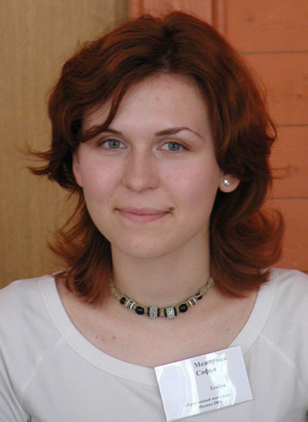

Sofya Mezhorina, Russia

Sofya Mezhorina will graduate this summer from Tambov State University in Russia, where she is studying linguistics and teaching methodology. In addition to her studies, two years ago Mezhorina became a fellow of a prestigious academic exchange program sponsored by the U.S. government, and for a year studied education with an emphasis on IT at University of Wisconsin-La Crosse. Upon her return to Russia, Mezhorina designed and taught an experimental English course for Russian-American distance education students at Tambov State University.

Mezhorina is an editor of a youth educational journal called FreeDom and uses technology to communicate with the head office, which is more than 3,000 kilometers away. Earlier this year, she joined TakingITGlobal (TIG), an international organization that creates global information and communications technology (ICT) opportunities for young people; Mezhorina develops the Russian version of the TIG Web site. She hopes that modern technologies soon will become more accessible for Russian youth, who will be able to widely use IT resources in daily activities and as an advanced platform for their special initiatives.

Mezhorina is very active in youth leadership and community development, through which she hopes to contribute to the development of a democratic society in Russia. She is involved in local and national social action projects, trains volunteers in local nongovernment organizations, performs in a civic education theater project, and volunteers at a youth center.

