

Hyper-V Server 2008 Setup and Configuration Tool Guide

Microsoft Corporation

Published: October 2008

Author: Cynthia Nottingham

Abstract

This guide will help you set up and configure Microsoft® Hyper-V™ Server 2008. For more information about Hyper-V Server 2008, see the Microsoft Web site (<http://go.microsoft.com/fwlink/?LinkId=129170>).



Copyright Information

Information in this document, including URL and other Internet Web site references, is subject to change without notice. Unless otherwise noted, the companies, organizations, products, domain names, e-mail addresses, logos, people, places, and events depicted in examples herein are fictitious. No association with any real company, organization, product, domain name, e-mail address, logo, person, place, or event is intended or should be inferred. Complying with all applicable copyright laws is the responsibility of the user. Without limiting the rights under copyright, no part of this document may be reproduced, stored in or introduced into a retrieval system, or transmitted in any form or by any means (electronic, mechanical, photocopying, recording, or otherwise), or for any purpose, without the express written permission of Microsoft Corporation.

Microsoft may have patents, patent applications, trademarks, copyrights, or other intellectual property rights covering subject matter in this document. Except as expressly provided in any written license agreement from Microsoft, the furnishing of this document does not give you any license to these patents, trademarks, copyrights, or other intellectual property.

© 2008 Microsoft Corporation. All rights reserved.

Microsoft, Hyper-V, Windows, Windows Vista, and Windows Server are either registered trademarks or trademarks of Microsoft Corporation in the United States and/or other countries.

All other trademarks are property of their respective owners.

Contents

Setting the Administrator Password 5

Hyper-V Configuration Tool 5

Domain/Workgroup 6

Computer Name 7

Network Settings 7

Add Local Administrator 8

Windows Update Settings 9

Download and Install Updates 9

Remote Desktop 10

Regional and Language Options 10

Date and Time 12

Log Off User 12

Restart Server 12

Shut Down Server 13

Exit to Command Line 13

Open a new Command Line window 13

Hyper-V Server Remote Management 13

Hyper-V Server Remote Management with Microsoft® Windows Server 2008 13

Hyper-V Server Remote Management with Microsoft® Windows Vista SP1 13

Hyper-V Server Remote Management with Microsoft® System Center Virtual Machine Manager 14

Setup Hyper-V Server virtual networks 14

Creating Hyper-V Server Virtual Networks 14

Additional Resources: 15

Hyper-V Installation Prerequisites

Hyper-V requires specific hardware. You can identify systems that support the x64 architecture and Hyper-V by searching the Windows Server® catalog for Hyper-V as an additional qualification. The Windows Server catalog is available on the Microsoft Web site (<http://go.microsoft.com/fwlink/?LinkId=111228>).

To install and use Hyper-V, you need the following:

* An x64-based processor.
* Hardware-assisted virtualization. This is available in processors that include a virtualization option; specifically, Intel VT or AMD Virtualization (AMD-V).
* Hardware Data Execution Protection (DEP) must be available and be enabled. Specifically, you must enable the Intel XD bit (execute disable bit) or the AMD NX bit (no execute bit).

#### Additional considerations

* The settings for hardware-assisted virtualization and hardware data execution protection are available in the BIOS. However, the names of the settings may differ from the names identified previously.   
  For more information about whether a specific processor model supports Hyper-V, check with the manufacturer of the computer.
* If you modify the settings for hardware-assisted virtualization or hardware data execution protection, you may need to turn off the power to the computer and then turn it back on. Restarting the computer may not apply the changes to the settings.

# Setting the Administrator Password

During the first logon after the installation of Hyper-V Server, you will be prompted to enter a user name and create a password. The following instructions outline this process.

***Note:*** *This process will only occur during the first logon after the installation of Hyper-V Server.*

1. Click on **Other User**.
2. In the user name field type **Administrator** and then press ENTER.
3. A message stating that “The user’s password must be changed before logging on the first time” appears. Click **OK.**
4. Type a new password in the **New password** field.
5. Type the same password again in the **Confirm password** field, and then press ENTER.
6. You will see a confirmation that your password has been changed. Click **OK**.

# Hyper-V Configuration Tool

The Hyper-V configuration tool is intended to support the administrator with amenu driven User Interface (UI) to configure Hyper-V Server. The Hyper-V configuration tool starts automatically at login of the system administrator or it can be started manually.

**To manually start the Hyper-V configuration tool**

1. Change to the system drive.
2. Type **hvconfig.cmd**and then press ENTER.

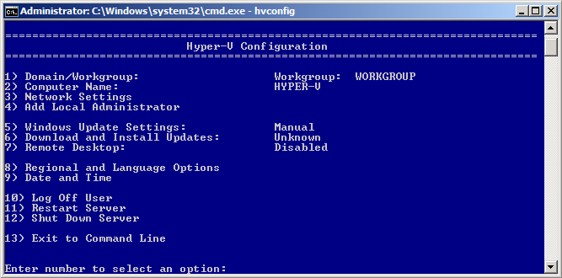

Figure 1: Hyper-V Server Configuration Tool

## Domain/Workgroup

The current Domain/Workgroup settings are displayed in the default Hyper-V Configuration screen.

|  |  |
| --- | --- |
| **To join a domain** | 1. Type **1** and press ENTER. 2. Type **D** and press ENTER. 3. Type the domain name and press ENTER.   ***Example:*** *domain.corp.company.com*   1. Type an authorized domain\user   ***Example:*** *domain\user1*   1. When prompted, type a password for the user and press ENTER. 2. You will be prompted with “You must restart your computer to apply these changes. Restart now?” 3. Click **Yes** to reboot.   ***NOTE:*** *By default, running virtual machines will automatically be saved prior to restarting the Hyper-V Server.*  ***NOTE:*** *If a domain user has not been added to the local administrators group, you will not be able to make system changes, such as changing the computer name, using the domain user. To add a domain user to the local administrators group, allow the computer to reboot. Next, log onto the computer as the local administrator and follow the steps listed below in the section* *Add Local Administrator**.* |
| **To join a workgroup** | 1. Type **1** and press ENTER. 2. Type **W** and press ENTER. 3. Do one of the following:   **If currently joined to a workgroup**   * 1. Type the name of the workgroup to join and press ENTER.   2. You will be prompted with “Welcome to the workgroup: *workgroup name*”   3. Click **OK**.   **If currently joined to a domain**   1. Type the name of the workgroup to join and press ENTER. 2. You will be prompted with “Machine currently joined to domain. Do you want to remove this computer from the current domain now?” Click **Yes**. 3. Type an authorized domain\user   ***Example:*** *domain\user1*   1. When prompted, type a password for the user and press ENTER. 2. Yo**u w**ill be prompted with “You must restart your computer to apply these changes. Restart now?” Cl**ick** **No.** 3. Type **1** and press ENTER to configure the Hyper-V Server Workgroup name. 4. Type **W** and pressENTER. 5. Type the name of the workgroup to join and press ENTER. 6. You will be prompted with “Welcome to the workgroup: *workgroup name*” 7. Click **OK**. 8. Type 11 and press ENTER to restart the Hyper-V Server. 9. You will be prompted with “Are you sure you want to restart?” 10. Click Yes.   ***NOTE****: By default, running virtual machines will automatically be saved prior to restarting the Hyper-V Server.* |

## Computer Name

The current computer name is displayed in the default Hyper-V Configuration screen.

|  |  |
| --- | --- |
| **If joined to a workgroup** | 1. Type **2** and press ENTER to change the computer name. 2. Type the new computer name and press ENTER. 3. You will be prompted with “The computer needs to be restarted in order to complete the operation. The command completed successfully.” Click **OK**. 4. You will be prompted with “You must restart your computer to apply these changes. Restart now?” Click **Yes** to reboot.   ***NOTE****: By default, running virtual machines will automatically be saved prior to restarting the Hyper-V Server.* |
| **If joined to a domain** | 1. Type **2** and press ENTER to change the computer name. 2. Type the new computer name and press ENTER. 3. When prompted type the domain and the name of an authorized user and press ENTER. 4. Next, type a password for the user and press ENTER. 5. You will be prompted with “You must restart your computer to apply these changes. Restart now?” Click **Yes** to restart.   ***NOTE****: By default, running virtual machines will automatically be saved prior to restarting the Hyper-V Server.* |

## Network Settings

Hyper-V Server network settings can be assigned by a DHCP Server or an IP Address can be assigned manually.

1. Type **3** and press ENTER to configure the Hyper-V Server network settings.
2. You will be presented with a list of available network adapters attached to your Hyper-V Server.
3. Type the Index# of the adapter you want to configure and press ENTER.
4. You will be presented with the current configuration for the network adapter you selected.
5. Type **1** and press ENTER to configure the IP address for the selected network adapter

|  |  |
| --- | --- |
| **To receive an IP from a DHCP Server** | 1. Type **D** and press ENTER |
| **To assign a static IP to the network adapter** | 1. Type **S** and press ENTER to manually assign a static IP to the network adapter. 2. Type the desired static IP address and press ENTER. 3. Type the desired subnet mask and press ENTER. 4. Type the desired default gateway and press ENTER. |

|  |  |
| --- | --- |
| **To configure DNS Server settings for the selected network adapter** | 1. Type **2** and press ENTER. 2. Type the IP address of the desired preferred DNS server and press ENTER. 3. You will be prompted with “Preferred DNS server set.” 4. Click **OK.** 5. Type the IP address of the desired alternate DNS server and press ENTER. 6. You will be prompted with “Alternate DNS server set.” 7. Click **OK.** |
| **To clear the current DNS Server settings** | 1. Type **3** and press ENTER. 2. You will be prompted with “DNS servers removed. DNS servers will be automatically obtained from network.” 3. Click **OK**. |

1. Type **4** and press ENTER to return to the default configuration page.

## Add Local Administrator

Additional users can be added to the local administrators group on a Hyper-V Server computer.

|  |  |
| --- | --- |
| **To add a domain user to the local administrator group** | 1. Type **4** and press ENTER. 2. Type the domain name + username and press ENTER.   ***Example:*** *domain\domain user*   1. You will be prompted with “User added to local Administrators group. *domain\domain user”* 2. Click **OK**.   ***NOTE:*** *To add a domain user to the local administrator group, you must be currently joined to a domain (See* *Domain/Workgroup* *above).* |
| **To add a workgroup user to the local administrator group** | 1. Type **4** and press ENTER. 2. Type the username and press ENTER.   ***Example:*** *user1*   1. When prompted, type a password for the user and press ENTER. 2. When prompted, type the password a second time and press ENTER. 3. You will be prompted with “User added to local Administrators group. *Username*.” 4. Click **OK**. |

## Windows Update Settings

The current Update settings are displayed in the default Hyper-V Configuration screen.

|  |  |
| --- | --- |
| **To set updates to automatic** | 1. Type **5** and press ENTER. 2. Type **A** and press ENTER to set updates to automatic. 3. You will be prompted with “Windows Update set to Automatic. System will check for and install updates every day at 3:00AM.” 4. Click **OK.** 5. You will be returned to the Hyper-V Server Configuration Tool and you will see “Automatic” next to “Windows Update Settings”. |
| **To set updates to manual** | 1. Type **5** and press ENTER. 2. Type **M** and press ENTER to set updates to manual. 3. You will be prompted with “Windows Update set to Manual. System will never check for updates.” 4. Click **OK.** 5. You will be returned to the Hyper-V Server Configuration Tool and will see “Manual” next to “Windows Update Settings”. |

## Download and Install Updates

The current Update Status is displayed in the default Hyper-V Configuration screen.

***NOTE:*** *You must be connected to the internet to receive Hyper-V Server updates.*

1. Type **6** and press ENTER to search for updates. You will be presented with a list of applicable updates.
2. Type **Y** and press ENTER to download and install all updates.
3. The download and installation of updates will begin.

***Note:*** *This may take some time.*

***Note:*** *You may be prompted with “A restart is required to complete Windows Updates. Restart now?” Click* ***Yes*** *to initiate a restart. By default, running virtual machines will automatically be saved prior to restarting the Hyper-V Server.*

1. You will be returned to the Hyper-V Server Configuration Tool and will see the current Hyper-V Update status next to “Download and Install Updates“.

## Remote Desktop

The current Remote Desktop status is displayed in the default Hyper-V Configuration screen.

|  |  |
| --- | --- |
| **To enable Remote Desktop for clients running Remote Desktop with network Level Authentication** | 1. Type **7** and press ENTER. 2. Type **E** and press ENTER to enable Remote Desktop. 3. Type **1** and press ENTER to allow only clients running Remote Desktop with Network Level Authentication (more secure). 4. You will be prompted with “Remote Desktop enabled for clients only running Remote Desktop with Network Level Authentication (more secure).” 5. Click **OK.** 6. You will be returned to the Hyper-V Server Configuration Tool and will see “Enabled (more secure clients only)” next to “Remote Desktop”. |
| **To enable Remote Desktop for clients running any version of Remote Desktop** | 1. Type **7** and press ENTER. 2. Type **2** and press ENTER to allow clients running any version of Remote Desktop (less secure). 3. You will be prompted with “Remote Desktop enabled for clients running any version of Remote Desktop (less secure).” 4. Click **OK.** 5. You will be returned to the Hyper-V Server Configuration Tool and will see “Enabled (all clients)” next to “Remote Desktop”. |
| **To disable Remote Desktop** | 1. Type **7** and press ENTER. 2. Type **D** and press ENTER to disable Remote Desktop. 3. You will be prompted with “Remote Desktop disabled.” 4. Click **OK.** 5. You will be returned to the Hyper-V Server Configuration Tool and will see “Disabled” next to “Remote Desktop”. |

## Regional and Language Options

1. Type **8** and press ENTER to configure or modify the Hyper-V Server Regional and Language options.
2. You will be presented with the Hyper-V Server Regional and Language options dialog box.
3. When you are finished configuring Regional and Language Options, click **OK** or **Apply** to commit the changes or **Cancel** to discard them.

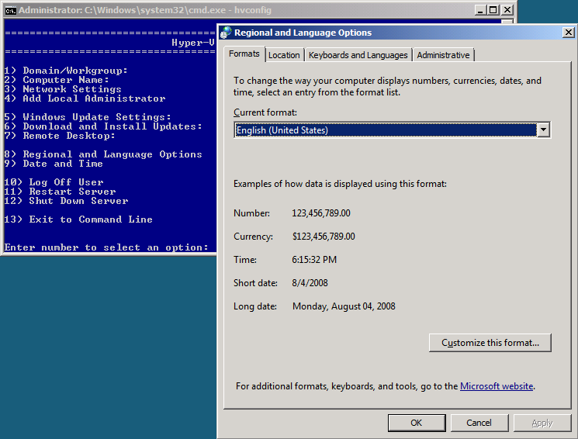

Figure 2: Hyper-V Regional and Language Options

## Date and Time

* 1. Type **9** and press ENTER to configure or modify the Hyper-V Server Date and Time options.
  2. You will be presented with the Hyper-V Server Date and Time options dialog box.
  3. When you are finished configuring Date and Time options, click **OK** to commit the changes or **Cancel** to discard them.

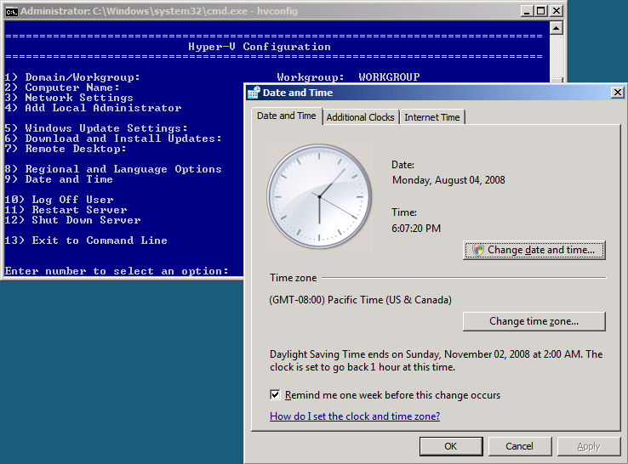

Figure 3: Hyper-V Server Date and Time Settings

## Log Off User

* 1. Type **10** and press ENTER to log off the current user.
  2. You will be prompted with “Are you sure you want to log off?”

1. Click **Yes**.

## Restart Server

* 1. Type **11** and press ENTER to restart the Hyper-V Server.
  2. You will be prompted with “Are you sure you want to restart?”
  3. Click Yes.

***NOTE****: By default, running virtual machines will automatically be saved prior to restarting the Hyper-V Server.*

## Shut Down Server

* 1. Type **12** and press ENTERto shut down the Hyper-V Server.
  2. You will be prompted with “Are you sure you want to shut down?”
  3. Click **Yes.**

***NOTE****: By default, running virtual machines will automatically be saved prior to shutting down the Hyper-V Server.*

## Exit to Command Line

1. Type **13** and press ENTER to exit to the Command Line.

***NOTE****: To return to the Hyper-V Server Configuration Tool, type* ***hvconfig*** *and press* ***ENTER.***

## Open a new Command Line window

1. *Press* CTRL+Shift+ESC to open Task Manager
2. In Task Manager click File -> New Task (Run) -> CMD.

# Hyper-V Server Remote Management

There are a few ways to remotely manage Microsoft Hyper-V Server:

* Microsoft® Windows Server 2008 (a full installation) with the Hyper-V Manager
* Microsoft® Windows® Vista SP1 with the Hyper-V Manager
* Microsoft® System Center Virtual Machine Manager 2008

Choose which option is right for you and follow the corresponding steps below.

### Hyper-V Server Remote Management with Microsoft® Windows Server 2008

To enable the Microsoft® Windows Server 2008 Hyper-V Manager MMC:

***NOTE****: The Hyper-V Manager MMC is automatically installed when the Hyper-V role is enabled on full installations of Windows Server 2008.*

1. Launch **Server Manager** from the Start menu.
2. Click **Add Features.**
3. Under Remote Server Administration Tools→Role Administration Tools→
   1. Enable **Hyper-V Tools** and click **Next**.
4. Click **Install**.
5. After the reboot, go to **Administrative Tools** in the Start menu and click on the **Hyper-V Manager**.
6. On the left side of the MMC window, click on **Hyper-V Manager.**
7. From the Actions menu, click **Connect to Server,** select **Another Computer** and enter the name or IP address of the server you want to connect to.

### 

### Hyper-V Server Remote Management with Microsoft® Windows Vista SP1

To enable the Microsoft® Windows Vista SP1 Hyper-V Manager MMC,

1. Download and install the Hyper-V MMC for Vista SP1. Please visit <http://www.microsoft.com/Hyper-VServer> for more information.
2. After the reboot, go to **Administrative Tools** in the Start Menu and click on the **Hyper-V Manager**.
3. On the left side of the MMC window, click on **Hyper-V Manager.**
4. From the Actions menu, click **Connect to Server,** select **Another Computer** and enter the name or IP address of the server you want to connect to.

### Hyper-V Server Remote Management with Microsoft® System Center Virtual Machine Manager

Please see the Microsoft® System Center Virtual Machine Manager documentation.

# Setup Hyper-V Server virtual networks

Configure one or more virtual networks for virtual machines to access network resources.

### Creating Hyper-V Server Virtual Networks

From a system running Microsoft® Windows Server 2008 or Microsoft® Windows Vista SP1 with the Hyper-V Manager management pack loaded, launch the Hyper-V Manager.

1. On the left side of the MMC window, click on **Hyper-V Manager.**
2. From the Actions menu, click **Connect to Server,** select **Another Computer** and enter the name or IP address of the server you want to connect to.
3. In the Actions menu click **Virtual Network Manager…**
4. Under **Create virtual network**, select **External** and click **Add.**
5. Type a name for the new virtual network, such as *Corpnet*andclick **OK**.

*NOTE: When you create a virtual network remotely, Hyper-V Server creates the new virtual switch and binds it to the physical network TCP/IP stack. If the Hyper-V Server system is configured with only one physical network adapter, this may result in a dropped network connection. This is normal while the virtual network is being created.*

# Additional Resources:

For more information about Microsoft® Hyper-V Server 2008, visit:

<http://www.microsoft.com/Hyper-VServer>

For more information about Microsoft® System Center Virtual Machine Manager, visit:

<http://www.microsoft.com/systemcenter/scvmm/default.mspx>

© 2008 Microsoft Corporation. Microsoft, Windows, Hyper-V, Active Directory and Windows Server are trademarks of the Microsoft group of companies.