
Microsoft Office Word 2007

Microsoft® Office Word 2007 helps you create professional-looking content more quickly than ever before. Using a host of new tools, you can quickly construct documents from predefined parts and styles, as well as compose and publish blogs from within Word. Advanced integration with Microsoft Office SharePoint® Server 2007 and a new XML-based file format make Office Word 2007 the ideal choice for building integrated document management solutions.
Create Professional-Looking Content Easily
Office Word 2007 gives you the tools you need to create professional-looking content.
- New! A streamlined results-oriented user interface presents the right tools to you when you need them.
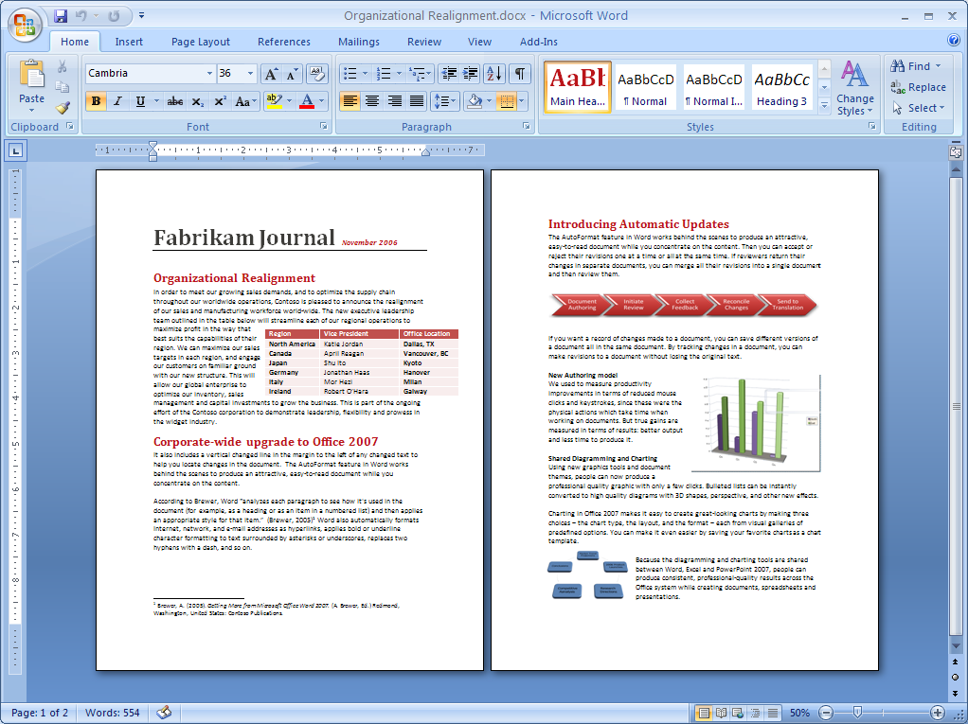
A host of new editing tools in Office Word 2007 help you create great-looking documents more easily than ever before.

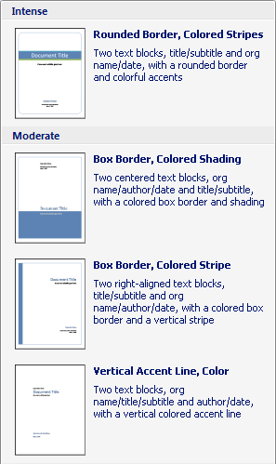
- New! Use Building Blocks of predefined content for more efficient document creation and to reduce the chance of errors associated with copying and pasting frequently used content.
- New! Use Quick Styles to quickly format text and tables throughout your document.
- New! Apply Document Themes to give your documents a consistent look with colors, fonts, and effects.
Building Blocks help you quickly add frequently used content to your documents.
- New! Use SmartArt™ diagrams and a new charting engine to help add a professional look to documents, with a minimum of effort.
- New! Compose and publish Web logs (blogs)—complete with pictures, rich formatting, and more—from within Office Word 2007, using the familiar Word interface.
- New! Use Equation Builder to construct editable, in-line mathematical equations using mathematical symbols, prebuilt equations, and automatic formatting.
- New! Check live word count—always in view in the new Word user interface—to keep track of the number of words in your document as you type.
- Improved! Typographic capabilities offer improved bulleted and numbered lists and numbered list styles, as well as new fonts designed to improve on-screen legibility.
- Improved! Use Citation Manager and Reference Builder to manage and format bibliographies, footnotes, endnotes, tables of contents, tables of figures, and tables of authorities. Format citations automatically by selecting a predefined style, including AP, APA, MLA, The Chicago Manual of Style, and others.
- New! The contextual spelling checker helps you avoid common spelling errors and the misuse of similarly spelled words.

Share Your Documents and Content Efficiently and with Confidence
New Word features help you avoid unwanted distribution of your documents and help ensure that private comments and hidden text are removed prior to publishing. Use Office Word 2007 with Office SharePoint Server 2007 to provide feedback on important documents and participate in more efficient review and approval workflows.
- New! Use the tri-pane review panel to compare and combine edited versions of a Word document. Simultaneous scrolling of the three panes makes it easier to review the changes and combine them into a final draft.
- New! Initiate an Office SharePoint Server 2007 review and approval workflow directly from Office Word 2007. You can simplify the document review and approval process across your organization using familiar tools integrated with powerful server capabilities.
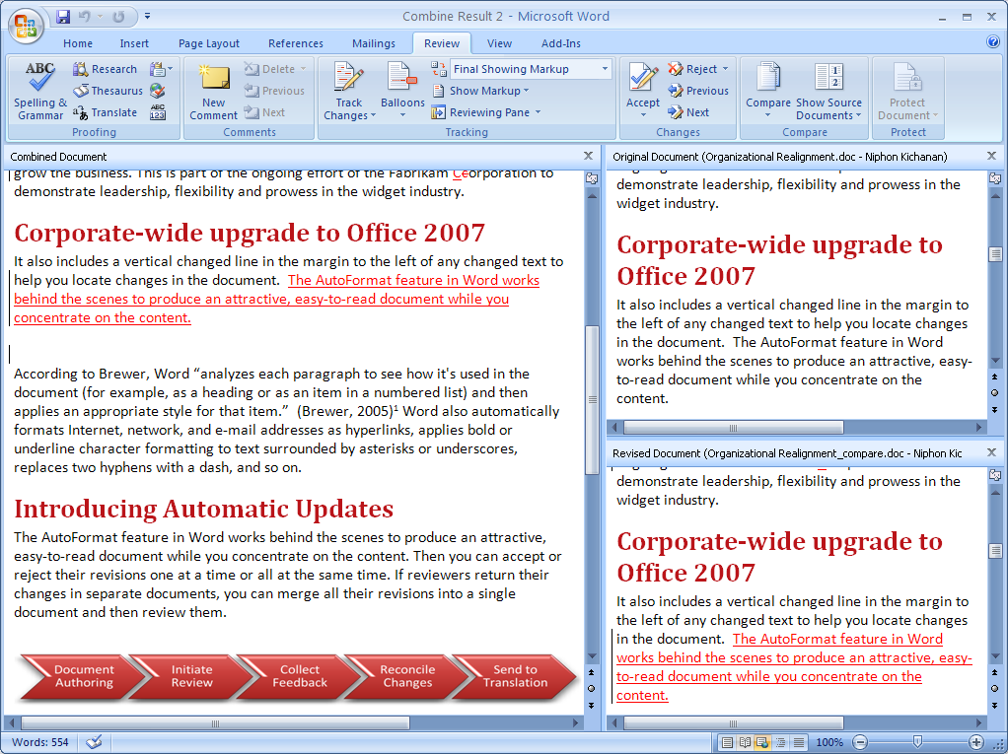
A new tri-pane review panel makes it easy to compare two versions of a document or combine feedback from reviewers.
- New! Save your document as a Portable Document Format (PDF) or XML Paper Specification (XPS) file to share it online and with others regardless of the type of computer or document-authoring program they use.
- New! Use the Document Inspector feature to detect and remove unwanted comments, personally identifiable information, hidden text, or other information from the document so that private information stays that way.
- Improved! Add a digital signature to a
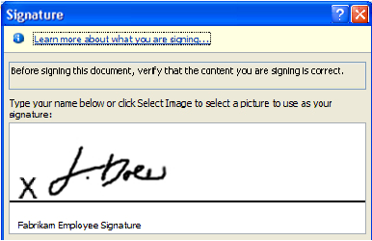
Office Word 2007 makes it easy to digitally sign your documents.
document to help others verify that the content has not been changed since you published it. A signature line can be added to a document to prompt other Word users for their signature or to provide a visible digital signature within your documents.
- Improved! Reading Mode provides an uncluttered, full-screen reading experience, reducing the need to print. New navigation tools and display improvements make the reading experience better than ever.

Connect Your Documents to Business Processes
Office Word 2007 offers a host of integration points to enable organizations to build powerful document management solutions that are easy to use.
- New! Open XML Formats give developers unprecedented access to the contents of your documents, enabling broad interoperability with a wide range of programs and solutions.
- New! Use the Document Information Panel to define what information is associated with a document type. Help users enter the correct metadata by linking document properties to Microsoft Windows® SharePoint Services or to other external data sources.
- New! Content Controls help you structure the document-authoring process by requiring specific types of information or by adding document sections that cannot be edited or reformatted.
- Improved! Custom-defined schema support of the Open XML Formats enables developers to host their own content within Word documents, using their own XML vocabularies. Instead of expensive translations, custom XML content is hosted directly within the file.
- Improved! Data Binding in Office Word 2007 provides developers with an easy way to link the contents of external data sources and custom-defined schemas to their Word documents.

Manage Content
with Office SharePoint Server 2007
Use Office Word 2007 with Office SharePoint Server 2007 to provide more effective ways to manage content, helping ensure consistency
and compliance with regulations across your company.
- New! Participate in Office SharePoint Server 2007 workflows without leaving Office Word 2007 for more efficiency when working in a managed environment. You can start workflows, interact with workflow tasks, and get information about your documents from the new Document Alert Bar.
- New! Access managed document repositories from within Office Word 2007 for greater control over document versions.
- New! Use information management policies to consistently enforce the labeling, auditing, and expiration of documents stored in Office SharePoint Server 2007 managed document repositories.

For More Information
Learn more about Office Word 2007 and the 2007 Microsoft Office system at www.microsoft.com/office/word.
For complete system requirements, visit www.microsoft.com/office/word.

This document is for informational purposes only. MICROSOFT MAKES NO WARRANTIES, EXPRESS OR IMPLIED, IN THIS SUMMARY.
The example companies, organizations, products, domain names, e-mail addresses, logos, people, places, and events depicted herein are fictitious. No association with any real company, organization, product, domain name, e-mail address, logo, person, places, or events is intended or should be inferred.


© 2006 Microsoft Corporation. All rights reserved. Microsoft, the Office logo, SharePoint, SmartArt, and Windows are either registered trademarks or trademarks of Microsoft Corporation in the United States and/or other countries. All other trademarks are property of their respective owners.

You can save as a PDF or XPS file from a 2007 Microsoft Office system program only after you install an add-in. For more information, see Install and use a PDF or XPS add-in.

