business notification
Microsoft^{â} Business Solutions for Supply Chain Management–Navision^{â} Business Notification helps you manage your business more easily and effectively. You can identify any business-critical issues early and resolve them and exercise better control over your supply chain.

Key Benefits:
- Use your time more efficiently to focus on the critical areas of your business.
- Understand and control events and processes in the supply chain.
- Integrate business processes and critical data.
- Resolve issues before they turn into problems.

Manage Your Business More Effectively
Microsoft Business Notification provides easy-to-use functionality within Microsoft Business Solutions–Navision to generate e-mail messages to your employees, suppliers, partners, and customers informing and alerting them of critical business conditions. Microsoft Business Notification helps you to improve management control of your business and the effectiveness of your business processes. With Microsoft Business Notification, you are always aware of changing business conditions, and you can make sure that all operations keep on track. You can use any of the templates included with Microsoft Business Notification, and also set up your own alerts based on the way you like to run your business.

Make Better Use of Your Time
You can focus on the information that matters to you, so you don’t waste time searching for it among the copious amounts of data generated by your business every day. You can set Microsoft Business Notification to alert you to events that are important to your work, so you can manage your supply chain processes and other business areas with more impact. Similarly, you can direct notifications to go automatically to your employees and business partners to keep them informed, so you don’t have to spend the time manually finding the information and sending it to them.
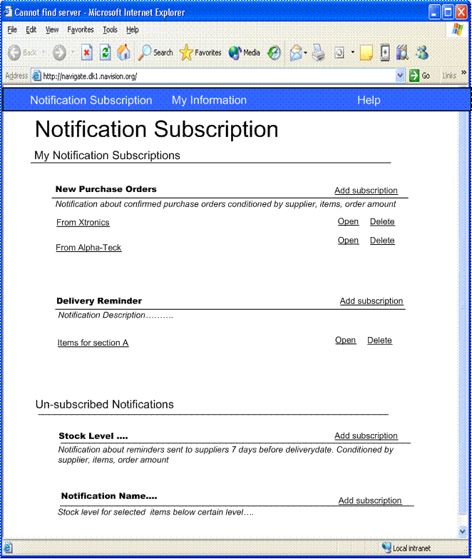
Microsoft Business Solutions—Navision Business Notification Subscription

Understand Events in Your Supply Chain
Microsoft Business Notification can help you keep abreast of your supply chain, so you can be in better control of your business. You can receive alerts to tell you whether goods have been delivered or whether they are late, or you can be updated on adjustments made to a bill-of-materials, so you can change your orders accordingly. An alert can also be set up to warn you and your vendors that a crucial item will soon be out of stock in your warehouse, so the vendors can replenish your supply, or you can make other plans if you need to.

Integrate Business Processes
Microsoft Business Notification helps you increase the value of your investment in your business solution by bringing important business data to your awareness. You can use all of the rich data within your Microsoft Navision solution as a tool to help you manage and improve business performance and productivity. You have immediate access to important information that concerns you, from any area of the business—without the cost of purchasing and implementing an additional solution. You can, for example, improve financial management by setting up a notification to alert you when your cash reserve has reached a certain level.
Microsoft Navision uses dependable, standard architecture to leverage your business data. Microsoft Business Notification integrates with Microsoft Navision through Extensible Markup Language (XML) ports in Microsoft Navision, and creates events and triggers in Microsoft Navision C/SIDE Application Language (C/AL) code. Upon activation of a trigger, the C/AL code sends data defined in the XML port to Microsoft Business Notification to make it create a notification.

Resolve Issues Before They Cause Problems
Microsoft Business Notification makes it possible for you to be aware of business-critical events anywhere in your organization, and to prevent problems long before they might occur. For example, you can receive notifications to tell you if there is a delay in shipping or production, or when the inventory on crucial items sinks beyond a certain level. You can then plan any necessary changes to the business processes in a timely manner and initiate any communications to customers, suppliers, and business partners.

About Microsoft Business Solutions
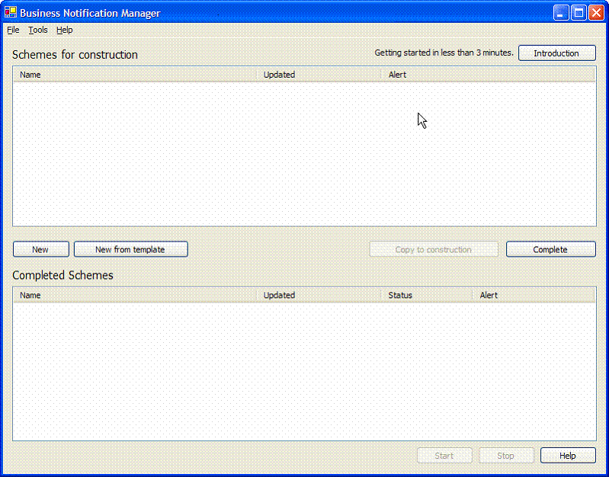
Microsoft Business Solutions for Supply Chain Management—Navision Business Notification Manager

Microsoft Business Solutions, a division of Microsoft, offers a wide range of integrated, end-to-end business applications and services designed to help small, midmarket, and corporate businesses become more connected with customers, employees, partners, and suppliers. Microsoft Business Solutions' applications optimize strategic business processes across financial management, analytics, human resources management, project management, customer relationship management, field service management, supply chain management, e-commerce, manufacturing, and retail management. The applications are designed to provide insight to help customers achieve business success. More information about Microsoft Business Solutions can be found at www.microsoft.com/BusinessSolutions.

Address:
Microsoft Business Solutions
Frydenlunds Allé 6
2950 Vedbaek
Denmark
Tel +45 45 67 80 00
Fax +45 45 67 80 01
www.microsoft.com/BusinessSolutions

Key Features | Description
Easy access to all Microsoft navision data | - Receive alerts about any critical values and events in any area of your business.  - Get notifications by e-mail, no matter what e-mail system you are using.  - Receive alerts and notifications directly in your e-mail box without searching for data.  - Avoid the cost and complexity of implementing a solution in addition to Microsoft Navision to monitor business data and generate notifications.  - Replace setup, printing, and reading of reports with notifications and alerts.
Notification setup in a few steps | - Set up notifications for any area within Microsoft Navision. After a quick setup by your Microsoft Certified Partner, you are ready to set up the notifications you need to gain better control of your business. Access the Business Entity Administration to administrate and manage business entities defined in Navision, such as Purchase Orders, Customers, and Items.  - Use the Notification Manager to set up new notifications. In a few minutes, the Notification Manager guides you through the few steps that are required to create notifications.  - Use the Notification Filter to define a set of conditions that filter the business data further. For example, set up notifications about purchase orders including specific items from the item group table.  - Use the Notification Message to create contents for the notification e-mails, with plain text or as a result of merging fields and parameters from the system.  - Use the Notification Permission to define which employees will be able to subscribe to which notification.
choice of notifications you want to receive | - Use the Notification Subscription to easily subscribe to notifications and only receive the notifications that are relevant to you.  - When you no longer need a notification, it is very easy to unsubscribe.
notification templates to deliver the value of the functionality quickly | Microsoft Business Notification includes out-of-the box functionality, mainly to enhance your supply chain management. These are the six templates you receive:  - Purchase order — Ensure Delivery of Goods: Send notifications to selected recipients—for example, your suppliers—to remind them of upcoming deliveries.  - Purchase Order — Vendor Confirmation Not Received: Send a notification to suppliers or recipients, when you have not received an order confirmation from them.  - Purchase Order — Goods Not Received from Vendor: Notify selected recipients, such as a supplier or someone in your company, when you have not received expected goods on the promised day.  - Production Order — Production Delayed: Send notifications to selected recipients—for example, an account manager in your company—to inform them when production has not started on time or will end later than planned.  - Inventory — Item Quantity Status: Control your inventory level. You can set up the program to send a notification to selected recipients, such as your supplier, when the quantity of a selected item has reached a defined level in your inventory.  - Production BOM — Items Updated: Send a notification to your purchase manager or other recipients when a bill-of-material has been modified.

System Requirements
To obtain all of the features mentioned in this fact sheet, the following modules and technologies are required.
Microsoft Business Solutions for Supply Chain Management—Navision Business Notification Client
The following system requirements apply only to the Microsoft^{â} Navision^{â} Client, database servers, and Microsoft^{â} Business Solutions–Navision^{â} Application Server.
Component | Requirement
RAM  Operating system  Hard disk | 60 MB free memory with default cache settings  Microsoft^{â} Windows^{â} 2000, Windows Server™ 2003, or Windows^{â} XP  About 250 MB (full installation including two language modules)  About 110 MB (minimal installation including two language modules)
Microsoft Business Solutions for Supply Chain Management—Navision Business Notification Server
Component | Requirement | Recommendation
Processor  Operating system  Hard disk | PC with a Pentium III 450-MHz or higher processor  Microsoft Windows 2000 Server, Windows 2000 Advanced Server, or Windows^{â} Datacenter Server (including Microsoft Internet Information Server)  500 MB of available hard disk space | PC with a Pentium III 733-MHz or higher processor  Microsoft Windows 2000 Server, Windows 2000 Advanced Server, Windows Datacenter Server, or Windows Server 2003 (including Microsoft^{â} Internet Information Server)  1 GB or more of available hard disk space

© 2004 Microsoft Business Solutions ApS, Denmark. All rights reserved. Microsoft, Great Plains, Navision, Visual Studio, and Windows are either registered trademarks or trademarks of Microsoft Corporation, Great Plains Software, Inc., FRx Software Corporation, or Microsoft Business Solutions ApS or their affiliates in the United States and/or other countries. Great Plains Software, Inc., FRx Software Corporation, and Microsoft Business Solutions ApS are subsidiaries of Microsoft Corporation. The names of actual companies and products mentioned herein may be the trademarks of their respective owners. The example companies, organizations, products, domain names, email addresses, logos, people, and events depicted herein are fictitious. No association with any real company, organization, product, domain name, e-mail address, logo, person, or event is intended or should be inferred.

