Technology Overview:
Microsoft® Windows® Internet Explorer 7 for the Enterprise



Updated: October 2007

Abstract: This enterprise-focused paper provides IT professionals with an overview of the new features of Internet Explorer 7 for Windows XP and Windows Server 2003 and how these improvements in the new browser will help in deploying and managing Internet Explorer 7 in business environment. This paper will review the major steps forward that Internet Explorer 7 provides in security and privacy protection, the user experience, and management and platform advances.
The information contained in this document represents the current view of Microsoft Corp. on the issues discussed as of the date of publication. Because Microsoft must respond to changing market conditions, it should not be interpreted to be a commitment on the part of Microsoft, and Microsoft cannot guarantee the accuracy of any information presented after the date of publication.

This document is for informational purposes only. MICROSOFT MAKES NO WARRANTIES, EXPRESS, IMPLIED OR STATUTORY, AS TO THE INFORMATION IN THIS DOCUMENT.

Complying with all applicable copyright laws is the responsibility of the user. Without limiting the rights under copyright, no part of this document may be reproduced, stored in or introduced into a retrieval system, or transmitted in any form or by any means (electronic, mechanical, photocopying, recording or otherwise), or for any purpose, without the express written permission of Microsoft Corp.

Microsoft may have patents, patent applications, trademarks, copyrights or other intellectual property rights covering subject matter in this document. Except as expressly provided in any written license agreement from Microsoft, the furnishing of this document does not give you any license to these patents, trademarks, copyrights or other intellectual property.

Unless otherwise noted, the example companies, organizations, products, domain names, e-mail addresses, logos, people, places and events depicted herein are fictitious, and no association with any real company, organization, product, domain name, email address, logo, person, place or event is intended or should be inferred.

© 2007 Microsoft Corp. All rights reserved.

Microsoft, Windows, Windows Vista, Windows Server, ActiveX, Expedia, Active Directory, the Internet Explorer logo, MSN and the MSN logo are either registered trademarks or trademarks of Microsoft Corp. in the United States and/or other countries.
The names of actual companies and products mentioned herein may be the trademarks of their respective owners.

Table of Contents

Introduction 1
About Internet Explorer 7 2
I. Improving Employee Productivity 4
New Interface 4
Tabbed Browsing 5
Instant Search 7
Printing Advances 8
RSS Feed Support 9
Page Zoom 10
Key Features – Making Everyday Tasks Easier 11
II. Easy to Deploy and Manage 12
Planning and Preparation 12
Deployment and Management 14
Improved Platform 18
Key Features – Improved Platform and Manageability 22
III. Security Improvements in Internet Explorer 7 23
Protection Against Malware 23
Personal Data Safeguards 27
Key Features – Dynamic Security Protection 35
IV. Conclusion 37
Appendix 38
Internet Explorer 7 Articles and Resources 38
Connect with the Internet Explorer Community 39

Introduction
Welcome to the Microsoft® Windows® Internet Explorer 7 technology overview for enterprises. Internet Explorer is the most widely used browser in business, education and government. We have released this new version of the popular Web browser to ensure that our enterprise customers have the most recent and secure version available.

Business customers have asked Microsoft for a browser that provides the following:
- Helps to protect proprietary and institutional information;
- Is easy to deploy and manage; and
- Empowers developers and designers to deliver additional functionality and delivers a streamlined browsing experience.

The final release of Internet Explorer 7 (IE7) is a browser that is ready for deployment in the enterprise. Whether you’re an IT professional or a developer, we’re confident you will find that the new capabilities in Internet Explorer 7 will dramatically improve your employees’ online experience, provide a more secured environment, and make it easier for you to deploy, manage, and maintain for your organization. You can upgrade with confidence.

Internet Explorer 7 is available in two versions:
- Internet Explorer 7 for Windows XP: a stand-alone version for Windows XP Service Pack 2, Windows XP Professional x64 Edition as well as Windows Server™ 2003
- Internet Explorer 7 in Windows Vista: a version built into Microsoft Windows Vista™ to take advantage of new features of the Windows Vista platform.

This technology overview focuses on the functionality in the standalone version of Internet Explorer 7. All of these features are included within Internet Explorer 7 in Windows Vista. Features unique to Internet Explorer 7 in Windows Vista are noted in this document as those features are described.

To help you prepare your organization for the deployment of Internet Explorer 7, Microsoft has provided readiness tools and resources which are downloadable for free at http://www.microsoft.com/ie. The MSDN Internet Explorer Developer Center, TechNet, and the IE team blog contain articles and insight about Internet Explorer 7 to assist you in preparing your Web sites and ensuring your Web-based applications will work with the new browser. A more complete list of relevant Microsoft Web sites and articles is included in the appendix.

About Internet Explorer 7
This document will to help enterprise customers understand the value of upgrading and preparing your organization for Internet Explorer 7.
We understand the need for IT professionals to evaluate software products and define the business value before committing time and resources to deploying software updates. We believe that browsers are unique in the way they serve as an interface to other applications, line of business tools, and general business productivity on a daily basis. These factors require you to have a thorough understanding of the benefits delivered in IE7; we will review these at a high-level in this technology overview.
The benefits of upgrading are easy to evaluate; Internet Explorer 7 will help your business save and make money. Let’s look at why your company will benefit by upgrading to Internet Explorer 7 as soon as possible; below are the three primary benefits:
- Internet Explorer 7 improves employee productivity.
As part of Microsoft’s efforts to simplify the common tasks users perform every day, Internet Explorer 7 includes enhanced functionality with improved navigation such as tabbed browsing, easy subscription to RSS feeds, and a new inline search toolbar. Advanced printing makes it possible to print a Web page without losing content. The new improved design includes consolidated menu items and smaller icons, optimizing the available screen space.
- Internet Explorer 7 is easy to deploy and manage.
Robust tools make IE7 easy to deploy; companies can upgrade their Windows XP and Windows Server 2003 machines at the same time, and all share a common browser experience across platforms. Internet Explorer 7 updates itself with the latest security updates available at install time, so multiple reboots are not necessary. New Group Policy feature settings give administrators more control and give users more visibility into the options that may or may not be available to them. It’s important to note that you won’t need to worry about hardware upgrades – Internet Explorer 7 will work on computers that are already running Internet Explorer 6 on Windows XP – and upgrades won’t lose configuration settings. Finally, developers will find that Internet Explorer 7 is more CSS standards compliant, so new site development should be easier.

- Internet Explorer 7 provides dynamic security protection for the enterprise.
Online security is an industry concern and Internet Explorer 7 will help protect your enterprise from current and emerging threats. We are helping to protect proprietary and institutional information through a robust new architecture, improved security features that help defend against malicious software (also known as malware), and new ways to better protect against the theft of personal data from fraudulent Web sites, a practice known as phishing. Internet Explorer 7 provides users with more visible security feedback and clear messages to help prevent them from accidentally lowering their security settings below acceptable levels, protecting confidential business information. In addition, with Internet Explorer 7 in Windows Vista, the Protected Mode provides additional safety as it helps prevents malicious software from taking over the browser and executing code on the system.

Improving Employee Productivity
Accessing information via the Internet is one of the top activities performed by PC users. The Internet is now a mission-critical resource for many information workers who need easier ways to routinely search for information from multiple places.

Internet Explorer 7 has been redesigned to empower application developers and Web designers to deliver additional functionality and enhanced browsing capabilities. Equally as important, information workers can perform everyday tasks more productively and efficiently. Conducting research, reviewing relevant news sites, accessing the company intranet, and entering time sheet data are just a few of the many tasks employees perform on a daily basis. Tabbed browsing, shrink-to-fit Web page printing, the ability to preview and subscribe to Web feeds, and inline toolbar searching are a few examples of the new features designed to improve employee productivity and efficiency.

New Interface
Microsoft has invested heavily in the user interface improvements in Internet Explorer 7, and your employees will experience the difference the moment they launch the new browser.

In Internet Explorer 6, the default configuration includes menus at the top and a row with buttons for Back, Forward, Stop, Home, Go and so on; below that is the Address Bar.

Internet Explorer 6

In Internet Explorer 7, the cleaner, sleeker user interface minimizes the number of toolbars needed and maximizes the amount of screen real estate devoted to the Web pages that users need to view. It’s easier for information workers to add Web sites to their Favorites, search the Web, clear history and access the tasks and tools that they use the most. The new streamlined look reduces the size of the back and forward buttons which are now next to the Address Bar for easier navigation. The Windows flag icon in the upper-right corner of Internet Explorer 6 has been removed to make room for the Instant Search box.

Internet Explorer 7

Users will notice the classic ‘File…Edit’ menu is no longer necessary as all of the functionality that previously existed in those drop-down menus is now available in the icons on the right side of the Toolbar. These new icons are visually intuitive and allow more space for Web pages. However, to help users become more accustomed to the new look and feel, the classic menus are displayed by default during installation.

Once the user is comfortable accessing the menu items by using the icons located to the right of the tabs, they may easily hide the classic Menu Bar. To hide the menus, the user can right click the toolbar and de-select Menu Bar. This will reduce the overall frame size and maximize the screen real estate devoted to Web pages.

To provide flexibility, users can restore the classic menus at any time by right clicking the toolbar and selecting Menu Bar. The menus can also be displayed or hidden for a single use simply by pressing the ALT key. Administrators can also use Group Policy to control this setting for users.

Note: All screenshots in this paper show the new streamlined user interface.

Tabbed Browsing
Users looking to open or manage multiple Web sites, especially on a regular basis, will quickly experience the benefits of the tabbed browsing interface. To create or open tabs in Internet Explorer 7, users can click on the empty tab on the Toolbar or right-click on any hyperlink in a Web page and choose Open in New Tab. They also can right-click on a tab to refresh each page as an individual tab or refresh all of them as a group, close individual tabs or the entire group, and reorder tabs on the tab bar by simply dragging and dropping.

Quick Tabs
Internet Explorer 7 helps manage multiple tabs with a feature called Quick Tabs. Quick Tabs enables users to view thumbnail images of all open tabs on one screen. By simply clicking the Quick Tab icon just to the right of the Favorites icon, users can view all open tabs. From the Quick Tabs view, clicking on a thumbnail image will open the corresponding tab. Tabs can be removed quickly and easily from the Quick Tabs view, by simply clicking the “X” in the far right corner of the image. The Quick Tabs page will scale to the number of tabs the user has open. For example, if a user has five tabs open, Quick Tabs will preview thumbnail images of all five tabs so the user will still be able to see all tabs in a single view.

For example, an IT administrator can create a Quick Tabs group that is called “Routers” that starts up at the beginning of a browser session, essentially a group of Web pages. In this group, she has five tabs that open, providing thumbnail images of each tab within one window so she will see all the router activity in a single view, and can quickly click through to any that need further attention.

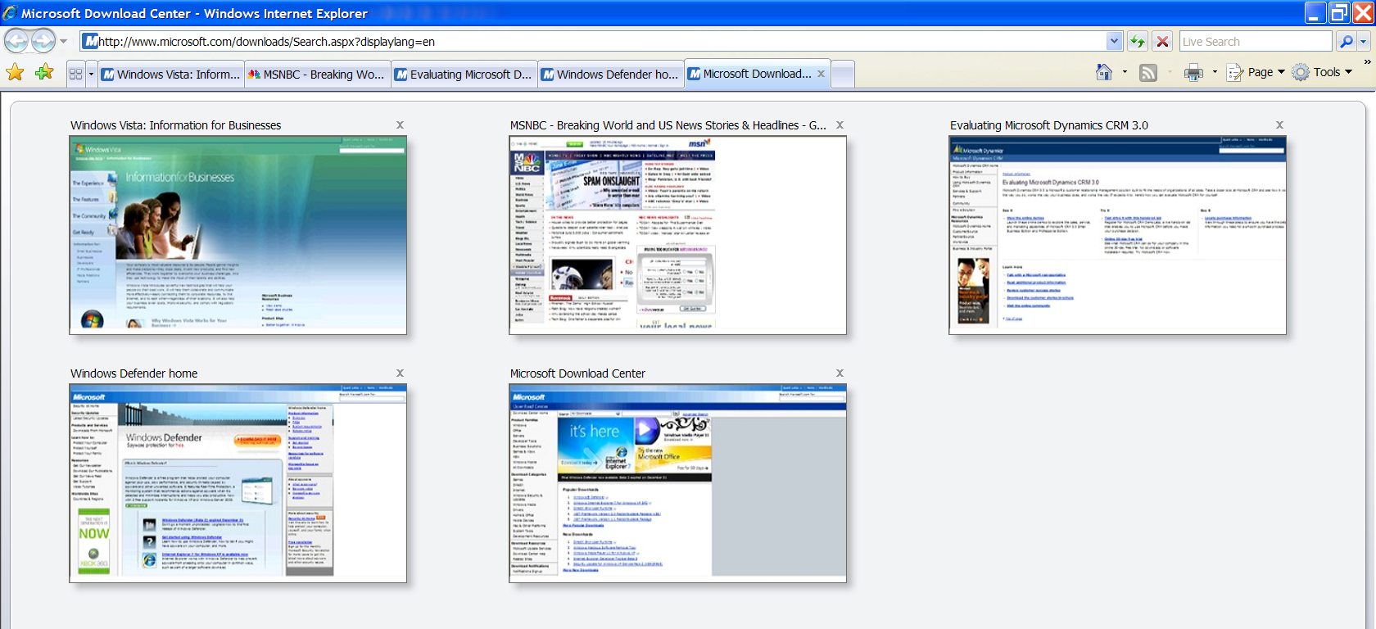

Tab Groups
Internet Explorer 7 simplifies the organization of multiple tabs with Tab Groups. Tab Groups enable users to create a custom group of Web site Favorites for easy organization and access. Tab Groups can be created for any group of tasks, subjects or categories such as the healthcare, finance and manufacturing industries or research and competitive Web sites. The Tab Group will appear as a folder in the Favorites menu. By clicking on the folder, the Tab Group will expand to show the unique sites organized within the folder. The user can open all of the sites in the Tab Group with a single click on the arrow to the right of the folder. A Tab Group may contain an unlimited number of tabs or sites, and users can create an unlimited number of Tab Groups within Favorites.

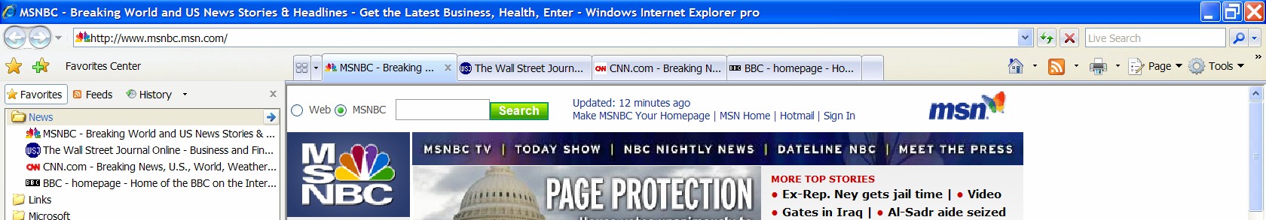

Instant Search
The Instant Search box makes it quick and easy for users to search the Internet directly from the browser frame using their favorite search provider. Users can choose a search provider from the drop-down list and easily add more providers to the list. Through the use of Group Policy, enterprises can add custom search options that are relevant for their organization, for example a search of the corporate library or records management for their business.

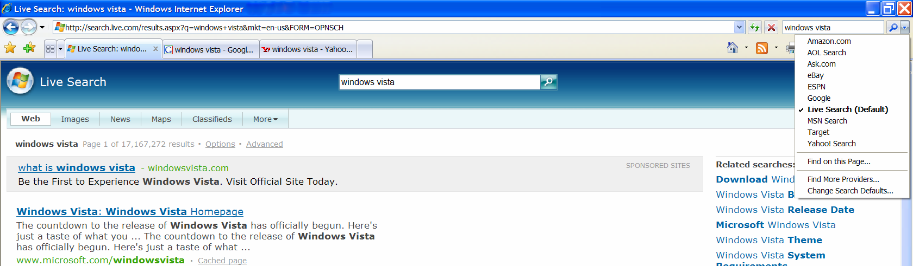

When users upgrade to Internet Explorer 7, the Instant Search box will work the same as users are accustomed to with AutoSearch in Internet Explorer 6, and it will inherit the previous default setting. To offer users the greatest choice, Internet Explorer 7 expands the definition of search provider by including broad and vertical search providers as potential candidates in the Instant Search drop-down list. From the Instant Search drop-down menu the user can simply click on Find More Providers to be linked to the Windows Search Guide. In addition, Internet Explorer 7 supports OpenSearch 1.1, the latest Creative Commons release of the standard from A9.com, Inc., a subsidiary of Amazon.com Inc., which enables syndication formats such as RSS and Atom to be used in search applications. Using OpenSearch offers enterprise administrators the ability to easily enable their Intranets for Instant Search, making it much quicker for users to access internal data; this function can be enabled by Group Policy. Furthermore, the search provider can be configured to be an internal portal like SharePoint in order to better integrate Internet Explorer 7 with your business information.

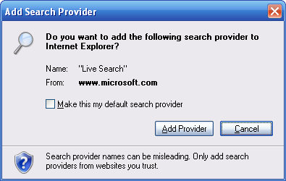

Printing Advances
As part of Microsoft’s efforts to simplify the common tasks users perform every day, Internet Explorer 7 includes enhanced functionality making printing easier and more flexible. By default, Internet Explorer 7 will shrink a Web page’s content just enough to ensure that the entire page prints properly, so users will no longer lose content at the left or right margin. It also eliminates orphan pages by shrinking enough to fit all the text to keep it all on one page, reducing paper usage and eliminating help desk calls due to these previously common printing issues.

Users can also adjust Web page margins, change the page layout, remove headers and footers, and increase or decrease the print space.

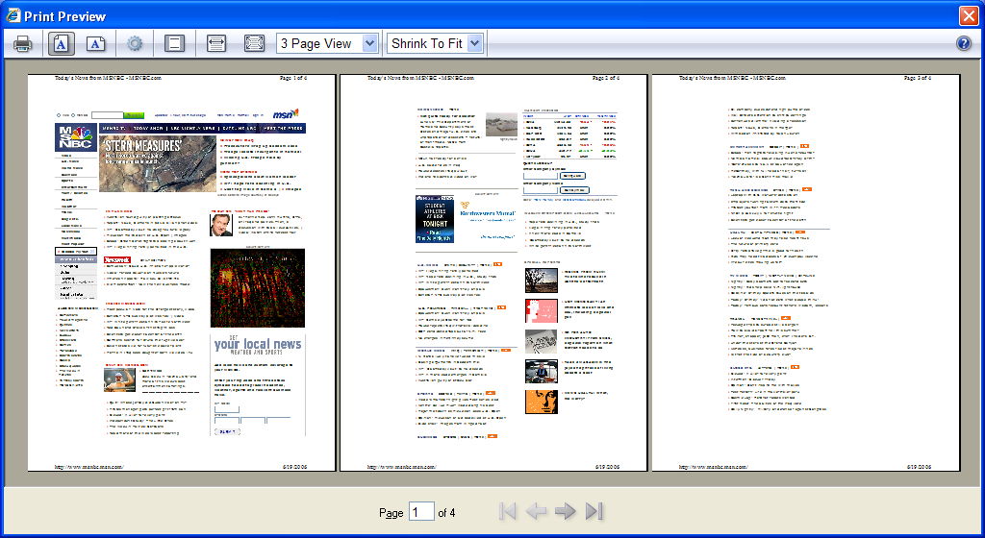

RSS Feed Support
Dynamic sites, such as news sites, now offer a service called RSS feeds, or just RSS. An inexpensive way to push information, RSS is used by Web publishers to create and broadcast information such as headlines, links, and summaries about a variety of information such as industry news, price discounts, weather and other timely content throughout the day directly to RSS subscribers. With an RSS reader, a user can subscribe to many feeds and quickly read updated, relevant content all in one place without visiting individual Web sites.

With new integrated support for RSS in Internet Explorer 7, users can easily scan for important stories, get a description of the content, and read RSS feeds directly in the browser. They may also subscribe to an RSS feed and have news feeds delivered directly to them, with a single click – a process that is very similar to adding a Web site Favorite.

RSS feeds can be used in a variety of ways in the enterprise. As described above, employees can subscribe to RSS feeds relevant to their job, and have information delivered right to their desktop enabling them perform their job more efficiently. For example, a public relations manager may subscribe to several industry, competitive and business news RSS feeds, reducing the time to monitor them each day. Enterprises can also use RSS feeds to communicate internally to employees. For example, an HR department may use an RSS feed to communicate information about employee training, policies, benefit changes, pertinent security information and enrollment deadlines to subscribers.

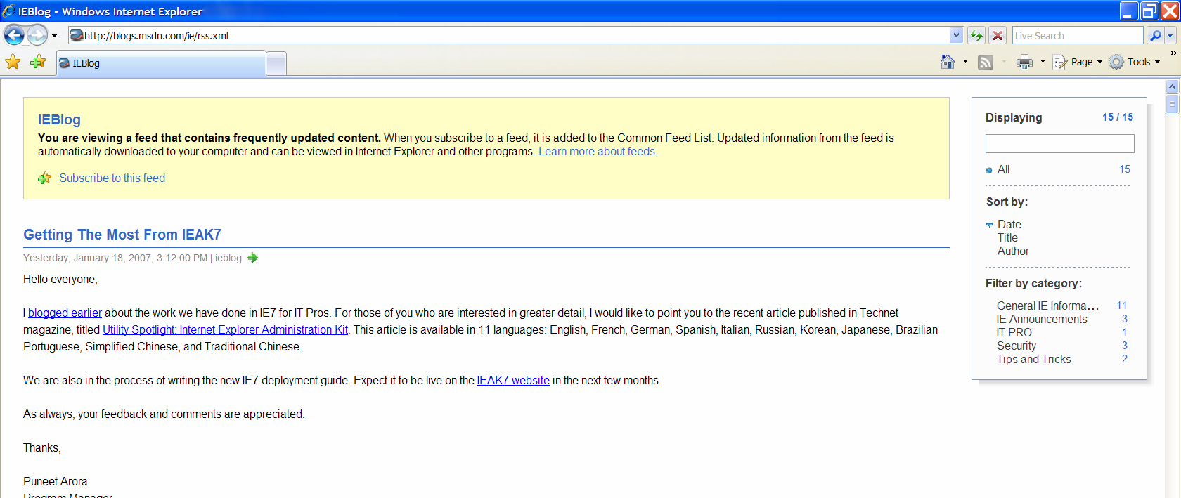

Installing Internet Explorer 7 also delivers the RSS platform so all applications can share the same set of RSS subscriptions, allowing developers to focus on creating new end-user experiences rather than on the details of RSS functionality. More details on this functionality are provided in the Deploy and Manage section of this overview.

Page Zoom
To improve the user experience, Internet Explorer 7 has added a Page Zoom feature, which enables users to increase or decrease the page size for easier viewing. Not only can the user change the text size, but any graphics or embedded text in graphics can also be modified. Hard-to-read text or small thumbnail images on Web sites can now be enlarged as well.
100 Percent View Zoomed View
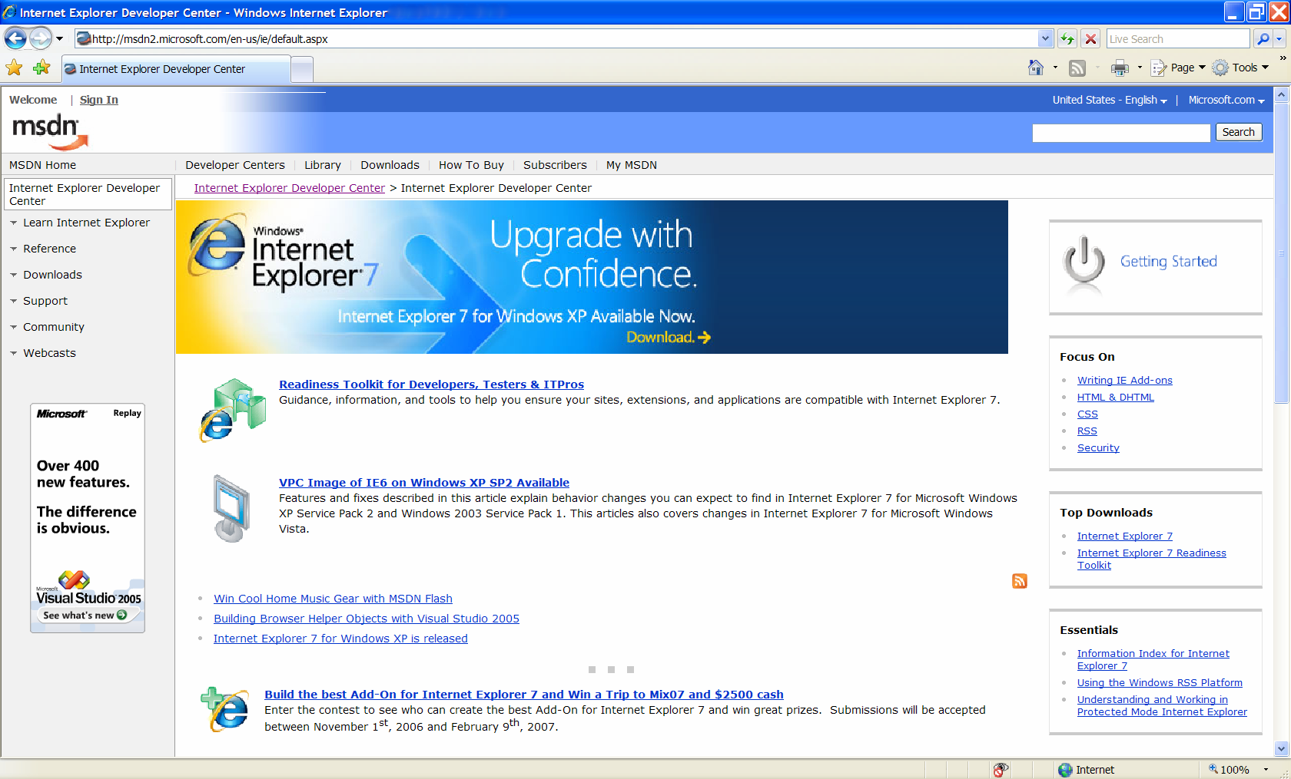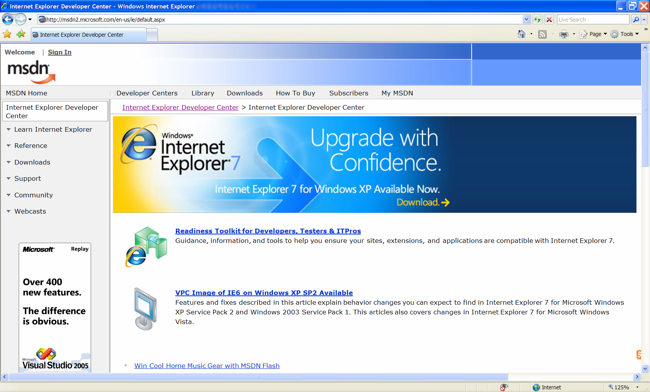

Key Features – Making Everyday Tasks Easier
Feature | Brief Description
Advanced printing | Automatically scales a printed Web page so it is not wider than the paper it’s printed on. Internet Explorer 7 also includes a multi-page Print Preview with live margins, resizing of text to avoid document clipping, and an option to print only selected text.
Toolbar Search Box | You can run a Web search query using your favorite search provider by entering it in a search box on the Toolbar. This eliminates the clutter of having a separate toolbar. You can choose a provider from the drop-down list and easily add more providers.
Tabbed browsing | You can view multiple sites in a single browser window and easily switch from one site to another via tabs at the top of the browser frame.
Simplified user experience | The Internet Explorer 7 frame is noticeably simpler, more streamlined, and less cluttered with unnecessary items compared to earlier versions. This maximizes the screen real estate devoted to the Web pages that users want to view and makes it easy to perform the most common browsing tasks.
Favorites Center | Offers easy and fast access to Favorites, Tab Groups, Browsing History, and RSS feed subscriptions. Expands out when needed and can be pinned in place for even easier access.
Quick Tabs | Provides easy tab selection and navigation by displaying thumbnails of all open tabs in a single window.
Tab Groups | You can group and save tabs into logical categories, allowing you to open multiple tabs with a single click. You can easily set a Tab Group as the Home Page Group so the entire Tab Group opens every time Internet Explorer is launched from the Start Menu.
Page Zoom | Enlarge or zoom in on individual Web pages, including both text and graphics, to focus on specific content or make the content more accessible to those with vision limitations.
RSS feeds | Automatically detects RSS feeds on sites by illuminating an icon on the toolbar. With a single click on the icon, you can preview and optionally subscribe to the site’s feed, and then be automatically notified as content is updated. Read RSS feeds directly in the browser, scan for important stories, and filter your view with search terms or site-specific categories.

Easy to Deploy and Manage

IT administrators will find that deploying and managing Internet Explorer 7 within their enterprise environments will be easier than ever before. With robust tools such as the Application Compatibility Toolkit 5.0 (ACT 5.0) and the Internet Explorer Administration Kit (IEAK), centralized control over settings via Active Directory® Group Policy, and significant improvements in security such as updates during install, Internet Explorer 7 will provide administrators with a secure, easy to use common browser across multiple platforms.

Available on Windows XP and Windows Server 2003, as well as in Windows Vista, Internet Explorer 7 provides a common browser across the organization. By updating Windows XP SP2 systems with this newest release, administrators are providing a more secure and safe browsing experience as well as setting the stage for Windows Vista in the future. When introduced to Windows Vista, employees will already be experienced with the new browser since the user interface remains the same across the systems. In addition, as with all software upgrades, the testing and preparation of your Web sites and Web-based applications with Internet Explorer 7 for Windows XP will help you identify and minimize any compatibility issues with Windows Vista.

The Internet Explorer 7 Deployment Guide available on www.microsoft.com provides a more thorough resource for IT administrators in planning enterprise deployments of Internet Explorer 7.

Planning and Preparation
As with any new or upgrade software release, IT organizations should follow their established processes to ensure that the introduction of the software will be seamless for their users, provide minimal disruption, and provide real value to their organization. With Internet Explorer 7, the browser architecture has been reengineered to address security, compatibility, and to support a variety of rich end-user experiences. In doing so, some changes may impact the way Web sites and Web-based applications work within your organization. Microsoft has provided several tools and resources to help you plan and prepare for the deployment of Internet Explorer 7:
- Internet Explorer 7 Readiness Kit
- Windows Application Compatibility Toolkit 5.0
- Internet Explorer 7 Blocker Toolkit

As announced in June 2006, Internet Explorer 7 is being distributed worldwide to customers via Automatic Updates (AU) based on its security improvements. For those using Automatic Updates and Windows Update, the automatic update notice will prompt the user to update to the newest browser. The updating process offers users a clear choice to accept or decline the update, or to be reminded later.

Those organizations that use automatic updates and/or provide remote access from employees’ home computers to internal Web sites and Web-based applications will need to ensure their organization is prepared for those using the new browser. You can find more information on the planned Automatic Update Notification process at http://www.microsoft.com/technet/updatemanagement/windowsupdate/ie7announcement.mspx.

Internet Explorer 7 Readiness Toolkit
The Internet Explorer 7 Readiness Toolkit is available for companies and partners to use to prepare Web sites, extensions, and applications for Internet Explorer 7. Developed in early 2006, the toolkit provides an easy way for any audience that is involved in the development, testing, or support of Web sites, extensions, and/or applications for Internet Explorer 7 and provides the following:
- Testing guidance and tips for isolating and identifying a compatibility issue
- Tools for development and testing
- Developer checklist including new features and changes
- Links to resources, technical articles and helpful blog posts
The Internet Explorer 7 Readiness Toolkit is available at: http://www.microsoft.com/downloads/details.aspx?familyid=D13EE10D-2718-47F1-AA86-1E32D526383D&displaylang=en.

Windows Application Compatibility Toolkit
The Windows Application Compatibility Toolkit 5.0 (ACT 5.0) is available to enable enterprises and partners to test their browser-based applications to ensure they will work seamlessly with Internet Explorer 7. In addition, the appendix of this document includes a list of Web articles and resources to help troubleshoot common compatibility issues. Download at: http://www.microsoft.com/technet/windowsvista/appcompat/tools.mspx.

Internet Explorer 7 Blocker Toolkit
For managed environments not using Windows Server Update Services, the Internet Explorer 7 Blocker Toolkit is available so that employees will not be prompted to download the new browser. This was developed so administrators may prepare, plan, download, test, and distribute the new browser when they deem the organization ready.
A non-expiring Internet Explorer 7 Blocker Toolkit that blocks automatic delivery of the new browser is available for organizations relying on AU for patch management that want to manage their organization’s deployment schedule of Internet Explorer 7. The Blocker Toolkit will not expire and includes a Group Policy template and an executable script. The Blocker Toolkit is available today for customer download at http://go.microsoft.com/fwlink/?linkid=65788. The Blocker is recommended for those organizations that want to manage their browser update process as automatic updating is scheduled to begin shortly after each language release and is expected to take several months to complete.

Deployment and Management
Managing the installation and updates of software within enterprises is critical to IT administrators and the browser is not an exception. With Internet Explorer 7, administrators have more control of the browser – its look and feel, features, and security settings – particularly in those organizations that use Active Directory and Group Policy. The manageability of Internet Explorer 7 gives enterprise administrators the ability to control or lock down application settings using policies. They can use policies to enforce company standards and most importantly, avoid misuse of the applications and safeguard the interests of corporations by enforcing security settings. With the updated Internet Explorer 7 Administration Kit (IEAK 7), organizations have the ability to customize and efficiently install the latest browser. With this release, Microsoft has committed more tools and resources to help deploy and manage Internet Explorer 7 in the enterprise.

Active Directory
Active Directory is a part of the Windows Server environment and is used by companies with domains and organizational units (OUs). An organizational unit is a logical container into which users, groups, computers, and other organizational units are placed and to which a Group Policy object can be linked and policy can be applied. Active Directory provides essential directory services for the domain and provides features that enable advanced controls through Group Policy.
In an Active Directory environment, the administrator can deploy and manage Internet Explorer using the Active Directory infrastructure. The administrator has the ability to lock down Internet Explorer settings using Group Policy. This is the best way to manage Internet Explorer settings and is consistent with how other Windows settings can be managed. Also in an Active Directory environment, a client side extension ensures that policies are applied all of the time. If policies are changed, they can be refreshed quickly rather than relying on a logon or startup script for policies to be applied to the user machine.
Windows Installer
As of October 2007, the Internet Explorer 7 Administration Kit (IEAK 7) includes a Windows Installer (.MSI) to make enterprise deployment easier for those customers using Active Directory to deploy Internet Explorer 7 within their organizations. If you previously downloaded the IEAK 7, you will need to download the most recent version of IEAK 7 from http://technet.microsoft.com/en-us/ie/bb219543.aspx. Learn more about this IEAK 7 update by reading the Knowledge Base article at http://support.microsoft.com/kb/942812.

Group Policy
With Internet Explorer 7, administrators have centralized control over settings via Active Directory® Group Policy, which makes enterprise browser deployments more manageable and help administrators ensure that browser users comply with company standards. The additional Group Policy settings for new features in Internet Explorer 7 give administrators more control and give users more visibility into the options that may or may not be available to them. The newly available features within Internet Explorer 7 are also manageable via Group Policy, including the Phishing Filter and all browser add-ons.
Here are a few scenarios of how an administrator may use Group Policy in the enterprise:
- An IT administrator of a bank wants to deploy Internet Explorer 7 throughout the corporation. Using IEAK, he customizes the browser by specifying the default home page and favorites. Using Group Policy, he manages the browser by locking down the home page and sets security settings for particular users. For example, bank tellers have access to the intranet but not the Internet.
- An enterprise wants to ensure that employees don’t unintentionally disclose confidential information to fraudulent Web sites. The IT administrator, by setting a policy to "Turn off managing the phishing filter”, ensures that the Phishing Filter is always on so users receive a warning when they click on a fraudulent site.
- An IT administrator needs to make sure that legacy systems using ActiveX® controls continue to work seamlessly for employees after upgrading to IE7. Using Group Policy, she sets the security bar to “minimum” for the Trusted Sites zone and adds their online HR system (that includes an internally-developed ActiveX control) to this zone. This ensures access for employees, while making sure that the standard medium security bar setting is maintained for other Web sites.
- In this healthcare institution, browsing history needs to be managed in a specific way to comply with their records policy. Using Group Policy, the IT administrator sets this feature so that browsing history is deleted every day and complies with records management policy while improving privacy at the same time.
- An IT administrator is ready to deploy the Windows Vista operating system, which installs with the new Protected Mode feature on by default. In order to take advantage of this security feature, she defines a policy so that users cannot turn off Protected Mode.
Internet Explorer 7 provides policies for all new features and makes the Internet Control Panel Group Policy aware. Policies can be applied to any logical group; when Group Policy is set at the local computer level, everyone who logs on to the local machine is affected by the policy settings (Local Group Policy). In addition, we have made most existing Internet Explorer Maintenance (IEM) Group Policy Editor snap-in settings as true policies, including IEM preference mode settings, and available outside of Preference Mode. This provides corporate administrators greater control in locking down legacy Internet Explorer settings. This also improves the ability of the administrator to manage multiple versions of Internet Explorer within the same environment.

Internet Explorer Administration Kit 7 (IEAK 7)
For those environments where a corporate administrator cannot use Group Policy, the Internet Explorer Administration Kit 7 (IEAK 7) enables IT administrators to easily customize settings of Internet Explorer 7 at the time of installation, and manage deployment of those custom browser software packages. It is important to note that this customization may be changed by the end user after installation.
If your organization has a large number of desktops and a number of Organizational Units to manage, we strongly recommend using Group Policy. However, if you are unable to use Group Policy, you will find the improvements in IEAK 7, including an improved user interface, the structure of the wizard, and the ability to add Search Providers, will make it easier to deploy Internet Explorer 7.
With the Internet Explorer Customization Wizard, step-by-step screens for each stage guide you through the process of creating custom browser packages. When these packages are installed on your desktops, they'll receive customized versions of Internet Explorer 7 with the settings and options that you selected.
Administrators can deploy Internet Explorer 7 using IEAK 7 in a variety of ways, including creating a CD or hosting on an internal server or creating flat files (all files in one directory). If you build your packages on a local area network you can select the flat file option to place all the necessary files in one folder under the target destination. Even in environments that use Active Directory and Group Policy, IT administrators may use the IEAK to deploy Internet Explorer 7 across their organization.
Here are two scenarios of how an administrator may use IEAK 7 in the enterprise:
- An IT administrator wants to deploy IE7 with some default settings set, but also wants to be able to change those defaults at a later date. Using IEAK 7, he customizes a package and deploys it. In the future, he can use Profile Manager to make changes to the default setting, save to the install.ini, and refresh the INS file using the Auto Configure option.
- An IT administrator wants to set defaults for IE7 settings but doesn’t want to lock them down with Group Policy. She creates a customized IE7 package using IEAK 7 and deploys it using the deployment technology that the organization currently uses, or use the windows installer (MSI) customized IE7 package created by IEAK 7 to deploy through Active Directory.

Using Group Policy and IEAK 7 to Set Policies and Preferences
Settings in Internet Explorer 7 can be configured as true policies (locked down with values specified) or as preferences (just configured by specifying a default value). It is important to understand the differences and the process you should use in order for them to execute the way you need.

- Group Policy Objects (GPO) – has settings under Administrative templates that are policies and settings under IEM (Internet Explorer Maintenance as snap-ins to Group Policy editor).
- IEAK 7 – has preferences and some settings under the Additional Settings page that are policies.

Policies always take priority over preferences. However, as noted above, both Group Policy and IEAK 7 can be used to set both policies and preferences. In the case where both set a policy or preference, the one that gets top priority will be the one that is applied last.

It is recommended to use GPO to set true policies and use IEAK 7 to set preferences. This will avoid conflicts and ambiguities in the resulting IE7 behavior.

Software Management Solution
Microsoft recommends that enterprises wanting maximum flexibility over delivery of updates to their desktops deploy a software update management solution such as the free Microsoft Windows Server Update Services (WSUS) which is available at http://www.microsoft.com/windowsserversystem/updateservices/default.mspx. For more advanced businesses, System Management Services (SMS) Server provides the most flexibility and control over software delivery.

Internet Explorer 7 Add-ons
Browser add-ons can help add personalized features and functionality to enhance the way an individual uses the Internet. The add-ons available in the Windows Marketplace have been carefully screened by Microsoft and rated by users to help you select ones that suit your organization’s needs and preferences. While the initial launch focused on individual users, it is expected that more will developed for enterprise customers. The same IE Add-ons are also available at http://ieaddons.com.

Support
Internet Explorer will continue to be supported as part of the Windows platform, with continuous incident response support provided by the Microsoft Security Response Center. Further, there will be not be any change to Windows support life-cycle timelines with this new release, so administrators can be assured that Microsoft is standing behind the new release.

In addition, IT administrators and developers can access online resources, such as the Internet Explorer Developer Center, the Internet Explorer Support Center, and direct access to the IE team through the IE Team Blog at http://blogs.msdn.com/ie/ to best support their Internet Explorer 7 deployment and management needs.

Improved Platform
Web developers have expressed frustration in the behavior of Internet Explorer 6, especially in the areas of standards support. In addition, application developers who want to take advantage of new Web capabilities have been required to develop everything from the ground up. Network administrators have also been looking for better ways to manage large numbers of browser users.
With Internet Explorer 7, the browser architecture has been reengineered to address compatibility and to support a variety of rich end-user experiences. Internet Explorer 7 makes Web and application development easier and is more standards-compliant than ever with improved support for CSS and more transparent support for the PNG typographical file format.

CSS Support
CSS is a widely used standard for creating Web pages. Internet Explorer 7 prioritizes compliance with CSS standards by implementing the features that developers consider most important. In the process, it has addressed some of the major inconsistencies that can cause Web developers problems when creating rich, interactive Web pages. This includes fixing some positioning and layout issues related to the way Internet Explorer 6 handles <div> tags. (More information about these bugs can be found at www.positioniseverything.net/explorer/peekaboo.html and www.positioniseverything.net/explorer/guillotine.html.)
Internet Explorer 7 ships with improved CSS 2.1 support. Specific issues addressed by Internet Explorer 7 include the following:
- Ability to hover on all elements
- Fixed positioning
- CSS 2 selectors
- HTML 4.01 improvements
- Windowless Select Element

Transparent PNG Support
Internet Explorer 7 supports alpha-channel transparent PNGs. PNG is a typographical file format that can indicate the exact degree of transparency a picture should have through a measurement called the alpha channel. Using an alpha channel, designers can more easily use special effects without resorting to unique workarounds that were required in earlier versions of the product. For instance, they can create Web page images with shadows that do not obscure the background image behind them.

RSS Feed Platform
The Windows RSS Platform provides rich functionality for downloading, storing and accessing feeds across the entire operating system, and enables more users than ever to embrace RSS. This means that once a feed is subscribed to in one application, that subscription and associated content will be made available for all applications that choose to write to the platform.

The Windows RSS Platform provides this rich data layer through two primary components: the Common Feed List and the Common Data Store. The Common Feed List — accessible through either the Windows RSS Platform APIs or the file system — provides a common storage location for all subscribed-to sites. Any application with appropriate permissions can add or delete sites and can share information about the feeds, such as how subscriptions are organized in folders, for example. The Common Data Store — accessible through either the Windows RSS Platform APIs or the file system — handles downloading, storing and managing read and unread status of feed data.

Microsoft expects that the use and popularity of RSS feeds will increase as Internet Explorer 7 is distributed and installed worldwide. The Common Data Store is an ideal tool for ensuring that the most updated content — such as text, calendar entries, pictures, streaming media and many other types of files — is delivered and accessible to anyone who subscribes to it. Further, because the platform does all the hard work of synching, parsing and storing RSS feeds, application developers will have a much easier time building applications that use RSS for their synching strategy. Microsoft believes that this platform technology will help enable a major increase in the number of applications that use RSS.

Admittedly, the initial users of the Windows RSS Platform are technical enthusiasts who already use and subscribe to RSS and application developers who are looking for a new technology to help them share varied content between applications. As RSS adoption grows and Internet Explorer installations increase, Microsoft expects general users to begin using RSS ubiquitously.

OpenSearch
Internet Explorer 7 supports OpenSearch 1.1, the latest Creative Commons release of the standard from A9.com, Inc., a subsidiary of Amazon.com Inc., which enables syndication formats such as RSS and Atom to be used in search applications. Further, the Toolbar Search Box in Internet Explorer 7 adopts OpenSearch extensions, permitting search engines to plug in to Internet Explorer simply by supporting OpenSearch.
When upgrading to IE7, the user’s previous default search engine will remain the default. In a corporate environment, the IT department can choose and deploy a default search engine for all its users, and the administrators may prevent users from changing these settings through group policy.

Improved AJAX Support
Internet Explorer 7 improves the implementation of the XMLHTTP Request as a native JavaScript object for rich AJAX-style applications. While Internet Explorer 6 handled XMLHTTP requests with an ActiveX control, Internet Explorer 7 exposes XMLHTTP natively. This improves syntactical compatibility across different browsers and allows for clients to configure and customize a security policy of their choice without compromising key AJAX scenarios.

Key Features – Improved Platform and Manageability
Feature | Brief Description
Alpha channel in PNG | Supports transparency within the PNG image format, resulting in better-looking Web sites that are simpler to build.
Group Policy improvements | Support for all aspects of Internet Explorer settings through Group Policy, greatly easing management across an enterprise.
CSS improvements | Addresses many of the major inconsistencies that can cause Web developers problems when producing visually rich, interactive Web pages. Improved support for CSS 2.1, including selectors and fixed positioning, allows Web developers to create more powerful effects without the use of script.
Improved AJAX support | Improves the implementation of the XMLHTTP Request as a native JavaScript object for rich AJAX-style applications. While Internet Explorer 6 handles XMLHTTP requests with an ActiveX control, Internet Explorer 7 exposes XMLHTTP natively. This improves syntactical compatibility across different browsers and allows for clients to configure and customize a security policy of their choice without compromising key AJAX scenarios.
Open Search Extensions | In conjunction with Amazon.com, Microsoft submitted a set of RSS Simple List Extensions to the RSS community and released them under the Creative Commons license. Among other features, these extensions greatly simplify development of applications that interact with Open Search–compatible search engines.
RSS Platform | Provides rich functionality for downloading, storing, and accessing RSS feeds across the entire operating system and enables more users to embrace RSS. Once a feed is subscribed to in one application, that subscription, and all the associated content, is available across the operating system to any application that wants to consume it.
Application Compatibility Toolkit | Allows IT pros and developers to understand any incompatibilities with their existing Web sites, applications, and deployments.
Internet Explorer Administration Kit | OEMs and deployment specialists can prepackage Internet Explorer with customized settings or additional programs for their users. Windows Installer (.MSI installer) now included to ease deployment in enterprises.

Security Improvements in Internet Explorer 7

At Microsoft, we take security seriously and we’ve invested a lot of effort in making Internet Explorer 7 more secure. The two security priorities we focused on were improving the quality of the code and providing a secure user experience.

All software has vulnerabilities and Web browsers in particular are an attractive vehicle for attack based on their use in everyday business activities. In enterprises, the large number of users combined with their basic understanding of technology, presents IT administrators with complex security concerns. Malicious individuals who exploit social behaviors and employ user misinformation techniques, trick users into turning over personally identifiable information through obscured Web sites, confusing dialog boxes and unexpected add-on behavior. Internet Explorer 7 can help enterprise customers address these issues and help prevent security exposure or unwanted information disclosure.

Internet Explorer 7 provides a significantly strengthened browser by eliminating legacy code to deliver stronger and more secure software. Microsoft has two primary security objectives with Internet Explorer 7:
- Protection against malware. Microsoft is committed to giving customers more confidence in the security of their browsing activity and helping to prevent the installation of malicious software. The company defines malware as all malicious code or unwanted software, including worms, viruses, adware and spyware.
- Personal data safeguards. Microsoft aims to protect users from phishing attacks, prevent fraudulent Web sites from stealing user data, and help users more safely and securely engage in legitimate e-commerce without divulging their personal information unintentionally.

Protection Against Malware
Malware, short for malicious software, refers to software applications designed to damage or disrupt a user’s system. The proliferation of malware and its impact on security is a driving force behind the design of Internet Explorer 7. The new version has been improved to reduce the potential for hackers to compromise a user’s browser or system. Core parts of the browser’s architecture have been fortified to better defend against exploitation and improve the way the browser handles data. In addition, Internet Explorer 7 includes several technical features designed to thwart hackers’ efforts to lead users into inadvertently providing personal data to illegitimate Web sites.

MSRT Scan on Setup
The Malicious Software Removal Tool (MSRT) is now executed prior to Internet Explorer 7 setup. The MSRT scans for the most prevalent and malicious software and attempts to clean any infections that are found. This is done to provide a clean starting point for the install of Internet Explorer 7, helping to eliminate issues that arise due to prior malware infections.

URL Handling Protections
Historically, attackers have taken advantage of internal code design issues within the Web browser to attack a system. A hacker would rely on a user clicking on an HTML link referencing some type of malformed URL that contains odd or excessive characters. In the process of parsing the URL, the system’s buffer would overflow and execute some code the hacker wanted to install. Given the size of Web browser application code, the most efficient solution to fixing these types of attacks was to issue updates as each was discovered and the root cause identified. Yet even with only a handful of such updates required, the more optimal solution was to rewrite the baseline application code. Internet Explorer 7 benefits from these experiences and the analysis of attack signatures. Rewriting certain sections of the code has drastically reduced the internal attack surface of Internet Explorer 7 by defining a single function to process URL data. This new data handler ensures higher reliability while providing greater features and flexibility to address the changing nature of the Internet as well as the globalization of URLs, international character sets and domain names.

ActiveX Opt-In
Internet Explorer offers Web developers the ActiveX platform as a mechanism to greatly extend browser capabilities and enhance online experiences. Some malicious developers have co-opted the platform to write harmful applications that steal information and damage user systems. Many of these attacks were made against ActiveX Controls shipped within the Windows operating system, even though the controls were never intended to be used by Internet-facing applications. Internet Explorer 7 offers users a powerful new security mechanism for the ActiveX platform. ActiveX Opt-In automatically disables entire classes of controls —controls the user has not previously enabled — which greatly reduces the attack surface. This new feature mitigates the potential misuse of preinstalled controls. Users will now be prompted by the Information Bar before a previously installed but as-yet unused ActiveX Control can be accessed. This notification mechanism will enable users to permit or deny access when viewing unfamiliar Web sites. For Web sites that attempt automated attacks, ActiveX Opt-In protects users by preventing unwanted access and giving the user total control. If the user opts to permit loading an ActiveX Control, the appropriate control is easily enabled by clicking in the Information Bar.

In enterprise environments, there may be legitimate, internally-developed applications and Web sites that use ActiveX controls. In such environments, IT administrators may use Group Policy to define a list of allowed ActiveX components and thus provide a seamless experience for their employees.

Protection Against Cross-Domain Scripting Attacks
Cross-domain scripting attacks involve a script from one Internet domain manipulating content from another domain. For example, a user might visit a malicious page that opens a new window containing a legitimate page (such as a banking Web site) and prompts the user to enter account information, which is then extracted by the hacker. Internet Explorer 7 has been improved to help deter this malicious behavior by appending the domain name from which each script originates and limiting that script’s ability to interact only with windows and content from that same domain. These cross-domain script barriers will help ensure that user information remains in the hands of only those to which the user intentionally provides it. This new control will further protect against malware by limiting the potential for a malicious Web site to manipulate flaws in other Web sites and initiate the download of undesired content to a user’s PC.

Protected Mode
Available only to users running Internet Explorer 7 in Windows Vista, Internet Explorer Protected Mode will provide new levels of security and data protection for Windows users. Designed to defend against “elevation of privilege” attacks, Protected Mode provides the safety of a robust Internet browsing experience while helping prevent hackers from taking over the browser and executing code using administrator rights.

Protected Mode makes use of the new User Account Control feature in Windows Vista, and starts Internet Explorer 7 in a low rights user mode. Internet Explorer 7 Protected Mode in Windows Vista is unable to modify user or system files and settings. All communications occur via a broker process that mediates between the Internet Explorer browser and the operating system. The broker process is initiated only when the user clicks on the Internet Explorer menus and screens. The highly restrictive broker process prohibits scripted work-arounds from bypassing Protected Mode. Specifically, Component Object Model (COM) objects will only be self-aware and will have no reference information by which to identify and attack other applications or the operating system.

Internet Explorer Protected Mode helps protect users from malicious downloads by restricting the ability to write to any local machine zone resources other than temporary Internet files. Attempting to write to the Windows Registry or other locations will require the broker process to provide the necessary elevated permissions. Internet Explorer Protected Mode also offers tabbed browsing security protection by opening new windows — rather than new tabs — for content contained outside the current security zone.

In the enterprise, Protected Mode provides security as employees browse the Internet; however it does not impact intranet use or Web sites that IT administrators have designated as Trusted Sites. Protected mode is, by default, disabled in the intranet zone as well as for sites listed in Trusted Sites. Within these designations, intranets and extranets with line-of-business applications that have legacy Active X controls will continue to be available and functional for users of Internet Explorer 7.

Fix My Settings
Knowing that most users are likely to install and operate applications using the default configuration, Internet Explorer 7 ships with security settings designed to provide the maximum level of usability while maintaining controlled security. There are legitimate reasons why a custom application may require a user to lower security settings from a default, but it is critical that those changes are reversed when they are no longer needed. Internet Explorer 7 introduces users to the new Fix My Settings feature to keep users protected from browsing with unsafe settings. This new feature in Internet Explorer 7 displays an Information Bar that alerts users when current security settings may put them at risk. When a user makes changes in the security settings window, they will see settings automatically highlight in red if they modify certain critical items. In addition to dialog alerts warning the user about unsafe settings, the user will be reminded by the Information Bar as long as the settings remain unsafe. Users can instantly reset the security settings to the ‘Medium-High’ default level by clicking the ‘Fix My Settings’ option in the Information Bar.

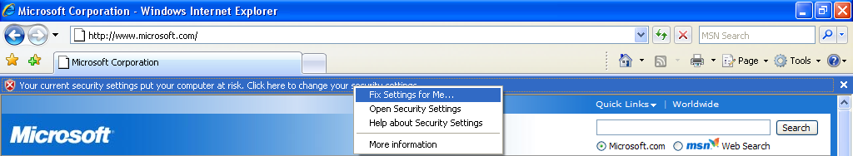

In enterprises, IT administrators may create a Group Policy to control security settings or to reset security settings to the designated default setting each time the browser is opened. For example, an enterprise may have the browser with a specific security setting, such as medium, but allow employees to alter the setting based on their need. An employee may lower security settings to access a legitimate partner site. When the activity is done the employee closes the browser. The next time Internet Explorer is opened, the security settings automatically reset back to the medium security setting.

Advanced Protection Against Spyware with Anti-malware Software
The browser will continue to be a vehicle that malware, also known as spyware, invades to get access and infect a machine. While it provides significant security enhancements over its previous version, Internet Explorer 7 along with anti-malware software, such as Windows Defender and Forefront Client Security, will extend security and privacy protections and help prevent malware from entering the machine and silently installed along with other applications.

Although the improvements in Internet Explorer 7 cannot stop non-browser-based spyware from infecting the machine, using it with anti-malware software will provide a solid defense on several levels. Windows Defender is currently available for Windows XP and Windows Server 2003 and is also included in Windows Vista.

Personal Data Safeguards
Most users are unaware of how much personal, traceable data is transmitted with every click of the mouse while they are browsing the Web. The extent of this information continues to grow as browser developers and Web site operators evolve their technologies to enable more powerful and convenient user features. Similarly, most online users are likely to have trouble discerning a valid Web site from a bogus copy.
The extent to which convenience and discount pricing are available online gives users an attractive reason to click and buy. The Internet enables any large or small business to easily create an online storefront for selling goods, enabling the business to reach a consumer audience well beyond traditional physical and geographic boundaries. Search engine marketing efforts allow these Web sites to establish instant consumer credibility and reach millions of users through some of the largest search engines or portal Web sites. The combination of these factors creates situations in which consumers are dealing with distant businesses and left with fewer concrete mechanisms to differentiate legitimate businesses from those seeking to collect their information for improper gain. Another challenge facing users is the ability for malicious Web site operators to abuse the same search listing services to attract unsuspecting consumers to knockoff Web sites designed to mimic the appearance and function of well-known and trusted businesses.

A technique known as phishing is used by many malicious Web site operators to gather personal information as they masquerade online as a legitimate person or business for the purpose of acquiring sensitive information. Such fake Web sites designed to look like the legitimate sites are referred to as spoofed sites. Over the past year, phishing attacks have been reported in record numbers, and identity theft is emerging as a major threat to personal financial security. Learn more at Microsoft’s Anti-Phishing Technologies at http://www.microsoft.com/mscorp/safety/technologies/antiphishing/default.mspx.

Unlike direct attacks where hackers break into a system to obtain account information, a phishing attack does not require technical sophistication but instead relies on users willingly divulging information such as financial account passwords or Social Security numbers. These socially engineered attacks are among the most difficult to defend because they require user education and understanding rather than merely issuing an update for an application. Even experienced professionals can be fooled by the quality and details of some phishing Web sites as hackers become more experienced and learn to react more quickly to avoid detection.

Internet Explorer 7 offers a range of enhancements and solutions to better protect against malicious Web site operators and help prevent users from becoming victims of confusing URLs. The new Security Status Bar, located next to the Address Bar, is designed to help users quickly differentiate authentic Web sites from suspicious or malicious ones.

Certificates also play an essential role for users in validating e-commerce Web sites and helping to thwart phishing scams. The Security Status Bar in Internet Explorer 7 enhances access to certificate information by placing it more prominently in front of users and providing single-click access to the certificate.

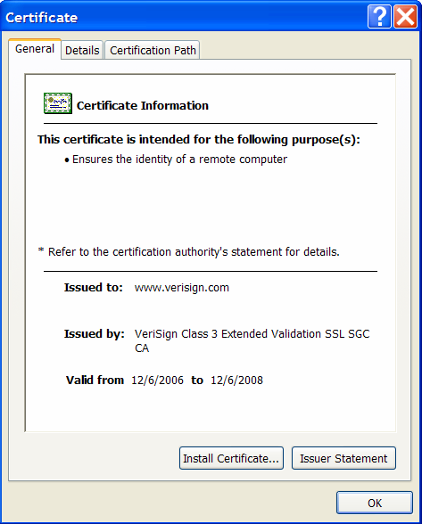

Extended Validation SSL Certificates
Over the past few years, Web browser users have been introduced to the concept of encrypted communications and secure sockets layer (SSL) technologies to better protect their information from being obtained by third parties. Although many users have become quite familiar with SSL and its associated security benefits, a large proportion of Internet users remain overly trusting that any Web site asking for their confidential information must be protected. With the explosion of small- and home-based business Web sites selling goods that span the pricing spectrum, users are even more likely to encounter unfamiliar entities asking for their financial information. The combination of these factors creates a situation ripe for abuse. Internet Explorer 7 addresses this issue by providing users with clear, prominent, color-coded visual cues to the safety and trustworthiness of a Web site. With the assistance of Internet Explorer 7 to help identify legitimate Web sites, users can more confidently browse and shop anywhere on the Internet.

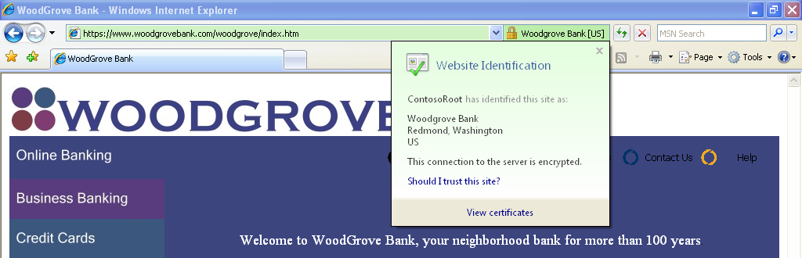

Previous versions of Internet Explorer placed a gold padlock icon in the lower-right corner of the browser window to designate the trust and security level of the connected Web site. Given the importance and inherent trust value associated with the gold padlock, the new Security Status Bar places it more prominently in users’ line of sight. Users can now view the certificate information with a single click on the padlock icon. The Security Status Bar also supports information about Enhanced Validation certificates for those sites meeting guidelines for better entity identity validation. Users can benefit from support for Enhanced Validation certification by having instant visual access to the increased validation of authenticity for a given Web site. To provide users with another visual cue designed to help them recognize questionable Web sites, the padlock now appears on a red background if Internet Explorer 7 detects any irregularities in the site’s certificate information. By contrast, trusted Web sites will clearly display the name of the certificate owner and a gold background to indicate that users can provide confidential data.

Microsoft Phishing Filter
Developers of phishing and other malicious activities thrive on lack of communication and limited sharing of information. Using an online service that is updated several times an hour, the new Phishing Filter in Internet Explorer 7 consolidates the latest industry information about fraudulent Web sites and shares it with Internet Explorer 7 customers to proactively warn and help protect them. The filter is designed around the principle that, to be effective, early warning systems must derive information dynamically and update it frequently.

The Phishing Filter combines client-side scans for suspicious Web site characteristics with an opt-in online service. It helps protect users from phishing scams in three ways:
- It compares the addresses of Web sites a user attempts to visit with a list of reported legitimate sites that is stored on the user’s computer.
- It analyzes sites that users want to visit by checking those sites for characteristics common to phishing sites.
- It sends the Web site address that a user attempts to visit to an online service run by Microsoft to be checked immediately against a frequently updated list of reported phishing sites.

Internet Explorer 7 uses the Security Status Bar to signal users (in yellow) if a Web site is suspicious. The example below shows a site that may be attempting to spoof a legitimate Woodgrove Bank site.

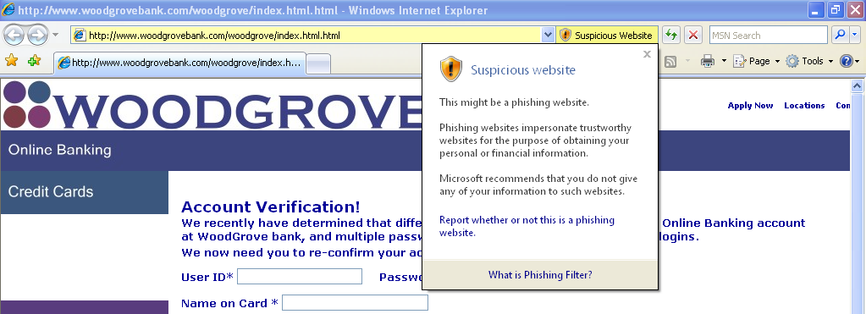

If the Web destination has been confirmed as a known phishing site, Internet Explorer 7 signifies the threat level in red and automatically navigates the user away from that site.

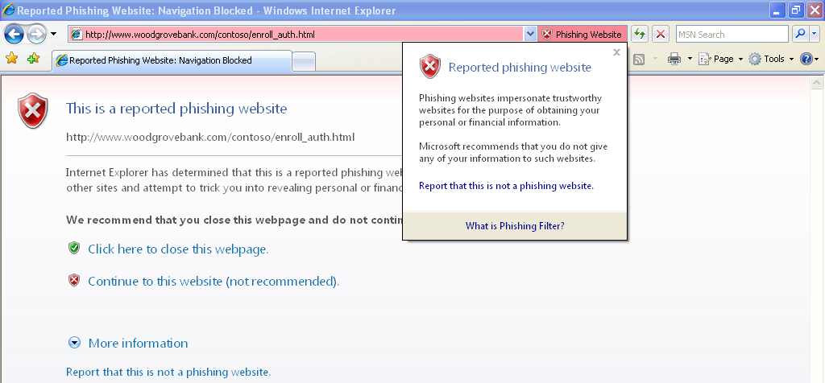

The Phishing Filter can be managed by Group Policy and Microsoft recommends that businesses also employ a proxy filter at the network edge in order to provide the best security against phishing attacks.

URL Display Protections
Hackers commonly attempt to mislead users into thinking they are looking at information from a known and trusted source. A valuable hacking tool has been the ability to hide true URL information and domain names from users. Internet Explorer 7 contains two powerful visual tools to help prevent users from being duped: an Address Bar in every window and Internationalized Domain Name (IDN) support. Many of the settings for these new security features may be managed via Group Policy.

Address Bar in Every Window
With Internet Explorer 7, all browser windows require an Address Bar. Because hackers often have abused valid pop-up window actions to display windows with misleading graphics and data as a way to convince users to download or install their malware, the requirement of an Address Bar in each window will help ensure that users always know more about the true source of information they are seeing. In corporate environments, administrators can change this behavior through setting a Group Policy within the Trusted Zone or their intranet. This flexibility enables IT administrators to provide the experience they determine is appropriate for their organization.

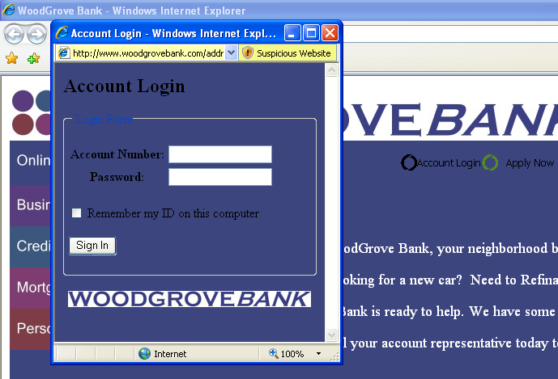

IDN Display Protections
Internet Explorer 7 natively delivers full IDN functionality and display protections. The Internet is used by a global community, and browsers must be able to handle non-English characters and domain names. Operators of malicious Web sites have used international character display issues as a mechanism for phishing attacks against users and as a way to hide the true Web site domain name. The problem derives from international alphabets; many characters in certain languages (e.g., the letter “a” in English) can resemble entirely different characters in other languages (e.g., the letter “а” in Cyrillic). As a result, an individual with malicious intent may register a similar domain name to fool users into submitting their content to a false site. Previous versions of Internet Explorer did not have IDN support and thus were not vulnerable to this attack. Internet Explorer 7 not only delivers native IDN support but also provides security mechanisms to protect users from attack. One of the core security features of IDN support in Internet Explorer 7 is the multiple language display in the Address Bar.

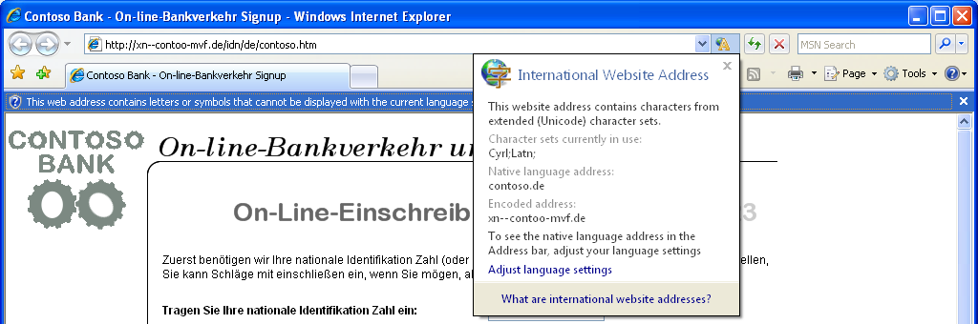

Internet Explorer 7 IDN rules force the display of the Punycode domain name format when multiple character sets are contained within a single domain name label. IDN protections also prevent the browser from displaying characters for character sets the user has not configured. For example, the URL http://www.microsóft.com would be displayed in Punycode since it mixes both the French and English character sets in the same label portion. The address bar would display http://www.xn--microsft-03a.com, alerting the user and calling attention to the suspicious URL. Assuming the system was configured for French language support, the URL http://ŵŵŵ.microsoft.com would be displayed correctly because the language character sets are contained in separate labels.

Delete Browsing History for Better Protection of Privacy and Passwords
All Web browsers provide mechanisms to delete history information, clean the cache, erase automatically completed form history and clear the Start/Run history. Removing this data requires deleting each set individually, and not all of the necessary removal buttons are located on a single screen or within one application.

Internet Explorer 7 provides a Delete Browsing History option that provides users with one-click cleanup to easily and instantly erase personal data. This is another way Microsoft is working proactively to deliver tools that improve user safety and data protection.

Delete Browsing History is especially valuable in shared-resource environments. Accessing online resources using a co-worker’s computer seems harmless enough, but the user then becomes reliant on the security of the other person’s system to protect his or her data. For example, in a hospital, there may be a kiosk for nurses to access to check email, relevant files, and log in their time. Ensuring that personal information and online history is cleared at the end of the browser session may be essential in order to comply with internal regulations. Likewise, in public environments such as libraries, schools and conference centers, computers may be used by hundreds of people and potentially expose personal data and history information to every one of those users.

Delete Browsing History provides a simple mechanism to instantly erase information and eliminates any concern for data privacy on other systems. In addition, based on user feedback from previous versions of IE, the cleanup in IE7 is faster and won’t prevent users from doing other tasks (including browsing or closing IE7) while the cleanup is in progress.

Browsing history settings can be controlled through Group Policy so that enterprise IT administrators have the ability to define and control policy around data retention/expiration periods established for their organization.

Key Features – Dynamic Security Protection
Feature | Brief Description
Protected Mode | Internet Explorer 7 in Windows Vista runs in isolation from other applications that run on the operating system. Exploits and malicious software are restricted from writing to any location beyond Temporary Internet Files without explicit user consent.
ActiveX Opt-In | Disables nearly all preinstalled ActiveX controls to reduce the attack surface, and requires user consent before a previously unused control can be accessed. Users can easily enable or disable ActiveX controls as needed through the Information Bar and the Add-on Manager.
Phishing Filter | Proactively warns and helps protect users against potential or known fraudulent sites and blocks the site if appropriate. The opt-in filter is updated several times per hour using the latest security information from Microsoft and several partners to help identify fraudulent Web sites.
Fix My Settings | Prevents users from browsing with unsafe settings by warning them with an Information Bar when current security settings might put them at risk. When you make changes in the Security Settings window, you also see red highlighting if you try to modify certain critical items. In addition to getting dialog box alerts warning about unsafe settings, you are reminded by the Information Bar as long as the settings remain unsafe. You can instantly reset Internet security settings to the Medium-High default level by clicking the Fix My Settings option in the Information Bar.
URL Handling Security | Redesigned URL parsing ensures consistent processing and minimizes possible exploits. The new URL handler helps centralize critical data parsing and increases data consistency throughout the application.
High Assurance SSL | Internet Explorer 7 provides support for the new High Assurance certificates, coloring the Address Bar green to indicate that the site has completed the additional validations and independent verification processes of certificate authorities. High Assurance certificates help increase user trust for online transactions and visually alert the user when they are present—all of which helps safeguard personal data.
Delete Browsing History | Enables users to clean up cached pages, passwords, form data, cookies, and history, all from a single window.
Parental Controls | To help keep kids safe online, parents can control browsing behavior through the parental control settings built into Windows Vista. The child’s safety level can be monitored and safely changed remotely. The safety level carries over to many PC activities other than browsing the Internet, such as playing games or accessing the machine outside of certain approved usage times. Further, a parent can view a child’s browsing session logs, and these logs cannot be removed without the parent’s permission.
Internationalized Domain Name Support | In addition to adding support for Internationalized Domain Names in URLs, Internet Explorer also notifies the user when visually similar characters in the URL are not expressed in supported language character sets or combinations, thus protecting the user against sites that could otherwise appear as a known, trustworthy site.
Address Bar protection | Every window, regardless of whether it is a pop-up or a standard window, presents a read-only Address Bar to the user, helping to block malicious sites from emulating trusted sites.
Security Status Bar | Enhances user awareness of Web site security and privacy settings by displaying color-coded notifications next to the Address Bar. Internet Explorer 7 changes the Address Bar to green for Web sites bearing new High Assurance certificates, indicating that the site owner has passed extensive identity verification checks. Phishing Filter notifications, certificate names, and the gold padlock icon also reside next to the Address Bar for better visibility. Certificate and privacy detail information can easily be displayed with a single mouse-click on the Security Status Bar.
Cross-domain barriers | These prevent scripts on Web pages from interacting with content from other domains or windows. This enhanced safeguard further protects against malware by limiting the potential for malicious Web sites to manipulate flaws in other Web sites or cause the user to download undesired content or software.
Add-ons Disabled Mode | To help troubleshoot difficulties with launching Internet Explorer or reaching specific Web sites, users can start in Add-ons Disabled Mode, where only critical system add-ons are enabled.

Conclusion

With this release, Microsoft is confident that Internet Explorer 7 is ready for deployment in your enterprise. Whether you are an IT professional or a developer, we’re confident you will find that the new capabilities in Internet Explorer 7 will dramatically improve employees’ online experience, provide a more secured environment, and make it easier for you to deploy, manage, and maintain for your organization.
Microsoft has delivered a browser that:
- Helps to protect proprietary and institutional information;
- Is easy to deploy and manage; and
- Empowers developers and designers to deliver additional functionality and delivers a streamlined browsing experience.
IT administrators can be confident that Microsoft has renewed its commitment to the browser, ensuring that security updates are provided regularly, and that the planning process that has already begun for the next release will continue to support the needs of the enterprise.
For a more thorough resource in planning your enterprise deployment, look for the Internet Explorer 7 Deployment Guide which will be available in first quarter of 2007.

Appendix

Internet Explorer 7 Articles and Resources
The following sites contain details on updated functionality in IE7:
- Internet Explorer 7 Release Notes: (includes information on installing, uninstalling, compatibility and more) http://msdn2.microsoft.com/en-us/ie/aa740486.aspx
- What’s New in Internet Explorer 7: http://msdn.microsoft.com/library/default.asp?url=/workshop/essentials/whatsnew/whatsnew_70_sdk.asp
- Internet Explorer Developer Center:
http://msdn.microsoft.com/ie/
- Internet Explorer 7 Deployment Guide: http://www.microsoft.com/downloads/details.aspx?FamilyID=e41d8800-d134-4356-a2e7-c01bee790908&displaylang=en
- Information Index for Internet Explorer 7:
http://msdn2.microsoft.com/en-us/ie/aa740472.aspx
- Internet Explorer 7 Checklists: http://www.microsoft.com/windows/ie/ie7/downloads/checklists.mspx
- CSS Compatibility in Internet Explorer 7: http://msdn.microsoft.com/library/default.asp?url=/library/en-us/ietechcol/cols/dnexpie/ie7_css_compat.asp
- Understanding and Working in Protected Mode (IE7 in Windows Vista): http://msdn.microsoft.com/ie/default.aspx?pull=/library/en-us/IETechCol/dnwebgen/ProtectedMode.asp
- Developer Best Practices and Guidelines for Applications in a Least Privileged Environment: http://msdn2.microsoft.com/en-us/library/aa480150.aspx
- Windows Vista’s RFC-Compliant TLS Extensions: http://blogs.msdn.com/ie/archive/2006/04/17/577702.aspx
- Microsoft Phishing Filter and Anti-Phishing Technologies: http://www.microsoft.com/mscorp/safety/technologies/antiphishing/default.mspx
- Internet Explorer 7 Readiness Toolkit: http://www.microsoft.com/downloads/details.aspx?familyid=D13EE10D-2718-47F1-AA86-1E32D526383D&displaylang=en
- Application Compatibility Toolkit 5.0: (ACT for Windows Vista, including IE7) http://www.microsoft.com/technet/windowsvista/appcompat/tools.mspx
- Internet Explorer 7 Distribution over Automatic Distribution: http://www.microsoft.com/technet/updatemanagement/windowsupdate/ie7announcement.mspx
- Internet Explorer 7 Distribution over Automatic Distribution – FAQ: http://www.microsoft.com/technet/updatemanagement/windowsupdate/ie7blockertoolfaq.mspx
- Internet Explorer 7 Blocker Toolkit FAQ and Link to Blocker Toolkit: http://www.microsoft.com/technet/updatemanagement/windowsupdate/ie7blockertoolfaq.mspx
- Internet Explorer 7 Administration Kit (IEAK 7): http://www.microsoft.com/technet/prodtechnol/ie/ieak/default.mspx
- IEAK 7: Use Windows Installer (.MSI files) to Deploy Internet Explorer 7 in Active Directory Environments:
http://support.microsoft.com/kb/942812
- Administrative Templates for Internet Explorer 7 for Windows: http://www.microsoft.com/downloads/details.aspx?FamilyID=11ab3e81-6462-4fda-8ee5-fcb8264c44b1&displaylang=en
- Using Software Restriction Policies to Protect Against Unauthorized Software: http://www.microsoft.com/technet/prodtechnol/winxppro/maintain/rstrplcy.mspx
- Free Microsoft Windows Server Update Services: http://www.microsoft.com/windowsserversystem/updateservices/default.mspx

Connect with the Internet Explorer Community
The following sites, blogs, and newsgroups enable customers to ask questions, provide feedback, and find out what others are saying about IE7:
- Internet Explorer 7 Blog:
http://blogs.msdn.com/ie/
- Internet Explorer Web Development: http://forums.microsoft.com/MSDN/ShowForum.aspx?ForumID=923&SiteID=1
- Internet Explorer Extension Development: http://forums.microsoft.com/MSDN/ShowForum.aspx?ForumID=924&SiteID=1
- Internet Explorer Newsgroups: http://www.microsoft.com/communities/newsgroups/list/en-us/default.aspx?dg=microsoft.public.internetexplorer.general&cat=en_us_28cca3eb-7037-4d4f-bde1-d8efee1f1420&lang=en&cr=us

