Training Voucher
Benefit Administration
User Guide

A reference guide for administering the Training Voucher Benefit

September 2003
© 2003 Microsoft Corporation. All rights reserved.
This document is for informational purposes only. Microsoft makes no warranties, express or implied, in this summary.
Microsoft, FrontPage, InfoPath, OneNote, Outlook, PowerPoint, SharePoint, Windows, and Visio are either registered trademarks or trademarks of Microsoft Corporation in the United States and/or other countries.
The example companies, organizations, products, domain names, e-mail addresses, logos, people, places, and events depicted herein are fictitious. No association with any real company, organization, product, domain name, e-mail address, logo, person, places, or events is intended or should be inferred.

Training Voucher Benefit
The Software Assurance Training Voucher benefit provides electronic vouchers for instructor-led courses at Microsoft Certified Technical Education Centers (MS CTECs). The vouchers can be used for a specified list of courses at any participating MS CTEC.
The list of courses and participating MS CTECs can be found at: www.microsoft.com/traincert/sa

This guide covers the following topics:
Training Voucher Benefit Rules
Activating the Training Voucher Benefit
Viewing Training Voucher Benefit Details
Creating a Training Voucher
Viewing Training Voucher Details
Revoking a Training Voucher
Canceling a Training Reservation
Printing a Training Voucher / Voucher Confirmation
Redeeming a Training Voucher
Viewing Training Voucher Benefit History
Actions on the Training Voucher Benefit
Training Voucher Detail E-mail
Additional Notes
Assistance with the Training Voucher Benefit
Glossary of Terms

Training Voucher Benefit Rules

- Once the voucher is created, it cannot be changed. To change the recipient of the voucher or the number of training days, you must revoke the voucher and create a new one.
- Vouchers can only be created if there are enough training days available for assignment.
- Once a voucher is created, it is valid for 180 days (approximately 6 months). If the voucher is not used in that time period (and is not revoked or canceled), the training days are returned to the pool as long as the agreement has not expired.
- Voucher statuses are:
Assigned – The voucher has been created but a reservation for training has not been made yet (and the voucher has not been redeemed).
Reserved – A reservation for a training course has been made using the voucher, but the voucher has not yet been redeemed.
Redeemed – The voucher has been redeemed at a MS CTEC for a training course.
Revoked – The voucher has been revoked.
Paid – The MS CTEC has received payment for the voucher.

Return to Topic List

Activating the Training Voucher Benefit

To determine if activation is necessary, check the Enrollment Status of the Training Voucher benefit on the Benefit Summary window.
If the status is Not Enrolled, you must activate the benefit in order to begin creating training vouchers. If the status is Enrolled, activation has already been completed.

To activate the training voucher benefit:

- Click on the Training Voucher hyperlink in the Benefit column.

Note: If the link to Training Voucher is not active it means that you have not purchased the required number of products to use this benefit (but you have purchased some qualifying products otherwise the benefit would not be shown on the window).
If the link to Training Voucher is not displayed, it means that either you do not have benefit administration rights for the benefit, or no qualifying products have been purchased.

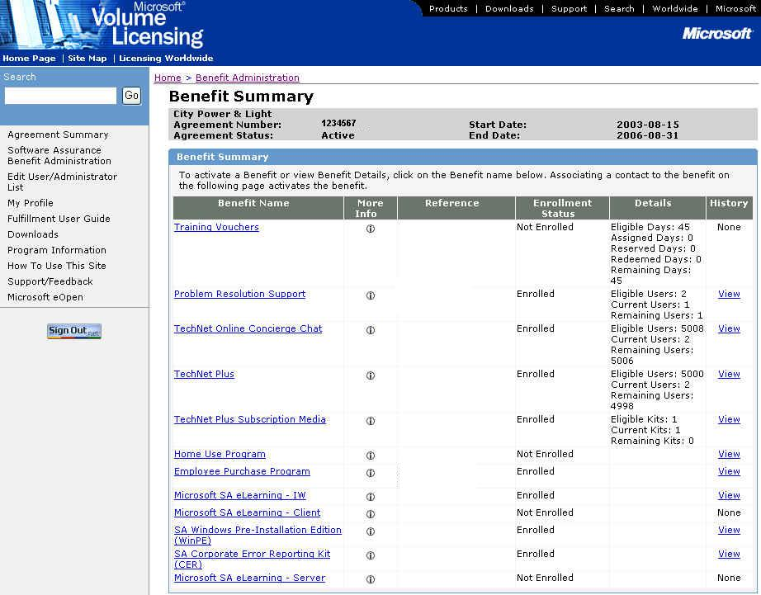

- The Choose Existing Benefit Contact window appears.

Note: This window only appears if another benefit for this agreement has been activated. If this is the first benefit activated for the agreement, the Activate Benefit window appears (see Step 5).

Note: To activate the Training Voucher benefit, one benefit contact must be specified. This contact should be the benefit administrator.
To search the list of existing benefit contacts, enter the First Name and/or Last Name and click OK.

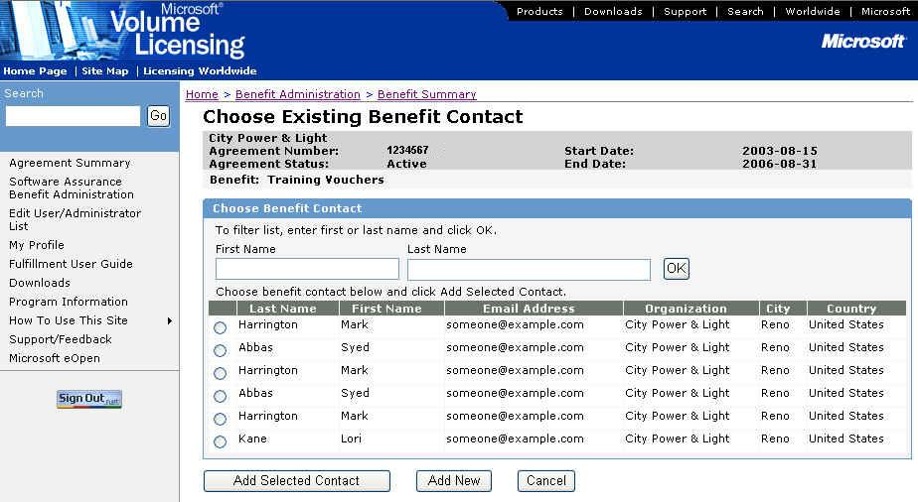

- If the person you wish to designate as the benefit contact is shown on the Choose Existing Benefit Contact window, select the radio button next to their name and click Add Selected Contact. (Go to Step 5).

- If the person you wish to designate as the benefit contact is not shown on the Choose Existing Benefit Contact window, click Add New.

- The Activate Benefit window appears.
If you selected an existing contact, their information will be shown in the Benefit Subscriber Detail section of the window. The information will be grayed out and you can not modify it.
If you did not select an existing contact, enter the information about the Benefit Contact. The organization information will be pre-populated.

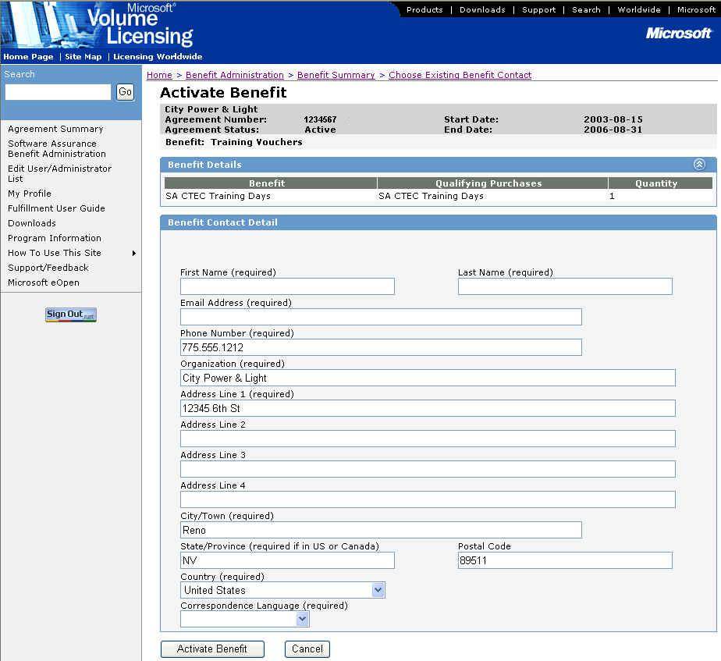

- Click Activate Benefit to activate the benefit.

Note: If you click Cancel, a confirmation dialog box stating “Canceling will cause you to lose all changes. Are you sure you want to cancel?” will appear. If you click OK, all changes will be deleted and the Benefit Summary window appears. If you click Cancel, you will return to the Activate Benefit window.

- The Benefit Activation Confirmation window is displayed.

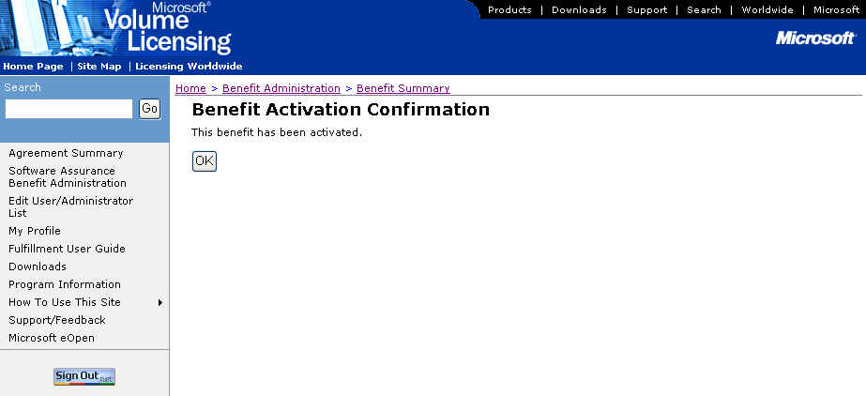

- Click OK to display the Training Benefit Detail window.

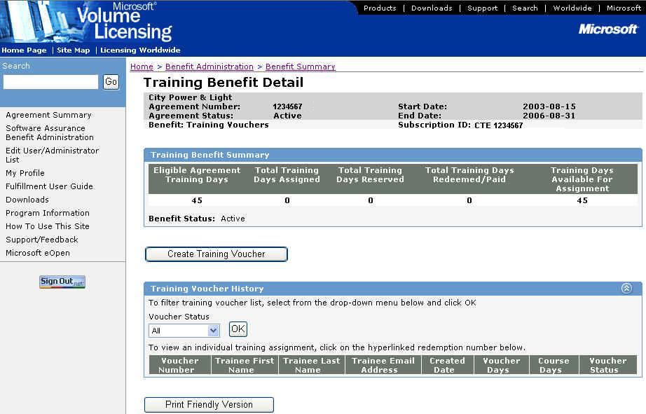

Once the benefit has been activated:
- The Enrollment Status on the Benefits Summary window is changed to Enrolled and the History column value changes to View. To view the benefit history, see Viewing the Training Voucher Benefit History.

Return to Topic List

Viewing Training Voucher Benefit Details

To view the Training Voucher benefit details:

    - On the Benefit Summary window, click on the Training Voucher link in the Benefit column.

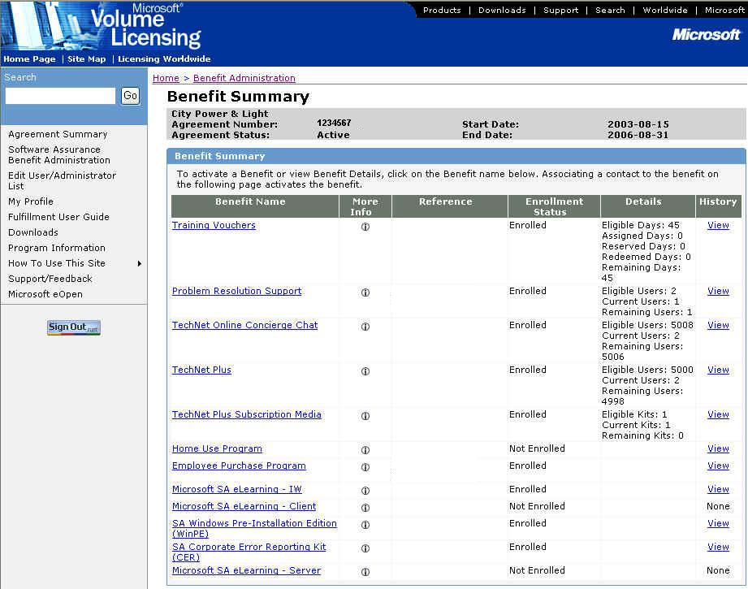

    - The Training Benefit Detail window appears.

Training Benefit Summary – The benefit status is shown but cannot be changed here. The benefit statuses are:
- Active – Benefit is available for consumption.
- Ended – Benefit subscription has come to an end. This status is set only by the MVLS system.
- Inactive – Prevents the use of the existing benefit. This status can only be set by Microsoft administrators.
- Expired – Indicates that the agreement/benefit has reached the end date. This status is set automatically by the MVLS system.
- HAR (Held Awaiting Reactivation) – Indicates that the subscription has been placed into a transitory state where the subscription may not be used to consume a benefit. The subscription has not been ended and may be reactivated at a later date with the existing associated contact information. This status is set only by the MVLS system.

Return to Topic List

Creating a Training Voucher

To create a training voucher:

- On the Benefit Summary window, click on the Training Voucher link in the Benefit column.

- The Training Benefit Detail window appears. Click Create Training Voucher.

- The Create Training Voucher window is displayed.

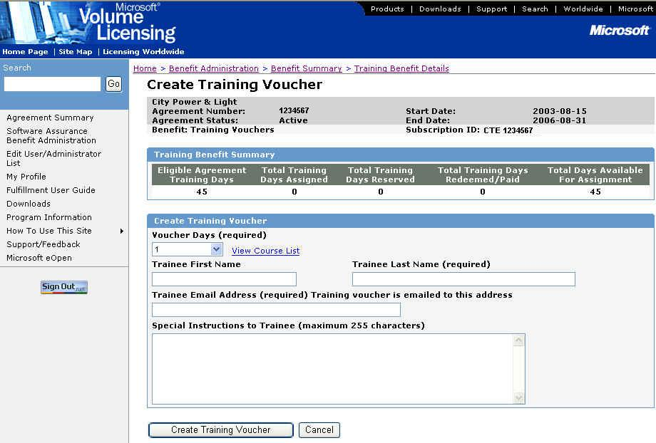

- Select the number of days for the voucher from the drop down box (Voucher Days). Voucher Days must be equal to or less than the Training Days Available for Assignment.

Note: The Voucher Expiration Date is set to 180 days after the current date.

- Enter the Trainee First Name and Last Name (only Last Name is required).

Note: Last Name is only one field. If the Last Name is comprised of two words, enter them both in the Last Name field.

- Enter the Trainee E-mail Address (required).

- Enter any special instructions to the trainee in the Special Instructions to Trainee box.

- Click Create Training Voucher to create the voucher (or click Cancel if you do not want to create this voucher).

- The Voucher Confirmation window will be displayed. In addition, the training voucher detail e-mail will automatically be sent to the trainee. See Training Voucher Detail E-mail for the complete text of the e-mail sent.

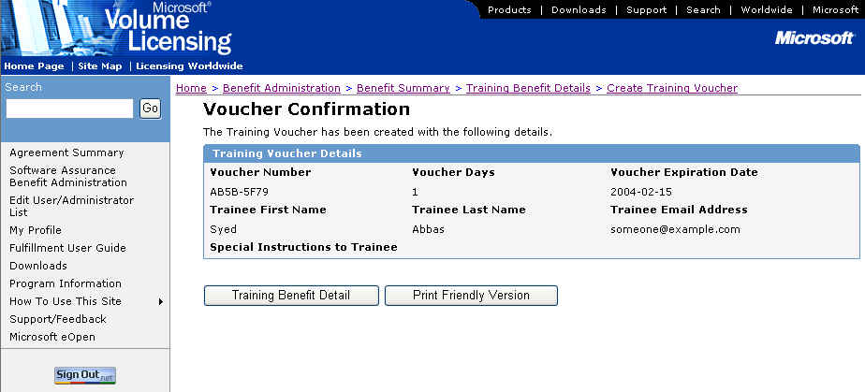

Note: If there is an error during creation of the training voucher (i.e., incorrect information was entered), you must revoke the voucher and create a new one with the proper information. See Revoking a Training Voucher for more information.

- To display a printer friendly version of the training voucher, click Print Friendly Version. If you want to print the voucher, use your standard method of printing.

- To return to the Training Benefit Detail window, click Training Benefit Detail.

Return to Topic List

Viewing Training Voucher Details

To view the details of a training voucher:

- On the Training Benefit Detail window, you can view a list of all training vouchers.

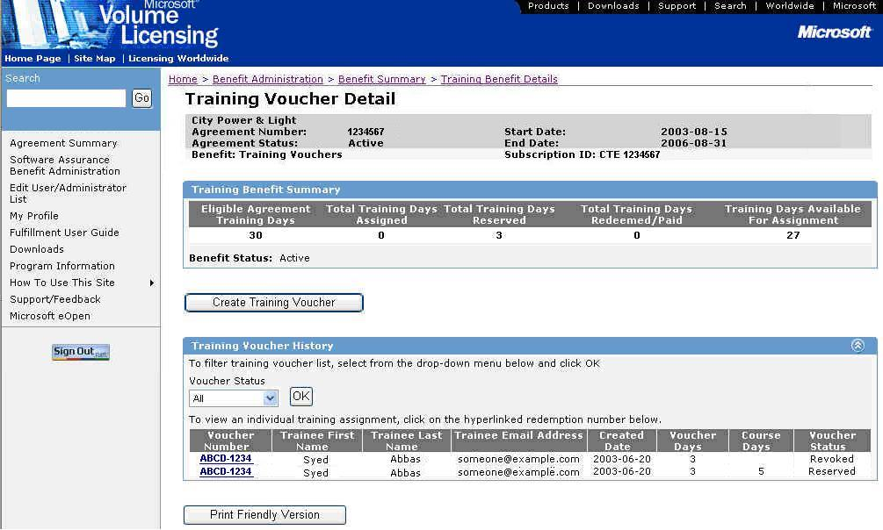

- In the Training Voucher History section, click on the Voucher Number for which you want to see the details.

- The Training Voucher Detail window appears.

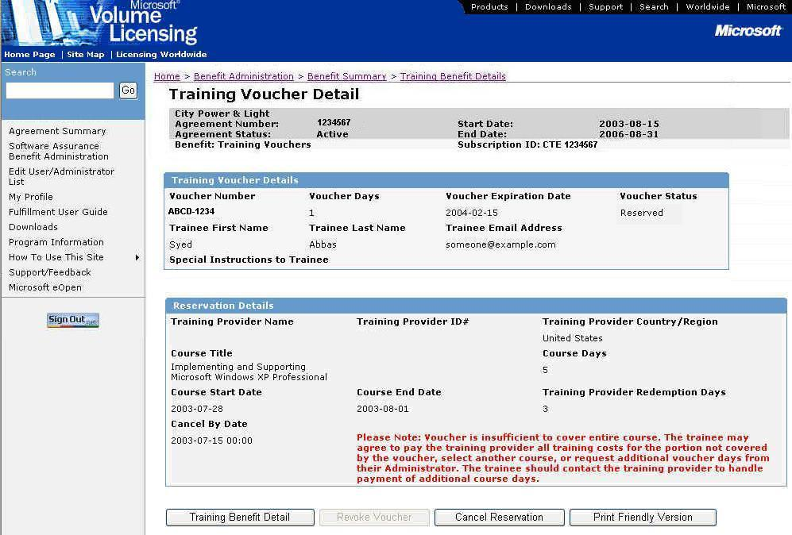

From this window you can see the current status of the voucher, as well as the course reservation (if it has been made).
- Voucher status can be Assigned, Reserved, Redeemed, Revoked, or Paid.
- Reservation Details – This section is displayed only when a training reservation has been made or the voucher has been Redeemed or Paid.
- If the course is longer than the Voucher Days, payment will be necessary for the trainee to take the course. Contact the CTEC to handle payment details for the additional course days.
- If the course is shorter than the Voucher Days, the remaining days will be added back into the Total Days Available for Assignment when the voucher has a status of Paid.

You can also revoke the voucher (see Revoking a Training Voucher), cancel the training reservation (see Canceling a Training Reservation), or display a print friendly version of the voucher.

Note: The options available at a particular time depend on the current status of the voucher. For example, if the training reservation has not been made, you will not be able to cancel the reservation.

Return to Topic List

Revoking a Training Voucher

Revoking a training voucher is done when you want to make a change to a training voucher (e.g., number of training days, person assigned to the voucher, or approaching expiration date). Because a particular voucher cannot be changed directly, you must revoke the voucher and then create a new voucher.
Vouchers can be revoked only if the status is Assigned and the Voucher Expiration Date has not passed. If a training reservation has already been made for the voucher that you want to revoke, you must first cancel the training reservation and then revoke the voucher. See Canceling a Training Reservation for more information.

To revoke a training voucher:

- Find the training voucher that you want to revoke on the Training Benefit Detail window.

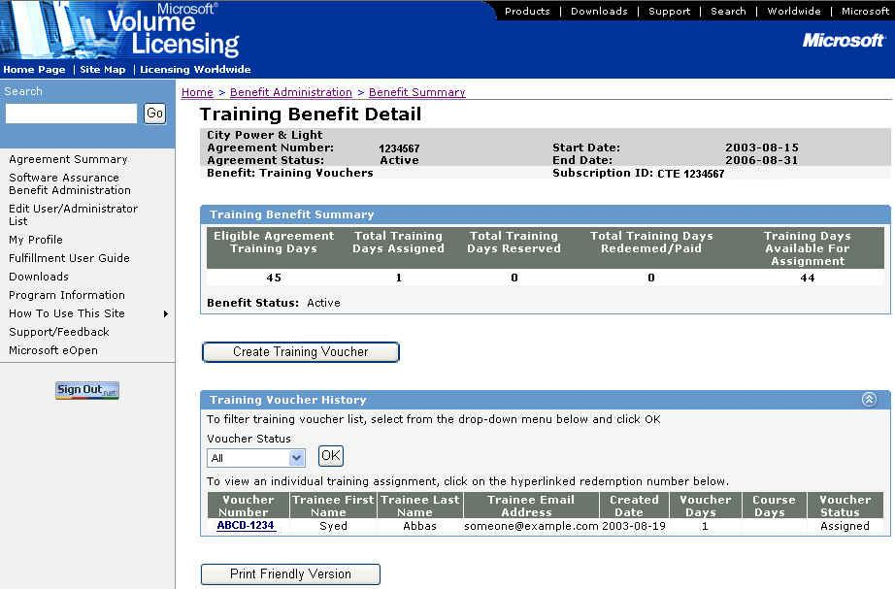

- In the Training Voucher History section, click on the Voucher Number to display the Training Voucher Detail window.

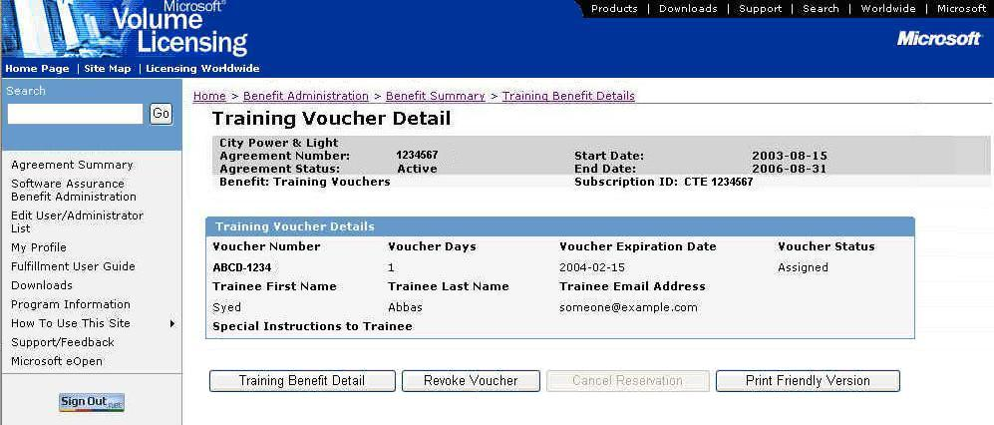

- Click Revoke Voucher.

- The Training Voucher Detail window is refreshed and displays the revised status (Revoked).

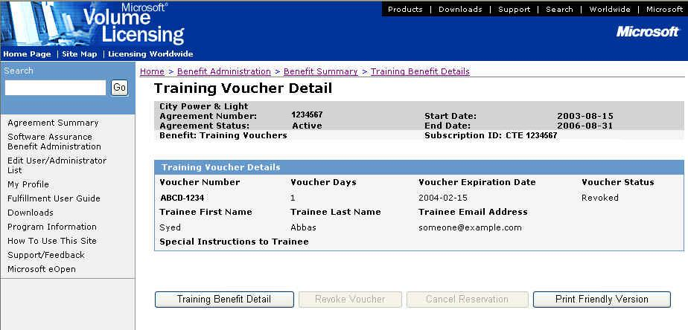

- Click Training Benefit Detail to return to the Training Benefit Detail window.

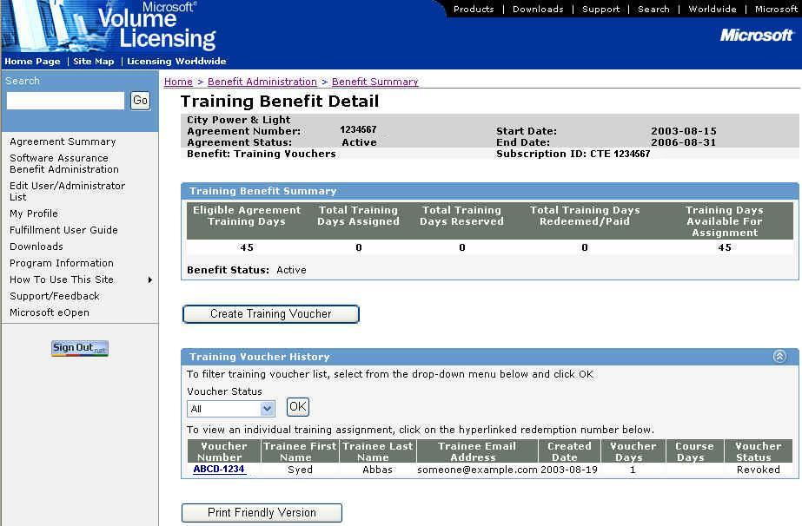

The Training Days Available for Assignment is incremented to reflect the days being added back into the pool, and Total Training Days Assigned is decremented.

- Inform the trainee that the voucher has been revoked. You must call or e-mail the trainee, as no automated messages are sent.

Return to Topic List

Canceling a Training Reservation

Canceling a training reservation is done when you want to cancel the reservation that the trainee has made for a particular course. Once the reservation has been cancelled, you must contact the trainee and the MS CTEC to let them know (no automatic e-mail is sent). Canceling a reservation does not revoke the voucher, so the trainee can still use the voucher. To revoke the voucher (so the trainee can not use it), see Revoking a Training Voucher.
Training reservations can be canceled if the voucher status is Reserved and the Cancel By date has not passed. Contact the MS CTEC directly to attempt to cancel the reservation if the Cancel By date has passed.

To cancel a training reservation:

- Find the training voucher for which you want to cancel the reservation on the Training Benefit Detail window.

- Click on the Voucher Number to display the Training Voucher Detail window.

- Click Cancel Reservation.

- The Training Voucher Detail window is refreshed and displays the revised status (Assigned).

- Click Training Benefit Detail to return to the Training Benefit Detail window.

The Total Training Days Reserved is decremented.

- Inform the trainee that the reservation has been canceled. You must call or e-mail the trainee, as no automated messages are sent. Contact the MS CTEC to avoid a no-show fee.

Return to Topic List

Printing a Training Voucher

To print a training voucher:

- On the Voucher Confirmation window or the Training Voucher Detail window, click Print Friendly Version to view a printer friendly version of the voucher.

- Print using your normal method of printing.

Return to Topic List

Redeeming a Training Voucher

When a training voucher is created, a training voucher notification e-mail is automatically sent to the trainee containing the voucher details and any special information that has been provided.
If you have any questions about the MS CTEC policies regarding retakes, no shows, etc. please call the MS CTEC directly.

To redeem a training voucher:

- Trainee receives e-mail.

See Training Voucher Detail E-mail for the full text of the e-mail.

- Trainee looks up course and/or MS CTECs at www.microsoft.com/traincert/sa.

- Trainee calls MS CTEC and reserves a seat in the course.

- MS CTEC reserves the course and updates the voucher status to Reserved. (Go to the Training Voucher Detail window to view the reservation details.)

- Trainee attends course.

- MS CTEC updates voucher to Redeemed status. (Go to the Training Voucher Detail window to view the voucher details.)

- MS CTEC receives payment for the voucher and sets the status to Paid. (Go to the Training Voucher Detail window to view the voucher details.)

Return to Topic List

Viewing the Training Voucher Benefit History

To view the Training Voucher benefit history:

- On the Benefit Summary window, click on the View hyperlink in the History column for the Training Voucher benefit.
Note: If the benefit is not currently Active, the history will not have a View link, instead the word None will be displayed without a hyperlink.

- The History window appears.
The History window displays information about the current and previously activated (and/or ended) subscriptions of the benefit under the agreement.

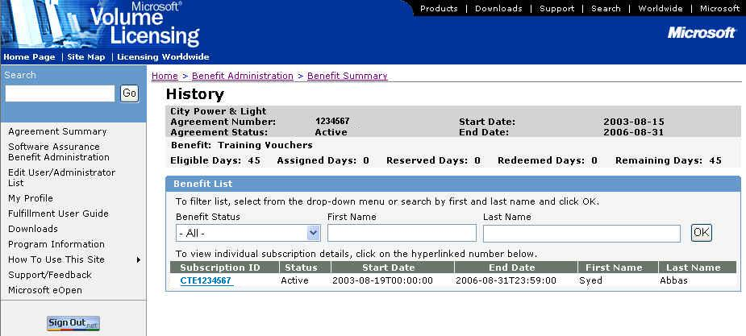

- To see subscription information, click on the appropriate Subscription ID in the Subscription ID column. Depending on the subscription status, you will be able to view or edit the subscription on the Training Benefit Detail window. See Actions on the Training Voucher Benefit for more information.

Return to Topic List

Actions on the Training Voucher Benefit

Different actions can be taken on the Training Voucher benefit based on the current status. The table below outlines these actions and when they can be performed.
Benefit Name | Subscription  Status | Edit Contact Detail * | Edit User Authentication ** | Status Change in UI  (Allowed - Change To)
Training Vouchers  (For Vouchers, the contact created is a placeholder, "contact column" refers to voucher creation) | Active | Yes | N/A | No
 | Expired | No | N/A | No
 | Ended | No | N/A | No
 | HAR | No | N/A | No
 | Hold | N/A | N/A | N/A
 | Inactive | No | N/A | No

Return to Topic List

Training Voucher Detail E-mail

When a training voucher is created, the training voucher detail e-mail is automatically sent to the trainee.

- If there is an error in the delivery of the e-mail, the e-mail is returned to the Benefit Administrator who can then attempt to manually resend the e-mail. (It is returned to the Benefit Administrator because when the e-mail is created the Benefit Administrator is shown as the sender.)
- If the e-mail is delivered incorrectly or to the wrong address, the Benefit Administrator will have to call the trainee or write an individual e-mail.
- There are no automated resend capabilities.

Text of the training voucher detail e-mail:

Subject: Your Microsoft® Software Assurance Training benefit is now available.

From: <Training Administrator E-mail Address>

Body:
Dear <First Name> <Last Name>,
Please note that the contents of this e-mail have been created by the Microsoft Worldwide Software Assurance enhancements team and are being sent to you by Microsoft, on behalf of your Training Administrator <Insert TA Name> within your organization.
Welcome to Microsoft® Software Assurance enhancements. As a Software Assurance customer, your organization is eligible for enhancements which can help you get the most value from up-to-date technology. The Microsoft Training Voucher Benefit is offered as one of these enhancements and you have been granted a Voucher which entitles you to <Voucher Days> days of training at a Microsoft Certified Technical Education Center (CTEC).
Microsoft CTECs are Microsoft's premier channel for delivering learning products and services. These centers are full-service technical training companies qualified by Microsoft to deliver world-class training and skills to IT Professionals and developers. Microsoft CTECs offer early access to training solutions and skills products, which will give your organization the competitive advantage you need.
How do you obtain this free CTEC training?
To take advantage of this offer, all you need to do is to present the Voucher ID below to a participating Microsoft CTEC of your choice along with your corporate e-mail address (for authentication purposes only). These details are provided below:

Your Voucher ID is: <Voucher ID>
Voucher Value: <Days of Training> days of training *
Voucher Expiration Date: <Voucher Expiration Date> **

Should you wish to learn more about the courses available or to locate a participating Microsoft CTEC in your area, please visit the Software Assurance Training Voucher site at: <http://www.microsoft.com/traincert/sa/>

<If Open Text Field is Not Null>
Please note that your <Training Administrator> has included the following note about the voucher:
<Voucher Note>
Once again, we welcome you to Microsoft Software Assurance enhancements! We trust you will enjoy these benefits and we look forward to your participation and feedback. Feedback for your country or region can be provided at https://licensing.microsoft.com by clicking on the Support/Feedback link.
Thank You,

Microsoft, on behalf of your Benefits Administrator

* Terms and Conditions: Local “Terms of Usage” established by the Microsoft CTEC apply. The company participating in the Software Assurance Enrollment under which the vouchers were created, has the ability to revoke or un-reserve this benefit before the cancellation date. Any course days not covered by the voucher will need to be paid by the person receiving the training. Any voucher days in excess of the amount of the course, will be returned to the pool of benefit days available to be assigned by the benefit administrator. The voucher is only redeemable for days of instructor-led training at Microsoft CTECs and only for courses within the list available within the Software Assurance Training Voucher program. These vouchers are non transferable - vouchers may only be redeemed by the individual they have been assigned to (Authentication of the training recipient is accomplished by providing the e-mail address of the individual to whom this e-mail is addressed). Vouchers may not be exchanged for cash, monies or other valuable considerations. The voucher will expire 6 months (180 days) from issue date, per the expiration date displayed above. Vouchers may be used to reserve training at only one Microsoft CTEC at a time. The Microsoft CTEC reserves the right to cancel a class according to local cancellation policy.

** Date by which the voucher must be utilized. After this date, the voucher will no longer be valid.

** Date by which the voucher must be utilized. After this date, the voucher will no longer be valid.

Return to Topic List

Additional Notes

- Vouchers can be created for training classes up to 6 months in advance. The Voucher Expiration Date is set for 180 days after the “created on” date.
- Available training days expire at the end of the agreement (although vouchers issued before the end of the agreement that have an Assigned or Reserved status are still valid).
- If a trainee signs up for a class that is longer than voucher days (3 day voucher for a 5 day class), they are responsible for the additional cost of the course. If you want to change the number of days on the voucher (so that all class days are covered), they will revoke the voucher and issue a new one. Note that only one voucher can be used for a particular class, so creating a supplemental voucher of 2 days (rather than revoking the original and creating a new voucher) is not a valid option in this case.
- If a trainee takes a class that is shorter than the voucher days (5 day voucher for a 3 day class), the extra days will be returned to the Training Days Available for Assignment pool once the voucher has been marked as Paid.

Return to Topic List

Assistance with the Training Voucher Benefit

For assistance administering the Training Voucher benefit, go to the MVLS Support page (select Support from the left navigation bar on the MVLS site).
For a list of participating Microsoft CTECs and the Software Assurance eligible courses, go to www.microsoft.com/traincert/sa.
For information about the different Microsoft certifications available and the courses required to earn them, go to http://www.microsoft.com/traincert.

Return to Topic List

Glossary of Terms

Eligible Agreement Training Days – The number of training days available based on your Software Assurance agreement.

Cancel reservation – Canceling a training reservation changes the voucher status from Reserved to Assigned. If you have canceled a reservation, you must inform the trainee (as well as the MS CTEC) – there is no automatic notification facility. The trainee can still use the voucher for another training course (as long as the Voucher Expiration Date has not passed).

Revoke voucher – Revoking a training voucher changes the voucher status from Assigned to Revoked. Once a training voucher has been revoked it can no longer be used. If you have revoked a training voucher, you must inform the trainee – there is no automatic notification facility.

Training Days Available for Assignment – The number of training days that are still available for assignment (vouchers have not been created yet).

Total Training Days Assigned – The number of training days for which vouchers have been created (voucher is in Assigned status).

Total Training Days Reserved – The number of training days for which training reservations have been made (voucher is in Reserved status).

Total Training Days Redeemed – The number of training days for which training vouchers have been redeemed (voucher is in Redeemed status).

Training voucher – A training voucher is created and redeemed for course days at participating MS CTEC training facilities.

Return to Topic List

