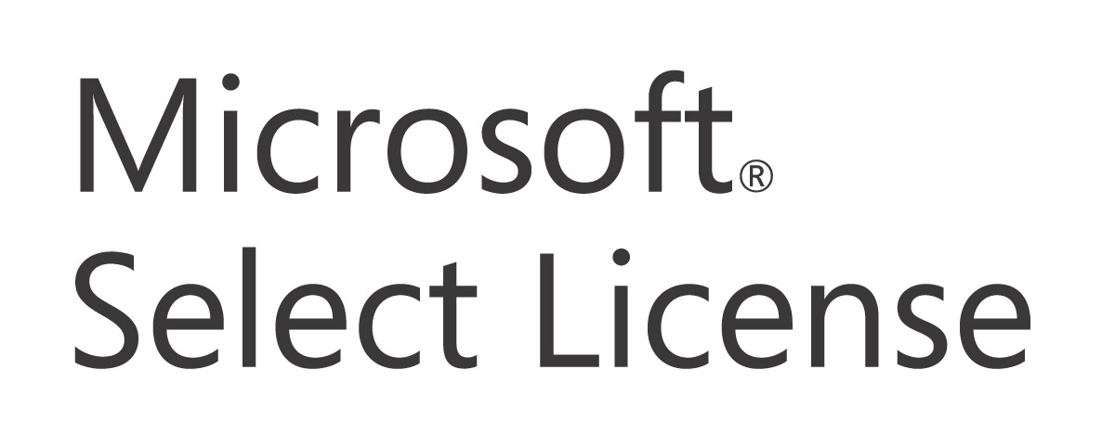

Customer Guide

A reference guide to the Microsoft Select License software licensing program including:
- Program Benefits
- Purchase Options
- How to Begin

Table of Contents
Select License Introduction 4
Select License Benefits 4
Volume Price Levels 4
Software Assurance in Select License 6
Additional Select License Features 8
Agreement Structure 9
Purchasing Select License 10
Product Fulfillment 10
Agreement Renewal 12
Additional Resources 12
Appendix A - What is a Software License? 13
Appendix C- Software Assurance Membership & Support Offerings Worldwide 15
Glossary 17

© 2005 Microsoft Corporation. All rights reserved.
This document is for informational purposes only. MICROSOFT MAKES NO WARRANTIES, EXPRESS OR IMPLIED, IN THIS SUMMARY.
Microsoft, Encarta, FrontPage, InfoPath, OneNote, Outlook, PowerPoint, Visio, Visual Studio, Windows, and Windows NT are either registered trademarks or trademarks of Microsoft Corporation in the United States and/or other countries. The names of actual companies and products mentioned herein may be the trademarks of their respective owners.

The contents of this guide are subject to change. Please contact your Microsoft account manager or Large Account Reseller for the most current version of this guide.
Select License Introduction
The Select License program was designed for medium and large organizations that value choice, flexibility, and volume license purchase options for software used the most. The Select License is a volume licensing program for medium to large corporate, multinational, and academic organizations with 250 or more desktops, mixed product requirements, and the ability to forecast acquisitions.

Select License Benefits
The Select License program offers organizations excellent value beyond just great volume prices for software licenses.

- Volume Pricing. A three-year software license forecast helps organizations to receive the best possible price for licenses for software used the most.
- Available Worldwide. Both simple and flexible, the Select License agreement provides a framework for worldwide access to a broad line of business software products and consistent agreement terms and conditions.
- Instant Access to Software. Select License customers have instant access to hundreds of software titles via CD-Kits. This makes it more convenient than ever to evaluate, deploy, and train employees on business solutions based on Microsoft® software.
- Annual Payment Option. License and Software Assurance is an affordable and predictable option for spreading payments equally over the remaining term of the Select License agreement. Spreading payments can provide relief from up-front software expenditures and predictability for budget considerations.
- Simple Software Asset Management. Select License may reduce the amount of time spent managing software assets. Online licensing tools offer electronic access to purchase history, order confirmations, and other helpful resources.

Volume Price Levels
The Select License groups software into three separate product pools; the applications pool, the systems pool, and the server pool.

Examples of products included in the applications pool include Office XP, Excel, and Project. The Systems pool contains Microsoft Windows® operating system upgrades like Windows XP Professional. Examples of products offered within the Server pool include Windows XP Standard Server and Client Access Licenses.

Each software license carries a point value. For example, Office Professional is 2 points, and Windows XP Standard Server is 15 points. The Software Assurance component of License & Software Assurance is worth ½ the total point value of its accompanying license annually. So for example, if Office is worth 2 points, Software Assurance is worth 1 point for each year it is maintained during the term of the Select License agreement.

There are three options for acquiring the point minimum for each product pool:
- Acquire new Licenses (L);
- Acquire License and Software Assurance (L&SA); or
- Acquire Software Assurance (SA) alone for products already covered with L&SA from a previous order or where SA is purchased based on the eligibility rules outlined above.

Applications Pool | Points | Systems Pool | Points | Servers Pool | Points
Microsoft Office XP Professional | 2 | Microsoft Windows XP Professional Upgrade | 2 | Microsoft Windows XP Standard Server | 15
Microsoft Excel | 1 | Microsoft Windows XP Professional Upgrade | 2 | Microsoft Windows XP Server Client Access License | 1
Microsoft Project | 1

How the Select License Establishes Price Levels
In the Select License, a “forecast” is a customer’s best estimate of the total number of points per product pool they might reasonably purchase over a three-year period. Product pools allow for the combining of a variety of similar Microsoft software licenses in order to achieve higher volume pricing levels.

A minimum forecast of 1,500 points for each product pool selected over a three-year agreement term is required to qualify for a volume price level. There are four price levels. The points for each price level are listed below.

Price levels are established according to the total number of points forecasted for purchase in each product pool over a three-year period. For example, in order to qualify for the Level B Price for the applications pool, a forecast of 12,000 points minimum within that pool over a three-year period is required.

Select License Price Level | Point Minimums for a three-year Forecast/Acquisition per Pool
A | 1,500
B | 12,000
C | 30,000
D | 75,000

Price Level Adjustment
The annual Price Level Adjustment ensures that price levels fairly reflect actual software license acquisitions, price levels for each product pool going forward may be increased, decreased, or remain the same based on that review.

The following table shows the minimum points required for each price level throughout the three-year forecasted term.

Levels | End of Year 1 | End of Year 2 | End of Year 3
A | 500 | 1,000 | 1,500
B | 4,000 | 8,000 | 12,000
C | 10,000 | 20,000 | 30,000
D | 25,000 | 50,000 | 75,000

If points totaling one-third or two-thirds of a higher pricing level at the 12-month and 24-month check are acquired for any given product pool, Microsoft will re-level the price level for those product pools upwards. As a result, orders for software licenses in the product pools with adjusted price levels will cost less. If total points purchased per product pool total less than the milestone quantity of the three-year forecast, the price level is re-leveled downwards.

Software Assurance in Select License
Software Assurance can help you get the most value from up-to-date technology with several key benefits that can save time and money. With Software Assurance’s powerful combination of productivity benefits, support, tools, and training, your company can gain the flexibility it needs to keep your business edge. For information about Software Assurance benefits available through Select License, please visit http://www.microsoft.com/licensing.

How Software Assurance Works
Software Assurance (SA) may be purchased with the License through License & Software Assurance (L&SA). SA runs to the end of the Select License term and may be renewed at the end of the Select License term. SA may also be purchased standalone when:
- Renewing upgrade coverage previously offered through expired Upgrade Advantage or an Enterprise Agreement. Restrictions on when upgrade coverage can be renewed are noted in the Product List.
- Systems or server products are purchased either through Retail (full packaged product) (FPP)) or from an Original Equipment Manufacturer (OEM). There is a period of 90 days to enroll that product in Software Assurance.
- For Office 2003 licenses purchased through OEM within 90-days of purchase of the OEM license.

Subject to the conditions explained above, SA may be purchased at any time in the life of the Select License enrollment, and is pro-rated on a yearly basis. The amount of SA paid is based on the remaining years left in the enrollment term and may be annualized over the remainder of that term. This enables payments for SA or L&SA to be spread evenly across the term of the enrollment, which reduces initial upfront costs and provides a framework for annual budget predictability. SA is in effect for the remaining term of the enrollment.
Software Assurance Renewal
It is easy to continue the benefits enjoyed through Software Assurance (SA) at the expiration of a Select License agreement. To ensure that upgrade protection remains uninterrupted through SA, simply re-enroll all SA covered products within thirty days of the Select License agreement expiration. This can be accomplished by either renewing the Select License agreement and re-enrolling in SA, or by purchasing SA through the Open License program.

If SA coverage lapses, new L&SA purchases are required before SA may be acquired again.

To learn more about Software Assurance, visit http://www.microsoft.com/licensing/programs/sa/.

Additional Select License Features
Beyond merely reducing the price organizations pay for software licenses over full packaged product prices, the Select License offers organizations many other opportunities to maximize the value they receive by simply participating in the program.

Cross Language Use Rights may enhance a business’s ability to have a global presence and helps ensure that staff located internationally can communicate easily.

Training and Evaluation Licenses helps budget for software training and evaluation purposes go farther by offering a limited number of training and evaluation software license use grants.
- 20 copies per software title for use in dedicated training facility, and
- 10 copies per software title for 60-day evaluation

Downgrade Rights provide businesses with version standardization considerations the flexibility necessary to purchase the latest software version available, but run a previous version.

Re-Imaging Rights allow the use of certain software media for re-imaging to provide added convenience during product roll outs.

Secondary Use Rights allow employees who are primary users of a licensed PC to be more productive by sharing the same application license on the work PC as well as a portable PC for work-related purposes only.

NOTE: For full details, please reference the Select License agreement.
Agreement Structure
The laborious process of negotiating terms and conditions common to multiple agreements is streamlined through Microsoft’s volume licensing agreement structure.

A perpetual Microsoft Business Agreement (MBA) defines general terms and conditions common to the Select License, Enterprise Agreement, and Microsoft Services Agreements. A separate license or services agreement is signed to cover the specific terms of the Select, Enterprise Agreement, or Services programs. This structure allows for flexible contract maintenance in the renewing of contracts and licensing Microsoft products. A key benefit to this structure is that the contract terms common to Microsoft licensing, service and support agreements are signed once.

Microsoft Business Agreement (MBA) is a perpetual agreement between the customer and Microsoft. It contains high level terms and conditions that are applicable to all agreements signed under it. Terms and conditions such as use and ownership, confidentiality, warranties, and others can be found is the MBA. It must be signed either in conjunction with or prior to the Select Agreement.

The Select agreement establishes the details of your organizations purchase needs, like forecast levels and product pools.

The Select enrollment supplies the basic information required to allow affiliates the ability to buy product licenses under the Select agreement. Large Account Resellers are also identified on the Select enrollment. Having a separate Select License agreement and select License enrollment structure allows greater flexibility for different enrolled affiliates to assign their selection of Large Account Resellers to their own Select enrollment.

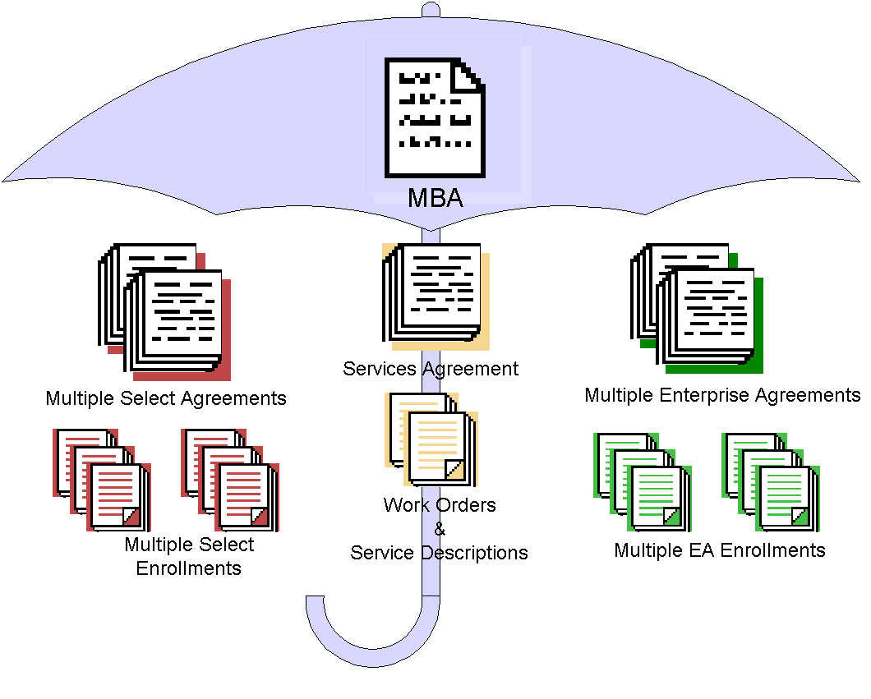

A Select agreement cannot be initiated without an MBA, and a Select enrollment cannot be initiated without a Select agreement.

Purchasing Select License
Initiating a Select License can be a simple process with the help of an authorized Large Account Reseller (LAR). For more information regarding LAR locations worldwide, please reference the Large Account reseller locator tool at http://www.microsoft.com/products/info/render.aspx?view=22&type=mnp&content=22/licensing.

Product Fulfillment
Volume Licensing Product Fulfillment (CD-ROM kit)
Customized according to the languages and product pools specified on the Select License enrollment, the Welcome Kit and subsequent Update Kits offer convenience and access to a broad range of business software titles. The Welcome Kits and Update Kits are automatically provided to the contacts specified on each Select License enrollment. Additional CD-ROM kits may be ordered from the LAR for an additional charge.
Making Copies
Select License allows for the immediate reproduction and use of Microsoft products, as long as licenses are ordered for all copies of the deployed products by the end of the month for which they were installed.
Ordering CD-ROM, Disks, and Documentation
The CD-ROM kits contain only the groups and languages specified on the Select License enrollment. The three product pools (Applications, Systems, and Servers) are divided into seven groupings and are color coded to make them easier to organize.

The following chart shows the groups and colors.

Pool | Group | Color Code | Examples
Applications | Microsoft® Office Family | Blue | Microsoft Office suites and individual applications such as Microsoft Project, Visio, etc.
Applications | Developer Tools | Gold | Visual Studio®, SQL Server Developer Edition, Office Developer, etc.
Applications | Training and Learning | Purple | MSPress titles (Step by Step, Mastering, etc.), Encarta®, etc.
Applications | Products for Macintosh | Olive | Microsoft Office suites and individual applications for Macintosh.
Systems | Windows Client: Business | Green | Windows NT® Workstation, Windows 2000 Professional, Windows XP Professional
Servers | Server Applications | Red | SNA Server, Proxy Server, Site Server etc.
Servers | Windows Servers | Aqua | Windows 2000 Servers and Windows NT Servers

Use the CD-ROM Kit User’s Guide website to help you manage the CD-ROM kit. Access these site features via the link on http://licensing.microsoft.com/.

Microsoft Volume Licensing Services Website
Microsoft Volume Licensing Services online offers advances in software asset management. Information that traditionally has only been available in hard copy form is brought to your fingertips electronically. Microsoft Volume Licensing Services online offers secure, personalized access to details about Select License and EA agreement(s), including Volume License Product Keys, agreement status, and purchase order information. For more information, visit http://licensing.microsoft.com/.

Software Assurance benefit entitlements are also managed on the Microsoft Volume Services website.
Agreement Renewal
It’s easy to renew an expiring Select License agreement. By selecting either the one-year or three-year renewal options, renewing the Select License agreement ensures the continued ability to realize savings on software license purchases, without interruption.

Additional Resources
Microsoft offers a variety of information about the Select License and other volume licensing programs on the Volume Licensing page of Microsoft’s web site. Please visit http://www.microsoft.com/licensing for additional resources.

Appendix A - What is a Software License?
Purchasing software licenses through volume licensing is different than purchasing retail boxed software licenses. A retail software license is usually sold in a box and contains media (in either floppy disk or CD form), a users’ guide, access to product support, and an End User License Agreement (EULA). The EULA dictates how the software may and may not be used.

Software purchased through volume licensing is a software license only. A software license provides the right to run a Microsoft software product. A license acquired through volume licensing does not include an individual disk or CD, users’ guides, or product support.

Savings over retail boxed software prices can be realized by participating in Microsoft’s volume licensing programs. By purchasing software licenses through volume licensing, customers only pay for the software license and have the option to acquire disks (or supplemental disks in the case of Select License or Enterprise Agreements), documentation, and product support separately as needed at less cost.

There are three basic steps required to purchase a software license:

- Determine the license you need.
- Decide the best purchase option.
- Determine where you should purchase.

Determining the License You Need
A software product license can be broken into five main elements: product pool, product, version, edition, and license type.

Product Pool
Microsoft software products fall into one of the following three product pools:

Applications: Examples of Microsoft applications include Microsoft Office, Microsoft Visio®, and Microsoft Project. Developer tools and utilities, such as Microsoft Visual Studio® are also part of the Microsoft applications pool.

Systems: An example of a Microsoft desktop operating system software program is Microsoft Windows® 2000 Professional.

Servers: Examples of Microsoft server software programs are Microsoft Exchange 2000 Server, Microsoft SQL Server™ 2000, and Windows 2000 Server.

Product
This is the actual product itself, for example, Microsoft Office, Visual Studio, Windows 2000, or SQL Server.

Version
Differentiates between various releases of the product (e.g., Microsoft Office 97 and Microsoft Office 2000)

Edition
Specifies the level of features and/or applications included in a product (i.e., Microsoft Office 2000 Standard includes Microsoft Word, Microsoft Excel, Microsoft Outlook®, and Microsoft PowerPoint®, while Office 2000 Professional includes Microsoft Word, Microsoft Excel, Microsoft Outlook, Microsoft PowerPoint, Microsoft Publisher, Microsoft Small Business Tools, and Microsoft Access).

Product Type
Product type refers to the kind of license it is–for example, whether it’s a full license that is required at the initial product purchase, or whether it’s a kind of upgrade license.

Software Assurance (SA): A simpler way of obtaining the latest version of Microsoft products, which replaces the array of upgrade licenses previously offered. SA also helps your organization maintain a business edge with a wide array of tools, resources, training, and other benefits. SA is automatically included in the Enterprise Agreement (EA) and the Enterprise Agreement Subscription.
Note: Options and rules differ across products.

Deciding the Best Purchase Option and Determining Where to Purchase

Original Equipment Manufacturer (OEM)
You may license products through an Original Equipment Manufacturer. These are products (e.g., Windows 2000 Professional operating system) that come pre-installed when you purchase a new computer.

Full Packaged Product (FPP) Retail
Physical, shrink-wrapped boxes of product can be purchased in a local retail store.

Volume Licensing for Organizations
If you require multiple software licenses you could potentially realize a significant savings off the FPP price of Microsoft software by purchasing your software through a volume licensing program such as Select License.

Appendix C- Software Assurance Membership & Support Offerings Worldwide
Microsoft has expanded our support offerings to design a new support program as part of Software Assurance Membership. This support offering will be specific to Software Assurance Members. This support offering includes high-value features such as enhanced resolution services, global support access, and fixed-rate consulting services. This support offering is tightly integrated with volume licensing.

It is not necessary to have Software Assurance Membership in order to be eligible for the existing Premier Support offerings. However, the option to select this new higher support offering will become a feature of Software Assurance Membership.
Offering this new higher level of support for Software Assurance Members will provide customers with greater choice and flexibility in choosing support offerings based on their enterprise scale of product deployment. It’s about integrating services with volume licenses.

What do I get if I have… | You are entitled to receive…
A License (L) | Hot-fixes and service packs
Software Assurance (SA) | Upgrades to the most current product released during your enrollment term
Software Assurance Membership | L and SA benefits, plus the eligibility for a higher level of support
All customers are entitled to purchase Premier Support.

Q&As

Q: Why has Microsoft provided an additional support feature?
A: Microsoft has added support as a feature of the Software Assurance Membership program design in order to offer you a complete software solution.

Q: What are the special needs unique to Software Assurance Members?
A: Software Assurance Members’ needs relate to the rapid adoption of new technology and the fast pace changes that result. Software Assurance Membership, with its feature-rich support programs, will greatly assist these customers.

Q: How does this affect me?
A: First, you should determine the value of Software Assurance to your organization and whether you want to become a Software Assurance Member. By becoming a Software Assurance Member, you will receive the benefits of Software Assurance Membership in addition to being eligible for the higher level of support.

Q: How do I get Premier Support, now and in the future?
A: Obtaining Premier Support has not changed. You may contact your Microsoft account manager to sign up for Premier Support or call 800-936-3200.

Q: What support offerings do Software Assurance Members get?
A: Software Assurance Members have all of the current Premier Support offerings available to them, plus they are entitled to a higher-level support offering as part of SAM.

Q: Do customers without Software Assurance Members get support?
A: Without Software Assurance Membership, customers are still entitled to purchase the currently available Premier Support offerings.

Glossary
Affiliate | A company or legal entity which owns and controls, is owned and controlled by, or is under common ownership and control with, the customer signing the agreement. Ownership is defined as more than 50% ownership. For an academic customer, their affiliate must be an eligible education customer.
Agreement Term | A Microsoft Select License agreement term consists of 36 full calendar months from the Select License agreement effective date. So, if an enrolled affiliate’s effective date falls in the middle of the calendar month (for example January 20th), the agreement term will include a partial month (January 20th to January 31st), plus the upcoming 36 months. The terms of all enrollments are tied to the Select License agreement and end simultaneously.
Annual Adjustment Process | Annual Microsoft review of Select License enrolled affiliates’ actual aggregated purchase history against the forecasted price level. The price level will either be adjusted up, down or remain the same depending on the enrolled affiliates’ actual consumption.
Effective Date | The agreement or enrollment start date. For a Select License agreement this is the date Microsoft signs it, or if an enrollment under it has an earlier effective date, then it is that earlier date. For a Select License enrollment, this is either the date that Microsoft signs it, or the date immediately following the expiration of Software Assurance being rolled over from another agreement.

Enterprise Agreement | Enterprise Agreement refers to Microsoft’s volume licensing offering as described in the Enterprise Agreement Sales Reference Guide.
Enrollment | A Microsoft document which allows qualifying affiliates to sign up for Select License under an existing Select License agreement and acquire licenses for Microsoft products. An enrollment permits business units, divisions, or subsidiaries to acquire software under the terms of the Select License agreement; an outsourcer enrollment permits a third party to act on behalf of the enrolled affiliate. Enrolling affiliates must commit to ordering a minimum of 750 points during the initial term.
FPP | Full Package Product that is sold through the retail distribution channel and contains one license per box.
Large Account Reseller (LAR) | Any authorized reseller or distributor which Microsoft permits to distribute the Select License to customers.
License | Any one of those offerings identified in the Product List (including standard licenses, and upgrades for desktop operating systems) that provides the right to run the version of the product for which it is ordered.
L&SA | See License & Software Assurance.
License & Software Assurance | The combination of both a License and Software Assurance under a single SKU.
Microsoft | Microsoft Corporation or any of its affiliates that have executed the Microsoft Business Agreement, Select License agreement or enrollments.
Microsoft Business Agreement | The “MBA” agreement entered into at the beginning of a volume license relationship to cover common terms that do not have to be changed throughout the duration of the customer’s volume licensing relationship with Microsoft. The term of the agreement is perpetual in order to eliminate administration time spent in negotiating the same terms multiple times.
OEM | Original Equipment Manufacturer is a company who pre-loads Microsoft products onto computers prior to shipment to the customer.
Pools | Microsoft products available through Select License are categorized as applications, systems, or servers products. Prices are established according to the volume levels acquired in each category or “pool,” also referred to as the applications pool, systems pool, and servers pool.
Product List | The statement published by Microsoft from time to time (which statement may vary by region) which identifies the products available under the program and any product-specific conditions or limitations on the acquisition of licenses for the product.
Renewal Period | Upon expiration of the agreement, the customer has the options to renew for one or three additional years.
SA | See Software Assurance.
Select | Select refers to the Microsoft Select License offerings as described in this Customer Guide.
Select Agreement | A Microsoft document which, when signed by the customer and Microsoft, legally binds all applicable parties to a three year agreement and sets the framework for the acquisition of Microsoft licenses under corresponding Select enrollments.
Software Assurance | For any underlying licensed product for which it is ordered, the right to run the latest version and the ability to spread payments annually. Also includes tools, support, training, and other benefits.
Software Assurance Membership | An integrated set of support services and benefits for Enterprise Agreement customers. Select License customers who have chosen SAM for one or more product pools on their Select License enrollment, and Open Value customers who select the Company-wide Option. In addition to new version benefits, SAM is designed to help customers more successfully deploy the software they’ve licensed with training and other offerings.

