Agreement Guidebook for the
Microsoft Business Agreement (MBA)

This Guidebook will assist you in understanding recent changes effective March 2003 to the Microsoft Business Agreement (MBA).

Copyright © 2003 Microsoft Corporation. This Guidebook is intended for informational purposes only. All rights reserved. Microsoft and other Microsoft products are either registered trademarks or trademarks of Microsoft Corporation in the United States and/or other countries.

Introduction

In response to feedback from customers, we are making alterations to our contracts for volume licensing and services. We think that our current customers also would value these contract terms.

Here is a summary of these alterations:
- Customers have told us that our product warranty does not give them enough time to test and deploy our products. So we are extending that warranty from 90 days to 1 year.
- Customers have told us that our “duty to defend” provisions leave them with too much risk. Customers want more protection from claims about intellectual property rights. We are expanding our defense duty to cover trade secret and trademark claims. This means that your coverage will include these additional claims.
- Customers have this same concern about the cap that applies to the damages we will pay when we cover infringement claims. So we are removing that monetary cap.
You may keep the provisions in your current Microsoft agreement if you prefer. But if you want to take advantage of any – or all – of these three improvements, you don’t need to do anything to accept any of these provisions, either now or in the future.

Summary of Changes Items in grey do not appear in this agreement

Contact information
1
Previously, your primary contact person named on the cover page of the agreement was, by default, the recipient of notifications and the online administrator with access to license information on MVLS. Now, in addition to designating another person to be the notification contact, you may designate another person to be the online administrator.

Contact information continued
2
You may choose to have duplicate electronic notifications sent to a secondary location.

Warranties
3
Product warranties for all volume licensing agreements have been extended from 90 days to one year. This warranty extension is in response to customers’ concerns about 90 days not being consistent with their business cycles and deployment constraints.

Defense of infringement and misappropriation claims
4
Commercial product service packs and other generally released fixes are now covered under Microsoft’s duty to defend against intellectual property infringement or misappropriation claims.

Defense of infringement and misappropriation claims continued
5
If a court prohibits use of a product as a result of a covered infringement or misappropriation claim, Microsoft will choose one of the following four options: (1) procure the right for you to continue using the product, (2) replace it with a functional equivalent, (3) modify the product to make it noninfringing, or (4) refund the amount paid for the product and terminate the applicable licenses. Previously, Microsoft was obligated to exercise commercially reasonable efforts to provide a remedy for you, but now Microsoft is obligated to choose one of the specified alternatives.

Defense of infringement and misappropriation claims continued
6
Microsoft has expanded the subject-matter scope of its duty to defend against intellectual property claims. It now also covers trademark infringement and trade secret misappropriation. This change addresses customers’ concern that limiting Microsoft’s defense obligation to copyright and patent claims allocated too much risk to them.

Limitation of liability
7
The monetary cap on Microsoft’s liability for paying judgments and settlements arising from covered intellectual property claims under the agreement has been removed. This change is in response to customers’ concern about assuming too much risk under the old provision, which limited Microsoft’s payment obligation to the amount paid by you for the particular product about which the infringement or misappropriation claim was made. The monetary cap on Microsoft’s liability for gross negligence and willful misconduct under the agreement has also been removed.

Verifying compliance
8
To help you prepare for audits, and to minimize business interruptions and inconveniences, Microsoft has extended the audit notice period from 15 days to 30 days. The extended period will assist you in compiling your records associated with license acquisitions.

Non-exclusivity
9
Microsoft has added this provision to make explicit the fact that this agreement does not preclude the use of non-Microsoft products or services.

Survival
10
The two-year limitation on either party bringing claims against the other has been eliminated. Previously, any action arising under the agreement had to be brought within two years from the date that the cause of action arose.

Term, termination, and renewal
11
Microsoft has qualified its right to terminate your agreement and all enrollments if you or an enrolled affiliate breaches a single enrollment. Microsoft will work with you to resolve the problem(s) within a reasonable period of time before considering termination of the agreement and all enrollments.

How the license program works
12
The word “reasonably” was removed and replaced with the more globally acceptable “if we have a business reason for doing so...” This change is primarily for localization reasons and does not alter the intent of the clause.

How to order enterprise product licenses
13
Open License Value customers who elected the Company-wide Option may qualify to step up to an Enterprise Agreement and order only Software Assurance for the enterprise product licenses that you acquired under the Open License Value Company-wide Option. This renewal pricing is available if you meet the Enterprise Agreement requirements.

Qualifying systems licenses
14
You are directed to the Product List to find out what operating systems qualify for the Microsoft Windows Desktop Operating System Upgrade.

Delivery and payment terms
15
Changes in this section clarify that applicable sales tax is calculated based on where the media is delivered. Language has been added to reflect actual Microsoft practices regarding importation and customs formalities. While you remain responsible for all legal requirements and costs associated with importing media, licenses and associated software documentation into its country, the new language indicates that Microsoft may decide to act on your behalf to carry out customs formalities. See section on License grant for details on separation of licenses and media.

License grant
16
In order to assist with accurate customs duties assessment for the media, the media fulfillment order form has been removed from the enrollment, and language has been added to this section to further clarify that the media and software licenses are separate. See CD Order Form for additional information.

Product Use Rights
17
Microsoft has clarified that you may acquire CALs under your volume license agreement and assign them to external devices or users, provided that those devices or users access or otherwise use, for your benefit, the applicable server software licensed under your volume license agreement.

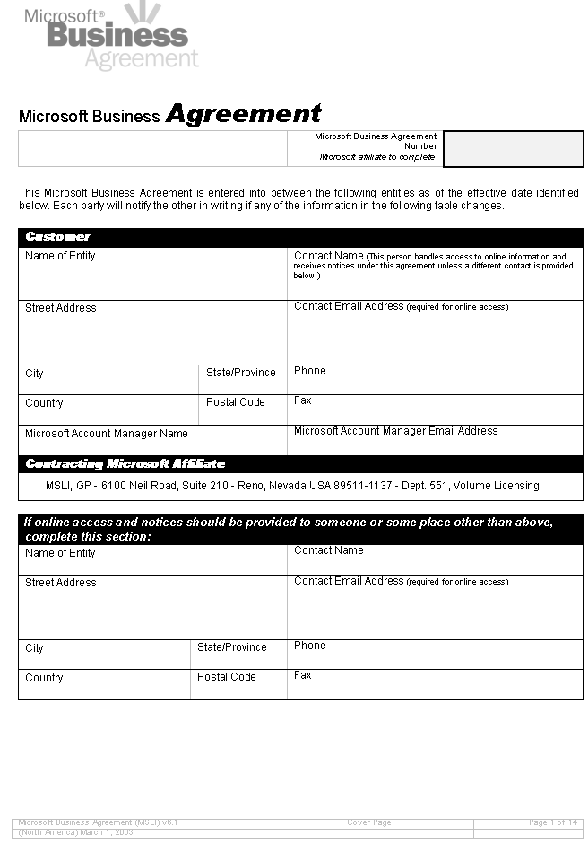

Contact information
Previously, your primary contact person named on the cover page of the agreement was, by default, the recipient of notifications and the online administrator with access to license information on MVLS. Now, in addition to designating another person to be the notification contact, you may designate another person to be the online administrator.

1

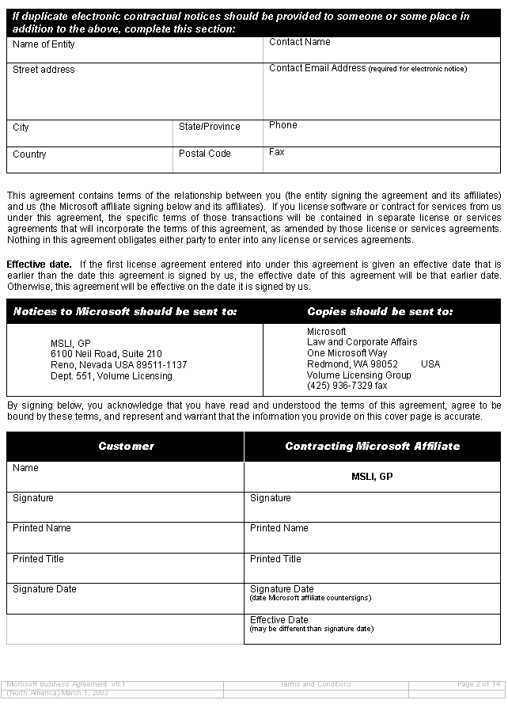

Contact information continued
You may choose to have duplicate electronic notifications sent to a secondary location.

2

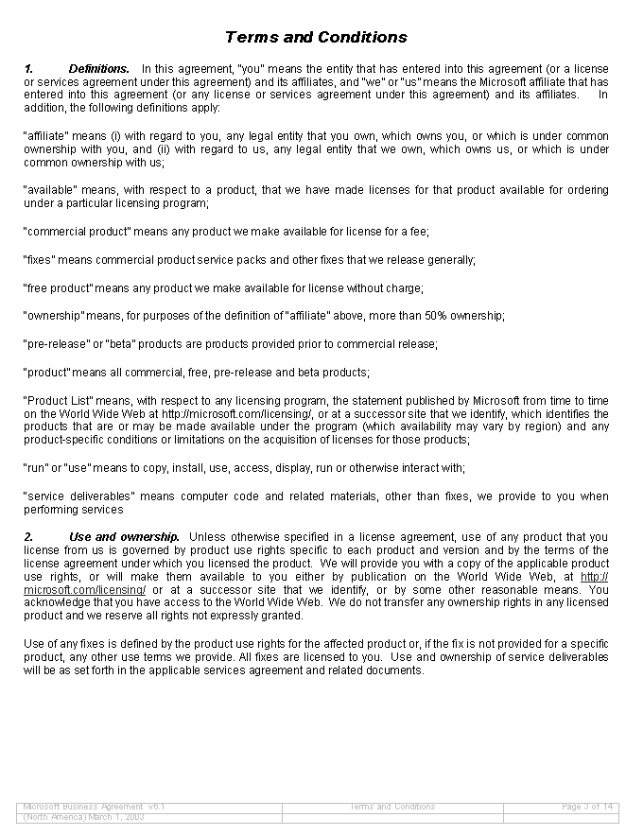
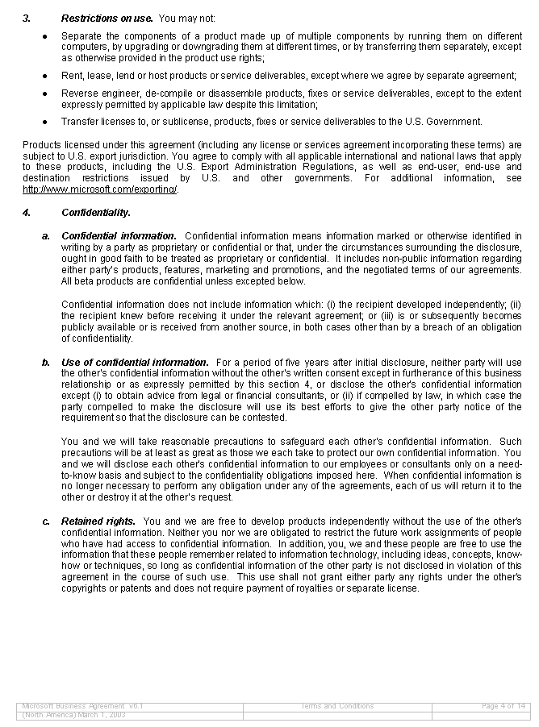

Warranties
Product warranties for all volume licensing agreements have been extended from 90 days to one year. This warranty extension is in response to customers’ concerns about 90 days not being consistent with their business cycles and deployment constraints.

3

Defense of infringement and misappropriation claims
Commercial product service packs and other generally released fixes are now covered under Microsoft’s duty to defend against intellectual property infringement or misappropriation claims.

Defense of infringement and misappropriation claims
Microsoft has expanded the subject-matter scope of its duty to defend against intellectual property claims. It now also covers trademark infringement and trade secret misappropriation. This change addresses customers’ concern that limiting Microsoft’s defense obligation to copyright and patent allocated too much risk to them.

4
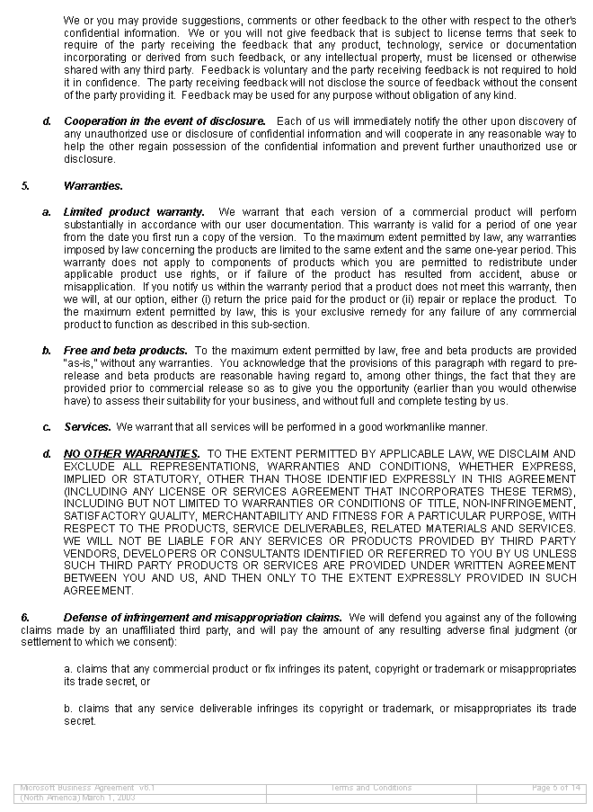
6

Defense of infringement and misappropriation claims
continued
If a court prohibits use of a product as a result of a covered infringement or misappropriation claim, Microsoft will choose one of the following four options: (1) procure the right for you to continue using the product, (2) replace it with a functional equivalent, (3) modify the product to make it noninfringing, or (4) refund the amount paid for the product and terminate the applicable licenses. Previously, Microsoft was obligated to exercise commercially reasonable efforts to provide a remedy for the customer, but now Microsoft is obligated to choose one of the specified alternatives.

Limitation of liability
The monetary cap on Microsoft’s liability for paying judgments and settlements arising from covered intellectual property claims under the agreement has been removed. This change is in response to customers’ concern about assuming too much risk under the old provision, which limited Microsoft’s payment obligation to the amount paid by you for the particular product about which the infringement or misappropriation claim was made. The monetary cap on Microsoft’s liability for gross negligence and willful misconduct under the agreement has also been removed.

7
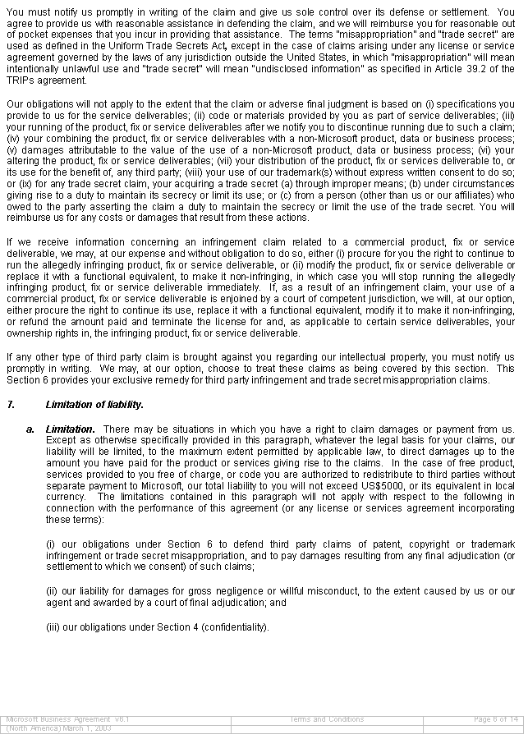
5
Verifying compliance
To help you prepare for audits, and to minimize business interruptions and inconveniences, Microsoft has extended the audit notice period from 15 days to 30 days. The extended period will assist you in compiling your records associated with license acquisitions.

8
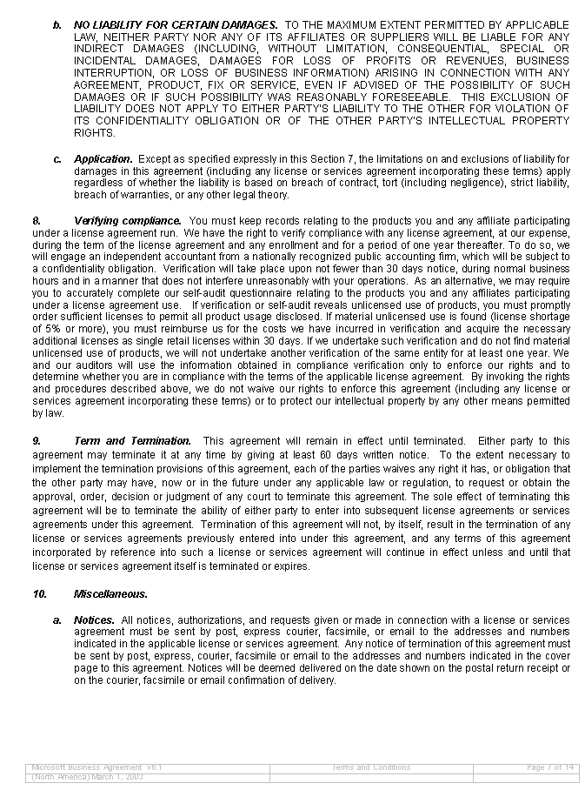
Survival
The two-year limitation on either party bringing claims against the other has been eliminated. Previously, any action arising under the agreement had to be brought within two years from the date that the cause of action arose.

10

Non-exclusivity
Microsoft has added this provision to make explicit the fact that this agreement does not preclude the use of non-Microsoft products or services.

9
