Microsoft SA eLearning
Benefit Administration
User Guide

A reference guide for administering the two SA eLearning Benefits

Microsoft SA eLearning - IW

Microsoft SA eLearning – Client

Microsoft SA eLearning – Server

November 2003

© 2003 Microsoft Corporation. All rights reserved.
This document is for informational purposes only. Microsoft makes no warranties, express or implied, in this summary.
Microsoft, FrontPage, InfoPath, OneNote, Outlook, PowerPoint, SharePoint, Windows, and Visio are either registered trademarks or trademarks of Microsoft Corporation in the United States and/or other countries.
The example companies, organizations, products, domain names, e-mail addresses, logos, people, places, and events depicted herein are fictitious. No association with any real company, organization, product, domain name, e-mail address, logo, person, places, or events is intended or should be inferred.

Microsoft SA eLearning
Microsoft's eLearning courses use simulations, demonstrations, animations, and assessment to provide an engaging, effective learning experience for employees who need to upgrade their skills and knowledge. Designed by subject matter experts, Microsoft’s eLearning courses can be used as traditional training or as a just-in-time reference resource - either online or offline.

There are three Microsoft Software Assurance (SA) eLearning benefits:
- Microsoft SA eLearning – IW
eLearning media kit containing a subset of the Microsoft eLearning Library Desktop Edition. This media kit contains interactive training on desktop applications.
- Microsoft SA eLearning – Client
eLearning media kit containing a subset of the Microsoft eLearning Library Desktop Edition. This media kit contains interactive training on systems products.
- Microsoft SA eLearning – Server
eLearning media kit containing a subset of the Microsoft eLearning Library Developer Edition. This media kit contains interactive training on servers.
The information to administer all of these benefits is the same so all are contained in this document.

This guide covers the following sections:
eLearning Benefit Rules
Activating the eLearning Benefit
Viewing the eLearning Benefit Details
Updating Benefit Contact Information for the eLearning Benefit
Placing a Hold on the eLearning Benefit
Viewing the eLearning Benefit History
Actions on the eLearning Benefits
eLearning Enrollment E-mail
Using the eLearning Benefit
Assistance with the eLearning Benefit
Glossary of Terms

eLearning Benefit Rules

eLearning course and material updates will be sent on a semester basis as long as the agreement has not ended. After the agreement has ended, you may still use the materials but no updates will be sent.

Return to Topic List

Activating the eLearning Benefit

To determine if activation is necessary, check the Enrollment Status of the eLearning benefit on the Benefit Summary window.
If the status is Not Enrolled, you must activate the benefit in order to begin using it. If the status is Enrolled, activation has already been completed.

To activate the eLearning benefits:

Open License Business and Open License Volume Customers
If you are licensed in Open License Business or Volume, your eLearning benefits are automatically activated at the time of enrollment. eLearning media may be ordered from your reseller.
- Login to the Microsoft Volume Licensing Services website (https://licensing.microsoft.com/eLicense/L1033/Default.asp)

Open License Value Select License Enterprise Agreement (EA) Customers
- Then go to the Benefits Administration page.
- Click on the Microsoft SA eLearning – IW, Microsoft SA eLearning – Client, or Microsoft SA eLearning - Server link in the Benefit Name column.

Note: If the link to any of the Microsoft SA eLearning benefits is not active it means that you have not purchased the required number of products to use the benefit (but you have purchased some qualifying products otherwise the benefit would not be shown on the window).
If the link to any of the Microsoft SA eLearning benefits is not displayed, it means that either you do not have benefit administration rights for the benefit, or no qualifying products have been purchased.

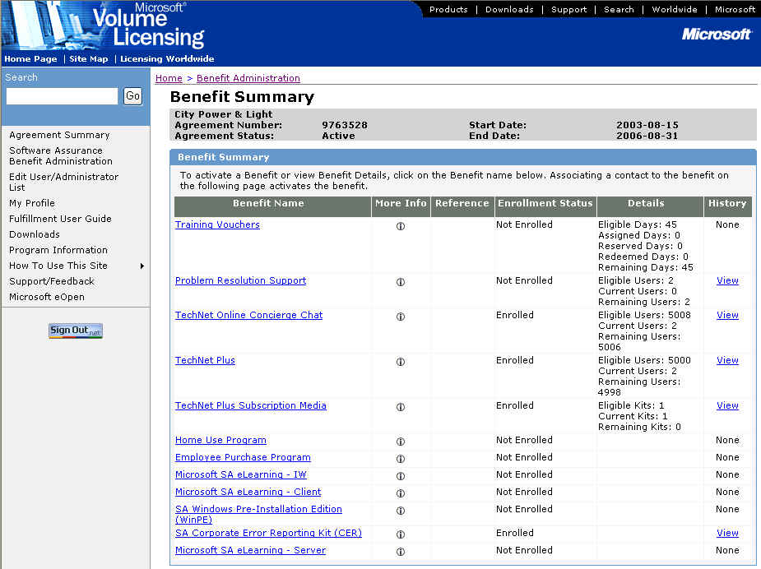

- The Choose Existing Benefit Contact window appears.

Note: This window only appears if another benefit for this agreement has been activated. If this is the first benefit activated for the agreement, the Activate Benefit window appears (see Step 5).

Note: To activate a Microsoft SA eLearning benefit, one benefit contact must be specified. The benefit contact will be the person who receives the media or is responsible for downloading the courses. Please be sure the contact you specify is the proper person. The benefit contact must be a Benefit Administrator with MVLS access in order to download the media.
To search the list of existing benefit contacts, enter the First Name and/or Last Name and click OK.

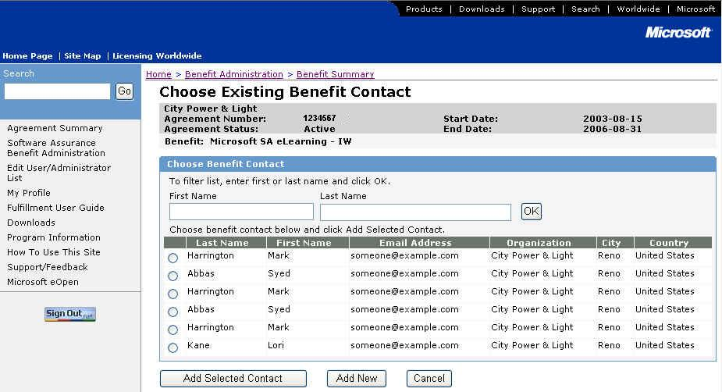

- If the person you wish to designate as the benefit contact is shown on the Choose Existing Benefit Contact window, select the radio button next to their name and click Add Selected Contact. (Go to Step 5.)

- If the person you wish to designate as the benefit contact is not shown on the Choose Existing Benefit Contact window, click Add New.

- The Activate Benefit window appears.
If you selected an existing contact, their information will be shown in the Benefit Contact Detail section of the window. The information will be grayed out and you cannot modify it. (If you need to modify the contact information for the person selected, see Updating Benefit Contact Information for the eLearning Benefit.)
If you did not select an existing contact, enter the information about the Benefit Contact. The organization information will be pre-populated.

Note: Select the appropriate fulfillment language for the eLearning media from the Fulfillment Languages drop down box in the Benefit Details section of this window. This is the language in which the media kit will be sent. You cannot change this language once the benefit is activated.

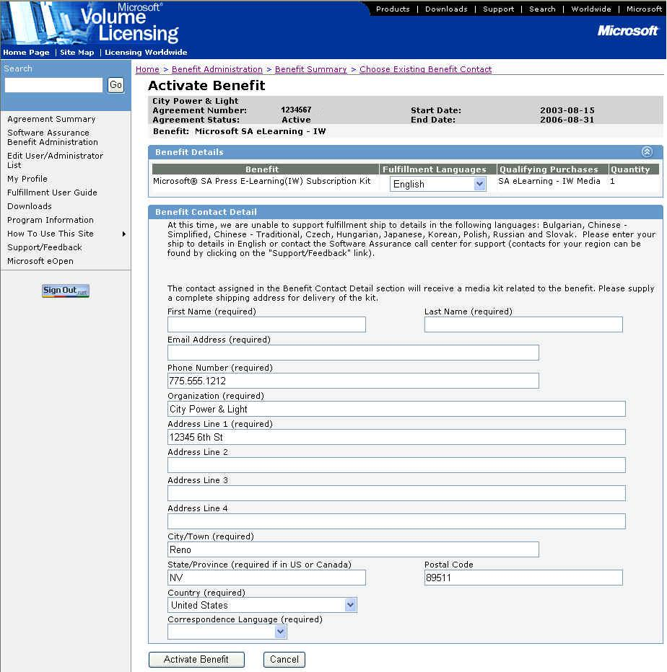

- Click Activate Benefit.

Note: If you click Cancel, a confirmation dialog box stating “Canceling will cause you to lose all changes. Are you sure you want to cancel?” will appear. If you click OK, all changes will be deleted and the Benefit Summary window appears. If you click Cancel, you will return to the Activate Benefit window.

- The Benefit Activation Confirmation window appears.

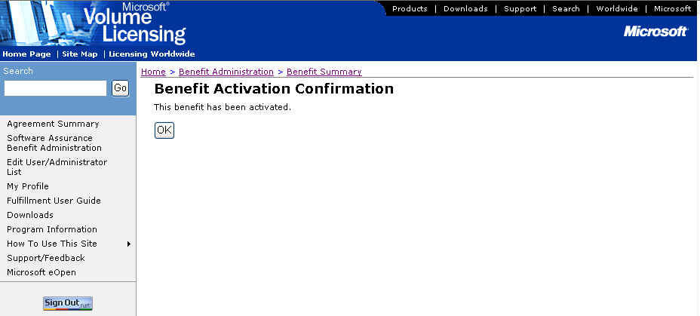

- Click OK to display the Benefit Details window.

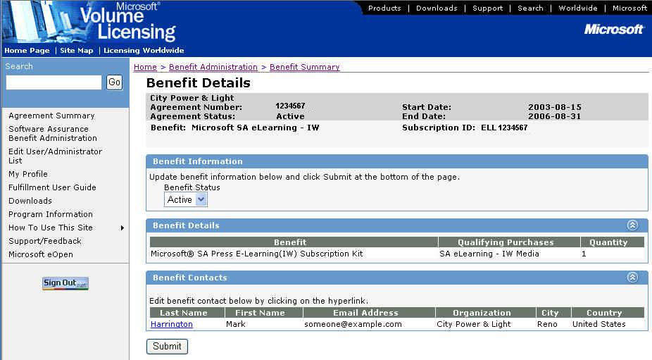

Once the benefit has been activated:
- The Enrollment Status on the Benefits Summary window is changed to Enrolled and the History column value changes to View. To view the benefit history, see Viewing the eLearning Benefit History.
- The designated benefit contact receives the Microsoft SA eLearning enrollment e-mail. See eLearning Enrollment E-mail for the full text of this e-mail.
- The designated benefit contact receives the appropriate eLearning media kit.

Return to Topic List

Viewing the eLearning Benefit Details

To view the Microsoft SA eLearning benefit details:

- On the Benefit Summary window, click on the Microsoft SA eLearning – IW, Microsoft SA eLearning – Client, or Microsoft SA eLearning – Server hyperlink in the Benefit column.

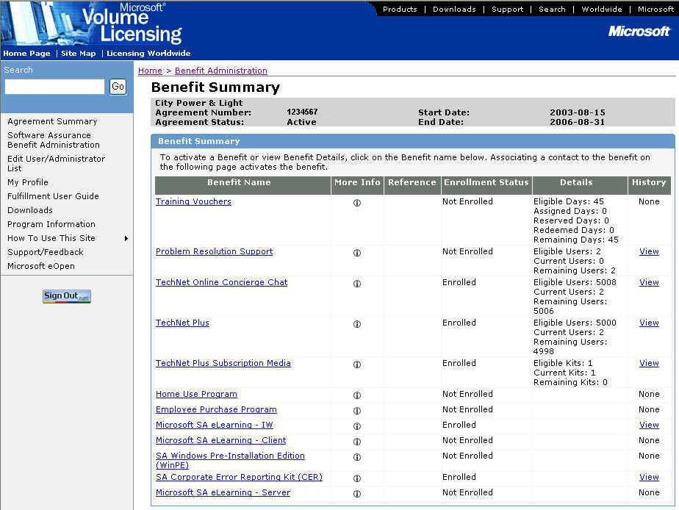

- The Benefit Details window appears showing the benefit contact information.

Benefit Information – The benefit status is shown and can be changed here. The available benefit statuses are:
- Active – Benefit is available for consumption.
- Hold – Prevents use of the existing benefit.
- Ended – Benefit subscription has come to an end. This status is set only by the MVLS system.
- Inactive – Prevents the use of the existing benefit. This status can only be set by Microsoft administrators.
- Expired – Indicates that the agreement/benefit has reached the end date. This status is set automatically by the MVLS system.
- HAR (Held Awaiting Reactivation) – Indicates that the subscription has been placed into a transitory state where the subscription may not be used to consume a benefit. The subscription has not been ended and may be reactivated at a later date with the existing associated contact information. This status is set only by the MVLS system.
Benefit Contacts – For the eLearning benefits, only one benefit contact is allowed.
- To update the contact details, see Updating Benefit Contact Information for the eLearning Benefit.
- The benefit contact cannot be changed.

Return to Topic List

Updating Benefit Contact Information for the eLearning Benefit

To update the benefit contact information for the eLearning benefits:

- On the Benefit Summary window, click on the Microsoft SA eLearning – IW, Microsoft SA eLearning – Client, or Microsoft SA eLearning – Server hyperlink in the Benefit column.

- The Benefit Details window appears showing the benefit contact information.

- Click on the Last Name hyperlink. The Edit Benefit Contact Detail window appears.

Note: Use the Edit Benefit Contact Detail window to edit an existing contact’s information. This window should not be used to “replace” or “create” a new contact.

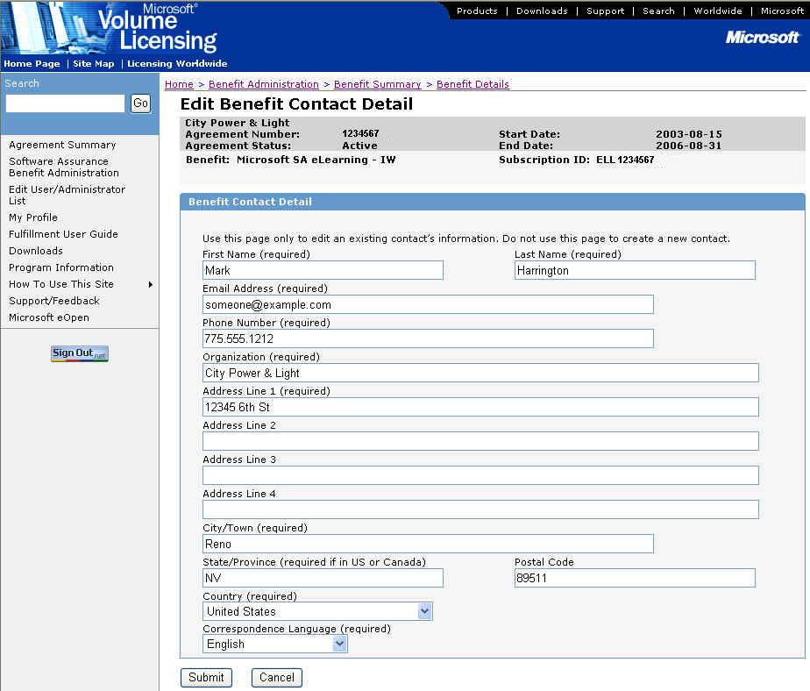

- Edit the contact information and click Submit. The Benefit Details window is displayed.

Return to Topic List

Placing a Hold on the eLearning Benefit

The eLearning benefit should be placed on hold if you want to hold the shipment of the initial eLearning kit (if it has not already been sent) or subsequent updates.

To place a hold on the eLearning benefits:

- On the Benefit Summary window, click on the Microsoft SA eLearning – IW, Microsoft SA eLearning – Client, or Microsoft SA eLearning – Server hyperlink in the Benefit column.

- The Benefit Details window appears.

- In the Benefit Status drop-down box, select the Hold status. This will place the subscription on hold. Click Submit.
- Note: See Actions on the eLearning Benefit to see which actions are allowed for the different Status settings.

The subscription will remain on hold until the status is changed to Active by the benefit administrator or Ended by the system.

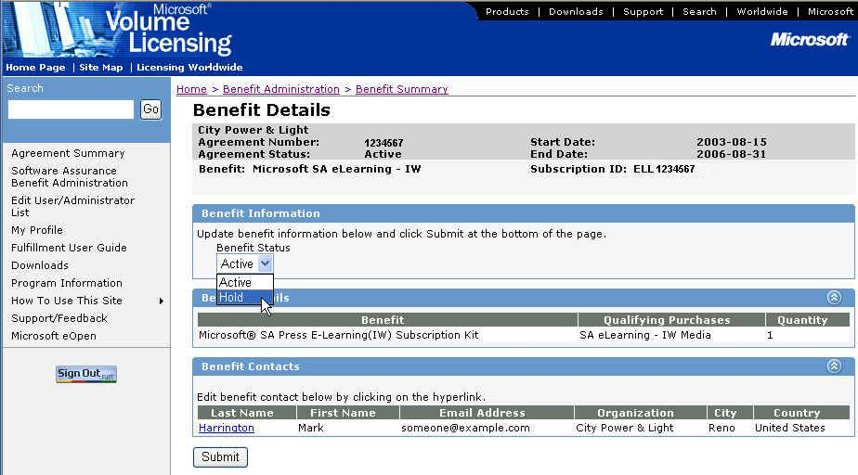

- To set the status back to active, follow the steps above but select Active status and click Submit.

Return to Topic List

Viewing the eLearning Benefit History

To view the eLearning benefit history:

- On the Benefit Summary window, click on the View hyperlink in the History column for the appropriate eLearning benefit.
Note: If the benefit is not currently Active, the history will not have a View link, instead the word None will be displayed without a hyperlink.

- The History window appears.
The History window displays information about the current and previously activated (and/or ended) subscriptions of the benefit under the agreement.
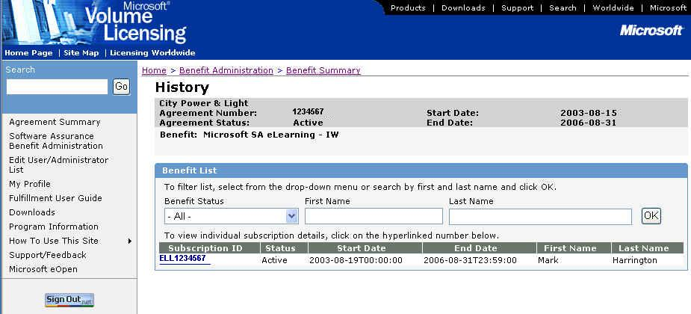

- To see subscription information, click on the appropriate Subscription ID in the Subscription ID column. Depending on the subscription status, you will be able to view or edit the subscription on the Benefit Details window. See Actions on the eLearning Benefits for more information.

Return to Topic List

Actions on the eLearning Benefits

Different actions can be taken on the eLearning benefits based on the current status. The table below outlines these actions and when they can be performed.
Benefit Name | Subscription  Status | Edit Contact Detail * | Edit User Authentication ** | Status Change in UI  (Allowed - Change To)
Microsoft SA eLearning - Client  Microsoft SA eLearning - IW  Microsoft SA eLearning - Server | Active | Yes | N/A | Yes - Hold
 | Expired | No | N/A | No
 | Ended | No | N/A | No
 | HAR | No | N/A | No  ( Active - Process Only)
 | Hold | Yes | N/A | Yes - Active
 | Inactive | No | N/A | No

Return to Topic List

eLearning Enrollment E-mail

When either eLearning benefit is activated, the benefit contact specified during the activation process will receive an automated e-mail. The e-mail contains program information about the eLearning benefit.

Text of the eLearning enrollment e-mail:

Subject: Your Microsoft® Software Assurance eLearning benefit is now available.
From: <Benefit Administrator e-mail address>
Body:

Dear <First Name> <Last Name>,

Please note that the contents of this e-mail have been created by the Microsoft Worldwide Software Assurance enhancements team and are being sent to you by Microsoft, on behalf of your Benefit Administrator <insert BA name> within your organization.

Welcome to the Microsoft Software Assurance enhancements. As a Software Assurance customer, your organization is eligible for Software Assurance enhancements which can help us get the most value from up-to-date technology. eLearning is one of these enhancements and you have been elected as the benefits contact. In this capacity, you will be responsible for the deployment of this benefit within our organization.

Microsoft’s eLearning courses use simulations, demonstrations, animations, and assessment to provide an engaging, effective learning experience for employees who need to upgrade their skills and knowledge. Designed by subject matter experts and updated on a semester basis, Microsoft’s eLearning courses can be used as traditional training or as a just-in-time reference resource – either online or offline.

How do you obtain this eLearning benefit?
You can obtain your eLearning materials by either of the following methods:

- Microsoft Licensing Fulfillment Media Shipment
The media for the Software Assurance eLearning Information Worker, Client and Server benefits are available free of charge and are included in separate fulfillment kits which will be sent to you once chosen.
The media for the Software Assurance Information Worker, Client and Server benefits can be ordered through the Microsoft Licensing Fulfillment Centre. Your Channel Partner can assist you with this process.
Should you have any difficulty in obtaining this media, please contact me or your Channel Partner who will work with Microsoft on our behalf to resolve any queries we might have.

- Software Download from the MVLS website:
The materials for the Software Assurance eLearning Information Worker, Client and Server benefits can also be downloaded from the MVLS website: <https://licensing.microsoft.com>. Should you have any difficulty with this download, please request assistance using the support page available on the MVLS website.

Please be aware that your use and deployment of Software Assurance eLearning is subject to the terms and conditions of our Microsoft Volume License Agreement, the Product Use Rights (PUR) and the applicable eligibility criteria set forth in the Microsoft Product List and MVLS.

Once again, we welcome you to Microsoft Software Assurance enhancements! We trust you will enjoy these benefits and we look forward to your participation and feedback. Feedback for your country or region can be provided at https://licensing.microsoft.com by clicking on the Support/Feedback link.

Thank You,

Microsoft, on behalf of your Benefits Administrator

Return to Topic List

Using the eLearning Benefit

To use the eLearning benefit, the benefit contact can download the courses and place them on the intranet (or copy from the media received). Another option is to give the copy of the media to an individual who can copy the materials onto their computer directly.
The number of desktops on which the eLearning courses can be installed or accessed is limited to the number of qualifying licenses purchased.

Return to Topic List

Assistance with the eLearning Benefit

For assistance administering the eLearning benefit, go to the MVLS Support page (select Support from the left navigation bar on the MVLS site).
For benefit contact assistance with the eLearning benefit, go to https://licensing.microsoft.com.

Return to Topic List

Glossary of Terms

MELL – Microsoft eLearning Library

Return to Topic List

