

Customer Guide

A reference guide to the Microsoft Enterprise Agreement Subscription software licensing program including:
- Program Benefits
- Purchase Options
- How to Begin

Table of Contents
Enterprise Agreement Subscription Introduction 4
Enterprise Agreement Subscription Benefits 4
Enterprise Agreement Subscription Overview 4
Enterprise Agreement Subscription Program Features 5
Enterprise Products 5
Additional Products 6
Software Assurance in Enterprise Agreement Subscription 6
How it works 6
Agreement Term 6
Annual Price Per Desktop 6
Annual PC Count 7
Additional Value-Adds 7
Agreement Structure 8
Price Levels 9
Qualified desktop 9
Placing an Enterprise Agreement Subscription Order 10
Product Fulfillment 10
Ordering CD-ROMs, Disks, and Documentation 10
Groupings and Color Codes 11
Microsoft Volume Licensing Services Web site 11
Agreement Term and Renewal 11
Renewal Option 11
Option to not Renew 12
Additional Resources 13
Glossary 14

© 2005 Microsoft Corporation. All rights reserved.
This document is for informational purposes only. MICROSOFT MAKES NO WARRANTIES, EXPRESS OR IMPLIED, IN THIS SUMMARY.
Microsoft, FrontPage, InfoPath, OneNote, Outlook, PowerPoint, SharePoint, Visio, Visual Studio, Windows, and Windows NT are either registered trademarks or trademarks of Microsoft Corporation in the United States and/or other countries. The names of actual companies and products mentioned herein may be the trademarks of their respective owners.

Enterprise Agreement Subscription Introduction
The Enterprise Agreement (EA) Subscription program was designed for customers with variable business environments that wish to implement enterprise wide standards to enhance business productivity. The EA Subscription provides a framework for making software license acquisitions and management easier for businesses with as few as 250 desktops. Software licenses offered through the EA Subscription program are non-perpetual, meaning that product use rights are only in effect for the term of the enrollment.

Enterprise Agreement Subscription Benefits
Get more through Software Assurance. Get more value, more manageability, and more assistance from your technology investments through Software Assurance. Software Assurance can help you get the most value from up-to-date technology with several key benefits that can save time, money, and help deploy software more efficiently.
Build a flexible infrastructure. An EA Subscription helps an organization more easily build and maintain its infrastructure so it can respond rapidly to changing business needs.
Drive standardization throughout the enterprise. An EA Subscription can help a company more successfully use standards to reduce the cost of computing.
Ensure compliance. The EA Subscription significantly reduces the administration required to show compliance on enrolled enterprise products, thereby mitigating the associated legal risk.
Simplify license administration and budgeting. An EA Subscription helps streamline the administration and budgeting processes while improving the accuracy of business planning.

Enterprise Agreement Subscription Overview
Businesses with a minimum of 250 desktops that wish to license 100% of their qualified desktops for a three-year period can initiate an EA Subscription. The EA Subscription offers:
- Software Assurance provides a powerful combination of benefits that include new version rights, the Home Use Program, and many other advantages including support, tools, and training, your company can gain the flexibility it needs to keep your business edge.
- Selection of enterprise products, including Microsoft® Office Professional, Microsoft Windows® operating system upgrades, and the Core CAL (each product described in detail on next page).
- Additional products offer a broad selection of Microsoft business software products. Examples of products offered as additional products include Microsoft Office Visio®, Microsoft Office Project, Windows servers, and Exchange servers.
- Non-perpetual software use rights provide temporary use of software (with an option to buy out software licenses for permanent use rights).
- A fixed, annual price per desktop for enterprise products based on the initial number of desktops enrolled.
- The Annual PC Count enables an organization to shape software license acquisition needs around fluctuations in the enterprise.
- Annual payments for a three-year enrollment term, with a renewal option of one year or three years.

Enterprise Agreement Subscription Program Features
Enterprise Products
The EA Subscription offers businesses access to the most recent releases of the Enterprise Desktop Professional Platform Products. The Enterprise Desktop Professional Platform Products are:
- Windows Desktop Operating System Upgrade; (this can be either the upgrade to Windows 2000 Professional or Windows XP Professional)
- Microsoft Office Professional (The current version includes Microsoft Office Word, Microsoft Office Excel, Microsoft Office PowerPoint®, Microsoft Office Outlook® messaging and collaboration client, and Microsoft Office Access)
- Microsoft Core Client Access License (The current version consists of Client Access Licenses (CALs) for Windows 2000 Server, Microsoft SharePoint® Portal Server, Microsoft Exchange 2000 Server, and Systems Management Server 2.0). The Core CAL is a new way to conveniently cover and manage CALs for certain basic server components across all licensed desktops within the firewall. The Core CAL reduces the complexity for the IT professional in managing client access licenses for server products.

Why consider enrolling the full Enterprise Desktop Professional Platform?
Businesses benefit from building both simplicity and flexibility into their information technology infrastructure. For many companies, the first step toward achieving this is to adopt the Microsoft platform as the core of its software infrastructure.

The Enterprise Platform offers products that are integrated and optimized. Microsoft products are optimized to work well together in a seamless, integrated fashion. For example, a common programming model is used to improve information sharing between applications.

The full platform leverages a consistent interface for users, developers, and administrators that improves productivity and reduces costs. Common commands, menus, windows, and interchange models improve training and development.

Strong vendor and developer support offered by both Microsoft and our partners for business applications increases business flexibility.

New customers who enroll in the Enterprise Platform, (Windows desktops operating system upgrade, Office Professional, and Core CAL) receive a 15% platform discount.

Microsoft has a track record as being one of the largest investors in research and development for new product improvements. Additionally, there is a broad developer and ISV base that is focused on developing applications that are supported by the Enterprise Desktop Professional Platform.

Additional Products
A broad selection of software titles is available as additional products. They provide the same License & Software Assurance coverage as enterprise products, but do not require an enterprise wide commitment. Spreading the cost of software licenses over three years can enable businesses to refocus critical IT budget and provide a predictable framework for budgeting purposes.

Examples of products available as additional products option include Visio, Project and Windows Servers, and Exchange Servers. A complete list of additional products is available on the Microsoft Product List, which is referenced in the “Additional Resources” section of this guide.

Software Assurance in Enterprise Agreement Subscription
Software Assurance can help you get the most value from up-to-date technology with several key benefits that can save time and money. With Software Assurance’s powerful combination of productivity benefits, support, tools, and training, your company can gain the flexibility it needs to keep your business edge. For information about Software Assurance benefits available through Select License, please visit http://www.microsoft.com/licensing.

How it works

Agreement Term
The three-year enrollment term and one or three-year renewal options provide businesses with a defined window of time for which the terms and prices (within price levels) of their purchasing relationship with Microsoft will remain constant. This enhances a business’ ability to plan and budget for software license purchases up to three years in advance, which reduces annual budget restrictions and fiscal year spending challenges.

Annual Price Per Desktop
The Annual Price Per Desktop feature provides a predictable budgeting framework that can be used to determine desktop technology costs up to three years in advance.

A payment (based on the pre-established price per desktop) is due each year at the anniversary date of the Enterprise Subscription enrollment. Because the software licenses are paid for once annually, the costs normally associated with software license purchases are reduced. In many cases, the number of software purchase orders made annually is minimized from hundreds to two or three total. The pre-determined price paid for software licenses protects software budget from unanticipated price increases.

Annual PC Count
The price paid for selected software is based on the quantity of qualified desktops. The EA Subscription program establishes the price level at the beginning of the Enterprise Subscription enrollment. The price for selected enterprise products and additional products will not fluctuate unless the number of qualified desktops reported annually changes, and the price level changes as a consequence.

When changes occur to the qualified desktop count, EA Subscription customers are not locked into a price level. Desktops added between Annual PC Counts are automatically covered for enterprise products selected on the Enterprise Subscription enrollment. The price level at the following Annual PC Count is determined by the amount of qualified desktops for that year and that year alone.

Additional Value-Adds
Take advantage of these additional features in the EA Subscription to help boost the value received by participating in the program:

Commitment on Use Rights provide Enterprise Agreement customers the security of knowing exactly what the use rights are for the products they license under their Enterprise enrollment. Microsoft agrees not to change product use rights for any version of a product after it becomes available. Furthermore, we make a commitment that we will not change use rights for enterprise products during the term of an enrollment to be more restrictive or to the customers’ detriment (this commitment does not relate to new features and functionality).

Training and Evaluation Licenses helps budget for software training and evaluation purposes go farther by offering a limited number of complimentary training and evaluation copies of any additional product.
- 20 copies per software title for use in dedicated training facility, and
- 10 copies per software title for 60-day evaluation

Downgrade Rights provide businesses with version standardization considerations the flexibility necessary to purchase the latest software version available, but run a previous version.

Re-Imaging Rights allow the use of certain software media for re-imaging to provide added convenience during product roll outs.

Secondary Use Rights allow employees to be more productive by sharing the same application license for any additional product on a work PC as well as a portable PC for work-related purposes only.

NOTE: For full details, please reference the 6.0 Enterprise Subscription Agreement.

Agreement Structure
The laborious process of negotiating terms and conditions common to multiple agreements is streamlined through Microsoft’s volume licensing agreement structure.

A perpetual Microsoft Business Agreement (MBA) defines general terms and conditions common to the Enterprise Subscription Agreement, Enterprise Agreement, Select License, and Microsoft Services Agreements. A separate license or services agreement is signed to cover the specific terms of the Enterprise Subscription Agreement, Enterprise Agreement, Select License, or Services programs. This structure allows for flexible contract maintenance in the renewing of contracts and licensing Microsoft products. A key benefit to this structure is that the contract terms common to Microsoft licensing, service, and support agreements are signed once.

Microsoft Business Agreement (MBA) is a perpetual agreement between the customer and Microsoft. It contains high-level terms and conditions that are applicable to all agreements signed under it. Terms and conditions such as use and ownership, confidentiality, warranties, and others can be found is the MBA. It must be signed either in conjunction with or prior to the Enterprise Subscription agreement.

The Enterprise Subscription agreement defines the terms for enterprise and additional product license acquisitions, subsequent orders, license grants, and buy-out options.

The Enterprise Subscription enrollment establishes the basic information that allows your business to buy product licenses under the Enterprise Subscription Agreement. It defines purchase details like the term of the agreement, products, prices, and Enterprise Service Advisor (or Large Account Reseller, where applicable).

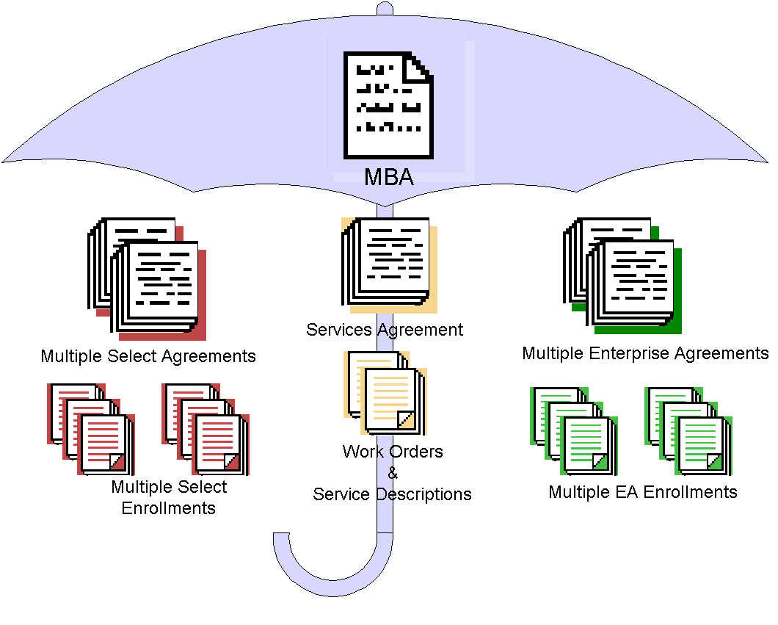

An Enterprise Subscription agreement cannot be initiated without an MBA, and an Enterprise Subscription enrollment cannot be initiated without an Enterprise Subscription agreement.

Price Levels
The total quantity of initial qualified desktops determines the initial price level for enterprise products and additional products. Price levels for subsequent years are determined by the qualified desktop count as of the date of the annual order.

Qualified desktop
The qualified desktop count reported at signing and at each Enterprise Subscription enrollment anniversary is used to determine the annual price level for the enterprise products and additional products (where additional products are in the same pool as enterprise products elected to license). EA Subscription customers are responsible for reporting the number of qualified desktops within the enterprise at each Enterprise Subscription enrollment anniversary.

Qualified desktops are the personal desktop computers, portable computers, workstations and similar devices, which are used by or for the benefit of an enrolled affiliate (including affiliates in the enterprise) and which meet the minimum requirements for running any of the enterprise products.

Qualified desktops do not include any computers designated for use as a server rather than used as a personal computer, any system dedicated to run only line-of-business software or any system running an embedded operating system (e.g. Windows 9.x for embedded or Windows XP embedded).

Customers who sign an Enterprise Subscription enrollment are referred to as an “enrolled affiliate.” An Enterprise Subscription enrollment is a standard option giving global companies greater flexibility in defining their enterprise. Each enterprise must consist of entire legal entities, not partial entities such as departments, divisions, or business units. Each affiliate must be entirely “in” or entirely “out.”

Example: This customer has 1,500 desktops in the defined enterprise. Of those desktops, 1,100 are running Windows 98, 200 desktops are running the Windows NT® and 200 desktops are dedicated servers. There are only 1,300 qualified desktops in this enterprise.
Unqualified
1,100 Desktops + 200 Desktops = 1,300 Qualified Desktops

Macintosh computers may also be enrolled in an EA Subscription.
1,500 MACs = 1,500 Qualified Desktops

Placing an Enterprise Agreement Subscription Order
Contact Microsoft to find a Microsoft Authorized Enterprise Software Advisor (ESA) or a Microsoft Authorized Large Account Reseller (LAR) to assist with the acquisition of licenses under the EA Subscription. For the Microsoft ESA or LAR nearest you, please refer to http://www.microsoft.com/licensing/howtoacquire.asp.

Product Fulfillment
Customized according to the languages and products selected on the Enterprise Subscription enrollment, the Welcome Kit and subsequent Update Kits offer convenience and access to a broad range of business software titles. The Welcome Kits and Update Kits are automatically provided to the contacts specified on each Enterprise Subscription enrollment. Additional CD-ROM kits may be ordered from the LAR for an additional charge.

Ordering CD-ROMs, Disks, and Documentation
Use the CD Kit User’s Guide website to manage the CD-ROM kit. Access these site features via the link on http://licensing.microsoft.com/.

Groupings and Color Codes
Product pools (Applications, Systems, and Servers) are divided into seven groupings and are color coded to make them easier to organize. The following chart shows the groups and colors.

Pool | Group | Color Code | Examples
Applications | Microsoft Office Family | Blue | Microsoft Office suites and individual applications such as Microsoft Project, Visio, etc.
Applications | Developer Tools | Gold | Visual Studio®, SQL Server Developer Edition, Office Developer, etc.
Applications | Training and Learning | Purple | MS Press titles (Step by Step, Mastering, Encarta, etc.
Applications | Products for Macintosh | Olive | Microsoft Office suites and individual applications for Macintosh.
Systems | Windows Client: Business | Green | Windows NT Workstation, Windows 2000 Professional, Windows XP Professional
Servers | Server Applications | Red | SNA Server, Proxy Server, Site Server, etc.
Servers | Windows Servers | Aqua | Windows 2000 Server and Windows NT Servers

Microsoft Volume Licensing Services Web site
Microsoft Volume Licensing Services online offers advances in software asset management. Information that traditionally has only been available in hard copy form is brought to your fingertips electronically. Microsoft Volume Licensing Services online offers secure, personalized access to details about Select License and EA agreement(s), including Volume License Product Keys, agreement status, and purchase order information. For more information, visit http://licensing.microsoft.com/.

Software Assurance benefit entitlements are also managed on the Microsoft Volume Services website.

Agreement Term and Renewal
Renewal Option
The initial term of the Enterprise Subscription enrollment is three years. Microsoft will notify the enrolled affiliate 60 days prior to the expiration of their initial Enterprise Subscription enrollment or renewal term advising them of their option to renew, allow the Enterprise Subscription enrollment to expire, or obtain perpetual licenses through the buy out option. If they decide to renew, they have the option to renew their Enterprise Subscription enrollment for one or three years.

Buy-Out Option
EA Subscription customers have the option to buy out their agreement within 60 days prior to the end of the initial Enterprise Subscription enrollment or renewal term.
The buy-out price for each product license will equal to 1.75 times the current annual price (or reference price) for that product as of the buy out order date. The price level for the buy out order will be the price level the enrolled affiliate qualified for as of the anniversary of the Enterprise Subscription enrollment effective date immediately preceding the applicable expiration date. The buy-out option requires the following:
- An order for the number of desktops and additional product copies added during the final year
- An order for the number of qualified desktops as of the date of the buy out order for each enterprise product and
- An order for the additional product copies the enrolled affiliate wishes to obtain.

Option to not Renew
If renewal of the Enterprise Subscription enrollment is not chosen, and the buy out option is not selected when the Enterprise Subscription enrollment expires, all products must be deleted from the enrolled desktops and the associated media must be destroyed.

Additional Resources
Microsoft offers a variety of information about the EA Subscription and other volume licensing programs on the Volume Licensing page of Microsoft’s web site. Please visit http://www.microsoft.com/licensing for additional resources.

The Enterprise Agreement Subscription Overview provides an overview of Enterprise Agreement Subscription and its features.

The Enterprise Agreement Subscription Program Comparison provides a snapshot of the differences between the Select License and other volume licensing programs.

The Microsoft Product List is used to determine which products are available through the Enterprise Agreement Subscription. The Microsoft Product List provides information specific to each product like product point values and product upgrade eligibility.

Frequently Asked Questions about volume licensing programs contain the most commonly asked questions and answers to those questions.

Volume Licensing Program Briefs are also available. These one page documents address specific "hot" licensing topics and follow a consistent format of topic discussion, related Questions & Answers, and the location of the specific licensing terms in the license agreements or product use rights.
Glossary
Agreement Term | A Microsoft Enterprise Subscription Enrollment initial term consists of 36 full calendar months from the Enterprise Subscription Enrollment effective date. So, if an enrolled affiliate’s effective date falls in the middle of the calendar month (for example January 20th), the agreement term will include a partial month (January 20th to January 31), plus the upcoming 36 months.
Customer | The company or entity signing an EA Subscription or EA Subscription enrollment.
Customer Affiliate | A company or legal entity which owns and controls, is owned and controlled by, or is under common ownership and control with, the customer signing an MBA, Enterprise Subscription Agreement or Enterprise Subscription Enrollment.
Effective Date | The agreement or enrollment start date. For an EA Subscription Agreement or enrollment this is the date the contracting Microsoft Affiliate signs the agreement or enrollment.
Enterprise Agreement | Enterprise Agreement refers to Microsoft’s volume licensing offering as described in the Enterprise Agreement Sales Reference Guide.
Enterprise Subscription Agreement | Enterprise Subscription Agreement refers to Microsoft’s volume licensing offering as described in the Enterprise Subscription Agreement Sales Reference Guide.
Enterprise Software Advisor (ESA) | An entity authorized by Microsoft and engaged by an enrolled affiliate to provide Enterprise Agreement pre and post-sales assistance.
Enrollment | A Microsoft document which allows qualifying affiliates to sign up for EA Subscription enrollment under an existing EA Subscription Agreement and acquire licenses for Microsoft products.
License | Any one of those offerings identified in the Product List (including standard licenses, and upgrades for desktop operating systems) that provides the right to run the version of the product for which it is ordered.
L&SA | See License & Software Assurance.
License & Software Assurance | Combines the License and Software Assurance under a single SKU.
Microsoft | The contracting Microsoft affiliate under a Microsoft Business Agreement, EA or enrollments and its affiliates.
Microsoft Business Agreement | The “MBA” agreement entered into at the beginning of a volume license relationship to cover common terms that do not have to be changed throughout the duration of the customer’s volume licensing relationship with Microsoft, or any time a new license agreement is signed. The term of the agreement is perpetual in order to reduce administration time spent in negotiating the same terms, and signing new agreements.
Pools | Microsoft products available through Volume Licensing programs are categorized as applications, systems, or servers products. Prices are established according to the volume levels acquired in each category or “pool,” also referred to as the applications pool, systems pool, and servers’ pool.
Product List | A document which identifies the Microsoft products that are available or may be available under the volume licensing programs and any product-specific conditions or limitations on the acquisition of licenses for those products
Renewal Period | The one or three year period after the expiration of the initial term of the EA Subscription Enrollment.
SA | See Software Assurance.
Sales Support Partners | In this document, sales support partners refers collectively to Enterprise Software Advisors (ESAs), distributors, and other resellers who are qualified to provide pre- and post-sales assistance for or sell Microsoft products through Microsoft’s Select, Enterprise Agreement or Enterprise Subscription Agreement licensing programs.
Select | Select refers to Microsoft volume licensing offerings including the Select license option as described in the Select License Sales Reference Guide.
Select Agreement | A legally binding Microsoft agreement signed by the customer and Microsoft which allows customers to license Microsoft products at discount prices based on the volume of their license purchases during a three-year period.
Software Assurance (SA) | Provides the right to run the latest version of licensed product and the ability to spread payments annually. Also includes tools, support, training, and other benefits.

