

Customer Guide

A reference guide to the Microsoft Enterprise Agreement software licensing program including:
- Program Benefits
- Purchase Options
- How to Begin

Table of Contents
Enterprise Agreement Introduction 4
Enterprise Agreement Benefits 4
Enterprise Agreement Overview 4
Enterprise Agreement Program Features 5
Enterprise Products 5
Additional Products 6
Software Assurance in Enterprise Agreement 6
Software Assurance Renewal 6
Agreement Term 7
Annual Price Per Desktop 7
True Up 7
Additional Value-Adds 7
Agreement Structure 8
Price Levels 9
Qualified desktop 9
Placing an Enterprise Agreement Order 10
Product Fulfillment 10
Ordering CD-ROMs, Disks, and Documentation 10
Groupings and Color Codes 10
Microsoft Volume Licensing Services Website 11
Agreement Renewal 11
Additional Resources 11
Glossary 12

© 2005 Microsoft Corporation. All rights reserved.
This document is for informational purposes only. MICROSOFT MAKES NO WARRANTIES, EXPRESS OR IMPLIED, IN THIS SUMMARY.
Microsoft, FrontPage, InfoPath, OneNote, Outlook, PowerPoint, SharePoint, Visio, Visual Studio, Windows, and Windows NT are either registered trademarks or trademarks of Microsoft Corporation in the United States and/or other countries. The names of actual companies and products mentioned herein may be the trademarks of their respective owners.

Enterprise Agreement Introduction
The Enterprise Agreement offers simplicity in the face of today’s complex business software environment. Designed for businesses who implement enterprise wide standards to enhance business productivity, the Enterprise Agreement provides a framework for making software license acquisitions and management easier for businesses with as few as 250 desktops.

Enterprise Agreement Benefits
Get more through Software Assurance. Get more value, more manageability, and more assistance from your technology investments through Software Assurance. Software Assurance can help you get the most value from up-to-date technology with several key benefits that can save time, money, and help deploy software more efficiently.
Build a flexible infrastructure. An Enterprise Agreement helps an organization more easily build and maintain its infrastructure so it can respond rapidly to changing business needs.
Drive standardization throughout the enterprise. An Enterprise Agreement can help a company more successfully use standards to reduce the cost of computing.
Ensure compliance. The Enterprise Agreement significantly reduces the administration required to show compliance on enrolled enterprise products, thereby mitigating the associated legal risk.
Simplify license administration and budgeting. An Enterprise Agreement helps streamline the administration and budgeting processes while improving the accuracy of business planning.

Enterprise Agreement Overview
Businesses with a minimum of 250 desktops that wish to license 100% of their qualified desktops for a three-year period can initiate an Enterprise Agreement. The Enterprise Agreement offers:
- Software Assurance provides a powerful combination of benefits that include new version rights, the Home Use Program, and many other advantages including support, tools, and training, your company can gain the flexibility it needs to keep your business edge.
- Selection of enterprise products, including Office Professional, Microsoft Windows® operating system upgrades, and the Core CAL (each product described in detail on next page).
- Additional products offer a broad selection of Microsoft business software products. Examples of products offered as additional products include Microsoft Office Visio®, Microsoft Office Project, Windows servers, and Exchange servers.
- A fixed, annual price per desktop for enterprise products based on the initial number of desktops enrolled.
- Annual True Up allows businesses to run software on desktops as they are acquired, then pay a predetermined price for the software licenses annually for the remaining term of the enrollment.
- Equal, annual payments for a three-year enrollment term, with a renewal option of one year or three years.

Enterprise Agreement Program Features
Enterprise Products
The Enterprise Agreement offers businesses access to the most recent releases of the Enterprise Desktop Professional Platform Products. The Enterprise Desktop Professional Platform Products are:
- Windows Desktop Operating System upgrade; (this can be either the upgrade to Windows 2000 Professional or Windows XP Professional)
- Microsoft Office Professional (The current version includes Microsoft Office Word, Microsoft Office Excel, Microsoft Office PowerPoint®, and Microsoft Outlook® messaging and collaboration client, and Microsoft Access)
- Microsoft Core Client Access License (The current version consists of Client Access Licenses (CALs) for Windows Server 2003, SharePoint® Portal Server 2003, Microsoft Exchange 2003 Server, and Systems Management Server 2003). The Core CAL is a way to conveniently cover and manage CALs for certain basic server components across all licensed desktops within the firewall. The Core CAL reduces the complexity for the IT professional in managing client access licenses for server products.

Why consider enrolling the full Enterprise Desktop Professional Platform?
Businesses benefit from building both simplicity and flexibility into their information technology infrastructure. For many companies, the first step toward achieving this is to adopt the Microsoft platform as the core of its software infrastructure.

The Enterprise Platform offers products that are integrated and optimized. Microsoft products are optimized to work well together in a seamless, integrated fashion. For example, a common programming model is used to improve information sharing between applications.

The full platform leverages a consistent interface for users, developers, and administrators that improves productivity and reduces costs. Common commands, menus, windows, and interchange models improve training and development.

Strong vendor and developer support offered by both Microsoft and our partners for business applications increases business flexibility.

New customers who enroll in the Enterprise Platform (Windows desktops operating system upgrade, Office Professional, and Core CAL) receive a 15% platform discount.

Microsoft has a track record as being one of the largest investors in research and development for new product improvements. Additionally, there is a broad developer and ISV base that is focused on developing applications that are supported by the Enterprise Desktop Professional Platform.

Additional Products
A broad selection of software titles is available as additional products. They provide the same License & Software Assurance coverage as enterprise products, but do not require an enterprise wide commitment. For products licensed at signing, payments can be spread over three years in the same way that enterprise product payments are annualized. Spreading the cost of software licenses over three years can enable businesses to refocus critical IT budget and provide a predictable framework for budgeting purposes.

Examples of products available as additional products include Visio, Project, and Windows Servers and Exchange Servers. A complete list of additional products is available on the Microsoft Product List, which is referenced in the “Additional Resources” section of this guide.

Software Assurance in Enterprise Agreement
Software Assurance is a feature within the Enterprise Agreement to help you get the most value from up-to-date technology with several key benefits that can save time and money. With Software Assurance’s powerful combination of productivity benefits, support, tools, and training, your company can gain the flexibility it needs to keep your business edge.

Having Software Assurance in place across an entire enterprise can reduce the amount of valuable time spent tracking multiple versions of software. Additionally, it may promote more expedient execution of business solutions due to the reduced need for ongoing management approval to finance new software licenses. For more information about Software Assurance benefits, please visit http://www.microsoft.com/licensing.

Software Assurance Renewal
To ensure the continued benefits provided by SA, all SA covered products must be renewed within thirty days of an Enterprise enrollment expiration. If transitioning from a pre-6.0 Enterprise enrollment, see the Product List for the required timeframe to enroll those products covered under that Enterprise enrollment.

To learn more about Software Assurance, visit http://www.microsoft.com/licensing/programs/sa/.

Agreement Term
The three year enrollment term and one or three year renewal options provide businesses with a defined window of time for which the terms and prices of their purchasing relationship with Microsoft will remain consistent. This enhances a business’ ability to plan and budget for software license purchases up to three years in advance, which reduces annual budget restrictions and fiscal year spending challenges.

Annual Price Per Desktop
The Annual Price Per Desktop feature provides a predictable budgeting framework that can be used to determine desktop technology costs up to three years in advance.

A payment (based on the pre-established price per desktop), is due each year at the anniversary date of the Enterprise enrollment. Because the software licenses are paid for once annually, the costs normally associated with software license acquisition are reduced. In many cases, the numbers of software license purchase orders made annually are minimized from hundreds to two or three total. The pre-determined price paid for software licenses protects software budget from unanticipated price increases.

True Up
During the Enterprise enrollment term, it is plausible that desktops will be added to the enterprise. When this occurs, those added desktops immediately receive the same license coverage as the desktops enrolled at the beginning of the enrollment. These added desktops are then reported through a once annual process called “True Up”. True Up consolidates orders for new software licenses as one order annually.

The annual True Up feature helps reduce time and expense attributed to processing multiple software purchase orders.

Additional Value-Adds
Take advantage of these additional features in the Enterprise Agreement to help boost the value received by participating in the program:

Commitment on Use Rights provide Enterprise Agreement customers the security of knowing exactly what the use rights are for the products they license under their Enterprise enrollment. Microsoft agrees not to change product use rights for any version of a product after it becomes available. Furthermore, we make a commitment that we will not change use rights for enterprise products during the term of an enrollment to be more restrictive or to the customers’ detriment (this commitment does not relate to new features and functionality).

Training and Evaluation Licenses helps budget for software training and evaluation purposes go farther by offering a limited number of complimentary training and evaluation copies of any additional product.
- 20 copies per software title for use in dedicated training facility, and
- 10 copies per software title for 60-day evaluation

Downgrade Rights provide businesses with version standardization considerations the flexibility necessary to purchase the latest software version available, but run a previous version.

Re-Imaging Rights allow the use of certain software media for re-imaging to provide added convenience during product rollouts.

Secondary Use Rights allow employees to be more productive by sharing the same application license for any additional product on a work PC as well as a portable PC for work-related purposes only.

NOTE: For full details, please reference the 6.0 Enterprise agreement.

Agreement Structure
The laborious process of negotiating terms and conditions common to multiple agreements is streamlined through Microsoft’s volume licensing agreement structure.

A perpetual Microsoft Business Agreement (MBA) defines general terms and conditions common to the Enterprise Agreement, Enterprise Subscription Agreement, Select License, and Microsoft Services Agreements. A separate license or services agreement is signed to cover the specific terms of the Enterprise Agreement, Enterprise Subscription Agreement, Select License, or Services programs. This structure allows for flexible contract maintenance in the renewing of contracts and licensing Microsoft products. A key benefit to this structure is that the contract terms common to Microsoft licensing, service, and support agreements are signed once.

Microsoft Business Agreement (MBA) is a perpetual agreement between the customer and Microsoft. It contains high-level terms and conditions that are applicable to all agreements signed under it. Terms and conditions such as use and ownership, confidentiality, warranties, and others can be found in the MBA. It must be signed either in conjunction with or prior to the Enterprise agreement.

The Enterprise agreement defines the terms for enterprise and additional product license acquisitions, subsequent orders, true up, and perpetual rights.

The Enterprise enrollment establishes the basic information that allows your business to buy product licenses under the Enterprise Agreement. It defines purchase details like the term of the licensing arrangement, products, prices, and Enterprise Service Advisor (or Large Account Reseller, where applicable).

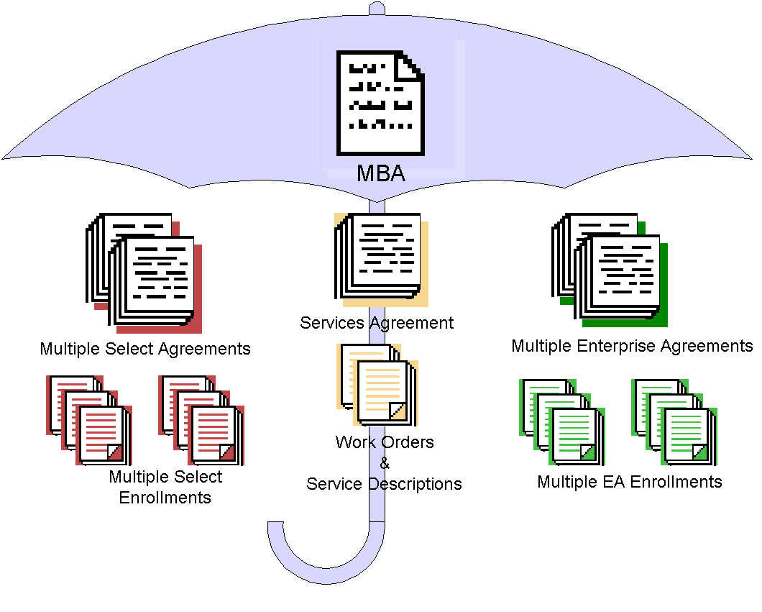

An Enterprise agreement cannot be initiated without an MBA, and an Enterprise enrollment cannot be initiated without an Enterprise agreement.

Price Levels
The total quantity of initial qualified desktops determines the price level of enterprise products.

Qualified desktop
As part of an enrollment, Enterprise Agreement customers are responsible for reporting the number of qualified desktops within their enterprise. This number is the quantity indicated on the initial order at signing along with any additional desktops added through the True Up process. Qualified desktops are the personal desktop computers, portable computers, workstations and similar devices, which are used by or for the benefit of an enrolled affiliate (including affiliates in the enterprise) and which meet the minimum requirements for running any of the enterprise products.

Customers who sign an Enterprise enrollment are referred to as an “enrolled affiliate.” An enrollment is a standard option giving global companies greater flexibility in defining their enterprise. Each enterprise must consist of entire legal entities, not partial entities such as departments, divisions, or business units. Each affiliate must be entirely “in” or entirely “out.”

Qualified desktops do not include any computers designated for use as a server rather than used as a personal computer, any system dedicated to run only line-of-business software or any system running an embedded operating system (e.g. Windows 9.x for embedded or Windows XP embedded).

Example: This customer has 1,500 desktops in the defined enterprise. Of those desktops, 1,100 are running Windows 98, 200 desktops are running the Windows NT® and 200 desktops are dedicated servers. There are only 1,300 qualified desktops in this enterprise.
Unqualified
1,100 Desktops + 200 Desktops = 1,300 Qualified Desktops

Macintosh computers may also be enrolled in an Enterprise Agreement.
1,500 MACs = 1,500 Qualified Desktops

Placing an Enterprise Agreement Order
Contact Microsoft to find a Microsoft Authorized Enterprise Software Advisor (ESA) or a Microsoft Authorized Large Account Reseller (LAR) to assist with the acquisition of licenses under the Enterprise Agreement. For the Microsoft ESA or LAR nearest you, please refer to http://www.microsoft.com/products/info/render.aspx?view=22&type=mnp&content=22/licensing.

Product Fulfillment
Customized according to the languages and products selected on the Enterprise enrollment, the Welcome Kit and subsequent Update Kits offer convenience and access to a broad range of business software titles. The Welcome Kits and Update Kits are automatically provided to the contacts specified on each Enterprise enrollment. Additional CD-ROM kits may be ordered from the LAR for an additional charge.

Ordering CD-ROMs, Disks, and Documentation
Use the CD Kit User’s Guide website to manage the CD-ROM kit. Access these site features via the link on http://licensing.microsoft.com/.

Groupings and Color Codes
Product pools (Applications, Systems, and Servers) are divided into seven groupings and are color coded to make them easier to organize. The following chart shows the groups and colors.

Pool | Group | Color Code | Examples
Applications | Microsoft Office Family | Blue | Microsoft Office suites and individual applications such as Microsoft Project, Visio, etc.
Applications | Developer Tools | Gold | Visual Studio®, SQL Server Developer Edition, Office Developer, etc.
Applications | Training and Learning | Purple | MS Press titles (Step by Step, Mastering, Encarta, etc.
Applications | Products for Macintosh | Olive | Microsoft Office suites and individual applications for Macintosh.
Systems | Windows Client: Business | Green | Windows NT Workstation, Windows 2000 Professional, Windows XP Professional
Servers | Server Applications | Red | SNA Server, Proxy Server, Site Server, etc.
Servers | Windows Servers | Aqua | Windows 2000 Server and Windows NT Servers

Microsoft Volume Licensing Services Website
Microsoft Volume Licensing Services online offers advances in software asset management. Information that traditionally has only been available in hard copy form is brought to your fingertips electronically. Microsoft Volume Licensing Services online offers secure, personalized access to details about Select License and EA agreement(s), including Volume License Product Keys, agreement status, and purchase order information. For more information, visit http://licensing.microsoft.com/.

Software Assurance benefit entitlements are also managed on the Microsoft Volume Services website.

Agreement Renewal
The initial term of the Enterprise enrollment is three years. At the end of the third year, the Enterprise enrollment may be renewed (upon mutual agreement) for one or three year terms continuously. Renewal pricing for existing desktops is based on Software Assurance only. Contact your ESA or LAR for additional information.

Additional Resources
Microsoft offers a variety of information about the Enterprise Agreement and other volume licensing programs on the Volume Licensing page of Microsoft’s Web site. Please visit http://www.microsoft.com/licensing for additional resources.

Glossary
Affiliate | A company or legal entity which owns and controls, is owned and controlled by, or is under common ownership and control with, the customer signing an MBA.
Effective Date | The agreement or enrollment start date.
Enterprise Agreement | Enterprise Agreement refers to Microsoft’s volume licensing offering that gives customers that wish to license one or more of Microsoft’s platform products across their enterprise the means to ensure that their entire enterprise will be licensed.
Enterprise Software Advisor (ESA) | An entity authorized by Microsoft and engaged by an enrolled affiliate to provide Enterprise Agreement pre and post-sales assistance.
Enrollment | A Microsoft document which allows qualifying affiliates to sign up for enterprise enrollment under an existing EA and acquire licenses for Microsoft products.
License | Any one of those offerings identified in the Product List (including standard licenses, and upgrades for desktop operating systems) that provides the right to run the version of the product for which it is ordered.
L&SA | See License & Software Assurance.
License & Software Assurance | Combines the License and Software Assurance under a single SKU.
Microsoft | The contracting Microsoft affiliate under a Microsoft Business Agreement, EA or enrollments and its affiliates.
Pools | Microsoft products available through Volume Licensing programs are categorized as applications, systems, or servers products. Prices are established according to the volume levels acquired in each category or “pool,” also referred to as the applications pool, systems pool, and servers’ pool.
Product List | A document which identifies the Microsoft products that are available or may be available under the volume licensing programs and any product-specific conditions or limitations on the acquisition of licenses for those products.
Renewal Period | The one or three year period after the expiration of the original term of the EA enrollment.
SA | See Software Assurance.
Select | Select refers to Microsoft volume licensing offerings including the Select license option as described in the Select License Customer Guide.
Select Agreement | A legally binding Microsoft agreement signed by the customer and Microsoft which allows customers to license Microsoft products at discount prices based on the volume of their license purchases over a three-year period.
Software Assurance (SA) | Provides the right to run the latest version of licensed product and the ability to spread payments annually. Also includes tools, support, training, and other benefits.

