
Currency Manager

Microsoft Dynamics™ SL

Benefits
- Manage currencies easily
View transactions and balances in
The currency you need when you need it. Currency-related processing and reporting capabilities are integrated with other Microsoft Dynamics SL modules, including General Ledger, Accounts Payable, Accounts Receivable, Order Management, Purchasing, and Cash Manager.

- Increase your options
Work with an unlimited number and
combination of currencies and rate types and associate multiple exchange rates with a particular currency and effective date. This allows you to maintain historical rates, use average rates for planning exercises, and use spot rates for monthly reporting.

- Customize your setup
Adapt currency processing to your
company’s needs, define multi-currency
data entry and processing rules, establish a central location for account revaluation, and process unrealized gains and losses.

- Ease data entry and viewing
Use the readily available currency selection button to switch currencies while in a data entry screen. View the transaction currency and your local currency at a detail level, and view the general ledger account balances in the local currency or any other currency you wish.

Conduct global business easily, whether your company uses a single currency with plans to expand or already operates with multiple currencies. Integrate transaction processing across Microsoft Dynamics SL to track exchange rate fluctuations, determine possible gains and losses when making payments in another currency, and maximize multi-national business profits.

Work
with an unlimited number and combination of currencies and rate types.

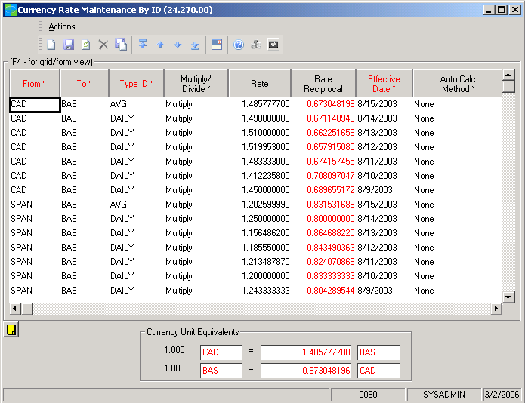

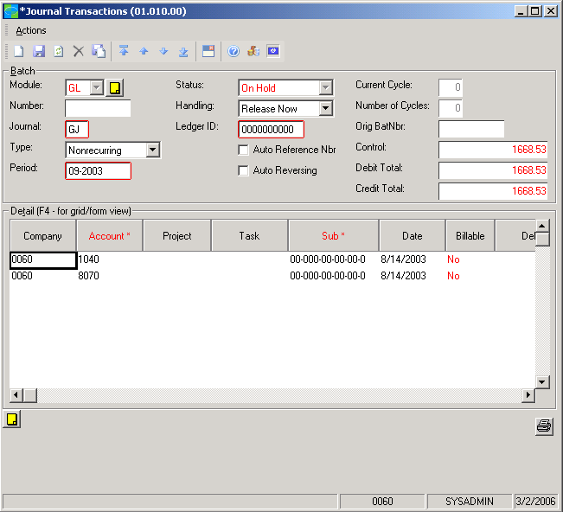

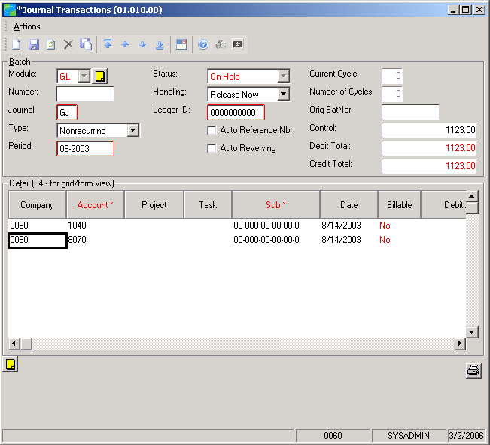

View
the transaction currency and your local currency at a detailed level.

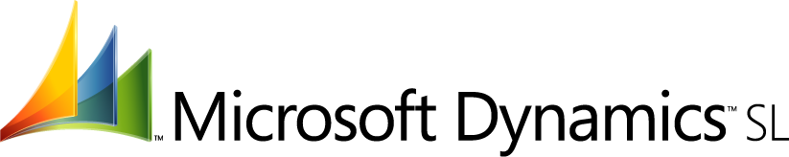

Integrated Transaction Processing  features  BENEFITS | Report financials in multiple currencies through tight integration with Microsoft Dynamics SL Financial Statement Translation to automate the steps needed to accurately reflect your business operations in another currency.
Customizable Setup | Define default rate types, vendor and customer currency defaults, currency  effective dates, and the level of currency validation that is used during data entry.
Intuitive Interface | Simply click the Select Currency toolbar button to change currency and rate  details, or use the Change Currency View button to shift between a transaction  currency and your local currency for a particular field amount.
Account Revaluation | Perform non-local currency account revaluations to calculate the gain or loss  taken due to currency rate fluctuations.
Unlimited Currencies | Record payables and receivables in any currency or make partial payments in multiple currencies.
Easy Calculation and Tracking | Automatically calculate realized gains/losses and post them to user- defined  accounts, giving you the ability to track and report them at any time.
Multiple Currencies, Rates and Transactions | Maintain several currencies and different rates for each. Enter currency rate values, currency IDs, captions, symbols, and descriptions. Work easily with an unlimited number of currencies for each customer and vendor transaction.
Customizable Interface | Associate a button image with each currency. The images you select appear on the toolbar when you shift amount fields between transaction and domestic currencies.
Flexible Process Handling | Capitalize on integration with other Microsoft Dynamics SL financial management modules. Process payment vouchers, purchase orders, sales orders, invoices, and other transactions in any number of foreign currencies.
Routine Calculation | Identify certain accounts as foreign currency accounts for automatic calculation  of the domestic currency amount — for every transaction entered in a foreign  currency.
Process Automation | Automatically calculate each currency’s revaluation gains and losses, adjust  general ledger entries, and reclassify unrealized gain/loss general ledger batches  after a period close.

For more information about Microsoft Dynamics™ SL, visit: http://www.microsoft.com/dynamics/sl

This document is for information purposes only.
MICROSOFT MAKES NO WARRANTIES, EXPRESS, IMPLIED, OR STATUTORY, AS TO THE INFORMATION IN THIS DOCUMENT.

© 2005 Microsoft Corporation. All rights reserved.
Microsoft, The Microsoft Dynamics Logo, are either registered trademarks or trademarks of Microsoft Corporation or Microsoft Business Solutions ApS in the United States and/or other countries. Microsoft Business Solutions ApS is a subsidiary of Microsoft Corporation.

