Microsoft® Office InfoPath™

Reviewers Supplement

March 2003

For more information, press only:
Catherine Brooker
Waggener Edstrom
(425) 638-7000
catherineb@wagged.com

Umran Hasan
Waggener Edstrom
(503) 443-7000
umranh@wagged.com

Rapid Response Team
Waggener Edstrom
(503) 443-7000
rrt@wagged.com

The information contained in this document represents the current view of Microsoft Corp. on the issues discussed as of the date of publication. Because Microsoft must respond to changing market conditions, it should not be interpreted to be a commitment on the part of Microsoft, and Microsoft cannot guarantee the accuracy of any information presented after the date of publication.

This document is for informational purposes only. MICROSOFT MAKES NO WARRANTIES, EXPRESS OR IMPLIED, IN THIS DOCUMENT.

© 2003 Microsoft Corp. All rights reserved.

Microsoft, InfoPath, Windows, SharePoint, BizTalk, ActiveX and IntelliMouse are either registered trademarks or trademarks of Microsoft Corp. in the United States and/or other countries.
The names of actual companies and products mentioned herein may be the trademarks of their respective owners.

Contents
Introduction 1
Design Goals for InfoPath 2
The Advantages of InfoPath Over Existing Approaches 4
Key Features 5
InfoPath in Practice 6
Using an InfoPath Form 6
Sharing and Reusing Business Information 10
Self-Contained Solutions 12
Multiple Views of Information 12
Creating an InfoPath Form Template 13
Repeating Sections 16
Connecting the Form to a Database via ADO 17
Conditional Formatting and Data Validation 19
Adding Color to the Form 19
InfoPath and Windows SharePoint Services 20
Property Promotion 21
Merging InfoPath Forms on SharePoint 23
Using InfoPath With XML Web Services 25
Querying Against a Web Service 26
Top-Line System Requirements 28

Introduction
Welcome to the reviewers supplement for the Microsoft® Office InfoPath™ information-gathering program, a new member of the Microsoft Office system of products.
Today’s organizations create and use massive amounts of information, from sales figures to performance appraisals to purchase orders. Many information workers collect that information via inefficient processes such as paper forms, or electronically through documents, spreadsheets and e-mail. Some companies have built custom, in-house applications using Web-based or proprietary tools.
Because of the difficulty of extracting and reusing information from these applications or tools, information workers often must retype information, leading to data-entry errors and inefficient business processes. Moreover, managers are often unable to make informed decisions because the information they need is trapped within documents or databases in another part of the organization.
Technologies such as Extensible Markup Language (XML) Web services have been helpful in improving business processes from server to server, but to date they have not been connected directly to information workers at their desktops, meaning that information workers have not had a way to interact with XML Web services directly, or to access and use the enterprise information they need.

Design Goals for InfoPath
InfoPath is meant to streamline the process of gathering business information and make it easy to reuse that information throughout the organization. InfoPath was designed to be the “premier smart client” for XML Web services — a user-friendly application that enables information workers at their desktops to access and use enterprise information through XML Web services, helping them gather and share information across a wide range of formal and informal business processes. InfoPath provides a high level of flexibility so that companies can integrate its capabilities with their unique business needs.
InfoPath was created to provide users with an information-gathering solution that would enable them to accomplish the following:
- Gather information efficiently and accurately
- Manage information flexibly
- Share information across business processes
- Take advantage of existing IT investments and skills
By enabling the creation of dynamic business forms that interact natively with any XSD-based XML schema, as well as with XML Web services, InfoPath allows workers to easily integrate the information they create and consume daily into the organization’s back-end databases and servers. This means that any information gathered with InfoPath can be reused and repurposed by anyone or any process in the organization, which greatly increases the productivity and power of that information.
InfoPath supports business processes in three key ways:
- The creation of dynamic forms. InfoPath provides a robust, flexible, easy-to-use design tool that enables the creation of dynamic forms that information workers can use to gather information.
- The completion of these forms. The same rich InfoPath client also provides an application environment in which information workers can complete forms quickly and easily.
- The ability to incorporate data entered into these forms directly into business systems and processes. Through its support of XML, customer-defined schemas and XML Web services, InfoPath enables workers to connect the information gathered in InfoPath forms to organizational business processes and makes that information easy to reuse.
Before InfoPath, salespeople returning from a business trip might have filed a trip report using Microsoft Word, entered new sales figures and pricing into a CRM or ERP application as a separate task, and completed an expense report using a custom-developed Microsoft Excel solution. They would have needed to enter the same information — client contact information, sales figures, pricing — multiple times, in different applications that do not share or cross-validate that information. The information within one business process, such as the trip reports in Word, would be difficult to reuse in the other business processes without manually re-entering it.
InfoPath was designed to improve this error-prone and inefficient process. Using the powerful design tools in InfoPath, a form designer can quickly and easily create a trip report form for the sales force. Because InfoPath enables users to work with forms offline, they can complete an entire trip form on the road and submit the completed form as soon as they reconnect with the corporate network.
The information submitted in an InfoPath form can be passed directly into a company’s business processes via XML and XML-based Web services into CRM and ERP systems as well as other back-end systems, providing organizations with a robust tool to aid in purchase order creation, fulfillment, shipping and customer shipment notification.
Finally, InfoPath is a valuable tool for the team’s informal processes, because the sales manager can use InfoPath with Microsoft Windows® SharePoint™ Services (STS) to review the entire sales team’s reports in one convenient summary view.
Information gathered through InfoPath can be stored directly in a database, on a Web server or file share, or on a server running STS. From there, the information could be analyzed or easily repurposed, reducing or eliminating the need to retype the information as it is used in different documents or transactions. InfoPath provides individuals and organizations with more flexibility than is available in current digital formats, enabling a level of interapplication and interprocess integration that has never been so easy to achieve.

The Advantages of InfoPath Over Existing Approaches
As a method of gathering information and integrating it with business processes, InfoPath provides numerous advantages over paper forms, text documents, Web forms and custom-built solutions:
- Improved efficiency. Information collected in an InfoPath form can be submitted directly to a Web service, a URL, a database or similar destination — no rekeying of information is required.
- Validation. InfoPath validates user input according to rules created by the form designer, and the form will alert users immediately when input does not appear valid.
- Reusabilty. The information collected in a single InfoPath form can be used by many systems and processes, because the information is stored as XML. Moreover, InfoPath communicates with ADO databases and XML Web services bidirectionally, enabling the information stored in databases and servers to populate fields within InfoPath forms. This increases the speed and accuracy of filling out forms.
- Rich, flexible authoring environment. InfoPath forms support richly formatted data, including information formatted with boldface, italics and underlined fonts, information formatted in a variety of list and tabular formats, and information that takes the form of a graphic or picture, all of which can be bound to the XML schema for easy reuse throughout the organization. InfoPath also provides built-in spelling checker support.
- Rapid response to change. InfoPath forms can be updated, revised and made available for use quickly.
- Connection to business processes. Because InfoPath relies on an underlying XML schema that can be recognized by different business systems and processes, the information captured in a single InfoPath form can be easily shared within the organization.
- Flexibility. InfoPath enables users to begin working on a form and save the incomplete form for later completion and submission. InfoPath forms can even be completed offline and submitted when the user is later connected to the network. Because InfoPath provides the ability to work offline, users no longer have to worry about losing their information and are free to work at their own pace.
- Deployment. InfoPath provides instant access to both a design and form completion environment that can be tailored quickly to meet the needs of the entire organization. As a member of the Microsoft Office system of products, InfoPath builds on users’ familiarity with the conventions of Microsoft Office and the Office application interface. The application can also receive automatic updates and patches from Microsoft. Microsoft support is also available, so there is always a source for answers to questions.
- Increased productivity. InfoPath provides a design environment that facilitates the rapid creation and modification of forms, which in turn ensures that forms are always ready to capture the information required by the organization.
The bottom line? Today, InfoPath is the only application that provides all the capabilities for structured document creation and editing in a single, easy-to-use package. Some products allow rich text editing with flat structures, while others provide repeated structure with little rich text editing. Most products require users to write code or possess advanced XML knowledge to build or even fill out forms. InfoPath is the only application that combines all the necessary features into a single, easy-to-use product that empowers information workers of all skill levels.

Key Features
InfoPath provides a wealth of functionality and features to help information workers capture and reuse business information. Discussed in more detail in the accompanying product guide, the following are some highlights:
- Familiar Office-like environment for editing forms. InfoPath provides a Microsoft Office-like environment in which users can fill out forms while the XML code is created behind the scenes. This allows users to work with structured documents without needing to know XML.
- WYSIWYG design mode. The InfoPath design mode makes it easy to customize existing forms or build a custom form from scratch using customer-defined XML schemas. It provides a view of the underlying XML schema, drag-and-drop insertion of controls, content modeling and editing, data validation, an interactive preview so users will know exactly how the form will behave and look when it is being filled out, and a publishing wizard that simplifies form deployment.
- Rich offline functionality. InfoPath is designed to allow users to save forms to their desktops and work offline without any loss in functionality. Data validation rules, for example, are built into the form so users working offline will be alerted to potential errors the same way they would be if they were working online.
- Sample forms. InfoPath provides 25 sample forms that are ready for immediate use or, in the design mode, can be customized to suit a specific business need. In addition, InfoPath provides sample forms and resources for developers and demonstrates how to integrate the forms into various business processes.
- Programmability. For programmers who prefer to write and edit their own script, InfoPath includes a script editor, object model, editing controls and a clear-text XML format for various form files to aid developers in designing views, adding custom scripting, controlling the runtime behavior, and integrating custom forms directly with a server or Web service.
- Compatibility. InfoPath can work with BizTalk® Server and Internet Information Services (IIS) or Microsoft SQL Server™ through ASP.NET. InfoPath can also use the ActiveX® Data Objects (ADO) interface to talk directly to SQL or other data sources such as Microsoft Access. InfoPath can also save XML to a SharePoint Team Services site. In addition, because InfoPath works natively with XML, using XML Web services, it can be connected to any XML-enabled back end, such as Oracle, DB2 or Siebel.
- Information validation and conditional formatting. InfoPath forms can be set to validate entered information against parameters set by the designer and alert users to irregularities through formatting differences such as font-color changes and dialog boxes.

InfoPath in Practice
InfoPath streamlines the process of gathering information by enabling teams and organizations to easily create and work with rich, dynamic forms. Because InfoPath outputs well-formed XML, the information submitted can be understood by any XML-enabled back-end system and can therefore be reused, reaggregated and repurposed throughout the company.
An expense report, for example, might open with a set of boilerplate employee information, a list of itemized expenses, and a text box for writing in additional expense items or adding notes. In healthcare, an InfoPath health insurance claim form could be created, which may have several paragraphs of optional text, or a varying number of procedures requiring multiple supplies. InfoPath provides the rich authoring environment of Microsoft Office, including the ability to include such things as graphics, charts, bulleted lists and formatted text. Whatever unique business process is being addressed, InfoPath provides the flexibility to capture and reuse information within whatever structure is needed.
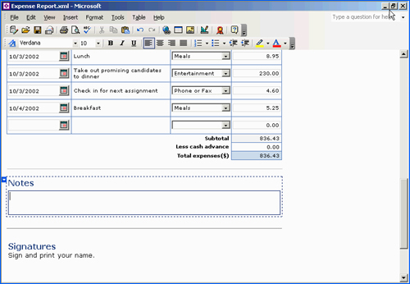
An expense report might be created containing employee information and a list of itemized expenses that can be selected.

Using an InfoPath Form
InfoPath forms are dynamic and can link to back-end systems bidirectionally. This means that information entered into the form by employees can be submitted to the back-end systems and that the systems can be used to prepopulate entries on the form or validate data as it is entered.
A form reporting on a sales call, for instance, might contain general information to input about the day, the salesperson and so on, as well as customer-specific information such as the company, the sales made and any comments about what was observed during the sales call. Based on business logic, the period, year and date can be automatically filled in, and support for auto-completion helps reduce the amount of information that needs to be manually entered, which helps avoid errors. Items such as telephone numbers and e-mail addresses can be automatically populated from back-end data repositories including databases that support ADO, an XML file, or an XML Web service.
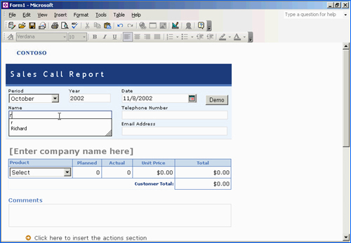
InfoPath supports Auto-Complete, spell checking and other user aids, helping ensure accuracy and making data entry easier for employees in the field. In addition, an ADO connection to a company database can be set up to automatically enter telephone numbers, e-mail addresses and other information into the form.

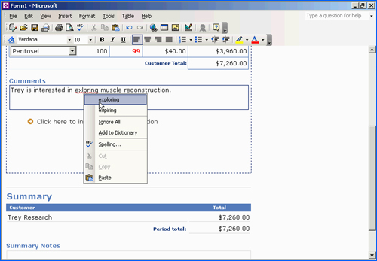
InfoPath forms support the rich formatting and composition options of other Office applications, so users can enter bulleted lists and other formatted text, with the benefit of spell-checking running in the background. As with other Office applications, a right-click helps users quickly correct mistakes.

InfoPath can also use information from back-end systems to validate entered data within certain parameters. Support for “conditional formatting” allows InfoPath form designers to set different formatting to highlight entries that fall outside maximum or minimum thresholds, indicating that the information doesn’t meet the validation rules for a specific field. A dialog box can also be created to alert users to the required threshold.
This feature is made possible via a live connection between InfoPath and an XML Web service or back-end database. The InfoPath form provides a threshold, such as the minimum price for products sold by the company. These parameters can also be updated dynamically by the database or Web service. When the price entered by the user doesn’t meet the minimum defined by the InfoPath form or XML Web service, InfoPath invokes the conditional formatting set by the form designer to alert the user that the data isn’t valid.
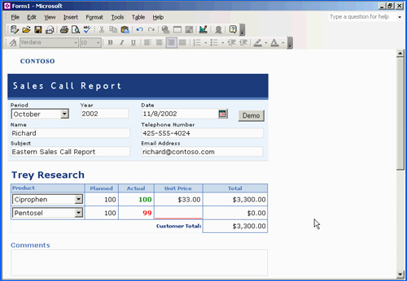
Support for conditional formatting allows the creation of forms that visually alert users to entries that are invalid or irregular, in this case highlighting the fact that an entered sales price falls below the minimum threshold.

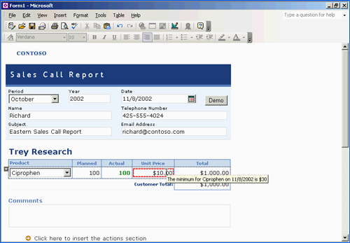
Once the data is corrected to within the established parameters, the conditional formatting disappears.
Need to add another customer or additional comments? InfoPath forms can also include optional sections for comments, action items, dates or other bits of information. Conditional formatting can also be applied to entire sections within InfoPath, changing an action item designated as high priority to red, for example.

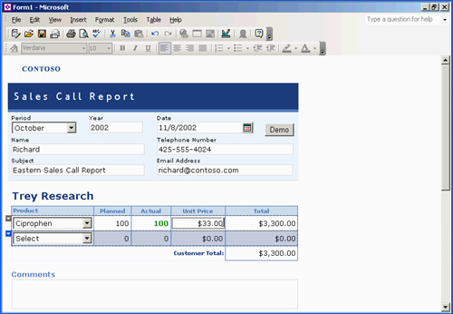
Conditional formatting can be applied to individual entries or entire sections, helping users prioritize and alerting them to irregularities.

Sharing and Reusing Business Information
When a user submits data in the InfoPath form, that information can be sent to an application server such as Microsoft BizTalk Server or any server that supports Web protocols such as XML, HTTP or SOAP, to be reused, reaggregated and repurposed throughout the company.

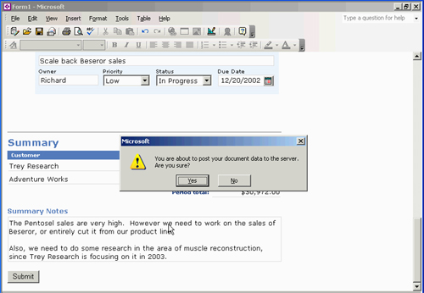
By submitting an InfoPath form, XML data is transmitted to the company’s back-end application server, where the information can be reused across the company.

For instance, the company’s BizTalk Server may have a triggered event set up to generate and distribute an InfoPath form containing all sales activity for the past 24 hours. It sends this report to all interested parties via e-mail. The e-mail attachment is an XML file, which opens in InfoPath to display the combined information for all team members — all sales, action items and summary comments submitted over the past 24 hours. With InfoPath, this attachment is more than just a report — it’s an active document, in which users can perform further editing.

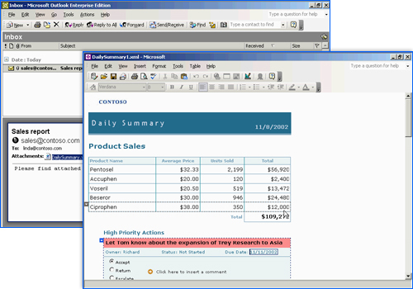
With InfoPath, reports become active documents, in which users can perform further editing and submit changes directly to the server.

Self-Contained Solutions
The ability to send these forms via e-mail rather than simply submitting into the information store allows customers more flexibility in dealing with exceptions to established business processes. When the form is sent in this way, recipients have the best of both worlds: They’ll see the information displayed in the body of the mail, and they’ll also receive the form as an attachment. Because they have InfoPath installed on their PCs, they will be able to click on the attachment and work on the form within InfoPath.
Because InfoPath forms are self-contained, the form can be sent to the team, for its feedback. After the user is satisfied that all the necessary data has been entered, the information can then be rejoined into the business process.
This same capability, to have all this information contained within an InfoPath form, also enables users to work offline. Users could work with the form on an airplane, for example, or any other time they are disconnected from the network. For example, this could apply to salespeople who fill out InfoPath forms in the field and then submit them at the end of the day when they return to headquarters.

Multiple Views of Information
InfoPath gives users the ability to access current information and use it however they want. For example, salespeople planning a sales call can research the history of sales calls at the account. In addition to sales numbers, a report based on InfoPath forms can provide the comments and action items that salespeople have recorded over time. This allows the salesperson to be more prepared for the meeting and can help set the meeting’s agenda.
Using a simple query that enables users to search for information by company, users can easily create a form showing the history of comments, actions and sales data for the customer. Because this is a dynamic form created in InfoPath, the user can interact with the information, using it to set the agenda for the meeting.
One of the capabilities that InfoPath enables is the ability to have multiple views on a given set of XML data. In this case, the user can change to a meeting agenda view, which was designed and associated with this form when the form was created. The user simply selects the meeting agenda view from the views menu to present the information in a more concise, summary format that looks like a meeting agenda, for distribution to the team before a meeting.
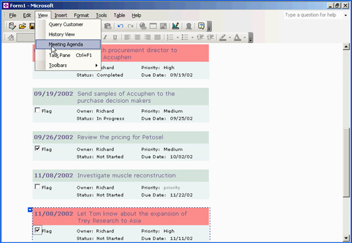
InfoPath enables multiple views of the same information.

Creating an InfoPath Form Template
InfoPath form templates can be created quickly and easily by most users. The features available are as applicable to enterprise or organizationwide solutions as they are to team and workgroup scenarios.
At the enterprise level, InfoPath works well with business-process back-ends that support XML, such as BizTalk, SQL Server and the .NET framework for Web services. At the departmental or team level, a Web server or file share can serve as the back end. In addition, Microsoft has done some integration work with SharePoint Team Services, the Microsoft Windows collaboration platform that will allow users to design an InfoPath form and create a team collaboration workspace as one integrated activity.
The following procedure can be used to quickly create a simple InfoPath form template:
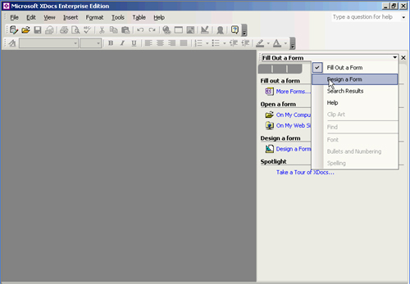
Open InfoPath, and choose Design a Form from the File menu. A blank form will appear.

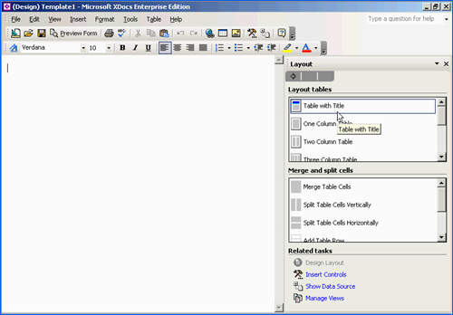
Click on and drag a Table with Title to get the layout started. The right-hand task pane makes it easy to access InfoPath layout features.

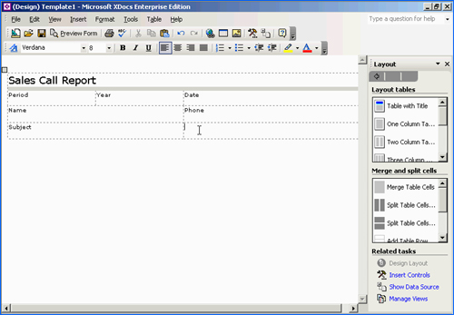
After this part of the layout is set, users can enter labels. Click on various areas of the design surface to enter titles and labels for those areas.

Now that everything is labeled, users can add controls. Switch the task pane view to Control View by selecting More Controls from the Insert menu. Users have many traditional and several new controls at their disposal.

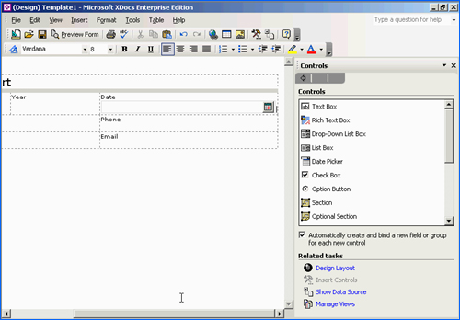
Say you want to add a date picker to select a date. Simply click and drag.

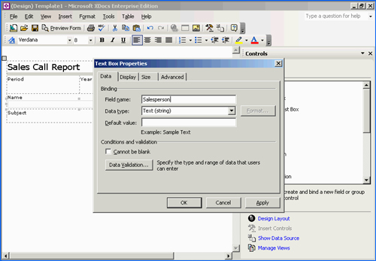
Now you’ll grab a text box for the salesperson’s name and set the field appropriately. Go back and change the date picker field name to “date.”

Repeating Sections
By dragging and dropping a repeating section into the form, users can enable the form to expand as necessary to allow information from multiple customers or products to be entered. Any controls deposited into the repeating section will repeat, and repeating sections can be inserted into repeating sections to allow the template to expand and contract as necessary.
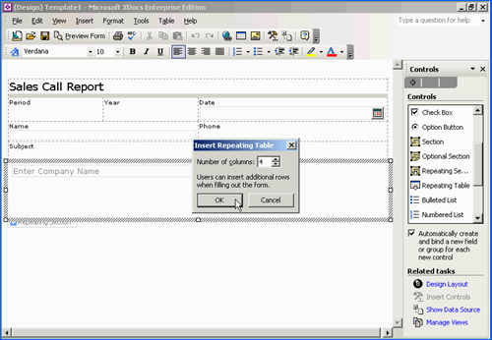

Connecting the Form to a Database via ADO
For some fields on the form, users may want to change the text box to a drop-down list, or provide another type of data connection to assist form users with prepopulated information.
For example, form designers may want a list of products to appear in the form as a drop-down list. They add the drop-down list control to the form by dragging and dropping, and can then connect the drop-down list box via ADO to a database. This can be accomplished in the following manner:
Set the field name, in this case, to “product.”
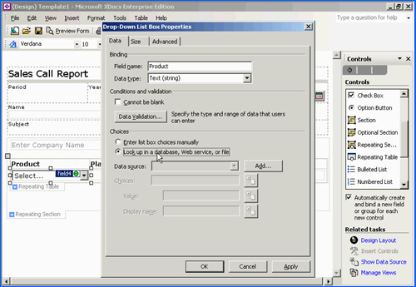

Indicate that you want to populate this list via a lookup by selecting the radio button that specifies lookup via a data source under Choices. A lookup can be performed from an XML data file, a database or a Web service, in this case a database.

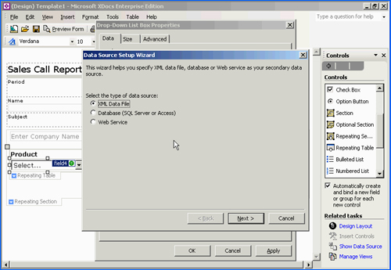
InfoPath walks you through a wizard, easily making the database connection.

Conditional Formatting and Data Validation
Conditional formatting and data validation can be used to alert users when information is entered that meets or fails to meet certain criteria, as validated by back-end information systems or by the form itself.
Conditional formatting can be set when designing the InfoPath form by selecting the control that allows you to reach the properties for that control. From the choices of tabs at the top of the Properties dialog box, select the Display tab. Then select the Conditional Formatting button. Users specify the formatting and then set the conditional event that triggers the alternate format.
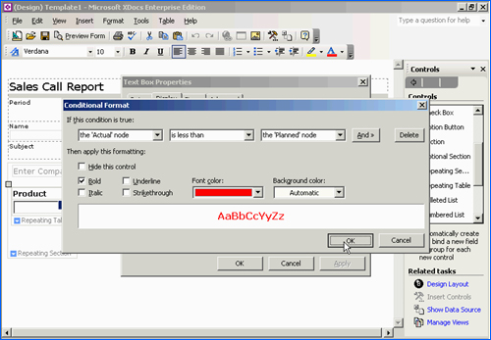
User can specify maximum or minimum thresholds or other criteria to trigger conditional formatting.

Validation launches a separate wizard that provides several validation options. Validation can be set to use data from an XML Web service or database, or can be hard-coded around a numerical threshold or other condition. Form designers can also set the form to alert users to irregularities via a pop-up or a dialog box.

Adding Color to the Form
Form designers can also spruce up the look of their forms by automatically adding a color scheme.
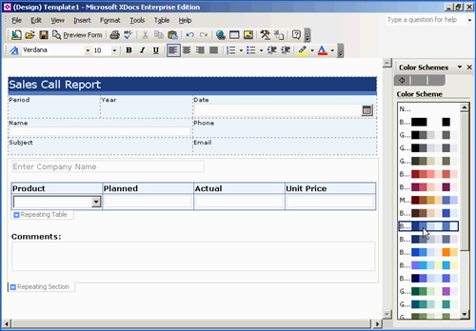

InfoPath and Windows SharePoint Services
Microsoft has integrated InfoPath with Windows SharePoint Services to provide even more options for organizations and teams to share their vital business information. Forms libraries can be created easily on SharePoint sites through a wizard-driven interface.
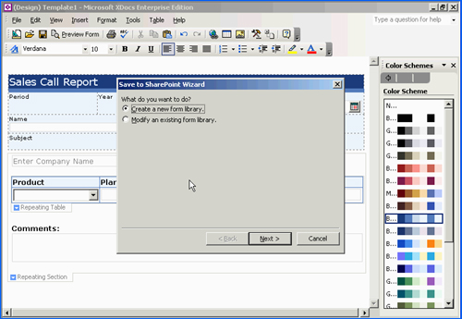
To create a SharePoint library for InfoPath forms, select Save to SharePoint from the File menu, which brings up the wizard. Click on Next to create a new form library. Then set the location for the site and give it a name.

Property Promotion
Data from InfoPath forms can be set to display automatically on a SharePoint library. Called “property promotion,” this feature allows InfoPath forms libraries on SharePoint to become a rich display of integrated business data. This data can also be used with data from other forms on the library site to provide an integrated picture of company information.
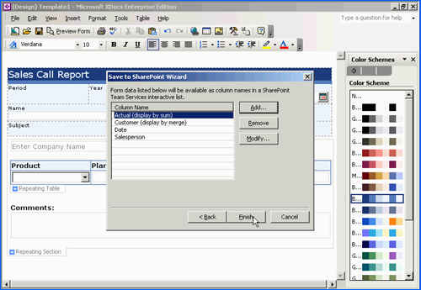
Here the wizard is enabling the user to select fields from the InfoPath form for display in the SharePoint list. Selected data will automatically be extracted and displayed in the SharePoint list.

Once the fields to be displayed are selected, users can then decide how to aggregate the data. They can select merge to show data from all forms in one integrated list. Numerical figures such as actual sales can also be summed on the SharePoint site for an easy snapshot of company activities.
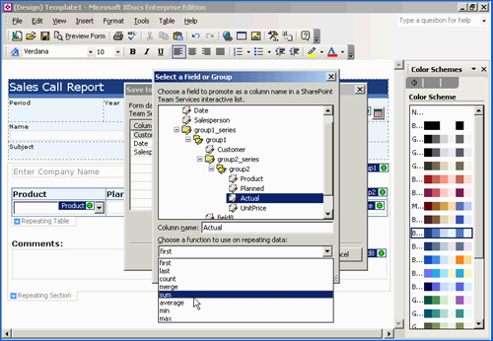
Data from InfoPath forms can be merged, summed and otherwise brought together in a SharePoint library, providing an easy snapshot of company activities.

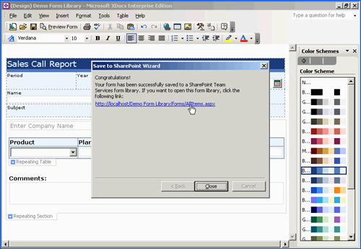
Clicking on the URL brings up the SharePoint site.

Merging InfoPath Forms on SharePoint
InfoPath and SharePoint also allow organizations to take a number of forms or documents and merge the information to create one summary document. Imagine, for instance, sales managers who need to create a summary report for all their salespeople. Normally they would have to cut and paste from all their different forms. With InfoPath, it’s easy to merge forms.
SharePoint has a great way of exposing the ability of InfoPath to merge:

Click on Merge Forms.
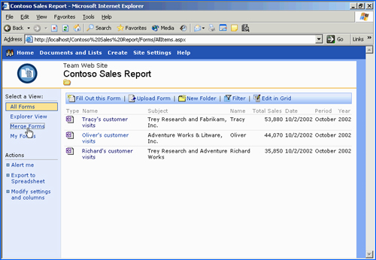
Check the forms to be merged.
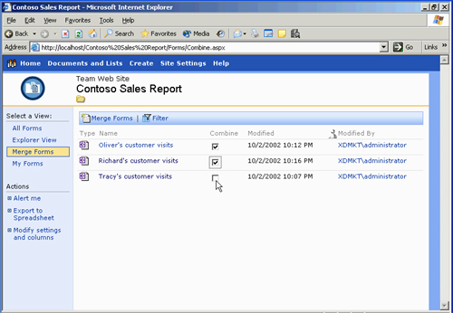
Then select the new merge forms command from the top of the list.
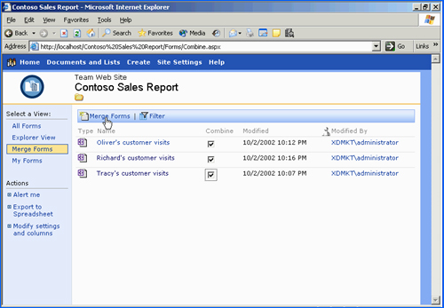
When these steps are completed, InfoPath opens and all the data from the library site is combined into one summary form. All the richness of InfoPath is available if users want or need to interact with the form.
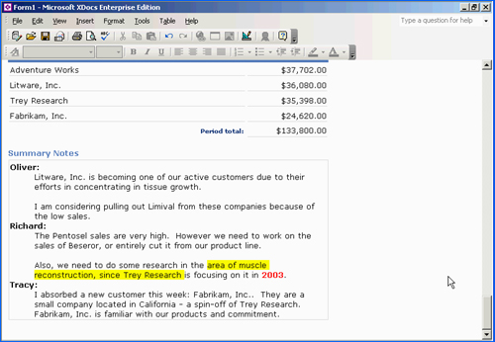
To save a modified form back to the form library, simply hit the save button and enter a name. The completed form will be saved to the form library, any fields that were promoted when the library was created will appear, and any extracted data will be summed or merged as set up.

Using InfoPath With XML Web Services
Using InfoPath, users can create forms with data provided by an XML Web service in a matter of minutes. This allows InfoPath to be used as a front end to XML Web services.
To accomplish this, users first launch InfoPath and choose to design a form. This time, instead of selecting a blank form, they will select New from data source. A dialog box should appear outlining the different data-source types supported by InfoPath. The data source could be a custom-built XML schema, an industry-standard schema or a schema from a consortium. As mentioned earlier, databases are supported as well.
Support for Web services in InfoPath includes both data submission and receipt. InfoPath also supports UDDI (Universal Description, Discovery and Integration), so that form designers with UDDI servers running can run a query to discover XML Web services available to them. In other cases, simply entering the URL of the Web service will connect the form to the XML Web service, and InfoPath will display the capabilities the service can provide.
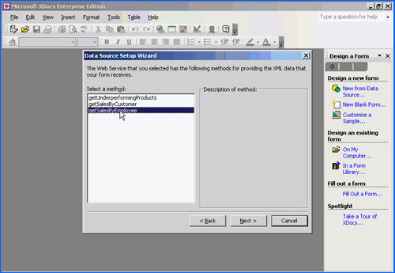
Select any information you want from the Web service, and then finish the wizard.
Once connected to the XML Web service, InfoPath returns to a blank form. The task pane will now display the schema returned by the XML Web service. There’s a schema for the parameters and a schema for the data. This is the same scenario as if you had started from a schema you had already designed as part of your business processes.
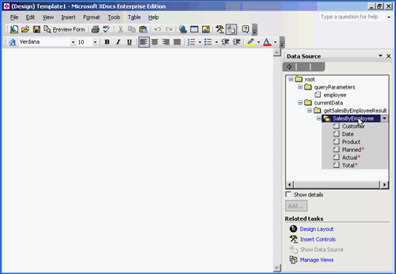
To create a form from this schema, simply drag and drop the schema elements from the task pane to the design surface, and InfoPath will automatically create and bind the correct controls for the data types represented by the schema. It’s that easy to build a form with a schema from a Web service.

Querying Against a Web Service
To set up a query, drag and drop the parameter for the query from the schema onto the form design template. Switch to a preview of the form to try it out.
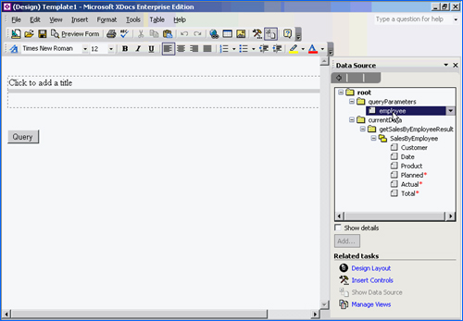

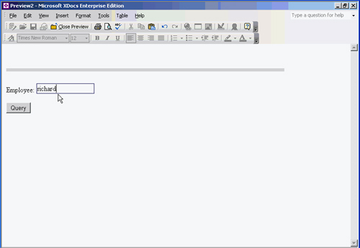
Now that you’ve entered the name, select query. You’re connecting to the XML Web service, and the results are returned. With that, you can easily see how InfoPath is a great smart client for XML Web services.
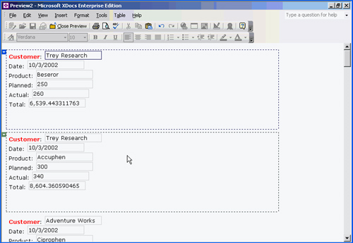

Top-Line System Requirements
General
- PC with Pentium 133MHz or higher processor; Pentium III recommended
- Microsoft Windows 2000 with Service Pack 3, or Windows XP or later operating system
For Windows 2000 and Windows XP
- 64 MB of RAM (128 MB recommended) for the operating system, and an additional 8 MB of RAM for each application running simultaneously
- 245 MB of available hard disk space, with 115 MB on the hard disk where the operating system is installed (hard disk usage will vary depending on configuration; custom installation choices may require more or less hard disk space)
- CD-ROM drive
- Super VGA 800x600 or higher-resolution monitor with 256 colors
- Microsoft Mouse, Microsoft IntelliMouse® or compatible pointing device

