Your Best Ideas are There—Now Remember How You Got Them
OneNote® 2010 helps you remember everything in this age of information overload. Good ideas, things you need to do, Web sites you need to revisit for a project. OneNote 2010 makes it easy to track where those ideas came from using Linked Notes, which let you link what you type to what you were looking at as you typed it. This can be especially useful when working on team notebooks—it gives others more information so they can better understand your ideas too.
Using Linked Notes
Make a note of the Web site or Office document you were looking at when you had that thought, or give more context to the notes you take while researching. Linked Notes help you manage information overload by giving you context for your thoughts.

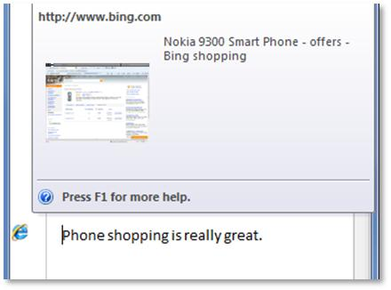
Step by Step:
- Type a note while looking at a Web site. The Internet Explorer icon will hover when that line is highlighted; scroll over the icon, and the linked site displays in a pop-up box. Linked Notes automatically link to the browser page you have open. Click on the link icon to open the site.  - This process also works with Microsoft Office programs such as Word and PowerPoint. | 