Microsoft

# Microsoft SharePoint Product Group Rebuilds Web Site in SharePoint, Saves Money, Improves Efficiency

*Microsoft wanted to create an engaging and dynamic experience for customers, developers, and end users to learn more about the capabilities of Microsoft® Office SharePoint® Server. To achieve this objective while showcasing the design flexibility and content management features of the SharePoint environment, Microsoft built a new version of its existing Web site in Office SharePoint Server 2007. Rebuilding the Web site in Office SharePoint Server 2007 helped to streamline and standardize the content publishing processes across the SharePoint product team, improve customers’ ability to find up-to-date and relevant content based on their needs, and provide a best practice for other Microsoft product groups to publish information. By using many out-of-the-box features of SharePoint, Microsoft can keep the rebuilt site updated without relying on developers or third-party vendors.*

# Situation

After years of updates, the Microsoft® Office SharePoint® Server Web site was rich in content, but it was getting difficult for users to find relevant content easily. Developers needed to quickly get to code samples, blogs, and white papers about SharePoint capabilities and related technologies; IT professionals and other decision makers needed easy access to reviews, demos, and deployment resources. With SharePoint Server 2010 on the horizon, the new Web site would need to accommodate new content, such as case studies, white papers, and download trials, to support customers in converting their SharePoint installations. In addition, the site needed to adopt the new look and feel of the Microsoft Server and Tools family of products.

The main goal for Microsoft was to take advantage of the value of its SharePoint technology as a Web site foundation while showcasing the integration of additional Microsoft products, such as Microsoft Silverlight™ browser plug-in, and using Microsoft technology, such as Microsoft Office SharePoint Designer 2007, Windows Live™ ID, Microsoft Expression Blend™ 2 design software, and Microsoft Visual Studio® 2008 development system. Another goal was to improve the Web content management capabilities of the Web site.

To meet the requirements of a growing user base and to accommodate new content related to SharePoint Server 2010, Microsoft needed a solution that could handle a high volume of updates. Ideally, content authors would be able to manage content from inception, into the review cycle, and through the publishing process without third-party vendor assistance. Tony Tai, Senior Product Manager at Microsoft, says, “We need a Web site that can scale and perform to keep up with our business demands.”

**“We need a Web site that can scale and perform to keep up with our business demands.”**

**Tony Tai  
Senior Product Manager, Microsoft**

The solution needed to be equally suited to content providers and content consumers—with scalable lists to accommodate a fluctuating volume of data, the ability to filter content for several types of audiences, and the ease of managing the content in one place to ensure accuracy and timely delivery.

Rebuilding the Web site in Office SharePoint Server 2007 would demonstrate that SharePoint is a viable environment for creating public Web sites. Then, when SharePoint Server 2010 is released, Microsoft will be ready for the first-hand experience of upgrading its own Web site from Office SharePoint Server 2007 to SharePoint Server 2010.

# Solution

The Microsoft SharePoint team wanted to release phase one of the rebuilt site, the conversion of content to Office SharePoint Server 2007, in May 2009. To meet the delivery deadline, they partnered with [Advaiya, Inc.](http://www.advaiya.com/) for technical expertise in site design, taxonomy, architecture, development, graphic design, and deployment.

The project started with a vision and scope session to define the purpose of the rebuilt site, determine what would constitute a successful site, understand the audience, discuss technical details, and schedule phase-one milestones. After several joint working sessions to lay out site pages and identify detailed requirements, the team moved forward with a “staged by page” approach, in which Microsoft reviewed daily builds.

Phase one included four main focus areas: site navigation, publishing model, a foundation for search engine optimization, and repeatable processes.

## Redesigned Site Navigation

To improve site navigation and make content more accessible, the team did the following:

* **Defined a new information architecture.** The existing site comprised long pages that required users to scroll through paragraphs to find content. For the rebuild, the team organized pages into categories and logical subgroups. The resulting pages were shorter segments that help users quickly locate the information they need.
* **Simplified visual design.** To help users get to relevant content quickly, the team identified and eliminated elements that did not provide value, such as multiple conference banner ads scattered throughout the site and images that did not support text.
* **Created a new menu structure.** The existing site had one menu with several levels of submenus to navigate to all the content in the site, so it was difficult for users to find what they needed. Once users found content, it was difficult to know where they were in the site. The team designed and implemented a main menu bar across the top of the site and a submenu at the right side of the page to give users more than one way to approach content. A new navigation path control helps users know their current location in the site and return to a previously viewed page. The solution used out-of-the box SharePoint navigation and a custom site design.

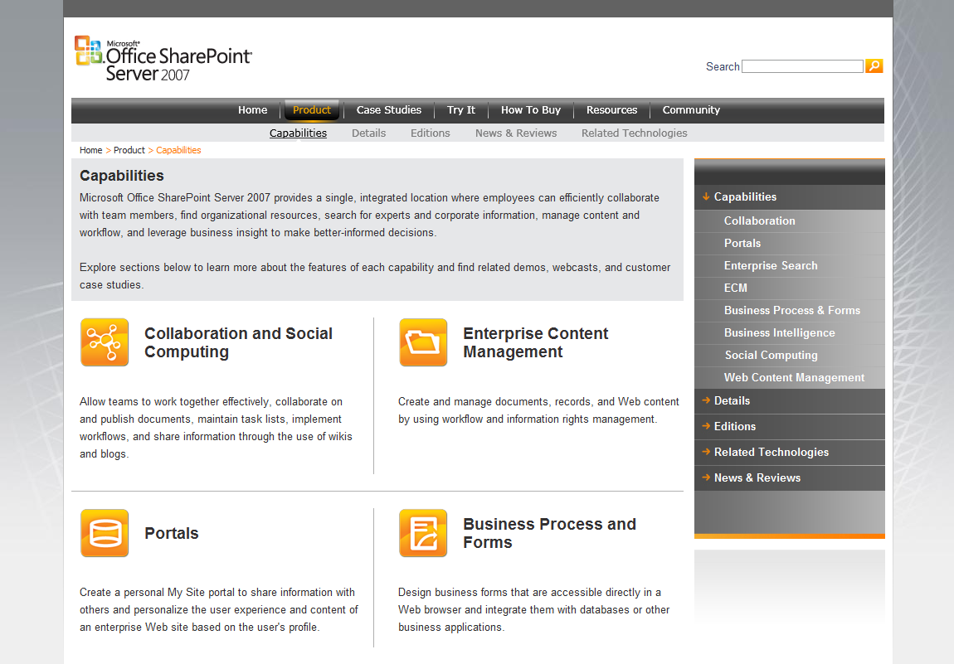

Submenu

Navigation path

Main menu

## More Efficient Publishing Model

To provide a content publishing model that content owners could use without third-party or developer assistance, the team implemented SharePoint and Silverlight features and controls, developed custom page layouts, and defined dynamic navigation controls that display updated content.

### Content Owners Manage Content

The process Microsoft used to update content in the previous Web site included authoring content, submitting the content for approval, and then working with a third-party vendor to incorporate the content into the Web site. This time-consuming process made it hard to keep content up-to-date and it was not cost effective.

The new publishing process, based on Office SharePoint Server 2007, enables content authors to author, get approval, and publish content to the rebuilt Web site within a Web browser, which eliminates the need for third-party assistance or technical skills in Web site development.

The following figure illustrates the new publishing process.



### Single Source, Multiple Instances

Previously, identical content resided on several different pages in the site, so authors had to update it at each location. In the rebuilt site, content authors can update a single instance of content by using a SharePoint list for the content source and display the content in several locations by using content query Web Parts. The case studies in the new site are excellent examples of this functionality. On the case studies page, a content query Web Part displays a collection of case studies, while on other pages in the site the case studies are filtered by product capability. Similar examples include content for Books, News and Reviews, Events, Webcasts, Templates, Demos, Virtual Labs, White Papers, Developer Resources, and Deployment Planning Services FAQs.

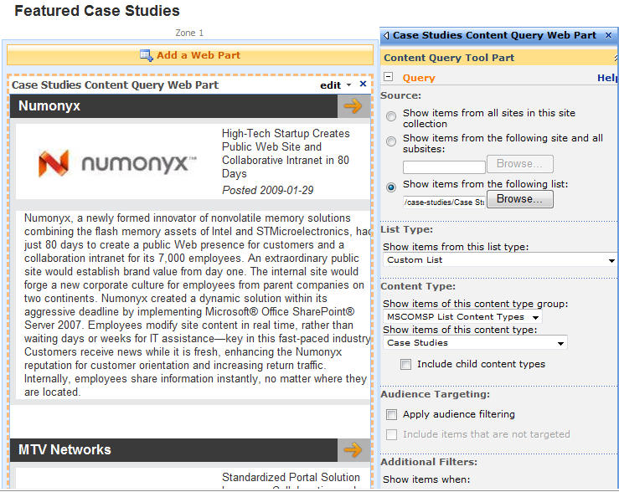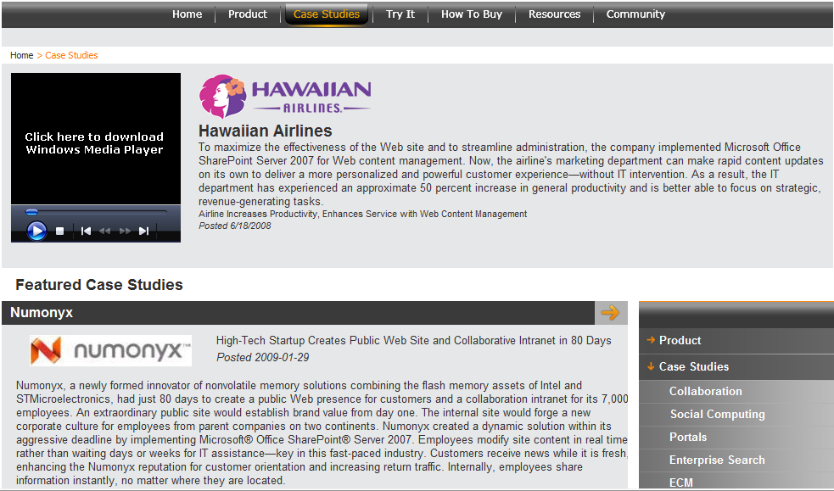

### Site Design Managed Separately from Content

Much of the content in the rebuilt site is stored in pages that use custom page layouts and field controls to define exactly how the information is displayed. For example, the page layout specifies where text and graphics elements are placed and how they are sized and aligned. Content authors can quickly create or edit content without having to worry about its appearance. Custom cascading style sheets (CSS) govern how the information is formatted (such as font styles, colors, and sizes) and ensure a consistent experience across Web browsers.

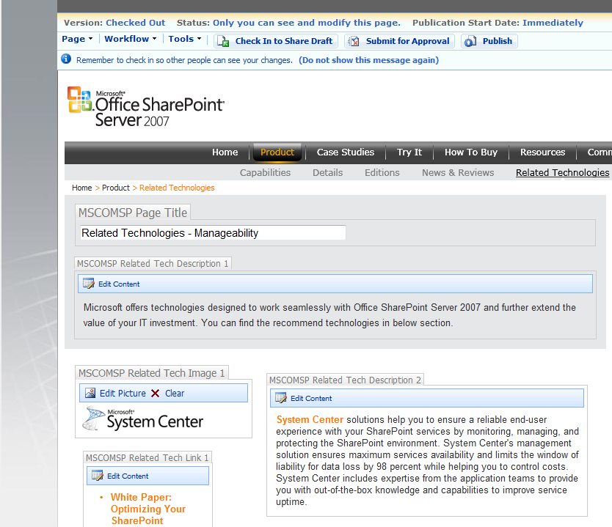

### Dynamic Navigation Menus

When content authors update the SharePoint site with new subsites or new pages, the new content is automatically navigable because the main menu, navigation path, and submenu controls are dynamic. The main menu uses a custom Silverlight control that was integrated with the out-of-the-box navigation providers that come with SharePoint, and the submenu is a stylized Quick Launch menu. Content authors make changes in the out-of-the-box Modify Navigation administration page (Site Settings) to define exactly how they want the navigation menus to appear.

### Dynamic Home Page Content

You’ve probably seen graphical menus in other Web sites—typically they are used to highlight and link directly to new or time-sensitive content. Sometimes they are animated banners that cycle through new content. In the SharePoint Web site, the Silverlight graphical menu is both eye-catching and dynamic. It was designed to display text and graphics from SharePoint lists so that users can browse to customer information, events, and downloads. Content authors can create or edit items directly in SharePoint lists—and updated content displays inside the animated Silverlight control on the home page. This functionality saves an incredible amount of time and effort normally associated with custom Silverlight development, and it will empower the SharePoint product team to keep content fresh.

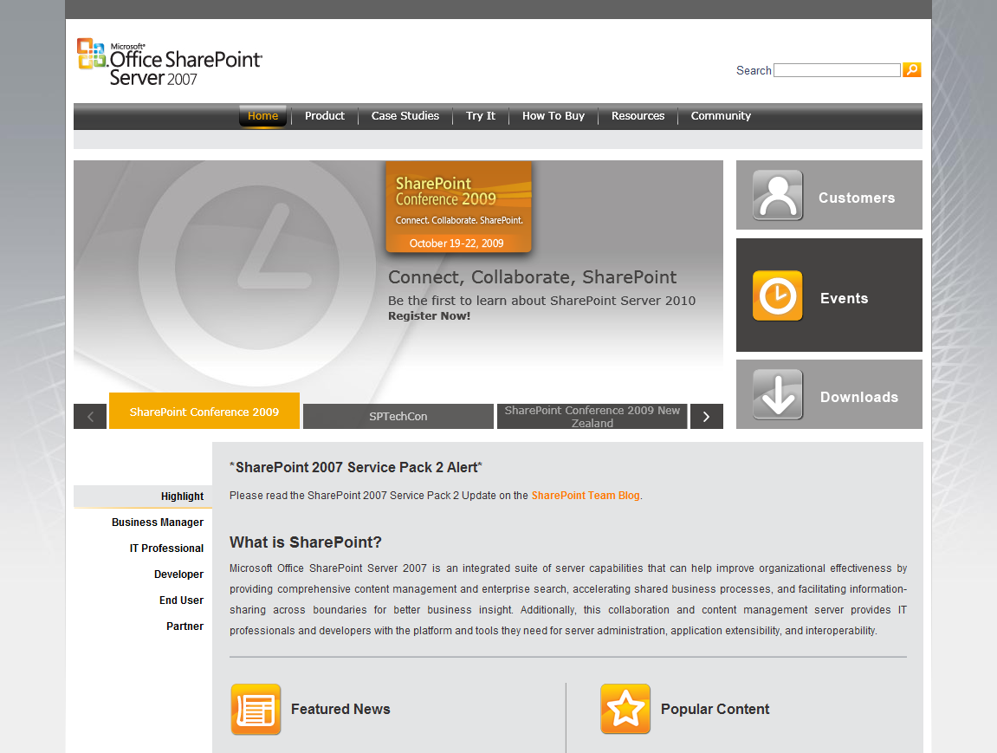

Silverlight graphical menu

Main menu

The content below the Silverlight graphical menu is the target for the Web site’s main audience. This focused content can be authored and maintained inside SharePoint pages that are based on a custom page layout. Content authors can display the pages in edit mode and update content directly within the pages. A custom Web server control aggregates the information on the home page and presents it in an interface that allows users to browse without refreshing the home page. Content authors can quickly change content on the home page without having Web development skills.

## Search Engine Optimization

Content authors are considered subject matter experts—it makes sense for them to specify the title and keywords for content they author. Formerly, this task required coding skills. However, the rebuilt site includes two custom field controls that enable content authors to easily enter the title and keywords for each page. Content authors can fine-tune keywords that search engines use to index the content without having to get a developer involved.



To further optimize pages for search engines, the team added descriptive titles to all of the pages in the Web site. The site and subsite structure and the names given to Web pages adhere to best practices associated with search engine optimization.

## Repeatable Process

Throughout the project, the team carefully documented the development process and created reusable elements, such as requirements, specifications, technical procedures, and taxonomy lists. In the future, other Microsoft product teams can use this documentation to repeat a proven process. In addition, the components that deliver site functionality are configurable and can be easily adapted to meet the needs of other Microsoft product teams.

# Benefits

By rebuilding the Microsoft SharePoint team’s Web site using Office SharePoint Server 2007, Microsoft demonstrated that SharePoint is an effective environment for building Internet Web sites. Office SharePoint Server provides a publishing model and processes that save time and money. But more importantly, the new SharePoint site improves the customer experience, is easier and less expensive for content authors to maintain and update, and is positioned to quickly adapt to emerging technology.

## Timely, Relevant Content Delivered to Customers

With clearer organization of content, improved navigation, and less clutter, customers can find and read information more easily. And with a fresh and interesting design, learning more about SharePoint is both informative and exciting.

## Empowered Business Users

The most useful and effective Web sites have current content. Often, keeping Web content up-to-date requires a technical skill set (coding, networking, and navigating IT systems) in addition to a content development skill set (researching, writing, and tuning information). The SharePoint Web project proves that it is possible to keep a Web site current without relying on developers, IT professionals, and third-party vendors. Content authors can deliver Web content quickly, directly, and less expensively by using Office SharePoint Server 2007. “With the new SharePoint Web site, our product marketing team now makes real-time updates without requiring any IT resources,” says Tai. “We expect an annual cost saving of more than $100,000 for fiscal year 2010.”

**“With the new SharePoint Web site, our product marketing team now makes real-time updates without requiring any IT resources.”**

**Tony Tai  
Senior Product Manager, Microsoft**

## Platform Solution Is Future-Ready

With a fresh approach to content delivery, the Microsoft SharePoint team can now easily add new content about SharePoint Server 2010 to its Web site. Subsequent phases of the SharePoint Web project will also be easier to carry out because the SharePoint product engineering team at Microsoft, working closely with Advaiya, developed site architecture and components that will work well in SharePoint Server 2010.

This case study is for informational purposes only. MICROSOFT MAKES NO WARRANTIES, EXPRESS

OR IMPLIED, IN THIS SUMMARY.

Document published July 2009