
Web Services Authentication in a Multi-Vendor Environment

White paper prepared for:
Government of British Columbia

December 10, 2005 Version 3
Prepared by
Principal Enterprise Strategy Consultant
Microsoft Enterprise Services
stevebar@microsoft.com

Introduction 3
Background 3
Goals 3
Approach 3
Audience 4
Executive summary 5
Common challenges to unlocking the information goldmine 8
The vision of web services and Service Orientated Architecture 11
What SOA and Web Services means to BC Government and public sector 14
The challenge of Cross platform authentication and web services – (what this paper is primarily addressing) 18
Standards and specifications for Web Services 22
Understanding the standards bodies and participant workshop process 22
Basic standards that underpin a web service 25
Standards for security and authentication in web services 27
WS-Federation and Active Directory Federated Services 33
WS-Federation and the Liberty Alliance 35
Case Study: Standards and infrastructure in place at the BC Government 36
Web service design considerations 37
General guidance in the context of SOA 37
Guidelines for web service design for successful interoperability across platforms 38
Sun 39
Oracle (Peoplesoft) 39
IBM 40
Computer Associates (Netegrity) 40
SAP. 40
BEA. 41
Systinet. 41
Microsoft. 41
Cross Platform / Cross organization authentication for Web Services 42
Roadmap to federated identity and WS-Federation 42
Option 1: Web Services Security using WS-Security – lay the foundation. 43
Option 2: WS-Federation Passive Requestor Profile 46
Option 3: Web Services and cross platform authentication using WS-Federation passive requestor profile and WS-Security 48
Using web services to leverage existing investments across platforms 49
Mainframe legacy applications 49
Exposing COM based legacy applications as web services 50
Leveraging web services with Microsoft Office 51
The Developer Tools to support web services and SOA 52
Java based tools supporting WS standards and interoperability 52
Microsoft tools supporting WS standards and interoperability 54
References 55
Glossary 58

Introduction

Background
Over the last few years, the IT industry has reached broad consensus on the measurable benefits of a service oriented approach to building systems. IT leaders have always had a vision of making data readily available across systems and organizations while vastly reducing the cost and complexity. Service orientation is the promise and web services provide fundamental building blocks that make it a reality.
Like everything else in IT, it is important that we approach the design of systems and web services with due consideration of current technology options as well as future directions. The broader adoption of web services that we see today can be attributed to some important developments in three key areas: industry standards, developer tools and security/authentication.
Major IT vendors have ratified key standards from organizations like OASIS and these are pivotal milestones to successful interoperability of web services across platforms. Better developer tools vastly simplify the development effort for the creation of web services. Much has been written about standards and tools with the assumption that the resulting web service will be used only within a single security realm.
For service orientation to make good on its promise of fully connected systems across security boundaries, web services need to be designed with a bigger picture authentication strategy in mind.
Goals
This paper will present approaches that address some of the common challenges around authentication when designing web services in a multi vendor environment. The primary goal is to present architectural guidance when building or extending web services today, with an authentication strategy that will take full advantage of the federated identity models of tomorrow.
This is an exciting time in the industry with an unprecedented level of collaboration among major IT vendors wishing to establish standards for web services. There is an enormous amount of data from Oasis, W3C and other standards organizations covering many different specifications.
An important goal of this paper is to crystallize the information and background down to the most relevant standards that have already matured or are shaping up to play a pivotal role in web services for authentication and security.
Approach
We begin by placing this paper into context by covering the problem space relating to the way that legacy systems were designed and describe why service orientation has been heralded as the next phase in the evolution of the IT industry.
Microsoft, IBM, Sun and other leading industry vendors are working together to make interoperability across platforms easier. We will cover the standards and tools that are in place to enable better interoperability across platforms.
Increasingly, architects are visualizing the exciting possibilities through harnessing web services. We will describe some examples and portray realistic scenarios that will underscore the benefits for business decision makers and architects across the Government and public sector.
Finally, we will present approaches available to accomplish this type of connectivity. We will offer guidance and pointers to more detailed material for architects and developers.
Audience
This paper was primarily created for architects and IT decision makers at the BC Government, broader public sector and their solution providers. However, the content is also very relevant to other governmental jurisdictions given the commonality of the IT challenges within public sector today.
The BC Government is as an excellent example of where successful interoperability by its major vendors is critical to the success of the top initiatives. Recognizing that the content here is relevant to architects focused on different platforms including UNIX, Java, Mainframe and Microsoft, this paper is structured accordingly. We will indicate where the content is general to the IT industry, specific to Microsoft or specific to the BC Government as a case in point example.
The following color-coding is used throughout this paper.
Content specific to the BC Government is boxed in light grey.
Content specific to Microsoft is boxed in light blue (appears as dark grey on black & white printout).

Executive summary
It was a highly visible IT project. The top directors in the organization were focused on the end result and for once, funding was not an issue. The new system was built using the most up to date development tools and technologies - at least when it began. In the end it took a team of 35 full time resources and over 18 months to complete.
It was an elaborate system and considered revolutionary at the time. From a security standpoint it was completely isolated and self contained and it required no interfaces to any other environment. The business leads were certainly glad when it was over but they were also very disappointed in the final result. By the time the system was delivered it met only a portion of the newly evolving business requirements.
The information stored by the system was invaluable to other parts of the business. Yet there were no external system interfaces and therefore no other system could leverage the information. A great deal of what was captured and stored had to be replicated again and again in other applications. Often there were inconsistencies.
It utilized a complex authentication mechanism. One that was cleverly customized in order to isolate the system to make sure that no other application or user could gain access. However over 500 staff had to perform a separate sign-on step each day in addition to the main authentication login. Lost passwords and password resets were becoming a major drain on the helpdesk staff.
Later on, the organization was acquired and the work began to connect, replace and interface the various business applications. Getting access to the information in this system became even more critical than ever. Many of the original team had either moved to another role or had left the organization. Because of the proprietary nature of the data store and the types of programming interfaces used, there was very little available knowledge to crack open the application.
It was a data goldmine. One that was virtually unusable.
This scenario takes on many forms but most organizations can attest to a similar story to a greater or lesser degree. This paper is about web services in the context of service oriented architecture and a federated authentication strategy. It is about how leading IT vendors are cooperating to ratify industry standards so that systems can communicate seamlessly across platforms and across organizations.
It describes options that are available today and others that are forthcoming, to accomplish a single sign-on experience without compromising the organization’s precious secrets. Many organizations are already realizing some of the enormous benefits of utilizing web services and a service oriented architecture approach. Increasingly, architects are starting to visualize the exciting possibilities that lie ahead. For Government and public sector services, the implications go far beyond cost savings to ultimately affect how services will be provided to citizens and business. It is a vision most effectively articulated through an example such as the following:-
Jeff is a troubled teen who is in danger of being expelled from school.
Shelly is a social worker assigned to the case and is on her way to meet the teen at his school. She needs to quickly access as much information as possible on Jeff’s background and history. Using her mobile device, Shelly initiates a search based on the limited information she has available. Through wireless access, she connects securely to the main portal application hosted at the Ministry of Children and Families where she is based.
The portal application uses web services to reach into other systems. It pulls information from the Ministry of Education on his school history and grades. It pulls vital statistics from the application at the Ministry of Health to confirm his place and date of birth. It initiates a search of the Justin system residing at the Ministry of Attorney General that retains a history of court and criminal cases within the justice system.
All of these applications reside on different platforms and in different organizations. There are different authentication mechanisms involved. The applications are written in numerous different programming languages. Yet Shelly is authenticated to all systems seamlessly. She is automatically granted the necessary access to the specific applications she badly needs to query. This happens quickly and securely and the mobile device leverages advanced biometrics to ensure integrity, privacy and confidentiality.
Each of these systems expose web services interfaces and it is only when data is gathered from the Ministry of Public Safety that the true picture becomes clear to Shelly.
This system returns information related to past police reports and it quickly highlights the fact that child abuse is a factor in the case of Jeff. Because this information was made in a timely fashion, Shelly will handle the case quite differently in the light of this newfound knowledge.

For IT in Government, the ability to achieve this type of connectivity across disparate systems and organizations can make a major impact on people’s lives. A primary goal of this paper is to provide guidance on new approaches that will help pave the way to making this vision a reality.
Like many organizations, the BC government depends on a range of IT vendors for their mission critical applications. Cross-platform interoperability is key to success. Industry standards have now matured to the point where developers can create web services that are consumable on other platforms. Furthermore, newly evolving standards enabling federated identity take this one step further to enable web service interoperability across organization boundaries. This is a barrier that has historically been extremely difficult and costly to overcome.
Huge investments have gone into legacy systems. There are also tools and technologies available to leverage existing investments in legacy systems by exposing them as web services. Guidance on how to expose legacy systems such as web services and how to preserve investments in existing investments is also covered. Finally, this paper provides a roadmap for the standards and tools that are planned over the next two years.

Common challenges to unlocking the information goldmine

The evolution and expansion of Government services often leads to a deep need to get at data from applications residing in different ministries and across the broader public sector space. Legacy applications can contain data goldmines and architects would benefit greatly if they could be more easily leveraged. More often than not, these applications were built as self contained solutions and getting at the underlying data can be extremely difficult or cost prohibitive.

Figure 1. The challenge to getting at data 'goldmines'. (Source: Government of British Columbia CIO office - illustrative sample.

Architects who have been in the industry for while will likely have been involved in some kind of application integration project. Those around long enough to remember the early ‘hard-wire’ attempts will also remember the incredible costs that resulted - often completely obliterating any benefits in terms of ROI. For this reason, some organizations have been willing to live with the costly ramifications of logging on to multiple systems and reentering duplicate data. There have been countless stories of failed or costly attempts at tying these systems together.

With the introduction of tools utilizing XML for enterprise application integration (EAI), we started to experience the benefits of harnessing industry standards like XML to make application integration possible at a more reasonable cost and much greater ROI. Complex business processes can be logically represented and orchestrated within these EAI tools.
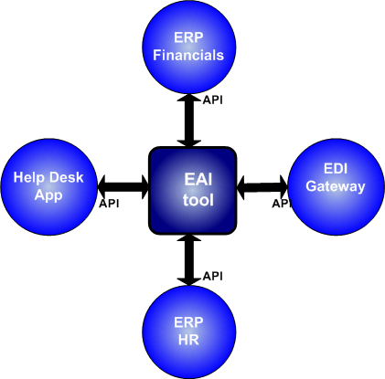
There are many examples today that demonstrate how EAI tools have enabled a seamless view of data across multiple systems. This is often accomplished by having the applications expose callable interfaces that send or receive XML using an agreed upon schema. While this approach has been successful, there was a cost downside associated with maintaining multiple application interfaces and the associated XML schemas. Since each application interface was typically proprietary in nature, developers usually needed to learn about proprietary APIs for the interface that would accomplish the necessary business function. While the benefits of having a standard way to express data (XML) brought great value, the complexities involved in mapping and transacting with the application endpoints were still costly.
Figure 2. Use of Enterprise Application Integration tools to connect disparate systems together.
What was needed was an industry standard way to interface with applications and a common understanding of how to express the schema and its use.
The introduction of SOAP (simple object access protocol) made it possible to have a standard way of calling into application functionality without the need to learn a proprietary API. Other key industry standards like WSDL and UDDI have been introduced and broadly accepted as the standard way to find, express and consume the data that is made available through SOAP.
These standards form the core elements that have made Web Services a reality today. Great progress has been made among some of the largest IT vendors including Microsoft, IBM and SUN, to further refine and agree on standards so that cross platform interoperability is made even easier.
Even with all of this, there is a major challenge that has until recently been a major impediment to the dream of getting at data at multiple applications across platforms and organizational boundaries. That is to provide connectivity across security realms or across organizational boundaries and to make the experience as seamless as possible.

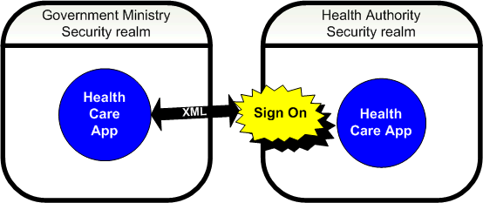
Figure 3. The authentication challenge - Cross organization.

The major focus of this paper is to describe how this challenge can be addressed using industry standards. Throughout this paper we will use the term connected systems to represent a vision of making web services readily available across platforms, across security boundaries and across organizations.

The vision of web services and Service Orientated Architecture

In recent years, there has been a fundamental shift in the way that organizations think about their IT assets. Mapping out the core business functions and identifying what IT services need to be in place to support them, has led to a very different way of thinking about how to architect systems. Much has been written about the concept of services oriented architecture (SOA). While the terms may vary, the general concept is the same and fundamentally the approach is intended to move away from building systems that are isolated, thus making it too difficult and expensive to connect later on.
As we start to think of IT as a set of services that support the business or public sector services, one of the best ways of enabling these services is through a set of web services.
The promise of web services is that there is a standard way of connecting systems easily regardless of what platform they are running on. In the case of the BC Government and broader public sector this is critical given the technologies that are in place from many different vendors. There is a need to better interoperate and in recognition of that, an organization known as WS-I is working with all major vendors to create a standard approach so that the vision of services oriented architecture can become a reality. Major vendors to BC Government have also been listed as members of WS-I. These include Sun, IBM, Microsoft and Oracle.
Web Services Interoperability Organization,
http://www.ws-i.org/

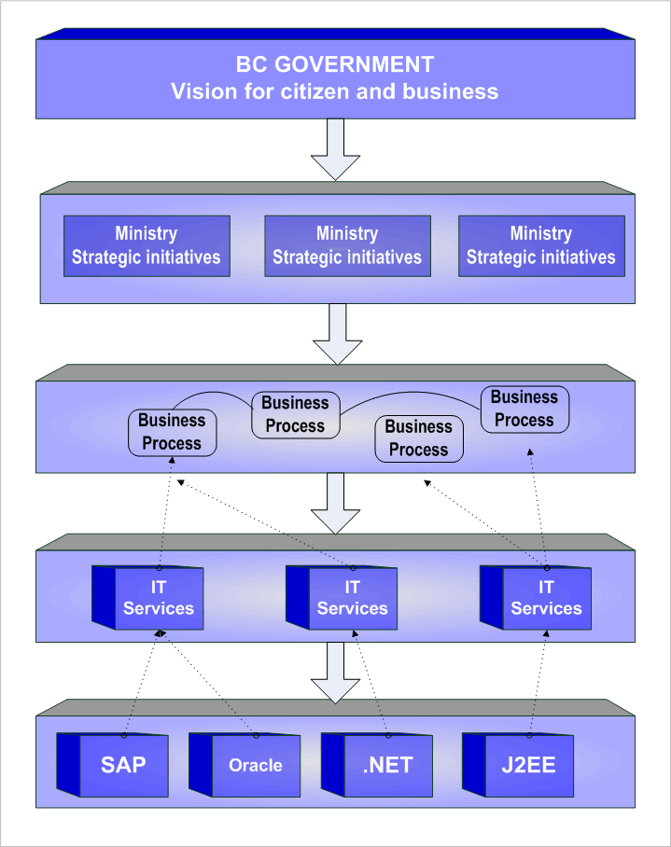
Figure 4 Typical layered SOA approach

How major IT vendors are enabling the vision of SOA.

This is a most exciting time in the industry. There is growing momentum to support and embrace the standards for web services. The developer tools needed to create web services are rapidly evolving. Major vendors of development tools like IBM, SUN, BEA and SYSTINET are releasing enhancements that enable web services development for Java/J2EE. Microsoft and other technology partners are releasing tools for the web services and SOA development on the .NET-based platform.
On the Microsoft-based platform, the Web Services Enhancements (WSE) tool set is available for the Visual Studio® development suite. This framework is updated regularly to help Microsoft customers keep step with the ratified OASIS standards and it made freely available so that so that the latest major standards are incorporated in a timely manner. In January 2005, Microsoft underscored the commitment to making software interoperable by design through the launch of a series of initiatives focused on interoperability across platforms. Microsoft has created an entire program around interoperability and has a central site devoted to the latest guidance and tools to help developers with cross platform issues. Over the years, Microsoft has been incorporating and refining support for web services into its products and technologies. The overarching principal is to provide a seamless experience for developers and architects so that there is a completely consistent approach when using Visual Studio for the Windows .NET-based platform. Through Visual Studio, developers can expose relevant Microsoft products as a web service or enable consumption of web services. Examples are seen today by through such tools as the Information Bridge Framework which allows the Office system to consume web services with Visual Tools for Office. Another example is the ability to exposing business processes as a web service using BizTalk® server. The Microsoft product and technology groups are coordinating efforts more closely than ever to build support of service orientation and web services so that it touches on every aspect of the vision of connected systems. Further examples are seen in areas such as collaboration using SharePoint®, mainframe connectivity using Host Integration server and database/data mining services using SQL Server™.
^{1.} http://msdn.microsoft.com/webservices/webservices/building/interop
ERP vendors such as SAP, Oracle (Peoplesoft), and others are making key business functions available through web services. Microsoft has also web service enabled its own suite of business applications (Microsoft Dynamics).
In addition to the standards ratified by major vendors for interoperability, the other exciting area of development is federated identity.
WS-Federation is a standard that Microsoft, IBM and other leading web single sign-on vendors have been working to overcome the last major bastion of pain, namely the need to simplify trust relationships over security boundaries. This area has historically posed a major challenge when trying to make information available on demand.
All of this is making it easier to achieve the vision of connected systems. This is why it is so important to consider the future vision when designing an architecture that will be able to take advantage of the future world of open standards.

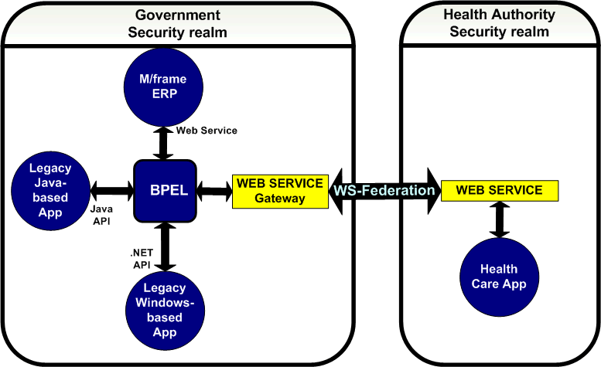
Figure 5. Vision of a seamless connected systems architecture through web services and federated identity.

What SOA and Web Services means to BC Government and public sector

The strategic plan for British Columbia lays out a vision that includes network services to even the remotest parts of the province. This initiative is referred to as Network BC and is an obvious building block for the vision of connected systems. It will enable on line access of public sector services to most citizens and businesses in BC. The government views the following priorities as the key enablers to success with online services:

- Security.
Increasing network access and broadening the reach into applications also highlights the need for greater security. As part of a multi year initiative referred to as the Security Enhancement Project (SEP), the BC Government is enhancing security through policy, governance and technical architecture. SOA means that a more consistent, standard approach can be defined.
- Authentication, Privacy & Protection.
An initiative is underway referred to as the Common Authentication Program (CAP) that will provide a framework for success in how identities are stored and managed to help ensure security, privacy and integrity. Federated identity can play an important role in achieving the goals for authentication within the vision of CAP. The overall solution must address issues that go far beyond the technical solution. The first phase of CAP addresses the crucial governance and policy issues that need to be thoroughly thought out in order for federated identity to become a reality. Users need to be assured that their privacy is protected and where necessary their anonymity is maintained and part of the mandate of CAP is to address these challenges.
- Integration and Interoperability.
The BC Government has many different applications running on different platforms. Web services and SOA will be a big part of making it possible to leverage the information within these diverse systems. There has also been ongoing work at the CIO office to define standards that architects across the public sector can reference so that when they design a solution, it too can participate in the connected systems infrastructure.

http://www.cio.gov.bc.ca/ebc/egovplan20041215.pdf

Already we have seen a multitude of government services coming on line through organizations such as BC Online, Ministry of Attorney General and Ministry of Water Land and Air Protection. These services reach into various back end applications to gather the information that a citizen or business needs. This information exists across many different systems and today it might require that the user sign in, or authenticate several times as they traverse the various information stores.

For example, a citizen may sign on and use the BC Online service to get information related to their current property valuation and then sign on again to a different system to check the status of their tax return. A business owner may wish to check to see if a supplier was ever involved in a court case in one system, and then re-authenticate yet again on another system to see how long they have been in business. All of this type of information is already available in many different diverse systems and portals. If a business owner needs to get a more complete picture, it may take quite a while to manually traverse the various information sources. Architects wishing to provide a more centralized online view often find it to be too costly or complex to expose information that resides within other applications or organizations.

By adopting a service oriented architecture approach, most if not all of the information can be made available through web services. If web services comply with the interoperability guidelines in WS-I and the WS* set of Web Services specifications2, it will mean that these services can exist on any platform and be readily available to consume in a fraction of the IT development time it used to take.

The executive summary described a scenario where a case worker was able to access crucial information more easily and how this type of connectivity across applications and organizations can impact people’s lives.

For business, the potential impact is just as remarkable. Take the case of John who is a business owner and wants to open a new liquor store in Vancouver. There are several steps involved in the process. He will need to request a business license from the Ministry of Small Business and Economic Development. He needs to update and retrieve data residing on systems at Liquor License Board (LLB) and Liquor Distribution Branch (LDB). His new business must be registered at the corporate registry within the Ministry of Finance and he will need to ensure he has a single business number (SBN) assigned.

Like many scenarios today this is a multi step process involving many different applications spanning different Ministries and public Sector organizations. There is more than one authentication mechanism to deal with and there are separate security boundaries in place.

Let’s visualize how this scenario could play out with federated identity and with systems that leverage web services in the context of a service oriented architecture:-

John accesses just one web site and uses an application that provides seamless connectivity into all the necessary systems across the different organizations. John signs in once with his BCeID. Behind the scenes he is then authenticated with the appropriate level of access to the other applications within each organization. ‘Federated identity’ means that there are well defined policies to ensure the necessary privacy, security and trust is in place to map John into his associated identity within the other directories. The application reaches out to these other systems which expose Web Services using industry standards for cross platform interoperability.

http://www.ws-i.org
2http://msdn.microsoft.com/webservices/understanding/specs

Enabling a virtually seamless single sign-on experience across security boundaries based on an industry standard means that architects and IT professionals will not need to worry about setting up complex hard-wired trust relationships or proprietary solutions as they do today. They will also be spared the task of having to deal with the complexities of shuffling identities around.

In this paper we will explain the concept of a federated identity and a new type of trust model that is part of an emerging standard called WS-Federation. The result of this specification is that there will be a preexisting, carefully considered trust policy in place between the organizations - one that does not require opening up the directory or compromise the security policies that each organization has in place. This seamless authentication allows architects and developers gain access to the required information through web services much more easily. It means an unprecedented amount of information that can be leveraged and incorporated into a composite view on an e-Government site.

This ultimately results in enormous benefits in several ways:
1. The total cost to expose this type of composite view will be a fraction of what it used to be. In the world of public sector IT and limited budgets this will result in massive financial benefits.
2. This new agility will provide enormous value to the tax payer through the proliferation of valuable services that simply would have been impractical to achieve before. As new Government initiatives are introduced, it will enable CIOs and business leaders to be extremely nimble in responding to the requests placed on IT.
3. An architect will be able to demonstrate enormous value and return on investment to their CIO by having a standard architectural approach across ministries and IT in the public sector. There are enormous ramifications and benefits to having this type of framework in place.

The exciting potential illustrated in the previous examples exemplifies the benefits resulting from cross organizational single sign-on where a user authenticates once and then has access to many different services regardless of where they exist. We will introduce in this paper the concept of brokered trust. Different organizations will each have their own set of identities within their individual directory stores. For example, a health authority might have a directory that contains all the identities of the individual recipients of health services within their jurisdiction. As such, this health authority can broker services on behalf of the identities within their store. When one health authority has a need to access the services existing within another public sector organization, there is a need to have some form of mutual agreement regarding trust. Traditionally, this has implied significant and often prohibitive complexity in setting up the necessary trust relationships both from a technical and from an organizational (and often political) standpoint.

Federated identity as outlined in an evolving specification called WS-Federation is a more recent term used to describe a way to accomplish such a trust but without the technical complexities. It achieves the necessary policy and trust agreements in a manner that allows organizations to have complete control over exactly who and how access is provided to applications within their respective organizations. In much the same way as a certificate authority issues a public encryption key, there is a tremendous benefit to having a brokered identity authority for guaranteeing the validity of an identity. When dealing with the management aspects of public/private keys there are proven benefits to having a few well trusted certificate authorities rather than a large number of diverse authorities. For exactly the same underlying reason, in the federation model there is a benefit to having a few highly trusted identity stores. For the vision of connected systems, this will be extremely valuable so that a single trusted source is available to verify the identities of security claims. As such, organizations can limit the number of federated trusts they need to have in place.

To help facilitate and simplify this vision, the BC Government has created namespaces for both citizens and business. This is managed as a shared service within the BC Government called the Corporate Authentication Program. The technical solution relies on Microsoft Active Directory® and is called BCeID. The government also uses Computer Associates SiteMinder and is anticipating enabling federation through web services protocols. Vendors and business in BC are gaining familiarity with the benefits of having a single identity that will allow access to a growing number of government services.
Wireless technology has seen some major advances to overcome the challenges of coverage and bandwidth. Proliferated wireless access at broadband speeds is becoming more evident in the plans of many telecommunications providers in BC. Any citizen can now walk into a growing number of public places today and gain full broadband access to a wireless network. Combining federated identity with the broad reach of wireless access and the ability to connect systems through web services opens up enormous potential for citizens and businesses.

Privacy, integrity and security are fundamental concepts of secure communications. Keeping these as baseline tenants to maintain for everything we do in the wireless world, there are some very exciting possibilities that are opened up when we harness the vision of federated identity and a citizen wide identity store.

Another example of where federated identity and web services may play an important role is in outsourcing. At BC Government there have been a number of IT services that indicated a business case for alternative service delivery (ASD). The impact of a streamlined authentication and availability of web services in an outsourced ASD scenario can dramatically simplify and improve the transition over what is involved today. The outsource provider and the BC Government can define a mutually agreeable federated identity trust model that provides the level of access needed but avoids the need to open up full hard-wired cross domain trusts.

The challenge of Cross platform authentication and web services – (what this paper is primarily addressing)

Incorporating a web service model that complies with basic interoperability guidelines can work well and is relatively easy to implement so long as we are dealing with a single directory within a single security realm.

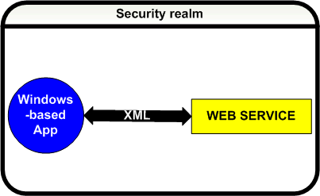
Figure 6. Authentication within a single security realm.

However if we place the consumer and web service in different security realms we immediately run into a problem. An example of two security realms in this context would be separate Active Directory forests that have no preexisting trusts in place. As soon as the user hits the web service in the other security realm, there will be a need to authenticate against the end point system (referred to as the resource domain).

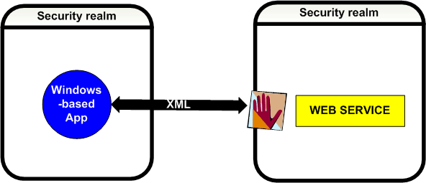
Figure 7. Crossing two different security realms.

This need for seamless single sign across security realms on is a common challenge within the industry and there have been a number of excellent approaches introduced to help overcome the problem - at least where it pertains to the one organization. Some of the more common approaches are described in the following table.

Approach | Description | Strengths and weaknesses
Trusts | Create a direct trust between the two security realms.  E.g. Active Directory Trusts. | In Active Directory it is relatively easy to implement simple trusts. This makes it a powerful way to connect and manage two organizational security domains. However, when the number of trusts increases significantly, this approach runs into a limitation in terms of practical manageability. Too many trusts results in an overly complex environment.  When the security boundary is crossing to another  organization, there are also practical challenges to using this approach. Typically an IT security group has spent a great deal of time diligently helping to protect against any outside access. Opening up a trust to another organization in this fashion is sometimes perceived as counter to these efforts and can be met with understandably high resistance. This is because of the broad ramifications of a direct trust.  There are additional complexities both technical and in terms of ensuring that the trusts are appropriate. For example, on a technical level, may be important considerations in terms of setting up VPN and performance.
Directory store  synchronization | Proliferate the user’s claims across different directory stores through directory synchronization. Examples of some technologies that harness this approach across platforms are Microsoft MIIS, Oracle OID and IBM Tivoli Identity Manager. | The fundamental philosophy of this approach is to make the user’s identity exist in several different identity stores. The advantage is that a user password change only needs to be performed once. This helps reduce manual intervention and exposure. It also helps to achieve single sign-on within an organization. Many organizations see good cost savings in terms of managing their users across different directories. These tools are excellent for helping to achieve directory consolidation.  There are downsides to this approach and there are operational costs associated with setting up and maintaining synchronization across many directory stores. If the directory contains a large number of items there are important operational considerations to avoid the risks of down time.  Getting this solution in place across two organizations implies additional levels of management and complexity and there are security issues that result in the need for careful planning and monitoring. This approach is also dependent on full compatibility of the tool across all directories and versions.
PKI  (Public Private  Key Infrastructure) | Each user present as private key certificate to  the authenticating resource domain. | Organizations have attempted to adopt this approach  with varying degrees of success. While the PKI approach is based on standards the implementation may result in significant management overhead for the issuance, maintenance and release of certificates.  Without a standard in place to map the certificate to the end point directory, the onus is on each organization to manage this. Again, there are numerous proprietary ways to accomplish this with complexity and manageability being the #1 limitation when it comes to scaling.
Proprietary  Single Sign-On  solutions | A number of vendors enable single sign on by providing SSO agents that are loaded onto web servers in the organization. The agents intercept web server requests, verify the identity and then redirect to the relevant web site. | This approach is intended to make the authentication process to multiple security realms transparent. It is very effective where there are a number of authentication stores within the same organization.  Once the need arises to expand the SSO experience across organizational boundaries, this approach is dependent on whether the necessary agent is in place and whether they are compatible. Referring back to the limitations of the trust approach, there may be challenges here both organizationally to gain agreement as well as complexities and cost.  There has been an increase in vendor acquisitions in the identity management and SSO space. For this reason some organizational are looking to decouple reliance on a single vendor solution and are seeking those vendors who follow a more standards based approach.  Since these rely on proprietary technical solutions, there may not be compatibility with the industry standards and this can make it difficult to extend these approaches to web services.
SAML (Security Assertion Markup Language) | Some SSO vendors have also adopted a standard specification called SAML to provide a level of federated identity. | The use of SAML has been a major step forward because it moves away from proprietary solutions for SSO and this makes a difference when two organizations are looking to federate. This approach has been used successfully to enable browser based SSO resulting in a reduced dependency on having proprietary solutions in place across the different security realms.  SAML plays a very important role in federated identity but relying on SAML alone does not address some of the broader authentication requirement for web services.

Considering the goal of connected systems to access applications through web services across platforms and eventually across organizations, there are limitations with all of these approaches. While there are excellent examples of where each method has solved unique authentication problem, there is a need to standardize and simplify the authentication story further if we want to reach to vision if connected systems. Such an industry standard has been evolving with direct involvement from many of the vendors in the single sign-on space. We now have a more efficient way to meet the authentication challenge for web services based on open standards. This is outlined in the standards section below and is a key part of the approach outlined in this paper.

Standards and specifications for Web Services
Understanding the standards bodies and participant workshop process

One of the main drivers that has significantly accelerated the uptake of web services is the progress made within the standards space. Architects are seeing more and more confirmation that web services and a service oriented approach will be embraced and supported by the industry, their peers and major IT vendors. There are three organizations that have played a particularly important role in setting the standards for web services thorough major vendor participation:

W3C (World Wide Web Consortium)
An industry consortium. Services provided include: a repository of information about the World Wide Web for developers and users, and various prototype and sample applications to demonstrate use of new technology. Over 400 organizations are Members of the Consortium. Examples of standards that have been defined by this body are HTML, XML and SOAP.
OASIS (Organization for the Advancement of Structured Information Standards)
OASIS is a not-for-profit, international consortium that drives the development, convergence, and adoption of e-business standards. OASIS has more than 4,000 participants representing over 600 organizations and individual members in 100 countries. UDDI, PKI, WS-Security are just a few of the standards from this organization.
WS-I (Web Services Interoperability organization)
Until February 2002 much of the work on improving interoperability of SOAP messages was conducted at more of a grass roots level. The emergence of an organization called WS-I has formalized these efforts through such deliverables as Basic Profile, test tools and sample implementations and guidelines. WS-I is an open industry organization chartered to promote Web services interoperability across platforms, operating systems and has over 120+ members.

There is a set of recommendations specifically focused on Web Service that has had excellent participation from major vendors. These specifications are generally referred to as WS star (WS*). The list below is just a sub set of the many industry vendors who are listed as having participated in WS* workshops. At the time of writing there have been a number of mergers and acquisitions in the vendor space. Some more recent examples are indicated in brackets.

IBM Sun Microsoft Oracle (Oblix) WebMethods
Systinet BEA Layer 7 Computer Associates (Netegrity)
BMC (OpenNetworks) Intel SAP Ping Identity Verisign

A major milestone for security of web services in 2004 was the broad ratification by the vendor community of WS-Security. There is a structured process for reaching consensus with the WS* specifications and it is intended to get representative industry input to a specification as it is perfected. Workshops are often held to demonstrate a working prototype and one example was the multi-vendor workshop held in May 2004 to demonstrate WS-Federation between multiple vendors. There are many steps to final ratification and this typically results in a close working relationship between vendors especially at the feedback and interoperability workshops.
The high level process for WS* specifications:
- Vendors collaborate to publish a specification
- Feedback and interoperability workshops are held
- Specification is revised
- Specification submitted to the standards organization
- Standards organization reviews and agree on any changes
- Standards organization ratifies the specification

A more recent trend that has been very much welcomed by the development community is the progress made to achieve closer collaboration between major vendors. In December 2004 a specification on standardization for server management called WS-Management was released. It was jointly authored by several vendors including Microsoft, Sun, Intel and AMD.
In April 2005, Sun and Microsoft jointly announced a set of significant initiatives to increase interoperability between the worlds of UNIX and Windows®.
The WS* set of specifications address the core requirements of service orientation of making web services secure, reliable and transactional. Covering the entire spectrum of WS* specifications is not a goal of this paper although full set of references are provided at the appendix section of this paper.
Figure 8. Web Services Architecture

In the context of this paper however, it is very important to have an understanding of the relevant WS* specifications relating to security, authentication and interoperability. The following sections provide an overview.

Basic standards that underpin a web service

Much like the evolution of XML and HTML, the core standards and specifications that underpin web services have shifted from being regarded as an emerging technology, to a becoming widely accepted as an industry standard embraced by the IT industry. Given the momentum of adoption of web services by major vendors and the milestone announcements on fully ratified standards, we have clearly moved into the phase where web services is now accepted as an industry standard approach. When considering the implementing web services especially for interoperability, there are some important points relating to standards that we need to be aware of.

A brief glance at the list of specifications from standards bodies like Oasis will make it easy to see why those new to the area can become a somewhat overwhelmed. The good news is that there has been tremendous progress in the area of developer tools that are made available to help simplify creation, usage and ensure conformance.

Tools for creation of web services are available from Sun, IBM, Systinet, Microsoft and BEA among others.
As an example, the Web Services Enhancements (WSE) add on for Microsoft Visual Studio will help expedite the effort by automatically generating the necessary code structures to help ensure conformity to the necessary standards of WS-I for interoperability.

The WS-I organization is focused primarily on interoperability and is supported by major vendors. This organization was formed in recognition of the fact that cross platform interoperability is a key requirement to achieve the vision of connected systems everywhere. It is important to note that within each standard (such as WSDL); there are subtle nuances that need to be clarified to help ensure successful interoperability across platforms. Just making a web service compliant with the WSDL and SOAP standards will not ensure a successful interaction across platforms. The WS-I organization has therefore defined what it is referred to as the WS-I Basic Profile which defines what standards need to be used and how, in order for successful interoperability to occur. The Basic Profile defines in much more granular detail the correct implementation of the core standards by removing ambiguity through clarification and restriction.

The basic elements of a web service using WS-I Basic Profile 1.0
Purpose | Standard and version | Description
Transport | HTTP 1.1 | Hyperlink Transport protocol.  Standard way to communicate over the wire.
Data | XML 1.0 | Extensible Markup Language.  Standard way to express data.
Data structure (schema) | XSD 1.0 | Extensible schema definition.  Standard way to express the structure of the data.
Web service usage description | WSDL 1.1 | Web Service Description Language.  Standard way to describe how the web services are used.
The service (application interface) | SOAP 1.1 | Simple Object Access Protocol.  Standard way to expose application functionality.
The way to locate a web service | UDDI 2.0 | Universal Data and Description Language.  Standard way to locate a service or make it universally available.

IT vendors continue to release development tools or enhancements that help automate the coding required to implement the above standards.

There is ongoing collaboration between major vendors to provide guidance on how to build web services that interoperate across platforms. In addition to defining the basic profile, WS-I also provides guidance and tools on interoperability. WS Basic Profile 1.1 provides further clarification for release in 2005.
In the case of Microsoft, Visual Studio with the Web Services Enhancements (WSE) already helps reduce the time and effort needed to build WS-I Basic Profile compliant web services. The next major release for web services and SOA slated for release in 2006 is code named ‘Indigo’.
This is a set of .NET technologies for building and running connected systems. It is a new breed of communications infrastructure built around the Web services architecture. The vision is to remove the plumbing by automatically handling the underlying code relating to web services and allow the developer to focus purely on the business problem.

Standards for security and authentication in web services

One of the most important milestones along the road to reaching the vision of connected systems has been the ratification and broad vendor support of key standards relating to security.

We needed a standard way to attach a security identity to a SOAP message so that authentication can occur. We also needed a standard way to sign and encrypt the SOAP message. SSL provided a good solution for point to point communications. However it was not conducive to a SOAP message in a web services world that may traverse many points before reaching an end point.

WS-Security.

The web services security (WS-Security) specification was ratified by OASIS in 2004 with support from a long list of major vendors including IBM, Microsoft, SUN and Oracle, Verisign and RSA. Taking advantage of existing security mechanisms like Kerberos and X509, WS-Security provides a standard way to implement a consistent security approach for web services in three key areas:

Authenticity Using a ‘security token’ to pass information that can be used for authorization and identification. E.g. Kerberos, X509 certificate, SAML.

Integrity Ensuring no one has tampered with the
message. This means digitally signing it and the standard harnessed here is XML-DSIG.

Confidentiality Helping to protect the contents through
encryption using XML-ENC.

WS-Security is now a fully ratified OASIS standard support by key vendors that is the first steps in allowing security credentials to be used by Web services across platforms. The OASIS specifications for WS-Security are laid in more detail on the OASIS site

This information is passed within the header of a SOAP message. With WS-Security as the basic foundation, there are a set of complimentary specifications used to round out the web services security picture. These specifications are important when we want to address the federated identity problem.

Security token. A standard way to pass credentials.

A security Token contains information needed to validate the identity of the caller. Tokens can therefore contain things like a User Name, a password, an X509 certificate or a Kerberos ticket. Security experts often refer to these elements as security principals. By passing this information within the WS-security specification the caller is making an assertion or claim as to their authenticity. Security tokens are basically a collection of one or more claims about identity, capability, or privilege.

The Secure Assertion Markup Language (SAML) token is a type of security token that is particularly important when we want to build on WS-Security to use web services across security boundaries (federated identity). SAML provides for a standard way to exchange authentication and authorization information using XML format. It is a token type used by WS-Federation.

WS-Trust. A standard way to generate a security token.

Rather than force developers to have to figure out and build in the complex plumbing necessary to generate a correctly formatted security token, the WS-trust specification provides a standard way to do this. In order to issue an X509 certificate, we need to define the certificate authority. In order to generate a Kerberos ticket we need to specify a ticket granting service. The WS-trust specification uses the concept of a security token service (STS) to automatically generate the necessary security token for a given context. More importantly, WS-trust enables the concept of brokered trust. By that we mean that a security token can be issued to a caller by an entity that is outside their security realm. This is where federated identity comes into play.

What differentiates one security conversation from another is based on the information specified through WS-Policy.

WS-policy – What needs to be place before we can communicate.

The general Web Services Description Language (WSDL) is a standard specification that describes how to use and interact with a SOAP message at the core interface level. WS-policy describes at a higher level, what must be in place in order for the caller and the web service to successfully communicate in the first place. Within the general preferences and requirements defined through the WS-policy specification is a standard way to state some specifics around the overall security requirements. These policy statements are contained within a subset of the specification called WS-SecurityPolicy. It is here that the caller and the service agree on things like what type of security token needs to be used. As an example, the agreement may state that an X509 certificate must be used to digitally encrypt the message. Another example is where a policy might state that a SAML security token must be used to enable federated trust scenarios.
WS-SecurityPolicy defines what type of security mechanism will be utilized for a particular interaction. WS-trust then provides a fast way to generate the appropriate tokens through the use of a security token service (STS) and brokered trust.

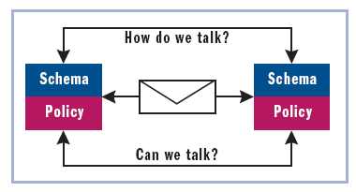
Figure 9. WS-Policy and WSDL set the ground rules of communication

WS-SecureConversation – Setting a security context for a conversation.

SSL has traditionally been used to establish a security context for a conversation. When we think about how SOAP messages can be passed around in a connected web services world, there is often a need to maintain context through many intermediary steps. SSL has some inherent challenges in making this happen. The WS-Security specification takes care of encryption. WS-trust and WS-policy take care of generating the necessary tokens for the initial identification and authorization claims. To avoid repeating the initial steps of generating a new security token for each exchange during a particular SOAP interaction, the WS-SecureConversation specification provides a way to maintain context for the duration of a particular conversation between a caller and the service. This results in better performance during the exchanges.

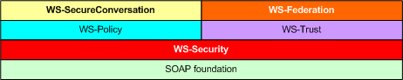
Figure 10. The WS* set of specifications are based on the core SOAP foundation.

WS-Federation – Federated Identity across organizational and security boundaries.

The specifications described above combine nicely to help enable secure invocation of web services across systems and across platforms. For the vision of connected systems, one of the most exciting specifications is WS-Federation. It builds upon WS-Policy and WS-Trust to provide a standard mechanism of enabling federation of identities across security boundaries. WS-Federation goes far beyond the pure technical considerations and addresses very practical issues that can arise when implementing brokered trust in more complex scenarios. As an example, it introduces the ability to use pseudonyms as a means to help protect privacy as a user traverses resources within other security realms. WS-Federation also provides the ability to map identities such that user JBolton in one domain can appear as JohnB in another domain.

One of the main goals of WS-Federation is to make it much easier to allow a caller to instantiate a web services or an application in a completely separate realm such as another organization. Historically the challenge has been that each organization acts as an isolated security fortress with its own security boundary. This has made it extremely difficult to establish trust through any of the normal methods without network, directory, cost or privacy related complexities.

The WS-Federation specification uses vendor neutral standards and web services to solve the problem and is based on the following overarching guiding principles.
- Reduce the cost of identity management by reducing duplication of effort; each individual's identity is almost always already managed by a trusted organization (such as the individual's bank, employer, or physician).

- Leverage the work these existing identity managers have already done by giving other parties access (as required and with appropriate privacy protection) to the relevant identity information.

- Preserve the autonomy of all parties - an identity manager's choice of authentication technology should not impose that technology on parties who rely on its identity information. An identity manager's choice of operating system, or networking protocol, or database, should not impose the same choice on its partners.

- Respect business' pre-existing trust structures and contracts. Signing up to receive identity information from an identity provider must not require an organization to establish a trust relationship with any party other than the identity provider, and must not require adoption of any specific user authentication technology.

- Help protect individuals' privacy by respecting and strongly enforcing user preferences governing the use of individually identifiable information, observing governmental and regional privacy rules, seeking the user's consent for new uses, and implementing strong recordkeeping and accountability mechanisms to ensure that privacy practices are followed.

- Build on open standards to help enable secure reliable transactions for businesses and individuals.

In the WS-Federation model, each organization has federation services components that act as a layer in front of their internal directory. In the case of Active Directory as an example, the diagram below illustrates how this would work. In this example a user in the ministry (left) access the health authority web site (right) which has its own separate directory and security boundary. The federation server components take care of all the necessary handshaking and mapping to enable a virtually seamless single sign-on user experience across both organizations.

Figure 11. High-level view of the main components enabling WS-Federation – this example with AD.

The key differentiator is that this is accomplished through industry standards. Microsoft, IBM and other vendors have agreed to support WS-Federation by making it available as in stages that align to ‘profiles’ within the specification. Vendors like Computer Associates (Netegrity), Quest (Vintela) and Centrify have been working to enable WS-Federation for the UNIX platform. These first two profiles are defined as follows:

Passive Requestor Profile: Enables federated web single sign-on for browser based applications based on WS-Federation.
Microsoft enables the passive requestor profile in 2005 through the Windows Server 2003 R2 release. Support for the active requestor profile will ship in a future Windows Server release. (Longhorn).

Active Requestor Profile: Full support for SOAP and non browser based applications.

One of the barriers to achieving seamless web services invocation over security boundaries has been that the identity of the caller needs to also exist as an identity in the destination directory. WS-Federation defines a standard way to utilize a trusted Secure Token Services (STS) to broker the job of issuing the necessary identities and avoid the need to have outside entities access their internal directory. Thus, a request from an incoming identity from a trusted source can easily be mapped to a local identity or group that has been set up to have the required access to the web services resources.

Like WS-Security, each vendor will provide support for WS-Federation by implementing their own unique technical implementation. Yet the end result is a completely standard, vendor neutral approach to federated identity. A web services developer is therefore spared from having to deal with the enormous complexities related to cross boundary security and can instead, focus more on most important goal of enabling connected systems.

In March 2004 a number of vendors participated in a workshop to demonstrate the WS-Federation passive requestor profile. The participants included some of the top vendors in the identity management and web single sign-on space - Microsoft, IBM, RSA, Oblix (now part of Oracle), BMC (Open Networks), Ping and Netegrity (now part of CA).

WS-Federation and Active Directory Federated Services

Within the WS-Federation specification, browser based single sign-on is referenced in the Passive Requestor Profile. The technology that enables federated identity on the Microsoft-based platform is called Active Directory Federated Services or ADFS. It provides support for the passive requestor profile as part of the Windows Server R2 release in 2005.

In order to take advantage of the underlying components that enable federated identity there is a need to translate the token from the ADFS Secure Token Service (STS) into a format that is easily understood by a browser – such as a cookie. ADFS provides the necessary components to perform this transformation and it is referred to as the Federation Service Proxy. It has the primary responsibility of allowing a dumb browser based application take advantage of the trust and policy mechanisms that WS-Federation provides. This really translates into web single sign-on but using a standard vendor neutral approach based on WS-Federation.

ADFS is tightly integrated with the Windows Server OS and Active Directory. It can be configured to work with any existing implementation of Active Directory running under Windows 2000 or Windows 2003. Components of ADFS are designed to take advantage of the existing integrated security capabilities of Active Directory on the Windows-based platform. As such, under certain configurations, a browser based application can utilize a web service across security boundaries by leveraging an IIS server that is running under the integrated security context of Active Directory. The cross platform authentication section later in this paper covers this and other options available to take advantage of WS-Federation.
.

The following diagram shows in the components of ADFS and how the WS-Federation Passive Requestor Profile is enabled on the Microsoft-based platform.

Active Directory Federated Services
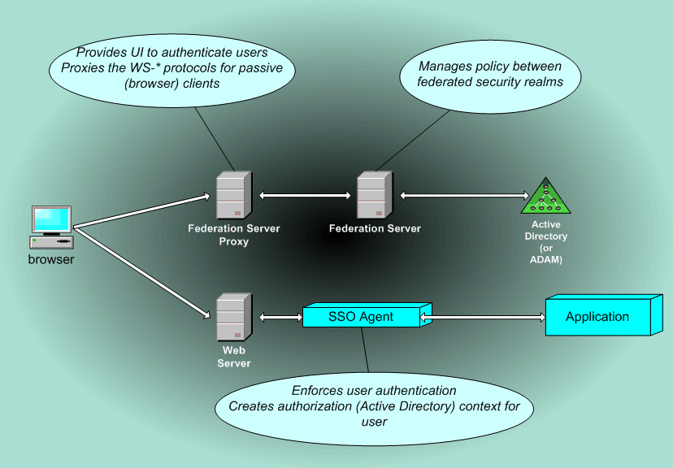

WS-Federation and the Liberty Alliance
Sun and a number of other vendors have been pursuing an alternative approach to federated identity for browser single sign-on. This is referred to as Liberty Alliance (ID-FF) and it also incorporates SAML. WS-Federation represents the approach that Microsoft and other vendors are taking as part of an overall WS* set of specifications geared towards web services.

Although both approaches harness the SAML token format, there are significant differences and the two approaches are not compatible. In recognition of the need to bridge this gap for customers, both Sun and Microsoft worked together to come up with a way to bridge the gap.

In May 2005 a joint announcement was made by Sun and Microsoft on interoperability and this included collaboration on two key specifications:

- Web Single Sign-On Metadata Exchange Protocol (Web SSO MEX)
- Web Single Sign-On Interoperability Profile (Web SSO Interop Profile).

These new specifications enable browser-based Web single sign-on between security domains that use Liberty ID-FF and WS-Federation.

In this paper we focus on the WS-Federation specification as one of the WS* series focused specifically on web services. However, both companies are working to make it seamless across platforms regardless of what approach is used.

Case Study: Standards and infrastructure in place at the BC Government

The BC Government is well positioned to take advantage specifications like WS-security and WS-Federation. Like most organizations there are technologies in place from multiple vendors including Microsoft, IBM, Sun, Computer Associates and Oracle. The Computer Associates Siteminder product has been used to enable single sign on across different applications and platforms within the BC Government.

From a core directory standpoint, the BC Government is also in a beneficial position through the existence of three directory namespaces.

IDIR : For internal BC Government usage
BCEID : For Citizens, Business and Broader Public Sector

These directories are implemented on Microsoft Active Directory.
There are significant advantages to a having central namespace such as IDIR for all users within BC Government. Any application that can leverage Kerberos can already experience a streamlined experienced. This extends beyond just the Windows-based environment through Kerberos integration with UNIX platforms.

A great deal of work has been undertaken to define policies for authentication and classification of identities through the work of the Corporate Authentication Program (CAP). The outcomes from this project will be extremely important in preparing the ground work for how and what to provision for identities. The recommendations and government policies resulting from the CAP project will be extremely important in preparing for federated identity. In order for the concept of federated identity to be adopted and accepted, there needs to be a great deal of analysis and thinking to arrive at a set of clear, comprehensive policies and guidelines that will make sense to all participating organizations.

The CAP project is heavily focused on policy as well as classification and recommendations on the usage of identities. The use of pseudonyms for example, may be required for cases where a user’s original identity must maintain a degree of anonymity as they traverse applications within other security realms. This also happens to be one of the key design goals for the WS-Federation specification.

In order for the vision of connected systems to become a reality, there needs to be a common approach to architecture, service orientation and authentication. In recognition of this fact there has been ongoing consultation with Ministries and the CIO office to formulate a more standard approach starting with the annual planning process.

The BC Government has been using Oracle Financials and Peoplesoft (HR). The Oracle databases are running on both UNIX-based and Windows-based platforms.

Web service design considerations

It pays to keep the industry directions in mind when deciding how to create, expose or consume a web service. An architect may choose to implement a web service as a very basic SOAP message and this may well accomplish a particular localized need today. In thinking about the broader ramifications of service orientated architecture and what it can mean in the future, it may make more sense to put in place the building blocks that will allow the web service to fully participate in a connected systems world.
It is beyond the scope of this paper to cover all aspects of building web services. However, in the context of building web services for cross platform authentication there are some important considerations and assumptions that need to be stated.
General guidance in the context of SOA
For the design of web services within the context of services oriented architecture, the following general principles are important to keep in mind
(An excerpt from patterns and practices: Services Oriented Integration).
- Boundaries are explicit. Crossing service boundaries can be costly. For example, you may need to span geography, trust boundaries, or execution environments. You should therefore explicitly opt into service orientation by formally passing defined messages between services. The explicit boundaries allow you to formally express implementation-independent interaction so that your interactions do not depend on the different platform, middleware, or coding language choices used to implement other services.
- Services are autonomous. There is no presiding authority in a service-oriented environment. Services are independently deployed, versioned, and managed. The topology in which a service executes evolves over time. The service should expect that peer services will fail and that it will receive malformed or malicious messages. The services should be built by using techniques such as redundancy and failover so that the services do not fail.
- Services share schema and contract, not class. Services interact solely on their expression of structures through schemas and behaviors through contracts. The service's contract describes the structure of messages and ordering constraints over messages. The formality of the expression allows machine verification of incoming messages. Machine verification of incoming messages allows you to protect the service's integrity. Contracts and schemas must remain stable over time, so building them flexibly is important.
- Service compatibility is based on policy. Services express their capabilities and requirements in terms of a machine readable policy expression. Policy assertions are identified by a stable, globally unique name. Individual policy assertions are opaque to the system as a whole; services must simply be able to satisfy each other’s policy requirements.

Guidelines for web service design for successful interoperability across platforms
Through WS-I and other associated vendor cooperation efforts, there are now excellent guidelines available to understand how to achieve better interoperability across platforms. This section provides pointers and high level guidance along with references to more in depth patterns and practices. The following are some initial pointers that can help when considering the design of a web service in preparation for interoperability:-

- Adhere to the WS-I Basic Profile guidelines and harness the guidance, test tools and sample applications that are available at WS-I.
Microsoft has been putting a lot of emphasis on providing guidance for interoperability across platforms. Some of the material is referenced here. To stay up to date on the latest documents, tools for web services interoperability guidance the best place to start is: -http://msdn.microsoft.com/webservices/building/interop

For general guidance on interoperability:-
http://www.microsoft.com/windowsserversystem/interop/default.mspx

- Design by contract. To help avoid issues with web service interoperability, start with the WSDL design first choosing data types that are supported across platforms.
- Refer to the top 10 tips for Web Services Interoperability – Video and transcript.
- Refer to the patterns and practices document on building Interoperable Web Services: WS-I Basic Profile 1.0.

Sun

In April 2004, Microsoft and Sun Microsystems entered into a landmark 10-year cooperation agreement. Microsoft and Sun remain strong competitors but are working together to improve interoperability across product lines, which in turn can help reduce costs, help increase reliability and enable customers to focus more on their core business instead of IT integration initiatives.

Through outreach and dialogue with customers, the companies recognize that accelerating the use of Web services for interoperability between the two platforms is a top priority. To that end and working with other technology partner companies, Sun Microsystems and Microsoft have co-authored several Web services specifications and are committed to building products that are interoperable by design.

References to guidance on interoperability:
- WS-Security Interoperability Using WSE 2.0 and
Sun Java Web Services Development Pack 1.5
- http://msdn.microsoft.com/webservices/building/interop.
- http://developers.sun.com/techtopics/webservices/
- http://www.microsoft.com/windowsserversystem/interop/resources/sun.mspx

A sample implementation of the WS-I sample application for Sun is available at http://www.ws-i.org/deliverables/workinggroup.aspx?wg=sampleapps. The Sample Application presents a high-level, interoperable example of a supply chain management application in the form of a set of Use Cases that demonstrate use of Web services that conform to the Basic Profile 1.0.

Oracle (Peoplesoft)

In May 2004 Oracle announced participation in the Microsoft Visual Studio Industry Partner Program (VSIP) as a premier level partner. The Visual Studio Industry Partner program is designed for Independent Software Vendors (ISV's), Systems Integrators (SI's), academic institutions, corporations and developers interested in integrating tools, components, and languages into the Visual Studio IDE.
Oracle has released a set of tools that are integrated into the Microsoft Visual Studio development suite. At the time of writing, information on the Oracle Developer Tools for Visual Studio .NET and associated information can be found at: http://www.oracle.com/technology/tech/dotnet/index.html

Oracle has published information describing how to secure web services with
WS-Security using Oracle JDeveloper 10g Release 10.1.3. Oracle has also been an active member of the WS-I, the organization with a mandate to ensure cross platform interoperability.

There has also been published information describing use of the WS-I testing tools with a web service created in Oracle JDeveloper. A sample implementation of the WS-I sample application for Oracle is available at:-
http://www.ws-i.org/deliverables/workinggroup.aspx?wg=sampleapps. The Sample Application presents a high-level, interoperable example of a supply chain management application in the form of a set of Use Cases that demonstrate use of Web services that conform to the Basic Profile 1.0.

IBM

The IBM Tivoli Federated Identity Manager is a product that IBM provides to enable support for WS-Federation and SAML.

Guidance on Web services Interoperability between Microsoft .NET Framework 1.1 and IBM WebSphere Application Developer 5.1.2 available at http://msdn.microsoft.com/webservices/building/interop.

Contract First Web Services Interoperability between Microsoft .NET and IBM WebSphere available at: http://msdn.microsoft.com/webservices/building/interop.

On demand Web casts of video instruction to accomplish cross platform interoperability of Microsoft and IBM between available at http://blogs.msdn.com/smguest/articles/webcasts.aspx.

A sample implementation of the WS-I sample application for IBM is available at http://www.ws-i.org/deliverables/workinggroup.aspx?wg=sampleapps. The Sample Application presents a high-level, interoperable example of a supply chain management application in the form of a set of Use Cases that demonstrate use of Web services that conform to the Basic Profile 1.0.

Computer Associates (Netegrity)

The Computer Associates (also known as CA) SiteMinder product has been in use at BC Government to provide a single sign-on experience for Government users. Through the workshop efforts and subsequent discussions, Microsoft and Computer Associates have been working to provide compatibility between SiteMinder and Active Directory Federated Services. CA has supported the SAML standard for some time and is committed to supporting WS-Federation in eTrust® SiteMinder Federation Security Services SP5, scheduled for release in Q2 2006.
http://www.ca.com

SAP.

There is a site dedicated providing information for Microsoft customer running SAP at: -
http://www.microsoft-sap.com
Information on the Microsoft BizTalk Adapter v2.0 for mySAP Business Suite is available at http://www.microsoft.com/biztalk/evaluation/adapter/adapters/sap/2004/default.asp.
There is case study showing how the Microsoft internal finance IT group uses smart client technology and web services to Interface with SAP, available at http://www.microsoft.com/technet/itsolutions/msit/busint/smartclientandsap.mspx.

Guidance on SAP NetWeaver and Microsoft .NET Interoperability (2005) at http://www.sdn.sap.com/irj/servlet/prt/portal/prtroot/com.sap.km.cm.docs/library/unkown/SAP%20NetWeaver%20and%20Microsoft%20.NET%20Interoperability.pdf.

BEA.

Web Services Security Interoperability Using WSE 2.0 SP3 and WebLogic Workshop 8.1.4
This article explains Interoperability based on OASIS Web Services Security (WS-Security) 1.0 between Microsoft WSE 2.0 SP3 and WebLogic Platform 8.1.4.
Web services Interoperability between Microsoft .NET Framework 1.1 and BEA WebLogic 8.1 SP3 (8.1.3). Specific guidance is available at: http://msdn.microsoft.com/webservices/building/interop

A sample implementation of the WS-I sample application for BEA is available at http://www.ws-i.org/deliverables/workinggroup.aspx?wg=sampleapps. The Sample Application presents a high-level, interoperable example of a supply chain management application in the form of a set of Use Cases that demonstrate use of Web services that conform to the Basic Profile 1.0.

Systinet.

Web services Interoperability between Microsoft .NET Framework 1.1 and Web Services Security Interoperability Using WSE 2.0 and Systinet Server 5.0 for Java. Specific guidance is available at:-http://msdn.microsoft.com/webservices/building/interop

Microsoft.

WS-I Basic Security Profile 1.0 Reference Implementation: for the .NET Framework version 1.1
The WS-I Basic Security Profile Reference Implementation is built using Web Services Enhancements (WSE) 2.0 and the .NET Framework 1.1 to illustrate how to help build resilient, real-world, interoperable Web services.

http://msdn.microsoft.com/webservices/building/interop
This site is the launch point to access specific guidance on interoperability for web services. It has separate papers and articles describing how to interoperate with each vendor. Some of the references above refer to content in this site which is hosted by Simon Guest.

http://www.microsoft.com/events/series/interopseries.mspx. Over 60 web casts dedicated to interoperability.

Cross Platform / Cross organization authentication for Web Services
Roadmap to federated identity and WS-Federation
In 2004 we saw full ratification for the OASIS WS-Security standard. Key standards like WS-Trust and WS-Policy will be further refined and submitted for final ratification in a similar manner. We can create web services today that confirm the core specification and in doing so, we are setting the foundation for the future of federation. Microsoft is making the passive requestor available for the Windows-based platform in 2005 and there are several IT vendors like CA who are making the passive requestor profile available for the UNIX world.
Microsoft is deeply committed to supporting the WS* standards. The following roadmap gives a view of what is coming to support WS* and Federation within the core products and technologies.
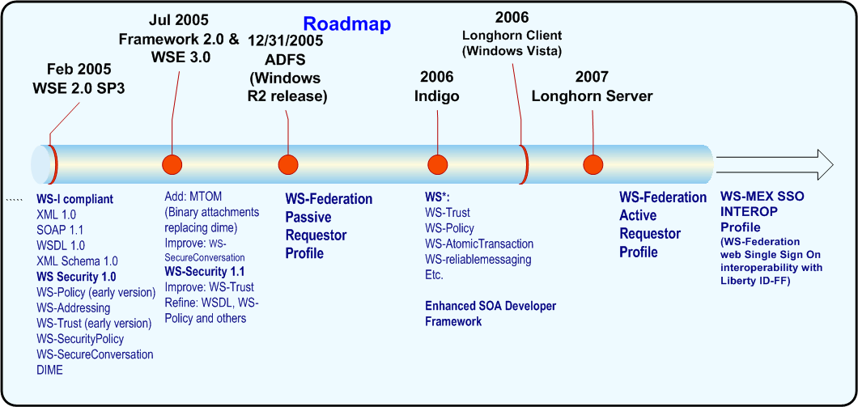

The decisions we make today when designing web services can make a big difference to how well we are positioned to take advantage of the coming federated identity models. The following sections of the paper provides options available that can harness what is available today in context of what is coming in the future for SOA, WS-federation and WS-Security.

Option 1: Web Services Security using WS-Security – lay the foundation.

The OASIS WS-Security standard has been ratified by the major industry IT vendors and supporting development tools are available today to begin creating web services that comply to both the WS-I interoperability guidelines and the WS-Security standard for authentication. Building Web Services today that comply with both of these standards will lay the foundation for WS-Federation in the future.
WS-Security provides a standard way to formulate a SOAP header such that authentication information can be passed between across vendor platforms. It does this be enabling the passing of security tokens. It also leverages the existing standards for digital signatures and encryption to provide integrity (XML-DSIG) and confidentiality (XML-ENC).

WS-Security allows us to help secure the message in an industry standard way and this is a very important and fundamental difference from the transitional approach where it was necessary to depend completely on securing the channel (e.g. SSL).

WS-Security is supported on both the UNIX and Windows-based platforms through developer tools available from a number of software vendors.
Vendors like SUN, IBM, BEA and Systinet also provide various levels of support for WS-Security on the J2EE/JAVA platform.
WS-Security basically provides an industry standard way to pass credentials SOAP message and help secure it at the message level through encryption and digital signatures.
Microsoft provides support for WS-Security using the Web Services Enhancements (WSE) toolkit for Visual Studio: http://msdn.microsoft.com/webservices/building/wse/

WS-Security and SOAP: Cross platform authentication example.
An underlying assumption of passing credentials within the SOAP message is that the claims need to be readily available and recognizable by both the caller and receiver. An example best illustrates the implications of this assumption.
A user is accessing a web based IIS application running on Windows. The application collects information on address changes and the user provides an update for their new residence. The user exists in Active Directory. The web application now needs to update this information on a back end UNIX server that is running a database application. There is a separate directory to store credential for the UNIX database application. The web service is used to expose the necessary access the database application. Using SOAP, WS-Security and the WS-I guidelines, the IIS web application calls the web service and passes the data that needs to be updated. Within the header of the SOAP message, the WS-Security standard is used to pass the user id and password that is required to access the custom database application on the UNIX platform.
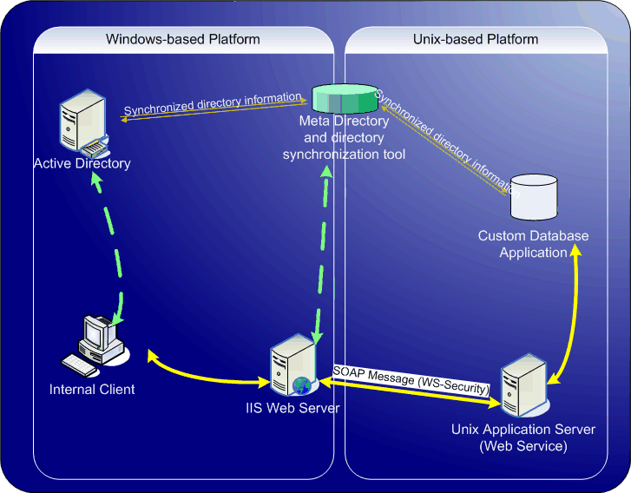
Figure 12. Example using WS-Security
Because the message is signed and encrypted, the integrity of the credentials can be validated using the WS-Security standard. With this information, the web service can connect to the back end database application and perform the update.

In the above example there are two sets of credentials for the same user. To avoid the need to have the user provide the second set of credentials, single sign-on is achieved here by replicating credentials into a meta-directory from both directory stores. This allows the credentials of Active Directory to be mapped to the customer database credentials to provide a virtually seamless single sign-on experience.
Microsoft provides a tool called MIIS to accomplish this kind of directory synchronization. MIIS can synchronize Active Directory with other directories across platforms. http://www.microsoft.com/windowsserversystem/miis2003/default.mspx

One very important implication highlighted in this example is that there is a need to have a high degree of trust in place such that user credentials used to access the back end application are known and shared by both entities. This is certainly a reasonable assumption when both applications exist within the same organization. If however, the two applications are residing in completely separate security realms across divisions or across organizations then this is where WS-Security leaves off and WS-Federation begins.
Option 1 presented here using WS-Security, will suit many requirements today and it lays the foundation for harnessing WS-Trust, WS-policy and later WS-Federation. In cases where it is either too complex or simply impractical to implement this degree of trust and identity sharing, ADFS can be used as described in the following sections.

Option 2: WS-Federation Passive Requestor Profile

WS-Federation provides a standard way to have a trust between two security realms without necessarily having to share or expose local security credentials. The pre-defined agreements that are set up between the two organizations allow each entity to decide what applications are shared and what mapping needs to take place when a security token is received. Each entity has its own federation service that handles the necessary mapping transparently and also handles the plumbing and interaction with the back end directory. The trust agreements and initial interactions are handled between the outward facing federation servers and this means that there is no need for hard-wired trusts, multiple sign-on or a shared meta-directory.
IBM and Computer Associates, Microsoft and other vendors have been working together on the passive requestor profile for WS-Federation. These vendors are releasing support for WS-Federation that will enable federated identity across platforms. Active Directory Federated Services is available in 2005 for the Windows-based platform. Taking common scenarios from within public sector BC today, the examples that follow show how WS-Federation Passive Requestor Profile would work in conjunction with other technologies such as ASP.NET. These scenarios illustrate how, with additional customization effort, we can extend ADFS beyond the basic web based SSO functionality that comes out of the box.

ADFS: Web services invocation and authentication across organizations.
The following example uses ADFS to enable a user in one security realm to consume a web services on a different platform in a completely separate security realm within another organization.

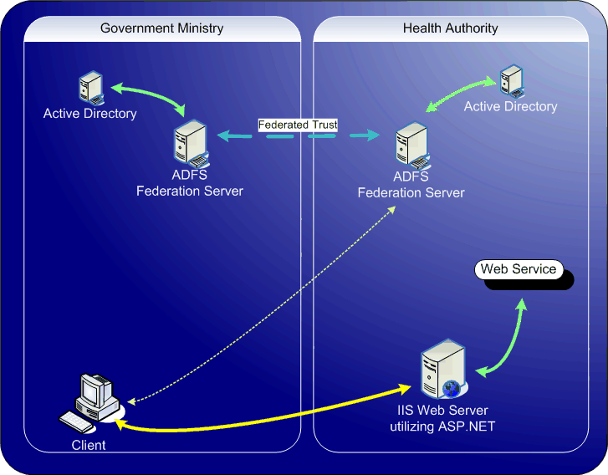
A user in a BC Government Ministry accesses a web site application running within a health authority. Access to this site is only available to users that have existing accounts within the health authority’s internal Active Directory. The Ministry user exists the BC Government IDIR directory. However, because both organizations have agreed on a federated trust policy and have federation servers in place (ADFS), the user is automatically given access to the health authority web site. The health authority federation server components, map the incoming user credentials to a local account that has been given very limited access to allow invocation of a web service.

Because o
Because of the integrated security features of Active Directory with the IIS web server, the web service can be invoked in of the local context of the federated user.

Option 3: Web Services and cross platform authentication using WS-Federation passive requestor profile and WS-Security
Building upon option 2 we can harness ADFS and the power of web services in a multi vendor platform scenario today by utilizing WS-Security.
One increasingly common scenario seen today is illustrated below where a web site is used to provide a composite view of back end applications. Using the power of federated identity, the end user (1) can accomplish browser based single sign-on to get access the web site (2). Once authenticated, the web site can then harness WS-Security to call out to a back end application (3) in the context of the end user.
Following the guidelines of WS-I for WS-Security and WS-I, the back end web service can reside on a different platform.
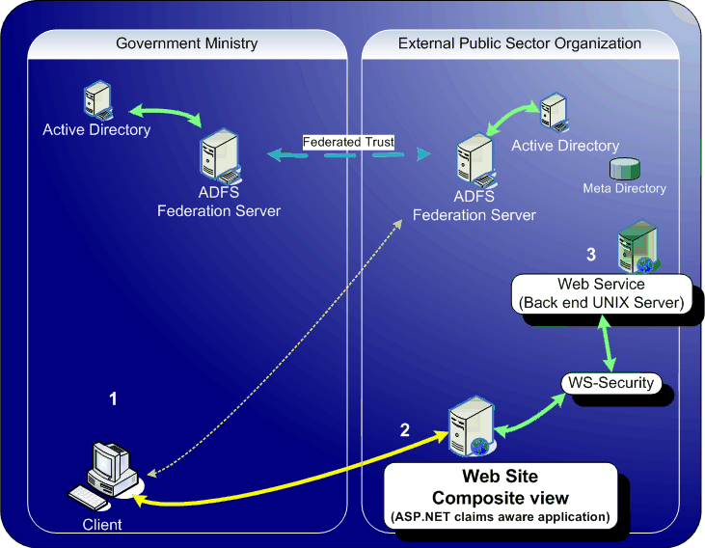

This is a very high level view of a much more complex scenario and employs directory synchronization to ensure that the local user credentials are synchronized across platforms so that the user exists in the directory store that is used by the UNIX Web Service.

Using web services to leverage existing investments across platforms

In the BC Government and across public sector, there are a large number of legacy applications running mission critical services. These include Mainframe, CICS, OS400 and older Windows based COM applications. Many years of work has been invested into evolving these applications to host critical IT services for the BC Government. As such, they are likely to remain in place for some time. We must therefore look at ways to make some of these key business functions available and interoperable with other platforms like Windows. In light of the vision we are outlining of truly connected systems across platforms this also means that we need to examine how to expose these legacy functions as web services.
Mainframe legacy applications

A number of tools are available from different vendors to help leverage the investments in the mainframe environment. Screen scraping tools have been broadly used as one way to access the data in these legacy systems. Another powerful approach accomplishes this through business logic interfaces. This approach can achieve impressive results for example by exposing a CICS transaction as a web service.
Microsoft Host Integration Server (HIS) takes care of the plumbing necessary to map from IBM S390/ OS400 world to the Windows-based platform. A component of HIS called Transaction Integrator allows a system administrator to expose a CICS transaction as a web service. It performs the same type of cross platform translation between Active Directory and the OS400 platform. Transaction Integrator is used for integration with CICS, IMS applications on IBM mainframes, and RPG applications on OS/400. HIS also provides a web service to access Host data providers like VSAM and DB2. The diagram below is a high level view of how we address the two top challenges in this space:
      - Exposing a CICS transaction as a web service using HIS transaction integrator.
      - Cross platform authentication using HIS Enterprise Single Sign on (ESSO)
ESSO provides the ability to have a virtually seamless mapping between a user’s identity stored in Active Directory and their identity stored on the Mainframe. ESSO takes care of password synchronization.
Some of the collaboration and productivity technologies in use today at BC Government are Office and Windows SharePoint Services.
MSDN Webcast: IBM Systems: Using Host Integration Server to Expose Mainframe and Midrange Applications as XML Web Services available at http://msevents.microsoft.com/cui/WebCastEventDetails.aspx?EventID=1032265814&EventCategory=5&culture=en-US&CountryCode=US.

.

Exposing COM based legacy applications as web services
Prior to the .NET framework on the Windows-based platform, many applications were developed using the Component Object Model (COM+). Exposing these as web services can be accomplished by utilizing a technique called a COM wrapper within in the .NET framework. This opens the COM+ application up the .NET framework and in turn, enables the COM object to be exposed as a web service. Microsoft Enterprise Services (ES)¹ provides a powerful framework for building connected systems that leverages both the .NET framework as well as legacy COM+ applications.

Further guidance for developers is provided in the patterns and practices: Web Service Façade for Legacy Applications²

¹http://msdn.microsoft.com/library/en-us/dnanchor/html/enterpriseservices.asp
²http://msdn.microsoft.com/library/default.asp?url=/library/en-us/dnpag/html/wsfacadelegacyapp.asp

Leveraging web services with Microsoft Office
Using Visual Studio Tools for Office (VSTO) we can already extend the power of familiar productivity tools in Office 2003¹. This allows a developer working in Visual Studio to consume web services within Office. For a more elaborate enterprise solution, the Information Bridge Framework² allows data and actions from web services to be consumed within Office in the context of the e-mail messages, documents, spreadsheets, and forms that information workers interact with on a daily basis. Using intelligent smart tags within the Office suite, the data from the web service can be contextualized to optimize productivity. The Information Bridge Framework (IBF) is available for any licensed user of Office 2003 today.
The next major release of Office releasing in 2006³ will further refine the virtual seamless connectivity between client and backend systems through web services. It uses industry standard XML as the default file format. This transparent file format extends Office interoperability across platforms. This release also provides a mechanism to expose the input and output from a spreadsheet using Excel as a web service.
¹http://msdn.microsoft.com/office/understanding/vsto/
²http://msdn.microsoft.com/office/understanding/ibframework/default.aspx
³http://www.microsoft.com/office/preview

The Developer Tools to support web services and SOA

Throughout this paper we have referenced the standards and tools available from multiple vendors that enable the design of web services for cross platform authentication. Here we will dive deeper into some of the tools utilized by from vendors who have participated in providing the WS-I sample application for basic profile, or who have been tested for interoperability with web services on the Microsoft-based platform. We will also provide a roadmap showing the interoperability and WS* standards support that will be coming from Microsoft.

Java based tools supporting WS standards and interoperability

Software companies like IBM, SUN and Microsoft are putting a focus on making tools available that will enable greater web services interoperability across platforms. Harnessing the work of the WS-I organization, vendors are providing sample applications to demonstrate interoperability using their developer toolsets. The following table outlines some of the developer toolsets from various vendors that have been used to demonstrate cross platform interoperability. Updated versions of these tools may have been made available since this paper was produced.

Java / J2EE based toolsets | WS-I basic profile sample application provided. http://www.ws-i.org | Specific Guidance available on interoperability with Microsoft .NET Framework 1.1 and WSE 2.0. All direct links below are available at:  http://msdn.microsoft.com/webservices/webservices/building/interop
Sun Java Web Services Development Pack  www.sun.com | http://www.ws-i.org/deliverables/workinggroup.aspx?wg=sampleapps | WS-Security Interoperability Using WSE 2.0 and Sun Java Web Services Development Pack 1.5  http://msdn.microsoft.com/webservices/webservices/building/interop/default.aspx?pull=/library/en-us/dnbda/html/wssinteropjwsdp15.asp
IBM WebSphere  www.ibm.com | http://www.ws-i.org/deliverables/workinggroup.aspx?wg=sampleapps | Web Services Interoperability Guidance (WSIG): IBM WebSphere Application Developer 5.1.2  http://msdn.microsoft.com/webservices/webservices/building/interop/default.aspx?pull=/library/en-us/dnbda/html/wsinteroprecsibm-final.asp
BEA WebLogic  www.bea.com | http://www.ws-i.org/deliverables/workinggroup.aspx?wg=sampleapps | Web Services Security Interoperability Using WSE 2.0 SP3 and WebLogic Workshop 8.1.4  http://msdn.microsoft.com/webservices/webservices/building/interop/default.aspx?pull=/library/en-us/dnbda/html/WSSInteropWbLg.asp
Systinet Server  www.systinet.com |  | Web Services Security Interoperability Using Web Services Enhancement 2.0 and Systinet Server 5.0 for Java  http://msdn.microsoft.com/webservices/webservices/building/interop/default.aspx?pull=/library/en-us/dnbda/html/wssecsysnet.asp
Oracle Jdeveloper  www.Oracle.com | http://www.ws-i.org/deliverables/workinggroup.aspx?wg=sampleapps

Microsoft tools supporting WS standards and interoperability
Using the Web Services Enhancements (WSE) with Microsoft Visual Studio today, there is already built in support for some of the key Oasis WS standards like WS-Security. By harnessing WSE, a developer can create a WS-I compliant web service without having to manually write the code required to make it work. This level of extraction is one of the key design goals of Visual Studio and WSE today and it will continue to be a focus so that eventually, a developer can implement web services security using just a few lines of code.
As the standards refine to a sufficient level of maturity, new releases of WSE are made available for developers. WSE provides the capability to build web services that comply with WS-I and WS-Security which means that developers can begin using the core foundation for OASIS web services security. New releases of WSE and Visual Studio in 2005 will make it easier create web services but with less code.
As part of a long term vision to make it even easier to realize the vision of connected systems and simplify design and development based on SOA, a new release code named Indigo will dramatically change the way that developers design and develop systems using web services. For more information see: http://msdn.microsoft.com/webservices/indigo/default.aspx
All the core WS* standards are supported in Indigo and this includes support for some of the most complex evolving standards like WS-AtomicTransaction.

References

SiteMinder is a registered trademark of Computer Associates International, Inc.

"IBM" is both a trademark of International Business Machines Corporation, and an abbreviation of its company name.

WebSphere is a registered trademark of IBM.

Java and Java Web Services Development Pack are trademarks of Sun Microsystems, Inc.

IBM Tivoli Federated Identity Manager is a registered trademark of IBM.

Oracle, Jdeveloper, JD Edwards and PeopleSoft are registered trademarks of Oracle Corporation and/or its affiliates.

WebLogic is a registered trademark of BEA Systems, Inc.

Visual Studio, BizTalk Server, SharePoint Server, SQL Server, Host Integration Server are registered trademarks of Microsoft Corporation.

Windows, Windows Server and Active Directory are registered trademarks of Microsoft Corporation.

Web Services.
http://msdn.microsoft.com/webservices/understanding/advancedwebservices/default.aspx

Web Services Specifications.
http://msdn.microsoft.com/library/default.asp?url=/library/en-us/dnglobspec/html/wsspecsover.asp
Security in a Web Services World: A Proposed Architecture and Roadmap. A Joint White Paper from IBM Corporation and Microsoft Corporation. http://msdn.microsoft.com/library/default.asp?url=/library/en-us/dnwssecur/html/securitywhitepaper.asp
Federation of Identities in a Web Services World.
http://www-128.ibm.com/developerworks/library/specification/ws-fedworld
or
http://msdn.microsoft.com/webservices/understanding/advancedwebservices/default.aspx?pull=/library/en-us/dnglobspec/html/ws-federation-strategy.asp
Federated Identity Management Interoperability. WS-Federation Passive Requestor Profile Interoperability Workshop.
http://msdn.microsoft.com/webservices/understanding/specs/default.aspx?pull=/library/en-us/dnwebsrv/html/wsfedinterop.asp
Kerberos. J. Kohl and C. Neuman, "The Kerberos Network Authentication Service (V5)", RFC 1510, September 1993.
http://www.ietf.org/rfc/rfc1510.txt
SOAP. W3C Note, "SOAP: Simple Object Access Protocol 1.1"`
http://www.w3.org/TR/2000/NOTE-SOAP-20000508
XML-Encrypt. W3C Working Draft, "XML Encryption Syntax and Processing",
http://www.w3.org/TR/xmlenc-core

XML Signature. W3C Proposed Recommendation, "XML Signature Syntax and Processing",
http://www.w3.org/TR/2001/PR-xmldsig-core-20010820

WS-Security Roadmap. "Security In A Web Services World: A Proposed Architecture and Roadmap", IBM, Microsoft.
http://msdn.microsoft.com/library/default.asp?url=/library/en-us/dnwssecur/html/securitywhitepaper.asp
WS-Security.
Web Services Security: SOAP Message Security 1.0.
http://docs.oasis-open.org/wss/2004/01/oasis-200401-wss-soap-message-security-1.0.pdf
"Web Services Security Language", IBM, Microsoft, VeriSign.
http://msdn.microsoft.com/webservices/default.aspx?pull=/library/en-us/dnglobspec/html/ws-security.asp
"WS-Security Addendum", IBM, Microsoft, VeriSign.
http://msdn.microsoft.com/webservices/default.aspx?pull=/library/en-us/dnglobspec/html/ws-security-addendum.asp
"WS-Security XML Tokens", IBM, Microsoft, VeriSign.
http://msdn.microsoft.com/webservices/default.aspx?pull=/library/en-us/dnglobspec/html/ws-security-xml-tokens.asp

WS-Policy.
BEA, http://ftpna2.bea.com/pub/downloads/WS-Policy.pdf
IBM, ftp://www6.software.ibm.com/software/developer/library/ws-policy.pdf
Microsoft, http://msdn.microsoft.com/ws/2004/09/policy/
SAP, http://ifr.sap.com/ws-policy/ws-policy.pdf

WS-SecurityPolicy.
"Web Services Security Policy Language", IBM, Microsoft, RSA, VeriSign.
http://msdn.microsoft.com/webservices/default.aspx?pull=/library/en-us/dnglobspec/html/ws-securitypolicy1202.asp
IBM, http://www-106.ibm.com/developerworks/library/ws-secpol/
Microsoft, http://msdn.microsoft.com/ws/2002/12/ws-security-policy/
Verisign, http://www.verisign.com/wss/WS-SecurityPolicy.pdf

WS-PolicyAttachment.
"Web Services Policy Attachment Language", BEA, IBM, and Microsoft, SAP.
http://msdn.microsoft.com/webservices/default.aspx?pull=/library/en-us/dnglobspec/html/ws-policyattachment1202.asp
BEA, http://ftpna2.bea.com/pub/downloads/WS-PolicyAttachment.pdf
IBM, ftp://www6.software.ibm.com/software/developer/library/ws-polat.pdf
Microsoft, http://msdn.microsoft.com/ws/2004/09/policyattachment/
SAP, http://ifr.sap.com/ws-policy/ws-policyattachment.pdf

WS-PolicyAssertions. "Web Services Policy Assertions Language", BEA, IBM, Microsoft, SAP.
http://msdn.microsoft.com/webservices/default.aspx?pull=/library/en-us/dnglobspec/html/ws-policyassertions.asp

WS-Trust.

"Web Services Trust Language", IBM, Microsoft, RSA, VeriSign.
http://msdn.microsoft.com/webservices/default.aspx?pull=/library/en-us/dnglobspec/html/ws-trust1202.asp
IBM, http://www-106.ibm.com/developerworks/library/specification/ws-trust
Microsoft, http://msdn.microsoft.com/ws/2004/04/ws-trust
Verisign, http://www.verisign.com/wss/WS-Trust.pdf
WS-SecureConversation.
"Web Services Secure Conversation Language", IBM, Microsoft, RSA, VeriSign.
http://msdn.microsoft.com/webservices/webservices/understanding/specs/default.aspx?pull=/library/en-us/dnglobspec/html/ws-secureconversation1202.asp
IBM, http://www-106.ibm.com/developerworks/library/specification/ws-secon/
Microsoft, http://msdn.microsoft.com/ws/2004/04/ws-secure-conversation/
Verisign, http://www.verisign.com/wss/WS-SecureConversation.pdf

WS-ReliableMessaging.

"Web Services Reliable Messaging Protocol", BEA, IBM, Microsoft, TIBCO.
http://msdn.microsoft.com/webservices/webservices/understanding/specs/default.aspx?pull=/library/en-us/dnglobspec/html/ws-reliablemessaging0303.asp
WS-Federation
"Web Services Federation Language", BEA, IBM, Microsoft, RSA Security, VeriSign.
http://msdn.microsoft.com/webservices/webservices/understanding/advancedwebservices/default.aspx?pull=/library/en-us/dnglobspec/html/ws-federation.asp
"Web Services Federation Language: Passive Requestor Profile", BEA, IBM, Microsoft, RSA Security.
http://msdn.microsoft.com/webservices/webservices/understanding/advancedwebservices/default.aspx?pull=/library/en-us/dnglobspec/html/passive-client-profile.asp
"Web Services Federation Language: Active Requestor Profile", BEA, IBM, Microsoft, RSA Security, VeriSign.
http://msdn.microsoft.com/webservices/webservices/understanding/advancedwebservices/default.aspx?pull=/library/en-us/dnglobspec/html/grfWS-FederationActiveRequestorProfile.asp

WS-I. Web Services Interoperability Organization, http://www.ws-i.org
WSIBP. WS-I Basic Profile 1.0, http://www.ws-i.org/Profiles/BasicProfile-1.0-2004-04-16.html
WSIBSP. WS-I Basic Security Profile 1.0 (WSIBSP), http://www.ws-i.org/Profiles/BasicSecurityProfile-1.0-2004-05-12.html
WSS-Username-Profile. Web Services Security: UsernameToken Profile 1.0.
http://docs.oasis-open.org/wss/2004/01/oasis-200401-wss-username-token-profile-1.0.pdf
WSS-X509-Profile. Web Services Security: X.509 Certificate Token Profile 1.0.
http://docs.oasis-open.org/wss/2004/01/oasis-200401-wss-x509-token-profile-1.0.pdf
WSS-Kerb-Profile. Web Services Security Kerberos Token Profile 1.0
http://www.oasis-open.org/committees/download.php/6394/oasis-xxxxx-wss-kerberos-token-profile-1.0.pdf
WSS-XMLTok-Profile. WS-Security Profile for XML-based Tokens.
http://www-106.ibm.com/developerworks/webservices/library/ws-sectoken.html

WS-MetadataExchange
SUN, http://developers.sun.com/techtopics/identity/interop/web_sso_mex_may2005.pdf
BEA, http://ftpna2.bea.com/pub/downloads/WS-MetadataExchange.pdf
IBM, ftp://www6.software.ibm.com/software/developer/library/WS-MetadataExchange.pdf
Microsoft, http://msdn.microsoft.com/ws/2004/03/ws-metadataexchange/
SAP, http://ifr.sap.com/ws-metadataexchange/WS-MetadataExchange.pdf
SAML. Web Services Security SAML Token Profile.
http://www.oasis-open.org/committees/download.php/7837/WSS-SAML-15.pdf

Glossary

Terminology
Because terminology varies between technologies, this document defines several terms that may be applied consistently across the different security formats and mechanisms. Consequently, the terminology used here may be different from other specifications and is defined so that the reader can map the terms to their preferred vocabulary.
Passive Browser - A passive browser is an HTTP browser capable of broadly supported HTTP (e.g. HTTP/1.1).
Active Requestor - An active requestor is an application (possibly a Web browser) that is capable of issuing Web services messages such as those described in WS-Security and WS-Trust.
Profile - A profile is a document that describes how this model is applied to a specific class of requestor (e.g., passive, or active).
Claim - A claim is a declaration made by an entity (e.g. name, identity, key, group, privilege, capability, attribute, etc).
Security Token - A security token represents a collection of claims.
Signed Security Token - A signed security token is a security token that is asserted and cryptographically signed by a specific authority (e.g. an X.509 certificate or a Kerberos ticket)
Proof-of-Possession - Proof-of-possession is authentication data that is provided with a message to prove that the message was sent and or created by a claimed identity.
Proof-of-Possession Token - A proof-of-possession token is a security token that contains data that a sending party can use to demonstrate proof-of-possession.
Digest - A digest is a cryptographic checksum of an octet stream.
Signature - A signature is a value computed with a cryptographic algorithm and bound to data in such a way that intended recipients of the data can use the signature to verify that the data has not been altered since it was signed by the signer.
Security Token Service (STS) - A security token service is a Web service that issues security tokens (see WS-Security and WS-Trust). That is, it makes assertions based on evidence that it trusts, to whoever trusts it. To communicate trust, a service requires proof, such as a security token or set of security tokens, and issues a security token with its own trust statement (note that for some security token formats this can just be a re-issuance or co-signature). This forms the basis of trust brokering.
Attribute Service - An attribute service is a Web service that maintains information (attributes) about principals within a trust realm or federation. The term principal, in this context, can be applied to any system entity, not just a person.
Pseudonym Service - A pseudonym service is a Web service that maintains alternate identity information about principals within a trust realm or federation. The term principal, in this context, can be applied to any system entity, not just a person.
Trust - Trust is the characteristic that one entity is willing to rely upon a second entity to execute a set of actions and/or to make set of assertions about a set of subjects and/or scopes.
Trust Domain - A Trust Domain is an administered security space in which the source and target of a request can determine and agree whether particular sets of credentials from a source satisfy the relevant security policies of the target. The target may defer the trust decision to a third party thus including the trusted third party in the Trust Domain.
Validation Service - A validation service is a Web service that uses the WS-Trust mechanisms to validate provided tokens and assess their level of trust (e.g. claims trusted).
Direct Trust - Direct trust is when a relying party accepts as true all (or some subset of) the claims in the token sent by the requestor.
Direct Brokered Trust - Direct Brokered Trust is when one party trusts a second party who, in turn, trusts or vouches for, the claims of a third party.
Indirect Brokered Trust - Indirect Brokered Trust is a variation on direct brokered trust where the second party can not immediately validate the claims of the third party to the first party and negotiates with the third party, or additional parties, to validate the claims and assess the trust of the third party.
Message Authentication - Message authentication is the process of verifying that the message received is the same as the one sent.
Sender Authentication - Sender authentication is corroborated authentication evidence possibly across Web service actors/roles indicating the sender of a Web service message (and its associated data). Note that it is possible that a message may have multiple senders if authenticated intermediaries exist. Also note that it is application-dependent (and out of scope) as to how it is determined who first created the messages as the message originator might be independent of, or hidden behind an authenticated sender.
Realm or Domain - A realm or domain represents a single unit of security administration or trust.
Federation - A federation is a collection of realms/domains that have established trust. The level of trust may vary, but typically includes authentication and may include authorization.
Identity Provider - Identity Provider is an entity that acts as a peer entity authentication service to end users and data origin authentication service to service providers (this is typically an extension of a security token service).
Single Sign-On (SSO) - Single Sign-On is an optimization of the authentication sequence to remove the burden of repeating actions placed on the end user. To facilitate SSO, an element called an Identity Provider can act as a proxy on a user's behalf to provide evidence of authentication events to 3rd parties requesting information about the user. These Identity Providers are trusted 3rd parties and need to be trusted both by the user (to maintain the user's identity information as the loss of this information can result in the compromise of the users identity) and the Web services which may grant access to valuable resources and information based upon the integrity of the identity information provided by the IP.
Identity Mapping - Identity Mapping is a method of creating relationships between identity properties. Some Identity Providers may make use of id mapping.
Sign-Out - A sign-out is the process by which security tokens are destroyed for a realm/domain or federation.

Federated identity related standards such as SAML and WS-Federation. Detailed in the standards section.
Extended Markup Language http://www.w3.org/XML/
Web Services Federation Language
http://msdn.microsoft.com/webservices/understanding/advancedwebservices/default.aspx?pull=/library/en-us/dnglobspec/html/ws-federation.asp
Web Services Interoperability http://www.ws-i.org
http://www.w3.org/
http://www.oasis-open.org
http://www.ws-i.org
IBM, Microsoft, Oblix, RSA, Netegrity and PingID
http://msdn.microsoft.com/webservices/community/workshops
http://developers.sun.com/techtopics/webservices/management/WS-Management.Feb.2005.pdf http://msdn.microsoft.com/library/en-us/dnglobspec/html/WS-Management.Feb.2005.pdf
http://www.microsoft.com/presspass/press/2005/may05/05-13MSSunEventPR.mspx http://www.sun.com/ http://www.sun.com/smi/Press/sunflash/2004-04/sunflash.20040402.3.html
http://www.ws-i.org
http://www.ws-i.org/Profiles/BasicProfile-1.0-2004-04-16.htmls
http://www.w3.org/Signature
http://www.w3.org/Encryption
http://docs.oasis-open.org/wss/2004/01/oasis-200401-wss-soap-message-security-1.0.pdf http://docs.oasis-open.org/wss/2004/01/oasis-200401-wss-username-token-profile-1.0.pdf http://docs.oasis-open.org/wss/2004/01/oasis-200401-wss-x509-token-profile-1.0.pdf
Federation of Identities in a Web Services World: http://msdn.microsoft.com/library/default.asp?url=/library/en-us/dnglobspec/html/ws-federation.asp Also see: http://msdn.microsoft.com/webservices/webservices/understanding/advancedwebservices
http://www.vintela.com
http://www.centrify.com
http://msdn.microsoft.com/webservices/community/workshops/wsfedprmar2004.aspx
http://www.microsoft.com/presspass/press/2005/may05/05-13MSSunEventPR.mspx http://www.sun.com/ http://www.sun.com/smi/Press/sunflash/2004-04/sunflash.20040402.3.html
http://msdn.microsoft.com/library/default.asp?url=/library/en-us/dnpag/html/archserviceorientedintegration.asp
http://www.ws-i.org.
http://msdn.microsoft.com/msdntv/transcripts/20050210WebServicesSGTranscript.aspx Video:http://msdn.microsoft.com/msdntv/episode.aspx?xml=episodes/en/20050210webservicessg/manifest.xml
http://msdn.microsoft.com/library/default.asp?url=/library/en-us/dnsvcinter/html/WSI-BP_MSDN_LandingPage.asp
Sun and Microsoft Announce New Identity Specifications and Additional Measures for Product Interoperability: http://www.microsoft.com/presspass/press/2005/may05/05-13MSSunEventPR.mspx
http://msdn.microsoft.com/library/default.asp?url=/library/en-us/dnbda/html/wssinteropjwsdp15.asp
http://www.oracle.com/technology/tech/dotnet/ or http://otn.oracle.com/dotnet
http://www.oracle.com/technology/oramag/oracle/05-jan/o15web.html
http://www.oracle.com/technology/products/jdev/howtos/10g/WS_WSI/WSI_HowTo.html
http://www-306.ibm.com/software/tivoli/products/federated-identity-mgr
http://msdn.microsoft.com/webservices/building/interop/default.aspx?pull=/library/en-us/dnbda/html/wsinteroprecsibm-final.asp
http://msdn.microsoft.com/vstudio/java/interop/websphereinterop/default.aspx
http://msdn.microsoft.com/webservices/building/interop/default.aspx?pull=/library/en-us/dnbda/html/wsinteroprecsbea.asp
http://msdn.microsoft.com/webservices/building/interop/default.aspx?pull=/library/en-us/dnbda/html/wssecsysnet.asp
http://msdn.microsoft.com/practices/default.aspx?pull=/library/en-us/dnpag2/html/MSWSIBSP.asp

