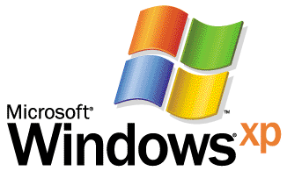

Operating System

Step-by-Step Guide to Remote Assistance
By John Kaiser
Microsoft Corporation
Published: July 2001

Abstract
This guide helps you get started using Remote Assistance, which allows an expert to connect to a novice’s computer and correct any problems directly. It includes the main scenarios used to initiate Remote Assistance sessions.

This is a preliminary document and may be changed substantially prior to final commercial release of the software described herein. The information contained in this document represents the current view of Microsoft Corporation on the issues discussed as of the date of publication. Because Microsoft must respond to changing market conditions, it should not be interpreted to be a commitment on the part of Microsoft, and Microsoft cannot guarantee the accuracy of any information presented after the date of publication.
This white paper is for informational purposes only. MICROSOFT MAKES NO WARRANTIES, EXPRESS OR IMPLIED, IN THIS DOCUMENT.
Complying with all applicable copyright laws is the responsibility of the user. Without limiting the rights under copyright, no part of this document may be reproduced, stored in or introduced into a retrieval system, or transmitted in any form or by any means (electronic, mechanical, photocopying, recording, or otherwise), or for any purpose, without the express written permission of Microsoft Corporation.
Microsoft may have patents, patent applications, trademarks, copyrights, or other intellectual property rights covering subject matter in this document. Except as expressly provided in any written license agreement from Microsoft, the furnishing of this document does not give you any license to these patents, trademarks, copyrights, or other intellectual property.

© 2001 Microsoft Corporation. All rights reserved. Microsoft, Windows, and Windows NT are either registered trademarks or trademarks of Microsoft Corporation in the United States and/or other countries.
Other product and company names mentioned herein may be the trademarks of their respective owners.
Microsoft Corporation • One Microsoft Way • Redmond, WA 98052-6399 • USA
Contents
Acknowledgements iii
Introduction 1
Remote Assistance: How it Works 2
Using Remote Assistance 3
Configuration Requirements 3
Using Remote Assistance via Windows Messenger 4
Sending a file 8
Using Remote Assistance via saving a file 10
Using Remote Assistance via e-mail 13
Offering Remote Assistance to a user 15
Configuring Group Policy for Remote Assistance 15
Administering Remote Assistance in Corporate Environments 17
Configuring Port 3389 to Enable Remote Assistance 17
Using Remote Assistance in a Home Network 17
Summary 18
Related Links 19

Acknowledgements
Mahmood Dhalla, program manager, Microsoft Corporation
John Kaiser, technical writer, Microsoft Corporation

Introduction
Computer users, particularly users without much technical expertise, often have configuration problems or usage questions that are difficult for a support professional or even just a friend or family member to diagnose and fix over the phone. Remote Assistance provides a way for users to get the help they need and makes it easier and less costly for corporate helpdesks to assist their users. Plus, experienced users can tap Remote Assistance to directly help their friends and family members.
The fastest way to use Remote Assistance is via Windows Messenger using the MSN® Messenger Service, described in the first scenario below. You can also initiate Remote Assistance sessions via e-mail, described in the second scenario below. Alternatively, you can fill out a form and save it as a file.
After receiving a request for Remote Assistance, the helper (expert) can remotely connect to a problem-PC and view the screen directly to fix the problem. When you initiate a request for help, the Remote Assistance client sends an XML-based encrypted ticket to the helper who is prompted to accept the invitation.

Remote Assistance: How it Works
Remote assistance uses Terminal Services technology, allowing a helper to assist you via a remote Terminal Services session. As shown in Figure 1 below, Remote Assistance uses a simple, secure process in establishing a connection between you and a helper. The request is encrypted in a public key and sent using XML.
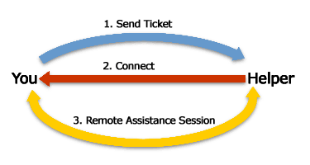

Figure 1. A high level view of Remote Assistance

Using Remote Assistance
This guide describes the following scenarios using Remote Assistance:
- Using Remote Assistance via Windows Messenger. This section shows how a home user initiates Remote Assistance via Windows Messenger to a trusted friend.
- Using Remote Assistance via saving a file. This section shows how to initiate a Remote Assistance invitation by saving the request as a file. This allows you to use Remote Assistance via Web-based e-mail such as Hotmail or other similar services.
- Using Remote Assistance via e-mail. This section explains initiating Remote Assistance via e-mail to a corporate Helpdesk. Home users can also follow this procedure to send a Remote Assistance request via e-mail.
- Offering Remote Assistance to a user. This section explains how to initiate a request to perform Remote Assistance on a user’s computer in a corporate IT environment.
- Administering Remote Assistance in Corporate Environments. This section briefly addresses notes for administrators in order to manage Remote Assistance in a corporate environment.

Configuration Requirements
You can duplicate these procedures in your own environment or lab by following the steps explained below. You will need the following configuration:
- Two computers running Microsoft® Windows® XP Professional or Windows XP Home Edition. Both computers must be connected to the Internet.

Using Remote Assistance via Windows Messenger
This section shows how a home user initiates Remote Assistance via Windows Messenger to a trusted friend.
User Paul West has just installed Windows XP Professional on his home computer and wants his My Documents folder to appear on his desktop. Paul already has a Hotmail e-mail account and uses Windows Messenger to stay in touch with friends. He turns to his friend and trusted computer expert, Cynthia Randall, whom Paul has listed as one of his Windows Messenger contacts. Cynthia is also running Windows XP and Paul can see she’s online. Paul decides to use Remote Assistance.
- Paul clicks Tools, clicks Asks for Remote Assistance, and chooses Cynthia’s e-mail address, as shown in Figure 2 below.
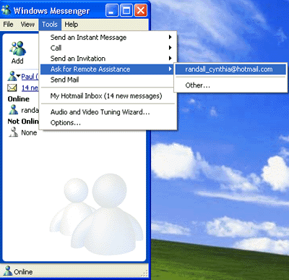

Figure 2. Starting Remote Assistance with Windows Messenger
The Windows Messenger window opens on Paul’s computer as shown in Figure 3 below.
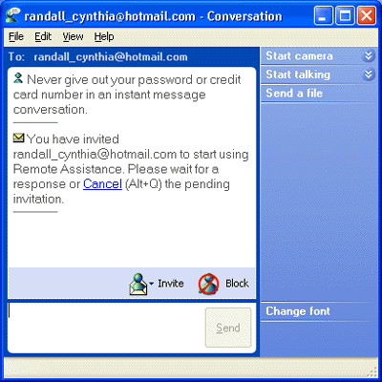

Figure 3. Inviting a friend for Remote Assistance

- Cynthia receives the invitation as an Instant Message. She clicks Accept.
- On Paul’s computer, a dialog box appears indicating that Cynthia has accepted the invitation for Remote Assistance. To initiate a Remote Assistance chat session, Paul clicks Yes.
- Cynthia’s computer attempts to connect to Paul’s computer. When the remote connection is established, the Remote Assistance session begins on Cynthia’s computer as shown in Figure 4 below.

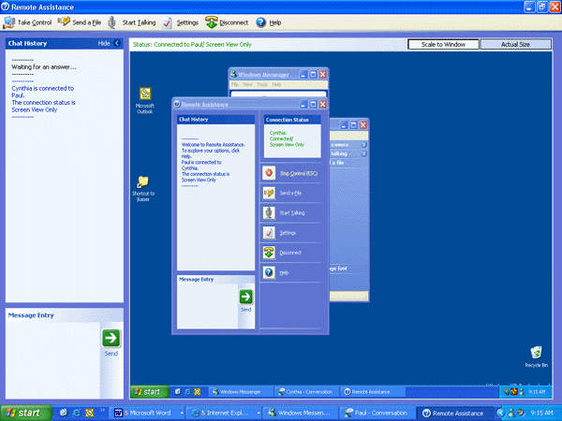

Figure 4. The expert’s view of Remote Assistance

Note the two Start menu buttons. The inside Start button controls Paul’s computer and the outside Start button controls Cynthia’s computer. Cynthia can see Paul’s desktop including his chat window in addition to her own chat window on the left side of the screen.
- At the same time, on Paul’s computer, the Remote Assistance page opens. Paul explains his request in the message entry box and clicks Send.
- Cynthia enters her response on the text window as shown in Figure 5 below.

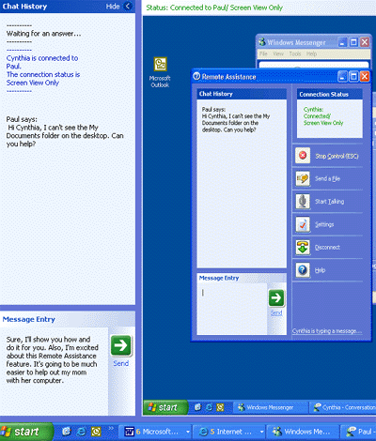

Figure 5. Using chat in Remote Assistance
- Cynthia clicks the Take Control button located in the top left corner of the screen, as shown in Figure 6 below.
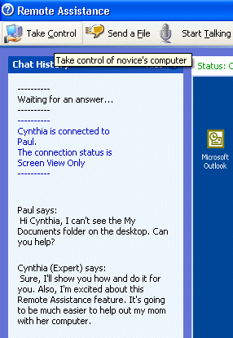

Figure 6. Taking control of novice’s computer
- Paul receives a notification dialog box asking him if he wants to allow Cynthia to take control. Paul clicks Yes.
Note that although Paul can allow Cynthia to temporarily use his machine, he remains in full control over the Remote Assistance session itself. Paul can end the session immediately by clicking the Stop Control button (or pressing the ESC key) in his Remote Assistance session.
In this scenario, however, Paul wants Cynthia to fix his problem and continues to let her control his computer. Cynthia can now use Paul’s computer as if she were sitting in front of his computer.
- Cynthia right-clicks the desktop, chooses New from the context menu and clicks Shortcut. The Create Shortcut wizard appears. Cynthia clicks Browse, navigates to My Documents and then clicks OK. The wizard enters the correct path. Cynthia clicks Finish to create the shortcut.

Sending a file
Cynthia decides she would like Paul to be able to do this task on his own next time.
- Cynthia opens Notepad, writes the procedure, names the file RAsupport.txt and saves it in her My Documents folder. She clicks the Send a File button at the top of the screen, clicks Browse and then clicks Send File.

- Paul receives notification that Cynthia is sending him a file. He clicks Save as and the My Documents folder opens as the default location for saved files. Paul clicks Save. Note that Paul can also decline to receive the file by clicking Cancel.
- A dialog box asks if Paul wants to open the file. Paul clicks Yes. The text file opens.
- Paul writes a message thanking Cynthia, clicks Send, then clicks Disconnect. A dialog box appears on Cynthia’s computer informing her that the session has been disconnected.

Using Remote Assistance via saving a file
This section shows how to initiate a Remote Assistance invitation by saving the request as a file. This allows you to use Remote Assistance via Web-based e-mail such as Hotmail or other similar services.
In this scenario, user Jon Grande initiates the same request as explained above.
- Jon clicks Start, clicks Help and Support, and under the Ask for assistance heading, he clicks Invite a friend to connect to your computer with Remote Assistance. The Remote Assistance page appears as shown in Figure 7 below.
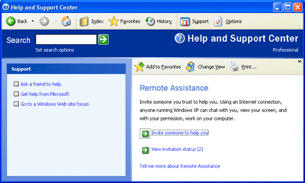

Figure 7. Inviting someone to help you
- Jon clicks Invite someone to help you and selects Save Invitation as a file.
- Jon enters his message and clicks Continue.
- The Save File dialog box appears and Jon is prompted to save the file in his My Documents folder as shown in Figure 8 below.

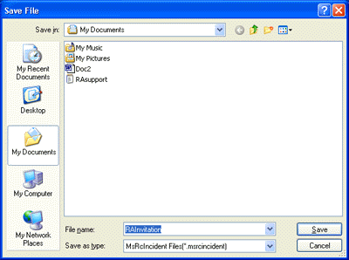

Figure 8. Saving the Remote Assistance file
- Jon opens his Hotmail e-mail, attaches the file from his My Documents folder and sends the message to Cynthia Randall.
- Cynthia opens Jon’s message, saves the attached file to her My Documents folder and opens it. The Remote Assistance Invitation box appears as shown in Figure 9 below.
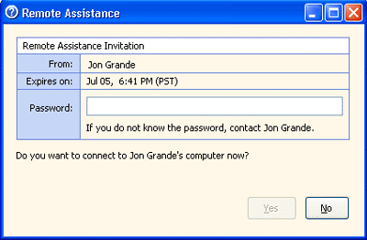

Figure 9. Accepting the Remote Assistance request
- Cynthia enters the password and clicks Yes.
Note: Paul will have needed to let Cynthia know what the password is in a separate communication such as a phone call or secure e-mail. Typically, users should relay the password via a phone call.

- The Attempting to Start Remote Assistance Session with Paul West box appears. Cynthia is able to begin Remote Assistance as explained in the previous example.

Using Remote Assistance via e-mail
This section explains initiating Remote Assistance via e-mail to a corporate Helpdesk. Home users can also follow this procedure to send a Remote Assistance request via e-mail.
In this scenario, novice user Jon Grande has a new computer running Windows XP Professional and logs onto the corporate network in the fictional company named Reskit. A dialog box appears informing Jon that he must contact a network administrator in order to install antivirus software on his computer.
Instead of calling the corporate Helpdesk, Jon elects to use Remote Assistance. He clicks Start menu, and then clicks Help and Support to open the Help and Support Services page. Jon clicks the Remote Assistance link.
- Jon clicks Invite someone to help you and enters the e-mail address helpdesk@reskit.com. He clicks Continue and the e-mail an invitation page appears. Jon enters his name in the From text box, types a message summarizing his problem, and clicks Continue. The next page appears showing options for setting an expiration time for the session and specifying a password.
- Jon leaves the default expiration time at 1 hour. Jon also sets a password and clicks Send Invitation, as shown in Figure 10 below. The wizard should confirm that the invitation was sent successfully.
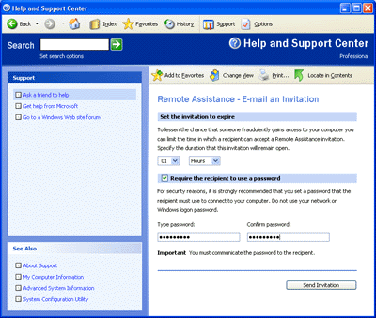

Figure 10. Sending the invitation
Note: The password should be something that is known by both Jon and Helpdesk. Jon will have needed to relay the password in a separate communication such as a phone call or e-mail.
- Helpdesk receives Jon’s e-mail request for assistance and clicks the attached file to open password dialog box. Helpdesk enters the password and clicks Yes.
- Helpdesk can now remotely connect to Jon’s computer. When the Remote Assistance screen opens showing Jon’s desktop, Helpdesk clicks the Take Control button. With Jon’s consent, Helpdesk can now control Jon’s computer to diagnose his problem of not being able to install antivirus software. Helpdesk concludes that Jon needs to be a member of the Administrator’s group on his own computer in order to install antivirus software.

Offering Remote Assistance to a user
This section explains how to initiate a request to perform Remote Assistance on a user’s computer in a corporate IT environment.

Configuring Group Policy for Remote Assistance
Remote Assistance is especially useful if you want to initiate troubleshooting on a user’s computer. In order to do this, you must enable the Offer Remote Assistance Local Group Policy setting on your local machine. To do this:
- Click Start, Run, then type gpedit.msc. The local Group Policy editor appears on the screen, enabling you to adjust policies that affect the local machine. Note: Corporate domain Group Policy may prevent you from adjusting this policy.
- Under the Computer Configuration node, double-click Administrative Templates, double-click System, then double-click Remote Assistance.
- Double-click Offer Remote Assistance and select Enable as shown in Figure 11 below.

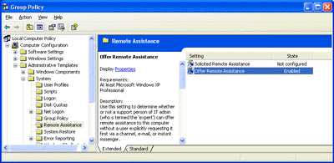

Figure 11. Enabling Local Group Policy to offer Remote Assistance
You can now initiate Remote Assistance requests:
- Open the Help and Support Services Center, click Tools, and click Offer Remote Assistance.
- In the dialog box, enter the user’s machine name as shown in Figure 12 below. Choose a user session if there is more then one.

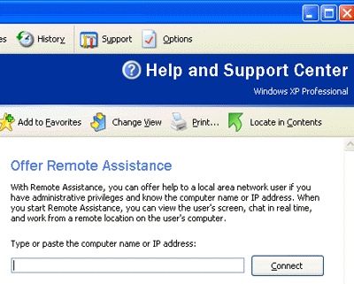

Figure 12. Offering Remote Assistance
- The user receives a pop-up box showing that the Helpdesk person is initiating a Remote Assistance request. The user accepts and Remote Assistance can proceed.

Administering Remote Assistance in Corporate Environments
There are several issues to consider when managing and administering Remote Assistance in the corporate environment or large organization. You can specify an open environment where employees can receive Remote Assistance from outside the corporate firewall. Or you can restrict Remote Assistance via Group Policy and specify various levels of permissions such as only allowing Remote Assistance from within the corporate firewall.

Configuring Port 3389 to Enable Remote Assistance
Remote Assistance runs over the top of Terminal Services technology, which means it needs to use the same port already used by Terminal Services: port 3389. For more information about using and configuring ports, see this Microsoft Knowledge Base article.
Note: If the person who is being helped is behind a firewall, NAT, or ICS, Remote Assistance will still function as long as the person being helped initiates the session via Windows Messenger. However, as stated above, Remote Assistance will not work in cases when the outbound traffic from port 3389 is blocked.

Using Remote Assistance in a Home Network
If you are using Personal Firewall or NAT in a home environment, you can use Remote Assistance without any special configurations. However, if you have a corporate-like firewall in a home environment, the same restrictions apply: you would need to open Port 3389 in order to use Remote Assistance.

Summary
This guide was written to help you get started with the Remote Assistance feature in Windows XP.
Remote Assistance brings a new set of options for users who need help troubleshooting or fixing a problem with their computer. It benefits novice users by enabling them to get direct help from trusted friends or support persons. And it benefits IT pros by making it easier and faster for them to assist friends, family members, or other co-workers.

Related Links
For information about the Remote Desktop feature in Windows XP, see
Improved Mobile Computing at
http://www.microsoft.com/windowsxp/pro/techinfo/howitworks/overview/07mobile.asp
For more information about Windows XP, visit the Microsoft Windows XP Web site.

