

Operating System

Windows XP Wireless Deployment Technology and Component Overview

Microsoft Corporation
Published: November 2002

Abstract
Before deploying IEEE 802.11 wireless LAN connectivity in your organization, it is helpful to understand the components of a secure wireless LAN and its authentication infrastructure. This article explains the elements of wireless LANs, the processes of connection, authentication, and encryption, and the components of secure wireless LANs that are provided with Windows XP and the Windows 2000 Server family.

The information contained in this document represents the current view of Microsoft Corporation on the issues discussed as of the date of publication. Because Microsoft must respond to changing market conditions, it should not be interpreted to be a commitment on the part of Microsoft, and Microsoft cannot guarantee the accuracy of any information presented after the date of publication.
This document is for informational purposes only. MICROSOFT MAKES NO WARRANTIES, EXPRESS OR IMPLIED, AS TO THE INFORMATION IN THIS DOCUMENT.
Complying with all applicable copyright laws is the responsibility of the user. Without limiting the rights under copyright, no part of this document may be reproduced, stored in or introduced into a retrieval system, or transmitted in any form or by any means (electronic, mechanical, photocopying, recording, or otherwise), or for any purpose, without the express written permission of Microsoft Corporation.
Microsoft may have patents, patent applications, trademarks, copyrights, or other intellectual property rights covering subject matter in this document. Except as expressly provided in any written license agreement from Microsoft, the furnishing of this document does not give you any license to these patents, trademarks, copyrights, or other intellectual property.
© 2002 Microsoft Corporation. All rights reserved.
Microsoft, ActiveX, Visual Basic, Windows, and Windows NT are either registered trademarks or trademarks of Microsoft Corporation in the United States and/or other countries.
The names of actual companies and products mentioned herein may be the trademarks of their respective owners.

Contents

Contents 3
Wireless LAN Technology Overview 1
Wireless LAN Networking Components 1
Stations 1
Wireless access points 1
Ports 2
IEEE 802.11 2
802.11 Physical Layer 2
802.11 MAC Sublayer 2
802.11b 3
802.11a 3
IEEE 802.11 Operating Modes 3
Ad Hoc Mode 3
Infrastructure Mode 4
Wireless Security 5
802.11 Authentication 5
Open System Authentication 5
Shared Key Authentication 6
802.11 Encryption with Wired Equivalent Privacy (WEP) 6
WEP Encryption and Decryption 7
WEP Concerns 7
Summary of 802.11 Security Issues 8
IEEE 802.1X 9
Port Access Entity 10
Authenticator 10
Supplicant 10
Authentication server 10
Controlled and Uncontrolled Ports 10
Windows XP Wireless Support 11
Wireless Network Adapter Support 11
Windows XP Wireless Zero Configuration Service 12
Roaming Support 12
Support for IEEE 802.1X Authentication 12
Wireless Networks Tab 12
Authentication Tab 15
Changes for Windows XP Service Pack 1 17
Microsoft 802.1X Authentication Client 18
RADIUS 20
RADIUS Overview 20
Components of a RADIUS Infrastructure 20
Access Clients 21
RADIUS Clients (access servers) 21
RADIUS Servers 21
User Account Databases 22
RADIUS Proxies 22
RADIUS Protocol 22
RADIUS Authentication and Accounting 23
EAP 25
EAP Overview 25
EAP Types in Windows 25
EAP-MD5 CHAP 26
EAP-TLS 26
Security Dynamics’ ACE/Agent™ for Windows 2000 27
Protected EAP 27
EAP Over RADIUS 27
EAP-TLS and the IEEE 802.1X Authentication Process 27
Step 1: Association and request for identity 28
Step 2: EAP-Response/Identity response 28
Step 3: EAP-Request from RADIUS server (Start TLS) 28
Step 4: EAP-Response from the wireless client (TLS Client Hello) 28
Step 5: EAP Request from RADIUS server (RADIUS Server’s Certificate) 28
Step 6: EAP-Response from the wireless client (Wireless Client’s Certificate) 28
Step 7: EAP-Request from RADIUS server (Cipher suite, TLS complete) 28
Step 8: EAP-Response from the wireless client 28
Step 9: EAP-Success from RADIUS server 29
Step 10: Multicast/global encryption key to the wireless client 29
PEAP Overview 30
MS-CHAP v2 Overview 31
PEAP with MS-CHAP v2 Operation 31
PEAP Fast Reconnect 32
PEAP Support in Windows 32
IAS and Remote Access Policies 34
IAS Overview 34
IAS as a RADIUS Server 34
Remote Access Policies 36
Remote Access Policy Conditions and Restrictions 36
Dial-in Properties of a User or Computer Account 37
Remote Access Permission Administration Models 38
Access by user 38
Access by policy in a native-mode domain 39
Access by policy in a Windows 2000 mixed-mode domain 39
Certificates 41
Computer Authentication and User Authentication 41
Obtaining a Certificate for IEEE 802.1X Authentication 42
Auto-enrollment 42
Request a certificate via the Web 43
Request a certificate using the Certificates snap-in 43
Import a certificate using the Certificates snap-in 43
Create a program or script using CAPICOM 43
Group Policy and IEEE 802.1X Authentication 44
IEEE 802.1X and Computer Configuration Group Policy 44
IEEE 802.1X and User Configuration Group Policy 44
Summary 45
Related Links 46

Wireless LAN Technology Overview
This section describes the following topics:
- Wireless LAN networking components
- IEEE 802.11
- 802.11 authentication and Wired Equivalent Privacy (WEP)
- IEEE 802.1X
- Windows XP support for IEEE 802.11 and 802.1X

Wireless LAN Networking Components
Wireless LAN networking consists of the following components:
- Stations
- Wireless access points
- Ports
These components are shown in Figure 1.
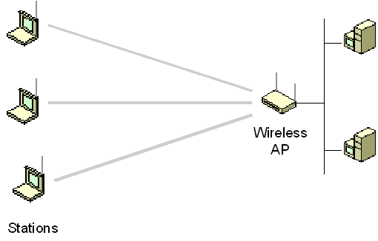
Figure 1 The components of wireless LAN networking

Stations
A station (STA) is a computing device that is equipped with a wireless LAN network adapter. A personal computer equipped with a wireless LAN network adapter is known as a wireless client. Wireless clients can communicate directly with each other or through a wireless access point.
Wireless clients are mobile.

Wireless access points
A wireless access point (AP) is a networking device equipped with a wireless LAN network adapter that acts as a bridge between STAs and a traditional wired network. An access point contains:
- At least one interface that connects the AP to an existing wired network (such as an Ethernet backbone).
- Radio equipment with which it creates wireless connections with wireless clients.
- IEEE 802.1D bridging software, so that it can act as a transparent bridge between wireless and wired Data Link layers.
The wireless AP is similar to a cellular phone network’s base station: wireless clients communicate with the wired network and other wireless clients through the wireless AP.
Wireless APs are not mobile and act as peripheral bridge devices to extend a wired network.

Ports
A port is a channel of a device that can support a single point-to-point connection. For IEEE 802.11b, a port is an association, a logical entity over which a single wireless connection is made. A typical wireless client with a single wireless LAN network adapter has a single port and can support only a single wireless connection. A typical wireless AP has multiple ports and can support multiple simultaneous wireless connections.
The logical connection between a port on the wireless client and the port on a wireless AP is a point-to-point bridged LAN segment, similar to an Ethernet-based network client connected to an Ethernet switch. All frames sent from a wireless client, whether unicast, multicast, or broadcast, are sent on the point-to-point LAN segment between the wireless client and the wireless AP. For frames sent by the wireless AP to wireless clients, unicast frames are sent on the point-to-point LAN segment and multicast and broadcast frames are sent to all connected wireless clients at the same time.

IEEE 802.11
IEEE 802.11 is an industry standard for a shared, wireless local area network (WLAN) that defines the physical layer and media access control (MAC) sublayer for wireless communications.

802.11 Physical Layer
At the physical layer, IEEE 802.11 defines both direct sequence spread spectrum (DSSS) and frequency hopping spread spectrum (FHSS) transmissions. The original bit rates for IEEE 802.11 was 2 and 1 megabits per second (Mbps) using the 2.45 gigahertz (GHz) Industrial, Scientific, and Medical (ISM) frequency band. The maximum bit rate for IEEE 802.11b is 11 Mbps (using DSSS). The maximum bit rate for IEEE 802.11a is 54 Mbps using orthogonal frequency-division multiplexing (OFDM) and the 5.8 gigahertz (GHz) frequency band.

802.11 MAC Sublayer
At the MAC sublayer, IEEE 802.11 uses the carrier sense multiple access with collision avoidance (CSMA/CA) media access control (MAC) protocol, which works in the following way:
- A wireless station with a frame to transmit first listens on the wireless channel to determine if another station is currently transmitting (carrier sense). If the medium is being used, the wireless station calculates a random backoff delay. Only after the random backoff delay can the wireless station again listen for a transmitting station. By instituting a random backoff delay, multiple stations that are waiting to transmit do not end up trying to transmit at the same time (collision avoidance).
The CSMA/CA scheme does not ensure that a collision never takes place and it is difficult for a transmitting node to detect that a collision is occurring. Additionally, depending on the placement of the wireless AP and the wireless clients, a radio frequency (RF) barrier can prevent a wireless client from sensing that another wireless node is transmitting. This is known as the hidden station problem.
To provide better detection of collisions and a solution to the hidden station problem, IEEE 802.11 also defines the use of an acknowledgment (ACK) frame to indicate that a wireless frame was successfully received and the use of Request to Send (RTS) and Clear to Send (CTS) messages. When a station wants to transmit a frame, it sends an RTS message indicating the amount of time it needs to send the frame. The wireless AP sends a CTS message to all stations, granting permission to the requesting station and informing all other stations that they are not allowed to transmit for the time reserved by the RTS message. The exchange of RTS and CTS messages eliminates collisions due to hidden stations.

802.11b
The major enhancement to IEEE 802.11 by IEEE 802.11b is the standardization of the physical layer to support higher bit rates. IEEE 802.11b supports two additional speeds, 5.5 Mbps and 11 Mbps, using the same frequency of 2.45 GHz. DSSS modulation scheme is used in order to provide the higher data rates. The bit rate of 11 Mbps is achievable in ideal conditions. In less-than-ideal conditions, the slower speeds of 5.5 Mbps, 2 Mbps, and 1 Mbps are used.

802.11a
The latest standard, IEEE 802.11a, operates at a data transmission rate as high as 54 Mbps and uses a radio frequency of 5.8 GHz. Instead of DSSS, 802.11a uses OFDM. ODFM allows data to be transmitted by subfrequencies in parallel. This provides greater resistance to interference and greater throughput. This higher speed technology allows wireless LAN networking to perform better for video and conferencing applications. Because they are not on the same frequencies as Bluetooth or microwave ovens, OFDM and IEEE 802.11a provides both a higher data rate and a cleaner signal. The bit rate of 54 Mbps is achievable in ideal conditions. In less-than-ideal conditions, the slower speeds of 48 Mbps, 36 Mbps, 24 Mbps, 18 Mbps, 12 Mbps, and 6 Mbps are used.

IEEE 802.11 Operating Modes
IEEE 802.11 defines the following operating modes:
- Ad hoc mode
- Infrastructure mode

Ad Hoc Mode
In ad hoc mode, wireless clients communicate directly with each other without the use of a wireless AP or a wired network, as shown in Figure 2.
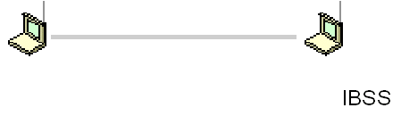
Figure 2 Ad hoc mode
Ad hoc mode is also called peer-to-peer mode. Wireless clients in ad hoc mode form an Independent Basic Service Set (IBSS), two or more wireless clients who communicate directly without the use of a wireless AP.
Ad hoc mode is used to connect wireless clients together when there is no wireless AP present, when the wireless AP rejects an association due to failed authentication, or when the wireless client is explicitly configured to use ad hoc mode.

Infrastructure Mode
In infrastructure mode, there is at least one wireless AP and one wireless client. The wireless client uses the wireless AP to access the resources of a traditional wired network. The wired network can be an organization intranet or the Internet, depending on the placement of the wireless AP.
A single wireless AP supporting one or multiple wireless clients is known as a Basic Service Set (BSS). A set of two or more wireless APs connected to the same wired network is known as an Extended Service Set (ESS). An ESS is a single logical network segment (also known as a subnet), and is identified by its SSID. An ESS is shown in Figure 3.
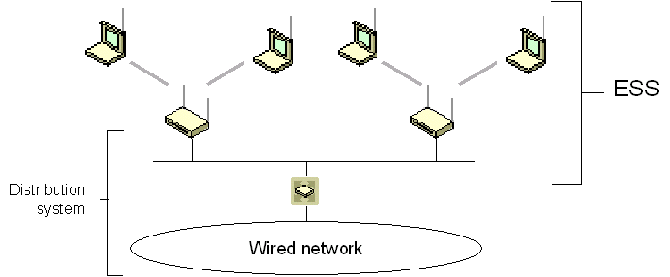
Figure 3 Infrastructure mode and an ESS
When a wireless adapter is turned on, it begins to scan across the wireless frequencies for wireless APs and other wireless clients. Scanning is an active listening process in which the wireless adapter listens on all the channels for beacon frames sent by wireless APs and other wireless clients. Assuming infrastructure mode, after scanning, a wireless adapter chooses a wireless AP with which to associate. This selection is made automatically by using the Service Set Identifier (SSID) of the wireless network and the wireless AP with the best signal strength (the highest signal-to-noise ratio). Next, the wireless client switches to the assigned channel of the chosen wireless AP and negotiates the use of a logical wireless port. This is known as an association.
Whether the wireless client prefers to associate with wireless APs or individual wireless clients is determined by configuration settings of the wireless client. By default, a Windows XP wireless client prefers to associate with a wireless AP rather than another wireless client.
If the signal strength of the wireless AP is too low, the error rate too high, or if instructed by the operating system (in the case of Windows XP, every 60 seconds), the wireless client scans for other wireless APs to determine whether a different wireless AP can provide a stronger signal to the same wireless network. If so, the wireless client switches to the channel of that wireless AP. This is known as reassociation.
Reassociation with a different wireless AP can occur for many different reasons. The signal can weaken because the wireless client moves away from the wireless AP or the wireless AP becomes congested with too much other traffic or interference. The wireless client, by switching to another wireless AP, can distribute the load over other wireless APs, increasing the performance for other wireless clients. By placing wireless APs so that their coverage areas overlap slightly but their channels do not, wireless connectivity for large areas can be achieved. As a wireless client moves its physical location, it can associate and reassociate from one wireless AP to another, maintaining a continuous connection during physical relocation.
If the coverage areas of the wireless APs within an ESS overlap, then a wireless client can roam, or move from one location (with a wireless AP) to another (with a different wireless AP), while maintaining network layer connectivity.
For example, for TCP/IP, a wireless client is assigned an IP address when it connects to the first wireless AP. When the wireless client roams within the ESS, it creates wireless connections with other wireless APs but keeps the same IP address because all the wireless APs are on the same logical subnet.
When the wireless client roams to a different ESS, the IP address configuration is no longer valid. For a Windows XP wireless client, a reassociation is interpreted as a media disconnect/connect event. This event causes Windows XP to perform a DHCP renewal for the TCP/IP protocol. Therefore, for reassociations within the ESS, the DHCP renewal refreshes the current IP address configuration. When the Windows XP wireless client reassociates with a wireless AP across an ESS boundary, the DHCP renewal process obtains a new IP address configuration that is relevant for the logical IP subnet of the new ESS.

Wireless Security
For authentication, the 802.11 standard defines open system and shared key authentication types. For data confidentiality, the 802.11 standard defines Wired Equivalent Privacy (WEP).
The 802.11 standard does not define or provide a WEP key management protocol that provides automatic encryption key determination and renewal. This is a limitation to IEEE 802.11 security services—especially for wireless infrastructure mode with a large number of wireless clients. This issue is solved by using the combination of IEEE 802.1X port-based network access control and the Extensible Authentication Protocol-Transport Level Security (EAP-TLS) for IEEE 802.11 networks.

802.11 Authentication
IEEE 802.11 defines the following types of authentication:
- Open System Authentication
- Shared Key Authentication

Open System Authentication
Open system authentication does not provide authentication, only identification using the wireless adapter’s MAC address. Open system authentication is used when no authentication is required. Open system authentication is the default authentication algorithm that uses the following process:
- The authentication-initiating wireless client sends an IEEE 802.11 authentication management frame that contains its identity.
- The receiving wireless node checks the initiating station’s identity and sends back an authentication verification frame.
With some wireless APs, you can configure the MAC addresses of allowed wireless clients. However, this is not secure because the MAC address of a wireless client can be spoofed. By default, a Windows XP wireless client configured to perform open system authentication sends its MAC address as the identity.

Shared Key Authentication
Shared key authentication verifies that an authentication-initiating station has knowledge of a shared secret. This is similar to preshared key authentication for Internet Protocol security (IPSec). The 802.11 standard currently assumes that the shared secret is delivered to the participating wireless clients by means of a secure channel that is independent of IEEE 802.11. In practice, this secret is manually typed at the wireless AP and the wireless client.
Shared key authentication uses the following process:
- The authentication-initiating wireless client sends a frame consisting of an identity assertion and a request for authentication.
- The authenticating wireless node responds to the authentication-initiating wireless node with challenge text.
- The authentication-initiating wireless node replies to the authenticating wireless node with the challenge text that is encrypted using WEP and an encryption key that is derived from the shared key authentication secret.
- The authentication result is positive if the authenticating wireless node determines that the decrypted challenge text matches the challenge text originally sent in the second frame. The authenticating wireless node sends the authentication result.
Because the shared key authentication secret must be manually distributed and typed, this method of authentication does not scale appropriately in large infrastructure network mode (for example, corporate campuses and public places). Additionally, shared key authentication is not secure and is not recommended for use.

802.11 Encryption with Wired Equivalent Privacy (WEP)
Due to the nature of wireless LAN networks, securing physical access to the network is difficult. Unlike a wired network where a physical connection is required, anyone within range of a wireless AP can conceivably send and receive frames as well as listen for other frames being sent, making eavesdropping and remote sniffing of wireless LAN frames very easy. Wired Equivalent Privacy (WEP) is defined by the IEEE 802.11 standard and is intended to provide a level of data confidentiality that is equivalent to a wired network.
WEP provides data confidentiality services by encrypting the data sent between wireless nodes. WEP encryption for an 802.11 frame is indicated by setting a WEP flag in the MAC header of the 802.11 frame. WEP provides data integrity for random errors by including integrity check value (ICV) in the encrypted portion of the wireless frame.
WEP defines two shared keys:
- A multicast/global key The multicast/global key is an encryption key that protects multicast and broadcast traffic from a wireless AP to all of its connected wireless clients.
- A unicast session key The unicast session key is an encryption key that protects unicast traffic between a wireless client and a wireless AP and multicast and broadcast traffic sent by the wireless client to the wireless AP.
WEP encryption uses the RC4 symmetric stream cipher with 40-bit and 104-bit encryption keys. 104-bit encryption keys are not standard, however, many wireless AP vendors support them.
Note Some implementations advertising the use of 128-bit keys are just adding a 104-bit encryption key to the 24-bit initialization vector and calling it a 128-bit key.

WEP Encryption and Decryption
To produce the encrypted frame, the following process is used:
- A 32-bit integrity check value (ICV) is calculated that provides data integrity for the MAC frame.
- The ICV is appended to the end of the frame data.
- A 24-bit initialization vector (IV) is appended to the WEP encryption key.
- The combination of [IV+WEP encryption key] is used as the input of a pseudo-random number generator (PRNG) to generate a bit sequence that is the same size as the combination of [data+ICV].
- The PRNG bit sequence, also known as the key stream, is bit-wise exclusive ORed (XORed) with [data+ICV] to produce the encrypted portion of the payload that is sent between the wireless AP and the wireless client.
- The IV is added to the front of the encrypted[data+ICV] to create the payload for the wireless MAC frame. The result is IV+encrypted[data+ICV].
To decrypt the wireless MAC payload, the following process is used:
- The IV is obtained from the front of the MAC payload.
- The WEP encryption key is concatenated with the IV.
- The concatenated WEP encryption key and IV is used as the input of the same PRNG to generate a bit sequence of the same size as the combination of the data and the ICV (the same bit sequence as that of the sending wireless node).
- The PRNG bit sequence is XORed with the encrypted[data+ICV] to decrypt the [data+ICV] portion of the payload.
- The ICV for the data portion of the payload is calculated and compared with the value included in the incoming frame. If the values match, the data is considered to be valid (sent from the wireless client and unmodified in transit).
While the secret key remains constant over a long duration, the IV is changed periodically and as frequently as every frame). The periodicity at which IV values are changed depends on the degree of privacy required of the WEP algorithm. Changing the IV after each frame is the ideal method of maintaining the effectiveness of WEP.

WEP Concerns
The main problem with WEP is that the determination and distribution of WEP keys are not defined. WEP keys must be distributed using a secure channel outside of the 802.11 protocol. In the real world, this is a text string that must be manually configured using a keyboard for both the wireless AP and wireless clients. Obviously, this key distribution system does not scale well to an enterprise organization and is not secure.
Additionally, there is no defined mechanism to change the WEP key either per authentication or periodically for an authenticated connection. All wireless APs and clients use the same manually configured WEP key for multiple sessions. With multiple wireless clients sending a large amount of data, an attacker can remotely capture large amounts of WEP cipher text and use cryptanalysis methods to determine the WEP key.
The lack of a WEP key management protocol is a principal limitation to providing 802.11 security, especially in infrastructure mode with a large number of stations. Some examples of this type of network include corporate campuses, and public places such as airports and malls. The lack of automated authentication and key determination services also effects operation in ad hoc mode where users may wish to engage in peer-to-peer collaborative communication; for example, in areas such as conference rooms.

Summary of 802.11 Security Issues
The current solutions for the security issues that exist with 802.11 are the following:
- No per-frame authentication mechanism to identify the frame source.
There is a current proposal to replace WEP RC4 encryption with Advanced Encryption Standard (AES). AES provides per-frame data origin authentication.
- Vulnerability to disassociation attacks (the forcing of wireless clients off of the wireless LAN network).
Although there are no easy solutions to the disassociation attack, the best solution for rogue wireless APs is to support a mutual authentication protocol such as EAP-TLS. With EAP-TLS, the wireless client ensures that the wireless AP is a trusted member of the secure wireless authentication infrastructure.
- No per-user identification and authentication.
The adaptation of IEEE 802.1X Port-Based Network Access Control specification for wireless connections and its use of EAP enforces a user-level authentication before allowing wireless frames to be forwarded.
- No mechanism for central authentication, authorization, and accounting (AAA).
By using RADIUS in conjunction with IEEE 802.1X, RADIUS servers provide AAA services for wireless connections.
- The RC4 stream cipher is vulnerable to known plaintext attacks.
The proposed replacement of RC4 with AES solves this problem. In the interim, you can use IPSec, supported by Windows XP and Windows 2000, to protect your TCP/IP traffic.
- Some implementations derive WEP keys from passwords, resulting in weak WEP keys.
By using IEEE 802.1X and EAP-TLS as the authentication method, public key certificates, not passwords, are used to perform authentication and derive encryption key material.
- No support for extended authentication methods; for example: token cards; certificates/smart cards; one-time passwords; biometrics; and so on.
IEEE 802.1X uses EAP as its authentication protocol. EAP was designed to be extensible for virtually any type of authentication method. For more information, see "EAP" in this article.
- No support for key management; for example, re-keying global keys, and dynamic, per-station or per-session key management.
By using IEEE 802.1X and EAP-TLS as the authentication method, high-entropy unicast session keys are derived for each authentication. Current vendor technologies, such as rapid rekeying, change the multicast global key periodically. Future technologies will provide a standards-based method to change the unicast session key periodically.
The best current solution (as of the time of publication for this article) for secure wireless consists of using the combination of IEEE 802.1X and EAP-TLS.

IEEE 802.1X
The IEEE 802.1X standard defines port-based, network access control used to provide authenticated network access for Ethernet networks. This port-based network access control uses the physical characteristics of the switched LAN infrastructure to authenticate devices attached to a LAN port. Access to the port can be denied if the authentication process fails. Although this standard was designed for wired Ethernet networks, it has been adapted for use on 802.11 wireless LANs.
IEEE 802.1X defines the following terms:
- Port access entity
- Authenticator
- Supplicant
- Authentication server
Figure 4 shows these components for a wireless LAN network.
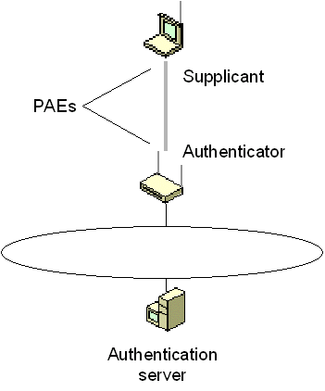
Figure 4 The components of IEEE 802.1X authentication

Port Access Entity
A LAN port, also known as port access entity (PAE), is the logical entity that supports the IEEE 802.1X protocol that associated with a port. A PAE can adopt the role of the authenticator, the supplicant, or both.

Authenticator
An authenticator is a LAN port that enforces authentication before allowing access to services accessible using that port. For wireless connections, the authenticator is the logical LAN port on a wireless AP through which wireless clients in infrastructure mode gain access to other wireless clients and the wired network.

Supplicant
The supplicant is a LAN port that requests access to services accessible using the authenticator. For wireless connections, the supplicant is the logical LAN port on a wireless LAN network adapter that requests access to the other wireless clients and the wired network by associating with and then authenticating itself to an authenticator.
Whether for wireless connections or wired Ethernet connections, the supplicant and authenticator are connected by a logical or physical point-to-point LAN segment.

Authentication server
To verify the credentials of the supplicant, the authenticator uses an authentication server. The authentication server checks the credentials of the supplicant on behalf of the authenticator, then responds to the authenticator indicating whether or not the supplicant is authorized to access the authenticator’s services. The authentication server may be:
- A component of the access point In this case, the access point must be configured with the sets of user credentials corresponding to the wireless clients that will be attempting to connect. This is typically not implemented for wireless APs.
- A separate entity In this case, the access point forwards the credentials of the wireless connection attempt to a separate authentication server. Typically, the wireless AP uses the Remote Authentication Dial-In User Service (RADIUS) protocol to send the connection attempt parameters to a RADIUS server.

Controlled and Uncontrolled Ports
The authenticator’s port-based, access control defines the following different types of logical ports that access the wired LAN via a single, physical LAN port:
- Uncontrolled port The uncontrolled port allows an uncontrolled exchange between the authenticator (the wireless AP) and other networking devices on the wired network—regardless of any wireless client’s authorization state. Frames sent by the wireless client are never sent using the uncontrolled port.
- Controlled port The controlled port allows data to be sent between a wireless client and the wired network only if the wireless client is authorized by 802.1X. Before authentication, the switch is open and no frames are forwarded between the wireless client and the wired network. When the wireless client is successfully authenticated using IEEE 802.1X, the switch is closed and frames can be sent between the wireless client and nodes on the wired network.
The different types of ports are shown in Figure 5.
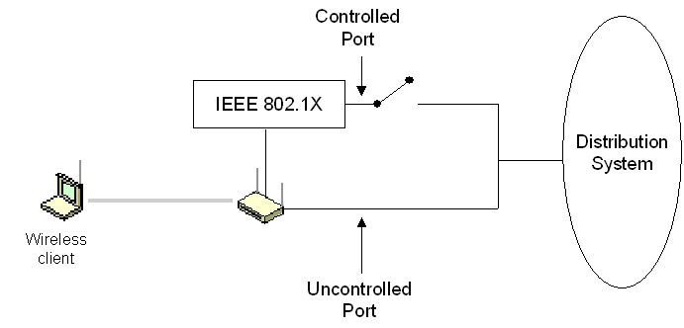
Figure 5 Controlled and uncontrolled ports for IEEE 802.1X
On an authenticating Ethernet switch, the wired Ethernet client can send Ethernet frames to the wired network as soon as authentication is complete. The switch identifies the traffic of a specific wired Ethernet client using the physical port to which the Ethernet client is connected. Typically, only a single Ethernet client is connected to a physical port on the Ethernet switch.
Because multiple wireless clients contend for access to the same channel and send data using the same channel, an extension to the basic IEEE 802.1X protocol is required to allow a wireless AP to identify the secured traffic of a particular wireless client. This is done through the mutual determination of a per-client unicast session key by the wireless client and wireless AP. Only authenticated wireless clients have knowledge of their per-client unicast session key. Without a valid unicast session key tied to a successful authentication, a wireless AP discards the traffic sent from the wireless client.
To provide a standard authentication mechanism for IEEE 802.1X, the Extensible Authentication Protocol (EAP) was chosen. EAP is a Point-to-Point Protocol (PPP)-based authentication mechanism that was adapted for use on point-to-point LAN segments. EAP messages are normally sent as the payload of PPP frames. To adapt EAP messages to be sent over Ethernet or wireless LAN segments, the IEEE 802.1X standard defines EAP over LAN (EAPOL), a standard way to encapsulate EAP messages.

Windows XP Wireless Support
Windows XP includes new and improved support for the following:
- Wireless network adapters
- Wireless Zero Configuration Service
- Roaming
- IEEE 802.1X authentication

Wireless Network Adapter Support
Microsoft partnered with 802.11 network adapter vendors to improve the roaming experience by automating the process of configuring the network adapter to associate with an available network.
The wireless network adapter and its Network Driver Interface Specification (NDIS) driver need to do very little beyond supporting some new NDIS Object Identifiers (OIDs) used for the querying and setting of device and driver behavior. The wireless network adapter scans for available wireless networks and passes the SSID information to Windows XP.

Windows XP Wireless Zero Configuration Service
The Windows XP Wireless Zero Configuration service configures the wireless network adapter with an available wireless network. If there are two networks covering the same area, the user can configure a preferred network order and the computer will try each network in the order defined until it finds one that is active. It is even possible to limit association to only the configured, preferred networks.
If a wireless AP is not found nearby, Windows XP configures the network adapter to use ad hoc mode. It is possible for the user to configure the wireless network adapter either to disable or be forced into ad hoc mode.
These network adapter enhancements are integrated with security features so that if authentication fails, Windows XP will attempt to authenticate with the additional detected wireless networks.
Windows XP attempts to perform an IEEE 802.11 shared key authentication if the network adapter has been preconfigured with a WEP shared key. In the event that shared key authentication fails or the network adapter is not preconfigured with a WEP shared key, the network adapter reverts to open system authentication.

Roaming Support
The media sense feature of Windows 2000 is enhanced in Windows XP to allow for detection of a move to a new wireless AP, thus forcing reauthentication in order to ensure appropriate network access. Along with reauthentication, a Windows XP wireless client also performs a DHCP renewal of the IP address configuration for the wireless network adapter. Within the same ESS, the IP address configuration does not change. When the Windows XP wireless client crosses an ESS boundary (a new subnet), the DHCP renewal obtains a new IP address configuration relevant for that subnet.
Through Windows Sockets extensions, network-aware applications are notified of changes in network connectivity and can update their behavior based on these changes. The auto-sensing and reconfiguration minimizes the need for mobile IP when a wireless node roams to another subnet.

Support for IEEE 802.1X Authentication
Windows XP supports IEEE 802.1X authentication for all LAN-based network adapters, including Ethernet and wireless. IEEE 802.1X authentication using the EAP-TLS authentication type is enabled by default.

Wireless Networks Tab
The primary user interface for configuring IEEE 802.11 and 801.1X settings on a Windows XP computer consists of the Wireless Networks and Authentication tabs for the properties of a connection in the Network Connections folder that corresponds to an installed wireless adapter. The Wireless Networks tab is shown in Figure 6. The Wireless Networks tab only appears for wireless adapters that support the Windows XP Wireless Zero Configuration Service.
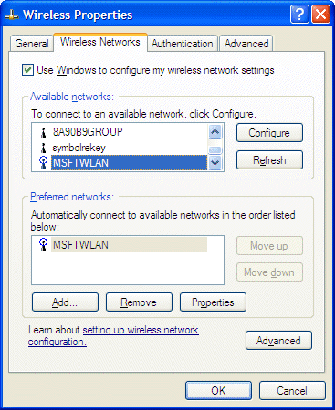
Figure 6 The Wireless Networks tab
On the Wireless Networks tab, you can view and configure the following:
- Use Windows to configure my wireless network settings Select this check box when you want Windows XP to automatically configure your wireless settings (the Wireless Zero Configuration Service). If you have third-party wireless software that you want to use, clear this check box. This option is enabled by default.
- Available networks The list of wireless LAN networks that are within association range of your computer. To view or change the configuration of a specific wireless LAN network and add it to the list of preferred networks, click it in the list of available networks and click Configure. To force the wireless adapter to initiate a new scan of the wireless APs and wireless clients within range, click Refresh.
- Preferred networks The list of wireless LAN networks to which the wireless client will attempt to connect and authenticate with, in the order in which they are listed. To add a new wireless LAN network that does not appear in the Available networks list, click Add. To remove a wireless LAN network, click Remove. To configure the settings of a wireless LAN network to which you are connecting, click Properties.
- Advanced To configure advanced wireless settings that are independent of the wireless LAN networks to which you are connecting, click Advanced.
Figure 7 shows the Wireless Network Properties dialog box.
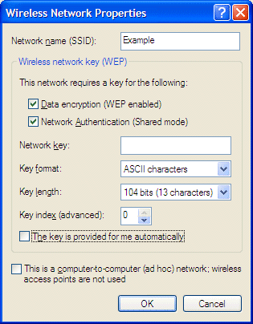
Figure 7 The Wireless Network Properties dialog box
In the Wireless Network Properties dialog box, you can configure the following:
- Network name (SSID) Displays or allows you to type the wireless LAN network name, also known as the Service Set Identifier (SSID). The network name is sent out with beacon frames by wireless APs and is automatically learned by wireless clients during the wireless client scanning process.
- Data encryption (WEP enabled) This check box specifies whether WEP is enabled for this wireless LAN network. This option is enabled by default.
- Network authentication (Shared mode) Specifies whether IEEE 802.11 shared key authentication is used to authenticate the wireless client. If disabled, open system authentication is used. This option is disabled by default. Note that this setting does not affect IEEE 802.1X authentication, which is configured on the Authentication tab.
- Network key Provides a space to type a manually configured network key that is used for WEP. Typical implementations use the same key for shared key authentication and for WEP encryption. In Windows XP SP1, there is also a Confirm network key text box.
- Key format Allows you to select the format for the network key (ASCII characters or hexadecimal digits). This is not present in Windows XP SP1. The key format is automatically determined from the typed key.
- Key length Allows you to select the size of the network key (40 bits or 104 bits). This is not present in Windows XP SP1. The key length is automatically determined from the typed key.
- Key index (advanced) Allows you to specify the location where the key is stored. Historically, IEEE 802.11 allowed for 4 different keys. The key index is an offset that is used to specify a single key when four keys are used. You can select 0 to 3 for Windows XP. You can select 1 to 4 for Windows XP SP1.
- The key is provided for me automatically This check box specifies whether a WEP key is provided through some means other than manual configuration, such as a key provided on the network adapter or through IEEE 802.1X authentication. This option is enabled by default. If you disable this setting, you cannot perform EAP-TLS authentication. You can only perform EAP-MD5 CHAP authentication.
- This is a computer-to-computer (ad hoc) network This check box specifies whether this wireless LAN network is operating in ad hoc mode. If disabled, the wireless LAN network is operating in infrastructure mode. This option is disabled by default.
Figure 8 shows the Advanced dialog box.
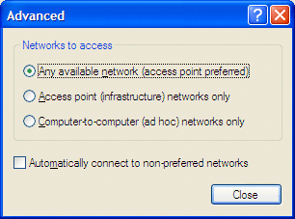
Figure 8 The Advanced dialog box
In the Advanced dialog box, you can configure the following:
- Networks to access To attempt to connect to wireless LAN networks that are operating in either ad hoc or infrastructure modes while preferring infrastructure mode, select Any available network. To attempt to connect to wireless LAN networks that are only operating in infrastructure mode, select Access point. To attempt to connect to wireless LAN networks that are only operating in ad hoc mode, select Computer-to-computer. By default, Any available network is selected.
- Automatically connect to non-preferred networks This check box specifies whether connection attempts are made to any wireless network within range, regardless of whether they are listed in the Preferred networks list. This option is disabled by default.

Authentication Tab
The Authentication tab appears for all LAN-based network adapters, as shown in Figure 9.
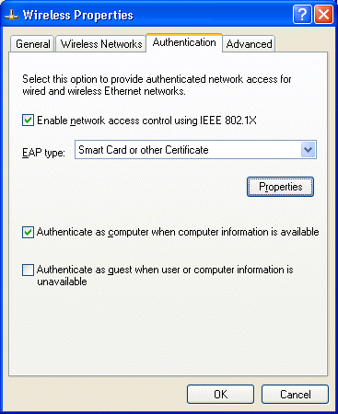
Figure 9 The Authentication tab
On the Authentication tab, you can view and configure the following:
- Enable network access control using IEEE 802.1X Select this check box when you want to use IEEE 802.1X to perform authentication for this connection. This option is enabled by default.
- EAP type Lists the EAP types that correspond to EAP DLLs installed on the computer. The default EAP types are MD-5 Challenge and Smart Card or other Certificate. By default the Smart Card or other Certificate EAP type is selected. For more information about EAP types, see “EAP” in this article.
- Properties Click to configure the properties of the selected EAP type. This button is not available for the MD-5 Challenge EAP type.
- Authenticate as computer with computer information is available This check box specifies whether the computer will attempt to authenticate using computer credentials (such as a computer certificate), without the user logging on. This option is enabled by default.
- Authenticate as guest when user or computer information is unavailable This check box specifies whether the computer will attempt to authenticate as a guest when either user or computer credentials are not available. This option is disabled by default.
Figure 10 shows the Smart Card or other Certificate Properties dialog box.
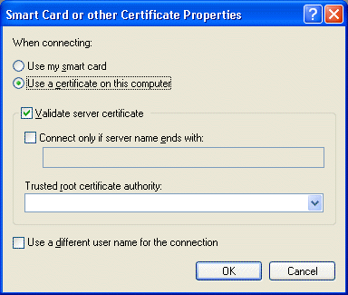
Figure 10 The Smart Card or other Certificate Properties dialog box
For the Smart Card or other Certificate Properties dialog box, you can view and configure the following:
- When connecting To use a certificate in the Current User or Local Computer certificate store for authentication, select Use a certificate on this computer. By default, Use a certificate on this computer is selected. When there are multiple user certificates installed, the user is prompted to select a specific user certificate for the first association. The use of that user certificate is cached for reassociations until the Windows XP user session is ended.
- Validate server certificate Select this check box when you want to validate the computer certificate of the authenticating server (typically, a RADIUS server). This option is enabled by default.
- Connect only if server name ends with This check box specifies whether you want to specify a string that must match the last part of the name in the authenticating server’s computer certificate. This option is disabled by default. If you enable this option and type the wrong string, authentication will fail.
- Trusted root certificate authority This option allows you to select the specific root certification authority (CA) of the authenticating server’s computer certificate. There is no specific trusted root CA selected by default. If you select the wrong trusted root CA, you will be prompted during authentication whether to accept the connection using the root CA of the authenticating server certificate. If you click “OK”, your selection of the trusted root CA will be automatically be set to the root CA of the authenticating server certificate.
- Use a different user name for the connection This check box specifies whether you want to use a user name for authentication that is different from the user name in the certificate. This option is disabled by default. If enabled, the user is prompted with a dialog box to select a user certificate, even if only one user certificate is installed. The selected certificate is used until the Windows XP user session is ended.

Changes for Windows XP Service Pack 1
Windows XP SP1 includes the following changes:
- Added support for Protected EAP (PEAP), with the PEAP/MS-CHAP v2 and PEAP/TLS PEAP types. For more information, see "Protected EAP" in this article.
- An improved user interface for managing wireless networks. From the properties of a wireless network, there is now an Association tab and an Authentication tab. The Association tab contains the settings that define the properties of the wireless network and how to associate with it. The Association tab is essentially the same as the properties of a wireless network with Windows XP (prior to SP1). The Authentication tab has been moved from the properties of the wireless network adapter to the properties of each wireless network.
- The properties of the Smart Card or other Certificate properties page has been improved. Figure 11 shows the new Smart Card or other Certificate properties page.
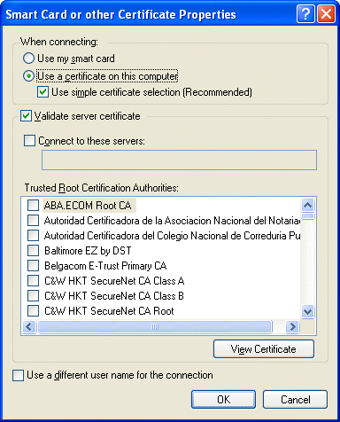
Figure 11 The Smart Card or other Certificate Properties dialog box for Windows XP SP1

Microsoft 802.1X Authentication Client
Microsoft 802.1X Authentication Client is a free download that allows computers running Windows 2000 to use IEEE 802.1X to authenticate network connections (including wireless). Prior to Microsoft 802.1X Authentication Client, only computers running Windows XP are capable of IEEE 802.1X authentication. For the Windows 2000 Server family, Microsoft 802.1X Authentication Client also provides support for PEAP authentication (both PEAP/MS-CHAP v2 and PEAP/TLS) for the Internet Authentication Service (IAS), the Microsoft implementation of a RADIUS server. A computer running a member of the Windows 2000 Server family, Microsoft 802.1X Authentication Client, and IAS can act as a RADIUS server that performs authentication and authorization for 802.1X-based wireless clients that use EAP-TLS, PEAP/MS-CHAP v2, or PEAP/TLS authentication types.
For more information, see Microsoft 802.1X Authentication Client.

RADIUS
This section describes the following topics:
- RADIUS overview
- Components of a RADIUS infrastructure
- RADIUS protocol

RADIUS Overview
Remote Authentication Dial-In User Service (RADIUS) is a widely deployed protocol enabling centralized authentication, authorization, and accounting for network access. RADIUS is described in RFC 2865, "Remote Authentication Dial-in User Service (RADIUS)," (IETF Draft Standard) and RFC 2866, "RADIUS Accounting" (Informational).
Originally developed for dial-up remote access, RADIUS is now supported by wireless APs, authenticating Ethernet switches, virtual private network (VPN) servers, Digital Subscriber Line (DSL) access servers and other network access servers.

Components of a RADIUS Infrastructure
A RADIUS authentication, authorization, and accounting (AAA) infrastructure consists of the following components:
- Access clients
- Access servers (RADIUS clients)
- RADIUS servers
- User account databases
- RADIUS proxies
These components are shown in Figure 12.
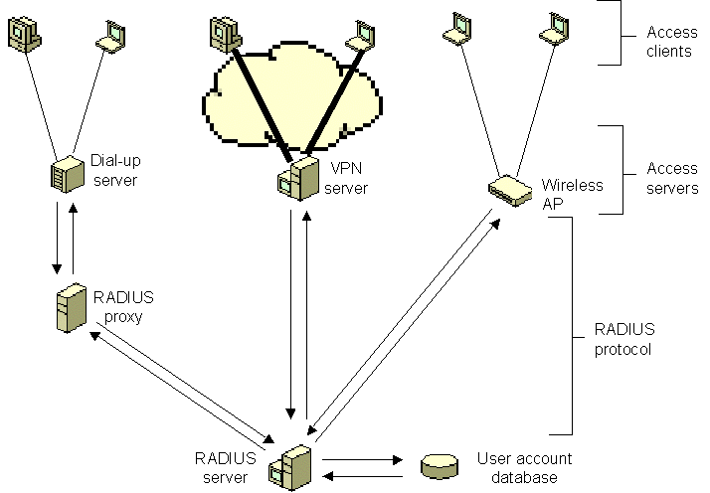
Figure 12 Components of a RADIUS infrastructure

Access Clients
An access client is a device that requires some level of access to a larger network. Examples of access clients are dial-up or virtual private network (VPN) clients, wireless clients, or LAN clients connected to a switch.

RADIUS Clients (access servers)
An access server is a device that provides some level of access to a larger network. An access server using a RADIUS infrastructure is also a RADIUS client, sending connection requests and accounting messages to a RADIUS server. Examples of access servers are:
- Wireless APs that provide physical layer access to an organization's network, using wireless-based transmission and reception technologies.
- Switches that provide physical layer access to an organization's network, using traditional LAN technologies such as Ethernet.
- Network access servers (NASs) that provide remote access connectivity to an organization network or the Internet. An example is a Windows 2000 computer running the Routing and Remote Access service and providing either traditional dial-up or virtual private network (VPN) remote access services to an organization's intranet.

RADIUS Servers
A RADIUS server is a device that receives and processes connection requests or accounting messages sent by RADIUS clients or RADIUS proxies. In the case of connection requests, the RADIUS server processes the list of RADIUS attributes in the connection request. Based on a set of rules and the information in the user account database, the RADIUS server either authenticates and authorizes the connection and sends back an Access-Accept message or sends back an Access-Reject message. The Access-Accept message can contain connection restrictions that are implemented by the access server for the duration of the connection.
The Internet Authentication Service (IAS) component of Windows 2000 Server is an industry-standard compliant RADIUS server.

User Account Databases
The user account database is the list of user accounts and their properties that can be checked by a RADIUS server to verify authentication credentials and obtain user account properties containing authorization and connection parameter information.
The user account databases that IAS can use are the local Security Accounts Manager (SAM), a Microsoft Windows NT® 4.0 domain, or the Active Directory® service. For Active Directory, IAS can provide authentication and authorization for user or computer accounts in the domain in which the IAS server is a member, two-way trusted domains, and trusted forests with domain controllers running a member of the Windows 2000 or Windows .NET Server family.
If the user accounts for authentication reside in a different type of database, you can use a RADIUS proxy to forward the authentication request to a RADIUS server that does have access to the user account database. Different databases for Active Directory include untrusted forests, untrusted domains, or one-way trusted domains.

RADIUS Proxies
A RADIUS proxy is a device that forwards or routes RADIUS connection requests and accounting messages between RADIUS clients (and RADIUS proxies) and RADIUS servers (or RADIUS proxies). The RADIUS proxy uses information within the RADIUS message to route the RADIUS message to the appropriate RADIUS server.
A RADIUS proxy can be used as a forwarding point for RADIUS messages when the authentication, authorization, and accounting must occur at multiple RADIUS servers in different organizations.

RADIUS Protocol
RADIUS messages are sent as User Datagram Protocol (UDP) messages. UDP port 1812 is used for RADIUS authentication messages and UDP port 1813 is used for RADIUS accounting messages. Some access servers might use UDP port 1645 for RADIUS authentication messages and UDP port 1646 for RADIUS accounting messages. Only one RADIUS message is included in the UDP payload of a RADIUS packet.
RFCs 2865 and 2866 define the following RADIUS message types:
- Access-Request Sent by a RADIUS client to request authentication and authorization for a network access connection attempt.
- Access-Accept Sent by a RADIUS server in response to an Access-Request message. This message informs the RADIUS client that the connection attempt is authenticated and authorized.
- Access-Reject Sent by a RADIUS server in response to an Access-Request message. This message informs the RADIUS client that the connection attempt is rejected. A RADIUS server sends this message if either the credentials are not authentic or the connection attempt is not authorized.
- Access-Challenge Sent by a RADIUS server in response to an Access-Request message. This message is a challenge to the RADIUS client that requires a response.
- Accounting-Request Sent by a RADIUS client to specify accounting information for a connection that was accepted.
- Accounting-Response Sent by the RADIUS server in response to the Accounting-Request message. This message acknowledges the successful receipt and processing of the Accounting-Request message.
A RADIUS message consists of a RADIUS header and RADIUS attributes. Each RADIUS attribute specifies a piece of information about the connection attempt. For example, there are RADIUS attributes for the user name, the user password, the type of service requested by the user, and the IP address of the access server. RADIUS attributes are used to convey information between RADIUS clients, RADIUS proxies, and RADIUS servers. For example, the list of attributes in the Access-Request message includes information about the user credentials and the parameters of the connection attempt. In contrast, the list of attributes in the Access-Accept message includes information about the type of connection that can be made, connection constraints, and any vendor-specific attributes (VSAs).
RADIUS attributes are described in RFCs 2865, 2866, 2867, 2868, 2869, and 3162. RFCs and Internet drafts for VSAs define additional RADIUS attributes.
For Point-to-Point Protocol (PPP) authentication protocols such as Password Authentication Protocol (PAP), Challenge-Handshake Authentication Protocol (CHAP), Microsoft Challenge Handshake Authentication Protocol (MS-CHAP), and MS-CHAP version 2 (MS-CHAP v2), the results of the authentication negotiation between the access server and the access client are forwarded to the RADIUS server for verification.
For EAP authentication, the negotiation occurs between the RADIUS server and the access client. The RADIUS server uses Access-Challenge messages to send EAP messages to the access client. The access server forwards EAP messages sent by the access client to the RADIUS server as Access-Request messages. For more information, see “EAP over RADIUS” later in this article.
To provide security for RADIUS messages, the RADIUS client and the RADIUS server are configured with a common shared secret. The shared secret is used to authenticate RADIUS messages and to encrypt sensitive RADIUS attributes. The shared secret is commonly configured as a text string on both the RADIUS client and server.

RADIUS Authentication and Accounting
RADIUS messages are used for authentication, authorization, and accounting of network access connections in the following way:
- Access servers, such as dial-up network access servers, VPN servers, and wireless APs, receive connection requests from access clients.
- The access server, configured to use RADIUS as the authentication, authorization, and accounting protocol, creates an Access-Request message and sends it to the RADIUS server.
- The RADIUS server evaluates the Access-Request message.
- If required (for example, when the authentication protocol is EAP), the RADIUS server sends an Access-Challenge message to the access server. The access server or access client processes the challenge and sends a new Access-Request to the RADIUS server.
- The user credentials and the authorization of the connection attempt are verified.
- If the connection attempt is both authenticated and authorized, the RADIUS server sends an Access-Accept message to the access server.
- If the connection attempt is either not authenticated or not authorized, the RADIUS server sends an Access-Reject message to the access server.
- Upon receipt of the Access-Accept message, the access server completes the connection process with the access client and sends an Accounting-Request message to the RADIUS server.
- After the Accounting-Request message is processed, the RADIUS server sends an Accounting-Response message.

EAP
This section describes the following:
- EAP overview
- EAP types in Windows
- EAP over RADIUS
- EAP-TLS and the IEEE 802.1X authentication process

EAP Overview
The Extensible Authentication Protocol (EAP) was originally created as an extension to PPP that allows for development of arbitrary network access authentication methods. With PPP authentication protocols such as CHAP, MS-CHAP, and MS-CHAP v2, a specific authentication mechanism is chosen during the link establishment phase. During the connection authentication phase, the negotiated authentication protocol is used to validate the connection. The authentication protocol itself is a fixed series of messages sent in a specific order. With EAP, the specific authentication mechanism is not chosen during the link establishment phase of the PPP connection. Instead, each PPP peer negotiates to perform EAP during the connection authentication phase. When the connection authentication phase is reached, the peers negotiate the use of a specific EAP authentication scheme known as an EAP type. EAP is described in RFC 2284.
After the EAP type is agreed upon, EAP allows for an open-ended exchange of messages between the access client and the authenticating server (the RADIUS server) that can vary based on the parameters of the connection. The conversation consists of requests for authentication information and the responses. The length and detail of the authentication conversation is dependent upon the EAP type.
Architecturally, EAP is designed to allow authentication plug-in modules at both the access client and authenticating server ends of a connection. To add support for a new EAP type, install an EAP type library file on both the access client and the authenticating server. This presents vendors with the opportunity to supply a new authentication scheme at any time. EAP provides the highest flexibility to allow for more secure authentication methods.
You can use EAP to support authentication schemes such as Generic Token Card, One Time Password (OTP), MD5-Challenge, Transport Level Security (TLS) for smart card and certificate support, as well as any future authentication technologies. EAP is a critical technology component for secure connections.
In addition to support within PPP, EAP is also supported within the IEEE 802 link layer. IEEE 802.1X defines how EAP is used for authentication by IEEE 802 devices, including IEEE 802.11b wireless APs and Ethernet switches. IEEE 802.1X differs from PPP in that only EAP authentication methods are supported.

EAP Types in Windows
The following EAP types are included with Windows 2000 and Windows XP:
- EAP-MD5 CHAP
- EAP-TLS
- Security Dynamics’ ACE/Agent™ for Windows 2000
- Protected EAP

EAP-MD5 CHAP
EAP-Message Digest 5 Challenge Handshake Authentication Protocol (EAP-MD5 CHAP) is a required EAP type that uses the same challenge handshake protocol as PPP-based CHAP, but the challenges and responses are sent as EAP messages. EAP-MD5 CHAP is described in RFC 2284.
A typical use for EAP-MD5 CHAP is to authenticate the credentials of remote access clients by using user name and password security systems. You can also use EAP-MD5 CHAP to test EAP interoperability.
EAP-MD5 CHAP is not a suitable authentication method for Windows XP wireless connections for the following reasons:
- CHAP requires the availability of a reversibly encrypted form of the account password to calculate the CHAP challenge response. This property of accounts is not enabled by default for accounts on the local computer or domain accounts.
- CHAP authentication for wireless connectivity results in multiple user logons to obtain wireless connectivity and then a domain logon.
- CHAP is a password-based authentication method where the user chooses passwords, resulting in a relatively weak authentication scheme.
- CHAP is susceptible to offline dictionary attacks where a malicious user captures the CHAP exchange and then attempts to determine the password.
- The CHAP authentication process does not result in mutually determined keying material for data encryption and data signing.
Windows XP SP1 no longer allows the use of EAP-MD5 CHAP as a wireless authentication method.

EAP-TLS
EAP-Transport Level Security (EAP-TLS) is an EAP type that is used in certificate-based security environments. If you are using smart cards for remote access authentication, you must use the EAP-TLS authentication method. The EAP-TLS exchange of messages provides mutual authentication, integrity-protected cipher suite negotiation, and secured private key exchange and determination between the access client and the authenticating server. EAP-TLS provides the strongest authentication method. EAP-TLS is described in RFC 2716.
EAP-TLS using registry-based user and computer certificates is the authentication method for Windows XP-based wireless connectivity for the following reasons:
- EAP-TLS does not require any dependencies on the user account’s password.
- EAP-TLS authentication occurs automatically, usually with no intervention by the user.
- EAP-TLS uses certificates, which is a relatively strong authentication scheme.
- The EAP-TLS exchange is protected with public key cryptography and is not susceptible to offline dictionary attacks.
- The EAP-TLS authentication process results in mutually determined keying material for data encryption and signing.
Note EAP-TLS authentication with smart cards, while supported for dial-up and VPN connections, is not supported for wireless connections.

Security Dynamics’ ACE/Agent™ for Windows 2000
The Security Dynamics’ ACE/Agent™ for Windows 2000 is an EAP type for Security Dynamics-based authentication methods for hard tokens, soft tokens, and smart cards. It is included on the Windows 2000 Server product CD-ROM in the Valueadd\3rdparty\Security\Sdti folder.

Protected EAP
Windows XP SP1 and Microsoft 802.1X Authentication Client support Protected EAP (PEAP) as a new EAP type. For more information about PEAP, see "PEAP Overview" in this article.

EAP Over RADIUS
EAP over RADIUS is not an EAP type, but the passing of EAP messages of any EAP type by the access server to a RADIUS server for authentication. An EAP message sent between the access client and access server is formatted as the EAP-Message RADIUS attribute (RFC 2869, section 5.13), and sent in a RADIUS message between the access server and the RADIUS server. The access server becomes a pass-through device passing EAP messages between the access client and the RADIUS server. Processing of EAP messages occurs at the access client and the RADIUS server, not at the access server. This is shown in Figure 13.
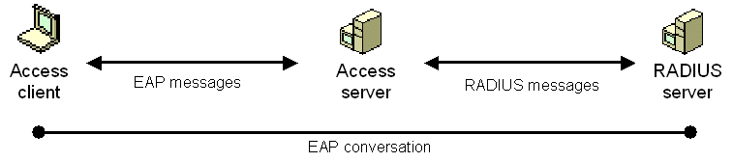
Figure 13 EAP over RADIUS
EAP over RADIUS is used in environments where RADIUS is used as the authentication provider. An advantage of using EAP over RADIUS is that EAP types do not need to be installed at each access server, only at the RADIUS server. However, the access server must support the negotiation of EAP as an authentication protocol and the passing of EAP messages to a RADIUS server.
In a typical use of EAP over RADIUS, the access server is configured to use EAP and to use RADIUS as its authentication provider. When a connection attempt is made, the access client negotiates the use of EAP with the access server. When the client sends an EAP message to the access server, the access server encapsulates the EAP message as the EAP-Message attribute of a RADIUS Access-Request message and sends it to its configured RADIUS server. The RADIUS server processes the EAP message in the EAP-Message attribute and sends an EAP response message as a RADIUS Access-Challenge message with the EAP-Message attribute to the access server. The access server then forwards the EAP message to the access client.

EAP-TLS and the IEEE 802.1X Authentication Process
The following is the EAP-TLS authentication process for a wireless client authenticating to a wireless AP configured to use a RADIUS server as its authentication server:

Step 1: Association and request for identity
If the wireless AP observes a new wireless client associating with it, the wireless AP transmits an EAP-Request/Identity message to the wireless client. Alternately, when a wireless client associates with a new wireless AP, it transmits an EAP-Start message. If the IEEE 802.1X process on the wireless AP receives an EAP-Start message from a wireless client, it transmits an EAP-Request/Identity message to the wireless client.

Step 2: EAP-Response/Identity response
If there is no user logged on to the wireless client, it transmits an EAP-Response/Identity containing the computer name. For Windows XP wireless clients, the FQDN of the computer account is sent. If there is a user logged on to the wireless client, it transmits an EAP-Response/Identity containing the user name. For Windows XP wireless clients, the UPN of the user account is sent.
The wireless AP forwards the EAP-Response/Identity message to the RADIUS server in the form of a RADIUS Access-Request message.

Step 3: EAP-Request from RADIUS server (Start TLS)
The RADIUS server sends a RADIUS Access-Challenge message containing an EAP-Request message with the EAP-Type set to EAP-TLS, requesting a start to the TLS authentication process.
The wireless AP forwards the EAP message to the wireless client.

Step 4: EAP-Response from the wireless client (TLS Client Hello)
The wireless client sends an EAP-Response message with the EAP-Type set to EAP-TLS, indicating the TLS client hello.
The wireless AP forwards the EAP message to the RADIUS server in the form of a RADIUS Access-Request message.

Step 5: EAP Request from RADIUS server (RADIUS Server’s Certificate)
The RADIUS server sends a RADIUS Access-Challenge message containing an EAP-Request message with the EAP-Type set to EAP-TLS, and includes the RADIUS server’s certificate chain.
The wireless AP forwards the EAP message to the wireless client.

Step 6: EAP-Response from the wireless client (Wireless Client’s Certificate)
The wireless client sends an EAP-Response message with the EAP-Type set to EAP-TLS, and includes the wireless client’s certificate chain.
The wireless AP forwards the EAP message to the RADIUS server in the form of a RADIUS Access-Request message.

Step 7: EAP-Request from RADIUS server (Cipher suite, TLS complete)
The RADIUS server sends an EAP-Request message with the EAP-Type set to EAP-TLS, and includes the cipher suite and an indication that TLS authentication message exchanges are complete.
The wireless AP forwards the EAP message to the wireless client.

Step 8: EAP-Response from the wireless client
The wireless client sends an EAP-Response message with the EAP-Type set to EAP-TLS.
The wireless AP forwards the EAP message to the RADIUS server in the form of a RADIUS Access-Request message.

Step 9: EAP-Success from RADIUS server
The RADIUS server derives the per-client unicast session key and the signing key from the keying material that is a result of the EAP-TLS authentication process. Next, the RADIUS server sends a RADIUS Access-Accept message containing an EAP-Success message and the MPPE-Send-Key and MPPE-Recv-Key attributes to the wireless AP.
The wireless AP uses the key encrypted in the MS-MPPE-Send-Key attribute as the per-client unicast session key for data transmissions to the wireless client (truncated to the appropriate WEP key length). The wireless AP uses the key encrypted in the MS-MPPE-Recv-Key attribute as a signing key for data transmissions to the wireless client that require signing (truncated to the appropriate WEP key length).
The wireless client derives the per-client unicast session key (the same value as the decrypted MS-MPPE-Send-Key attribute in the RADIUS message sent to the wireless AP) and the signing key (the same as value as the decrypted MS-MPPE-Recv-Key attribute in the RADIUS message sent to the wireless AP) from the keying material that is a result of the EAP-TLS authentication process. Therefore, both the wireless AP and the wireless client are using the same keys for both the encryption and signing of unicast data.
The wireless AP on receiving the RADIUS server message forwards the EAP-Success message to the wireless client. The EAP message does not contain the per-station unicast session or signing keys.

Step 10: Multicast/global encryption key to the wireless client
The wireless AP derives the multicast/global encryption key by generating a random number or by selecting it from a previously set value. Next, the wireless AP sends an EAP over LAN (EAPOL)-Key message to the wireless client containing the multicast/global key that is encrypted using the per-client unicast session key.
The Key field of the IEEE 802.1X EAPOL-Key message is RC4-encrypted using the per-client unicast session key and portions of the message are signed with HMAC-MD5 using the per-client unicast signing key.
Upon receiving the EAPOL-Key message, the wireless client uses the per-client unicast session key to verify the signed portions of the EAPOL-Key message and decrypt the multicast/global key. Next, the wireless LAN network adapter driver indicates the per-client unicast session key, the per-client unicast signing key, and the multicast/global key to the wireless LAN network adapter. After the keys have been indicated, the wireless client begins protocol configuration using the wireless adapter (such as using DHCP to obtain an IP address configuration).
When the wireless AP changes the multicast/global key, it generates and sends EAPOL-Key messages to its connected wireless clients. Each EAPOL-Key message contains the new multicast/global key encrypted with the particular wireless client’s per-client unicast session key.
This process is summarized in Figure 14.
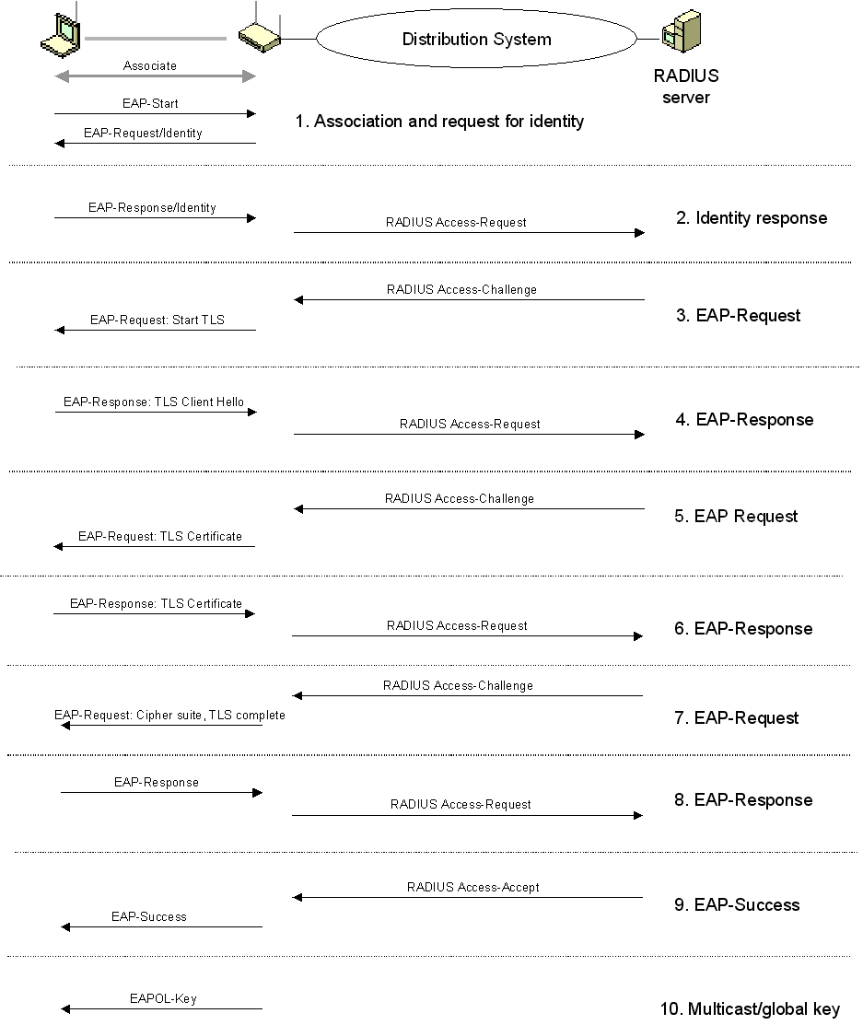
Figure 14 EAP-TLS and the IEEE 802.1X authentication process

PEAP Overview
Although EAP provides authentication flexibility through the use of EAP types, the entire EAP conversation might be sent as clear text (unencrypted). A malicious user with access to the media can inject packets into the conversation or capture the EAP messages from a successful authentication for analysis. This is especially problematic for wireless connections, in which the malicious user can be located outside of your business. EAP occurs during the IEEE 802.1X authentication process, before wireless frames are encrypted with Wired Equivalent Privacy (WEP).
PEAP is an EAP type that addresses this security issue by first creating a secure channel that is both encrypted and integrity-protected with TLS. Then, a new EAP negotiation with another EAP type occurs, authenticating the network access attempt of the client. Because the TLS channel protects EAP negotiation and authentication for the network access attempt, password-based authentication protocols that are normally susceptible to an offline dictionary attack can be used for authentication in wireless environments.

MS-CHAP v2 Overview
MS-CHAP v2 is a password-based, challenge-response, mutual authentication protocol that uses the industry-standard Message Digest 4 (MD4) and Data Encryption Standard (DES) algorithms to encrypt responses. The authenticating server challenges the access client and the access client challenges the authenticating server. If either challenge is not correctly answered, the connection is rejected. MS-CHAP v2 was originally designed by Microsoft as a PPP authentication protocol to provide better protection for dial-up and virtual private network (VPN) connections.
Although MS-CHAP v2 provides better protection than previous PPP-based challenge-response authentication protocols, it is still susceptible to an offline dictionary attack. A malicious user can capture a successful MS-CHAP v2 exchange and methodically guess passwords until the correct one is determined. Using the combination of PEAP with MS-CHAP v2, the MS-CHAP v2 exchange is protected with the strong security of the TLS channel.

PEAP with MS-CHAP v2 Operation
The PEAP authentication process occurs in two parts. The first part is the use of EAP and the PEAP EAP type to create an encrypted TLS channel. The second part is the use of EAP and a different EAP type to authenticate network access. This section examines PEAP with MS-CHAP v2 operation, using as an example, a wireless client that attempts to authenticate to a wireless AP that uses a RADIUS server for authentication and authorization.
The following steps are used to create the PEAP TLS channel:
- After creating the logical link, the wireless AP sends an EAP-Request/Identity message to the wireless client.
- The wireless client responds with an EAP-Response/Identity message that contains the identity (user or computer name) of the wireless client.
- The EAP-Response/Identity message is sent by the wireless AP to the RADIUS server. From this point on, the logical communication occurs between the RADIUS server and the wireless client, using the wireless AP as a pass-through device.
- The RADIUS server sends an EAP-Request/Start PEAP message to the wireless client.
- The wireless client and the RADIUS server exchange a series of TLS messages through which the cipher suite for the TLS channel is negotiated and the RADIUS server sends a certificate chain to the wireless client for authentication.
At the end of the PEAP negotiation, the RADIUS server has authenticated itself to the wireless client. Both nodes have determined mutual encryption and signing keys (using public key cryptography, not passwords) for the TLS channel.
After the PEAP TLS channel is created, the following steps are used to authenticate the wireless client credentials with MS-CHAP v2:
- The RADIUS server sends an EAP-Request/Identity message.
- The wireless client responds with an EAP-Response/Identity message that contains the identity (user or computer name) of the wireless client.
- The RADIUS server sends an EAP-Request/EAP-MS-CHAP-V2 Challenge message that contains a challenge string.
- The wireless client responds with an EAP-Response/EAP-MS-CHAP-V2 Response message that contains both the response to the RADIUS server challenge string and a challenge string for the RADIUS server.
- The RADIUS server sends an EAP-Request/EAP-MS-CHAP-V2 Success message, which indicates that the wireless client response was correct and contains the response to the wireless client challenge string.
- The wireless client responds with an EAP-Response/EAP-MS-CHAP-V2 Ack message, indicating that the RADIUS server response was correct.
- The RADIUS server sends an EAP-Success message.
At the end of this mutual authentication exchange, the wireless client has provided proof of knowledge of the correct password (the response to the RADIUS server challenge string), and the RADIUS server has provided proof of knowledge of the correct password (the response to the wireless client challenge string). The entire exchange is encrypted through the TLS channel created in the first part of the PEAP authentication.
If PEAP/TLS is used, a TLS authentication process occurs in the same way as EAP-TLS, except that the EAP messages are encrypted using the TLS channel created in the first part of the PEAP authentication.

PEAP Fast Reconnect
You can also use PEAP to quickly resume a TLS session. If PEAP Part 2 is successful, the RADIUS server can cache the TLS session created during PEAP Part 1. Because the cache entry was created through a successful PEAP Part 2 authentication process, the session can be resumed without having to perform PEAP Part 1 or PEAP Part 2. In this case, an EAP-Success message is sent immediately for a reauthentication attempt. This is known as fast reconnect. Fast reconnect minimizes the connection delay in wireless environments when a wireless client roams from one wireless AP to another.

PEAP Support in Windows
PEAP/MS-CHAP v2 and PEAP/TLS is provided with Windows XP SP 1, as part of enhanced EAP and IEEE 802.1X support. This allows Windows XP wireless clients to use PEAP with MS-CHAP v2 for secure wireless access⎯with passwords rather than certificates. The IAS networking component provided with Microsoft 802.1X Authentication Client for Windows 2000 also supports PEAP with MS-CHAP v2, allowing an IAS server authenticate wireless clients running Windows XP SP1 or Microsoft 802.1X Authentication Client.
PEAP with MS-CHAP v2 requires certificates on the IAS servers but not on the wireless clients. IAS servers must have a certificate installed in their Local Computer certificate store. Instead of deploying a PKI, you can purchase individual certificates from a third-party CA to install on your IAS servers. To ensure that wireless clients can validate the IAS server certificate chain, the root CA certificate of the CA that issued the IAS server certificates must be installed on each wireless client.
Windows XP includes the root CA certificates of many third-party CAs. If you purchase your IAS server certificates from a third-party CA that corresponds to an included root CA certificate, no additional wireless client configuration is required. If you purchase your IAS server certificates from a third party CA for which Windows XP does not include a corresponding root CA certificate, you must install the root CA certificate on each wireless client.

IAS and Remote Access Policies
This section describes the following topics:
- IAS overview
- IAS as a RADIUS server
- Remote access policies
- Remote access policy conditions and restrictions
- Dial-in properties of a user or computer account
- Authorizing access

IAS Overview
Internet Authentication Service (IAS) in Windows 2000 Server is the Microsoft implementation of a RADIUS server. IAS performs centralized connection authentication, authorization, and accounting for many types of network access, including wireless, authenticating switch, dial-up and virtual private network (VPN) remote access, and router-to-router connections. IAS supports RFCs 2865 and 2866, as well as additional RADIUS extension RFCs and Internet drafts.
IAS enables the use of a heterogeneous set of wireless, switch, remote access, or VPN equipment, and can be used with the Windows 2000 Routing and Remote Access service.
When an IAS server is a member of an Active Directory-based domain, IAS uses Active Directory as its user account database and is part of a single sign-on solution. The same set of credentials is used for network access control (authenticating and authorizing access to a network) and to log on to an Active Directory-based domain.
Different IAS configurations can be created for the following solutions:
- Wireless access
- Organization dial-up or virtual private network (VPN) remote access
- Outsourced dial-up or wireless access
- Internet access
- Authenticated access to extranet resources for business partners

IAS as a RADIUS Server
IAS can be used as a RADIUS server to perform authentication, authorization, and accounting for RADIUS clients. A RADIUS client can be either an access server or a RADIUS proxy. IAS as a RADIUS server is shown in Figure 15.
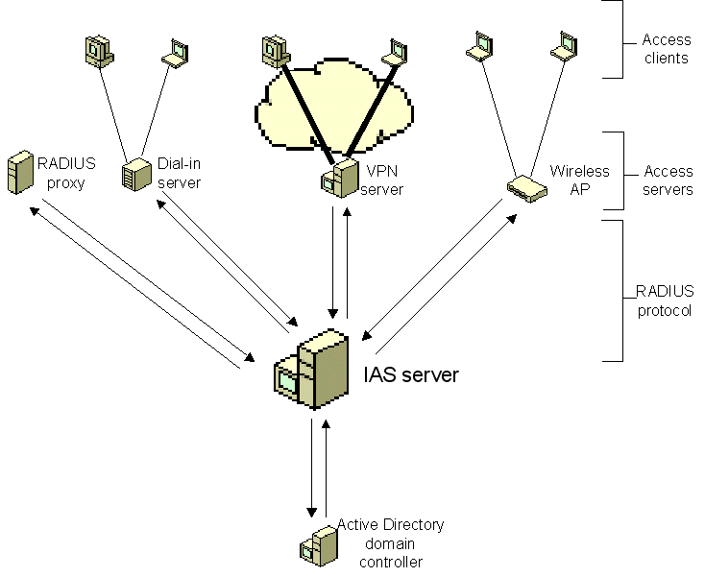
Figure 15 IAS as a RADIUS server
When IAS is used as a RADIUS server, it provides the following:
- A central authentication and authorization service for all access requests that are sent by RADIUS clients IAS uses either a Windows NT Server 4.0 domain, an Active Directory-based domain, or the local Security Accounts Manager (SAM) to authenticate user credentials for a connection attempt. IAS uses the dial-in properties of the user account and remote access policies to authorize a connection.
- A central accounting recording service for all accounting requests that are sent by RADIUS clients Accounting requests are stored in a local log file for analysis.
You can use IAS as a RADIUS server when:
- You are using a Windows NT Server 4.0 domain, an Active Directory-based domain, or the local Security Accounts Manager (SAM) as your user account database for access clients.
- You are using the Windows 2000 Routing and Remote Access service on multiple dial-up servers, VPN servers, or demand-dial routers and you want to centralize both the configuration of remote access policies and connection logging for accounting.
- You are outsourcing your dial-in, VPN, or wireless access to a service provider. The access servers use RADIUS to authenticate and authorize connections that are made by members of your organization.
- You want to centralize authentication, authorization, and accounting for a heterogeneous set of access servers.

Remote Access Policies
In Windows NT versions 3.5, 3.51, and 4.0, authorization was based on a Grant dial-in permission to user option in either User Manager or the Remote Access Admin utility. For IAS in Windows 2000, network access authorization is granted on the basis of user account dial-in properties and remote access policies.
Remote access policies are an ordered set of rules that define how connections are either authorized or rejected. For each rule, there are one or more conditions, a set of profile settings, and a remote access permission setting.
If a connection is authorized, the remote access policy profile specifies a set of connection restrictions. The dial-in properties of the user account also provide a set of restrictions. Where applicable, user account connection restrictions override the remote access policy profile connection restrictions.

Remote Access Policy Conditions and Restrictions
Remote access policies validate a number of connection settings before authorizing the connection, including the following:
- Group membership
- Type of connection
- Time of day
Advanced conditions include the following:
- Access server identity
- Access client phone number or MAC address
- Whether unauthenticated access is allowed
After the connection is authorized, remote access policies can also be used to specify connection restrictions, including the following:
- Idle timeout time
- Maximum session time
- Encryption strength
- Authentication method
- IP packet filters
- Advanced restrictions:
- IP address for PPP connections
- Static routes
Additionally, you can vary connection restrictions based on the following settings:
- Group membership
- Type of connection
- Time of day
- Authentication methods
- Identity of the access server
- Access client phone number or MAC address
- Whether unauthenticated access is allowed
For example, you can have policies that specify different maximum session times for different types of connections or groups. Additionally, you can specify restricted access for business partners or unauthenticated connections.

Dial-in Properties of a User or Computer Account
In Windows 2000, user and computer accounts for an Active Directory-based server contains a set of dial-in properties that are used when allowing or denying a connection attempt. On an Active Directory–based server, you can set the dial-in properties on the Dial-in tab for the user and computer account in the Active Directory Users and Computers snap-in. Figure 16 shows the Dial-in tab.
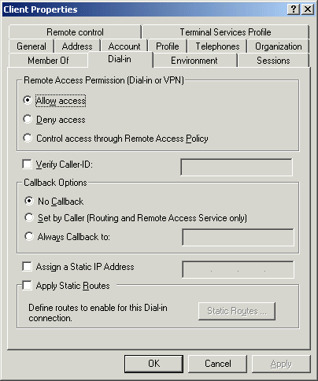
Figure 16 The Dial-in tab of a user account
The dial-in properties for a user and computer account are:
- Remote Access Permission (Dial-in or VPN)
You can use this property to set remote access permission to be explicitly allowed, denied, or determined through remote access policies. In all cases, remote access policies are also used to authorize the connection attempt. If access is explicitly allowed, remote access policy conditions, user account properties, or profile properties can still deny the connection attempt. The Control access through Remote Access Policy option is only available on user and computer accounts in a native-mode domain.
New accounts that are created for a native-mode domain are set to Control access through Remote Access Policy. New accounts that are created in a mixed-mode domain are set to Deny access.
- Verify Caller ID
If this property is enabled, the server verifies the caller's phone number. If the caller's phone number does not match the configured phone number, the connection attempt is denied.
The caller, the phone system between the caller and the remote access server, and the remote access server, must support caller ID. On a computer running the Routing and Remote Access service, caller ID support consists of call answering equipment that provides caller ID information and the appropriate driver to pass the caller ID information to the Routing and Remote Access service.
If you configure a caller ID phone number for a user, and you do not have support for the passing of caller ID information from the caller to the Routing and Remote Access service, the connection attempt is denied.
- Callback Options
If this property is enabled, the server calls the caller back during the connection process. Either the caller or the network administrator sets the phone number that is used by the server.
- Assign a Static IP Address
You can use this property to assign a specific IP address to a user when a connection is made.
- Apply Static Routes
You can use this property to define a series of static IP routes that are added to the routing table of the server running the Routing and Remote Access service when a connection is made. This setting is designed for user accounts that Windows 2000 routers use for demand-dial routing.
Note Dial-in properties for computer accounts are available only after the patch available in Knowledge Base article Q306260 is installed on domain controllers.

Remote Access Permission Administration Models
In Windows 2000, there are three primary models for administering remote access permissions and connection settings:
- Access by user.
- Access by policy in a Windows 2000 native-mode domain.
- Access by policy in a Windows 2000 mixed-mode domain.

Access by user
In the access-by-user administrative model, remote access permissions are determined by the remote access permission on the Dial-in tab of the user or computer account. You enable or disable remote access permission on a per-account basis by setting the remote access permission to either Allow access or Deny access.
The remote access permission setting on the remote access policy is effectively overridden by if the account remote access permission is set to either Allow access or Deny access. However, you can modify remote access policy conditions and profile properties to enforce connection settings, such as encryption requirements and idle time-outs.
You can administer access-by-user remote access with multiple remote access policies. Each remote access policy has its own profile settings. You must configure these settings carefully because a connection attempt may be rejected even when the remote access permission on the account is set to Allow access. If a connection attempt matches the conditions of a policy but does not match the profile settings or does not match any of the remote access policies, the connection attempt is rejected.
To explicitly allow access, set the remote access permission on the account to Allow access. If the connection attempt matches the conditions of the policy subject to the settings of the profile and the dial-in properties of the user account, the connection attempt is authorized and accepted.
To explicitly deny access, set the remote access permission on the account to Deny access. If the connection attempt matches the conditions of the policy, the connection attempt is rejected.
In Windows 2000, the access-by-user administrative model is equivalent to administering remote access on a Windows NT 4.0 RAS server.
In this administrative model, it is common to configure remote access policies with conditions that specify a connection type. For example, for wireless connectivity, you would configure a policy with the condition that the connection is a wireless connection type.

Access by policy in a native-mode domain
In the access-by-policy administrative model for a Windows 2000 native-mode domain, the remote access permission on every user or computer account is set to Control access through Remote Access Policy and remote access permissions are determined by the remote access permission setting on the remote access policy. Therefore, the remote access permission setting on the remote access policy determines whether remote access permission is allowed or denied.
To explicitly allow access, set the remote access permission on the remote access policy to Grant remote access permission. If the connection attempt matches the conditions of the policy subject to the settings of the profile and the dial-in properties of the user account, the connection attempt is authorized and accepted.
To explicitly deny access, set the remote access permission on the remote access policy to Deny remote access permission. If the connection attempt matches the conditions of the policy, the connection attempt is rejected.
In this administrative model, it is common to configure remote access policies with conditions that specify a group and a connection type. For example, for wireless connectivity, you would configure a policy with the following conditions:
- Wireless connection types
- Members of the WirelessUsers group (example)

Access by policy in a Windows 2000 mixed-mode domain
In the access-by-policy administrative model for a Windows 2000 mixed-mode domain, the remote access permission on every user and computer account is set to Allow access, the default remote access policy is deleted, and separate remote access policies are created to define the types of connections that are allowed. On a remote access server running Windows 2000 that is a member of a Windows 2000 mixed-mode domain, the Control access through Remote Access Policy option is not available for remote access permission on the user and computer account. If a connection attempt matches the conditions of a policy subject to the profile and user account dial-in settings, then the connection is accepted.
Because the remote access permissions of all accounts are set to Allow access, if the connection attempt matches the conditions of the policy subject to the settings of the profile and the dial-in properties of the user account, the connection attempt is authorized and accepted.
To explicitly deny access, create a policy in which the connection attempt matches the conditions of a policy but not the settings of the profile. You can explicitly deny access in this administrative model by enabling the Restrict Dial-in to this number only dial-in constraint and typing a number that does not correspond to any dial-in number being used by the access server. The Restrict Dial-in to this number only setting is configured on the Dial-in constraints tab in the profile properties of a remote access policy. If the connection attempt matches the conditions of the policy, the connection attempt is rejected.
In this administrative model, it is common to configure remote access policies with conditions that specify a group and a connection type. For example, for wireless connectivity, you would configure a policy with the following conditions:
- Wireless connection types
- Members of the WirelessUsers group (example)

Certificates
This section describes the following topics:
- Computer authentication and user authentication
- Obtaining a certificate for IEEE 802.1X authentication
- Group policy and IEEE 802.1X authentication

Computer Authentication and User Authentication
To successfully authenticate a Windows XP computer with a wireless AP, you must have a computer certificate, a user certificate, or both installed. Wireless clients running Windows XP can use EAP-TLS to authenticate the computer or the user logged on to the computer.
To authenticate the computer, the computer running Windows XP submits a computer certificate (along with its chain) stored in the Local Computer certificate store during EAP-TLS authentication. The Local Computer certificate store is always available, regardless of whether a user has logged on to the computer or who is logged on to the computer. More importantly, the Local Computer certificate store is available during the computer's startup process.
To authenticate the user logged on to the computer, the computer running Windows XP submits a user certificate stored in the Current User certificate store during EAP-TLS authentication. The user's certificate store is only available after the user has successfully logged on to the computer using the proper credentials. Each individual user that logs on to the computer has a separate user certificate store. The user certificate is not available during the startup process.
Without an installed computer certificate, a Windows XP wireless client computer that starts up within range of a wireless AP associates with it but authentication fails. A user can log on to a computer that does not have wireless LAN network connectivity using cached credentials. Once successfully logged on, the user's certificate store becomes available and the subsequent authentication with the wireless AP succeeds using the installed user certificate.
The following registry setting controls the computer and user authentication behavior of Windows XP:
AuthMode
Key: HKEY_LOCAL_MACHINE\Software\Microsoft\EAPOL\Parameters\General\Global
Value Type: REG_DWORD
Valid Range: 0-2
Default value: 0
Present by default: No
Values:
- 0 - Computer authentication mode If computer authentication is successful, no user authentication is attempted. If the user logon is successful before computer authentication, then user authentication is performed.
- 1 - Computer authentication with re-authentication If computer authentication completes successfully, a subsequent user logon results in a re-authentication with the user certificate. The user logon has to complete in 60 seconds or the existing network connectivity is terminated. The user certificate is used for subsequent authentication or re-authentication. Computer authentication is not attempted again until the user logs off the computer.
- 2 - Computer authentication only When a user logs on, it has no effect on the connection. 802.1X authentication is performed using the computer certificate only.
The exception to this behavior is that if you have a successful user logon and roam between wireless APs, then user authentication is performed.
For computers running Windows XP (prior to SP1), the default value of the AuthMode setting is 0. For computers running Windows XP SP1, the default value of the AuthMode setting is 1.
For changes to this setting to take effect, restart the Wireless Zero Configuration service.

Obtaining a Certificate for IEEE 802.1X Authentication
The following methods can be used to obtain certificates for Windows XP or Windows 2000 wireless clients and IAS server computers:
- Auto-enrollment
- Request a certificate via the Web
- Request a certificate using the Certificates snap-in
- Import a certificate using the Certificates snap-in
- Create a program or script using CAPICOM

Auto-enrollment
Auto-enrollment is the automatic requesting and issuing of certificates based on Computer Configuration Group Policy. By configuring the Automatic Certificate Request Settings Group Policy setting (found under Computer Configuration\Windows Settings\Security Settings\Public Key Policies), you can have the computers who are members of the domain system container for which the settings are configured automatically request a certificate of specified types when Computer Group Policy settings are refreshed.
For wireless client access and for the IAS server, configure the Automatic Certificate Request Settings Group Policy setting to automatically request the “Computer” certificate. The “Computer” certificate (as named in the Certificate Template dialog box of the Automatic Certificate Request Setup Wizard), is stored in the Local Computer certificate store of the member computer and contains both the User Authentication and Server Authentication certificate purpose. The certificate purpose is also known as an Enhanced Key Usage (EKU). An EKU is identified using an object identifier (OID). The OID for Server Authentication is "1.3.6.1.5.5.7.3.1" and the OID for Client Authentication is "1.3.6.1.5.5.7.3.2".
EAP-TLS in Windows requires that the certificate offered for validation by the authenticating client contain the Client Authentication certificate purpose and that the certificate offered for validation by the authenticating server contain the Server Authentication certificate purpose. If both of these conditions are not met, the authentication fails.
Because the auto-enrolled “Computer” certificate contains both the Client Authentication and Server Authentication certificate purposes, it can be used by both a Windows XP wireless client to perform computer authentication and by the IAS server as the authenticating server.

Request a certificate via the Web
Requesting a certificate via the Web, also known as Web enrollment, is done with Internet Explorer. For the address, type http://servername/certsrv, where servername is the computer name of Windows 2000 CA. A Web-based wizard takes you through the steps of requesting a certificate. Note that the location where the certificate is stored (whether it is the Current User store or the Local Computer store) is determined by the Use local machine store check box when performing an advanced certificate request. By default, this option is disabled, and certificates are stored in the Current User store. You must have local administrator privileges to store a certificate in the Local Computer store.

Request a certificate using the Certificates snap-in
Another way to request a certificate is using the Certificates snap-in. To request a certificate to store in the Current User store, open the Certificates-Current User\Personal\Certificates folder, right-click the Certificates folder, point to All tasks, then click Request New Certificate. A Certificate Request Wizard guides you through the steps of requesting a certificate. For wireless access, the certificate requested for the Current User store must have the Client Authentication certificate purpose.
To request a certificate to store in the Local Computer store, open the Certificates (Local Computer)\Personal\Certificates folder, right-click the Certificates folder, point to All tasks, then click Request New Certificate. A Certificate Request Wizard will guide you through the steps of requesting a certificate. For wireless access, the certificate requested for the Local Computer store must have the Client Authentication certificate purpose. For the certificate for the IAS server, the certificate requested for the Local Computer store must have the Server Authentication certificate purpose.

Import a certificate using the Certificates snap-in
All of the preceding ways of requesting a certificate assume that network connectivity already exists, such as using the Ethernet port on a laptop. For those configurations where the only network connectivity is wireless, which cannot be obtained without certificates, you can also import a certificate file from a floppy disk, CD-ROM, or other recordable media using the Certificates snap-in.
To import a certificate to store in the Current User store, open the Certificates-Current User\Personal\Certificates folder, right-click the Certificates folder, point to All tasks, then click Import. A Certificate Import Wizard will guide you through the steps of importing a certificate from a certificate file. For wireless access, the certificate imported into the Current User store must have the Client Authentication certificate purpose.
To import a certificate to store in the Local Computer store, open the Certificates (Local Computer)\Personal\Certificates folder, right-click the Certificates folder, point to All tasks, then click Import. A Certificate Import Wizard will guide you through the steps of importing a certificate from a certificate file. For wireless access, the certificate imported into the Local Computer store must have the Client Authentication certificate purpose. For the certificate for the IAS server, the certificate imported into the Local Computer store must have the Server Authentication certificate purpose.

Create a program or script using CAPICOM
Requesting a certificate using Web enrollment or the Certificates snap-in requires user intervention. To automate the certificate distribution process, a network administrator can write an executable program or script using CAPICOM. CAPICOM is a COM client, supporting Automation, that performs cryptographic functions (the CryptoAPI) using Microsoft® ActiveX® and COM objects.
The CAPICOM interface can be used to perform fundamental cryptographic tasks including signing data, verifying signatures. enveloping messages, decrypting enveloped messages, encryption of data, decryption of data, and checking the validity of digital certificates. CAPICOM can be used via Visual Basic®, Visual Basic Scripting Edition, and C++.
To perform an enterprise deployment of user and computer certificates, a CAPICOM program or script can be distributed through email for execution or users can be directed to a Web site containing a link to a CAPICOM program or script. Alternately, the CAPICOM program or script can be placed in the user’s logon script file for automatic execution. The storage location of the user or computer certificate can be specified using the CAPICOM APIs.
For information about CAPICOM, see CAPICOM at http://msdn.microsoft.com/library/en-us/security/security/capicom_start_page.asp?frame=true.

Group Policy and IEEE 802.1X Authentication
Group Policy settings define the various components of the user's desktop environment that a system administrator needs to manage; for example, the programs that are available to users, the programs that appear on the user's desktop, and Start menu options. Group Policy settings you specify are contained in a Group Policy object, which is in turn associated with selected Active Directory container objects—sites, domains, or organizational units. Group Policy includes settings for User Configuration, which affect users, and Computer Configuration, which affect computers.

IEEE 802.1X and Computer Configuration Group Policy
Updates to Computer Configuration Group Policy occur when the computer starts, achieves network connectivity, and locates a domain controller. The computer attempts to download the latest Computer Configuration Group Policy based on the computer's membership in a domain system container.
If a Windows XP wireless client does not have a computer certificate installed, it cannot authenticate to a wireless AP to obtain wireless LAN network connectivity. Therefore, the attempt to locate a domain controller and download the latest Computer Configuration Group Policy fails. This event is recorded in the event log.
The solution to this problem is to install a computer certificate on the Windows XP wireless client so that wireless LAN network connectivity is present during the location of the domain controller and the download of the Computer Configuration Group Policy.

IEEE 802.1X and User Configuration Group Policy
Updates to User Configuration Group Policy occur when a user supplies correct credentials and logs on to the domain. If a computer certificate is not installed (and the computer has not authenticated itself against the wireless AP), the logon uses cached credentials. After the user certificate in the user's certificate store becomes available, the Windows XP wireless client attempts to authenticate against the wireless AP. Depending on how long the wireless authentication takes, the download of the User Configuration Group Policy might also fail. This event is recorded in the event log.
The solution to this problem is to install a computer certificate on the Windows XP wireless client. With an installed computer certificate, the Windows XP wireless client has wireless LAN network connectivity during the entire logon process, and therefore should always be able to download the latest User Configuration Group Policy.

Summary
This article described the components of a wireless LAN that consist of wireless stations, wireless access points, a wired network, and an authentication infrastructure. The elements provided with Windows XP, Microsoft 802.1X Authentication Client, and the Windows 2000 Server family are wireless stations (computers running Windows with a supported wireless LAN adapter) and for the authentication infrastructure: RADIUS servers, domain controllers, and CAs (computers running a member of the Windows 2000 Server family). Using Windows XP, Microsoft 802.1X Authentication Client, and the Windows 2000 Server family along with wireless APs that support RADIUS and IEEE 802.1X, you have all the required elements to deploy a secure wireless LAN infrastructure that uses either EAP-TLS and certificates or PEAP/MS-CHAP v2 for strong authentication and per-session encryption key management.

Related Links
See the following resources for further information:
- Wi-Fi Web site at http://www.microsoft.com/windows2000/technologies/communications/wifi/default.asp
- Internet Authentication Service Web site at http://www.microsoft.com/windows2000/technologies/communications/ias/
- Security Services Web site at http://www.microsoft.com/windows2000/technologies/security/default.asp
- Microsoft 802.1X Authentication Client at http://www.microsoft.com/windows2000/server/evaluation/news/bulletins/8021xclient.asp

For the latest information about Windows XP, see the Windows XP Web site at http://www.microsoft.com/windowsxp.

