

Operating System

Usability Improvements in Windows XP for Knowledge Workers
By Piero Sierra
Microsoft Corporation
Published: June 2001

Abstract
This document outlines new features and usability improvements of the Microsoft® Windows® XP Professional operating system. These improvements help users find information, files, and programs and more quickly accomplish tasks, such as customizing computer settings and using, storing, and printing files and documents.

This is a preliminary document and may be changed substantially prior to final commercial release of the software described herein. The information contained in this document represents the current view of Microsoft Corporation on the issues discussed as of the date of publication. Because Microsoft must respond to changing market conditions, it should not be interpreted to be a commitment on the part of Microsoft, and Microsoft cannot guarantee the accuracy of any information presented after the date of publication.
This white paper is for informational purposes only. MICROSOFT MAKES NO WARRANTIES, EXPRESS OR IMPLIED, IN THIS DOCUMENT.
Complying with all applicable copyright laws is the responsibility of the user. Without limiting the rights under copyright, no part of this document may be reproduced, stored in or introduced into a retrieval system, or transmitted in any form or by any means (electronic, mechanical, photocopying, recording, or otherwise), or for any purpose, without the express written permission of Microsoft Corporation.
Microsoft may have patents, patent applications, trademarks, copyrights, or other intellectual property rights covering subject matter in this document. Except as expressly provided in any written license agreement from Microsoft, the furnishing of this document does not give you any license to these patents, trademarks, copyrights, or other intellectual property.

© 2001 Microsoft Corporation. All rights reserved. Microsoft and Windows are either registered trademarks or trademarks of Microsoft Corporation in the United States and/or other countries.
Other product and company names mentioned herein may be the trademarks of their respective owners.
Microsoft Corporation • One Microsoft Way • Redmond, WA 98052-6399 • USA

Contents
Contents 3
Acknowledgements 4
Start Menu 6
Taskbar Grouping and Notification Area Enhancements 8
File and Folder Management 9
Navigation Pane 9
New Sidebar: Tasks, Other Places, and Details 9
Viewing Files and Folders 10
Control Panel 12
Figure 4. Control Panel 12
Search Companion 13
Local/LAN Searches 13
Internet Searches 13
CD Burning 14
Summary 15
For More Information 15

Acknowledgements
Piero Sierra, program manager, Microsoft Corporation.
John Tippett, program manager, Microsoft Corporation.
John Schussler, program manager, Microsoft Corporation.
J. Brian Kurtz, program manager, Microsoft Corporation.
Jason Moore, program manager, Microsoft Corporation.

Introduction
This document outlines new features and usability improvements of the Microsoft® Windows® XP Professional operating system. These improvements help knowledge workers access information and more quickly accomplish tasks such as locating, using, storing, and printing files and documents.
This document covers improvements and features that will help you:
- Access files and programs quickly with the new Start Menu.
- Organize and locate items easily with the new taskbar.
- Explore your computer with enhancements to Windows Explorer.
- Explore and change your computer settings with a new Control Panel.
- Search Web pages and local content with the Search Companion.

Start Menu
The Windows XP Start menu has been redesigned to be faster and easier to use than ever. All system links that were formerly stored on the desktop (for example, My Computer and My Documents) are now on the Start menu, making it your single source for launching applications, finding documents, and changing settings.
The Start menu has several new features to make launching programs easy:
Internet and e-mail clients are now called out at the top of the Start menu by their functional names, making it much easier for beginning users to find these applications even when they don't know the names of the applications.
- A new Most Frequently Used Programs list has been added to the Start menu, directly below the Internet and e-mail objects. This list keeps track of applications you use based on how frequently you used them, not just how recently you've used them. So now your favorite applications will always automatically appear at the top of the menu for quick access.
- Newly installed applications are now highlighted. When a new application is installed, the new Start menu leads you down the All Programs list to the new application, making it much easier for beginning users to find the application they just installed. No more searching!
The Start menu also has new features for finding your documents:
- Your most important folders, My Documents, My Pictures, and My Music, are now called out at the top of the Start menu in the rightmost column. You no longer have to move other application windows out of the way to get to the My Documents folder on your desktop; it's always available on the Start menu. And with all the new features in My Pictures and My Music (for example. a Filmstrip view for pictures, and the option to order prints online and burn CDs), having links to these folders at the top of the Start menu makes them indispensable.
- The "document storage" area that holds My Documents, My Pictures, and My Music can also hold Recent Documents (this option is turned on by default in Windows XP Professional), Favorites, My Network Places, and My Computer. You can customize this area to show any combination of these links, or none of them if you so choose. Also, My Computer can be displayed as a cascading menu, so you now have quick access to removable drives, external devices such as digital cameras, and CD-ROM drives.
You'll find that making changes to your computer settings is now easier than ever. The Control Panel has been given a clear section on the Start menu, making it easy to find, and now includes all the various setting options that were spread across multiple menu items in previous versions of Windows. And with the Control Panel's new intuitive design that categorizes control panels by task rather than by name, changing computer settings is simple.
In conjunction with the new Start menu, Windows XP includes the new Desktop Cleanup Wizard. Although all the primary links for Windows components have been moved to the Start menu, thus making the desktop truly the "user's space," newly installed applications and Internet downloads can still clutter the desktop. Windows XP makes it easy to keep your desktop clean by periodically offering to store icons that you haven't used in a long time in a special folder on the desktop.

The Start menu is fully customizable. You can add and remove features, change the length of the Most Frequently Used List, even add things to the top of the Programs list by right-clicking an item and "pinning" it. All these customization features are available in the Start menu control panel, available either by clicking the Control Panel link on the Start menu, or by right-clicking the Start button itself and selecting Properties.
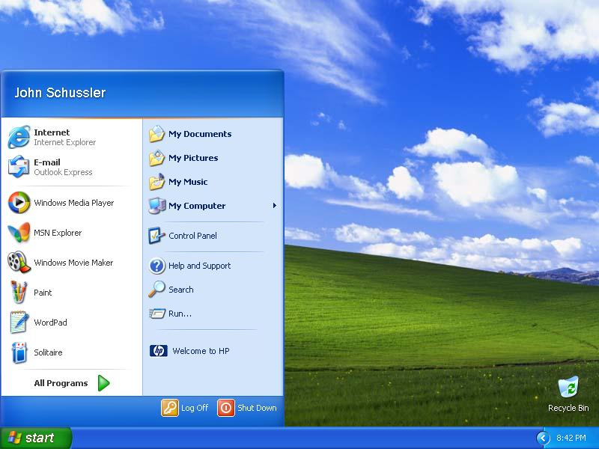

Figure 1. Start Menu
Figure

Figure 1. Start Menu

Figure 1. Start Menu
Figure 1. Start Menu

Taskbar Grouping and Notification Area Enhancements
The Windows® XP taskbar enhancements include two primary features: taskbar grouping and notification area cleanup.
Taskbar grouping organizes commonly used windows into one place. Before grouping, it was often difficult to locate a specific window when many windows were open. With Windows XP, when your taskbar gets too crowded to display all your programs adequately, it automatically groups items. When this happens, items belonging to the least recently used application combine to form a menu. Instead of having to search for an item on a crowded taskbar, you can simply access it using the program's "grouped" menu. When items are grouped, Windows displays the full text of the window title, making it much easier to locate the file you're looking for. Grouped taskbar buttons will ungroup automatically when enough space becomes available on the taskbar. The more windows you typically have open, the more likely you are to appreciate the grouping feature.
The notification area (formerly known as the "system tray") will be less crowded with the notification area cleanup turned on. Items that you don't use will become hidden. This reduces taskbar clutter and enables you to receive more meaningful notifications. Hidden items can be accessed by clicking the notification area expansion icon. If you like, you can go to the Taskbar and Start Menu control panel tool to customize specific icons to always remain visible or stay hidden.
By default, the Windows XP taskbar is locked in position. Microsoft has received a lot of feedback from users who inadvertently move their taskbar, often causing it to become invisible or to take up to half the screen. As a knowledge worker, you may want to customize your taskbar. To do this you can uncheck Lock the Taskbar in the Taskbar and Start Menu control panel tool.
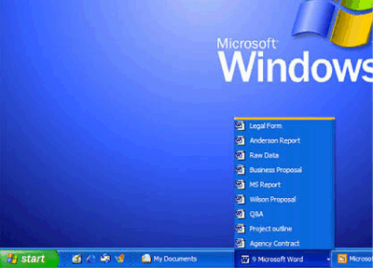

Figure 2. Taskbar grouping

File and Folder Management
Windows XP Explorer offers many new features that make it easier to find files, open programs, and navigate your system. Among these new features are an enhanced navigation pane, a new sidebar that displays tasks and details, and a new way of viewing files and folders called Tile View.

Navigation Pane
The new navigation pane in Windows Explorer behaves much like it did in previous versions of Windows, with two main differences:
- Single-clicking a folder will enable you to move to it and will auto-expand any subfolders the folder might have. In the process of expanding the sub folders, any other peer subfolders will be collapsed.
- The dotted tree lines have been removed.
Note The plus buttons (+) and minus buttons (-) still work like they always have. So, you can open two or more folders without triggering auto-collapse by using the plus and minus buttons.
This new behavior allows you to move deep into a folder and find files and folders more quickly than before.

New Sidebar: Tasks, Other Places, and Details
A new sidebar has been added to Windows Explorer to make finding files and completing tasks easier and quicker. The sidebar displays three new areas:
Tasks. The most common tasks in a specific folder are displayed for you as links that you can click from within Explorer. The tasks listed are specific to each folder. For example, the My Pictures folder displays the following tasks:
• View as a slide show
• Order prints online
• Print pictures
Other Places. Other Places gives you targets to drag and drop your files and folders to, and provides convenient links to places associated with your current folder. For example, from My Pictures, you can quickly access My Documents, Shared Pictures (for sharing your pictures on a network), My Computer, and My Network Places.
Details. Important details for your files and folders are displayed here. For a picture, Details would list the dimensions and the size of each image, in addition to when you took the picture. For a song, it might be the artist, album title, and even the length of the song.
The new sidebar is displayed with a contrasting background, making it easy for new users to quickly differentiate it from the rest of the Explorer window.

Viewing Files and Folders
Windows® XP provides several new ways for you to arrange and identify your files when viewing them in folders, such as My Documents. When a folder is open, you can access each of the following view options on the View menu. And you can change views in context, so you don't have to close the folder and re-open it to see the changed view.
Show in Groups
Show in Groups allows you to group your files by any detail of the file, such as name, size, type, or date modified. For example, if you group by file type, image files appear in one group, Microsoft Word files appear in another group, and Excel files in another. Show in Groups is available in the Thumbnails, Tiles, Icons, and Details views.
Thumbnails
Thumbnails view displays the images a folder contains on a folder icon so you can quickly identify the contents of the folder. For example, if you store pictures in several different folders, in Thumbnails view, you can tell at a glance which folder contains the pictures you want.
Windows XP displays up to four images on a folder background, by default. Or, you can choose one picture to identify a folder in Thumbnails view. The complete folder name is displayed under the thumbnail.
Tiles
Tiles view displays your files and folders as icons, as shown in Figure 3, below. The icons are larger than those in Icons view, and the sort information you select is displayed under the file or folder name. For example, if you sort your files by type, "Microsoft Word document" appears under the file name for a Microsoft Word document.
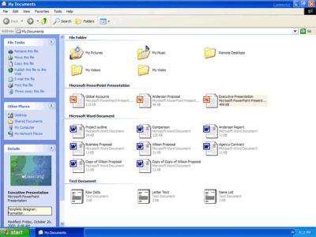
Figure 3. My Documents

Filmstrip
Filmstrip view is available in picture folders. Your pictures appear in a single row of thumbnail images. You can scroll through your pictures using the left and right arrow buttons. If you click a picture, it is displayed as a larger image above the other pictures. To edit, print, or save the image to another folder, double-click the picture.
Icons
Icons view displays your files and folders as icons. The file name is displayed under the icon; however, sort information is not displayed. In this view you can display your files and folders in groups.
List
List view displays the contents of a folder as a list of file or folder names preceded by small icons. This view is useful if your folder contains many files and you want to scan the list for a file name. You can sort your files and folders in this view; however, you cannot display your files in groups.
Details
In Details view, Windows lists the contents of the open folder and provides detailed information about your files, including name, type, size, and date modified. In Details view you can also show your files in groups.

Control Panel
Research indicates that having a single access point to multiple tasks is a significant productivity feature for Windows users. Often, these are tasks that can be accomplished using existing Control Panel features. However, for many users, these tasks are either difficult or time-consuming to locate.

Windows XP features a new Icons view in Control Panel called Category view. The refined Control Panel makes it easier to navigate to common settings and control panel tools, speeds access to frequently used control panels, and integrates user assistance with the Control Panel user interface. If you prefer the organization of the classic Control Panel interface, the classic Control Panel is always just a single click away. In fact, you can revert to the classic interface in context, so you can switch from one view to the other without closing and re-opening Control Panel. And when you reopen the Control Panel later, the view persists.

The new Category view uses a task-centric approach, as opposed to an application-centric approach, highlighting common and problematic tasks. It displays 10 top-level categories for you to choose from, along with a clear navigation path that links you directly to the settings you want to change. These groupings offer concise descriptions instead of one- or two-word labels. Second-level pages promote common, frequently used tasks and enable cross-linking and multiple entry points to make it easier for you to find what you're looking for. The categories are based on several iterations of research to ensure they reflect users’ way of thinking.

The Control Panel aggregates tasks that used to be spread out everywhere. For example, you can now easily trigger a Backup (from Windows XP Professional) directly from Control Panel instead of searching through the system. This may increase productivity by exposing functionality in Windows that may not have known existed.

With the refined Control Panel, you won’t have to turn to external support as often—Windows XP makes it faster and easier to find and perform the Control Panel tasks you need. Administrators maintain control over the appearance of users’ desktops with user policies. For example, an administrator could set a policy that ensures that the classic Control Panel displays on all desktops. He could also hide certain tasks by setting policies to disable the settings on the computer.

Help is integrated into the Windows XP Control Panel layout. The Help content relates directly to the task page you are focused on. You don’t have to go somewhere else to learn about settings or troubleshoot. Glossary definitions are available in both the user interface (UI) and in secondary Help topics. Furthermore, each control in the UI contains an Info Tip, a source of quick help.
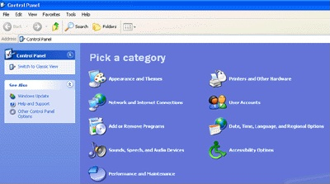

Figure 4. Control Panel

Search Companion
Searching for files or information on your computer, the local network, or the Internet should be quick, easy, and broadly accessible. Windows® XP improves the search process by consolidating search tasks, optimizing searches for the most common scenarios, and offering intelligent refinement.

Local/LAN Searches
Search Companion, shown in Figure 5, organizes local searches by common tasks, allowing you to easily find documents, media files, or any other type of file on their computer. Within each of these tasks, Search Companion is optimized to work the way people think about their files. For instance, if you’re looking for a Microsoft Word document, you don’t need to know the file extension or the exact file name. Instead, you can specify approximately when you last used the document and/or any part of the file name you remember. Search Companion also offers tasks based on your specific query and results. For instance, a search that returns few results will offer suggestions for expanding the number of places searched or looking for more types of files.

Internet Searches
Search Companion helps you find what you're looking for on the Internet by allowing you to enter queries in plain English, suggesting tasks that are most appropriate for your search, and brokering your query out to Internet services that are optimized for the search. At the same time that Search Companion sends your search to your favorite search site, it suggests tasks that are most appropriate for your query. For instance, the query “find John’s e-mail address” would suggest the task Find someone’s e-mail address. Selecting one of the tasks re-routes your query to a Web site that is optimized to perform the appropriate search.

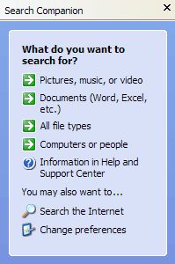
Figure 5. The Search Companion

CD Burning
Recordable CDs have become a common and convenient source of removable storage. With a CD-R/CD-RW recorder, knowledge workers can take up to 650 megabytes (MB) of data on the road and access it from any computer that has a CD drive. Windows XP makes it easier to work with your CD-R/CD-RW recorder in very simple steps. You first drag your files to the CD-R/RW icon in My Computer. Alternatively, in My Music and My Pictures folders, you can choose a task called "Copy to CD" to copy items to your CD-R/RW. Once you have done this, you can open the CD-R/RW folder and click the task Write these files to CD, which will invoke the CD Writing Wizard. This guides you through the simple steps of naming your CD and writing your files to it. You can also burn an audio CD for use in many CD players.

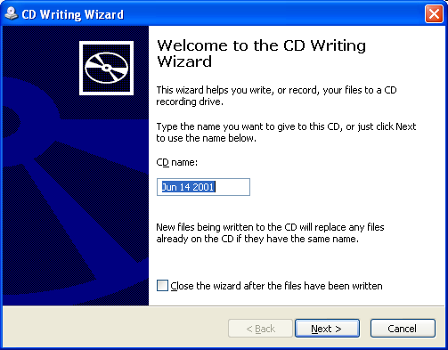
Figure 6. The CD Writing Wizard

Summary
While maintaining the core of Windows 2000, Windows XP features a fresh new visual design based on the results of usability studies. Common tasks have been consolidated and simplified, and new visual cues have been added to help you find files, folders, and tasks on your computer more quickly. The new UI takes the Windows operating system to a new level of usability, enabling you to complete tasks more easily and faster than ever before.

For More Information
For the latest information on Windows XP, check out our Web site at http://www.microsoft.com/windowsxp.

