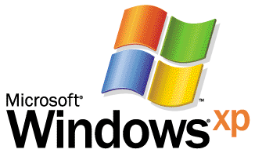

Operating System

Mobile Computing with Windows XP
By John Calhoon
Microsoft Corporation
Published: July 2001

Abstract
This white paper outlines the specific improvements the Microsoft® Windows® XP Professional operating system brings to mobile computing for business users. With new and extended features, Windows XP Professional addresses the unique requirements mobile users have for a laptop operating system and a consistent, fluid work experience both on the road and in the office.

This is a preliminary document and may be changed substantially prior to final commercial release of the software described herein. The information contained in this document represents the current view of Microsoft Corporation on the issues discussed as of the date of publication. Because Microsoft must respond to changing market conditions, it should not be interpreted to be a commitment on the part of Microsoft, and Microsoft cannot guarantee the accuracy of any information presented after the date of publication.
This white paper is for informational purposes only. MICROSOFT MAKES NO WARRANTIES, EXPRESS OR IMPLIED, IN THIS DOCUMENT.
Complying with all applicable copyright laws is the responsibility of the user. Without limiting the rights under copyright, no part of this document may be reproduced, stored in or introduced into a retrieval system, or transmitted in any form or by any means (electronic, mechanical, photocopying, recording, or otherwise), or for any purpose, without the express written permission of Microsoft Corporation.
Microsoft may have patents, patent applications, trademarks, copyrights, or other intellectual property rights covering subject matter in this document. Except as expressly provided in any written license agreement from Microsoft, the furnishing of this document does not give you any license to these patents, trademarks, copyrights, or other intellectual property.

© 2001 Microsoft Corporation. All rights reserved. Microsoft, ClearType, MSDN, Windows, and Windows NT are either registered trademarks or trademarks of Microsoft Corporation in the United States and/or other countries.
Other product and company names mentioned herein may be the trademarks of their respective owners.
Microsoft Corporation • One Microsoft Way • Redmond, WA 98052-6399 • USA
Contents
Acknowledgements 4
Introduction 5
Fast Startup and Power Management 6
Usability Improvements for Mobile Users 9
Remote Desktop 12
Creating Remote Connections 14
Virtual Private Networking 16
Wireless Connections 17
High-Speed Wireless 17
IrDA 17
Infrared (IrComm) Modem 18
Using the Same Device for Multiple Connections 19
Taking Resources Offline 20
Accessing Files and Folders When Offline 20
Accessing Web Content Offline 21
One-Stop Synchronization 21
Synchronization Manager 21
Securing Information 22
Protecting Data 23
Summary 25
For More Information 26

Acknowledgements
John Calhoon, Microsoft Corporation

Introduction
The popularity of laptops shows that people are eager to use mobile technology. Windows XP Professional is designed to make mobile computing easier. This operating system is built to provide access to your information while you're away from the office.
The mobile computing improvements in Windows XP Professional build on the flexibility of Microsoft Windows® 2000 Professional. New features for mobile computing will help you accomplish as much on the road or at home as you do in the office, so you can be productive no matter where you are. Add these capabilities to the reliability, performance, and communication features in Windows XP Professional and you have a system that can do things that you always thought a system should be able to do.
This paper outlines the specific improvements Windows XP Professional brings to mobile computing for business users. Unless noted, the capabilities described in this document do not require special hardware and will work in almost any networking environment.

Fast Startup and Power Management
A typical computer may take several minutes to completely start—far too long for a business meeting where potential clients are short on time and patience. Startup and shutdown times are a critical part of the mobile user experience. Windows XP Professional includes power management improvements that move the computer closer to turning on at the flip of a switch.
As in Windows 2000, power management in Windows XP is based on the Advanced Configuration and Power Interface (ACPI) specification, which allows a computer to emerge from Hibernate mode to being ready to use in less than 30 seconds. Hibernate mode turns off all power to the computer for an indefinite time, while maintaining the state of open programs and connected hardware that existed when the computer went into hibernation.
For super-fast access, Windows® XP Professional supports Suspend mode, which puts the system into a deep sleep, using very little power. Waking from Suspend mode takes only a few seconds, yet can add hours to a battery’s life. Hibernate and Resume performance improvements increase the availability of the system—multiple areas of the system where former delays occurred during the boot process have been minimized or removed.
With ACPI, Windows XP Professional is able to manage a system’s power state in response to input from the user, applications, and device drivers.
For instance, if you are a field sales representative making customer calls while using a mobile personal computer for taking occasional notes or referring to product specifications, you could configure the system to turn off the display and hard disk after two minutes of inactivity. And the system can be configured to stand by after a specified period of inactivity, as shown below in figure 1, allowing you to make it through an entire day of customer calls without running out of battery power. Performance in this case would be slow, but you can make the decision as to whether power conservation or performance is more important.
The device interface allows a system to respond to device-initiated events. For example, consider a mobile personal computer that has a modem connected to a cellular phone. Even while on a train the personal computer could be put into Wait for Fax mode, in which only the modem is on, so the computer uses little power. When the telephone rings, the modem turns on the computer, answers the telephone, and downloads the fax. Then the computer shuts off again, using only the minimal amount of power needed for the entire process.

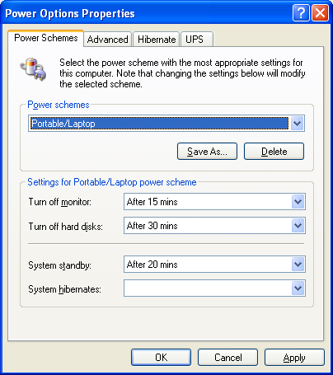

Figure 1. Windows XP Professional supports a variety of power management options, aimed at providing users with the ability to choose the balance between battery life and performance that best meets their needs
Microsoft® Windows® XP builds on the Windows 2000 implementation of ACPI to offer additional power management features that enable the operating system to control the use of power by computers and hardware. Many of the new power management features are beneficial to mobile computer users, such as:
- Processor power control. While the CPU runs at full speed on AC power, the mobile computer can be made to run with lower CPU speeds while on battery power. The reduced CPU speeds save on battery power, giving you extended use of your portable computers.
- CardBus Wake-on-LAN. Windows XP introduces support for CardBus Wake-on-LAN, a technology that allows information technology (IT) departments to better manage portable computers plugged into corporate networks. With CardBus Wake-on-LAN, portable computers in Standby mode can be "woken up" for system updates, software installations, and so forth, and then returned to Standby. This function allows system administrators to address networked portable computers as needed without requiring the portable computers to be left on full power. (Wake-on-LAN technology for desktop computers is also improved in Windows XP, allowing more refined control of wake-up events.)
- Wake-on-Battery. When a system in Standby is running on batteries and the power level drops to low, a wake event can be triggered that allows the system to enter Hibernation mode and preserve data.
- Lid power and display dimming. When the lid of a mobile computer is closed, the display is powered off, thus conserving battery power. And when a mobile computer is running on battery power, the LCD monitor is dimmed. Upon reconnection to AC power, the original brightness in the LCD resumes.
- Selective Suspend of USB Ports. The operating system can turn off individual USB ports to save power.

Usability Improvements for Mobile Users
Several new features in Windows XP Professional make it easier to get work done when you’re on the road, including:
ClearType Support
Microsoft ClearType®, a new text display technology triples the horizontal resolution available for rendering text through software resulting in clearer display of text on a standard LCD screen with digital interface.
Automatic Configuration for Multiple Networks
The automatic configuration option enables easy access to network devices and the Internet, allowing you to connect your mobile computer to both office and home networks without having to manually reconfigure TCP/IP settings. If a Dynamic Host Configuration Protocol (DHCP) server is not found, TCP/IP will use an alternate configuration. The alternate configuration is useful in situations where the computer is used on more than one network and one of those networks does not have a DHCP server and/or an automatic private IP addressing configuration is not desired.
Connection Manager Favorites
The Favorites feature for Connection Manager lets you eliminate repetitive configuration of the Connection Manager properties when switching between common dialing locations. This makes it easy to store and access settings. For example, if you travel between a home office and a business partner’s office, you can use Connection Manager to establish settings for each location, including the nearest access telephone number, area code, and dialing rules. You can then choose from saved settings to quickly set up network connections from each location.

DualView
As a mobile user, you can benefit from other hardware features designed to enhance your experience, such as DualView, which is an extension to the multiple monitor support built into Microsoft Windows® 98, Windows Millennium Edition (Windows Me), and Windows 2000. Some high-end display adapters and many portable computers support two interfaces to the same display adapter. DualView enables the two interfaces to display different outputs at the same time. For example, on a portable computer, you can connect a monitor and use both the portable computer display and the external monitor to expand your desktop space. Or, if you are using your portable computer for a presentation, you can use the computer display to look up data or documents, without interfering with the presentation on the second monitor.

User Profiles
Many businesses share laptops among employees. Windows XP Professional supports the use of multiple user profiles on the same machine, which protects one user's data from being viewed by another. Administrators can configure laptops with Windows XP Professional so users have their own protected set of data, applications, and preferences. Many hardware specific components, such as modems or networking cards, can be configured to work across each of the user profiles. Only users with administrative rights can view all the files.

Giving File Access Permissions
Windows XP Professional users can set access permissions to files, either over the network or locally. These permissions can be set for individual users or groups of users. For example, you can set a folder for "read-only" or "full control" access. This is useful for businesses that share laptops and also can be applied to removable media, such as personal computer card hard drives that can be formatted using the NTFS 5 file system.

Protecting Laptops with Smart Cards
Windows XP Professional gives organizations the option to equip users with Microsoft Smart Cards, which enable a multi-factor security system and make mobile computers even safer from attack. PC card Smart Card readers are available from a variety of manufacturers.
Note For more information about Smart Cards, see http://www.microsoft.com/windows2000/techinfo/howitworks/security/smart.asp.

Connecting and Managing Peripheral Devices
Setting up peripheral devices is getting easier all the time. You can quickly add peripheral devices to your portable computer even when you're working offline. Windows XP Professional automatically detects and installs most new and many older hardware devices for true Plug and Play performance. Plug and Play also saves time when attaching devices such as projectors and large monitors to laptops during a presentation.
Windows XP Professional support for ACPI also allows the Plug and Play manager to work more reliably than previous Plug and Play systems. It first identifies a new device and then assigns it system resources as necessary. The Plug and Play manager also automatically reconfigures resource assignments when it detects changes to the system.
To allow you to plug Universal Serial Bus (USB) devices into computers without rebooting, Windows XP Professional supports the USB standard. USB devices use a standard connection cable, which means there’s no need to travel with extra cables and connectors. Plus, most USB peripheral devices receive their power from the computer, eliminating the need for additional power cords and electrical outlets.

Docking and Undocking
Windows XP Professional users can plug mobile computers in and out of a docking station without changing hardware configurations or rebooting. This is especially helpful because when you move from one environment, such as an office, into a conference room for a presentation, it enables open applications and documents to continue to run.
If you dock the computer into a docking station that has a new configuration, new hardware is detected and installed. To use this feature, your applications and hardware must support hot docking.

Hardware Profiles
Microsoft Windows NT® Workstation version 4.0 required users to manually configure profiles—a set of instructions that indicate which devices to start when you start your computer—and then select them after starting the computer. A typical use for this feature is to allow a portable computer to use particular devices (a CRT monitor, for example) when docked and other devices when undocked.
Windows XP Professional users can move easily between different hardware environments without having to reconfigure hardware or to decipher error messages about devices that are not required for a given profile.
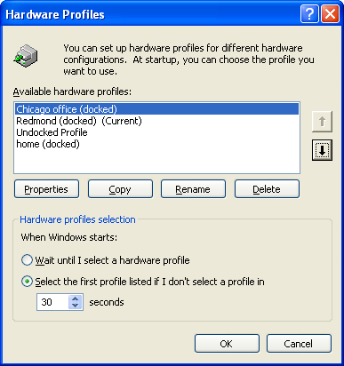

Figure 2. Windows XP Professional users can move easily between configurations for different environments

Remote Desktop
Remote Desktop is based on Terminal Services technology. Using Remote Desktop, you can run applications on a remote computer running Windows XP Professional from any other client running a Microsoft® Windows® operating system. The applications run on the Windows XP Professional–based computer and only the keyboard input, mouse input, and display output data are transmitted over the network to the remote location.
Remote Desktop lets you take advantage of the flexibility provided by a distributed computing environment. A standard component of Windows XP Professional (although not included in Windows XP Home Edition), Remote Desktop lets you access your Windows XP computer from anywhere, over any connection, using any Windows-based client. Remote Desktop gives you secure access to all your applications, files, and network resources—as if you were in front of your own workstation. Any applications that you leave running at the office will be running when you connect remotely—at home, in a conference room, or on the road.
Using Remote Desktop you can, for example, connect to your office computer from home and access all your applications, files, and network resources as though you were in front of your computer at the office. This ability allows more people in an organization to take advantage of the flexibility provided by a distributed computing environment.
Remote Desktop works well even under low-bandwidth conditions, because all your applications are hosted on the Terminal Server. Only keyboard, mouse, and display information are transmitted over the network.
If you’re an IT administrator, Remote Desktop provides you with a rapid response tool: It lets you remotely access a server running Windows 2000 Server or Whistler Server and see messages on the console, administer the computer remotely, or apply headless server control.
Remote Desktop Protocol
The features provided by Remote Desktop are made available through the Remote Desktop Protocol (RDP). RDP is a presentation protocol that allows a Windows-based terminal (WBT), or other Windows-based clients, to communicate with a Windows-based Terminal Server. RDP is designed to provide remote display and input capabilities over network connections for Windows-based applications running on your Windows XP Professional desktop. RDP works across any TCP/IP connection, including a dial-up connection, local area network (LAN), wide area network (WAN), Integrated Services Digital Network (ISDN), DSL, or Virtual Private Network (VPN).
Remote Desktop Resource Redirection
When you use Remote Desktop from a Windows XP−based client, or another RDP 5.1−enabled client, many of the client resources are available within the Remote Desktop connection. These resources include:
File system redirection. This makes the local file system available on the remote desktop within a terminal session. The client file system is accessible through the Remote Desktop as if it were a network-shared drive, and no network connectivity—except the Remote Desktop—is required. The client drives appear in Windows Explorer with the designation "<driveletter> on tsclient."
Printer redirection. This routes printing jobs from the Terminal Server to a printer attached to the local computer. When the client logs on to the remote computer, the local printer is detected, and the appropriate printer driver is installed on the remote computer.
Port redirection. This enables applications running within a terminal session to have access to the serial and parallel ports on the client. Port redirection allows these ports to access and manipulate devices such as bar code readers or scanners.
Audio. You can run an audio-enabled application on your remote desktop and hear the audio output from speakers attached to the computer you’re working on.
Clipboard. The Remote Desktop and the client computer share a clipboard that allows data to be interchanged.

Creating Remote Connections
Windows® XP Professional makes it significantly easier for you to remotely connect to networks, including to VPNs, over dialup connections, infrared, and direct cable connections. A wizard guides you through setting up connections to different types of networks, eliminating the need to manually configure settings.
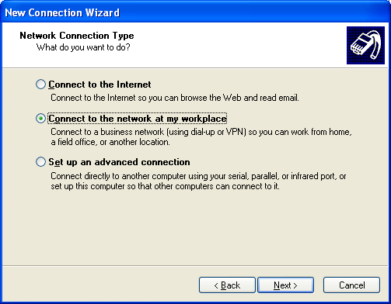The New Connection Wizard helps you create many types of new connections with a single tool. Connection setup is also automated, eliminating the need to download and install additional services—a necessary step in Windows 95 for setting up certain types of remote networking.

Figure 3. You can manage your network connections from one location

Other remote connection options include:
- Dialing up to a private network. There are now more options available for setting dialing properties when you connect to a private network over a telephone line, such as when to use calling cards, personal identification number (PINs), and other connection-specific information.
- Dialing up to the Internet. It's easier than ever to set proxy settings and other Internet-specific information when you dial into the Internet.
- Accepting incoming calls. You can now set access permissions when accepting connections through modem, IrDA, or direct cable connection.
- Connecting directly to another computer. A wizard guides you through the process of making a direct cable connection, which makes connecting computers much simpler.
- Connecting to private virtual networks through the Internet. Connecting to a VPN is easy. A wizard and automatic VPN component configuration option eliminate the need to reboot.

Virtual Private Networking
VPNs allow you to rely on the Internet as a secure pipeline to your corporate LAN. If you are traveling, you can dial into almost any local Internet Service Provider (ISP), then set up a VPN session to connect to your LAN over the Internet. With VPNs, companies can significantly reduce long-distance dial-up charges, and mobile employees have an inexpensive method of remaining connected to LANs for extended periods.
Configuring Windows XP Professional to connect to a VPN is significantly easier with the new New Connection Wizard. Simply enter the VPN server name, and Windows XP Professional will automatically configure the device and add the appropriate networking services—making all the settings required to get you connected in about one minute.

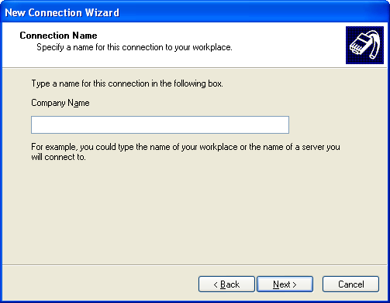
Figure 4. You can simply enter the name of the VPN server to connect to the network
In addition to supporting today’s most common VPN protocol, Point-to-Point Tunneling Protocol (PPTP), Windows XP Professional supports new, more secure ways of creating virtual connections. These include Layer-2 Tunneling Protocol (L2TP) and Internet Protocol Security (IPSec), which allow you to connect to corporate networks with confidence.
More information about PPTP, L2TP, and IPSec can be found in the Windows 2000 Technical Library at www.microsoft.com/windows2000/techinfo/default.asp.

Wireless Connections
The availability of wireless networking and wireless LANs can extend network users' freedom to solve various problems associated with hard-wired networks and even reduce network deployment costs in some cases. Windows® XP includes several keys enhancements that make wireless networking faster and easier.

High-Speed Wireless
In the past, if you wanted to get online with your laptop away from the office, the most reliable option was to find a telephone line. For high-speed access, you needed to find a network jack. Windows XP Professional takes advantage of wireless technology and wireless network access points, or “hot spots.” These hot spots are being installed in public locations such as airports, conference centers, and coffee shops. They use the leading technology for broadband wireless networks today, known as 802.11b.
Effortless Connectivity
Windows XP offers automatic wireless network configuration using the IEEE 802.11 standard for wireless networks, minimizing the configuration that is required to access wireless networks. When you enable automatic wireless network configuration on your computer, you can roam across different wireless networks without the need to reconfigure the network connection settings on your computer for each location. As you move from one location to a new location, automatic wireless network configuration searches for available wireless networks and notifies you when there are new wireless networks available for you to connect to. After you select the wireless network that you want to connect to, automatic wireless network configuration updates your wireless network adapter to match the settings of that wireless network, and attempts to connect to that wireless network.
With automatic wireless network configuration, you can create a list of preferred wireless networks, and you can specify the order in which to attempt connections to these wireless networks.
Seamless Roaming
Windows 2000 included enhancements for detecting the availability of a network and acting appropriately. These enhancements have been extended and supplemented in Windows XP to support the transitional nature of a wireless network.
In Windows 2000, media sense capability (detecting an attached network) was used to control the configuration of the network connection and inform the user when the network was unavailable. With Windows XP this feature is used to enhance the wireless roaming experience by detecting a move to a new access point, forcing re-authentication to ensure appropriate network access and detecting changes in the IP subnet so an appropriate address can be used to get optimum resource access.
802.1X Security
With support for the 802.1x security standard, Windows XP you can roam from access point to access point within your corporate LAN, or from hot spot to hot spot (for example, from airport lounge to Internet café), and be identified and allowed access to these networks, without additional logons. Access is controlled per user and/or per port, allowing for finer-grained access control and identification that enables a wide variety of future services. And thanks to security protocols used in this standard, you can use your networks with higher security confidence than even a wired connection can offer.

IrDA
Windows XP Professional supports the Infrared Data Association (IrDA) protocol suite that lets you transfer information and share resources, such as printers, between computers with no physical cables. Most newer portable computers include hardware support for IrDA.
Two users traveling with laptop computers can transfer files by setting up an IrDA connection, instead of using cables or floppy disks. When users place two computers close to one another, IrDA can automatically configure the connection.
IrDA also allows a computer to access resources that are attached to another computer. For example, a user with a laptop computer who needs to print a document could create an IrDA connection with a computer that is connected to a printer—either locally or on a network. When that connection is established, and with appropriate permission, the user could print over the IrDA connection.
Windows® XP Professional also enables you to allow or limits users other than a computer’s owner to send files using infrared communications. You can also specify the location where documents should be received. Windows XP Professional automatically detects devices that use infrared communications, such as other computers and cameras.
Infrared (IrComm) Modem
IrComm Modem is a driver that exposes the IrDA stack to cellular telephones. This lets you use legacy cellular telephones that have IrComm virtual serial ports. If you have an infrared-enabled cellular telephone with IrComm protocol and want to use it as a modem to access the Internet, the mobile computer will recognize the cellular telephone, enumerate it, and install it as a modem. This lets you dial in to the Internet in the same way you would with a built-in modem.

Using the Same Device for Multiple Connections
Mobile users often need to connect to many different networks while they are traveling, such as different client networks, corporate LANs, and ISPs. With Windows 95 and Windows NT Workstation 4.0, users must reconfigure their modems each time they connect to a different network. For example, a corporation’s proxy server might require a different modem configuration than the user’s ISP.
This manual reconfiguration isn’t needed with Windows XP Professional. Instead, the Per-Connection Settings feature retains individual settings for each network connection, so users can connect to many different networks without remembering and reconfiguring complex settings for each one.

Taking Resources Offline
Consistent access to network-based resources helps you stay more productive whether you're on an airplane or working at a remote site. Multiple users can work in the same files, folders, or Web sites whether they are connected or disconnected from the network, and they can easily synchronize those resources.

Accessing Files and Folders When Offline
The Offline Files and Folders feature lets you easily take any combination of files, folders, or entire mapped drives offline. Instead of using a separate tool, such as the Briefcase, simply right-click any network-based file or folder and click Make Available Offline on the menu.
Note to administrators: The Offline Files and Folders feature works with any Server Message Block (SMB)−based file server, including Microsoft® Windows® for Workgroups and any version of Windows NT Server. Administrators can also use third-party SMB utilities to make the feature available on non-Microsoft platforms, such as Novell NetWare and UNIX.
When the computer is offline, the files and folders appear in the same directory as they did online—as if they still resided in the same location on the network. This makes them easy to find. Plus, files and folders are visually tagged for offline use by the roundtrip arrows in their lower-left corners.
Additional improvements for taking resources offline are available when Windows XP Professional is used together with Windows 2000 Server. With Windows 2000 Server, administrators can set properties on shared network folders to define how those folders can be stored on client computers. For example, administrators can set a policy that a document cannot be taken offline for security reasons.

Accessing Web Content Offline
If you're a Windows XP Professional user, you can also take Web pages or entire Web sites offline for viewing in the same way they take files or folders offline; simply right-click the Web site in one of the Explorer bars. A wizard guides you through taking a Web page and its related links offline, and you can schedule when updates to the Web page content should be made.

One-Stop Synchronization
When working with any resources offline, it’s critical for you to update the online versions when you reconnect to the network, and/or update the local versions when you go back offline. Today, you must separately synchronize resources, such as e-mail, calendars, Web pages, and databases.
The new Synchronization Manager tool in Windows XP Professional lets you synchronize all network resources, including files, folders, e-mail, and databases, in a single location. You can set the Synchronization Manager to automatically synchronize some or all of these resources. For example, you can set certain files and folders to be synchronized every time you log on or off the network. The Synchronization Manager quickly scans the system for any changes, and if it detects any, the resources are automatically updated. Because only resources that have changed are updated, the synchronization process is completed much more quickly.
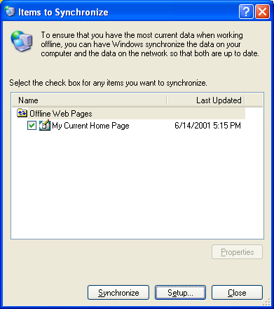

Figure 5. Windows XP Professional offers Synchronization Manager, which provides a single location for synchronizing offline resources
You can also determine whether files are synchronized when the system is idle, or schedule synchronization for specific time increments, such as every evening. As a result, you always have the most up-to-date information, such as pricing, inventory, or sales data, to communicate to partners and clients.
Synchronization Manager users can also synchronize resources based on their connection types. For example, you can save time by specifying that large database files only be synchronized when the computer is using a high-speed connection, and that all personal documents stored in a specific file are synchronized every time you are connected to the corporate LAN.
Although Synchronization Manager is designed primarily to synchronize documents, it can also resolve version conflicts in the event that multiple users edit the same document.

Securing Information
When traveling, you risk having your portable computer stolen. If a Windows XP Professional−based laptop is stolen, all files that you have encrypted, including confidential company and client information, can be made inaccessible to a thief.

Protecting Data
With the addition of Encrypting File System (EFS), Windows XP Professional offers more heightened security than Windows 95, Windows 98, and Windows NT Workstation 4.0. If you store sensitive information on a mobile computer, you can encrypt those files and folders. If the laptop is stolen, EFS protects its files and folders, even if the thief reinstalls Windows XP Professional. Only users with a special decryption key can access the file.
Note EFS provides only local encryption. If a file is sent over a network, for example, encryption must be handled differently, such as through IPSec or other network security technologies.
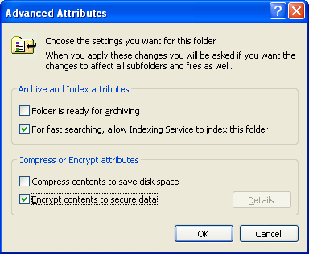

Figure 6. You can encrypt data to protect it
Windows® 2000 Server provides additional EFS security when used in combination with Windows XP Professional. If a user leaves a company, no one can gain access to encrypted files—even an administrator on the local system. But with Windows 2000 Server, administrators can set a policy to recover encrypted data if passwords are lost.

Surprise Removal of Hardware
When a personal computer user removes a piece of hardware from his or her system during a user session, problems can arise that must be handled by the operating system. With the existence of hot-swappable devices and docking stations, this occurrence, known as surprise removal of hardware, is now a common end-user scenario for mobile computer users. Windows® XP provides improved support for surprise removal of hardware.

Refined Caching
Windows XP has a refined caching policy. For consumer-oriented removable storage (USB, Flash, file compression programs, and so on) write caching is disabled by default. Disabling write caching means that, instead of saving up changes for a file on a removable storage device and then doing a bulk write, Windows XP writes changes to the file as the changes are made. This keeps data on removable storage devices more current, mitigating the likelihood of data loss. However, disabling write caching also has a performance impact. Therefore, for IEEE 1394 hard disk drives, Windows applies a special case for the default caching policy by not disabling write caching for these devices.

No More "Surprise Remove" Pop-up Messages
When a device is removed from a computer without first disabling it in Windows Device Manager, Windows displays a pop-up message warning the user of the “surprise removal” of the device. Mobile computer users experience surprise removal messages frequently because of docking stations and hot-swappable devices such as PC cards, CD-ROM drives, and floppy drives. In the past, Windows displayed pop-up messages that alerted users to surprise removal and undocking of these devices. These messages slowed down productivity and accomplished little. With Windows XP, you will no longer see a popup message upon surprise removal of hardware devices or docking units, eliminating the need to respond to these messages.

Summary
With tools to keep you connected to the Internet, and to your co-workers, customers, files, and applications, Windows® XP Professional keeps you in touch—even when you're away from work. Windows XP Professional is the most advanced operating system ever created for laptops, keeping you productive anytime and anywhere.

For More Information
For the latest information on Windows XP, check out our Web site at http://www.microsoft.com/windowsxp.

