Performance Monitor Scenarios for ISPs
June 2002

Introduction
This document is one in an ongoing series on ISP deployment, management, and best practices, based on Coho Internet’s Microsoft® Windows® 2000 Server setup. This document covers how to best monitor performance using the Performance Monitor Tool (PerfMon) included with Windows 2000 Server.
Using PerfMon as a monitoring tool for performance on Coho production machines has been challenging. They use PerfMon in their live, production environment where production machines run on different builds of Microsoft Windows, including Windows 2000 and Windows XP, and where every machine and service is affected by ever-changing network conditions. This deployment environment is uniquely difficult, and has enabled the Coho team to learn a few tricks in running PerfMon successfully in an ISP environment. Those rules boil down to:
- Run PerfMon on its own server.
- Use comma-separated value (CSV) files to record PerfMon data; use a database only in the largest installations.
- Combine HTML files and Internet Information Services (IIS) Web server to display log files on your intranet, where engineers can see them.
The Coho deployment is outlined in a graphic later in this document. Coho’s deployment features a single server that runs PerfMon processes, collects data from remote servers, and logs that data in CSV format in individual .csv files for each remote server.
After logging the .csv files, Coho transfers the .csv file data to their intranet site, where performance data for each monitored server can be reviewed in graph form.
The Coho PerfMon deployment is not the only choice available for small businesses wanting to use PerfMon; two alternative deployments are provided at the end of this document, along with a discussion of why Coho chose not to use these alternatives.

Machine Requirements
In Coho’s deployment, PerfMon does not require a server-class machine. Any workstation running at 500 megahertz (MHz) or greater, with 128 megabytes (MB) of RAM and a 10 gigabyte (GB) hard drive, can be used.

Platform Requirements
You can successfully run PerfMon on any version of Microsoft Windows Server or Windows Professional. Coho runs PerfMon on Windows XP Professional with SP1.

How to Set Up PerfMon Logging
To carry out logging, you must create a Performance account that has the right to execute the PerfMon service on the domain. If you make the Performance account an ordinary user, each server administrator would have to give Local Administrator rights to the Performance account on each server. Because of the maintenance problems this would create, Coho’s performance monitor engineer created a user account called “Performance” and gave it universal access to allow it to run as the Administrator.

Windows 2000 users
If you run PerfMon on a Windows 2000 machine, you must manually set up the account to run as Administrator.
To set up the Performance account as Administrator in Windows 2000
- Start the Windows 2000 Services tool by clicking Start, then selecting All Programs and Administrative Tools, and clicking Services.
- In the Services (Local) pane, right-click Performance Logs and Alerts and click Properties.
- Select the Log On tab. In the This account: text box, enter the account with permission to run PerfMon throughout the domain; in this case, Performance. To clarify, this account must be a member of the local Administrator group on the machine on which PerfMon is running. It must also be a local Administrator of each remote computer that it will monitor.
- The PerfMon service is turned off by default. Select the General tab in the Properties dialog box for Performance Logs and Alerts. Select Automatic in the Startup type: drop-down box.

Windows XP users
In the Active Directory Users and Computers tool, find the “Performance” user account and reset the password. If you fail to do this, you will not be able to set up logging.
To set up the Performance account as Administrator in Windows XP
- Click Start, and Run. In the text box, type perfmon to open the PerfMon tool.
- Double-click Performance Logs and Alerts in the left pane.
- In the right pane, right-click Counter Logs and click New Log Settings.
- In the Name text box, type the name of the first server you want to monitor and click OK.
- A dialog box for that server will open. In the Run As text box on the General tab, type Performance for the user account you created to run PerfMon. Enter the password you gave the account in Active Directory®.
- Click Add counters to open the Add counters dialog box.
- Make sure Select counters from computer is selected.
- In the drop-down box below Select counters from computer, the local computer’s NetBIOS name is listed by default. In this drop-down box, type the fully qualified domain name of the first server to monitor. Occasionally, PerfMon does not locate a server on the network by its NetBIOS name alone; it does find the server if you use the fully qualified domain name or if you specify the static IP address of the machine. If you are using Windows 2000, you cannot type the fully qualified domain name in the drop-down box, so you must use the NetBIOS name.
- In the Performance object drop down list, choose the first counter to monitor. The following list shows current counters for each machine, based on its function.

Which processes to monitor?
The processes you monitor depend on which services a machine offers. This list details the processes that Coho Internet monitors on different servers on its network.
CohoBackUp – Backup server for core network machines
CohoBackUp\Memory\Page Faults/sec
CohoBackUp\Memory\Page Reads/sec
CohoBackUp\Memory\Page Writes/sec
CohoBackUp\Network Interface(Compaq NC3163 Fast Ethernet NIC)\Bytes Total/sec
CohoBackUp\Processor(_Total)\% Processor Time
Cohodc1 – Domain controller
Cohodc1\Process(winlogon)\% Processor Time
Cohodc1\Processor(_Total)\% Processor Time
Coho-ia64 – DNS server
COHO-IA64\DNS\Total Query Received
COHO-IA64\DNS\Total Response Sent/sec
COHO-IA64\Network Interface(Intel[R] 82559 Fast Ethernet LOM with Basic Alert on LAN*)\Bytes Total/sec
COHO-IA64\Processor(_Total)\% Processor Time
CohoMOM1 – Microsoft Operations Manager server
CohoMOM1\Network Interface(Compaq Ethernet_FastEthernet or Gigabit NIC)\Bytes Total/sec
CohoMOM1\Network Interface(Compaq Ethernet_FastEthernet or Gigabit NIC)\Bytes Total/sec
CohoMOM1\Network Interface(Compaq Ethernet_FastEthernet or Gigabit NIC)\Packets Received/sec
CohoMOM1\Network Interface(Compaq Ethernet_FastEthernet or Gigabit NIC)\Packets Sent/sec
CohoMOM1\Processor(_Total)\% Processor Time
CohoMOM2 – Microsoft Operations Manager server
CohoMOM2\Network Interface(Compaq Ethernet_FastEthernet or Gigabit NIC)\Bytes Total/sec
CohoMOM2\Processor(_Total)\% Processor Time
Cohonetmon3 – Microsoft Operations Manager server
Cohonetmon3\Network Interface(Intel[R] PRO_100 VE Network Connection)\Bytes Total/sec
Cohonetmon3\Network Interface(Intel[R] PRO_100 VE Network Connection)\Current Bandwidth
Cohonetmon3\Process(winlogon)\% Processor Time
Cohonetmon3\Processor(_Total)\% Processor Time
Cohons1 – Primary DNS server
Cohons1\DNS\TCP Query Received
Cohons1\DNS\TCP Query Received/sec
Cohons1\Processor(_Total)\% Processor Time
Cohons2 – Secondary DNS server
Cohons2\DNS\TCP Query Received
Cohons2\DNS\TCP Query Received/sec
Cohons2\Processor(_Total)\% Processor Time
Cohopt01 – Exchange POP3 mail server
Cohopt01\MSExchangePOP3(_Total)\Connections Current
Cohopt01\Network Interface(Intel[R] PRO Adapter)\Bytes Total/sec
Cohopt01\Network Interface(Intel[R] PRO Adapter)\Current Bandwidth
Cohopt01\Process(WINLOGON)\% Processor Time
Cohopt01\Processor(_Total)\% Processor Time
CohoPT06 – Exchange News Server
CohoPT06\Cache\Copy Read Hits %
CohoPT06\Cache\Data Flushes/sec
CohoPT06\Network Interface(Intel[R] PRO Adapter)\Bytes Total/sec
CohoPT06\Processor(_Total)\% Processor Time
CohoPT20 – Exchange POP3 mail server
CohoPT20\MSExchange Web Mail(_Total)\Authentications (total)
CohoPT20\MSExchangePOP3(_Total)\AUTH Total
CohoPT20\Network Interface(Compaq Ethernet_FastEthernet or Gigabit NIC)\Bytes Total/secPT20\Processor(_Total)\% Processor Time
CohoPT20\SMTP Server(_Total)\Bytes Sent Total
COHOSQL – Shared SQL Server™ hosting user SQL databases
COHOSQL\Network Interface(Intel DC21143 PCI Fast Ethernet Adapter)\Bytes Total/sec
COHOSQL\Processor(_Total)\% Processor Time
COHOSQL\SQLServer:General Statistics\User Connections

- After choosing a counter, click Add. Repeat this step until you have chosen all the counters you need. Click Close.
- If you select at least one counter, a Sample data every: section will appear in the dialog box. Enter 15 minutes as the interval.
- Select the Log files tab.
- Clear the End files names with… checkbox.
- In the Log file type drop-down box, choose Text File (Comma delimited). Click Configure to open the Configure Log File dialog box.
- The directory, C:\perflogs, appears in the Location text box. During this process, PerfMon creates this default directory as the location for the output of your logging files. You will be asked to confirm that this is OK when you close this dialog box. The log file for the computer being monitored is given the name of that computer by default. The location of C:\perflogs should be shared to a Web server, or set up as a virtual Web folder on a Web server running on the PerfMon server itself.
- In the File name text box, type a name for the CSV file to store the data. Click OK.
- If you want to set specific monitoring times, select the Schedule tab and set the times. Otherwise click OK to close the dialog box and return to the PerfMon tool UI.
- Repeat steps 2-17 for each server you want to monitor.
- To verify that each log has been created, double-click Counter logs. Make sure there is a green stack-like icon to the left of each counter log you have created.
- In Windows Explorer, navigate to C:\Perflogs and open the .csv files with Notepad to verify that data has been logged.

How to Display Performance Logs as HTML Files
Performance Monitor can display its log files as dynamically updated Web pages. This is a useful facility for making logs available to staff. Coho Internet uses HTML files on its internal Web site to display the data files as graphs, for easier interpretation.
- In the PerfMon tool UI, double-click System Monitor in the left pane. This opens the graph view in the right pane.
- Clear the current activity by clicking Delete until all graph activity stops.
- On the toolbar above the graph, locate and click the View Log Data icon.
- On the Source tab, select Log files in the Data Source section.
- Click Add, and choose the .csv file for the server whose performance you are reviewing. Click Open, and then OK.
- Right-click the graph area and click Properties, then select the Source tab. In the Time range section, move the Total Range bar completely to the right. Click OK to return to graph view.
- On the toolbar above the graph, click the plus sign (+).
- In the Add Counters dialog box, select the All Counters radio button and click Add. Click Close.
- Right click the graph and select Save As. Type a name for the file and ensure that Web Page is selected in the Save as type box. Click Close.
- Repeat steps 2-9 for each log file.
- In Windows Explorer, navigate to C:\Perflogs. Open the .htm file for the first log in Notepad. To have the Web files refresh automatically with data from the .csv files, you must add a line to the HTML code.
- In the open file, find the following HTML line near the top:
<META NAME="GENERATOR" Content="Microsoft System Monitor">

- Directly under that line, paste the following HTML code:
<META HTTP-EQUIV="refresh" content="600">

- Make sure the toolbar is turned off by setting the value to 0 in this line:
<PARAM NAME="ShowToolbar" VALUE="0">

- Give the graph a name in this line:
<PARAM NAME="GraphTitle" VALUE="ns1">

- Set the path to the logs so the automation can find it. For this example, the value is as follows:
<PARAM NAME="LogFileName001" VALUE="\\Coho-web\perfmon$\ns1.csv">

- Make sure the DataSourceType parameter value is set to 2 in this line:
<PARAM NAME="DataSourceType" VALUE="2">

This tag may not exist in Windows 2000 generated .htm log files. If it is not preset, add it.
- Finally, delete the two lines with the LogViewStart and LogViewStop parameters. If these counters are not deleted, the refresh function in line 13 will not work.
- Save the file to a share where the Web server can access it. Coho Internet did this by saving the .htm file in \perflogs, the same folder that contained the PerfMon .csv files. They then started IIS on the PerfMon server and made a virtual Web folder from the perflogs folder so that the files are visible in a Web browser.
- To test that the Web page works, append its name to the URL string:
http://<web-host>.<perflogs_folder>/<monitored_server_name>.htm

If the page displays a graph of the performance monitor log, you can assume that it is working. The HTML line <META HTTP-EQUIV="refresh" content="600"> should refresh the page every 10 minutes. However, be aware that the log file shown on the Web page only changes when the log file is rewritten. This depends on how you set the original monitoring of the log file and the time scale that you set the log to display.
You can alter several other parameters to improve the Web presentation. Most parameter tags are self-documenting. For example, you can set the value in the YAxisLabel parameter to % to label charts for percentage of processor usage.

How to Migrate Log Configuration Files to a New Server
If, as in the recent case of Coho’s deployment of PerfMon, it becomes necessary to use a new machine for the main monitoring server, you can save the .csv files to a network location and rebuild them on the new machine.
On the source machine:
- Create a network share on a remote machine that is accessible to both the source (old) machine and destination (new) machine. In this example, this share is \\bigserver\PerfMon_files.
- In the PerfMon tool UI on the source machine, click Counter Logs in the left pane. In the right pane, right-click a .csv file to transfer and click Save settings as….
- In the Save As dialog box, change the Save In location to your network share. Click Save.
- Repeat steps 2 and 3 for each .csv file you want to transfer.
- Verify on the network share that each .csv file is present. The files are saved in an html format, but will be reconstituted as .csv files on the destination machine.
On the destination machine:
- Click Start, and Run. In the text box, type perfmon to open the PerfMon tool.
- Double-click Performance Logs and Alerts.
- In the right pane, right-click Counter Logs and click New log settings from….
- In the Open dialog box, change the Look In location to the network share containing your .csv files (which have been saved with .htm extensions).
- A New Log Settings dialog box will open; the name of the file you selected from the share should be listed next to Name. Click OK.
- The Properties dialog box for the file you have chosen will open. Verify that all the settings are correct and click OK.
- Allow enough time to pass for the log to gather at least one set of counters. Then verify that the logs are logging data to the default location, C:\Perflogs.
- Repeat steps 3-7 until all .csv files have been moved to the destination machine.

PerfMon Deployments

Coho Internet Deployment
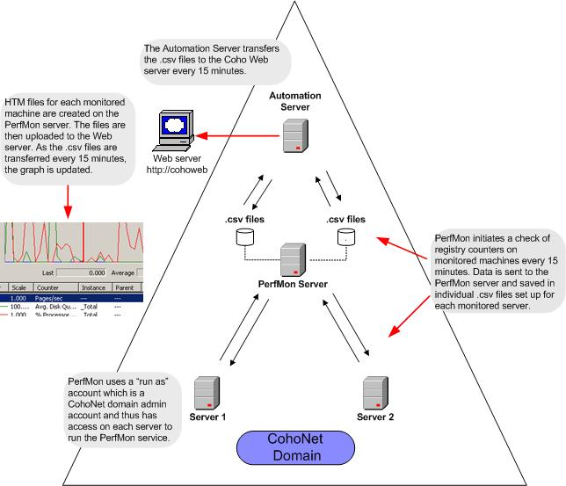

Scenario A Deployment

Instead of having the PerfMon process running exclusively on one machine and having Coho’s deployment dependent on the health of that machine, the process is run on each monitored server. The PerfMon server acts solely as storage for the .csv files. The automation and publication of files to http://cohoweb is unchanged.
Drawbacks:
- Component owners are unwilling to have outside processes running on their production servers. For example, some of Coho’s IIS servers run at near 100% CPU load; any additional burden is not welcome.
- This deployment doesn’t give Coho any noticeable benefits over their current deployment. Eliminating the PerfMon server and having the automation retrieve files directly from each server is unwieldy.
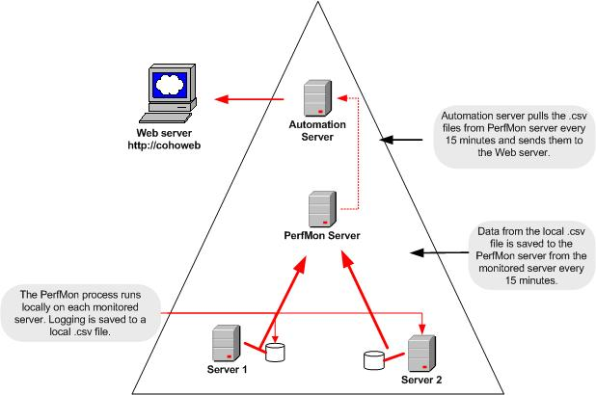

Scenario B Deployment

This deployment scenario is used by many enterprise customers. It basically follows the Coho Internet deployment, but instead of having a separate PerfMon process for each monitored server, all the monitoring and logging happens under one process. The benefit here is ease of deployment. The data is saved as a binary file, which is can be easier to work with using third party applications.
Drawbacks:
- Coho has too many servers to monitor with only one PerfMon process.
- Because there is a single point of failure, if the server running the PerfMon process fails, logging for all servers stops.
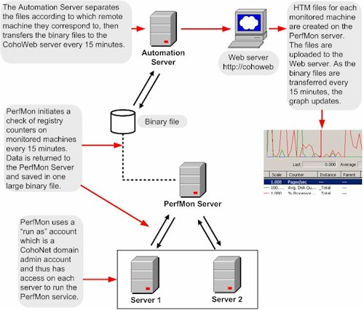

The information contained in this document represents the current view of Microsoft Corporation on the issues discussed as of the date of publication. Because Microsoft must respond to changing market conditions, it should not be interpreted to be a commitment on the part of Microsoft, and Microsoft cannot guarantee the accuracy of any information presented after the date of publication.
This White Paper is for informational purposes only. MICROSOFT MAKES NO WARRANTIES, EXPRESS, IMPLIED OR STATUTORY, AS TO THE INFORMATION IN THIS DOCUMENT.
Complying with all applicable copyright laws is the responsibility of the user. Without limiting the rights under copyright, no part of this document may be reproduced, stored in or introduced into a retrieval system, or transmitted in any form or by any means (electronic, mechanical, photocopying, recording, or otherwise), or for any purpose, without the express written permission of Microsoft Corporation.
Microsoft may have patents, patent applications, trademarks, copyrights, or other intellectual property rights covering subject matter in this document. Except as expressly provided in any written license agreement from Microsoft, the furnishing of this document does not give you any license to these patents, trademarks, copyrights, or other intellectual property.
Unless otherwise noted, the example companies, organizations, products, domain names, e-mail addresses, logos, people, places and events depicted herein are fictitious, and no association with any real company, organization, product, domain name, email address, logo, person, place or event is intended or should be inferred.
© 2002 Microsoft Corporation. All rights reserved.
Microsoft, Active Directory, SQL Server, and Windows are either registered trademarks or trademarks of Microsoft Corporation in the United States and/or other countries.
The names of actual companies and products mentioned herein may be the trademarks of their respective owners.

