How to Configure RAS Servers for ISP Environments
Remote access servers (RAS servers) in Internet service provider (ISP) environments are typically run under very different conditions to RAS servers in corporate environments. Chief among the differences is that dial-up users are more likely to fire their ISP than to be fired by their ISP. As a result, ISPs have less control over the hardware and operating system versions that users use to dial in, and have little leverage in enforcing the standards that might be appropriate in a corporate environment.
The operating conditions under which an ISP runs a RAS server are determined by the server’s configuration and Remote Access Policies. Running RAS on a Microsoft® Windows® 2000 server is much easier than running RAS on a Windows NT® 4 server because Remote Access Policies enable you to exercise fine levels of control over user access rights. However, getting to know Remote Access Policies is a challenge and deciding how many rights to give dial-up users is a tough call for anyone new to the process.
In this document, Windows 2000–based ISP Coho Internet reveals its formula for setting up RAS servers in its service provider environment. These steps assume that you already have Routing and Remote Access Services installed but not configured on a Windows 2000 server.
Two factors determine whether the following steps are appropriate for your environment; these factors often vary between RAS solutions. The first is whether you use separate RADIUS servers; the second is how you assign IP addresses. This document assumes you do not use a RADIUS server—and instead use the IAS service offered by a Windows server—and that you are using the RAS server to assign IP addresses as a DHCP server.
To configure a RAS server to follow these rules
- On the Start menu, click Programs, Administrative Tools, and Routing and Remote Access.
- The Configure Routing and Remote Access (RRAS) wizard starts, and the Common Configurations dialog box appears. Click Remote access server.
- The next dialog box gives the option of allowing the RAS server to assign IP addresses, either by acting as a DHCP server itself or by using an existing DHCP server on the network. Your choice depends on how your network is configured and whether a combined RAS/DHCP server can handle the peak load you anticipate placing on the server.
- The next dialog box asks you to configure RAS to use either a RADIUS server for central authentication or a Windows IAS server. The Windows IAS server can be installed on the RAS server or run on a separate server. Select No, I don’t want to set up this server to use RADIUS now.
- The RAS server should start. It may not start for a number of reasons—too many to detail here—but one of the most common failures is that the RAS server has not been authorized in the Active Directory configuration. Once the RAS server is running, the next step to perfect configuration is to set up security.
- Right-click the RAS server in the Routing and Remote Access snap-in, which should be visible after the RRAS wizard has completed. Click Properties and choose the Security tab.
- In the Authentication Provider window, choose Windows Authentication.
- In Authentication Methods disable:
- EAP
- Unauthenticated access
- Then enable these items, as shown in the following screenshot:
- MS-CHAP v2
- MS-CHAP
- CHAP
- PAP
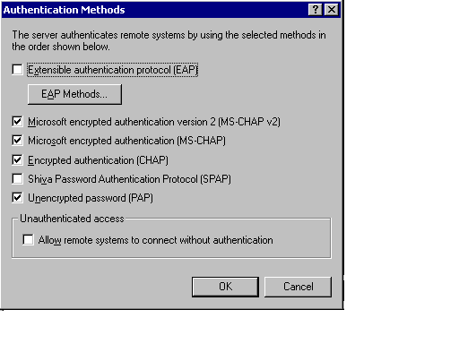

- Click OK to return to the Security tab. In Accounting Provider, choose RADIUS Accounting or Windows Accounting, depending on which accounting method you prefer. If you choose Windows Accounting, the RAS server downloads its logs to Windows 2000’s Event Viewer. If you plan to use a third party package to parse the RAS server log files—for example, because you already have one that has been parsing files produced by a RADIUS server—then choose RADIUS Accounting.
- On the IP tab.
- Enable IP routing.
- Allow IP-based remote access and demand-dial connections.
- Use DHCP for addresses or static pool.

- On the PPP tab, select:
- Enable Multilink
- BAP or BACP
- LCP
- Software compression

- On the Event Logging tab, select Log the maximum amount of information.
- At the end of this process you are warned that you selected more than one authentication method. You are asked if you want to read the RAS help files in order to properly configure authentication. The primary issue is that you need to set Remote Access Policies to allow, for example, MS_CHAP v2.

To Set Remote Access Policies
- Right-click the default Allow access if dial-in permission is enabled policy, as shown in the following screenshot, and click Properties.
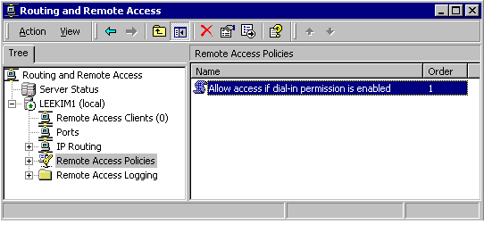

- Edit the profile. On the Multilink tab, limit multilink to two or three ports. Set Require BAP for dynamic Multilink requests. How many you set it to depends on both policy and technical considerations. Setting it to three allows home users equipped with ISDN to bring up both channels and use their phone line, which gives them maximum benefit. Setting it to two spreads the resource more evenly. Setting it to anything higher could allow users with ISND PRI cards – typically business users – to claim all the multilink channels at once. That would tie up the entire server.
- Set the policy to allow these items, as shown in the following screenshot:
- MS-CHAP v2
- MS-CHAP
- CHAP
- PAP
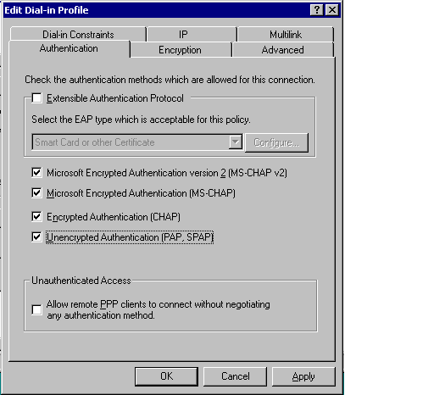

This should complete RAS server configuration, though there is much more to do to smoothly handle the daily issues that arise from running RAS servers.
One thing to assist daily operations is learning how to monitor and troubleshoot RAS. Although Windows 2000 ships with some built-in instrumentation for RAS services, ISP environments require a fine-grained view of RAS port and user activities. The Windows 2000 Resource Kit contains an excellent tool, RASSvrMon.exe, that can display this information. For more information, see How to Monitor Users and Ports with the Microsoft RAS Server Monitor Tool.

The information contained in this document represents the current view of Microsoft Corporation on the issues discussed as of the date of publication. Because Microsoft must respond to changing market conditions, it should not be interpreted to be a commitment on the part of Microsoft, and Microsoft cannot guarantee the accuracy of any information presented after the date of publication.
This White Paper is for informational purposes only. MICROSOFT MAKES NO WARRANTIES, EXPRESS, IMPLIED OR STATUTORY, AS TO THE INFORMATION IN THIS DOCUMENT.
Complying with all applicable copyright laws is the responsibility of the user. Without limiting the rights under copyright, no part of this document may be reproduced, stored in or introduced into a retrieval system, or transmitted in any form or by any means (electronic, mechanical, photocopying, recording, or otherwise), or for any purpose, without the express written permission of Microsoft Corporation.
Microsoft may have patents, patent applications, trademarks, copyrights, or other intellectual property rights covering subject matter in this document. Except as expressly provided in any written license agreement from Microsoft, the furnishing of this document does not give you any license to these patents, trademarks, copyrights, or other intellectual property.
Unless otherwise noted, the example companies, organizations, products, domain names, e-mail addresses, logos, people, places and events depicted herein are fictitious, and no association with any real company, organization, product, domain name, email address, logo, person, place or event is intended or should be inferred.
© 2002 Microsoft Corporation. All rights reserved.
Microsoft, Windows, and Windows NT are either registered trademarks or trademarks of Microsoft Corporation in the United States and/or other countries.

