

Microsoft Office Excel 2003
Product Guide
Table of Contents
1 Overview 3
Microsoft Office 2003 Introduction 3
Design Goals 3
Connect people 3
Connect information 4
Connect business processes 4
System Recommendations 5
Additional items or services 5
2 Connect People 8
Introduction 8
Windows SharePoint Services Integration with Office 2003 Editions Programs 8
Shared lists 8
Windows SharePoint Services, Excel 2003 and Access 2003 9
Protect Sensitive Documents 10
Information Rights Management in Office 2003 Editions 10
Permission options 12
Additional server requirements 13
Regional permissions 13
Summary 14
3 Connect Business Processes 15
Introduction 15
Business process management challenges 15
Business value of XML in Office Professional Edition 2003 15
New feature highlights 16
Key Functions Enabled by XML in Office Professional Edition 2003 17
Free up critical business information 17
XML in Excel 2003 24
Summary 26
4 Excel in Action 27
Introduction 27
List data integration with Windows SharePoint Services 27
Use improved standard deviation computation 28
5 Help and Office Online Services 279
Help and Office Online Training 29
Help 29
Assistance 29
Office Online Training 30
Downloads 30

The information contained in this document represents the current view of Microsoft Corporation on the issues discussed as of the date of publication. Because Microsoft must respond to changing market conditions, it should not be interpreted to be a commitment on the part of Microsoft, and Microsoft cannot guarantee the accuracy of any information presented after the date of publication.
This White Paper is for informational purposes only. MICROSOFT MAKES NO WARRANTIES, EXPRESS, IMPLIED OR STATUTORY, AS TO THE INFORMATION IN THIS DOCUMENT.
Complying with all applicable copyright laws is the responsibility of the user. Without limiting the rights under copyright, no part of this document may be reproduced, stored in or introduced into a retrieval system, or transmitted in any form or by any means (electronic, mechanical, photocopying, recording, or otherwise), or for any purpose, without the express written permission of Microsoft Corporation.
Microsoft may have patents, patent applications, trademarks, copyrights, or other intellectual property rights covering subject matter in this document. Except as expressly provided in any written license agreement from Microsoft, the furnishing of this document does not give you any license to these patents, trademarks, copyrights, or other intellectual property.
Unless otherwise noted, the example companies, organizations, products, domain names, e-mail addresses, logos, people, places, and events depicted herein are fictitious, and no association with any real company, organization, product, domain name, email address, logo, person, place, or event is intended or should be inferred.
© 2004 Microsoft Corporation. All rights reserved.
Microsoft, MSN, Outlook, PivotTable, PowerPoint, SharePoint, Visual Basic, Visual C#, Visual C++, Windows, and Windows Server are either registered trademarks or trademarks of Microsoft Corporation in the United States and/or other countries.
The names of actual companies and products mentioned herein may be the trademarks of their respective owners.

Microsoft Office 2003 Introduction
Welcome to Microsoft® Office Excel 2003, part of Microsoft Office 2003 Editions—the easiest way to help more people use information to make a positive impact on business. The Office 2003 Editions offer new technologies and features while improving upon existing and familiar tools to facilitate effective and efficient collaboration and information sharing.
This document delivers an overview of Office 2003 Editions, including how they can help you connect people and business processes as well as get valuable Help services. We’ll take a close look at Excel 2003 in action, providing guidance on the specific details of this integral part of Office 2003 Editions.
Through integration with Microsoft Windows® SharePoint™ Services, the Office 2003 Editions offer advances in intranet collaboration to help users gain access to and share information both internally and externally. Support for Information Rights Management (IRM) and industry-standard Extensible Markup Language (XML) provides a platform on which to build cost-effective solutions that can have an immediate, positive impact. In addition, the Office 2003 Editions offer new ways to organize and manage e-mail and make more use out of the workday.
Design Goals
With a focus on connecting people, information, and business processes, the design goals integrate collaboration, usability, and information management.
Connect people
Designed to integrate with intranet technologies such as Windows SharePoint Services, the Office 2003 Editions provide new ways to connect individuals, teams, and organizations. By incorporating the new tools with familiar Microsoft Office menus, functions, and interfaces, training and implementation time is minimized. Workers can collaborate from any location by using shared information and simplified review processes, including the following features:
- New! Shared Workspace task pane facilitates and simplifies efficient collaboration and document sharing.
- New! Shared Attachment option offers an automatic way of creating document workspaces through e-mail messages, when sending attachments for review. Document workspaces provides a forum for managing collaborative review and projects, with features such as automatic updates to the most current version and the ability to share documents and other relevant information in real time.
- New! Meeting Workspace option automatically creates workspaces through Microsoft Office Outlook® invitations. Meeting Workspaces help enhance the productivity of meetings by providing a place to coordinate schedules, disseminate materials, and store notes and minutes.

- New! Instant messaging (IM) and Alerts technology is integrated throughout the Office 2003 Editions collaboration tools, providing instant information and the ability to initiate IM conversations quickly from within documents, Shared Workspaces, or Microsoft Office Outlook 2003.
- New! Information Rights Management (IRM) functionality protects sensitive
information from unauthorized distribution or alteration, and allows companies to set and enforce policies that help control how their data is used.
Connect information
The Office 2003 Editions are designed to make it easier for people to manage an ever-increasing volume of business information. Improvements and new features in Outlook 2003 enable users to organize and prioritize e-mail messages quickly and easily, and new security settings offer increased support for junk e-mail filtering. Support for remote and mobile workers includes improvements to connectivity performance, such as better caching, and sharing calendars. Obtaining information from a variety of locations is made easier with organizational tools, such as the Research task pane. The following are new and improved features for connecting information:
- Improved! Research task pane accesses needed information more efficiently.
- Improved! E-mail Security enhancements help stop incoming messages that contain viruses, improve junk e-mail filtering, and block unsolicited attachments from communicating back to the originating servers.
- Improved! Enhanced Ink support provides a better experience overall when using Tablet PCs, offering support for handwritten e-mail messages and the ability to write directly in Word 2003, Microsoft Office PowerPoint® 2003, and Microsoft Office Excel 2003 documents.
Connect business processes
Often, critical business information is kept separate from the programs that workers know and use. With its extensive support for industry-standard XML, the Office 2003 Editions help bring business processes and information together on the desktop. To facilitate greater efficiency, features such as Smart Documents and Programmable task panes help users share customizable, task-specific information easily. New and improved tools for connecting business processes include the following features:
- New! Customer-defined XML schema support is available in Word 2003 and Excel 2003.
- New! Smart Documents bring relevant information directly to the task at hand through a new Programmable task pane user interface. With Smart Documents, XML solutions can be created to enable business processes, help users complete forms and other documents, and then link that information to back-end systems that support XML. As the user clicks through the document, the program is modified to present the appropriate functions to complete the task.
- New! Extensible Smart Tag support is now offered in all the Office programs, including PowerPoint 2003, Outlook 2003, and Microsoft Office Access 2003. Support includes automatic configuration capabilities such as formatting and populating an index at the end of an article.
- New! XML support for Word 2003 includes content management options, data reporting, content repurposing, and data mining.
- Improved! XML support for Excel 2003 and Access 2003 offers increased flexibility for importing XML files of any schema.
System Recommendations
Here are the system requirements for the Office 2003 Editions:
  - Personal computer with an Intel Pentium 233-megahertz (MHz) or faster processor (Pentium III recommended)
  - Microsoft Windows® 2000 with Service Pack 3 (SP3) or later; or Windows XP or later
  - Super VGA (800 × 600) or a higher-resolution monitor
  - 128 megabytes (MB) of RAM or more
Hard disk usage will vary depending on configuration; custom installation choices may require more or less hard disk space. The following are the hard disk requirements for individual Office 2003 Editions.
Microsoft Office Professional Edition 2003
- 400 MB of available hard disk space; 190 MB of hard disk space for Microsoft Office Outlook 2003 with Business Contact Manager.
- Optional installation files cache (recommended) requires an additional 290 MB of available hard disk space.
Microsoft Office Small Business Edition 2003
- 380 MB of available hard disk space; 190 MB of additional hard disk space to use the optional installation of Outlook 2003 with Business Contact Manager.
- Optional installation files cache (recommended) requires an additional 280 MB of available hard disk space.
Microsoft Office Standard Edition 2003
- 260 MB of available hard disk space.
- Optional installation files cache (recommended) requires an additional 250 MB of available hard disk space.
Microsoft Office Student and Teacher Edition 2003
- 260 MB of available hard disk space.
- Optional installation files cache (recommended) requires an additional 250 MB of available hard disk space.
Additional items or services
Some features or advanced functionality have additional requirements.
Microsoft Office Professional Edition 2003
To use the optional installation of Outlook 2003 with Business Contact Manager, you need to meet the following system requirements:
- A PC with a Pentium 450-MHz or faster processor.
- 260 MB of RAM or more recommended.
- 190 MB of additional hard disk space.
- For speech recognition:
  - Pentium II 400-MHz or faster processor.
  - Close-talk microphone and audio-output device.
- Microsoft Exchange Server is required for specific advanced functionality
in Outlook 2003.
- Microsoft Windows Server™ 2003 running Windows SharePoint Services is required for specific advanced collaboration functionality.
- Internet functionality requires dial-up or broadband Internet access provided separately; local or long-distance charges may apply.
- Specific inking features require running Microsoft Office XP Pack for Tablet PC (Tablet Pack) on the Tablet PC.
- Information Rights Management features require access to a Microsoft Windows 2003 Server running Windows Rights Management Services (RMS) for Windows Server™ 2003.
Note: Business Contact Manager will be disabled in the presence of an Exchange-technologies-based e-mail system.
Microsoft Office Small Business Edition 2003
- To use the optional installation of Outlook 2003 with Business Contact Manager you need to meet the following system requirements:
  - A PC with a Pentium 450-MHz or faster processor.
  - 260 MB of RAM or more recommended.
  - 190 MB of additional hard disk space.
- For speech recognition:
  - Pentium II 400-MHz or higher processor.
  - Close-talk microphone and audio output device.
- Exchange is required for certain advanced functionality in Outlook 2003.
Note: Business Contact Manager will be disabled in the presence of an Exchange-technologies-based e-mail system.
- Windows Server 2003 running Windows SharePoint Services is required for certain advanced collaboration functionality.
- Internet functionality requires dial-up or broadband Internet access provided separately; local or long-distance charges may apply.
Office Standard Edition 2003
- For speech recognition:
  - Pentium II 400-MHz or faster processor.
  - Close-talk microphone and audio-output device.
- Microsoft Exchange Server 2003 is required for certain advanced functionality in Outlook 2003.
- Microsoft Windows Server 2003 running Windows SharePoint Services is required for certain advanced collaboration functionality.
- Internet functionality requires dial-up or broadband Internet access provided separately; local or long-distance charges may apply.
- Specific inking features require running Microsoft Office XP Pack for Tablet PC (Tablet Pack) on the Tablet PC.

This section examined the design goals, system recommendations, and additional services of Office 2003 Editions. The next two sections take a deeper look at Office 2003 Editions and how
they facilitate connecting people and connecting business processes, particularly through Excel 2003.

Introduction
Every employee faces challenges when a project requires team collaboration. The Microsoft Office 2003 Editions and the integration with Microsoft Windows SharePoint Services (WSS) provides a platform that includes programs employees use daily to work with team members in a centralized location, making the team’s work more effective and efficient.
The Office 2003 Editions allow for closer teamwork experience. New task panes from within the documents and e-mail messages provide information about other team members and also offer access to resources. Team members can use Instant Messenger (IM) integration to see when other team members are online or offline. New calendar features in Microsoft Office Outlook 2003 make scheduling meetings with other team members quicker and more effective. The Office 2003 Editions also offer content protection rights to authors, ensuring that authors have complete access to and control over their documents.
Windows SharePoint Services Integration with Office 2003 Editions Programs
The integration of Office 2003 Editions and WSS offers users tools that are powerful and easy to use and that make collaboration easier. A WSS site provides a virtual community for team collaboration—making it easy for users to work together on documents, projects, events, and other activities where information sharing is essential.
In addition to the new Workspaces, Outlook 2003 offers a workgroup server, offline availability, and multiple calendar views and lists. Microsoft Office Access 2003 has features that allow users to link tables to other SharePoint Web sites and preserve full read/write capabilities. Because Microsoft Office Excel 2003 and the various SharePoint lists are integrated more closely, a user can import or export a list to or from Excel and share it with other team members. Office 2003 Editions and WSS integration gives users more opportunities for increased accessibility to view, edit, read, or write information within Outlook, Access, and Excel.
Shared lists
Users of WSS benefit from the enhanced ability of Office 2003 Editions to work with SharePoint lists. Each enhancement to the list experience in WSS enables a range of scenarios not previously available. The enhancements also provide the ability to combine SharePoint lists with the rich functionality of core Office programs, opening new possibilities for collaboration, data collection, and analysis.
- New! Grid view. This new view style is similar to the grid display style in Excel 2003 and brings Excel-like functionality to WSS with functions such as Calculation Formulas, AutoFill, AutoComplete, Sorting, and Filtering.
- New! Multiple-user list collaboration. Multiple users can now edit the same list at the same time. If WSS detects any conflicts, it presents conflict-resolution options.
- Improved! Easy editing. Users can drag and drop to rearrange rows and
columns or move data inside a list.
- Improved! Office program integration. Users can now have the best of both worlds, using Office programs to work with SharePoint lists. By using Excel 2003, for example, users can print lists, take lists offline, and create tables or charts with list data.
- New lists. New lists include Photo Library, which offers options for storing and viewing pictures, and Business Document Libraries, which enable XML solution authoring, editing, and storage in the team site.
- Improved lists. Improvements to the existing lists include options for scheduling recurring meetings in event lists, and new security settings that allow delegation of permissions to a per-list level.
Windows SharePoint Services, Excel 2003 and Access 2003
WSS provides users of Office 2003 Editions multiple ways to manipulate data in lists and tables created in Excel 2003 and Access 2003. Lists that reside on SharePoint sites can be synchronized using Excel 2003 and Access 2003. Both programs have individual benefits for users as well. Users can easily update WSS lists in Excel 2003. Users can now create a table in Access 2003 and link it to lists that reside on a SharePoint Web site while maintaining full read/write capabilities.
List synchronization
Microsoft Office Excel 2003 can now be used to view and edit data stored in lists on SharePoint sites. This is an excellent way to share information with other users, make use of information that is already published, and provide standardized lists of information (for example, product names or company departments) that can be used throughout the company.
Updating Windows SharePoint Services lists in Excel 2003
Office 2003 Editions make it easy for users to view, edit, and update WSS lists in Excel. Excel 2003 now offers the ability to share ranges that are designated as lists by exporting them as a SharePoint list. Users can also import SharePoint lists into Excel or link to them so that changes to the list are shared between the server and the Excel client.
The SharePoint Datasheet List Control, which is similar to the grid display style in Excel, makes an Excel-like editing experience available in a browser so that content can be edited in WSS through Datasheet Control.
Conflict resolution is also provided when lists are updated from Excel 2003, and lists can be modified offline by using Binary File Format (BIFF). XML tags that map to items on existing Excel business forms can also be created, such as “employee name,” “amount,” or “quantity,” making those forms another easy-to-use data warehouse.
The new Spreadsheet Web Component in WSS can consume any Excel spreadsheet that is mapped to an XML schema, and can provide that data to both SharePoint and non-SharePoint data sources. The component displays data according to a mapping of XML elements.
Linked tables between Access 2003 and Windows SharePoint Services
Users can now link tables that were created in Access 2003 to lists on SharePoint Web
sites and maintain full read/write capabilities. Users specify that they want to use SharePoint as the type, and then they select the Web site and the list name.
This means that WSS can act as a new type of database server for Access 2003 users who want to collaborate with others across the Web and use the familiar desktop program interface, or who want to incorporate SharePoint data into other tracking projects that they already perform.
The following table shows WSS integration features for each program in Office 2003 Editions:
Windows SharePoint Site Feature
Open and Save from File menu | Excel, Outlook, PowerPoint, Publisher, Word
Shared Workspace task pane | Excel, PowerPoint, Word
Document updates for shared attachments | Excel, PowerPoint, Word
Automatically collect metadata | Word, Excel, PowerPoint
Check-in / check-out | Word, Excel, PowerPoint
Version Tracking | Word, Excel, PowerPoint
Store inline discussions on the server | Word, Excel, PowerPoint
Import SharePoint list as data | Excel, Access
Export data as SharePoint list | Excel, Access
Protect Sensitive Documents
New technologies in Office 2003 Editions help protect digital intellectual property. Information Rights Management (IRM) in Office 2003 Professional allows functions such as cut, copy, paste, print, and e-mail forwarding to be restricted for specific documents and e-mail messages, giving users and organizations more control over their valuable information assets.
Information Rights Management in Office 2003 Editions
IRM is a new, policy enforcement technology in Office 2003 Editions that helps protect documents and e-mail messages from unauthorized access and use. IRM is a persistent, file-level protection technology that allows the owner to specify who can access a document or e-mail and control whether those users are allowed to edit, copy, forward, or print the contents. IRM is an extension of Windows Rights Management Services (RMS) into Office 2003. IRM in Office Professional 2003 Edition requires RMS on Windows Server 2003, either within the organization or through a service such as Microsoft Passport. Windows Rights Management Services for Windows 2003 is a new premium service that requires a separate Client Access License (CAL).
IRM is a policy enforcement technology, not a security technology, allowing documents and e-mail messages to be distributed while helping maintain control over who can access content and how they can use it. Once a document or e-mail is protected with this technology, the access and usage restrictions are enforced no matter where the file or e-mail goes.
IRM support in Office 2003 Editions helps corporations and knowledge-capital workers address two fundamental needs:
- Protects digital intellectual property. Most corporations today rely on firewalls, login security, and other network technologies to protect their digital intellectual property. The fundamental limitation of these technologies is that, after legitimate users have access to the information, the information can be intentionally or accidentally shared with unauthorized people, creating a potential breach in security policies. IRM helps protect the information itself from unauthorized access and reuse.
- Ensures information privacy, control, and integrity. Knowledge-capital workers often deal with confidential or sensitive information, relying on the discretion of others to keep sensitive materials in-house. IRM helps eliminate the risk of accidental leaks by disabling the forward, paste, or print functions in IRM-protected documents and e-mail messages. In addition, IRM can enforce expiration dates to help ensure that knowledge-capital workers only see and use up-to-date content.
For IT managers, IRM helps enforce enterprise policies regarding document confidentiality, workflow, and e-mail retention. For CEOs and security officers, it helps reduce the risk of having key company information get into the hands of the wrong people, whether by accident, thoughtlessness, or malicious intent.
When enabled by the organization, users of Office 2003 Editions will be able to easily take advantage of this technology. To create and protect documents and e-mail messages with IRM, Microsoft Office Professional Edition or the full stand-alone products are required. A simple user interface based on customizable “rights templates” available in the standard toolbar makes IRM convenient and easy to use. Other Office 2003 Editions will give users the ability to read and edit IRM-protected content but not create it. Integration with Active Directory® provides a level of convenience not seen on today’s document-specific passwords.
Finally, IRM-protected documents and e-mail can be shared across organizations and with users that do not have Office 2003 Editions. Microsoft is offering, for a limited time, an IRM service for customers who do not host their own Windows Rights Management Services Server. The Rights Management Add-On for Microsoft Internet Explorer allows Microsoft Windows users to consume IRM-protected documents whether or not they have Office 2003 Editions. This service will use Microsoft Passport® as the authentication mechanism instead of Active Directory. Users of this service will not be able to create custom rights templates, such as a company’s confidential template, but they will be able to share and access IRM-protected documents and e-mail messages.
Leveraging Information Rights Management (IRM) in Excel 2003
IRM in Microsoft Office Professional for Windows Edition 2003 allows the document owner to assign permissions to individual users and groups (groups based on Active Directory). In Excel 2003, each user or group can be given a set of permissions according to the following roles: read, change, and full control. Depending on the recipient’s role, IRM disables certain commands to enforce the rights that are assigned. The document owner can also prevent printing and can set expiration dates. After expiration, documents cannot be opened.
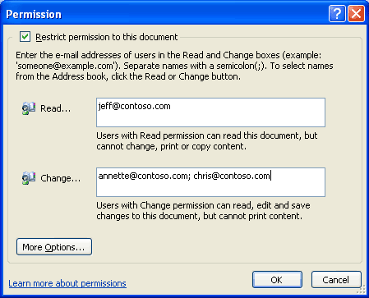
Users can apply usage restrictions to limit who can read, change, or control Excel 2003, Word 2003, and PowerPoint 2003 files.
Permission options
If a protected document is forwarded to an unauthorized recipient, the document cannot be opened and an error message that contains the document owner’s e-mail appears so that the recipient can request additional rights. If the document owner decides not to include an e-mail address, unauthorized recipients get an error message.
Organizational policies and template options
On the Windows Rights Management Services, organizations can create “rights templates” that will appear in Office Professional Edition 2003. For example, a company might define a template called “Company Confidential,” which specifies that a document or e-mail in that template can only be opened by users inside the company domain. These templates can reflect the policies of the organization, and the number of templates that can be created is unlimited.
Rights Management Add-On for Internet Explorer
Because enforcement of rights is done at the application level, Office files protected with IRM technology can only be opened and edited by Office 2003 Editions. However, Windows Rights Management Add-On for Internet Explorer (RMA) allows users
without Office 2003 Editions to read IRM-protected materials. The Rights Management Add-On for Internet Explorer is free and available for download at www.microsoft.com (connect-time charges may apply).
The Rights Management Add-On for Internet Explorer will play an important role in communication between business units and with business partners, as companies may choose to migrate to Office 2003 Editions on their own timeframes. Companies can use IRM in Office 2003 Editions knowing that authorized users will be able to access and consume protected content even if they do not have Office 2003 Editions.
Additional server requirements
Microsoft Windows Server 2003 with Rights Management Services and Active Directory® Services are required to enable IRM fully in Office Professional Edition 2003. The Rights Management Services feature requires a premium Client Access License (CAL). Microsoft is also hosting, for a limited time, an IRM service through Passport for customers who do not have Windows Server 2003. This service will enable users to share protected documents and e-mail by using Microsoft Passport as the authentication mechanism.
Note that users of Office Standard Edition 2003, Office Small Business Edition 2003, and Office Student and Teacher Edition 2003 cannot create new IRM-protected documents or e-mail messages, or modify the permissions on existing IRM-protected files. However, they can open, edit, save, and print IRM-protected documents and e-mail messages with the appropriate permissions.
Regional permissions
When teams collaborate on very large documents, some users may be assigned certain portions of the document to work on. In the past there was no way to ensure that each user only modified the assigned portion of the document. When it came time to reconcile the edits and merge changes into a master document, large numbers of conflicting edits often caused problems.
Document owners can set permissions to certain regions or specific portions of a document from being edited by some or all users. Using the Protect Document task pane (by selecting the Tools menu, and then Protect Document), a document owner can first protect the whole document against any edits (optionally allowing only comments) and then assign permissions to individual portions of the document by selecting them and specifying the users who should be able to edit that selected region. Later, when reconciling the changes of different individuals, the document owner is assured that no two people edited the same area and no conflicts will exist.
After the permissions have been set up, the task pane switches focus from helping the creator set up the permissions and manage the list of users to helping users find the parts of a document that they can edit.
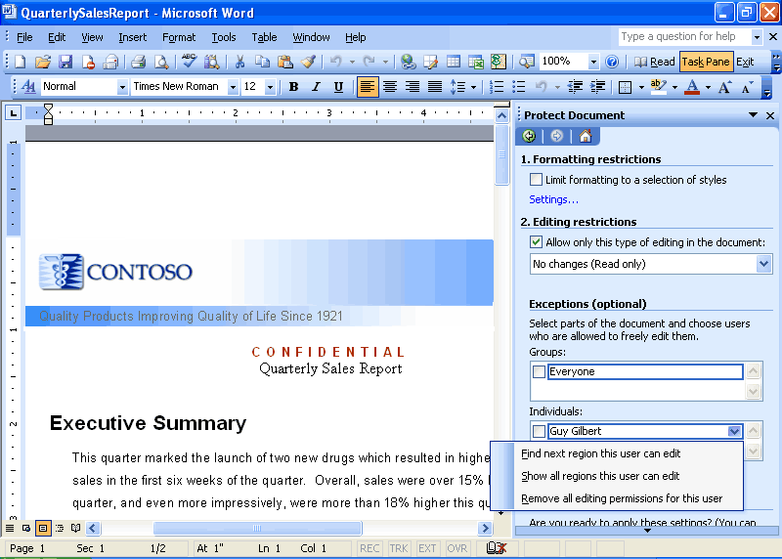
User view of the Protect Document task pane.

Summary
The Office 2003 Editions and WSS integration make it easier and more efficient for users to connect with other team members and the information they need. By enhancing the desktop programs that employees are already familiar with, the Office 2003 Editions help users spend their time making progress on their projects instead of learning a new set of features and commands. Office Professional Edition 2003 also allows authors to create documents and e-mail messages that are better protected from unauthorized use by offering IRM technology. This improved functionality in the Office 2003 Editions assists users when working on projects that require team efforts.

Introduction
The Microsoft Office 2003 Editions integrate support for Extensible Markup Language (XML) in a way that can help companies create new, simple, and efficient processes for everyday business functions, such as creating invoices, contracts, press releases, reports, presentations, customer-facing e-mail messages, and more. The new processes combined with the power of XML can bring all departments together and save time by eliminating the need to pass documents back and forth among departments and people.
Business process management challenges
Because different departments in an organization have varying needs for consuming and reporting the same data, sharing information between departments can be difficult. Often, data output from one department is in the wrong form or file type to be opened or used by others. This means that departments must spend extra time reworking data to fit their needs and then verifying that it remains accurate.
Business value of XML in Office Professional Edition 2003
A surprising amount of business information stored today is already in XML format or can be easily converted to XML as it is used. All major database tools on the market today—from any vendor—support access to stored information by using XML format. A solution developer can request information as XML by using the correct interface, and the database server automatically generates the XML.
Support for customer-defined schemas in Office Professional Edition 2003 means that the data coming from these databases can be used directly in the Office programs. Likewise, data collected or created in Office Professional Edition 2003 can be submitted to existing databases without reworking the data.
With Office 2003 Editions, there is no need to wait for existing business information to be converted to XML—most of it is already available to power users and solution developers who are trying to make business processes more efficient. Although XML is implemented in all the Microsoft® Office 2003 Editions, this chapter focuses on XML implementation in Office Professional 2003.
In Office Professional Edition 2003, the broad implementation of industry-standard XML, integrated task panes for research and communication, and expanded Smart Tag capabilities bring relevant and current business data to the user from within Office system programs. The task panes also provide a platform for business process solutions to be built on top of the familiar Office interface.
The following are some of the benefits of XML:
- Easy exchange of data. XML allows data to be retrieved and used from disparate and otherwise incompatible systems.
- Simple reuse of data. Reuse of information through XML eliminates the need
to re-key or recode, and thereby reduces the time required and errors
generated in repurposing information.
- Easily searchable information. XML gives structure and meaning to electronic information, so that information becomes much easier to search and organize.
- Different views of the same data. Because XML separates content from its presentation, the same information can be used in different environments, formats, programs, and devices, depending on the user's needs.
- Rapid solution development. Because more structured information uses the industry-standard XML data tags, business applications can be written from the ground up by developers, or even generated by experienced users, more quickly and easily.
New feature highlights
The new support for XML in Office Professional Edition 2003 is broad and deep across several products—in ways that are groundbreaking for desktop software.
Structure data and create solutions
Office Professional Edition 2003 provides support for customer-defined XML Schema Definitions (XSDs), meaning power users and developers can structure their data in a way that makes the most sense for them, and companies can create integrated business solutions inside documents that interact with other valuable XML-based Web services that any user can take advantage of, even without knowing anything about XML.
Manipulate XML-based data
Microsoft Office Excel 2003 can now read data within any customer-Defined XML Schema without the data having to be reformatted. Manipulating XML-based data in Excel for reuse and analysis is now as easy as selecting from a field chooser. Excel can also use XML to update charts, tables, and graphs as changes are made to the underlying XML data store, providing dynamic, real-time information for analysis in any Excel format.
Define XSDs for exporting data
Microsoft recognizes that each customer has an individualized approach to business and uses specific types of documents and data. For example, a purchase order document for an automotive parts supplier is a very different document from a legal contract written in a law firm.
Accordingly, the XML support in Office Professional Edition 2003 is not merely a way to save the formatting of a document. Instead, the Office programs allow a solution developer or power user to incorporate the actual structure of business data that is used by a particular customer in that customer's documents. This is done by creating or using an existing XML schema that identifies the parts of a document. In the case of the purchase order, these parts might include the customer’s name, ID number, item description, item ID, quantity, price, and so on.
After these parts of a document are identified in a template, anyone using that template or solution—even someone without any knowledge of XML—will be processing and creating XML data in the format that best suits the particular business needs. The data can then flow directly into business systems and processes.
In contrast to this, the “native schema” for Word or other programs is the schema that is used to contain the formatting for the document so it can be saved and reopened in Word
without loss of fidelity. To make this most accessible for customers who may
want to use this formatting information, the schema (or file format) is fully documented in the Office 2003 Developer Tool Kit.
For users who want to extract data from one or more tables in a database, Microsoft Access is the most appropriate Office tool. With Microsoft Office Access 2003, users can browse through related tables in a database and choose how to export data by defining the structure of a customer-defined XSD.

Key Functions Enabled by XML in Office Professional Edition 2003
Support for XML in Office Professional Edition 2003 helps seamlessly integrate data into related documents, spreadsheets, and databases, streamlining business processes. Along with providing full access to standard XML features, new XML-based tools in Word 2003, Excel 2003, and Microsoft Office Access 2003 help users interact with data and documents more easily.
Free up critical business information
Time and again, businesses have expressed the need to capture important business information in a way that allows them to reuse it in other documents or business processes, regardless of servers, programs, or platforms. To fulfill this need, Microsoft has built XML into the heart of Office Professional Edition 2003 programs by creating and enhancing the following features:
- XSDs. Support for standard and user-defined XSDs better enables data to fit needs.
- Research task pane. Efficient access to relevant data increases productivity.
- Smart Documents. Enabling custom solution development and deployment streamlines business processes.
- Programmable task panes. Displays of relevant tasks and information help automate daily work.
- Real-time data. Real-time updates to data that is inserted from other sources helps reduce valuable time spent on research.
- Smart Tags. Information and action options that function while data is being entered help automate work.
Support for XSDs
XML markup can be used to create "semi-structured" documents with regions of meaning, in addition to presentation and formatting. By creating or using specific XML schemas that define the structure of the document and the type of content that each data element contains, businesses can customize data presentation for their own use, making it easier to manipulate, search, and reuse information. XML bridges the gap between unstructured documents and rigidly structured data.
The World Wide Web Consortium (W3C) has created a standard for generating and describing XML schemas that is known as the XML Schema Definition Language, or XSD. Because each company knows best what type of data it needs to capture, it can define for itself the XSDs that are most relevant to its own business. This is called a “customer-defined schema,” as compared to one that Microsoft or another vendor has defined. Being able to define schemas is a critical business advantage.
By making it possible for businesses to capture the kind of information they need in a richer, more semantic, and structured way, Office 2003 Editions enable businesses to work with information in whatever way makes sense to their organization. For example, with Office 2003 Editions, a human resources system may have Word document resumes that are marked up with XML tags such as “name,” “address,” “career goals,” or “qualifications.” Once the Word documents are submitted to the system, a human resources director can run queries as rich as a database against the collection of XML resume files: Who has an MBA? Who speaks Polish? The human resources director can also use Excel to build charts, summary reports, and more from the data that is
contained in those documents.
These schemas can and often will be internal and unique to a company, such as an order-processing schema or a research report schema. But in some industries, it makes sense to create schemas for use among multiple companies or organizations. One example is XBRL, which stands for eXtensible Business Reporting Language, an open specification that uses XML schema to describe financial information. Another example is HL7, which is used in the healthcare industry. Having these standard schemas in place allows different organizations to easily share information, even if they are using completely different technologies from different vendors on different platforms. The standard schemas also create other communication and business efficiencies.
Research task pane
The Research task pane uses XML to provide a way for organizations to expose relevant internal business information and processes—and information from other relevant sources—directly in the context of each Office 2003 program.
Developers within an organization can create and deploy services by using XML that plugs directly into the Research task pane on computers that are running Office 2003 Editions. Services can include anything from data accessibility to interactive forms. An organization can also subscribe to vendor Web services that give personnel access to even more information in the Research task pane.
Developers can make services available to users over the Internet, through a corporate intranet, or by installing the services directly on a user's computer. Services that are available over a network, Internet, or intranet are better for information that may change frequently or is used by a large audience.
Services can be deployed manually, be discovered automatically by a user's computer, or be pre-registered when an Office 2003 Edition is installed on a computer. With manual deployment, a user navigates to a URL and registers for the service. With discovery, the user is prompted to register for a new service automatically. When a service is pre-registered, no user intervention is required.
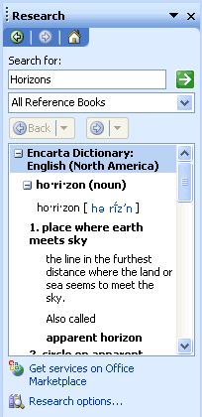
The Research task pane in Office 2003 Editions
Smart Documents
Smart Documents are XML-based solution development and deployment platforms that are available in Excel 2003. Smart Documents help developers tackle business-process problems by quickly building document-based solutions that combine the advantages of Word and Excel with the advantages of Web services. Benefits of these solutions include easier deployment and updating of the solution, and a larger selection of tools for solution development.
Smart Documents bring relevant information directly to the task at hand through a new Programmable task pane user interface. With Smart Documents, XML solutions can be created to enable business processes and help users complete forms and other documents, and then link that information to back-end systems that support XML. As the user clicks through the document, the program modifies itself to present the appropriate functions and help complete a task.
Smart Documents can easily be incorporated into business processes, such as creating expense reports, contracts, or anything else that might pass through multiple hands or systems while being authored, or that require information from back-end sources. A Smart Document solution can also include custom Smart Tags that are designed specifically to run only in that solution, or any other code that the developer would like.
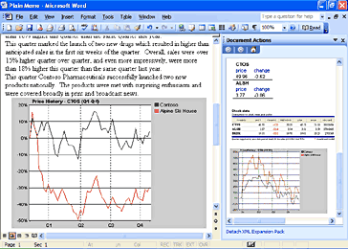
Smart Documents use the new Programmable task pane shown to bring relevant information directly to the user.
Using Smart Documents makes solution deployment much more flexible. Solution code can now be deployed once to a central server location, and Word and Excel will securely download and cache it locally when the smart document is opened. Updates to the solution code and even the document template itself can be delivered the same way, as a single update to the server location for the Smart Document solution, without having to deploy directly to hundreds or thousands of clients, just as with Web-based solutions. But unlike Web-based programs, Smart Document solutions can operate even when the computer is offline because they use the Office programs rather than a browser. In addition to solutions based on the Component Object Model, Smart Documents also accept solutions that are written in Microsoft Visual Basic® 6.0, Microsoft Visual C#®, Microsoft Visual C++®, and Microsoft .NET managed code for additional security and ease of development.
Smart Documents are new, and their use is virtually unlimited. The following are a few example scenarios.
- A purchase order solution using Excel might be linked to a business rule in a back-end server that takes the User ID and applies the user's current signing limit to the order directly in Excel, while the user is completing the form.
- A social services solution could be created that translates forms into different languages or assists applicants in completing the form, with context-sensitive help.
- Depending on the user type or ID, or on input from the user, a Word document could reconfigure itself to include the necessary sections that the user needs to complete—for example, a performance review form that has different sections for management and employees.
Programmable task panes
Developers can create custom actions for each section of a document based on the XML elements of the particular document and then make the actions available to users in a Programmable task pane. The task pane ties different controls to different parts of the document, revealing the most relevant services for each part while the document is being developed. For example, developers can build actions that display Help text, ask for input

(using standard Microsoft Windows controls like check boxes and text fields), or retrieve data from other programs or back-end servers. After the user enters the data that is necessary for a task, the Smart Document can perform actions such as looking up data, formatting it according to the document’s template, and placing it in the document.
As the user moves from section to section in the document, tasks and information that are relevant to a document or spreadsheet appear in the task pane, helping streamline and automate what may currently be lengthy day-to-day business processes. The task pane gives the user control over which actions are invoked and when, such as manipulating data in the document, making database queries, or interacting with line-of-business systems.
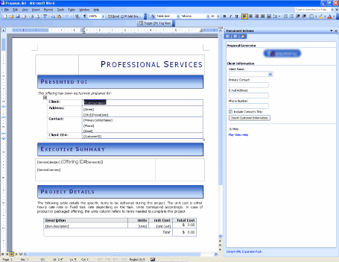
A sample Smart Document for writing proposals. The Programmable task pane shown is built to aid with the task of writing a proposal.
Real-time data
In a Smart Document, experienced users or template and solution creators can easily keep their documents current by creating dynamic charts and graphs that draw on up-to-date, real-time data from back-end systems to display business information as it changes, or they can create reports with up-to-the-minute information. Users can insert and manually refresh this data from the Research task pane or from a custom solution that is created for a specific purpose.
For example, a financial analyst writing a report can use the Research task pane to locate all the latest financial information about a particular organization and insert it into the report. Later, the analyst can easily update the data to reflect any changes that occurred after the report was written.
Smart Tag capabilities
As in Microsoft Office XP, Smart Tags in Office Professional Edition 2003 recognize certain words or strings as they are entered (such as a name, an address, or a stock ticker) and allow users to choose information and actions to associate with that entry. For example, a user can select an action, such as turning part numbers into hyperlinks in a sales database, adding properly formatted citations to the end of a research paper, or automatically populating an index with every person, company, or product that is mentioned in an article.
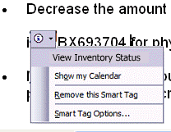
A Smart Tag is indicated by a series of purple dots under the text. Clicking the Smart Tag provides context-sensitive options.
Using Smart Tags in Office XP, independent software vendors (ISVs) and users have extended Smart Tags in ways that are specific to certain industries, such as facilitating the ability of a medical facility to look up patient records from a database by using names or ID numbers. Companies have also developed specialized capabilities using Smart Tags such as the ability to display customer data based on customer ID, or show inventory and sell-through for a particular stock-keeping unit number. Office Professional Edition 2003 extends the capabilities of Smart Tags even further and brings that functionality to more programs, for the benefit of both users and developers.
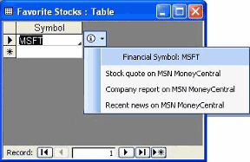
With the new Office Professional Edition 2003, Smart Tags can be attached to fields on tables, queries, forms, and data access pages in Access.

In Excel 2003, Smart Tags integrate with XML support, and Smart Tag actions can be linked to XML elements in documents or spreadsheets. Word also extends the functionality of Smart Tags to apply to XML elements directly, so actions can be provided for entire sections of documents rather than just a few words, and actions can work on “types” or collections of data rather than relying on text recognition. For example, a custom Smart Tag can be written that appears on fields that require the user to enter data and then offers to pre-populate the data. A Smart Tag action can also be provided that applies different transforms or views on XML data that the Research task pane retrieves.

Instead of using other programs, users can now save time by using Smart Tags to perform actions in Excel 2003. Smart Tags recognize certain types of text and then offer related functions and commands.
A Smart Tag can help users take advantage of external resources. For example, when a U.S. financial symbol such as "MSFT" is typed in a cell, Smart Tag actions provides a list of available Smart Tag actions. Users can click the Smart Tag (the purple triangle in the corner of a worksheet cell), and then select the action "Recent news on MSN Money Central." The browser opens to a Web page that contains news and information about the company. When finished, the user can close the browser and continue to work in Excel 2003.
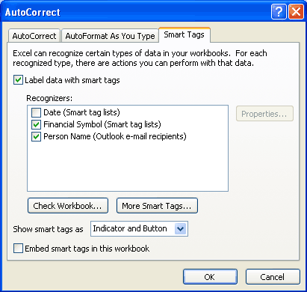
Select the types of SmartTags to recognize and specify their appearance.
How to use Smart Tags
To turn on Smart Tags:
- On the Tools menu, click AutoCorrect Options.
- Click the Smart Tags tab, and then select the Label data with Smart Tags check box.

To select a Smart Tag action:
- Cells with smart tags are indicated by a purple triangle in the lower-right corner of the cell. Move the cursor over the purple triangle in a cell until Smart Tag actions appear.
- Click the arrow. The actions that can be performed appear in a list.
- Select an action.
To find more Smart Tags, complete the following step:
- On the Tools menu, click AutoCorrect Options.
- Click the Smart Tags tab.
- Click More Smart Tags to go to Web sites to find new Smart Tags and actions.

As this section demonstrates, Excel 2003 is rich in features. Users who require assistance with Excel 2003 can get Help and services for Office 2003 Editions.

XML in Excel 2003
In the previous version of Excel (Excel 2002), users who wanted to work with XML had a great tool using the XML Spreadsheet (XMLSS) format. Excel 2003 has built on that initial XML experience and is now able to consume and generate XML data files expressed in customer-defined XML schemas (XSDs), not just in the XML Spreadsheet format. Excel is now an efficient XML data analyzer, editor, and viewer—expanding the ability to analyze, display, and insert up-to-the-second business information.
Advantages to sharing business data
The support for XML in Excel 2003 opens a wide range of possibilities for processing data from an Excel file in other programs. For example, an expense report solution could be created that consists of an Excel spreadsheet template mapped to an organization’s XML schema for expense reports. After entering data in Excel and producing an XML file matching the expense report schema, that data could easily be consumed by the company’s SAP accounting system—or any other back-end system or platform that supports XML—for processing. The XML capabilities of Excel unlock this information so that it can be used across multiple disparate systems within heterogeneous environments.
Capabilities and benefits
To simplify the process of sharing data across programs from within an Excel file, support for customer-defined XSDs make it easier for users to add structure to their data and to map data easily from external XML sources into an Excel workbook.
Excel now allows users to add structure around data that they track in spreadsheets. The list feature and its XML overlay provide a data entry row at the bottom of the list that automatically expands the list region as new items are entered. The Toggle Total Row feature turns on a total row where the user can specify average, count, count numbers, maximum, minimum, summation, standard deviation, or variance for the values in any of the list's columns. In addition, when data is in an Excel list, operations such as printing, charting, or creating a PivotTable® are easier to perform.
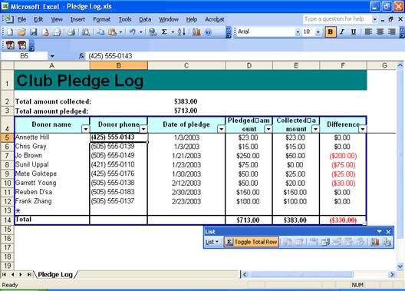
New List features in Excel help users arrange and analyze listed data.
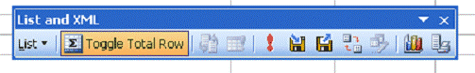
To import XML data, click Refresh and Import on the List and XML toolbar.
For importing data from other XML sources, Excel 2003 provides a user-friendly visual mapping tool that works much like a field chooser. With it, Office solution developers and even power users can do the following tasks, without writing any code:
- Map existing Excel spreadsheets to XML data structures, such as databases for importing.
- Create dynamic Excel documents that load XML data, display it, and write it in the same XML vocabulary with up-to-the-minute information.
- Create new XML-enabled information repositories from existing Excel spreadsheets.
Using the mapping tool to pull from data sources such as a back-end XML-enabled server, a Web service, or any XML data file, users can arrange information on the Excel grid and display it in any format they want. Clicking Refresh updates the spreadsheet, so up-to-date information is available for even the fastest moving data.
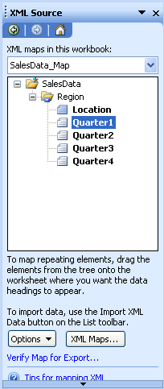
The new visual mapping tool for XML in Excel 2003 works much like a field chooser. With it, Office solution developers and even power users can now build a dynamic information structure into an existing spreadsheet, graph, or chart, using XML data as calculation inputs to the document. The tool makes this possible without writing any code.

Summary
Support for XML in Office Professional Edition 2003 simplifies business processes by making information accessible in multiple formats and in multiple programs. By enabling user-defined XSDs and XSLTs, organizations can also customize data output to meet their specific needs. With the added benefits and features of XML, Office Professional Edition 2003 can be the premier choice for businesses.

Introduction
With information in hand about how Microsoft Office 2003 Editions help users connect people and businesses, it is important to look at the new features Microsoft Office Excel 2003 delivers to its users in a team environment. These features are individually described within the following sections.
List data integration with Windows SharePoint Services
Through integration with Windows SharePoint Services, Excel 2003 lists make it easy to share data with other users. If the user has the Web address and authoring rights on a SharePoint site, the list can be shared so that other people can view, edit, and update it. If the user opts to link the list in Excel 2003 to a list on a SharePoint site, users can edit that list offline and synchronize changes with the SharePoint site at a later time so that other users can see updated data.
To manage the synchronization between the local Excel list and the SharePoint list, the List toolbar provides two buttons that allow users to choose how they want to handle updates to the list.
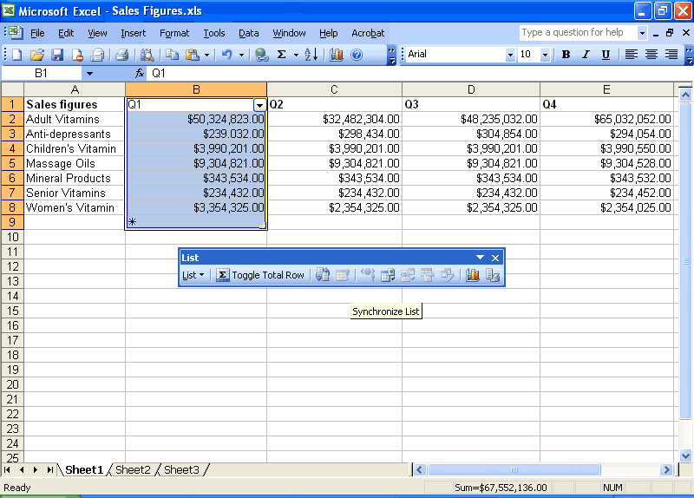Synchronize Excel and SharePoint lists using the List toolbar.
Synchronize lists
To publish any local changes to the SharePoint list and transfer any changes that were made to the SharePoint list to the local Excel list, complete the following step:
On the List toolbar, click Synchronize List .
To discard local changes to the list and download the current copy of the list from the Microsoft Windows SharePoint Services Web site, complete the following step:
On the List toolbar, click Discard Changes and Refresh .
Use improved standard deviation computation
Standard deviation functionality in Excel estimates standard deviation based on a sample. The standard deviation is a measure of how widely values are dispersed from the average value (the mean).
The procedure used in Excel 2003 uses a two-pass process through the data. First, the sum and count of the data values are computed and from these the sample mean (average) can be computed. Then, on the second pass, the squared difference between each data point and the sample mean is found and these squared differences are summed.
- Prior versions of Excel Standard Deviation Syntax = STDEV(number 1, number 2, and so on)
- Excel 2003 Standard Deviation Syntax = SQRT(DEVSQ(values)/(COUNT(values) – 1))

Help and Office Online Training
Microsoft Office 2003 Editions offer new and improved integration with Microsoft Office Online Web services. More powerful, better integrated, and with an improved online interface, these services are seamlessly available from within Office 2003 programs. The Web site, also available through a browser at www.microsoft.com/office, offers a resource page for each Office 2003 Editions program. The resources pages have assistance, columns, training, and templates.
Help
The Help system of Office 2003 Editions has been extended beyond individual workstations. If a user is connected to the Internet when choosing a Help topic or entering a word in the Ask-A-Question box, the Help system displays not only the Help information from the local system but also brings to the Help window information from the Microsoft Web site (www.microsoft.com). This provides the most current information on the topic that the user needs help with, in addition to links to other resources.
Assistance
The Assistance Web page provides up-to-date information with How To articles, conceptual topics, columns, and helpful tips for common tasks. Users can find answers to common questions, read articles on features in Office 2003 Editions, look for specific help in newsgroups, or suggest a topic for a future article.
Office Online Training
The Training site offers Web-based interactive training courses and self-paced exercises. Users can develop a deeper knowledge of tasks and application features, such as creating an outline in Microsoft Office Word 2003 or using motion paths in Microsoft Office PowerPoint 2003 slides. Courses include practice sessions where users can give things a try in the actual program, and short tests to assess comprehension. Courses cover a variety of topics, and are available for any Office 2003 Editions program.
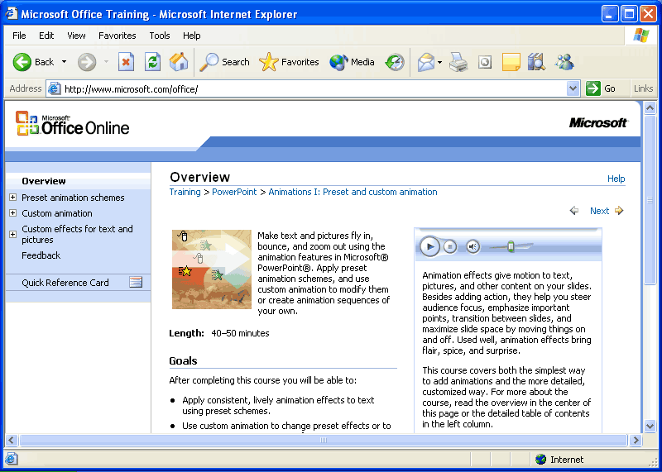
Use Office Online to find training opportunities for Office programs.
Downloads
On the Downloads site (formerly known as Office Update), users can check for free updates that improve the stability and security of Office 2003 Editions. On the Downloads home page, users can click Check for Updates to start the automatic detection tool, which scans the computer and then returns a list of new downloads that are available and compatible with the user's version of Office. In addition to security and performance updates, viewers, converters, add-ins, and stationery, other useful downloads are also available. The most popular downloads are listed in the Popular Office Downloads section.

