


Apache to IIS 7.0 – Migration Guide

Published: March 2009
For the latest information, please see www.microsoft.com/windowsserver2008

Document Version: 1.0

Contents

Overview 2
Planning your migration 3
Migration issues 3
Migration Steps 5
Demonstration applications 7
Joomla Web site 7
Task Management System 7
Perform the migration 8
Prerequisites 8
Migrating from Apache on Windows to Windows Server 2008 9
Migrating directories and files 9
Migrating directories and files using HTTP 9
Migrating directories and files using network sharing 11
Migrating databases 14
Export a database using mysqldump 14
Export a database using SQLyog 15
Import a MySQL database using a simple redirect command 16
Import a MySQL database using SQLyog 17
Configure the Joomla application 22
Migrating from Apache to IIS 7.0 in a Linux Environment 25
Prerequisites 25
Migrating a Linux directory structure to Windows Server 2008 25
Creating an archive from a Linux folder 25
Migrating directories and files migration using HTTP 27
Migrating directories and files migration using FTP 29
Migrating Databases from MySQL to SQL Server 2005 33
Linking a MySQL database to a Microsoft SQL Server 2005 database 33
Importing tables from MySQL to Microsoft SQL Server 2005 37
Linking a MySQL database to a Microsoft SQL Server 2005 database 38
Importing tables from MySQL to Microsoft SQL Server 2005 39
Migrating MySQL Data Types 40
Altering PHP Application Code 47
Completing the Database 49
Migration 49
Appendix I: Setting Up Virtual Hosts 50
Configuring the IIS 7.0 host 50
Installing and Configuring PHP on Windows Server 2008/IIS 7.0 51
Installing MySQL Server on Windows Server 2008 52
Configuring MySQL Server on Windows Server 2008 52
Installing SQLyog on Windows Server 2008 54
Connecting SQLyog to a MySQL 54
Installing a MySQL ODBC Driver 55
Configure a MySQL ODBC Driver 55
Appendix II: Non-Microsoft support 57
Conclusion 58

Overview
This migration guide provides a brief overview of various migration scenarios that Apache Administrators may encounter when migrating to IIS 7.0. IIS 7.0 offers a new modular Web server architecture comprises of more than 44+ features that can be assembled into small-footprint Web servers optimized for the desired role in your application topology. These features are built on top of a new extensibility layer that allows administrators to extend or replace virtually any aspect of the server, in native code or with the Microsoft® .NET Framework. IIS 7.0 offers extensibility throughout its runtime, management, and operational features to help you build end-to-end solutions for your specific needs.

Planning your migration
Before initiating the migration, it is important to plan ahead to effectively prepare for all of the issues that may occur during the migration process and to outline an overall migration framework/steps. Issues to consider before commencing migration include:
- Total time required for the migration;
- Selection of database;
- Web site compatibility with IIS 7.0 and Windows Server 2008.
In addition to these issues, following migration steps are covered in the document:
- Moving the files from Apache environment to IIS 7.0 environment;
- Moving the database;
- Updating configurations;
- Installing and using the support tools.

Migration issues

Time required for the migration
The total time required to get the new server up and running depends primarily on two factors, the type of migration process undertaken and the database platform being used.

Type of migration
Migration type refers to the different types of environments. A Web site already hosted in the Apache/Windows environment will take less time to migrate than a Web site completely hosted in a LAMP (Linux, Apache, MySQL and PHP) environment. The two types of migration processes depends on the base operating system:
- Migration of a Web site from Apache on Linux to IIS 7.0 on Windows Server 2008;
- Migration of a Web site from Apache on Windows (2000, XP, 2003) to IIS 7.0 on Windows Server 2008.

Data files and database volume
The number of files (static HTML or PHP) and the number of tables and procedures have a significant impact on the overall time required to complete the migration, the type of migration process undertaken and the database implemented. A Web site consisting of a large number of PHP files and that has no centralized database management will certainly take more time to migrate than a site using a centralized database configuration, because the aspects of the application, such as modifying queries and connection strings, need to be configured to work with the new database.
Similarly, a Web site with relatively high number of database tables may require modification of column types for the new database to run on SQL Server 2005 instead of MySQL.

Database type
Database can be migrated either from one MySQL instance of one server (Linux on Windows) to another MySQL instance of another server (Windows Server 2008) or from MySQL on one server (Linux Windows) to SQL Server 2005 on another server (Windows Server 2008).
Migrating data from MySQL to MySQL is simpler and more straightforward compared with migration from MySQL to SQL Server 2005. Migration of data from MySQL to SQL Server 2005 requires migrating not just the tables and their fields, but the data types of the fields, indexes, keys, etc. This specific issue is covered in the Database migration section later in the document.
Migration of a database from MySQL to SQL Server 2005 also requires the installation of a MySQL ODBC connector on Windows Server 2008. This driver helps create a link between the two types of database servers and facilitates the migration of tables. Installing the ODBC driver is covered in the Appendix. On the other hand, migrating data from MySQL on one server to MySQL on Windows Server 2008 does not require an ODBC driver.

Web site compatibility
The compatibility of an Apache-based Web site with IIS 7.0 and Windows Server 2008 should be determined before proceeding with the actual migration. Web sites hosted on Apache and Linux have different dependencies compared with Web sites hosted on IIS 7.0 and Windows Server 2008.

Database
If not properly planned for in advance, a potentially major compatibility issue that could arise during migration is the selection of database type.
Because massive databases comprising hundreds of tables and millions of records exist, site administrators managing such structures may prefer to continue using MySQL within the new environment of IIS 7.0 and Windows Server 2008. This decision requires taking a backup of the MySQL database from the first server and restoring it onto the new Windows Server 2008. Restoring millions of records may cause issues given the large size of the backup file. Using one of the five available MySQL configuration files can take care of this issue. By default, MySQL comes with the following five configuration files:
- my.ini;
- my-small.ini;
- my-medium.ini;
- my-large.ini;
- my-huge.in.
These configuration files exist in the MySQL installation directory. One of the files may be used, depending upon the size of the database. Each filename signifies the size of the database supported.
Administrators may decide to use SQL Server 2005 as the database platform for its ease, enhanced management and extensive support. In such a case, the following issues need to be addressed:
- Migration of tables by creating a link between SQL Server 2005 and MySQL using the ODBC driver/connector;
- Migration of data types, indexes and keys;
- Modifying code for database connectivity;
- Modifying code for database queries.

Dynamic Files
Another issue to consider before starting the migration process is the compatibility of dynamic content, such as PHP files. Static content that contains no executable code or requires no interpretation, such as HTML, jpg, and gif files is easily migrated to the IIS 7.0 and Windows Server 2008 environment. However, dynamic content code may require review to identify possible incompatibilities. For example, a PHP Web site specifically hosted on Linux may use Linux environment-specific functions that should be replaced with the relevant functions for the Windows Server 2008 environment.

External Modules
Moreover, a Web site running on Apache with external modules, such as Cold Fusion modules, may require special attention. In most cases, a version of the external module for Windows must be purchased, if it is not available for free. If the external module does not come with a Windows version, then the external module needs to be either coded to get it to work on Windows or simply needs to be dropped.
If no version exists for IIS 7.0 and Windows Server 2008, rewriting the external module will require the most effort during the migration process.
If the version of the external module for IIS 7.0 and Windows Server 2008 is purchased, it then needs to be properly installed and configured. Moreover, modifications to the PHP code that calls the external module may be required to accommodate for differences between external modules on Apache and IIS 7.0.

Migration Steps
This section outlines the steps that need to be taken when migrating applications from Apache to IIS 7.0.

Moving files
Migrating Web site files from one server to another can be done using the three different methods, which are described later in this document:
- Migrating files using Windows Sharing;
- Migrating files using FTP;
- Migrating files using HTTP.

Moving databases
The two methods for migrating databases from one server to another include:
- Migrating a database from MySQL on Windows Server 2003 to MySQL on Windows Server 2008;
- Migrating a database from MySQL on Linux to SQL Server 2005 on Windows Server 2008. These scenarios are outlined here and in greater detail later in this document.

Scenario
To migrate the database from MySQL on Windows Server 2003 to MySQL on Windows Server 2008:
- Take the backup of a database or export the database either using mysqldump.exe or SQLyog;
- Restore the database backup or import the database either by using mysqldump.exe or SQLyog.

Scenario
To migrate the database from MySQL on Linux to SQL Server 2005 on Windows Server 2008:
- Link the SQL Server 2005 with MySQL;
- Import the database tables;
- Alter and verify the column, keys and index data types.

Updating configurations
Updating PHP code is required to support SQL Server 2005. The primary changes to PHP code that are required are highlighted in the section on Web site compatibility issues above.

Installing and using the support tools
The installation and configuration of a variety of support tools, scripts and utilities used throughout in this document is covered in the Appendix. The topics in the Appendix include:
- PHP installation and configuration with IIS 7.0;
- MySQL installation and configuration on Windows Server 2008;
- SQLyog;
- ODBC driver/connector.

Demonstration applications
Two Web applications are used to illustrate the migration process. The first is hosted on a Linux environment using a virtual-host configuration. The second Web application is a PHP-based content management system called Joomla, with a relatively large database and hosted on Windows Server 2003.
End users will expect that, after migration, these Web applications will be able to do the following:
- Work with any Web browser;
- Validate credentials based authentication;
- Add, update and delete records.

Joomla Web site
Joomla, a popular PHP-based content management system, was selected for this demonstration because of its complex database and large number of files. Using Joomla thus demonstrates the simplicity of migrating PHP Web applications and Web sites that are configured and running.

Task Management System
The Task Management System (TMS) is a sample LAMP platform Web application used by a department’s employee to share and maintain weekly and monthly tasks. TMS consists of a few PHP scripts and a backend database with a table for each of the two tasks. It uses a built-in authentication scheme with credentials that contain appropriate permission levels and are stored in database.
TMS demonstrates a typical LAMP architecture, based on the following:
- Fedora Core 6 Linux.
- Apache 2.2.3
- MySQL 5.0.22
- PHP 5.1.6

Perform the migration
This section discusses common migration scenarios for PHP-based sites and Web applications hosted on an Apache Web server and that are being migrated to a Windows Server 2008/IIS 7.0 environment. A sample Web application and a PHP-based content management system are used to demonstrate the migration procedures. The step-by-step procedures for carrying out a sample of common migration tasks, including the following, are described below:
- Migrating virtual hosts from a Linux server to Windows Server 2008;
- Migrating a simple PHP Web application and its associated database from the Linux/Apache/MySQL (LAMP) platform to the Windows Server 2008/IIS 7.0/SQL Server 2005 platform;
- Migrating the PHP content management system from Windows Server 2003/Apache/MySQL Windows Server 2008/IIS 7.0/MySQL
Also discussed are additional configuration resources, including the following:
- Setting up and configuring PHP on Windows Server 2008;
- Setting up MySQL on Windows Server 2008;
- Setting up the MySQL management console on Windows Server 2008;
- Setting up the MySQL ODBC drivers for the migration of databases from MySQL to SQL Server 2005.

Prerequisites
The following walkthrough assumes basic management knowledge of Windows Server 2003 and Windows Server 2008. A dummy Web site based on the popular Joomla design and running on the following architecture should also be made available:
- Windows Server 2003
- Apache 2.2
- MySQL 5
- PHP 5
- MySQLyog
In addition, a second server should be running on the following architecture:
- Windows Server 2008
- IIS 7.0
- MySQL 5
- SQLyog

Migrating from Apache on Windows to Windows Server 2008
This section uses the Joomla-based Web site that is being migrated to illustrate the steps when moving from Apache on Windows to Windows Server 2008.

Migrating directories and files
The directory structure and files can be transferred from one host to another using the following methods:
- HTTP
- Network sharing

Migrating directories and files using HTTP
To migrate directories and files using HTTP, perform the following procedure:
- Locate the Joomla Web directory. Typically, it will be something like C:\wamp\www\joomla. If you cannot locate the Joomla Web directory within Windows Explorer, then run a search for configuration.php-dist. This file will be located in the Joomla Web directory.
- Create an archive by zipping all the files within the Joomla Web directory, and then place the zipped file within the Joomla Web directory as shown below.
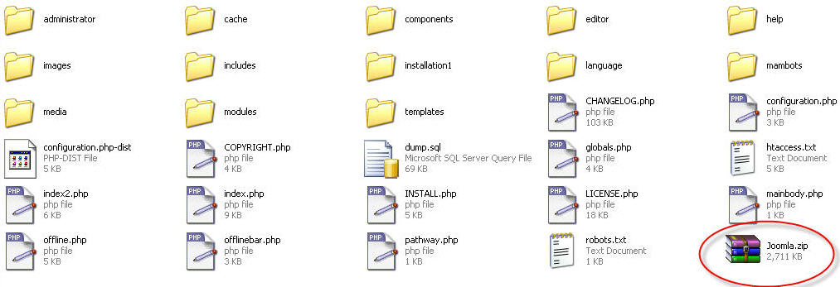
Joomla file’s zip archive within the Joomla Web directory

- On the Windows Server 2008 machine, launch Internet Explorer browser to locate the Joomla.zip archive on the Windows Server 2003.
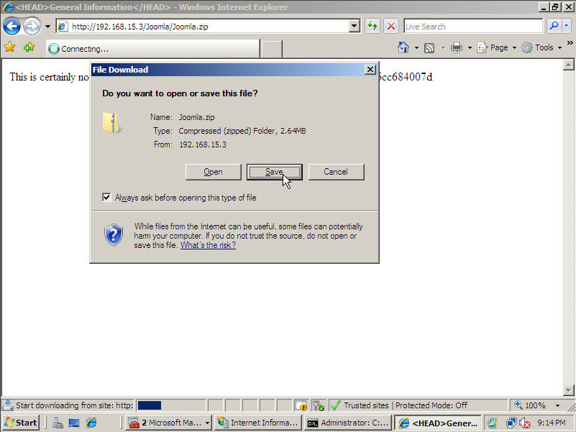
Download Joomla file’s archive

- Note: Normally, the path to the zipped file will be the IP address of the Windows Server 2003 machine, followed by the name of the Joomla site, and followed by the name of the Joomla zipped file. (For example, http://192.168.15.3/Joomla/joomla.zip).
- A File Download dialog box will open. Click on the Save button. A Save As dialog box will open. Select the destination for zipped file, typically Users\Administrators\Downloads, and leave its name unchanged. Click on Save to complete download.
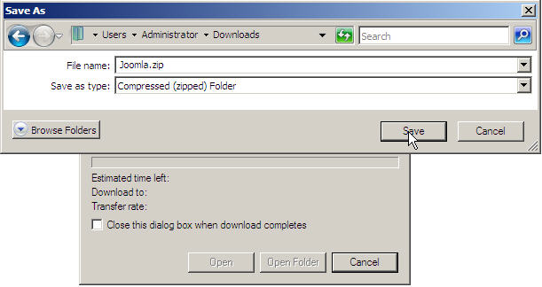
Archive location

Migrating directories and files using network sharing
Before migrating directories using network sharing, the user needs a user account with permissions to copy and paste files on both the Windows Server 2003 and the Windows Server 2008 machines to be able to perform the following procedure:
- On the Windows Server 2003 machine, create a folder and enable file sharing on it.
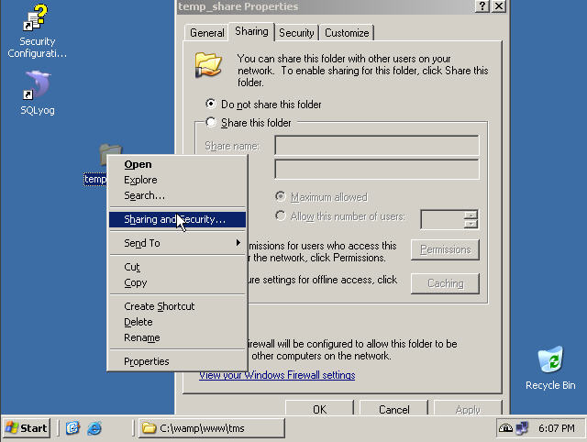
Joomla web content sharing on Windows Server 2003

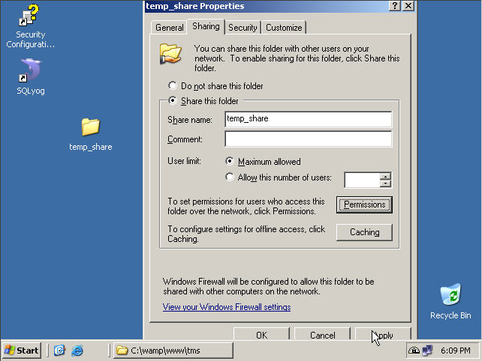
Joomla web content share name

- On the Windows Server 2008 machine, navigate to the shared folder.


Joomla shared directory
- Copy all of the Joomla files from the shared directory on the Windows Server 2003 machine and paste them in the HTTP root directory on the Windows Server 2008 machine, normally at c:\inetpub\wwwroot\Joomla.
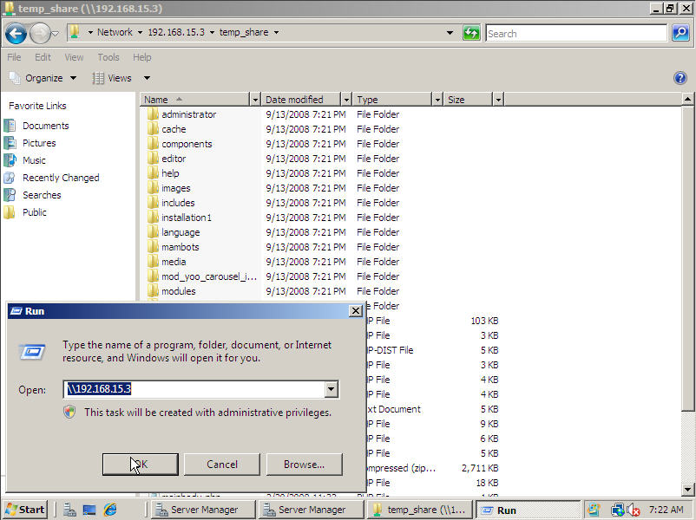
Copy Joomla web files from share directory to HTTP root directory

- Check the files in the HTTP root directory on the Windows Server 2008 machine against the Joomla folder on the Windows Server 2003 machine, to make certain that all of the files were copied.
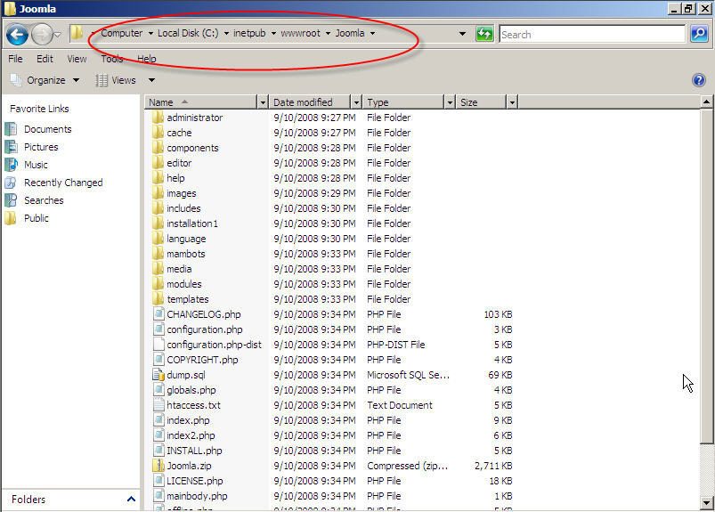
Joomla web files on HTTP root directory

Migrating databases
Database migration is done in two phases: Packaging the data to be exported from one machine, and importing and unpacking the data on another machine.
MySQL has two programs for handling MySQL data:
- Mysqldump.exe: A management utility packaged with MySQL and normally found in \wamp\myswl\bin folder. It runs from a command line with a wide range of options or arguments.
- SQLyog: A commercial application that furnishes a graphical user interface for managing a MySQL database installation. SQLyog has a procedure for backing up a database and its settings.

Export a database using mysqldump
To export a MySQL database from Windows Server 2003 to Windows Server 2008 using the mysqldump utility, perform the following the procedures:
- On the Windows Server 2003 machine, click on the Start button, and then select Run from the Start menu. In the Run field, type cmd.exe and click on OK.
- A Windows command console will open.
- At the command prompt (normally, C:\>) type following command:
- c:\wamp\mysql\bin\mysqldump.exe -u root -p joomla >
- c:\wamp\www\joomla\ dump.sql
- Then strike the Enter key.
- The cmd console will return a prompt Enter password: Type in the MySQL administrator password and strike the Enter key.
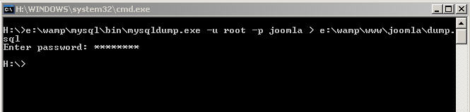
Database export using mysqldump.exe

- If the command runs successfully, the cmd console will return another command prompt. If not, an error message will appear and the user should check for the following:
- Typographical errors in the commands;
- A correct user name after the –u argument, and a correct password for that user after the –p argument; these are username and password for the \mysql\bin folder;
- The correct password at the Enter password: prompt. This will be a database administrator password.
- Follow the steps in the section on Migrating directories and files using network sharing to move the SQL dump file to the Windows Server 2008 machine.

Export a database using SQLyog
SQLyog is an enterprise database manager commonly purchased to manage MySQL installations. SQLyog offers a graphical user interface with a layout similar to Windows Explorer.
If SQLyog is installed on the Windows Server 2003 machine that hosts the MySQL database, the database can be exported to a Windows Server 2008 machine using the following procedure:
- Launch SQLyog from a desktop icon, which is by default, a leaping dolphin. The SQLyog – [localhost – root@localhost] window will open.
- In the left pane of the SQLyog window, expand the list of databases until the Joomla database becomes visible.
- Right-click on the Joomla entry. A context menu will open. Select Export Database as a SQL Dump… An Export Data dialog box will open.
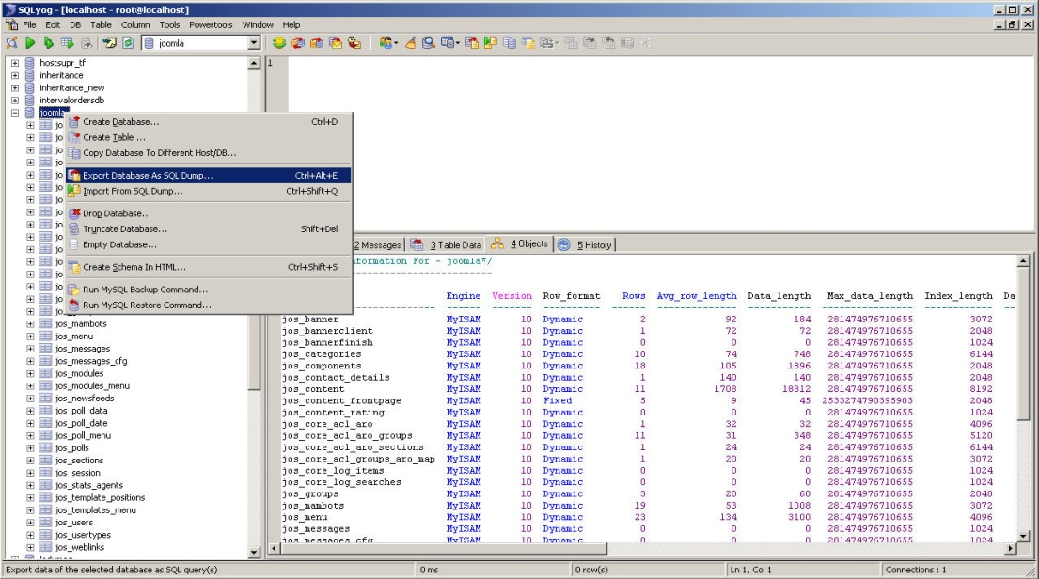
Database backup

- In the Export box in the upper right corner of the Export Data box, check the radio button marked Structure and Data. In the Export to file: field, enter the path to a dump.sql file in the Joomla directory (normally, c:\wamp\www\Joomla\dump.sql).

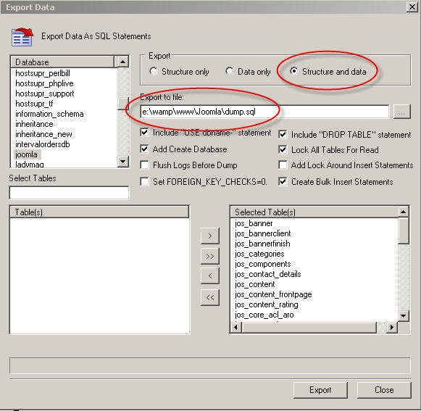
Database backup

- Click on the Export button to complete the process. A dump.sql file will appear in the target directory specified in step 4.
- Follow the steps in the section on Migrating directories and files using network sharing to move the SQL dump file to the folder c:\inetpub\wwwroot\Joomla on the Windows Server 2008 machine.

Import a MySQL database using a simple redirect command
To import a MySQL database from Windows Server 2003 to Windows Server 2008 using a simple redirect command, perform the following the procedures:
- On the Windows Server 2008 machine, click on the Start button, and then select Run from the Start menu. In the Run field, type cmd.exe and click on OK. A Windows command console will open.
- At the command prompt, normally, C:\>, type following command:
- mysql –u root –p < c:\inetpub\wwwroot\Joomla\dump.sql
- Then strike the Enter key.
- The cmd console will return a prompt Enter password: Type in the MySQL administrator password and strike the Enter key.
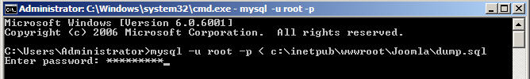
Database export using mysqldump.exe

- If the command runs successfully, the cmd console will return another command prompt. If not, an error message will appear and the user should check for the following:
- Typographical errors in the commands;
- Incorrect location for the file in question;
- A correct user name after the –u argument, and a correct password for that user after the –p argument; these are username and password for the \mysql\bin folder;
- The correct password at the Enter password: prompt. This will be a database administrator password.

Import a MySQL database using SQLyog
SQLyog is an enterprise database manager commonly purchased to manage MySQL installations. SQLyog offers a Graphical User Interface with a layout similar to Windows Explorer.
If SQLyog is installed on the Windows Server 2008 machine that hosts the MySQL database, the database can be exported to a Windows Server 2008 machine using the following procedure:
- Launch SQLyog from a desktop icon, which is by default a leaping dolphin. The SQLyog window will open, followed by a Connect to MySQL Host dialog box.

SQLyog

- In the Connect to MySQL Host dialog box, select localhost from the Saved Connections dropdown menu.
- Click on the Server tab, and enter the following values:
MySQL Host Address: localhost
User Name: root
Password: <root password>
Click on the Connect button to complete the procedure.
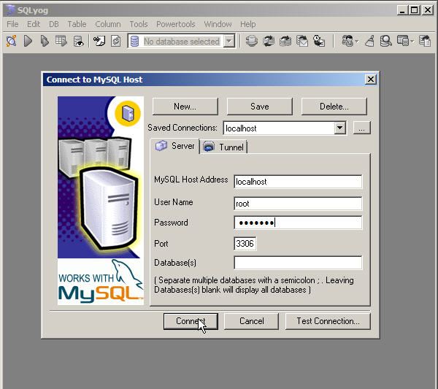
SQLyog login window

- An SQLyog welcome window will open. Click on OK to dismiss the window. The SQLyog – [localhost – root@localhost] window will open.
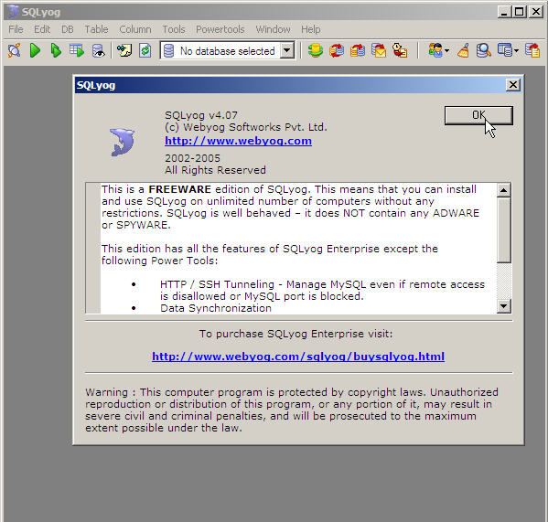
SQLyog welcome window

- In the left pane of the SQLyog window, right-click on the root@localhost entry. A context menu will open. Select Create Database. A Create Database dialog box will open.
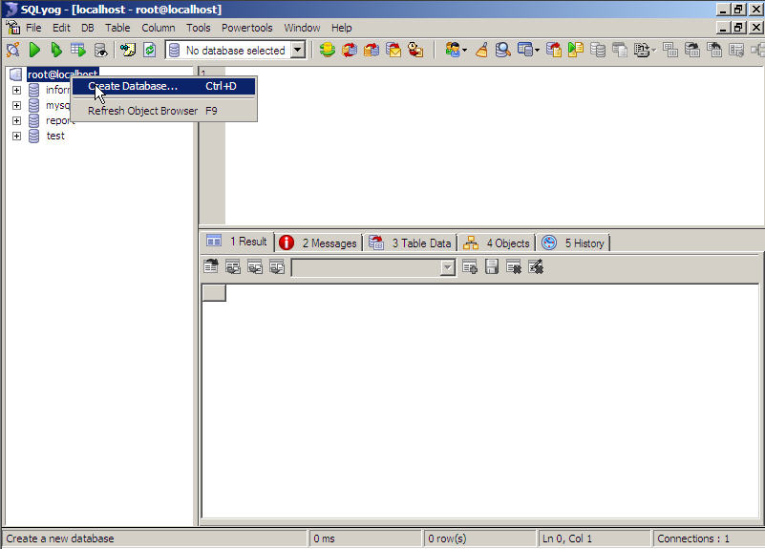
Database creation on Windows Server 2008

- On the Create Database dialog box, type a name in the Enter new database name field. This name should exactly match the name of the database on the Windows Server 2003 machine. Click on the Create button to commit the changes. The database should appear in the root@localhost tree in the left pane of the SQLyog window.
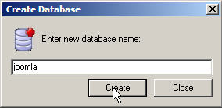
New database name on Windows Server 2008

- In the left pane of the SQLyog window, right-click on the database entry created in step 5. A context menu will appear. Select Import from SQL Dump. An Execute Query(s) from a File dialog box will open.

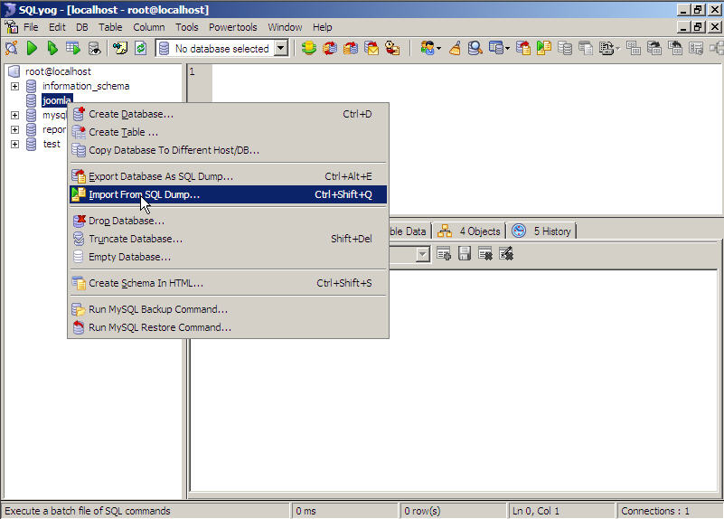
Database import on Windows Server 2008

- In the File to Execute field, enter the full path to the dump.sql file that was previously moved from the Windows Server 2003 machine. Normally, this path will be C:\inetpub\wwwroot\Joomla\dump.sql.
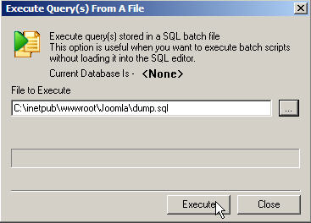
Database import execution

- Click on the Execute button. A progress bar will indicate when the process is complete.
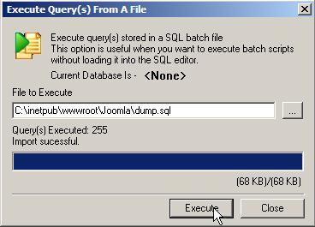
Database import progress

- Click on the Close button when the import is complete. Refresh the SQLyog wind. The tree in the left pane should show all the tables from the original database.
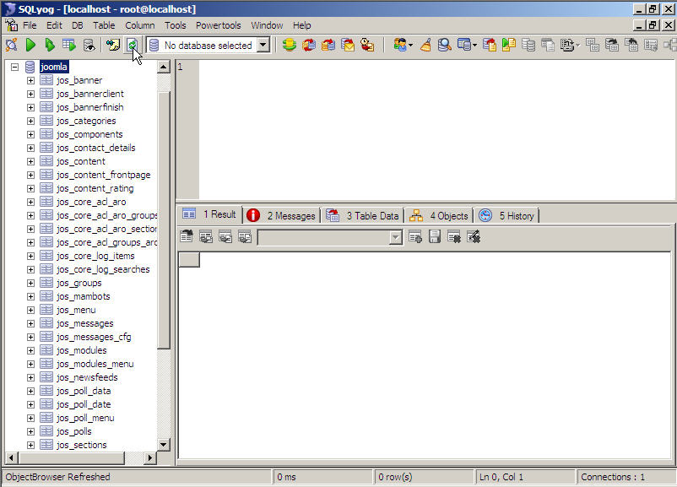
Tables of new database on Windows Server 2008

Configure the Joomla application
When an application is migrated, certain variables need to be configured to reflect the new server’s environment. To allow Joomla to operate in the new environment, the settings need to be adjusted in the configuration.php file, which is located in Joomla’s main Web directory.
To configure Joomla for the new Windows Server 2003 environment, perform the following procedures:
- Locate and right-click on the configuration.php file. A context menu will open. In the menu, select Open with and then Notepad. The file will open as a text file.
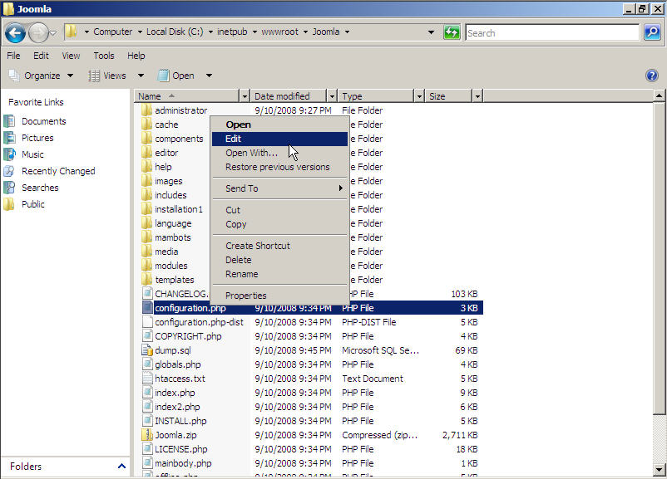
Joomla configuration file

- The file consists of about 70 entries, all starting with $mosConfig_. The following entries need to be edited to reflect the new environment:
  - $mosConfig_host
  - $mosConfig_user
  - $mosConfig_password
  - $mosConfig_db
  - $mosConfig_absolute path
  - $mosConfig_live_site
  - $mosConfig_sitename
  - $mosConfig_cachepath
  - $mosConfig_cachetime
- Save the changes and close Notepad. Repeat step 1 and verify that the changes have been written to the configuration.php file.

- To verify that the migration was successful, open a browser and navigate to http://localhost/<sitename>. The Web site should open without error.
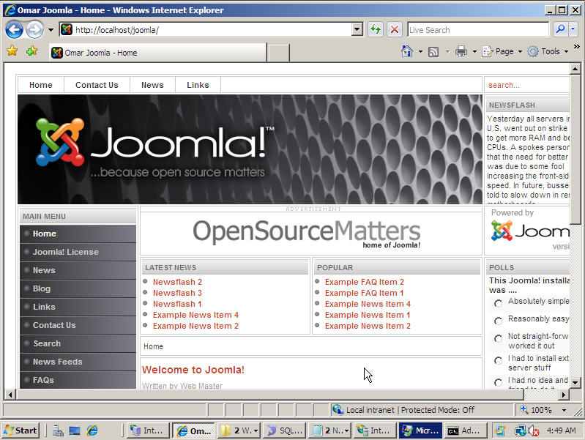
Joomla on Windows Server 2008 / IIS 7

Migrating from Apache to IIS 7.0 in a Linux Environment

Prerequisites
The following walkthrough assumes that the user has basic management knowledge of Linux server and Windows Server 2008. The user should also have two dummy Web applications running on the following architecture:
- Linux Fedora Core 6
- Apache 2.2
- MySQL 5 configured to allow remote connections
- PHP 5
In addition, a second machine should be running the following:
- Windows Server 2008
- IIS 7.0
- SQL Server 2005 with Microsoft SQL Server Management Studio Express installed
- Microsoft FTP Server
- MySQL ODBC driver

Migrating a Linux directory structure to Windows Server 2008
The directory structure and files can be transferred from a Linux server to Windows Server 2008 by creating a backup of the entire Web site and placing it in a zip archive in the root directory.
The zipped backup archive can be downloaded to Windows Server 2008 using either HTTP or FTP transfer.
In the following walkthrough, the user will be archiving and moving the files from the Task Management System.

Creating an archive from a Linux folder
To create a zipped archive from a Linux folder, perform the following procedure:
- Log on to the Linux machine with the root account and password.
- Locate the Terminal shortcut. The Terminal icon looks like the screen on a computer display, and can be found in the popup menu at the lower left corner of the desktop, or in the menu bar across the bottom of the desktop, or on the desktop itself.
- Click on the Terminal shortcut. A terminal console will open, and appears similar to the cmd.exe console in Windows. After displaying information about the system, the terminal console will display the following command prompt:
[root@localhost ~] #
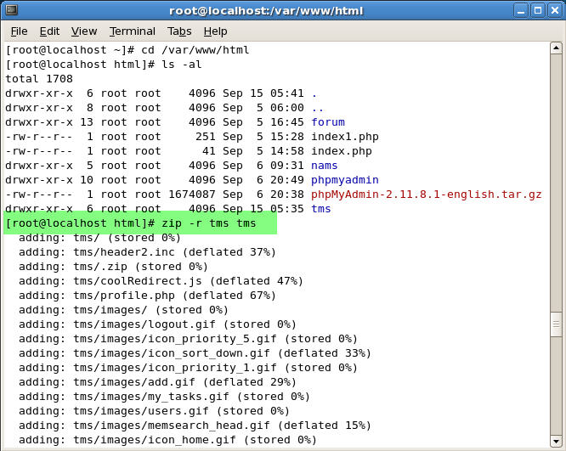
Backup zip archive creation

- At the command prompt, type the following command and strike Enter to change directories to the html directory:
[root@localhost ~] # cd /var/www/html

- At the next command prompt, type the following command and strike Enter to shows a long list of all files and folders in the html directory:
[root@localhost html] # ls –al

- At the next command prompt, type the following command and strike Enter to zip all the files in the tms folder into an archive called tms.zip:
[root@localhost html] # zip –r tms tms
The Terminal will show each file being archived with an entry similar to the following:
adding: tms/edit.php (deflated 67%)
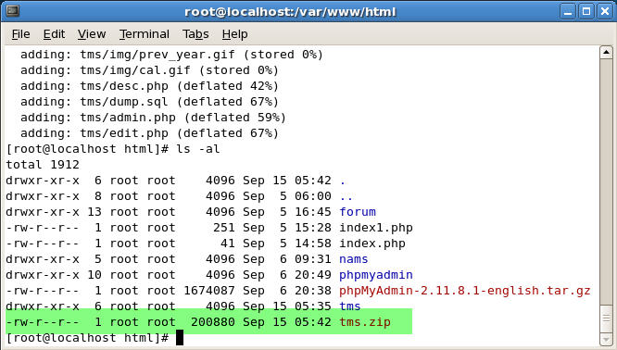
Backup zip archive within the root directory

- When the last file has been added to the archive, the command prompt will appear. Type in the following command and strike Enter to show the tms.zip file in the html directory list:
[root@localhost html] # ls –al

Migrating directories and files migration using HTTP
To migrate directories and files from a Linux server to Windows Server 2008 using the HTTP archive download, perform the following procedures:
- On the Windows Server 2008, open Internet Explorer and enter the following URL in the navigation field, using the IP address of the Linux server:
http://<ip address>/tms.zip
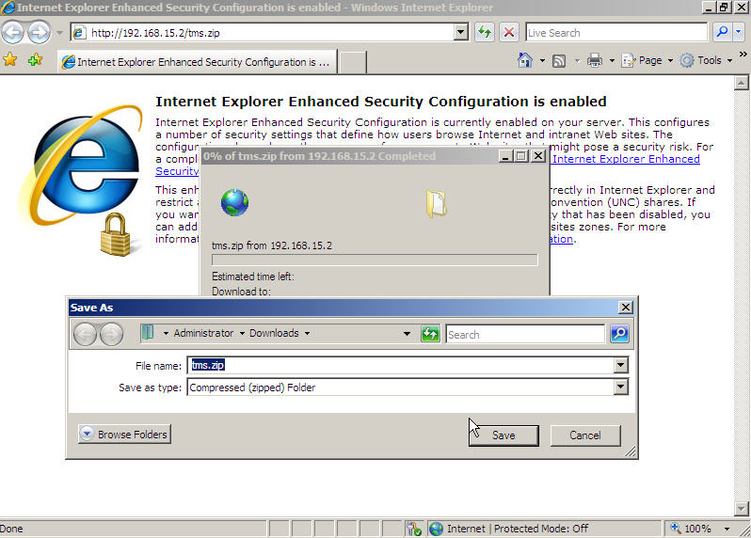
Download backup file’s archive

- Open Windows Explorer and locate the file. Right click on the file to open a context menu, and then select Extract All… An Extract Compressed (Zipped) Folders dialog box will open.
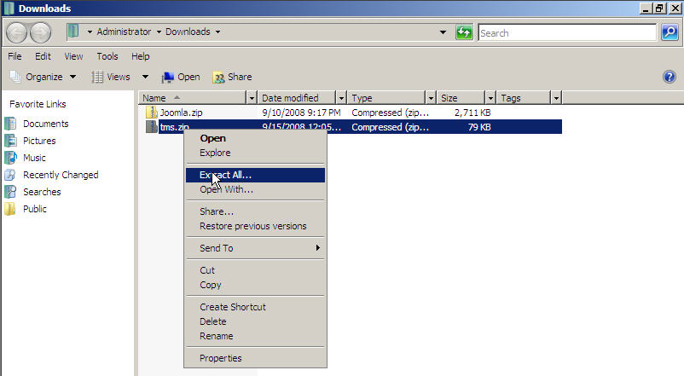
Extract backup zip archive

- In the Select a Destination and Extract Files field, enter the path to the destination folder, normally, c:\inetpub\wwwroot\tms or click on the Browse button and navigate to the destination folder. Then click on the Extract button.
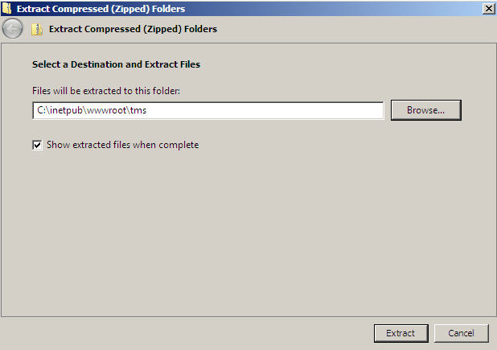
Backup archive into the Windows Server 2008 root directory

- Open the destination folder and compare the contents with the originals on the Linux server to verify the success of the transfer.

Migrating directories and files migration using FTP
In order to migrate directories and files from a Linux server to Windows Server 2008 using the HTTP archive download, perform the following procedure:
- On the Linux server, open a Terminal console and create a zipped archive by the method described above.
- At the command prompt, type the following command using the IP address of the Windows Server 2008 machine, and then strike Enter:
[root@localhost html] # ftp <IP address>

- Where prompted, enter a user name and password. That exchange will look like the following:
Name (<IP address from step 2>:root): Administrator
331 Password required for Administrator.
Password: <enter password>
230 - Welcome to FTP server
230 User Administrator logged in
Remote system type is Windows _NT

- The command prompts will change from [root@localhost html] # to ftp>. At the next prompt, type the following command and strike Enter, then note the subsequent response from the FTP service:
ftp > ascii
200 Type set to A
FTP> bin
200 Type set to I
ftp> put tms.zip
local: tms.zip remote tms.zip
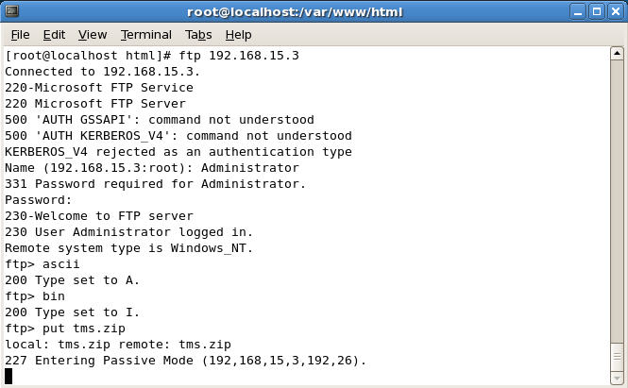
Transfer backup zip archive to FTP server

- On the Windows Server 2008 machine, open Windows Explorer and locate the file. Right click on the file to open a context menu, and then select Extract All… An Extract Compressed (Zipped) Folders dialog box will open.

Extract backup zip archive

- In the Select a Destination and Extract Files field, enter the path to the destination folder, normally c:\inetpub\wwwroot\tms, or click on the Browse button and navigate to the destination folder. Then click on the Extract button.
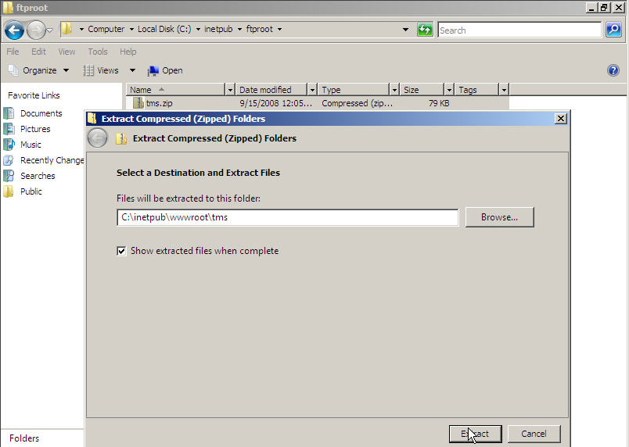
Backup archive from Windows Server 2008 ftp directory http root directory

- Open the destination folder and compare the contents with the originals on the Linux server to verify the success of the transfer.
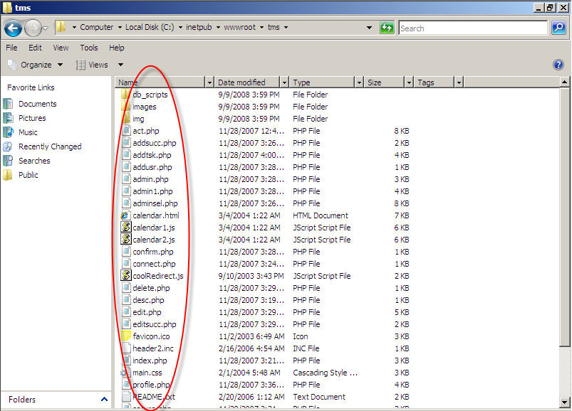

Directories and files in Windows Server 2008 http root directory

Migrating Databases from MySQL to SQL Server 2005
This section explains how to migrate data from a MySQL database running on a Linux server onto an SQL Server 2005 database running on Windows Server 2008. The migration uses the MySQL ODBC connector. This process assumes that the user has both database- and system-level administrator permissions on both machines.

Linking a MySQL database to a Microsoft SQL Server 2005 database
To link a MySQL database running on a Linux server to a Microsoft SQL Server 2005 database running on Windows Server 2008, perform the following procedures:
- On the Windows Server 2008 machine, open the Start menu and locate the SQL Server Management Studio Express link. Click on the link to open a SQL Server 2005 management console. A Connect to Server dialog box will open.
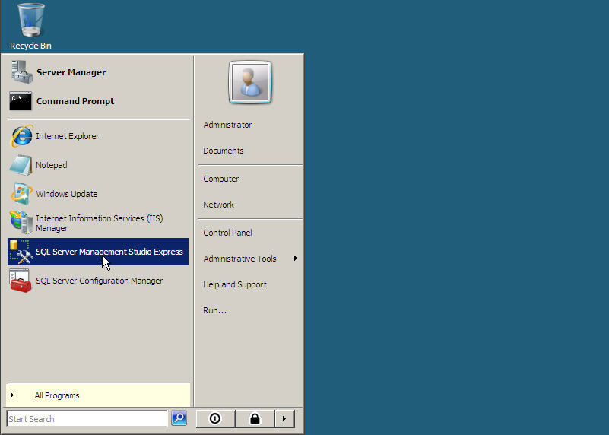
Launch SQL Server Management Studio Express

- Enter the Server Name, mode of Authentication, User name and Password, and then click on the Connect button. A SQL Server Management Studio Express window will open.
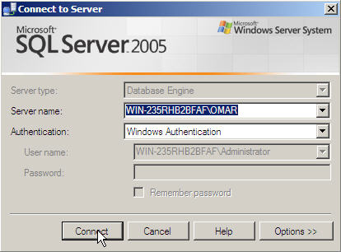
SQL Server Management Studio Express login console

- In the Object Explorer pane on the left side of the window, right-click on the Databases entry. A context menu will open. Select New Database. A New Database window will open.
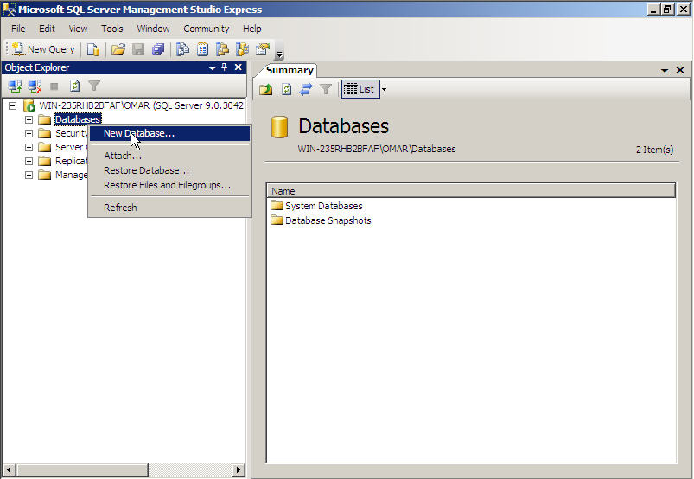
Create new database

- In the Select a Page pane in the upper-left corner of the window, make sure General is selected.

- In the Database name field, enter a name for the database that matches the name of the MySQL database on the Linux server. Click on the OK button.
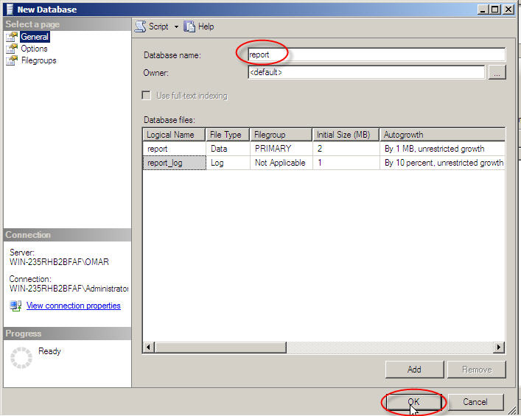
New database name

- The New Database window will close, and the new database will appear in the Object Explorer pane of the SQL Server Management Studio Express window.
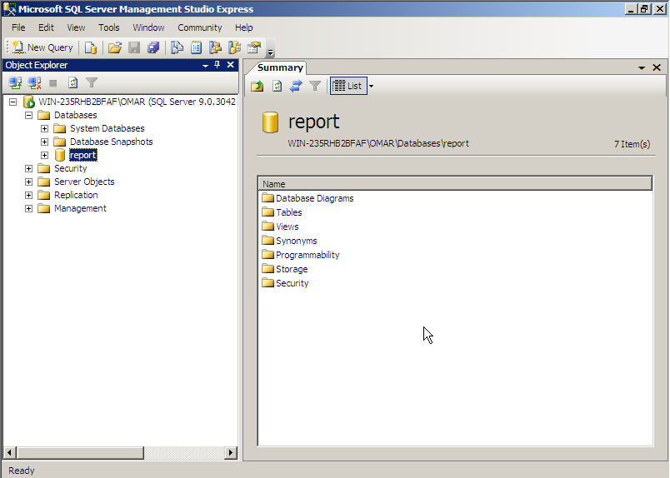
Newly created database “Report”

- Click on the New Query button in the upper-left corner of the SQL Server Management Studio Express window. A query field will open in the middle pane of the SQL management window.
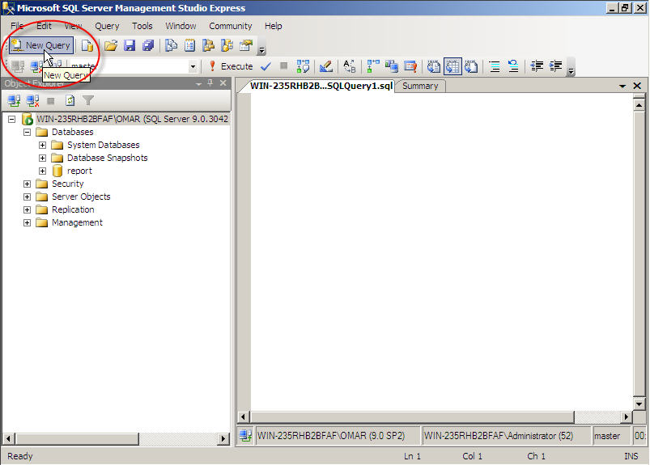
Microsoft SQL Server management Studio Express New Query window

- Enter the following query in the query field:
EXEC master.dbo.sp_addlinkedserver
@server = N’<Linux server name>,
@srvproduct=N’MySQL’,
@provider=N’MSDASQL’,
@provstr=N’DRIVER={MySQL ODBC 5.1 Driver};
SERVER=<Linux server IP address>;DATABASE=<MySQL database name>; USER=<username>;PASSWORD=<username’s password>;OPTION=3’

- Then click on the Execute button to launch the query.
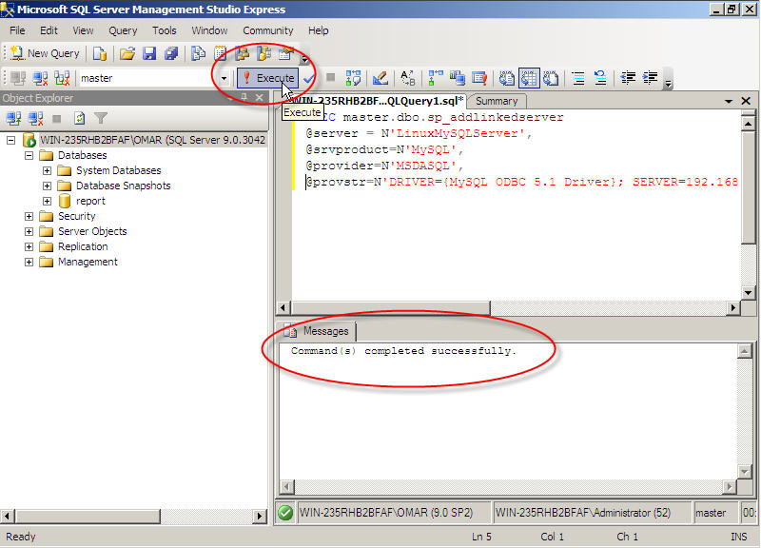
SQL Server 2005 to MySQL server link building

- When the query has run, the Messages field just beneath the query field will show the confirmation Command(s) completed successfully. If the query failed, a message will direct the user to the source of the problem.
- Verify the link SQL Server 2005 and MySQL by checking Object Explorer pane in the SQL management console. Expand the Server Objects node, and then the Linked Servers node. The name of the MySQL database entered in step 7 should appear.

Importing tables from MySQL to Microsoft SQL Server 2005
This section explains how to migrate data from a MySQL database running on a Linux server onto a SQL Server 2005 database running on Windows Server 2008. The migration uses the MySQL ODBC connector. This process assumes that the user has both database- and system-level administrator permissions on both machines.

Linking a MySQL database to a Microsoft SQL Server 2005 database
To link a MySQL database running on a Linux server to a Microsoft SQL Server 2005 database running on Windows Server 2008, perform the following procedures:
- On the Windows Server 2008 machine, open the Start menu and locate the SQL Server Management Studio Express link. Click on the link to open a SQL Server 2005 management console. A Connect to Server dialog box will open.
- Enter the Server Name, mode of Authentication, User Name and Password, and then click on the Connect button. An SQL Server Management Studio Express window will open.
- In the Object Explorer pane on the left side of the window, right-click on the Databases entry. A context menu will open. Select New Database. A New Database window will open.
- In the Select a Page pane in the upper-left corner of the window, make sure General is selected.
- In the Database name field, enter a name for the database that matches the name of the MySQL database on the Linux server. Click on the OK button. The New Database window will close, and the new database will appear in the Object Explorer pane of the SQL Server Management Studio Express window.
- Click on the New Query button in the upper-left corner of the SQL Server Management Studio Express window. A query field will open in the middle pane of the SQL management window.
- Enter the following query in the query field:
EXEC master.dbo.sp_addlinkedserver
@server = N’<Linux server name>,
@srvproduct=N’MySQL’,
@provider=N’MSDASQL’,
@provstr=N’DRIVER={MySQL ODBC 5.1 Driver};
SERVER=<Linux server IP address>;DATABASE=<MySQL database name>; USER=<username>;PASSWORD=<username’s password>;OPTION=3’
- Then click on the Execute button to launch the query.
- When the query has run, the Messages field just beneath the query field will show the confirmation Command(s) completed successfully. If the query failed, a message will direct the user to the source of the problem.
- Verify the link SQL Server 2005 and MySQL by checking Object Explorer pane in the SQL management console. Expand the Server Objects node, and then the Linked Servers node. The name of the MySQL database entered in step 7 should appear.
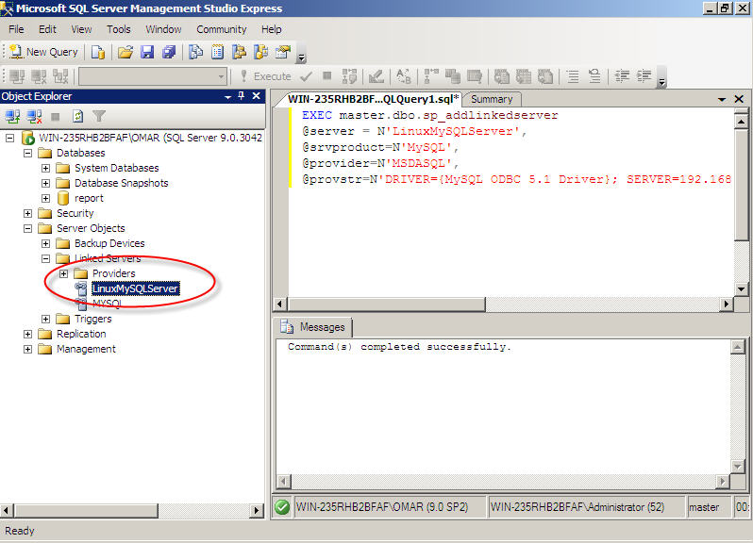

Importing tables from MySQL to Microsoft SQL Server 2005
Once the two databases are linked, all of the tables from the MySQL installation on the Linux server need to be imported into the Microsoft SQL Server 2005 database. This can be done by importing each remote table individually.
To import the tables one at a time, perform the following procedures:
- In the SQL Server Management Studio Express query window, type the following command:
SELECT * INTO <SQL server name>.dbo.per
FROM openquery(MYSQL,’SELECT * FROM <table name>.per

Click on the Execute button to import the table.

- In the Object Explorer, locate the name of the database created to receive the migrated material in the Linking a MySQL database to a Microsoft SQL Server 2005 database section above. Right-click on that entry. A context menu will open. Select Refresh.
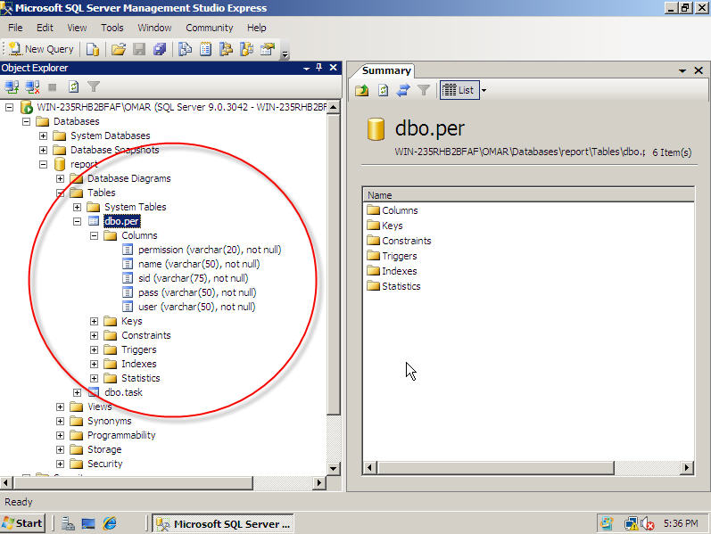

Migrating MySQL Data Types
This section explains mappings and differences between MySQL and SQL Server 2005 data types and specific data type handling, and provides solutions for problems related to data types.

Data Type Mappings
The following are common recommended type mappings for converting table columns and local variable data types.
MySQL Data Type | SQL Server 2005 Mapping | Conversion Comments
BIT (N) | varbinary (8) | Binary value has N bits. N = 1..64
TINYINT (M)  BOOL, BOOLEAN = TINYINT (1) | tinyint | M is the number of decimal places in the output for this value.
SMALLINT (M) | Smallint | M is the number of decimal places in the output for this value.
MEDIUMINT (M)  INT (M)  INTEGER (M) | Int | M is the number of decimal places in the output for this value.
BIGINT (M) | bigint | M is the number of decimal places in the output for this value.
FLOAT [(P, S)] | float (24) | Here, “(P,S)” means that values are displayed with up to P digits total, of which S digits may be after the decimal point. MySQL performs rounding when storing values.  If M and D are omitted, values are stored up to the size limits allowed by the hardware.
DECIMAL [(P [, S])]  DEC [(P [, S])]  NUMERIC [(P [, S])]  FIXED [(P [, S])] | decimal [(P [, S])]  numeric [(P [, S])] | Decimal types can have up to 65 digits. For a decimal with a precision of more than 38, use float or double data type.
DATETIME | datetime | MySQL can store dates from 0000-00-00 to 9999-12-31. MySQL can store zero-value of year, month and year.
DATE | datetime
TIME | datetime | Range is '-838:59:59' to '838:59:59'.
TIMESTAMP | smalldatetime | Range is '1970-01-01 00:00:00' to partway through the year 2037. If not defined during conversion, this type gets the current datetime value.
YEAR [(2| 4)] | smallint | In four-digit format, allowable values are 1901 to 2155, and 0000. In two-digit format, allowable values are 70 to 69, representing years from 1970 to 2069.
[NATIONAL] VARCHAR (N)  CHARACTER VARYING (N) | nvarchar (N | max) | Range of N is 0 to 65,535.  If N<=8000 then nvarchar(N) else nvarchar(max).
TEXT (N) | nvarchar (N | max) | A TEXT column with a maximum length of 65,535 characters.  If N<=8000 then nvarchar(N) else nvarchar(max).
BINARY (N) | binary (N)
BLOB (N) | varbinary (N | max) | A BLOB column with a maximum length of 65,535 bytes.  If N<=8000 then nvarchar(N) else nvarchar(max).

Changing Data Types
To change the data type of any field within any of the imported table, Open SQL Server Management Studio Express, Locate and Right click the table name within the database on the left pane and Click on Modify.
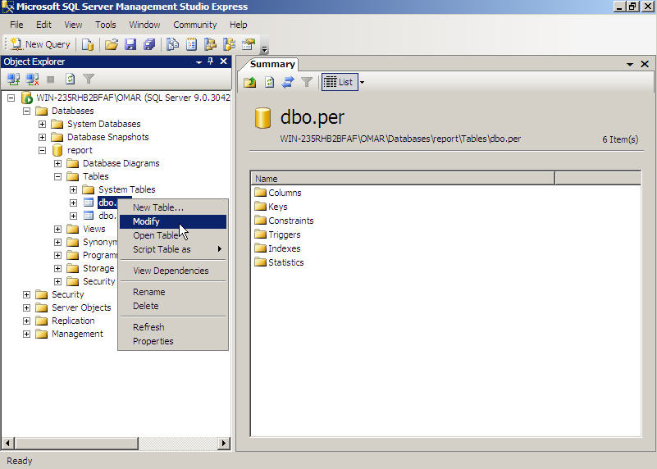
To change the data type of any field according to the data type map above, double click on the field’s Data Type and enter the appropriate data type with the required field size.
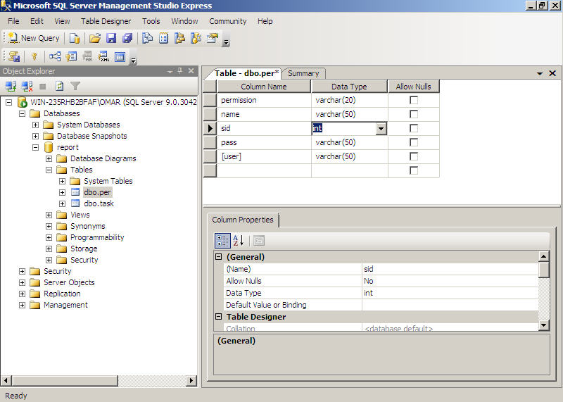

Creating Table Constraints and Indexes
This section covers the details of creating appropriate Primary Keys, Foreign Keys and Indexes within SQL Server 2005 database in contrast to those existing in MySQL database.

Defining Indexes
In MySQL, indexes can be defined in the body of a table declaration. In SQL Server 2005:
- Index declarations should be removed from table declarations;
- Index declarations should be converted into the separate CREATE INDEX statements;
- Valid and unique index names should be generated;
- The KEY keyword needs to be replaced with the INDEX keyword.
MySQL Example:
create table tab_index (
i int not null,
n int not null,
d datetime null,
v varchar(2048) not null,
primary key (i),
index idx_tab_index (n),
key (d),
fulltext index ft_tab_index (v)) engine = myisam;

SQL Server Example:
create table tab_index (
i int not null,
n int not null,
d datetime null,
v varchar(2048) not null,
primary key (i))
create index idx_tab_index on tab_index (n)
create index key_tab_index on tab_index (d)
create fulltext index on tab_index (v) key index pk__tab_index__72e607db

Defining Auto Increment Property
MySQL supports the AUTO_INCREMENT column option and AUTO_INCREMENT table option. The MySQL AUTO_INCREMENT column option should be replaced by using the SQL Server IDENTITY column property. The MySQL AUTO_INCREMENT table option value should be converted to SQL Server as a seed parameter of the IDENTITY property.
MySQL Example:
create table auto_a (
i int not null auto_increment primary key,
d datetime null
)
auto_increment = 1000;

insert auto_a values (null,now()),(null,now()),(null,now());
select * from auto_a;
-- 1000 2007-02-16 17:41:43
-- 1001 2007-02-16 17:41:43
-- 1002 2007-02-16 17:41:43

SQL Server Example:
create table auto_a (
i int not null identity(1000,1) primary key,
d datetime null
)

insert auto_a values (getdate())
insert auto_a values (getdate())
insert auto_a values (getdate())

To define the auto increment property to any field from SQL Server Management Console:
- Alter the data type of the field to be integer (int) as defined in the ‘changing data types’ section above.
- Scroll down the Column Properties tab to locate Identity Specification. Expand the Identity Specification property by clicking on + mark on the left of property name.
- Change the property of (Is Identity) from No to Yes
- Verify the increment Seed and click on Save to save the properties
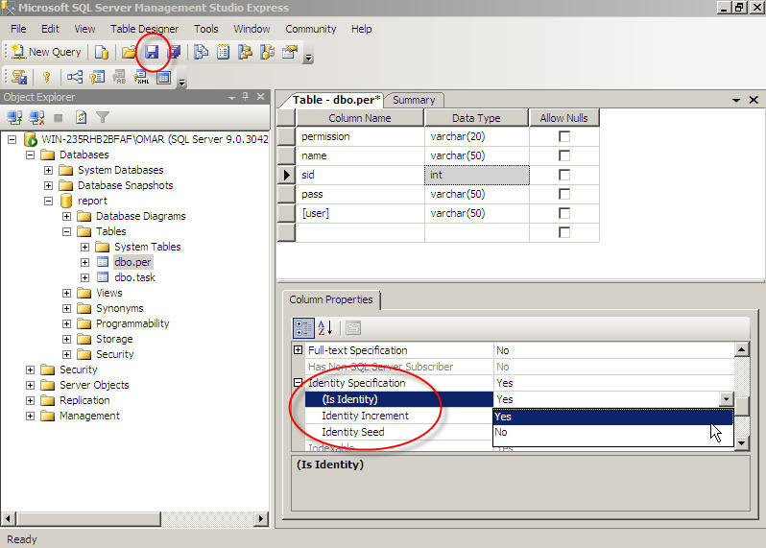

Defining Constraints
MySQL allows the omission of constraint names and duplicate constraint names. In SQL Server 2005, valid and unique constraint names needs to be defined.
MySQL Example:
create table tab_constr (
id int not null, d datetime,
fk int not null,
constraint primary key (id),
constraint unique (d),
constraint foreign key (fk) references tab_a (i)
);

create table tab_constr_dub (
id int not null, d datetime,
constraint key_tab_constr_dub primary key (id),
constraint key_tab_constr_dub unique (d)
);

SQL Server Example:
create table tab_constr (
id int not null, d datetime,
fk int not null,
constraint pk_tab_constr primary key (id),
constraint uq_tab_constr unique (d),
constraint fk_tab_constr foreign key (fk) references tab_a (i)
);

create table tab_constr_dub (
id int not null, d datetime,
constraint pk_tab_constr_dub primary key (id),
constraint uq_tab_constr_dub unique (d)
);

To define the primary key from SQL Server Management Studio Express, right click on the table and click on Modify. Select and right click on the field name to explore the additional options. Click on Primary Key to define the selected column as a Primary Key. Lastly, click on the Save button to save the changes.
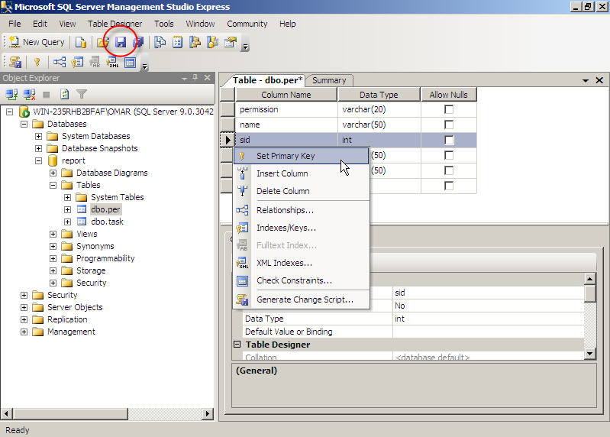
Once saved, a Key like icon will appear with the field name signifying that the field is defined as the primary key.
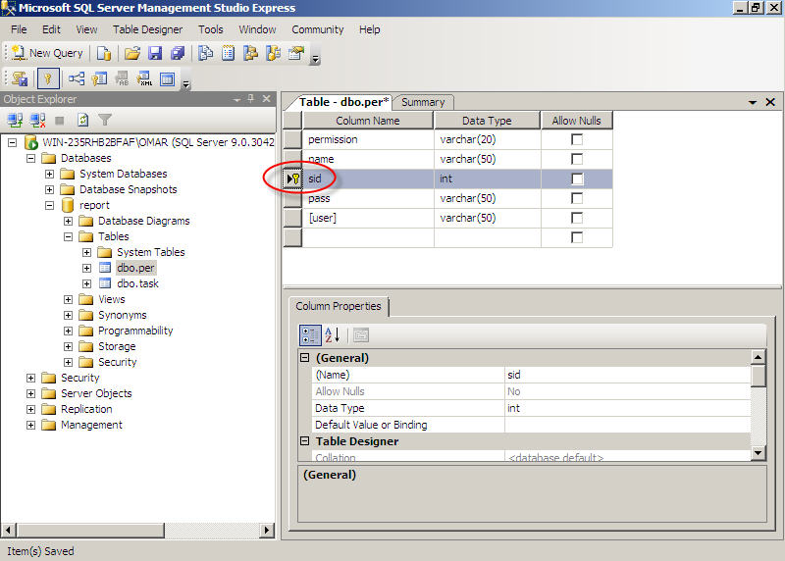

Altering PHP Application Code
This section covers the details of enabling a PHP application to work with SQL Server 2005 instead of MySQL.
PHP comes with handful of functions for the easy switch from MySQL to SQL Server 2005. PHP provides almost identical functions to be used for SQL Server 2005 as those for MySQL.

Connectivity

MySQL Function
resource mysql_connect ($servername, $username, $password)

MSSQL Function
resource mssql_connect ($servername, $username, $password)
Description: Establishes a connection to a MS SQL server.
Return Value: Returns a MS SQL link identifier on success, or FALSE on error.
Example:
<?php
// Server in the this format: <computer>\<instance name> or
// <server>,<port> when using a non default port number
$server = 'KALLESPC\SQLEXPRESS';
$link = mssql_connect($server, 'sa', 'phpfi');
if(!$link)
{
die('Something went wrong while connecting to MSSQL');
}
?>

Database Selection

MySQL Function
bool mysql_select_db ($database_name, $link_identifier)

MSSQL Function
bool mssql_select_db ($database_name, $link_identifier)
Description: Sets the current active database on the server that's associated with the specified link identifier.
Return Value: Returns TRUE on success or FALSE on failure.
Example:
<?php
// Create a link to MSSQL
$link = mssql_connect('KALLESPC\SQLEXPRESS', 'sa', 'phpfi');
// Select the database 'php'
mssql_select_db('php', $link);
?>

Querying the database

MySQL
mixed mysql_query ($query, $link_identifier)

MSSQL
mixed mssql_query ($query, $link_identifier)
Description: Sends a query to the currently active database on the server that's associated with the specified link identifier.
Return Value: Returns a MS SQL result resource on success, TRUE if no rows were returned, or FALSE on error.
Example:
<?php
// Connect to MSSQL
$link = mssql_connect('KALLESPC\SQLEXPRESS', 'sa', 'phpfi');
if(!$link || !mssql_select_db('php', $link))
{
die('Unable to connect or select database!');
}

// Do a simple query, select the version of
// MSSQL and print it.
$version = mssql_query('SELECT @@VERSION');
$row = mssql_fetch_array($version);
echo $row[0];
// Clean up
mssql_free_result($version);
?>

Fetching the data

MySQL
array mysql_fetch_row ($result)
array mysql_fetch_array ($result)
object mysql_fetch_object ($result)

MSSQL
array mssql_fetch_row ($result)
array mssql_fetch_array ($result)
object mssql_fetch_object ($result)
Description: All the above queries are used to fetch data from the database row by row and are very similar to each other. These queries are normally run within a loop to iterate through all the available or certain selected records.
Return Value:
- Returns an array that corresponds to the fetched row, or FALSE if there are no more rows.
- The second query is the extended version of the first query and returns an array that corresponds to the fetched row along with the data in associative indices, using the field names as keys, or FALSE if there are no more rows.
- The third query returns an object with properties that correspond to the fetched row, or FALSE if there are no more rows.
Example:
<?php
// Connect to server and database
$link = mssql_connect('MANGO\SQLEXPRESS', 'sa', 'phpfi');
mssql_select_db('php', $link);
// Query to execute
$query = mssql_query('SELECT [id], [quote] FROM [quotes] WHERE [id] = \'42\'', $link);
// Did the query failed?
if(!$query)
{
die('MSSQL error: ' . mssql_get_last_message());
}
// Fetch the row
$row = mssql_fetch_row($query);
// Print the 'quote'
echo 'Quote #' . $row[0] . ': "' . $row[1] . '"';
?>

Example Result:
Quote #42: "The answer to everything..."

Completing the Database Migration
Migrating a database from MySQL to SQL Server 2005 involves the following high-level steps:
- Migrate database objects, i.e., tables.
- Map data types from MySQL data types to a SQL Server data types.
- Create tables, constraints, and indexes.
- Change applications as necessary to enable them to connect and work with SQL Server 2005.

Appendix I: Setting Up Virtual Hosts
The IIS 7.0 counterpart to the Apache Virtual Host is a virtual Web site. As with Apache virtual hosts, each virtual Web site in IIS 7.0 has its own domain name and IP address. Apache also includes name-based virtual hosts in this category. IIS 7.0 supports this feature in the same manner as Apache, through host header names, but IIS 7.0 does not have a specific term for a virtual Web site.
The following section demonstrates the basic steps to migrate virtual hosts from the Linux/Apache environment to the Windows Server 2008/IIS 7.0 environment.

Configuring the IIS 7.0 host
In the Apache environment, the virtual host is configured in the httpd.conf file, which is normally located in the /etc/httpd/ folder.
For demonstration purposes, we assume that the Linux server has a separate virtual host for a MySQL management application called PHPMyAdmin.
The following is an example of an Apache Web server virtual host configuration:
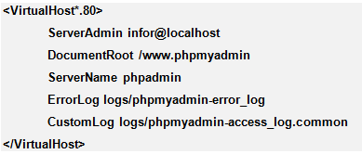
To replicate the same settings on a Windows Server 2008 machine, perform the following procedure:
- On the Windows Server 2008 machine, click on Start, then Administrative Tools, and then Internet Information Services Manager. An Internet Information Services (IIS) Manager window will open.
- In the Connections pane on the left of the IIS Manager window, select host name at the top of the menu (usually the name of the Windows Server 2008 machine) and right click. A context menu will open.
- In the context menu, click on Add Web Site. An Add Web Site dialog box will open. Enter the following data:

Site Name | Choose a name for the new site.
Physical path | The path to the folder containing the site’s content directory. Typically, this is c:\inetpub\wwwroot\<site name>
Binding type | By default, this should be http.
IP Address | Select either All Unassigned to use all the IP addresses assigned to the server, or select any single IP address from the dropdown menu.
Port | The default is port 80. Select an alternate port if the Web site is intended to run on any other port.
Host name | The namespace for the Web site, typically www<site name>.com.
Click on OK to commit the entries.
- In the Connections pane on the left of the IIS Manager window, expand the Sites folder and select the site name entered in Step 3. Right click on the new site’s name to open a context menu, then click on Explore to browse the site.
Important points to keep in mind when performing a virtual host migration from Apache to IIS 7.0:
- Application pools allow Web site resources to be isolated. This creates a separate server environment for each Web site.

Installing and Configuring PHP on Windows Server 2008/IIS 7.0
To install and configure PHP on a Windows Server 2008 and configure it with IIS 7.0 and SQL Server 2005, perform the following procedure:
- On the Windows Server 2008 machine, navigate to http://www.php.net/downloads.php and download the latest .zip file from the Windows Binaries section.
- Create the folder C:\php and extract the contents of the zip file to the folder. From the unzipped files in C:\php, copy the file php.ini-dist to C:\Windows and rename it php.ini.
- Open the php.ini file in Notepad. Search for the term mssql. The first instance should be a line that reads ; extension=php_mssql.dll. Remove the semicolon from the beginning of the line. Save the php.ini file and close Notepad.
- Return to the desktop and click on Start, then Administrative Tools, and then Internet Information Services Manager. An Internet Information Services (IIS) Manager window will open.
- In the middle pane of the IIS Manager window, double-click on the Handler Mappings icon. The window will refresh and display a Handler Mappings explorer in the middle pane of the IIS Manager window.
- Click the Add Script Map link in the Actions panel on the right side of the IIS Manager window. An Add Script Map dialog box will open. Enter the following information in the fields:
Request path: *.php
Executable: C:\php\php5isabi.dll (or whichever path applies)
Name: PHP
- Click on OK to commit the entries and create the PHP handler. The new PHP handler will appear in the Handler Mappings pane in the middle of the IIS Manager.
- To verify the installation, open Notepad and type the following:
<?php
Phpinfo();
?>
Then save the file to C:\inetpub\wwwroot as index.php. If an index.php file is already present, replace it with the file you are saving.
- Open Internet Explorer and enter http://localhost/index.php in the URL field. If the instance of PHP is properly installed, a Web page bearing the PHP logo and detailed information about the installation will open.

Installing MySQL Server on Windows Server 2008
To install and configure MySQL Server on a Windows Server 2008 machine, perform the following procedure:
- Open Internet Explorer and enter the URL http://www.mysql.com/downloads. Choose between the freeware Community version and the fully supported Enterprise version. Select the zipped file that unpacks into a Setup.exe file.
- When the download is complete, unzip the file to extract Setup.exe. Double-click on the Setup.exe icon to launch the MySQL 5.0 - Setup Wizard. A Welcome to the Setup Wizard window will open. Click on the Next button. The Setup Type windows will open.
- In the Setup Type window, select the Custom radio button. Click on the Next button. The Custom Setup window will open.
- In the Custom Setup window, by default the following components will be selected:
- MySQL Server
- Client Programs
- MySQL Instance Manager
- Documentation
- Developer Components Is not available in the Community edition
- By default, the program will be installed in the folder C:\Program Files\MySQL\MySQL Server 5.0. If the installation should go into any other folder, click on the Change button and select the desired folder. When the selections are made, click on Next. A Ready to Install window will open.
- The Ready to Install window will review the selections made in steps 5 and 6. If changes are needed, click on the Back button to return to the Custom Setup window. Otherwise, click on the Install button.
- A progress bar will track the installation, and then a promotional window will open. Click on Next, then Finish.

Configuring MySQL Server on Windows Server 2008
Once installation is complete, MySQL provides a wizard for configuring the MySQL instance. To set configuring settings, perform the following procedure:
- The MySQL Server Instance Configuration Wizard is accessible in three ways:
- Normally, the wizard will launch automatically after installation is complete.
- Click on Start, then the MySQL group folder, and then Configuration Wizard icon.
- Open the \bin\ folder in the MySQL installation directory, which is by default C:\Program Files\MySQL\MySQL Server 5.0\bin\ and double-click on MySQLInstanceConfig.exe.
- The Configuration Wizard will open with a Welcome window. Click on the Next button. A window will open inviting the user to Please select a configuration type. Click on the Detailed Configuration radio button, and then on the Next button.
- In the Please select a server type window, click on the Server Machine radio button and then click on the Next button.
- In the Please select the database usage window, click on the Multifunctional Database radio button and then click on the Next button.
- In the InnoDB Tablespace Settings, select a directory for the MySQL data files. The user can select a drive from the dropdown menu to the left and a path from the dropdown menu to the right, or click on the browse button to the right of the path field and navigate to a particular folder.

Note: Normally, the \data\ folder is a located in the installation directory. By default, MySQL is installed in C:\Program Files\MySQL\MySQL Server 5.0, and the data directory is C:\Program Files\MySQL\MySQL Server 5.0\data. If another path is chosen for the \data\ directory, the entire contents of the default \data\ directory should be copied to the new location.
Once the path is selected, click on the Next button.
- In the concurrent connections window, select the type of processing this instance of MySQL will perform from the following options:
- Decision Support / OLAP does not require a high number of concurrent connections. Setup will set the number at 20.
- Online Transaction Processing (OLTP) requires a high number of concurrent connections. In this mode, MySQL will be configured to handle up to 500 simultaneous connections.
- Manual setting allows the user to pick an arbitrary number of connections.
Make a selection by clicking on the appropriate radio button, then click on the Next button.
- In the networking options window, review the networking information. Typically, the MySQL Port Number should be left to its default settings. However, if there are any special requirements, the changes can be made on this page. TCP/IP Networking and Strict Mode are normally selected. Click Next to continue.
- In the default character set window, the default Latin 1 character is adequate for English and most Western European languages. Click Next.
- In the Windows options window, click on the check boxes to Install As Windows Service and Include Bin Directory in Windows PATH. Accept the default name of MySQL for the service, and decide whether to Launch the MySQL Server Automatically or manually. When all selections are made, click on the Next button.
- In the security options window, enter and confirm a root account password. Click on the Next button.
- A Processing Configuration window will mark progress. When the configuration is complete, click on the Finish button to close the wizard.
- To verify the installation, open a command shell by clicking on Start, then Run, and then enter cmd.exe. At the command prompt, enter the following command:
Mysql –u root –p
When prompted, enter the password you selected in step 10. The system will return the message Welcome to the MySQL monitor.

Installing SQLyog on Windows Server 2008
SQLyog is a commercial management tool for MySQL. Like MySQL, it has a free Community edition and a fully supported Enterprise edition. To install SQLyog, perform the following procedure:
- In Internet Explorer, navigate to http://www.webyog.com/en/downloads.php. Download the binaries for Windows. The file as of October 2008 was SQLyog71.exe.
- After the installation file is downloaded, double-click on the installation file. A Welcome to the SQLyog 7.1 Setup Wizard will open. Click on the Next button. A License Agreement window will open.
- Review the license agreement and click on the Next button. A Choose Components window will open. SQLyog core files are required; the other three collections let you elect or reject shortcuts in the Start Menu, Desktop or Quick Launch tray. When you have made your selections, click on the Next button. A Choose Installation Location window will open.
- By default, the installation will be directed to C:\\Program Files\SQLyog <Community or Enterprise>. If you want to install to another folder, click on the Browse button and navigate to the desired folder. When you’ve made your selection, click on the Install button.
- An Installing window will open ad mark progress. When installation is Completed, click on the Next button. The Completing the SQLyog 7.1 Setup Wizard window will open with Run SQLyog <Community or Enterprise> 7.1 selected. Click on the Finish button to launch SQLyog.
Note: If you have installed the Community edition, a screen will open inviting you to purchase the Enterprise edition. Click on the Continue button.

Connecting SQLyog to a MySQL
The SQLyog console will launch automatically by default when you finish installation. Thereafter, it will launch from the shortcut on your desktop or Start menu. In either case, you will need to connect to the database by the following procedure:
- Double-click the SQLyog icon to launch the administration console. The console will open with the SQLyog Enterprise Power Tools pop-up. Click on the Continue button to dismiss the pop-up. A Connect to MySQL Host dialog box will open.
- On the Connect to MySQL dialog box, click on New. A New Connection dialog box will open. Type a name for the connection in the Name field and click on the OK button.
- Enter the MySQL host address. If the database is running on the same machine as SQLyog, the default name is localhost. If you are connecting remotely, enter the address in the form <IP address/<host name>:<port number> (for 127.0.0.1/MySQL:3306).
- Type in User name and Password, and leave the Port set to 3306. Click on the Connect button, then on the Yes button to accept changes in connection details. The SQLyog management console window will open.
Note: The next time you open SQLyog, you can select the connection from the Saved Connections menu on the Connect to MySQL Host dialog box.

Installing a MySQL ODBC Driver
To migrate databases between MySQL and SQL Server 2005, you must build a link by installing the MySQL ODBC driver on a Windows Server 2008. To install the MySQL ODBC driver on a Windows Server 2008 machine, perform the following procedure:
- In Internet Explorer, navigate to http://dev.mysql.com/downloads/connector. Select Connector/ODBC, then click on the latest version. The latest as of October 2008 was version 5.1. Select the platform, then Windows MSI Installer, and then click on Download.
- After the driver is downloaded, double-click on the installation file to launch the MySQL Connector/ODBC installation wizard. The Welcome screen will open. Click Next to continue.
- A Setup Type window will open. Accept the Typical installation and click on the Next button. A Ready to Install window will open.
- On the Ready to Install window, click on the Install button to launch the installation. A progress bar with track the installation. Finally, a Wizard Completed window will open. Click on the Finish button.

Configure a MySQL ODBC Driver
Once the MySQL ODBC Driver is installed, you will need to add it to the system settings on your Windows Server 2008 machine. To configure the MySQL ODBC Driver, perform the following procedure:
- Open the Control Panel by clicking on the Start button, then Run. In the Run line, type control admintools, and strike Enter. The Administrative Tools window will open.
- From the Names list in the Administrative Tools window, double-click on Data Sources (ODBC). An ODBC Data Source Administrator window will open.
- Select the System DSN tab from the lineup at the top of the ODBC Data Source Administrator and click on the Add button. The Create New Data Source window will open.
- From the list on the Create New Data Source window, select MySQL ODBC 5.1 Driver from the available data source list. Click on Finish to commit the selection. A MySQL Connector/ODBC Data Source Configuration window will open.
- Fill in the fields with the following entries:
Data Source Name: MySQL
Description: Optional
Server: Localhost
Port: 3306
User: root
Password: root password
Database: Leave blank
- Click on Test to confirm the connection, then click on OK to commit the configuration.
- Open Microsoft SQL Server Management Studio. Click New Query to create a query. In the Query window, type the following query:
EXEC master.dbo.sp_addlinkedserver
@server = N’MySQL’,
@srvproduct =N’MySQL’,
@provider=N’MSDASQL’,
@provstr=N’Driver={MySQL ODBC 5.1 Driver}; SERVER=localhost

- Click on the Execute button in the SQL Server Management Studio Express. In the Messages field beneath the Query field, the message Command(s) completed successfully should appear.

Appendix II: Non-Microsoft support
Some of the applications used in these demonstrations come from the Open Source community, and documentation is accessible on the Web. The following is a list of key sites:
http://httpd.apache.org/docs/2.2/ - Apache HTTP Server Version 2.2 Documentation. Includes release notes, reference manual, a users’ guide, tutorials, FAQ and glossary.
http://www.apachelounge.com/download/ - Apache Lounge: Apache on Windows site for webmasters and programmers. Includes downloads, news and a users’ forum.
http://httpd.apache.org/docs-project - Links to online documentation for the Apache HTTP server project.
http://www.mysql.com/ - MySQL Enterprise resources. News, forums, training resources and downloads.
http://www.webyog.com/en/ - Source for SQLyog management tool for MySQL. Includes downloads and online support.
http://www.php.net/ - News and links to PHP resources, including downloads, documentation, a FAQ, and online help.
http://www.joomla.org/ - Joomla Web site resources, including links to documentation, a user forum, downloads of a range of extensions, and community portal.

Conclusion
These scenarios demonstrate that migrating from Apache can be achieved through simple planning. The level of complexity of the migration will depend on the solutions adopted to access the data. Support for PHP makes it possible to host applications with very limited changes and the availability of either free or inexpensive software makes migrating the supporting databases a relatively simple task.

The information contained in this document represents the current view of Microsoft Corporation on the issues discussed as of the date of publication. Because Microsoft must respond to changing market conditions, it should not be interpreted to be a commitment on the part of Microsoft, and Microsoft cannot guarantee the accuracy of any information presented after the date of publication.
This white paper is for informational purposes only. MICROSOFT MAKES NO WARRANTIES, EXPRESS OR IMPLIED, IN THIS DOCUMENT.
Complying with all applicable copyright laws is the responsibility of the user. Without limiting the rights under copyright, no part of this document may be reproduced, stored in, or introduced into a retrieval system, or transmitted in any form or by any means (electronic, mechanical, photocopying, recording, or otherwise), or for any purpose, without the express written permission of Microsoft Corporation.
Microsoft may have patents, patent applications, trademarks, copyrights, or other intellectual property rights covering subject matter in this document. Except as expressly provided in any written license agreement from Microsoft, furnishing this document does not give you any license to these patents, trademarks, copyrights, or other intellectual property.
© 2007 Microsoft Corporation. All rights reserved.
The example companies, organizations, products, domain names, e-mail addresses, logos, people, places, and events depicted herein are fictitious. No association with any real company, organization, product, domain name, e-mail address, logo, person, place, or event is intended or should be inferred.
Microsoft, Internet Information Server 7, SQL Server 2005, Windows Server 2003, Windows Server 2008, are either registered trademarks or trademarks of Microsoft Corporation in the United States and/or other countries.

All other trademarks are property of their respective owners.

