Role-Based Template for SharePoint My Sites: HR Manager
Functional Overview for
Business Decision Makers

With personalization becoming an increasingly important business need and the key to effective collaboration, Microsoft Office SharePoint Server 2007 offers My Site, a personal site that pulls together summary views of personal information and provides full control over information "for me, by me, and about me." Role-Based Templates for SharePoint My Sites are custom templates designed for Office SharePoint Server 2007 and tailored to address the unique needs and requirements of specific roles. They are envisioned as extensions to the standard My Site functionality, providing a personal portal and dashboard data relevant to your role.

Role-Based Templates for SharePoint My Sites can provide enhanced business insight and help drive company-wide productivity through a common interface to access priority information from varied sources and systems related to job roles, individual responsibilities, and surrounding processes. The templates display information in a way that is familiar and easy, and is built around the way people in the company work, enabling business decision-making with greater confidence.

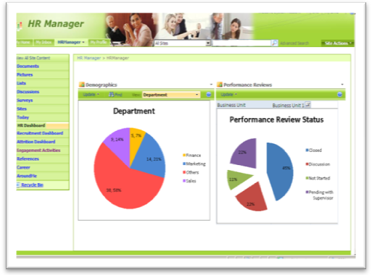
Description of the Template
In an organization, HR Managers are assigned the task of attracting and maintaining a quality workforce and hence they play a crucial role in the organization’s success. Responsibilities include a variety of functions such as recruitment, employee performance management, training, compliance to regulations, and retaining employees.

The HR Manager role-based template for SharePoint My Sites helps HR Managers keep a tab on the employee composition and distribution within the organization. During the performance review cycle, the template provides information on the status of performance reviews and helps the HR Manager in quickly identifying bottlenecks associated with it. As a part of employee engagement, the template displays various activities conducted on a monthly basis. It also displays details about training conducted for employees under various categories. These details help the HR Managers in devising policies to improve employee productivity through motivation, benefits and guidance. The template provides details about attrition rates at the organization and business unit level. The HR Manager template also shows job opening details and employee referrals along with interview schedules for hiring to help with recruitment management. Overall, the template aims at helping HR Managers in their task of attracting, retaining and maintaining a good quality workforce and thereby helping the organization in reaching their business targets.

Sample Activities Performed in this Role-Based My Site Template
Role-based My Site templates aim to provide a “one-stop shop” experience that enables users to view and access information relevant to their jobs by unlocking data buried in various business systems. These templates come with sample data. The following example shows how this template might be used in a typical organization.

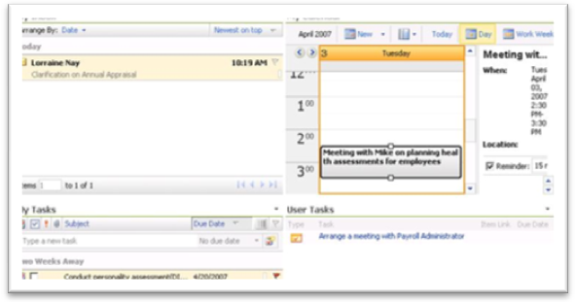
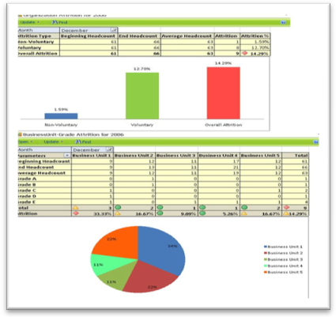
Claire is an HR Manager in Litware Inc’s Human Resources department. Like many information workers, she starts her day by accessing her personal productivity tool, Microsoft Office Outlook® 2007. Since her company has deployed Microsoft Office SharePoint Server 2007 and Role-Based My Site templates, she also logs into her personal My Site page. She starts responding the email messages from employees seeking queries/clarifications. She gets an Outlook alert on a performance review status. She visits the HR Dashboard page to check the status. Instead of going back into Office Outlook 2007, she sends out the reminder email to all the employees to close their appraisals from the My Inbox section of her Today page. She also sees under the User Tasks section that she has an assigned task to arrange a meeting with the payroll administrator.

Claire gets a call from her supervisor to send the monthly executive summary report on attrition rate for the month of December. She refers the Attrition Dashboard page from where she retrieves the details of overall organization attrition rate and also the business unit and grade segregation. Attrition percentage is calculated as (attrition/average headcount) x 100. She checks the attrition rate for different quarters, which are shown as key performance indicators (KPIs) with red, yellow, or green markers, and gets an idea whether the attrition rate is high or within acceptable limits. She then visits the Reference page to download the report template, compiles the information and sends it to her supervisor.

She receives a reminder email for a scheduled interview with Jesse. She visits the Recruitment Dashboard page, checks her interview schedules and finds that an interview is scheduled with Jesse at 2PM. She also gets an email from one of the business unit managers regarding the plan for recruitment. She checks the Recruitment Dashboard for open positions for the business unit and, from the References page, pulls out an InfoPath® form for job descriptions.
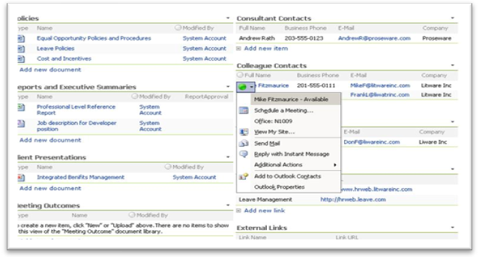
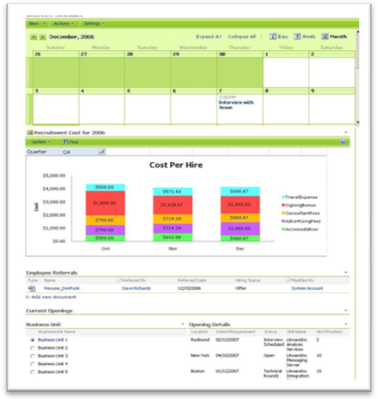

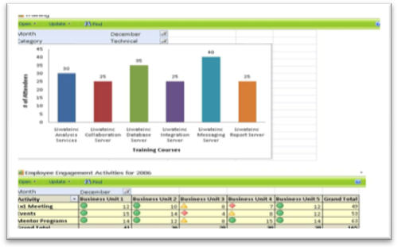
Claire reviews the past data of cost per hire, compiles a report of the plan for recruitment and the approximate cost involved and uploads it to the Report and Executive Summary on the References page. This upload triggers an approval workflow to the business unit manager. She instant messages the business unit manager and updates him.

Later in the day, Claire visits the Around Me page and finds that her supervisor has been awarded the “Dear Boss Award”. She congratulates her supervisor and suggests hosting a celebration. She updates her objectives by visiting the Career page and makes note of her objectives to meet the organization goal for employee engagement activities .She visits the engagement activities page to check the training and engagement status and plans her activities.

About Microsoft Office SharePoint Server 2007
Microsoft Office SharePoint Server 2007 is an integrated suite of server capabilities that can help improve organizational effectiveness by providing comprehensive content management and enterprise search, accelerating shared business processes, and facilitating information-sharing across boundaries for better business insight. Office SharePoint Server 2007 supports all intranet, extranet, and Web applications across an enterprise within one integrated platform, instead of relying on separate fragmented systems. Additionally, this collaboration and content management server provides IT professionals and developers with the platform and tools they need for server administration, application extensibility, and interoperability.

More Information
For more information on the technologies described in this article, please visit:

Microsoft Office SharePoint Server 2007:
http://www.microsoft.com/sharepoint

Role-Based Templates for SharePoint My Sites:
http://go.microsoft.com/?linkid=6060804

