

Microsoft Office Groove 2007
September 2006

Table of Contents

Cover is for
position only

Introduction to Microsoft Office Groove 2007 1
The New World of Work 1
What Is Office Groove 2007? 2
Bring Your Team Together Quickly, Easily, and Securely 4
Getting Started 4
Create a Collaborative Workspace 5
Invite Team Members to Join Your Workspace 7
Add Tools to Suit Your Team’s Evolving Needs 10
Files Tool 10
SharePoint Files Tool 10
Discussion Tool 12
Meetings Tool 13
Calendar Tool 14
Increase Impact by Staying in Sync 16
Keep Your Team in Sync 16
Work Effortlessly Anywhere—Online or Offline 16
Getting Used to Synchronization 17
Keep Yourself in Sync 18
Monitor Team Activity and Communicate in Real Time 19
Presence Awareness and Alerts 19
Unread Marks 21
Real-Time Communication Tools 21
Messaging 21
Workspace Chat 22
Office Communicator Integration 22
Customize Your Workspaces 24
Build Custom Forms 24
Import an InfoPath Form 24
Create Templates for Future Use 26
Summary 27
Resources 28
System Requirements 29

Introduction to Microsoft Office Groove 2007
Welcome to Microsoft® Office Groove® 2007, the new Microsoft collaboration tool for helping teams work together dynamically and efficiently. The purpose of this guide is to familiarize you with the features and functionality of Office Groove 2007. In addition, this guide provides scenarios to help you envision how Office Groove 2007 can enable your teams to work better together.

The New World of Work
The work environment is not what it was 10 or even 5 years ago. With more powerful software and computing systems, wireless connectivity, and a proliferation of mobile devices from laptop computers to smart phones, the definition of a workplace or team now cuts across locations, organizations, time zones, and cultures. An office is no longer simply a room or a building. It can be any place we create, share, and store information, and collaborate with employees, partners, customers, and others on projects and business processes.
In this new world of work, teams of information workers who need to work together dynamically often have a difficult time staying in sync. Because teams often are composed of individuals from multiple offices and companies, as well as mobile workers, they are forced to rely on a patchwork of tools to work together. These tools may include e-mail, phone, voice mail, file shares, Web sites, and specialized collaboration applications. While each of these tools has strengths for particular work activities, together they do not provide a persistent, contextual work environment that is accessible to all team members from any location. In addition, many of these tools were designed to support only internal company work. Infrastructure costs and security risks increase when they are used for work that crosses organizational boundaries.
Office Groove 2007 helps teams in the new world of work collaborate easily and purposefully toward their goals and deliverables—without being dependent on extensive IT support, without worrying about how to connect to people and information, without requiring significant ramp-up time to learn new software, and without being forced to switch constantly from one tool or application to another.

What Is Office Groove 2007?
Office Groove 2007 is a collaboration software program that enables teams to work together more effectively inside collaborative workspaces. Office Groove 2007 helps with tasks as simple as document collaboration and as complex as coordinating an event or developing a new product. Groove workspaces place all team members, communications, tools, and information in one convenient location accessible from each member’s computer. You can create a Groove workspace in minutes, add the right tools for the job, and invite anyone to join—employees, customers, or partners—with advanced security and without worrying about server space. Because you spend less time coordinating with your team, you have more time to work on your own contributions.
Here is a brief summary of a few of the Office Groove 2007 features that can help you and your team work together more efficiently and effectively:
- Document collaboration tools make the process of sharing and revising team files easy and efficient, and help you publish completed files to Microsoft Windows® SharePoint® Services document libraries for workflow or storage.
- Threaded discussions enable everybody on your team to track and contribute to a shared, ongoing conversation on important topics.
- Meeting tool and Calendar tool help keep everybody on your team apprised of important project milestones, meetings, and updates.
- Custom forms make it possible to collect structured information from your team using the Microsoft Office InfoPath® 2007 information-gathering program or Office Groove 2007 Forms.
- Presence awareness helps you figure out who is working on what, when, so you can engage team members at the right time.
- Alerts let you know when files and information change in your workspaces and when team members perform important activities.
- Workspace Chat enables you to hold impromptu, spontaneous exchanges of information with team members—wherever they are.
- Integration with Microsoft Office Communicator 2007 and 2005 enables you to initiate phone calls and instant messaging sessions with your team members right from Office Groove 2007.

Office Groove 2007 in Action
Scott Mitchell is a product manager and designer at Fabrikam Inc., a worldwide manufacturing firm. Fabrikam partners with engineers and suppliers across the globe to bring its products to market. To help ensure the timely delivery of its products to market, Fabrikam and its partners work closely on product plans and communicate regularly about inventory status and market changes. Office Groove 2007 helps Fabrikam’s geographically dispersed team to collaborate, helping to ensure a faster time-to-market and helping to reduce the total cost of production.

Bring Your Team Together Quickly, Easily, and Securely
Today’s workplaces and work teams cut across departments, offices, organizations, time zones, and cultures. While this fluidity has its advantages, such as helping organizations to quickly respond to business opportunities, it also creates coordination challenges. Teams that do not share a common office network often are forced to rely on e-mail, phone calls, and teleconferences or in-person meetings to work together and communicate critical project updates.
Office Groove 2007 can help your team work together more efficiently by bringing all team members, tools, and information together in one place—right on your computer.
Office Groove 2007 in Action
Scott decides to set up a Groove workspace for his team after his design partners in China complain about not being able to work collaboratively with Fabrikam’s product managers. Scott does not feel comfortable sending confidential product blueprints by e-mail, and because of the difference in time zones, he often cannot connect to his partners by phone or Web conferencing. As a result, Fabrikam is losing valuable time in the product development cycle. Scott is confident that a Groove workspace can help to resolve some of these collaboration challenges.

Getting Started
You do not need any special technical knowledge or IT assistance to get started with Office Groove 2007. If your company’s IT department has licensed Office Groove 2007, your IT manager will send you an e-mail message with your Groove account information. If you have acquired Office Groove 2007 on your own for your team, the Groove Account Setup Wizard walks you through the process of setting up an account.
The first thing you see when you start Office Groove 2007 is the Groove Launchbar. This easy-to-use tool helps you manage and organize all your Groove activities, including creating new workspaces, inviting others to workspaces, sending messages, monitoring workspace and contact activity, and setting your personal Groove preferences.
The Groove Launchbar includes two task panes, one for creating and managing your workspaces, and the other for adding and managing your Groove contacts. The panes can be viewed side by side or vertically. Both include a Common Tasks list that you can use to quickly access commonly used functions.
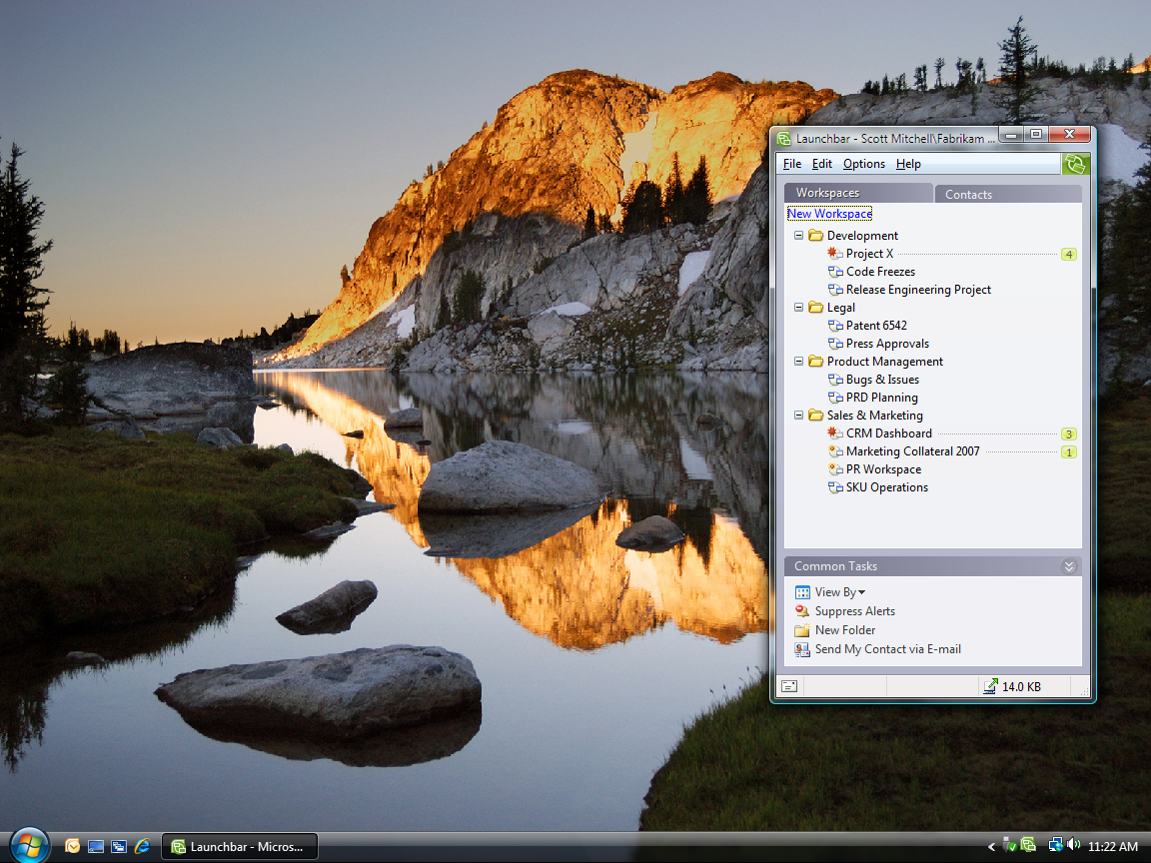
Quickly add new contacts, send invitations, and perform other common tasks here.

View and open existing workspaces here.

Figure 1: The Groove Launchbar

Create a Collaborative Workspace
In Office Groove 2007, a workspace is a virtual place where teams collaboratively share, modify, and discuss files; chat; hold threaded discussions; manage recurring project meetings; track tasks, opportunities, and issues; and more. Each workspace is an individual window that is opened and closed from the Launchbar as needed.
Any user who has Office Groove 2007 installed on his or her computer can create a workspace. Creating a workspace does not require any special privileges on the network or extensive IT support. In fact, the process is so simple, you can create and customize a Groove workspace for your team with just a few clicks of your mouse.
Office Groove 2007 includes three types of workspaces:
- A Standard workspace includes a Files tool and a Discussion tool. Additional tools can be added to a Standard workspace to meet changing project needs.
- A File Sharing workspace synchronizes a selected Microsoft Windows operating system file folder and its contents across team members’ computers. This type of workspace can be particularly useful for individual team members who want to keep files synchronized among their own computers. For more information, see the “Keep Yourself in Sync” section of this guide.
- A Template workspace enables you to choose from a list of precustomized options designed for a specific type of project need. You can connect to Microsoft Office Online and access additional Groove workspace templates tailored for particular business functions and markets. You can also create templates from your own workspaces for future use. For more information, see the “Customize Your Workspaces” section of this guide.

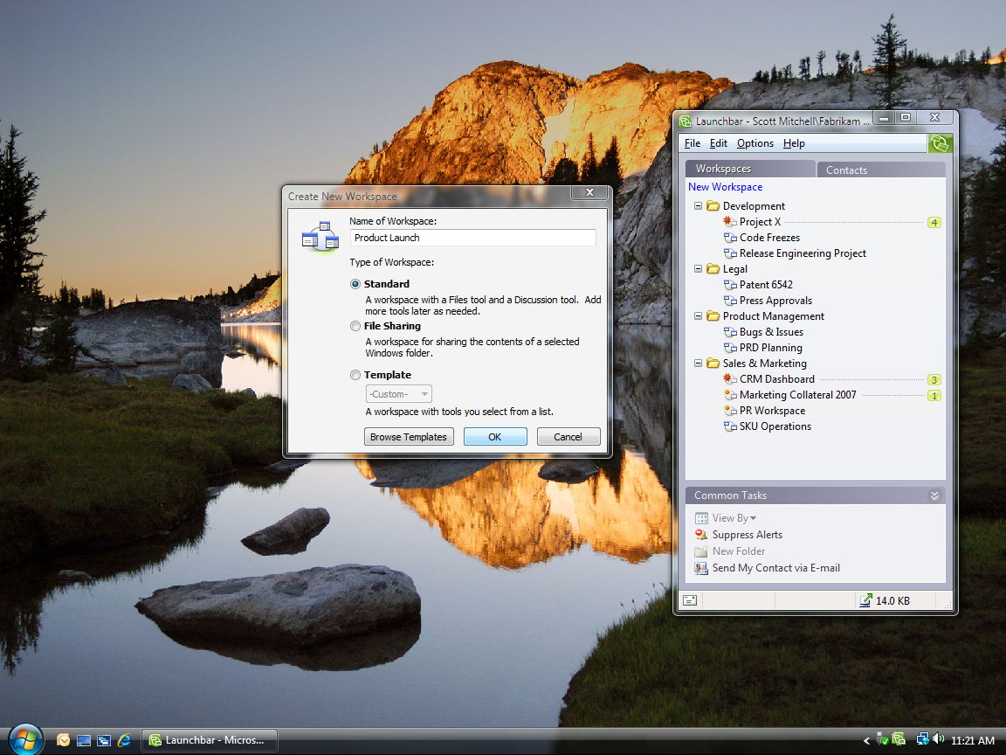
Figure 2: The Groove Create New Workspace wizard

Invite Team Members to Join Your Workspace
After you create a workspace, you send invitations to others to join that workspace. When you send an invitation, you can assign a role (Manager, Participant, or Guest) to the invitee to help control what he or she can and cannot do within the workspace. Roles and their associated permissions can be changed at any time during the project.
When invitees accept your invitation, they receive an exact copy of the workspace on their desktop, including all tools, files, and content. If you are not online when they accept, Groove sends the workspace to the new members’ computers the next time you connect; or, if there are other online workspace members, they get the workspace from them. After they are in the workspace, you can begin to work together. It is that simple.
The beauty of Office Groove 2007 is that you can invite anybody to join your workspace, even if they are not on the same network as you. You can share a workspace across offices with remote colleagues and across organizations with your partners, suppliers, and customers—all without servers or IT assistance.
The only requirement is that each member of the workspace has Office Groove 2007 installed on his or her computer. If the person you want to invite does not have Office Groove 2007 installed, you can send a workspace invitation in an e-mail message. E-mail invitations contain simple instructions on how to download a trial version of Office Groove 2007. After the person installs the trial version, he or she can then accept the workspace invitation.
Because Office Groove 2007 enables you to share information with people outside of your organization, it has powerful, always-on encryption to help ensure that all workspace data is protected on your computer and as it travels across unsecured wired or wireless networks. Only those whom you invite to the workspace can access the information it contains. There is no “master copy” on a server that can be compromised.
As another bonus, Office Groove 2007 supports 28 different languages, so when you are working with a global team, each team member can view Groove features and functions in their native language.
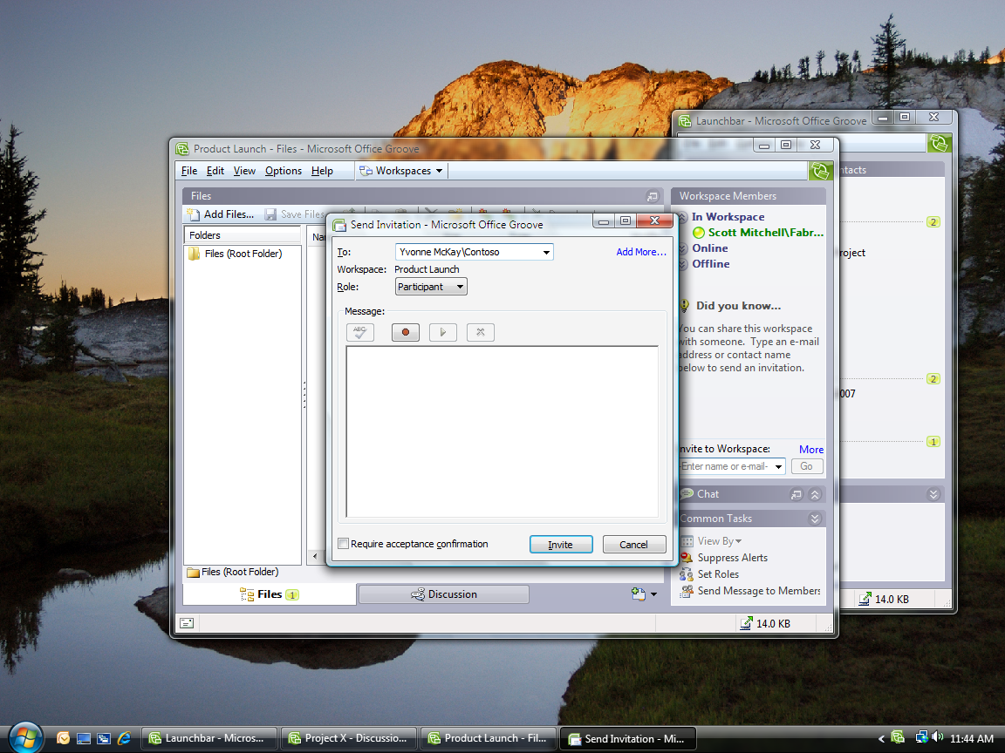
Select a role for the person here. The role determines what the person can and cannot do in the workspace.
Type the person’s contact information or e-mail address here.
Figure 3: Sending an invitation in Office Groove 2007
Office Groove 2007 in Action
Scott creates a Groove workspace for his team on his computer. In a matter of minutes, he sends invitations to join the workspace to key people from his internal, partner, and supplier teams. When they accept Scott’s invitation, each person receives a copy of the workspace, which is stored on each of their computers. Office Groove 2007 helps ensure that all members’ copies of the workspace stay in sync every step of the way.

Add Tools to Suit Your Team’s Evolving Needs
Office Groove 2007 is very flexible, so you can create a workspace tailored to the specific needs of each of your teams. You can customize the workspace at any time by adding or removing tools and data from it. Tools define the type of work your team does in the workspace. Though Office Groove 2007 includes more than 10 out-of-the-box workspace tools, the five tools discussed in this section are the most popular.

Files Tool
You can use the Files tool to work together collaboratively with your teammates on almost any type of computer file. The Files tool works similarly to Windows Explorer in that you can organize files into nested folders. One of the differences between Windows Explorer and the Groove Files tool, though, is that everybody in your workspace has access to those folders and files.
When you add a file to the Groove Files tool, any person you have invited to the workspace can open that file. Depending on the role they are assigned in the workspace, they can also make changes to it. When a person modifies a file and saves it back to the team workspace, the changes they have made—and only the changes—are automatically sent to the computers of every other member of the workspace. If another member happens to update the file at the same time, Groove creates two copies of the file for the users to resolve.

SharePoint Files Tool
The SharePoint Files tool offers all the capabilities of the Groove Files tool with the added benefit of integration with Windows SharePoint Services document libraries. Many teams and departments rely on SharePoint technologies to share and organize information and documents. With Office Groove 2007, you do not have to leave behind the tools that are already working for you. The SharePoint Files tool is tightly integrated with both Windows SharePoint Services 3.0 and Microsoft Office SharePoint Server 2007, so you and your team can synchronize SharePoint document libraries with your Groove workspace. You can easily check out documents from a SharePoint document library into your Groove workspace, share and revise those documents among your project team, and then publish them back to the document library when you are done.
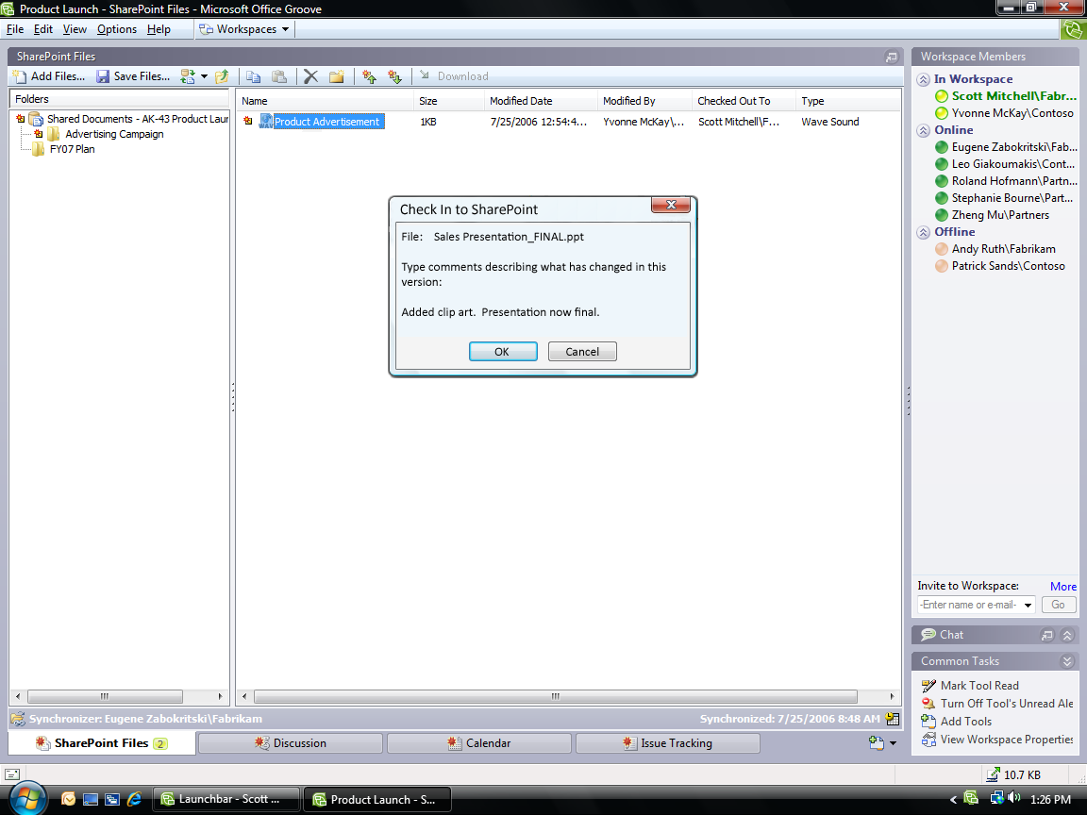
Figure 4: The Groove SharePoint Files tool
Office Groove 2007 in Action
In preparation for the launch of a new Fabrikam product, Scott is working closely with Jeff Hay, a market-research vendor. To ease the collaborative process, Scott sends Jeff an invitation to join the Groove workspace. Jeff uses the Groove Files tool to post a report of his research, which Scott can quickly access. Scott looks at the report, makes changes and adds comments, and saves the edited document back to the workspace. Scott’s changes are automatically sent to Jeff’s computer and synchronized with his copy of the workspace. After a few rounds of edits, Scott is ready to share the report with Fabrikam’s marketing team. He publishes the final report to the company’s SharePoint site as a resource for the team that is developing the new marketing strategy.

Discussion Tool
The Groove Discussion tool helps teams engage in a detailed exchange of ideas in context of the work they are doing in the workspace. The conversational thread is tracked in a chronological, topic/response structure. Anybody in the workspace can contribute to the discussion or review the entire thread. Roles determine who can delete discussion entries.
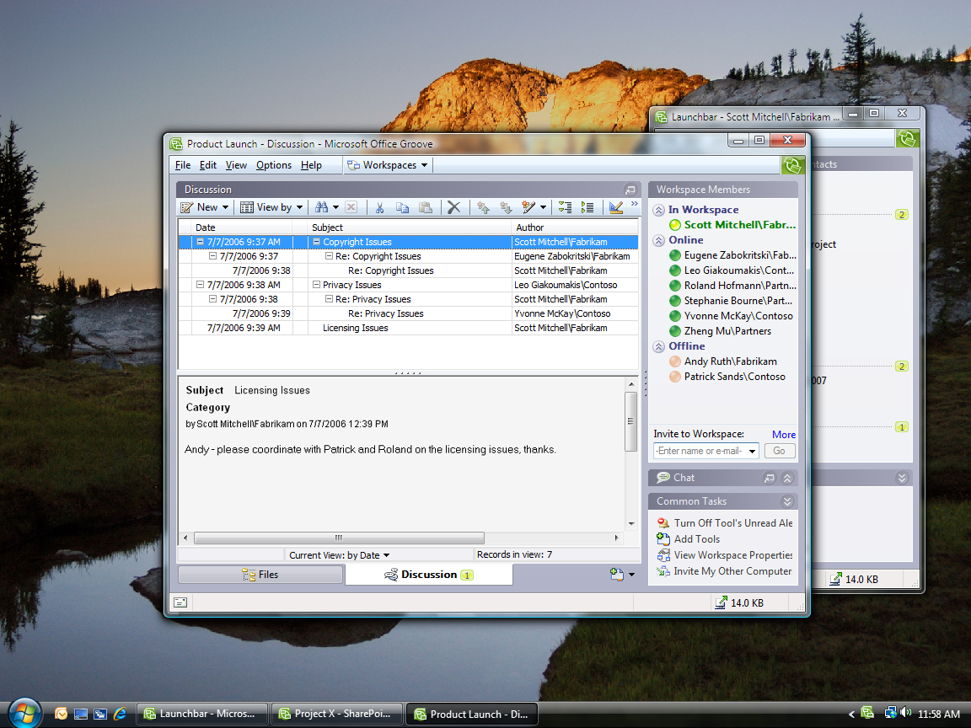
Figure 5: The Groove Discussion tool

Meetings Tool
Use the Groove Meetings tool to plan, conduct, and record recurring team project meetings. It is easy to set up a new meeting and select workspace participants using the Meetings Wizard. Because all workspace members can add information to a new meeting, agendas can be developed collaboratively rather than having one person collect input from the team. During the meeting, the minutes taker can insert the agenda into a note-taking space and record meeting minutes in real time. Participants can watch as the minutes are taken. After the meeting, action items can be recorded and assigned to team members. Agenda items, minutes, and action items from prior meetings can also be copied into future meetings.

Calendar Tool
You can use the Calendar tool to build a shared project schedule and track important project dates and milestones. When you add a Calendar event, everybody on your team can see it. Others can add their own events and edit existing events if they have the appropriate permissions.
Both the Meeting and Calendar tools help participants to focus solely on the tasks, events, and milestones of the project or activity for which the Groove workspace is created. Individual team members continue to manage and organize their own calendars, tasks, and contacts in the Microsoft Office Outlook® 2007 messaging and collaboration client or another personal information manager.
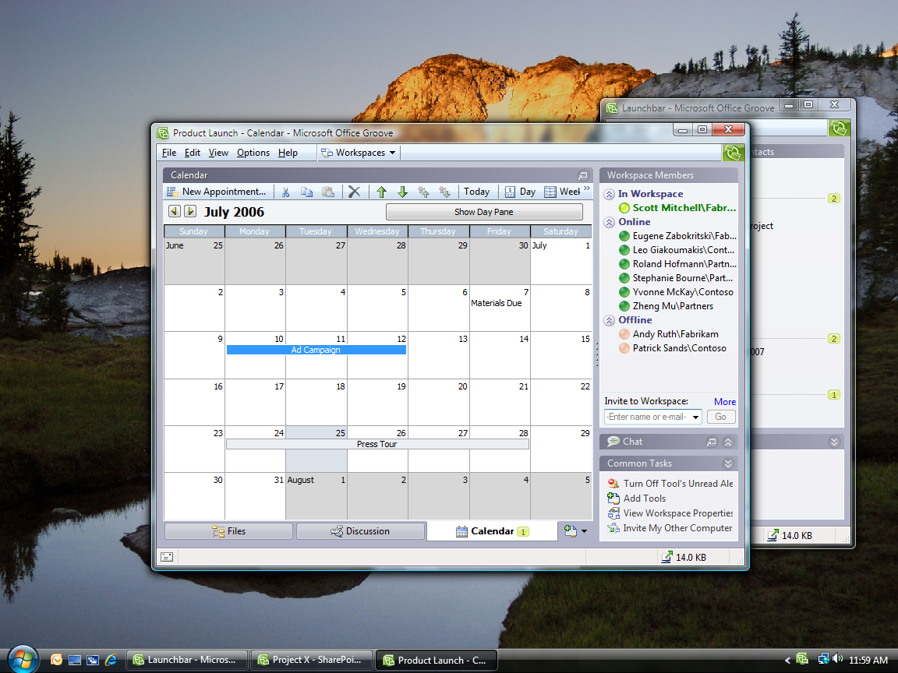
Figure 6: The Groove Calendar tool
Office Groove 2007 in Action
Initially, Scott’s team starts with a simple workspace consisting of a Files tool, which they use to share and collaborate on project plans, and a Discussion tool, which they use to exchange information about product changes and market supply that affect development. They quickly discover that it would be helpful to have a team activities calendar where they can share important project milestones. Scott goes to the workspace and adds a Calendar tool for his team.

Increase Impact by Staying in Sync
During the course of a team project that spans days, weeks, or months, the manual steps required just to share and revise files and coordinate activities among team members can consume hours or days of productivity—time that is taken away from content creation and improvement. When team members need to work offline, productivity is reduced even further. Slow connections and e-mail file size restrictions make it difficult to share and iterate files. Links to content stored on server-based file shares may not always work for partners or off-site employees. File versions proliferate. And perhaps worst of all, team members lack a shared context for all changes, input, and comments because they are spread across dozens of e-mail threads, file attachments, file shares, and Web sites.
By automating the synchronization of changes to ongoing work pertaining to each team project, rather than forcing each team member to send or upload their individual updates, Office Groove 2007 helps reduce the time spent keeping teams aligned. Because teams spend less time coordinating with each other, they have more time to spend improving the quality of deliverables. The next section gives more detail about how Groove synchronization works.

Keep Your Team in Sync
Office Groove 2007 has a unique decentralized architecture that helps streamline team collaboration. Every team member has an exact copy of the workspace, tools, and data on their computer. The automatic and efficient synchronization of Groove helps ensure that each person’s copy stays up to date—even if no two members are online at the same time.

Work Effortlessly Anywhere—Online or Offline
Office Groove 2007 stores workspaces and the data they contain right on your computer, not on a central server. You can access and update the information in your workspaces whether you are connected to the network or not. Each time you make a change—for example, update a file, respond to a discussion, or post some text in the workspace chat area—Office Groove 2007 sends your change (and only the change) automatically to all the members of your workspace. If you are not online when you make the change, Office Groove 2007 sends it when you next connect. If your team members are not connected, then they get the change the next time they connect.

Getting Used to Synchronization
Because Groove synchronization operates constantly in the background, it is best to run Office Groove 2007 while your computer is connected to your corporate network or the Internet, or to connect as often as possible. This helps ensure that you have the latest team changes, and that your team members have your most recent work. Just as you keep your e-mail up and running all day to monitor incoming messages, you should keep Groove open to monitor workspace activity and changes.
While synchronization saves you time, it takes a few moments to receive updates the first time you connect after being offline for a period of time. Startup synchronization time depends on several factors, including how many workspaces you have, how many team members are in each workspace, how many changes were made since you last connected, and the speed of your connection.
If you are working on a slow connection, or are frequently on the road, automatic synchronization of all workspace data may not always be practical. With Office Groove 2007, you have the power to decide the most productive setup for your work style.
Because files are among the largest types of data shared within a workspace, you can adjust the Download Settings in your Groove Files tools, SharePoint Files tools, and File Sharing workspaces. With Download Settings, you determine which files are automatically synchronized and which ones you want to download manually from your team members.
If you want to stop all incoming information, you can choose to work offline right from the Groove icon in the Windows taskbar. Alternatively, you can selectively decide which workspaces to synchronize or select Pause All in the Communications Manager feature in Office Groove 2007. Just remember to click Resume All and click the Work Offline feature when you regain a fast connection.

Keep Yourself in Sync
Many information workers use more than one computer (such as a home computer and a work computer) in their day-to-day work. It is just not efficient to spend your time e-mailing files to yourself or copying them to a disk each time you switch from one computer to another. In addition to helping teams stay in sync, Groove synchronization can also help you keep important files and workspaces up to date across the computers you use on a daily basis.
When you set up your Groove account for use on multiple computers, Office Groove 2007 automatically synchronizes the workspaces and files on each computer you use whenever you connect one of those devices to the Internet. Your computers do not have to be online at the same time to stay in sync.
Office Groove 2007 in Action
Scott finds that because of the difference in time zones, he often engages with his suppliers in China late in the evening after he leaves the office or early in the morning before he goes to work. On these occasions, Scott works from his home computer. Like his remote partners, Scott finds that it is a hassle to get access to the office network from his home computer, so he decides to set up a Groove account on multiple computers. When he sets up the account on his home computer, all of the workspaces Scott has stored on his computer at work are synchronized with his home computer. Now, thanks to the automatic synchronization capabilities of Office Groove 2007, Scott has easy access to his project information and files from whichever computer he is working on.

Monitor Team Activity and Communicate in Real Time
During the course of a project, teams often struggle to coordinate who is working on what, and when. A weekly status meeting is not always sufficient to address the minute-to-minute, hour-to-hour, and day-to-day changes that occur as team work progresses. Office Groove 2007 includes a number of features to help you and your team members monitor team activity—such as file updates—all the time, so you can spend less time coordinating and more time working. In addition, Office Groove 2007 provides a rich set of real-time communication features and tools to support both the spontaneous and deliberate team interactions that are so critical to project success.

Presence Awareness and Alerts
Office Groove 2007 includes built-in presence awareness and alerts, so you can figure out who is working on what, even if they are in another department, office, organization, or country.
Presence tells you which members are currently active in a workspace, which members are online but not actively working in a workspace, and which members are offline. Just by viewing your Launchbar or opening a specific workspace, you can scan your contacts’ presence and gain awareness of work activity without having to ask. In addition, if your team members are running Office Communicator 2007 or 2005, hovering over a contact reveals their current awareness state.
Alerts are pop-up text messages and audible sounds that proactively let you know when activity occurs in Groove. As you work, Groove may display or sound an alert:
- To notify you of any new information in a workspace.
- To notify you of new information in a particular workspace tool.
- To notify you of changes to a specific file folder or file.
- To notify you when contacts come online or enter workspaces.
- To notify you about new instant messages or invitations.
- To track the status of workspace invitations and messages you have sent or received.
Alerts that notify you of content changes are persistent and context sensitive. You can click them at any time, even if you are offline, and Office Groove 2007 takes you right to the workspace, tool, or folder that has new content.
You do not have to do anything to receive workspace alerts—Office Groove 2007 automatically determines the workspaces you use most and alerts you accordingly. But the real power of Groove alerts is that you can adjust them according to which contacts, workspaces, tools, and files are most important to you at any given time.
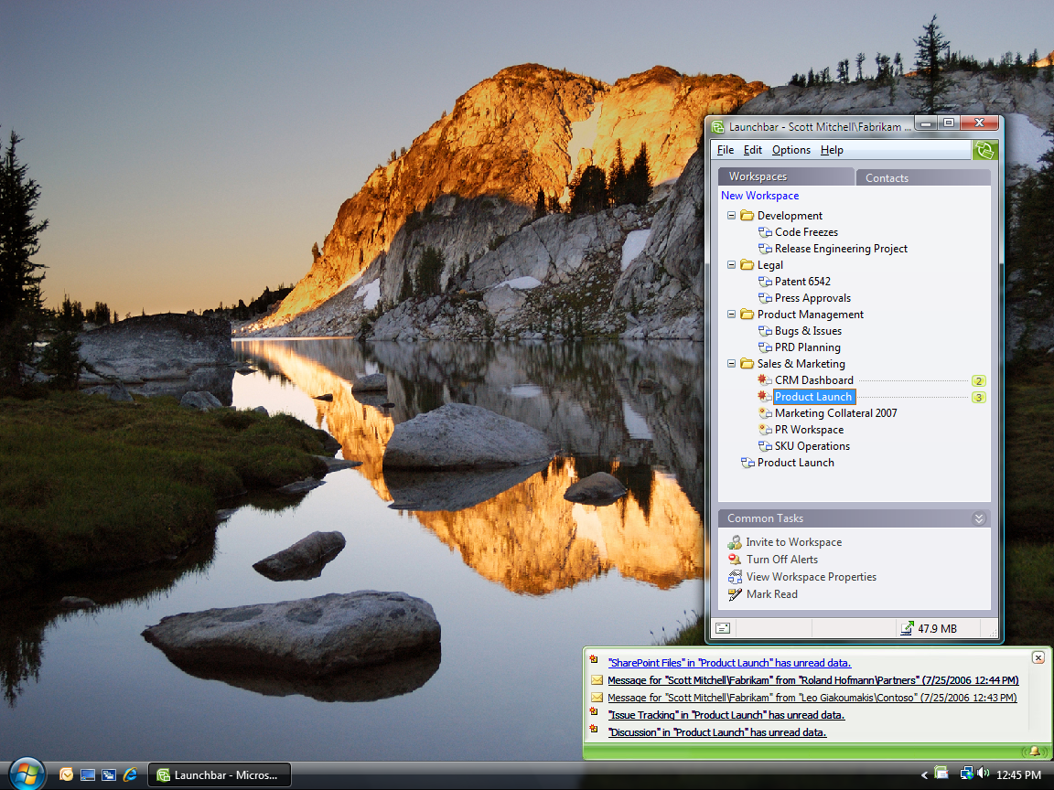
Figure 7: Groove text alerts pop up in the Windows taskbar

Unread Marks
While alerts notify you when changes are made inside your workspaces, unread marks help you find the specific content in a workspace that you have not yet seen. In your Launchbar, workspaces with unread content are marked with unread marks of varying levels of boldness, indicating how recently the changes were made.
Within workspaces, unread marks appear on the Tool tabs, as well as on the specific items that have new content, such as a file or discussion thread. As soon as you read the new content, the unread marks disappear. You can also manually remove all unread marks in a tool or workspace.

Real-Time Communication Tools
Everybody knows that frequent team communication is critical to the successful completion of most projects. Without that communication, important issues often go unaddressed, leading to a delay in delivery, or, worse yet, a misunderstanding about the final project deliverable. Yet teams in the new world of work often do not have the benefit of those spontaneous hallway conversations where so much valuable information can be exchanged.
Office Groove 2007 provides teams with integrated real-time communication tools to facilitate both deliberate and impromptu information exchange. Groove communications are embedded in the work, so everybody on the team understands the context for the communication. Office Groove 2007 supports multiple modes of communication to help your team make better, more-informed decisions and shorten overall project cycles.

Messaging
Office Groove 2007 includes a basic messaging capability that enables users to send simple text or voice messages to one or more contacts. Groove messaging is typically used for communications that may not be relevant to the team as a whole. You can send a message to a team member from the Launchbar or right from a workspace. Links to workspace content can be embedded in the text of messages, helping draw the message recipient’s attention to a particular work item. Messages are delivered in real time to recipients who are online, but can also be sent to offline users who receive the messages when they next connect. New messages appear in your system tray with your other Groove alerts.

Workspace Chat
Workspace Chat in Office Groove 2007 helps team members to communicate in real time in the context of a particular workspace. Workspace presence awareness helps you figure out the right time to engage a team member, and Workspace Chat enables you to do so. You can communicate in Workspace Chat using text or voice, depending on your needs. Voice messages are sent only to members who are actively working in the workspace. Text chats, on the other hand, are sent to all members, who receive a flashing alert indicating that someone is attempting to communicate with them. Clicking the alert brings them into the chat with you.
Office Groove 2007 in Action
Each morning when Scott goes into the office, he checks all his Groove alerts to see who has been in the workspace in the past 10 hours and what they have changed. He notices that Carol, one of the engineers from Fabrikam, has updated a product specification document. Scott opens the product spec from Groove, and, when he does, Carol receives an alert that Scott has entered the workspace. She clicks the alert, which takes her into the workspace with Scott. Carol then sends Scott a message through Workspace Chat with some questions about the product specification. Together, they engage in some impromptu problem-solving, which leads to a faster turnaround in finalizing the new product design.

Office Communicator Integration
While Groove messaging and Workspace Chat are sufficient for basic communication needs in Office Groove 2007, you can also take advantage of the powerful and robust real-time communications capabilities of Office Communicator directly from Groove. When you are running Office Groove 2007 and Office Communicator 2007 or 2005, you can view the awareness states (online, busy, or away, for example) of your Office Communicator contacts directly from the Groove Launchbar or a Groove workspace. When a contact is free, you can right-click to initiate an Office Communicator real-time chat or phone call with that contact directly from the Groove interface.
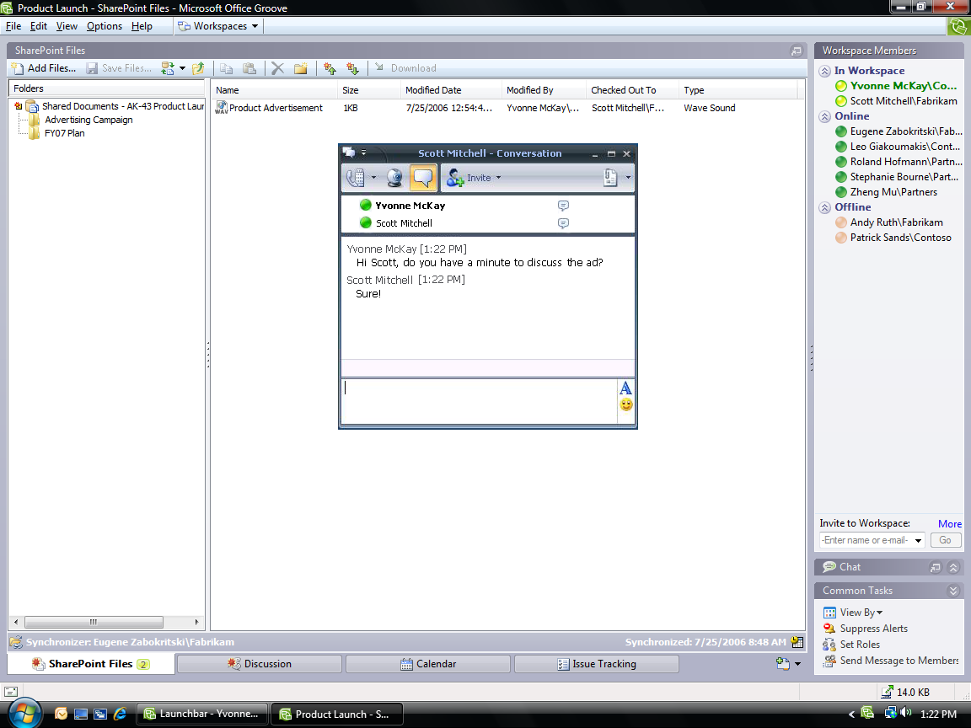

Figure 8: Launching an Office Communicator conversation from a Groove workspace

Customize Your Workspaces
From its inception, Office Groove 2007 was designed to help people quickly and effectively work together. For some teams, that just means having a workspace where they can share files or engage in team discussions. Other teams, however, may require tools that are customized to support a specific business process or project activity. Power users can use the Groove Forms tool and Groove InfoPath Forms tool to build custom workspace forms that meet their unique needs.

Build Custom Forms
The Groove Forms tool brings your structured data and business processes right into the Groove workspace environment. Your team can build custom forms to enter and update data, get detailed information about the status of work items, and represent simple workflows. A development team may want to create a Groove form to track incidents or bugs, for example, while a sales team might create a Groove form to share information about customers, prospects, and sales calls.
You can build custom forms directly in the Groove interface using the Office Groove 2007 Forms Designer. The Forms Designer is a rich and flexible environment that enables any workspace member with the necessary permissions to contribute to the design of the application. As with most Web page design tools, you can use the Forms Designer to create and make changes to a form and then preview it before you publish your changes to the workspace.

Import an InfoPath Form
Office Groove 2007 also includes an option for you to import forms that you build with Office InfoPath 2007. Office InfoPath 2007 provides an intuitive development environment with all the components you need to build a new form or modify an existing one. After you have built your form in Office InfoPath 2007, you import the form into the workspace using the Groove InfoPath Forms tool.
Office Groove 2007 in Action
Fabrikam has an internal system for tracking issues and incidents related to products that are in production. But for new products, it is often helpful for the product managers, engineers, and designers to track issues that arise as they collaborate on a product’s development. For these purposes, Fabrikam’s IT department created a basic Issue Tracking form using Office InfoPath 2007. Scott imports the Issue Tracking form into his Groove workspace so that he, his suppliers, and the designers can track issues as they develop the new product. After they are finished, they can export the issues they collected in the Groove workspace into Fabrikam’s internal system for the benefit of others.

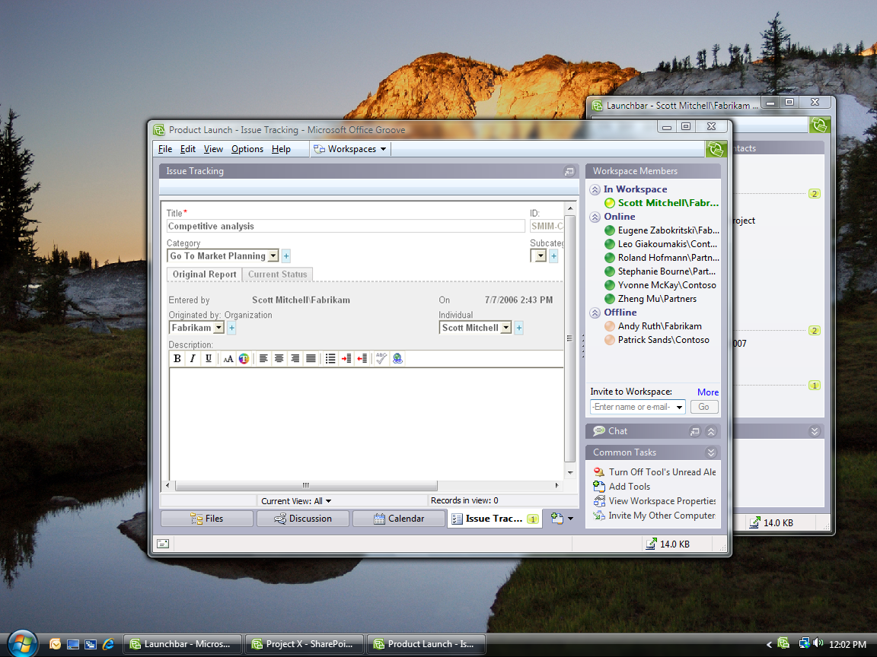
Figure 9: An Issue Tracking form in a Groove workspace

Create Templates for Future Use
Most teams complete similar projects over time—launching a new product, coordinating an event, or managing a new business engagement, for example. Using a workspace that has been preconfigured for these projects is often helpful. After you have created a workspace for a specific project, you can save it—or any custom tools within it—as a template for future use. Your tool templates automatically appear in the Groove Add Tool list, while your workspace templates appear in the Template list in the Create New Workspace wizard.

Summary
In today’s increasingly global and mobile work environment, teams that span offices, locations, organizations, and time zones need tools that help them work together dynamically and effectively—wherever they are in the world.
Microsoft Office Groove 2007 is a collaboration software program designed specifically to enable teams in this new environment to work together toward their goals and deliverables. Teams using Office Groove 2007 share collaborative workspaces that place all team members, tools, and information in one convenient location accessible from each member’s computer. While you may not be able to pop into your coworker’s office to hand her a document and chat about your project, Office Groove 2007 makes it possible for you to share the same valuable information and collaborate in that same spontaneous manner.

Resources
For more information about Office Groove 2007, please visit:
http://www.microsoft.com/office/groove

System Requirements
For complete system requirements, visit http://www.microsoft.com/office/groove.

This document is developed prior to the product’s release to manufacturing, and as such, we cannot guarantee that all details included herein will be exactly as what is found in the shipping product. The information contained in this document represents the current view of Microsoft Corporation on the issues discussed as of the date of publication. Because Microsoft must respond to changing market conditions, this document should not be interpreted to be a commitment on the part of Microsoft, and Microsoft cannot guarantee the accuracy of any information presented after the date of publication. The information represents the product at the time this document was printed and should be used for planning purposes only. Information is subject to change at any time without prior notice.

This document is for informational purposes only. MICROSOFT MAKES NO WARRANTIES, EXPRESS OR IMPLIED, IN THIS DOCUMENT.

© 2006 Microsoft Corporation. All rights reserved.

Microsoft, Groove, InfoPath, the Office logo, Outlook, SharePoint, and Windows are either registered trademarks or trademarks of Microsoft Corporation in the United States and/or other countries. All other trademarks are property of their respective owners.

