Microsoft Office Project Server 2007

**Microsoft® Office Project Server 2007 enables organizations to better manage projects and resources, collaborate across the entire enterprise, and effectively analyze and report on both projects and programs. Office Project Server 2007 is accessed via its clients, Microsoft Office Project Professional 2007 and Microsoft Office Project Web Access. Its extensible architecture also enables organizations to integrate Office Project Server 2007 with existing software. A bidirectional gateway integrates Office Project Server 2007 with Microsoft Office Project Portfolio Server 2007 to form the Microsoft Office Enterprise Project Management (EPM) Solution.**

Gain Visibility and Insight

Align all work with your strategic objectives.

Track the entire project life cycle. Office Project Web Access now includes Proposals that enable project initiation on the Web, so you can use the analytics in Office Project Server 2007 to track potential projects. Proposals help you anticipate needs with Resource Plans. You can also track operations work that follows the completion of a project with Activity Plans in Office Project Web Access.

Analyze and report. In addition to predefined reports and filter views, users can access the Cube Building Service with a flexible user interface to build portfolio analyzer cubes for reports with multiple data options and deep insight. This uses the Reporting Data Service, which transforms Project data into a format suitable for end-user reporting and Microsoft SQL Server™ Analysis Services cube building.

Test what-if scenarios. See the impact of potential changes to your project schedule with Visual Change Highlights and Task Drivers. Test and reverse various scenarios in a security-enhanced environment with Multiple Level Undo.

Control project finances. Assign a budget to projects and programs. You can define a budget at a high level in order to allocate funds and track costs against the budget.

Assign costs to tasks. With the new “Cost” resource type, you can assign multiple arbitrary costs (that is, not based on work time) to a task. Also, new fields for cost information enable better project accounting.

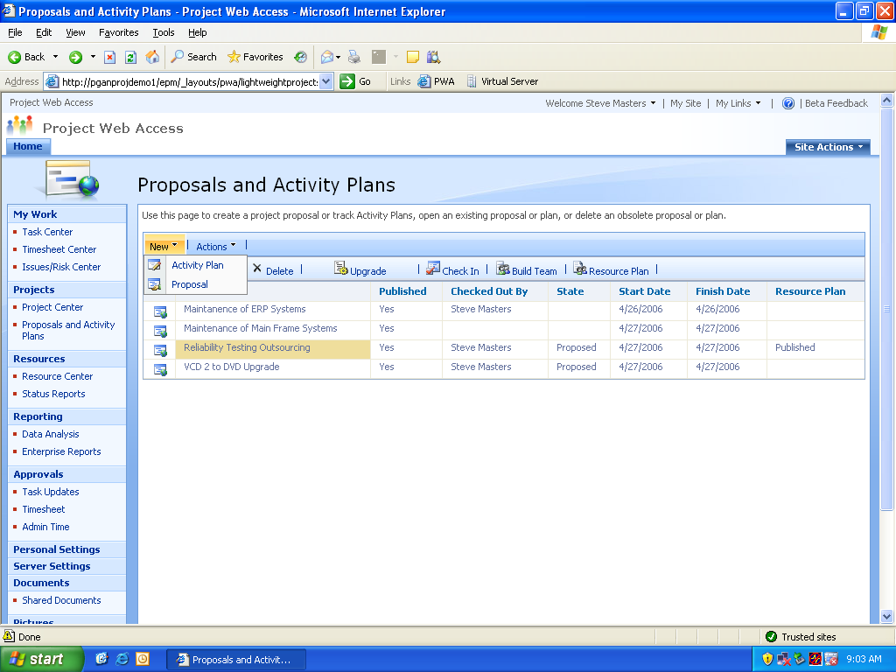

Initiate Proposals to track work prior to project approval.

Easy to Get Started

Enable fast and broad adoption.

Save time. Office Project 2007 provides various templates to help speed the project management process. A Project template can capture task and resource information, formatting, macros, and other project-specific settings. Get started quickly with the Project Guide Wizard, an interactive planning aid to help you master project management.

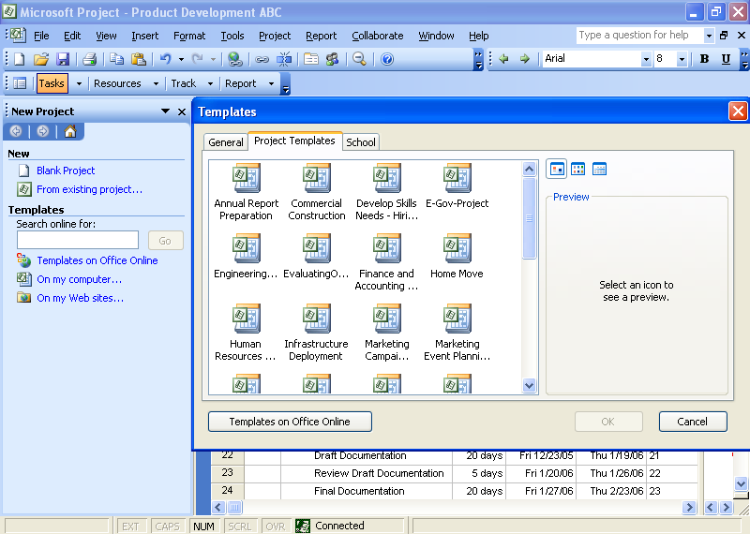

*Project templates help you capture best practices and enable consistency.*

Use existing investments. Access Project data in familiar desktop applications. Integration with Microsoft Office Outlook® 2007 enables team members to view and report progress on tasks from their calendar. This enables users to provide project managers with timely updates to promote accurate reporting. Project also provides integration for reporting in other Microsoft Office programs such as Microsoft Office Word, Microsoft Office Excel®, Microsoft Office Visio®, and Microsoft Office PowerPoint®.

Access project information using the Web. Partners, executives, and team members can access functions and interact with role-specific project data simply by using their browser to open Office Project Web Access or the project workspace, which exposes shared Project information.

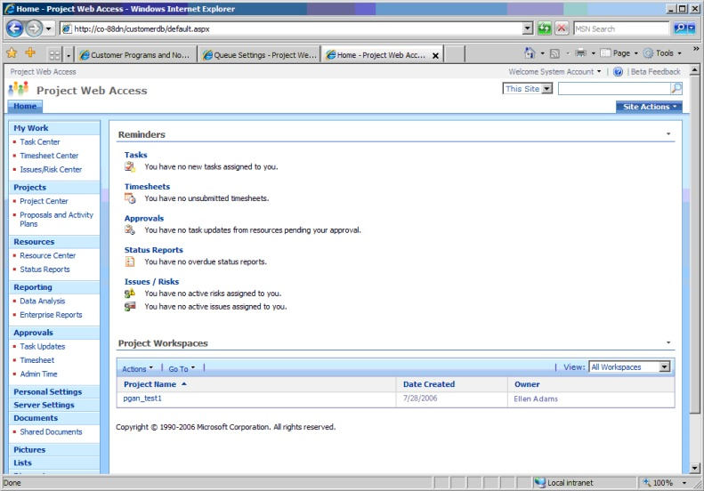

Office Project Web Access enables partners, executives, and team members to view and interact with role-specific project data.

Enterprise Ready

Scale to support distributed organizations.

Improve performance. The Active Cache provides extensive data on demand for quick open, save, publish, and other client/server communications for geographically distributed teams. This also enables offline use. Get exceptional resiliency and use of server resources with the Queuing Service, which queues work requests pending server availability.

Manage the simple and complex. For a simple project you can use Microsoft Windows® SharePoint® Services to create Project Task Lists that you can later import to Office Project Web Access. You can also now manage interrelated, large-scale projects as Programs. To better display the cross-project dependencies within a Program, Deliverables enable you to create a SharePoint list of committed task dates to which other project managers can link their projects or tasks.

Manage resources. Track resource use and skill levels. With Team Resources, you can assign work to an entire team rather than an individual resource. The Assignment Owner feature enables individuals other than the assigned resource to provide status updates on an assignment.

Use enhanced timesheet capabilities. Timesheets extend well beyond the basics to serve as input for financial systems and analyzing progress. Easily know which resources are available and which ones are working, enabling you to schedule work effectively.

Enhance knowledge sharing. Centrally manage and track project-related information through Office Project Server 2007 and Windows SharePoint Services working together. Centralized document, risk, and issues management helps users collaborate to improve the quality of project deliverables.

Extensible and Programmable

Easily integrate and automate your processes.

* **Customize and manage your solution.** The new API, Project Server Interface, enables you to access and extend the functionality of Office Project 2007 while leveraging your skills with the .NET Framework. You can use the new Server-Side Scheduling feature to build a custom Web UI without having to process schedule changes using Office Project Professional 2007. Additionally, you can flexibly format the Office Project Web Access interface with all of the tools in Windows SharePoint Services 3.0.
* **Extend functionality.** Incorporate business processes into projects with the Windows Workflow Foundation. Trigger the processes with events raised by Office Project Server 2007 with the Event Handler in Office Project Web Access.
* **Manage the EPM Solution.** Security and other management functions are consolidated on a single, refactored interface in Office Project Web Access called Server Settings. This not only helps saves time but helps reduce the learning curve for administrators.

**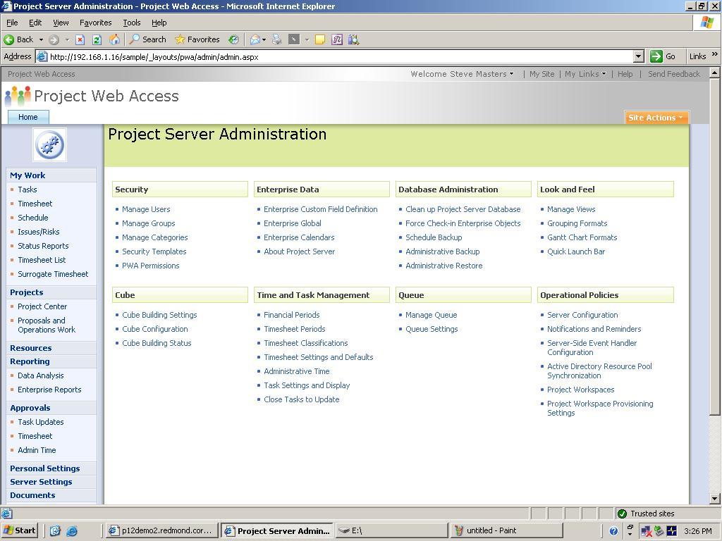**

*The improved administrator interface provides better control and more configuration options.*

For More Information

To learn more about Office Project Server 2007 and the Microsoft Office system, visit <www.microsoft.com/office/projectserver>.

For complete system requirements, visit [www.microsoft.com/office/projectserver](http://www.microsoft.com/office/projectserver).

This document is for informational purposes only. MICROSOFT MAKES NO WARRANTIES, EXPRESS OR IMPLIED, IN THIS SUMMARY.

The example companies, organizations, products, domain names, e-mail addresses, logos, people, places, and events depicted herein are fictitious. No association with any real company, organization, product, domain name, e-mail address, logo, person, place, or event is intended or should be inferred.

MSlogo_k_1118© 2006 Microsoft Corporation. All rights reserved. Microsoft, Excel, Internet Explorer, MSN, the Office logo, Outlook, PowerPoint, SharePoint, Visio, and Windows are either registered trademarks or trademarks of Microsoft Corporation in the United States and/or other countries. All other trademarks are property of their respective owners.