Information Protection

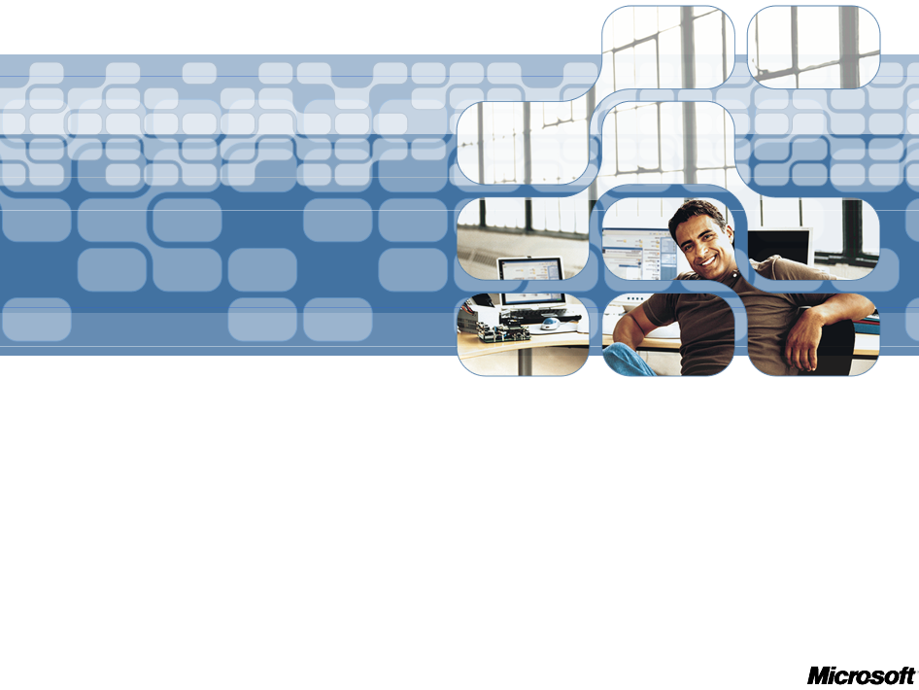
December 2005

Contents
Introduction 3

Information Protection Challenges 4
Information at Rest: The Importance of Secure Data Storage 4
Documents on Servers, Removable Storage, and Mobile Devices: 5
Documents on the Network: Safe Information Usage, Enterprise-wide 5
Information Distribution Outside the Firewall 6
Regulatory Compliance 6
Industry-Specific Compliance Challenges 7

Technologies Supporting Information Protection 8
Rights Management Services: Controlling Distribution of Sensitive Info 8
Encrypting File System 9
BitLocker Drive Encryption: Data Protection for an Entire Disk Volume 10

Summary 13
Next Steps 13
Additional Resources 13

Introduction
In today’s information age, application and system data are abundant in any organization, and are subject to a long list of threats from an increasing number of attacks. Loss of confidential information, customer records, and intellectual property can be damaging to the reputation and long term survival of an organization—resulting in lost revenue, weakened competitive advantage, and reduction in customer confidence. According to a recent report by analyst firm Jupiter Research, the unintentional forwarding of e-mails and loss of mobile devices are the most frequently cited security breaches in an enterprise, second only to virus infections.
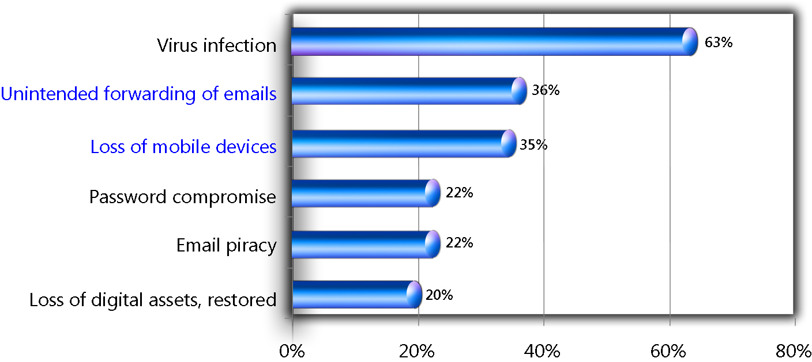
Figure 1: Top Sources of Security Breaches

Although organizations such as financial institutions, government agencies, healthcare organizations, and professional services firms address a variety of security threats, their strategies usually focus on restriction of access to servers and desktops. To augment traditional security technologies such as firewalls and antivirus software, organizations need to be proactive in protecting the information stored on computers while they are offline; secure files and folders; and enforce and manage specific document access rights inside and outside the firewall.
This white paper is intended for business and technical decision makers. It provides an overview of the challenges and solutions of protecting information, and addresses how Microsoft technologies can help enterprises establish a secure information system.

Information Protection Challenges
From a technology perspective, IT administrators need a way to ensure the confidentiality, integrity, and non-repudiation of information during distribution, and a means to enforce policies governing who can receive sensitive information, how it can be used, and when its use expires.
Information protection challenges typically follow the information use lifecycle: creation, storage, distribution, and usage. With the exponential growth of mobile users, PDAs, and laptops, critical corporate information needs to be protected on each of these form factors. Hard-drive data must be protected from attackers in case the drive is lost or stolen, and information in e-mail messages, on the Web, and on intranets must be secured.
From a business perspective, intellectual property and information comprise the vast majority of an enterprise’s value. The United States Department of Justice estimates that intellectual property (IP) theft cost enterprises $250 billion in 2004. Protecting that information, without hindering the productivity of a company’s employees, is paramount.
Generally, information protection challenges fall into four categories. Ideally, an enterprise will have the security infrastructure in place to protect information in each of the four:
- Information at rest
- Documents on laptops and mobile devices
- Documents on the network
- Information collaboration

Information at Rest: the Importance of Secure Data Storage
Offline information theft is a substantial threat that is often overlooked by many computer users. Although most people may think someone physically tampering with their computer is unlikely, a large percentage of IP theft occurs when computers are offline. In addition, the damage that is typically done in this type of attack is extensive, because attackers can gain access to an entire hard drive. According to a 2005 CSI/FBI report, the amount of financial damage caused by unauthorized access to sensitive information has risen 600 percent in the last year, with more than 30 percent of companies reporting known losses.
A relatively easy way to steal Intellectual Property (IP) or sensitive information on a computer without the user’s password is to attack when the computer is offline. An attacker can simply remove the cover on a computer, disconnect the hard drive, reconnect it to their laptop, and browse the hard drive without needing access privileges.
A second scenario where information—customer information in particular—is at risk is on decommissioned or disabled hard drives. Deleting information from a drive using the recycle bin can make it disappear from the files and folders view, but the information is actually still on the drive.
To help protect information at rest, Microsoft is investing substantial time and resources into its Trustworthy Computing Initiative, which utilizes a broad spectrum of integrated hardware and software technologies to secure computers. For example, Windows® BitLocker™ Drive Encryption encrypts an entire hard drive and ensures that it is protected even when disconnected from the computer; Code Integrity helps ensure that computers have not been tampered with while offline.

Documents on Servers, Removable Storage, and Mobile Devices:
Ensuring Mobile Information Storage
In today’s increasingly mobile workforce, laptops, removable storage devices (for example, USB drives), and mobile devices are a major potential information-loss liability. Not only does a lost laptop cripple a user’s productivity, but it also can cause a loss of intellectual property, trade secrets, and customer information. According to the FBI’s 2005 Computer Crime and Security Survey, nearly 50 percent of companies reported laptop or mobile device theft. A report by Anderson consulting estimates the direct cost (not counting IP and information) of each lost laptop is $90,000 per incident—and at many enterprises more than a hundred are lost per year.
Laptops also offer a pathway for attackers who want to gain access to a corporation’s network through an approved device. In fact a large market exists for stolen laptops, because of the demand for customer information and other sensitive materials by attackers. According to Safeware Computer Insurance company, more than 600,000 laptop thefts occurred in 2004, totaling an estimated $720 million in losses. A company convention, event, or industry conference offers an easy target for attackers, who can simply remove the hard drive on a laptop and browse it with another computer.
To alleviate the threat of mobile device loss, enterprises should lock down laptops and all of the files on them using an encryption program and secure computer configurations. To assist in this process, Microsoft has developed BitLocker Drive Encryption, a component of Microsoft® Windows Vista™. BitLocker Drive Encryption will protect data on hard drives from offline and registry-based attacks, with protection that extends to the hardware level—to prevent data in mobile devices from being accessed even if the hard drive is removed.

For remote users connecting to shared networks with Microsoft Windows® XP or older, Microsoft also offers Encrypting File System (EFS) to encrypt sensitive information on a computer, USB drive, or shared network resource at the folder or file level—preventing even internal employees from accessing a protected file. Companies can also ensure that data that does fall into the wrong hands is protected using Rights Management Services (RMS). RMS will prevent unauthorized users from viewing content on lost or stolen laptops, by restricting read, copy, and print rights for files. In addition, it can set rights to expire at a specified date for time-sensitive content, and also recertify rights every time a user opens a document—a useful feature for the high-sensitivity documents.

Documents on the Network: Safe Information Usage, Enterprise-wide
Internal documents must not only be protected on end-user computers, but also on corporate networks. According to a 2005 CSI/FBI report, 56 percent of damage due to security breaches is from internal attacks—employees, contractors, etc. Network files are also particularly vulnerable to attackers who are able to circumvent a firewall and from malware that finds its way onto the network.
In order to safeguard information on the network, enterprises need to install encryption software which will seamlessly secure information, and a system for controlling access only to individuals authorized by the document authors, corporate policy, or group within the directory. As mentioned in the previous segment of this white paper, Microsoft Encrypting File System (EFS) is an excellent technology for automating the encryption process by encrypting information at the folder or file level.
In addition, RMS protects documents regardless of their location—whether it’s a laptop, USB drive, network folder, shared site, or Web site. Collaboration software such as Microsoft SharePoint® Products and Technologies offers a secure, user friendly means to store sensitive information on a shared server. Lastly, role-based access control such as Microsoft Authorization Manager helps to automate access for specific job roles and groups, thereby eliminating the administrative headache of configuring and updating access for individual users or documents.

Information Distribution: Securing E-mail and Information Outside the Firewall
With the increasing numbers of remote workers, global offices, and partners, it is no longer adequate to rely on a firewall and secure information storage practices to safeguard information. E-mail, shared remote servers, intranets, and Internet sites are all efficient mechanisms for sharing information, collaborating, and connecting a global workforce.
Unfortunately, it is very difficult to control information usage after it leaves a corporate network. Although information workers may know the business value of their information, they typically are not familiar with the tools that can protect it. According to a survey by the American Society for Information Security, the average Fortune 1000 company reported loss of confidential or proprietary information more than twice a year, with the average loss costing the company more than $500,000. Recent articles in the financial services sector and a constant catalog of entries at www.internalmemos.com are striking examples of this problem.
Access control lists, which are currently being used by enterprises to secure access to corporate information and resources, are not only time-intensive to manage and maintain, but they also do not provide protection for files that leave the corporate firewall—they cannot enforce information use policies for those who have access to a file.
In addition to controlling information usage, compatibility of encryption solutions can be a problem when using proprietary software. There are many different types of encryption software outside of a company (and even within heterogeneous networks), making it difficult for users to anticipate whether a trusted customer or partner will be able to open a file.
In answer to this challenge, Microsoft has developed Rights Management Services (RMS), which provides a user-friendly, configurable means for companies and individuals to control information usage when distributing information—regardless of the platform or software structure of those receiving the information.
For example, authors of sensitive content do not always know if all of the recipients of their content have RMS. Using RMS, authors have the confidence of knowing that their information will be protected regardless of the information protection software on their computer—RMS protection travels with the file wherever it goes.

Regulatory Compliance
In addition to the technology-based challenges outlined in preceding sections, regulatory challenges have established a new, separate set of challenges to enterprises that relate to information protection. These require a coordinated business and operational strategy that must include a combination of people, process, and technology, and the cooperation of users throughout the enterprise. Violating these regulations can result in financial damage, business interruption, and PR nightmares to any company. What makes them particularly troublesome is that new regulations, and legal interpretations of existing ones, are constantly evolving.
Although information protection is not a panacea for compliance, it helps solve a specific set of regulatory requirements that relate to the safekeeping and use of personal information. Relevant regulations include:
The Gramm-Leach-Bliley Act requires companies to prevent unauthorized access of personal information.
The California Security Breach Information Act (SB 1386) states that companies must alert customers whenever “unencrypted personal information was, or is reasonably believed to have been, acquired by an unauthorized person.”
The Sarbanes-Oxley Act (SOX) makes corporate executives explicitly responsible for establishing, evaluating, and monitoring the effectiveness of internal controls over financial reporting. Although electronic spreadsheets are the most broadly used financial application today, password protection and file-level access controls in these programs do not satisfy SOX requirements. The act requires user authorization, protection of sensitive information from unauthorized access or modification during transmission or storage, and monitoring of user actions.
International Regulations: Many other countries within the European Union (EU) and beyond—from Ireland to Israel to Japan—have a Data Protection Act or similar laws in place. In general, these laws provide the full protection of personal information that has been recorded in data files, registers, banks, or other technical means of treatment.
For example, in May 2003, the Japanese Parliament (the Diet) passed the Japanese Personal Information Protection Act (JPIPA), in addition to several laws that require higher standards of care for companies that handle personal information in the medical, financial, or telecommunications industry. The (JPIPA) applies to both government and private entities, and specifically states that companies that handle personal information must, “ensure that personal data are kept secure from loss and unauthorized access and disclosure.”
Although each government regulation concerning document retention and privacy issues serves a specific need, all are united by a common thread: the need to archive document records safely and protect personal information from unauthorized access.
To ensure compliance, enterprises should consciously deploy business processes that reinforce standards set by regulations, and ensure the enforcement of policies relating to the use of sensitive information. At the infrastructure level, the most effective way to help enable this level of protection is to wrap sensitive content with security that prevents the information from being viewed, even if the information is unintentionally distributed beyond company walls and to unauthorized recipients.
Corporate Information Protection strategies should be developed with these standards in mind.

Industry-Specific Compliance Challenges
In addition to the regulations listed in the preceding section, there are many regulations specific to individual industries such as healthcare, financial services, and manufacturing:
Financial Services: In the case of mergers and acquisitions, banks must ensure that the internal mergers and acquisitions deal teams keep paperwork and related information separate from each other. Best practices and regulations such as NASD 2711 stipulate that investment banking be run separately from research and trading to ensure trust in the public markets. New technologies that improve communications, such as e-mail, can serve as a conduit of improper communication.
Manufacturing: Manufacturing firms often spend hundreds of millions of dollars over the course of a couple decades developing a product. In that time, many employees, partners, and contractors may have access to that information. If product designs, formulae, or intellectual property leak outside the company, the firm can suffer extreme financial hardship.
Healthcare: A substantial challenge in the healthcare business is privacy. Regulations like HIPAA mandate that personal health information be protected to ensure patient privacy, but information often exists in many locations and must be shared by people in a variety of roles. HIPAA requires companies to prevent unauthorized access of personal health information (PHI).
Government: RFP Process—governments put a lot of their work out to bid via RFP with some contracts valued in billions of dollars. The process is sensitive and requires that bids received be protected carefully and not shared with other participants either overtly or by accident.

Technologies Supporting Information Protection

The best way to provide information protection for desktops, laptops, e-mail, networks, and offline computers is to deploy technologies that will enable security in each of these scenarios—without inconveniencing users or requiring excessive administrative oversight. The most effective information protection solutions are those that take advantage of existing cryptographic, directory services, and communications infrastructure, adding protection without adding impediments for users.

The following section of this white paper provides an overview of Microsoft technologies that help provide enterprise-grade information protection, while building on top of existing systems to reduce complexity and total cost of ownership. This overview will discuss the primary benefits of each technology in relation to the challenges outlined previously in this white paper, and differentiate between the functionality each product provides. Further information is available in the Resources section.

Rights Management Services: Controlling Distribution of Sensitive Information
One of the biggest challenges to securing information is the control, sharing, and distribution of sensitive information. Accidental or intentional information leaks can occur when information is forwarded to an unauthorized recipient. After information leaves a company’s firewall, it is difficult to track or secure. In addition, with increasing globalization and cooperation between companies, the need for information sharing outside a company has become a business requirement.
Microsoft Windows Rights Management Services (RMS) is an information protection technology that works with RMS-enabled applications to help safeguard digital information from unauthorized use—both online and offline—inside and outside of the firewall. RMS combines proven security technologies—including encryption, certificates, and authorization—to help organizations create reliable information protection solutions.
Rights Management Services is a client-server technology that includes the server technology that handles certificates and licensing, a desktop client, and a Software Development Kit (SDK). Combining Microsoft Windows Server™ 2003 features such as authentication, developer tools, and industry security technologies—including encryption, Policy templates and certificates—RMS helps organizations create reliable information protection solutions. Primary benefits include:

- Safeguard sensitive information: With RMS, information workers can define exactly how the recipient can use information, such as who can open, modify, print, forward, and take other actions. Organizations can create custom usage policy templates such as “Confidential - Read Only” that can be applied directly to information, such as financial reports, product specifications, customer data, and e-mail messages. Authors can also set expiration dates so that time-sensitive content, such as a monthly sales price list, can no longer be accessed when it is out of date. In Windows Longhorn, RMS will support a number of new features, including smart card authentication, encryption, and ad hoc collaboration.

- Persistent protection: RMS augments an organization’s security strategy by providing policy enforcement, centralized management, and protection of information through persistent usage policies that remain with the information, no matter where it goes. For example, encrypted content stored on a lost USB drive will not be accessible and viewable to any unauthorized viewer, regardless of location.

- Flexible and customizable technology: Independent software vendors (ISVs) and developers can RMS-enable any application or enable other servers, such as content management systems or portal servers running on Windows or other platforms, to work with RMS to help safeguard sensitive information. With RMS, the range of possible RMS solutions is extended to include server applications—enabling ISVs to integrate information protection into server-based solutions such as document and records management, e-mail gateways and archival systems, automated workflows, and content inspection.

RMS Usage Scenarios
RMS supports a number of important scenarios on the client, server, platform, and management level:

Client-side Scenarios
Users can control e-mail circulation through “do not forward” settings to reduce internal and external forwarding of confidential information and keep sensitive e-mail where it belongs. Users can also set granular permissions that restrict information privileges on a per-user basis, and control the length of time users can access a document.

Server-side Scenarios
With the release of RMS Service Pack 1 (SP1), RMS now offers centrally managed information protection when integrated into server-based solutions. This is increasingly important as information is shared across teams, groups, and organizational units. RMS enables partner applications such as records management, workflow and archiving solutions, to work with protected documents more easily. Administrators can define policies for document usage using permission templates, so that end-users’ information will be protected by default.
RMS also helps support regulatory compliance by controlling access to documents and safeguarding their use based on organizational or user-defined policy. Administrators can log and audit which users have accessed rights-protected information, demonstrating that information has been properly secured.
In addition, RMS can be integrated with e-mail archival and enterprise content management solutions so that protected e-mail messages and other protected content can be securely indexed and searched. RMS also enables workflow engines to extend information protection to business process automation.

Encrypting File System
Encrypting File System (EFS) is a core file encryption technology used to securely store files on file system volumes. Because EFS is integrated with the file system, it is easy to manage—users only need to select a setting to enable it—and difficult to attack. This means that users do not have to manually decrypt files before use—they can simply open and change a file as they would normally.
Enabling EFS is similar to using permissions on files and folders—it is activated by setting the encryption property for folders and files—just like setting any other attribute such as read-only, compressed, or hidden. If a folder is encrypted, all files and subfolders created in the encrypted folder are automatically encrypted. Moving unencrypted files into an encrypted folder will automatically encrypt those files in the new folder.
EFS is the built-in file encryption tool for the Windows file system (called NTFS) that is used in Windows. EFS enables transparent encryption and decryption of files by using advanced, standard cryptographic algorithms. Any individual or program that does not possess the appropriate cryptographic key cannot read the encrypted data.
Encrypted files are protected even from those who gain physical possession of the computer that the files reside on. In addition, persons who are authorized to access the computer and its file system cannot view the information—even Administrators. Although other defensive strategies should be used, and encryption is not the optimum countermeasure for every threat, encryption is a powerful addition to any defensive strategy.

EFS benefits include:
- Protects sensitive user information on shared computers: By establishing a user-based encryption, EFS is able to prevent other users on a shared computer from browsing another person’s files.
- Protects sensitive documents on shared enterprise file folders and among work groups: EFS allows users to encrypt and files on shared file folders (and share decryption capability with specific users), helping to prevent unauthorized access.
- Secure key storage: A new feature in Windows Vista allows EFS keys to be stored on Smart Cards, providing strong key protection for laptop and shared workstations and enabling end-to-end encryption for remote files.
- Centralized administration of protection policies: A new feature of Windows Vista, EFS protection policies can be centrally controlled and configured for the entire enterprise using Group Policy.

BitLocker Drive Encryption: Data Protection for an Entire Disk Volume
BitLocker Drive Encryption has been developed by Microsoft to provide stronger protection for Windows Vista-based systems, even when the system is in unauthorized hands or is running a malicious operating system. It is a new feature in Windows Vista that protects an entire volume (hard drive) from offline data viewing and other attacks, and prevents information on lost or stolen computers from being accessed. It also helps protect against attacks by anyone who boots another operating system (OS) or runs a software hacking tool.
With BitLocker Drive Encryption, information is only unlocked after the veracity of the booting process has been confirmed. BitLocker Drive Encryption checks to see if any of a computer’s early boot files have been modified or corrupted; if no tampering is detected, then the key that is used to lock the volume is released by a specialized hardware device called a TPM. If tampering is found, the TPM will not release the required key, leaving the information and OS on the protected drive encrypted and inaccessible.

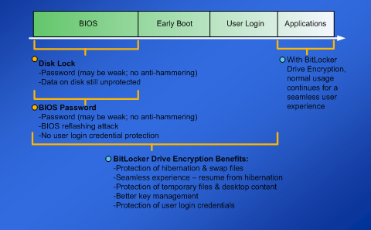
Figure X: How BitLocker Drive Encryption protects the boot process

BitLocker Drive Encryption is transparent to the user and is easy to deploy and manage. A high-performance Windows device driver assures that the on-the-fly cryptography operations occur seamlessly, while helping to protect data on the drive.
BitLocker Drive Encryption was developed by Microsoft to provide the following benefits:
- Boot integrity: BitLocker Drive Encryption prevents system tampering while Windows is booting up by comparing boot process characteristics against previously stored measurements. In the case the characteristics do not match, the operating system will not load.
- Full volume encryption: Because the entire Windows volume is encrypted and all encryption keys are secured off the disk, all data is protected, including:
  - The hibernation file
  - Swap files
  - File names and file metadata
  - Registry information
  - System and user data
- Attack resilience and data protection: Code and data modifications to disable security cannot be made while the system is offline. In addition, offline attacks cannot compromise a user’s password, which prevents someone from logging into the operating system and using VPN/RAS to launch network attacks.
- Simple deployment, usability, and recovery: BitLocker Drive Encryption was designed to provide a transparent user experience and require no interaction from users. It is simple to deploy, and minimizes IT management requirements. BitLocker Drive Encryption also includes a recovery feature to ensure authorized access in the event that the booting process has been altered inadvertently. Recovery passwords and keys can be stored in Microsoft Active Directory®, enabling users to call their corporate help desk or administrator for recovery keys and assistance with system reactivation.
- Eases equipment recycling: Normally, information which is “deleted” on a hard drive actually remains on the volume and can be easily recovered by attackers. From a security perspective, actually eliminating information on a hard drive is difficult and time-intensive. With BitLocker Drive Encryption, information on the encrypted volume can be rendered useless by deleting the root key material. As a result, disabling the drive can take seconds instead of hours, saving substantial time and costs associated with destroying or reformatting information to comply with data protection regulations.
Partners in Protection: RMS, BitLocker, and EFS
RMS, EFS, and BitLocker can all be used to address information protection in the enterprise. However, each performs an entirely different function in the information security chain. In fact, all three technologies are complimentary elements of information protection, and highly recommended for an enterprise’s overall security strategy. Each can be used separately or together, depending on an enterprise’s security needs.
As the following graphic indicates, RMS is designed to provide policy definition and enforcement for documents that will be distributed to others, so that confidential information cannot be distributed to unauthorized parties. In contrast, EFS provides file encryption for users on their own computers or the network shares that they utilize, to prevent attackers from accessing sensitive information on the computer or the network. BitLocker encrypts the system volume against offline attacks—including the operating system, registry, and other critical files—to prevent physical hardware attacks, disablement of security features, detection of passwords, or browsing of a hard drive using another computer.
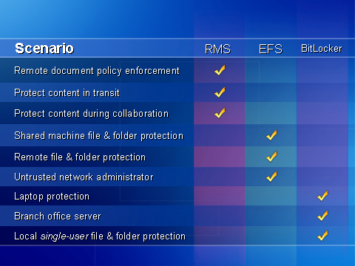
Figure 3: Comparing RMS, EFS, and BitLocker

The value of RMS lies in the combination of the policy and encryption technology that is included with the document wherever it travels. Unlike RMS, EFS is not designed to protect information while it is being transferred from one system to another. In EFS, all information on a file system, network share, volume, or computer is encrypted with a key belonging to a user. If the documents are extracted from the EFS volume by the owner or user and distributed to others, the protection does not persist. When used together, BitLocker, RMS, and EFS provide protection for a wide variety of scenarios—offline data, files in transit, and files on desktops and shared networks.

Summary

RMS, EFS, and BitLocker are three technologies designed to help protect an organization’s information, intellectual property, and customer data in today’s information age in the face of a long list of threats from an increasing number of attacks. Loss of this information can be damaging to the reputation and long term survival of an organization—resulting in lost revenue, weakened competitive advantage, and reduction in customer confidence.

To augment traditional security technologies such as firewalls and antivirus software, organizations need to proactively protect information stored on computers while they are offline; secure files and folders; and enforce and manage specific document access rights inside and outside the firewall.

Next Steps
- Inventory various types of sensitive information, IP, and other digital assets your company currently has. Then, review how they’re currently protected, who has access to them, and isolate any vulnerabilities in your information protection system.
- Assess your organization’s current information protection infrastructure. Consider which of the information protection challenges discussed in this white paper are priorities for your organization. Determine and rank the largest risks your organization faces.
- Based on your challenges, determine an overall information protection strategy.
- Establish goals and priorities for your information protection strategy. Through a coherent strategy that addresses your organization’s risks, you can better evaluate the feasibility of each technology and determine the return on investment for each initiative.
- Deploy information protection technologies in a phased approach to minimize impact to IT staff and users. Anticipate support needs for end users and prepare documentation to guide them.

Additional Resources
The Access Control White Paper Strategy Series on Microsoft.com can help you understand the primary components of access control technologies. Other papers in the series include:
- System Integrity: Securing computers at the system level
- Access Policy Management: Automating access based on organization policies for users, computers, and applications
- Information Protection: Securing information on networks, mobile devices, laptops, and when distributed outside the firewall
- Compliance: How access control can help ease compliance with regulations

The information contained in this document represents the current view of Microsoft Corporation on the issues discussed as of the date of publication. Because Microsoft must respond to changing market conditions, it should not be interpreted to be a commitment on the part of Microsoft, and Microsoft cannot guarantee the accuracy of any information presented after the date of publication.
This white paper is for informational purposes only. MICROSOFT MAKES NO WARRANTIES, EXPRESS OR IMPLIED, IN THIS DOCUMENT.
Complying with all applicable copyright laws is the responsibility of the user. Without limiting the rights under copyright, no part of this document may be reproduced, stored in, or introduced into a retrieval system, or transmitted in any form or by any means (electronic, mechanical, photocopying, recording, or otherwise), or for any purpose, without the express written permission of Microsoft Corporation.
Microsoft may have patents, patent applications, trademarks, copyrights, or other intellectual property rights covering subject matter in this document. Except as expressly provided in any written license agreement from Microsoft, the furnishing of this document does not give you any license to these patents, trademarks, copyrights, or other intellectual property.
The example companies, organizations, products, domain names, e-mail addresses, logos, people, places, and events depicted herein are fictitious. No association with any real company, organization, product, domain name, e-mail address, logo, person, place, or event is intended or should be inferred.
© 2005 Microsoft Corporation. All rights reserved.
Microsoft, Windows, Windows Vista, Active Directory, BitLocker, Windows Server, Authenticode, SharePoint, and Outlook are either registered trademarks or trademarks of Microsoft Corporation in the United States and/or other countries.

Jupiter Media Research Report, 2004
Jupiter Media Research Report, 2004
October, 2004 Report from the Department of Justice’s Task Force on Intellectual Property
2005 Computer Crime and Security Survey, Computer Security Institute and FBI
2005 Computer Crime and Security Survey, Computer Security Institute and FBI
www.privacycouncil.com/adSvs_japan.php

