

Operating System

File and Printer Sharing with Microsoft Windows

Microsoft Corporation
Published: November 2003

Abstract
File and printer sharing in Microsoft® Windows® allows you to share the contents of selected folders and locally attached printers with other computers. Windows XP, Windows 2000, Windows 98, Windows Millennium Edition (Me), and Windows NT® 4.0 support file and printer sharing. For each of these operating systems, this article describes the features, components, connection process, how to share a folder and connect to a shared folder, how to share a printer and connect to a shared printer, and how to manage file sharing in a small office/home office environment.

The information contained in this document represents the current view of Microsoft Corporation on the issues discussed as of the date of publication. Because Microsoft must respond to changing market conditions, it should not be interpreted to be a commitment on the part of Microsoft, and Microsoft cannot guarantee the accuracy of any information presented after the date of publication.
This document is for informational purposes only. MICROSOFT MAKES NO WARRANTIES, EXPRESS OR IMPLIED, AS TO THE INFORMATION IN THIS DOCUMENT.
Complying with all applicable copyright laws is the responsibility of the user. Without limiting the rights under copyright, no part of this document may be reproduced, stored in or introduced into a retrieval system, or transmitted in any form or by any means (electronic, mechanical, photocopying, recording, or otherwise), or for any purpose, without the express written permission of Microsoft Corporation.
Microsoft may have patents, patent applications, trademarks, copyrights, or other intellectual property rights covering subject matter in this document. Except as expressly provided in any written license agreement from Microsoft, the furnishing of this document does not give you any license to these patents, trademarks, copyrights, or other intellectual property.
© 2003 Microsoft Corporation. All rights reserved.
Microsoft, Windows, and Windows NT are either registered trademarks or trademarks of Microsoft Corporation in the United States and/or other countries.
The names of actual companies and products mentioned herein may be the trademarks of their respective owners.

Contents
File and Printer Sharing Overview 1
Windows XP 2
File Sharing in Windows XP 2
Shared Documents Folder 2
Simple File Sharing 2
Advanced File Sharing 3
Connecting to a Windows XP Shared Folder 6
Connecting When Simple File Sharing is Being Used 6
Connecting When Advanced File Sharing is Being Used 6
Components of File and Printer Sharing 7
Enabling File and Printer Sharing 10
Sharing a Folder 11
Connecting to a Shared Folder 11
Using Start-Run 11
Using My Network Places 12
Mapping a Network Drive 13
Sharing a Printer 15
Connecting to a Shared Printer 15
From the Add Printer Wizard 15
Using Start-Run 17
Using My Network Places 18
Managing Shared Folders 18
Windows 2000 20
File Sharing in Windows 2000 20
Connecting to a Windows 2000 Shared Folder 21
Components of File and Printer Sharing 22
Sharing a Folder 25
Connecting to a Shared Folder 26
Using Start-Run 26
Using My Network Places 27
Mapping a Network Drive 28
Sharing a Printer 29
Connecting to a Shared Printer 30
From the Add Printer Wizard 30
Using Start-Run 31
Using My Network Places 32
Managing Shared Folders 32
Windows 98 and Windows Me 34
File Sharing in Windows 98 and Windows Me 34
Share-Level Access 35
User-Level Access 36
Connecting to a Windows 98 or Windows Me Shared Folder 37
Connecting When Share-Level Access Control is Being Used 37
Connecting When User-Level Access Control is Being Used 38
Components of File and Printer Sharing 38
Sharing a Folder 40
Connecting to a Shared Folder 41
Using Start-Run 41
Using Network Neighborhood or My Network Places 41
Mapping a Network Drive 43
Sharing a Printer 44
Connecting to a Shared Printer 44
From the Add Printer Wizard 44
Using Start-Run 46
Using Network Neighborhood or My Network Places 47
Managing Shared Folders 47
Windows NT 4.0 49
File Sharing in Windows NT 4.0 49
Connecting to a Windows NT 4.0 Shared Folder 50
Components of File and Printer Sharing 50
Sharing a Folder 52
Connecting to a Shared Folder 52
Using Start-Run 52
Using Network Neighborhood 53
Mapping a Network Drive 54
Sharing a Printer 55
Connecting to a Shared Printer 56
From the Add Printer Wizard 56
Using Start-Run 57
Using Network Neighborhood 58
Summary 59
Related Links 60

File and Printer Sharing Overview
File and printer sharing is the ability of a computer running Windows to share a folder or attached printer with other computers on a network.
- File sharing allows you to make files and folders in a shared folder accessible to others on the network to view, copy, or modify.
For example, with file sharing, you can store all of your documents on a central computer and share the folder that contains them. Then, from another computer attached to the same network as the computer that contains the files, you can connect to the shared folder and work with the documents as if they were locally stored. For example, you can access files that are stored on a central desktop computer from a wireless laptop computer that you can carry from room to room in your home.
- Printer sharing allows you to make an attached printer available to other computer users on the network.
For example, a color printer is attached to a central computer in your home. You share the color printer. Then, from another computer attached to the same network as the computer to which the printer is attached, you can add the printer as a network printer and print to is as if it were locally attached. When you print to a shared printer, the information normally sent to the locally attached printer is sent across the network to the print server, which stores the print information and then sends it as a normal print job to its locally attached printer.
In a file or printer sharing connection, there is a client computer (the computer making the connection to a shared folder or printer) and a server computer (the computer with the shared folder or printer).
When initiating the file or printer sharing connection, the client computer sends a set of connection credentials in the form of a user name and an encrypted password. The combination of the received credentials, the type of file sharing used on the server, and the set of permissions associated with the shared folder or printer determine whether the connection will be allowed or denied.
In the following sections, this article examines file and printer sharing features, how the file or printer sharing process works, how to share files and printers, how to connect to file and printer shares, and how to manage shared folders for the following versions of Windows:
- Windows XP
- Windows 2000
- Windows 98 and Windows Me
- Windows NT 4.0

Windows XP
This section describes file and printer sharing support in Windows XP. For additional information about how to troubleshoot file and printer sharing in Windows XP, see Troubleshooting File and Printer Sharing in Microsoft® Windows® XP.

File Sharing in Windows XP
Windows XP supports three different ways of sharing files:
- The Shared Documents folder
- Simple file sharing
- Advanced file sharing
These three different types are described in the following sections.

Shared Documents Folder
Windows XP Home Edition file sharing is simplified by using a special folder named the Shared Documents folder. This folder is available in My Computer and Windows Explorer. Any file or folder within the Shared Documents folder is automatically shared on the network. You do not have to configure file sharing on separate folders. You only have to either move or copy the file or folder you want to share on the network to the Shared Documents folder.

Simple File Sharing
Windows XP Home Edition supports a file sharing mode known as simple file sharing for folders other than the Shared Documents folder. A computer running Windows XP Professional when it is a member of a workgroup also supports simple file sharing. With simple file sharing, the act of enabling file sharing on a folder and specifying the type of access is simplified to the following choices:
- Whether to enable sharing for the folder
- The name of the share
- Whether to allow network users to change files in the folder
The Sharing tab for simple file sharing is shown in the following figure.
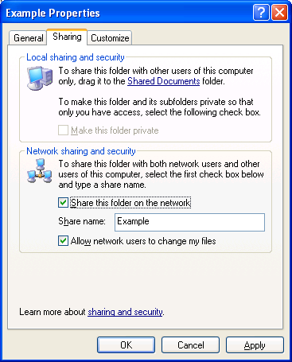

Advanced File Sharing
For a computer running Windows XP Professional (when it is a member of a workgroup), you can optionally disable simple file sharing and enable advanced file sharing, also known as classic file sharing. Advanced file sharing is the file sharing mode used by Windows 2000 and Windows NT 4.0. With advanced file sharing you can specify:
- Whether to enable sharing for the folder
- The share name
- A comment or description for the share
- The maximum number of computers that can connect to the share
- Permissions on the share, which include the list of user or group accounts and their level of access
- Offline folder settings
- If modifying the settings of an existing shared folder, whether to create a new share
The Sharing tab for advanced file sharing is shown in the following figure.
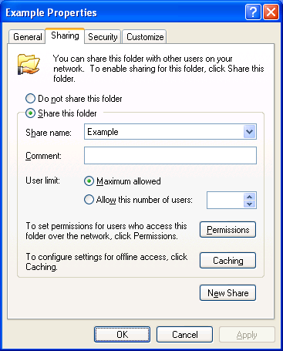
When you click Permissions, the Permissions dialog box is displayed, showing you the current set of permissions for connecting to the shared folder. The types of access are Full Control, Read, and Change, each of which can be allowed or denied. The default shared folder permissions for a computer that is a member of a workgroup are shown in the following figure.
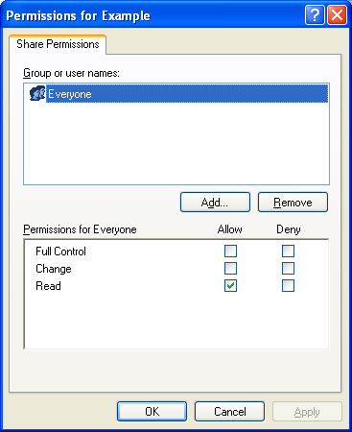
When you click Add, the Select Users or Groups window is displayed, from which you can type or locate the user or group account names to add. If the computer is a member of a workgroup, then only the accounts on the local computer are available. If the computer is a member of a domain, then you can select domain accounts, accounts from domains that are trusted by the domain of the computer, and local computer accounts.
An example of a computer running Windows XP Professional that is a member of a workgroup is shown in the following figure.
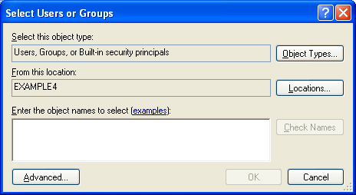
For a computer running Windows XP Professional that is a member of a domain, the domain name is listed by default in From this location.
To enable advanced file sharing on a computer running Windows XP Professional (when it is a member of a workgroup), do the following:
Click Start, and then click My Computer.
In My Computer, click Tools, and then click Folder Options.
In Folder Options, click the View tab.
In the Advanced settings, clear the Use simple file sharing (Recommended) check box. An example is shown in the following figure.
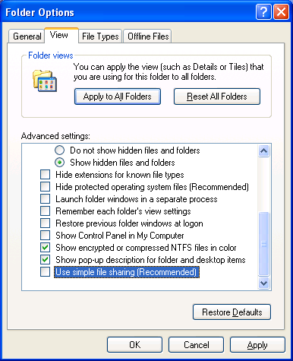
Click OK.
For a computer running Windows XP Professional that is a member of a domain, advanced file sharing is the only mode of file sharing.
The following table summarizes the different types of file sharing supported in Windows XP.
Operating System | Supported File Sharing Methods
Windows XP Home Edition | Shared Documents folder, simple file sharing
Windows XP Professional (when it is a member of a workgroup) | Simple file sharing, advanced file sharing
Windows XP Professional (when it is a member of a domain) | Advanced file sharing

Connecting to a Windows XP Shared Folder
The behavior of connecting to a folder or printer that is shared from a computer running Windows XP depends on whether simple or advanced file sharing is being used.

Connecting When Simple File Sharing is Being Used
For simple file sharing, which includes access to the Shared Documents folder, the set of credentials sent by the connecting client are essentially ignored. All access is based on the status of the Guest account on the computer running Windows XP. The Guest account is enabled by default; however, you cannot use it to logon to the computer. As long as the Guest account is enabled as an account, client computers can access shared folders using simple file sharing.

Connecting When Advanced File Sharing is Being Used
In order to connect to a Windows XP Professional shared folder when advanced file sharing is being used, you must be:
- Using a set of credentials that Windows XP can validate (it is either a local computer account or a domain account) and has been granted the Read, Change, or Full Control access type either explicitly (the account name) or though group membership, as specified in the permissions of the shared folder.
- Using a set of credentials that Windows XP cannot validate, and either the domain Guest account or the local Guest account has been enabled and has been granted the Read, Change, or Full Control access type either explicitly (the Guest account name) or though group membership, as specified in the permissions of the shared folder.
You can be denied access to a Windows XP shared folder through the following:
- The account name in the credentials sent by the connecting client is a valid user name, but the password is incorrect.
- The account name in the credentials sent by the connecting client is a user name that cannot be validated by Windows XP and the domain Guest and the local computer Guest accounts are either disabled or are not specified via the permissions of the shared folder. The domain Guest is disabled by default and the local computer Guest account is enabled by default for computers that are members of a workgroup and disabled by default for computers that are members of a domain.
- The account name and password in the credentials sent by the connecting client can be validated by Windows XP, but either access has not been granted or all types of access are set to Deny either explicitly (the account name) or though group membership.

Components of File and Printer Sharing
To act as a client computer, a computer running Windows XP must have the Client for Microsoft Networks component installed and enabled on a network connection that is attached to the home network. To verify that the Client for Microsoft Networks component is installed and enabled, do the following:
- Click Start, click Control Panel, click Network and Internet Connections, and then click Network Connections.
- Click the connection that is connected to your home network, and then, in the Tasks pane, click Change settings of this connection.
- In the properties of the network connection, under This connection uses the following items, verify that the Client for Microsoft Networks component is installed and enabled (the checkbox is checked). The following figure shows an example.
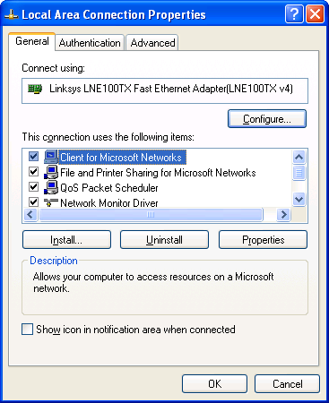
- If it is not installed, click Install.
- In Select Network Component Type, double-click Service.
- In Select Network Service, double-click Client for Microsoft Networks.
- Click Close.
To act as a server computer, a computer running Windows XP must have the File and Printer Sharing for Microsoft Networks component installed and enabled on a network connection that is attached to the home network. To verify that the File and Printer Sharing for Microsoft Windows component is installed and enabled, do the following:
- Click Start, click Control Panel, click Network and Internet Connections, and then click Network Connections.
- Click the connection that is connected to your home network, and then, in the Tasks pane, click Change settings of this connection.
- In the properties of the network connection, under This connection uses the following items, verify that the File and Printer Sharing for Microsoft Networks component is installed and enabled (the checkbox is checked). The following figure shows an example.
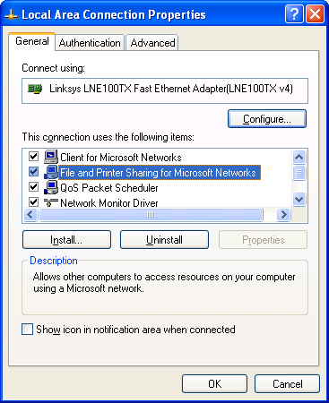
- If it is not installed, click Install.
- In Select Network Component Type, double-click Service.
- In Select Network Service, double-click File and Printer Sharing for Microsoft Networks.
- Click Close.
The Client for Microsoft Networks component corresponds to the Workstation service. The File and Printer Sharing for Microsoft Networks component corresponds to the Server service. To use the Services snap-in to check the status of the Workstation and Server services, do the following:
- Click Start, click Control Panel, click Performance and Maintenance, click Administrative Tools, and then double-click Services.
- In the details pane of the Services snap-in, double-click the Workstation service.
Startup type should be set to Automatic and the Service status should be Started.
An example is shown in the following figure.
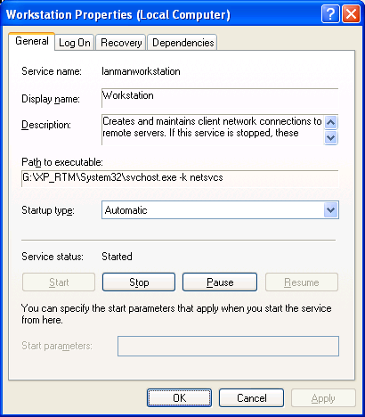
- Click OK.
- In the details pane of the Services snap-in, double-click the Server service.
Startup type should be set to Automatic and the Service status should be Started.
An example is shown in the following figure.
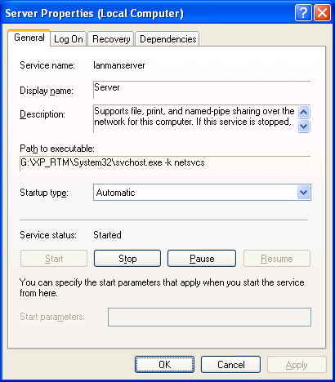
- Click OK.

Enabling File and Printer Sharing
For computers that are running Windows XP Home Edition and Windows XP Professional that are members of a workgroup, file and printer sharing is disabled by default. If you attempt to share a folder, the Sharing tab contains two links with which you can enable sharing in Network sharing and security. An example is shown in the following figure.
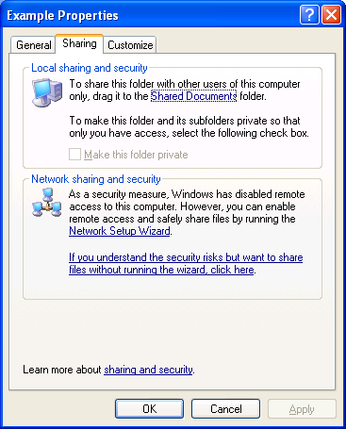
Similarly, if you attempt to share a printer before enabling file sharing, the Sharing tab contains two links with which you can enable sharing. An example is shown in the following figure.
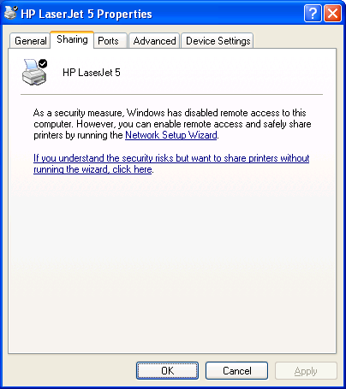
To enable file and printer sharing, you can either click the link to run the Network Setup Wizard or click the link to enable file and printer sharing without running the Network Setup Wizard. When you click the link to run the Home Network Setup Wizard, the Home Network Setup Wizard is run, which asks you a set of questions to automatically configure network settings. The Home Network Setup Wizard automatically enables file and printer sharing.
When you click the link to enable file sharing without running the Network Setup Wizard, you are prompted with an Enable File Sharing dialog box, as shown in the following figure.
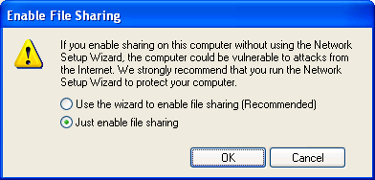
Click Just enable file sharing, and then click OK.
When you enable file and printer sharing, you are enabling file and printer sharing using simple file sharing. To enable advanced file sharing on a computer running Windows XP Professional, see the procedure in the "Advanced File Sharing" section of this article.

Sharing a Folder
For a computer running Windows XP Home Edition, you can share a folder or an individual file by copying or moving it to the Shared Documents folder. If you want to create a separate share for a folder, rather than using the Shared Documents folder, right-click the folder in My Computer, and then click Sharing and Security. Alternately, you can click the folder in My Computer, and then click Share this folder in the list of File and Folder Tasks.
From the Sharing tab for the folder's properties, do the following:
- For simple file sharing, click Share this folder on the network and make other changes as needed.
- For advanced file sharing, click Share this folder and make other changes as needed.
To share a folder from Windows Explorer, right-click the folder name in the tree pane, and then click Sharing and Security.

Connecting to a Shared Folder
There are many ways to connect to a shared folder, including the following:
- Using Start-Run to open a window containing the shared folder contents
- Using My Network Places to open a window containing the shared folder contents
- Mapping a network drive to the shared folder

Using Start-Run
The easiest way to make a connection to a shared folder is by doing the following:
Click Start, and then click Run.
In Open, type \\ComputerName\ShareName (in which ComputerName is the name of the computer sharing the folder and ShareName is the name of the share when the folder was shared), and then press ENTER.
For example, to open the share named STUFF on the computer named HOMESRV, you would type \\HOMESRV\STUFF. You can use upper or lowercase letters for the computer and share names. If the share name contains spaces, enclose the entire \\ComputerName\ShareName in quotes. For example, to open the Shared Documents share on the computer named MOMSPC, you would type "\\MOMSPC\Shared Documents".
If you don't remember the name of the share, you can do the following:
Click Start, and then click Run.
In Open, type \\ComputerName and then press ENTER.
The window that is displayed contains the file and printer shares of the specified computer. An example is shown in the following figure.
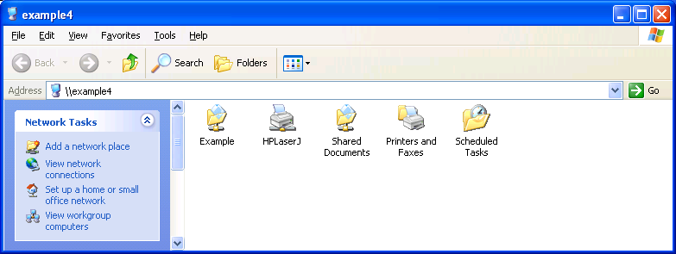
From this window, you can open the shared folders of the computer.

Using My Network Places
To use My Network Places to display the contents of a shared folder, do the following:
Click Start, and then click My Network Places.
In the Network Tasks list, click View workgroup computers.
A window is displayed containing the set of computers in your home or small office workgroup. An example is shown in the following figure.
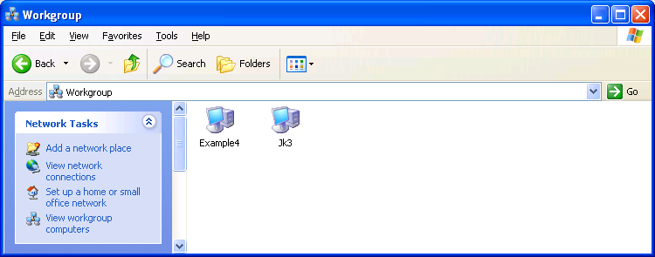
From the workgroup window, open the computer containing the shares, and then open the desired shared folder.
The contents of the workgroup window depend on the configuration of the workgroup name on all the computers on your network. All of the computers on your network should be configured with the same workgroup name. The workgroup name is normally configured during the Network Setup Wizard.
To manually change the workgroup name on a computer running Windows XP, do the following:
- Click Start, and then click Control Panel.
- In Control Panel, double-click System.
- In System Properties, click the Computer Name tab, and then click Change.
- In Computer Name Changes, type the name of the workgroup in Workgroup, and then click OK.
By default, the Network Setup Wizard uses the workgroup name MSHOME. A workgroup name must not be the same as the name of any of the computers on your network. A workgroup name can have as many as 15 characters, but it cannot contain any of the following characters:
; : " < > * + = \ | ? ,
All the computers on your network should use the same workgroup name.
If the computers on your network are using different workgroup names, then you can view all the workgroups on your network from the workgroup window by either clicking on the Up folder icon in the workgroup window toolbar (next to the Back and Forward icons) or clicking on the Address bar, and then clicking Microsoft Windows Network. The resulting window displays all of the workgroups on your network, from which you open the desired workgroup, computer, and shared folder.
The contents of the workgroup window also depend on the operation of the Windows Computer Browser service. The Computer Browser service operates by collecting periodic announcement messages sent by the computers on your network. Due to timing issues, the workgroup window might not contain all the active computers on your network or might contain computers that are no longer active on your network. If the computer to which you want to connect does not appear in the workgroup window, then open the computer from Start-Run.

Mapping a Network Drive
It is also possible to create a network drive that appears in My Computer as a drive but is actually mapped to a shared folder. To create a network drive, do the following:
- Click Start, and then click My Network Places.
- In My Network Places, click Tools, and then click Map Network Drive.
- In Map Network Drive, you can specify the following:
- The network drive letter. By default, Windows XP uses the last available drive letter.
- The folder name, which is the combination of computer and share name using \\ComputerName\ShareName. If you do not remember the computer or share name, click Browse and use the Browse window to locate the desired shared folder,
- Whether to automatically reconnect the network drive when you log on to the computer.
- Whether you want to use a different name and password to connect to the shared folder.
An example is shown in the following figure.
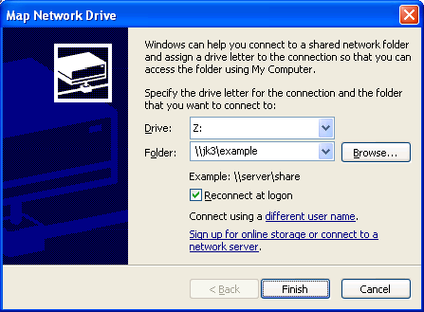
- Click Finish to map the network drive.
- A window appears displaying the contents of the newly mapped network drive. An example is shown in the following figure.
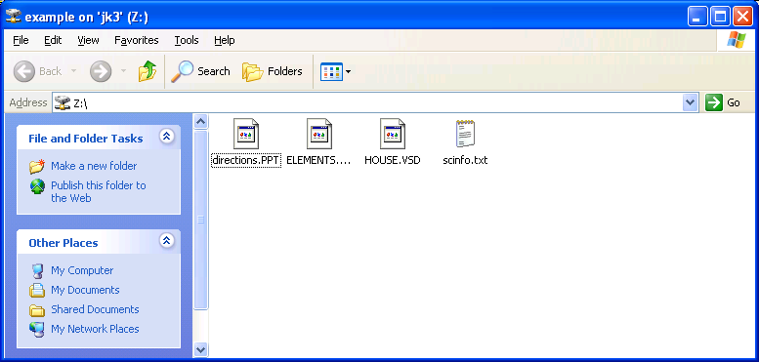
The mapped network drive also appears in My Computer. An example is shown in the following figure.
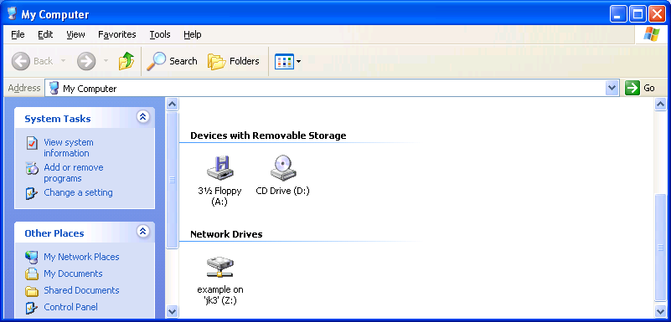

Sharing a Printer
Once file sharing has been enabled, you can share a printer from the Printers and Faxes folder by doing the following:
Click Start, and then click Printers and Faxes.
From Printers and Faxes, right-click the printer and click Sharing. Alternately, you can click the printer and then click Share this printer in the Printer Tasks list.
From the Sharing tab, click Share this printer.
If you are sharing the printer with users on computers running versions of Windows other than Windows 2000 and Windows XP and you want the printer drivers for those versions of Windows to be installed automatically, click Additional Drivers. In Additional Drivers, select the versions of Windows being used on the other computers on your network and then click OK.
If the printer drivers for the other versions of Windows are not already installed, you are prompted to insert a floppy disk or CD-ROM containing the printer drivers. Insert the appropriate disk and click OK. The drivers are installed on the Windows XP computer that is sharing the printer.
Click OK.

Connecting to a Shared Printer
There are several ways to connect to a shared printer, including the following:
- From the Add Printer Wizard
- Using Start-Run to open a window containing the shared printer
- Using My Network Places to open a window containing the shared printer

From the Add Printer Wizard
To connect to a shared printer from the Add Printer Wizard, do the following:
Click Start, and then click Printers and Faxes.
From Printers and Faxes, click Add a printer in the Printer Tasks list.
On the Welcome to the Add Printer Wizard page of the Add Printer Wizard, click Next.
On the Local or Network Printer page, click A network printer, or printer attached to another computer. An example is shown in the following figure.
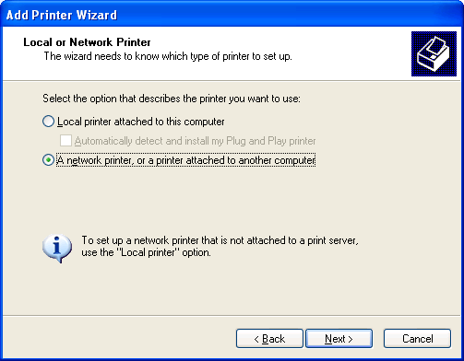
On the Specify a Printer page, you can do one of the following:
- Click Browse for a printer to use a Browse window to locate a shared printer on your network.
- Click Connect to this printer and type the \\ComputerName\SharedPrinterName (in which ComputerName is the name of the computer sharing the printer and SharedPrinterName is the name of the print share).
- Click Connect to a printer on the Internet or on a home or office network and type the Uniform Resource Locator (URL) address of the shared Internet printer.
An example of using the Connect to this printer option is shown in the following figure.
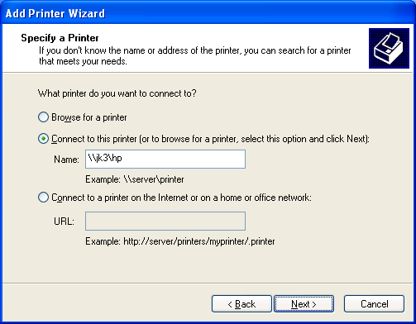
Click Next.
On the Default Printer page, click Yes if you want to make this network printer the default printer. Otherwise, click No. Click Next.
On the Completing the Add Printer Wizard page, click Finish.
The shared printer should now appear in your Printers and Faxes folder. An example is shown in the following figure.
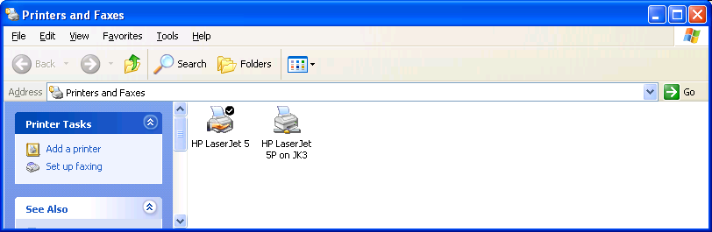

Using Start-Run
Another way to make a connection to a shared printer is by doing the following:
- Click Start, and then click Run.
- In Open, type \\ComputerName\SharedPrinterName, and then press ENTER.
For example, to connect to the shared printer named COLOR on the computer named HOMESRV, you would type \\HOMESRV\COLOR. You can use upper or lowercase letters for the computer and printer share names.
If you don't remember the name of the share, you can do the following:
- Click Start, and then click Run.
- In Open, type \\ComputerName and then press ENTER.
The window that is displayed contains the file and printer shares of the specified computer. An example is shown in the following figure.
From this window, you can double-click the shared printer icon to create a connection to it. Alternately, you can open the Printers and Faxes folder and double-click the shared printer icon.

Using My Network Places
To use My Network Places to display the contents of a shared folder, do the following:
Click Start, and then click My Network Places.
In the Network Tasks list, click View workgroup computers.
A window is displayed containing the set of computers in your home or small office workgroup. An example is shown in the following figure.
From the workgroup window, open the computer containing the shared printer, and then double-click the desired shared printer.

Managing Shared Folders
In Windows XP, you can manage shared folder using the Shared Folders snap-in. The Shared Folders snap-in is used to view and manage your shares, connected computers, and files that are open on your computer by connected computers. To open the Shared Folders snap-in, do the following:
Click Start, click Control Panel, click Performance and Maintenance, click Administrative Tools, and then double-click Computer Management.
In Computer Management, double-click Shared Folders under System Tools.
An example is shown in the following figure.
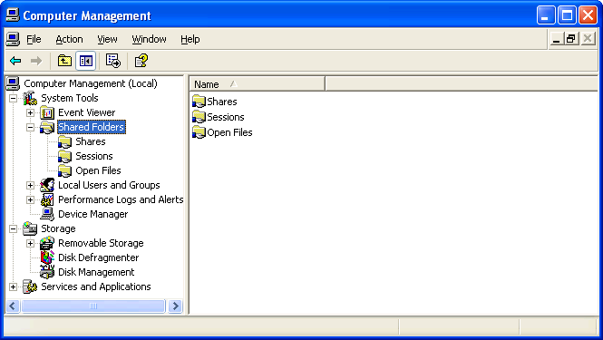
Using the Shared Folders snap-in, you can view:
- The set of shared folders shared on the computer (the Shares folder).
You can also stop the sharing of a shared folder or create a new shared folder.
- The names of the computers that are currently connected to the computer (the Sessions folder).
You can also manually disconnect a computer that is currently connected.
- The files that are open by remote computers (the Open Files folder).
You can also manually close a file that is open by a connected computer.

Windows 2000
This section describes file and printer sharing support in Windows 2000.

File Sharing in Windows 2000
In contrast to Windows XP, Windows 2000 supports only one file and printer sharing method that is equivalent to the advanced file sharing in Windows XP.
The Sharing tab for a Windows 2000 shared folder is shown in the following figure.
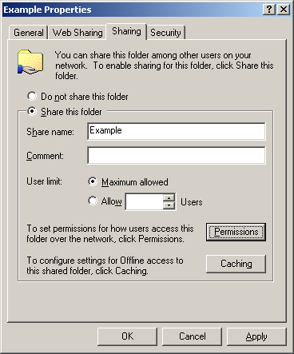
From the Sharing tab, you can specify:
- Whether to enable sharing for the folder
- The share name
- A comment or description for the share
- The maximum number of computers that can connect to the share
- Permissions on the share, which include the list of user or group accounts and their level of access
- Offline folder settings
- If modifying the settings of an existing shared folder, whether to create a new share
When you click Permissions, the Permissions dialog box is displayed, showing you the current set of permissions for connecting to the shared folder. The types of access are Full Control, Change, and Read, each of which can be allowed or denied. The default shared folder permissions are shown in the following figure.
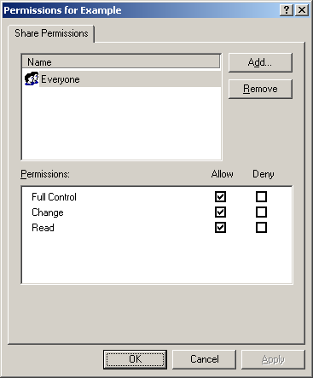
When you click Add, the Select Users, Computers, or Groups window is displayed, showing the set of accounts that are available from the computer running Windows 2000. If the computer is a member of a workgroup, then only the accounts on the local computer are available. If the computer is a member of a domain, then you can select domain accounts, accounts from domains that are trusted by the domain of the computer, and local computer accounts.
An example of a computer running Windows 2000 that is a member of a workgroup is shown in the following figure.
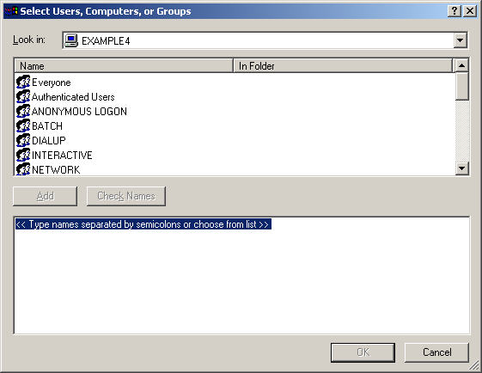

Connecting to a Windows 2000 Shared Folder
In order to connect to a Windows 2000 shared folder, you must be:
- Using a set of credentials that Windows 2000 can validate (it is either a local computer account or a domain account) and has been granted the Read, Change, or Full Control access type either explicitly (the account name) or though group membership, as specified in the permissions of the shared folder.
- Using a set of credentials that Windows 2000 cannot validate, and either the domain Guest account or the local Guest account has been enabled and has been granted the Read, Change, or Full Control access type either explicitly (the Guest account name) or though group membership, as specified in the permissions of the shared folder.
You can be denied access to a Windows 2000 shared folder through the following:
- The account name in the credentials sent by the connecting client is a valid user name, but the password is incorrect.
- The account name in the credentials sent by the connecting client is a user name that cannot be validated by Windows 2000 and the domain Guest and the local computer Guest accounts are either disabled or are not specified via the permissions of the shared folder. The domain Guest and local computer Guest accounts are disabled by default.
- The account name and password in the credentials sent by the connecting client can be validated by Windows 2000, but either access has not been granted or all types of access are set to Deny either explicitly (the account name) or though group membership.

Components of File and Printer Sharing
To act as a client computer, a computer running Windows 2000 must have the Client for Microsoft Networks component installed and enabled on a network connection that is attached to the home network. To verify that the Client for Microsoft Networks component is installed and enabled, do the following:
- From the Windows 2000 desktop, right-click My Network Places, and then click Properties.
- Right-click the connection that is connected to your network, and then Properties.
- In the properties of the network connection, under Components checked are used by this connection, verify that the Client for Microsoft Networks component is installed and enabled (the checkbox is checked). The following figure shows an example.
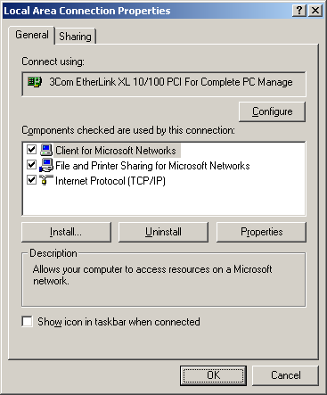
- If it is not installed, click Install.
- In Select Network Component Type, double-click Client.
- In Select Network Client, double-click Client for Microsoft Networks.
- Click Close.
To act as a server computer, a computer running Windows 2000 must have the File and Printer Sharing for Microsoft Networks component installed and enabled on a network connection that is attached to the home network. To verify that the File and Printer Sharing for Microsoft Networks component is installed and enabled, do the following:
From the Windows 2000 desktop, right-click My Network Places, and then click Properties.
Right-click the connection that is connected to your network, and then Properties.
In the properties of the network connection, under Components checked are used by this connection, verify that the File and Printer Sharing for Microsoft Networks component is installed and enabled. The following figure shows an example.
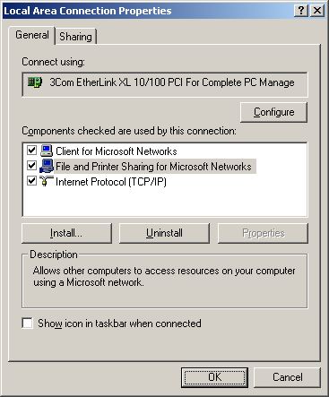
If it is not installed, click Install.
In Select Network Component Type, double-click Service.
In Select Network Service, double-click File and Printer Sharing for Microsoft Networks.
Click Close.
The Client for Microsoft Networks component corresponds to the Workstation service. The File and Printer Sharing for Microsoft Networks component corresponds to the Server service, which you can verify are running using the Services snap-in. To use the Services snap-in to check the status of the Workstation and Server services, do the following:
- Click Start, point to Settings, and then click Control Panel.
- In Control Panel, double-click Administrative Tools, and then double-click Services.
- In the details pane of the Services snap-in, double-click the Workstation service.
The Startup type should be set to Automatic and the Service status should be Started.
An example is shown in the following figure.
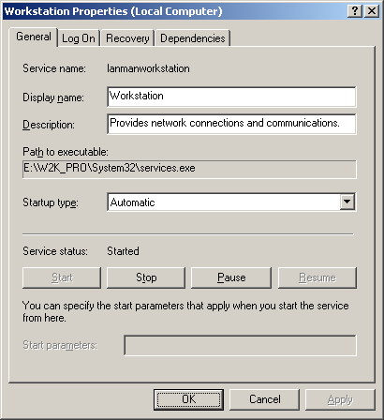
- Click OK.
- In the details pane of the Services snap-in, double-click the Server service.
The Startup type should be set to Automatic and the Service status should be Started.
An example is shown in the following figure.
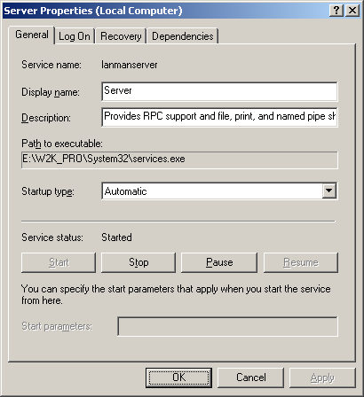
- Click OK.

Sharing a Folder
To share a folder, right-click the folder in My Computer, and then click Sharing. Alternately, you can share a folder from Windows Explorer; right-click the folder name in the tree pane, and then click Sharing.
From the Sharing tab for the folder's properties, click Share this folder and do the following:
- Type the name of the share, if different from the folder name (optional).
- Type a comment that describes the shared folder (optional).
- Specify the maximum number of users that can connect, as needed.
- Click Permissions to configure the accounts that can connect to the shared folder and their level of access. By default, shared folders are shared to the Everyone group with Read, Change, and Full Control access allowed.

Connecting to a Shared Folder
There are many ways to connect to a shared folder, including the following:
- Using Start-Run to open a window containing the shared folder contents
- Using My Network Places to open a window containing the shared folder contents
- Mapping a network drive to the shared folder

Using Start-Run
The easiest way to make a connection to a shared folder is by doing the following:
- Click Start, and then click Run.
- In Open, type \\ComputerName\ShareName (in which ComputerName is the name of the computer sharing the folder and ShareName is the name of the share when the folder was shared), and then press ENTER.
For example, to open the share named STUFF on the computer named HOMESRV, you would type \\HOMESRV\STUFF. You can use upper or lowercase letters for the computer and share names. If the share name contains spaces, enclose the entire \\ComputerName\ShareName in quotes. For example, to open the Shared Documents share on the computer named MOMSPC, you would type "\\MOMSPC\Shared Documents".
If you don't remember the name of the share, you can do the following:
- Click Start, and then click Run.
- In Open, type \\ComputerName and then press ENTER.
The window that is displayed contains the file and printer shares of the specified computer. An example is shown in the following figure.
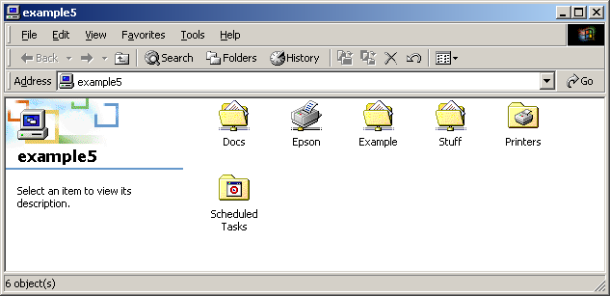
From this window, you can open the shared folders of the computer.

Using My Network Places
To use My Network Places to display the contents of a shared folder, do the following:
- From the Windows 2000 desktop, double-click My Network Places. An example is shown in the following figure.
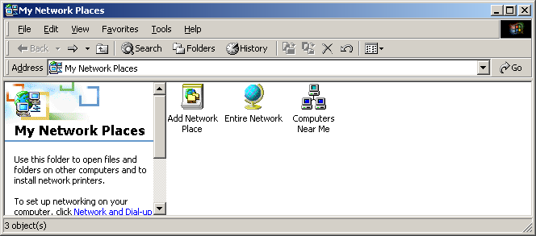
- In My Network Places, double-click Computers Near Me.
A window is displayed containing the set of computers in your home or small office workgroup. An example is shown in the following figure.
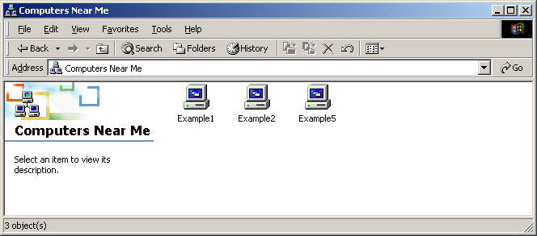
- From the Computers Near Me window, open the computer containing the shares, and then open the desired shared folder.
The contents of the workgroup window depend on the configuration of the workgroup name on all the computers on your network. All of the computers on your network should be configured with the same workgroup name.
To manually change the workgroup name on a computer running Windows 2000, do the following:
- Right-click My Computer, and then click Properties.
- In System Properties, click the Network Identification tab, and then click Properties.
- In Identification Changes, type the name of the workgroup in Workgroup, and then click OK.
If the computers on your network are using different workgroup names, then you can view all the workgroups on your network from the My Network Places window by double-clicking Entire Network, and then double-clicking Microsoft Windows Network. The resulting window displays all of the workgroups on your network, from which you open the desired workgroup, computer, and shared folder.
The contents of the workgroup window also depend on the operation of the Windows Computer Browser service. The Computer Browser service operates by collecting periodic announcement messages sent by the computers on your network. Due to timing issues, the workgroup window might not contain all the active computers on your network or might contain computers that are no longer active on your network. If the computer to which you want to connect does not appear in the workgroup window, then open the computer from Start-Run.

Mapping a Network Drive
It is also possible to create a network drive that appears in My Computer as a drive but is actually mapped to a shared folder. To create a network drive, do the following:
- From the Windows 2000 desktop, right-click My Network Places, and then click Properties.
- In Map Network Drive, you can specify the following:
- The network drive letter. By default, Windows 2000 uses the next available drive letter.
- The folder name, which is the combination of computer and share name using \\ComputerName\ShareName. If you do not remember the computer or share name, click Browse and use the Browse window to locate the desired shared folder,
- Whether to automatically reconnect the network drive when you log on to the computer.
- Whether you want to use a different name and password to connect to the shared folder.
- Whether you want to create a shortcut to a Web folder or an FTP site.
An example is shown in the following figure.
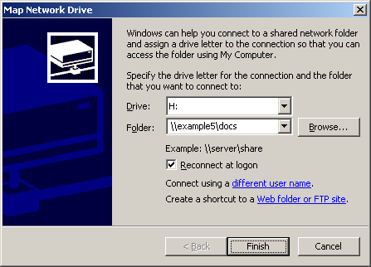
- Click Finish to map the network drive.
A window appears displaying the contents of the newly mapped network drive. An example is shown in the following figure.
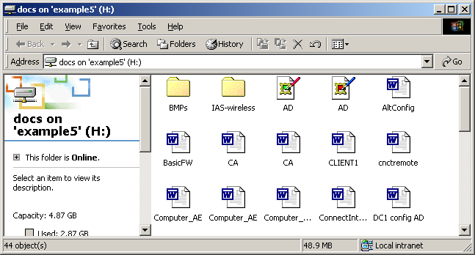
The mapped network drive also appears in My Computer. An example is shown in the following figure.
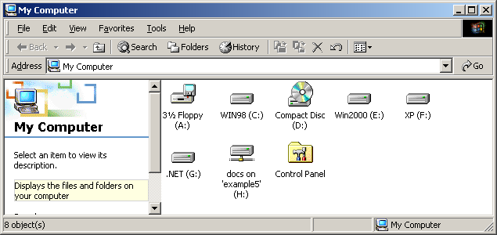

Sharing a Printer
You can share a printer from the Printers folder by doing the following:
- Click Start, point to Settings, and then click Printers.
- From Printers, right-click the printer and click Sharing.
- From the Sharing tab, click Shared as, type a printer name different that created by default (if needed), and then click OK.

Connecting to a Shared Printer
There are several ways to connect to a shared printer, including the following:
- From the Add Printer Wizard
- Using Start-Run to open a window containing the shared printer
- Using My Network Places to open a window containing the shared printer

From the Add Printer Wizard
To connect to a shared printer from the Add Printer Wizard, do the following:
- Click Start, point to Control Panel, and then click Printers.
- From Printers, double-click Add Printer.
- On the Welcome to the Add Printer Wizard page of the Add Printer Wizard, click Next.
- On the Local or Network Printer page, click Network printer. An example is shown in the following figure.
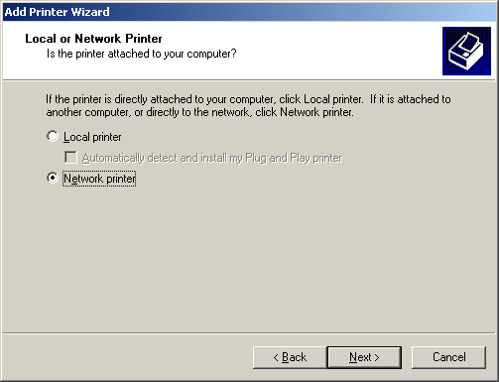
- On the Locate Your Printer page, you can do one of the following:
- Click Next to open a Browse window to locate a shared printer on your network.
- Click Type the printer name and type the \\ComputerName\SharedPrinterName (in which ComputerName is the name of the computer sharing the printer and SharedPrinterName is the name of the print share).
- Click Connect to a printer on the Internet or on your intranet and type the URL address of the shared Internet printer.
An example of using the Type the printer name option is shown in the following figure.
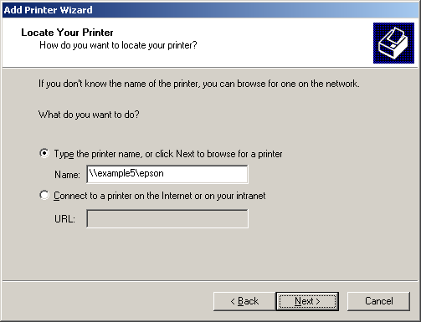
- Click Next.
- On the Default Printer page, click Yes if you want to make this network printer the default printer. Otherwise, click No. Click Next.
- On the Completing the Add Printer Wizard page, click Finish.
The network printer should now appear in your Printers folder. An example is shown in the following figure.
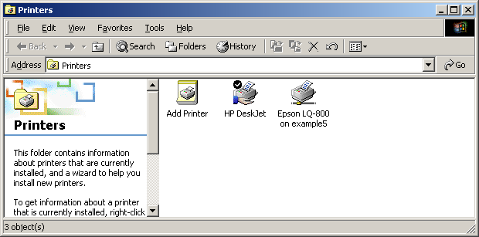

Using Start-Run
Another way to make a connection to a shared printer is by doing the following:
- Click Start, and then click Run.
- In Open, type \\ComputerName\SharedPrinterName, and then press ENTER.
For example, to connect to the shared printer named COLOR on the computer named HOMESRV, you would type \\HOMESRV\COLOR. You can use upper or lowercase letters for the computer and printer share names.
If you don't remember the name of the share, you can do the following:
- Click Start, and then click Run.
- In Open, type \\ComputerName and then press ENTER.
The window that is displayed contains the shared folders and printers of the specified computer. An example is shown in the following figure.
From this window, you can double-click the shared printer icon to create a connection to it. Alternately, you can open the Printers folder and double-click the shared printer icon.

Using My Network Places
To use My Network Places to display the contents of a shared folder, do the following:
- From the Windows 2000 desktop, double-click My Network Places.
- In My Network Places, double-click Computers Near Me.
A window is displayed containing the set of computers in your home or small office workgroup. An example is shown in the following figure.
- From the Computers Near Me window, open the computer containing the shared printer, and then double-click the desired shared printer.

Managing Shared Folders
In Windows 2000, you can manage shared folder using the Shared Folders snap-in. The Shared Folders snap-in is used to view and manage your shares, connected computers, and files that are open on your computer by connected client computers. To open the Shared Folders snap-in, do the following:
- Click Start, point to Settings, and then click Control Panel.
- In Control Panel, double-click Administrative Tools, and then double-click Computer Management.
- In Computer Management, double-click Shared Folders under System Tools.
An example is shown in the following figure.
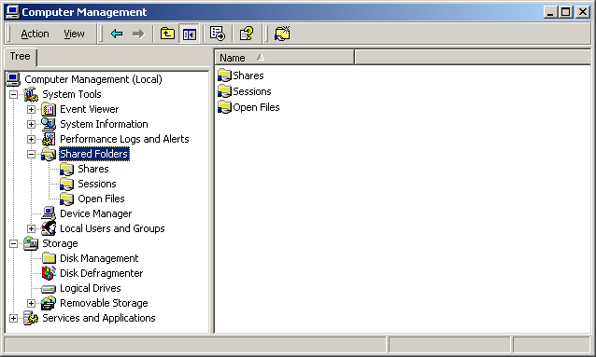
Using the Shared Folders snap-in, you can view:
- The set of shared folders shared on the computer (the Shares folder).
You can also stop the sharing of a shared folder or create a new shared folder.
- The names of the computers that are currently connected to the computer (the Sessions folder).
You can also manually disconnect a computer that is currently connected.
- The files that are open by remote computers (the Open Files folder).
You can also manually close a file that is open by a connected computer.

Windows 98 and Windows Me
This section describes file and printer sharing support in Windows 98 and Windows Me.

File Sharing in Windows 98 and Windows Me
Windows 98 and Windows Me supports two different levels of access when sharing files:
- Share-level access
- User-level access
You configure which level of access you want to use for share folder and printers by doing the following:
- On a computer running Windows 98, right-click Network Neighborhood, and then click Properties. On a computer running Windows Me, right-click My Network Places, and then click Properties.
- Click the Access Control tab. The following figure shows an example.
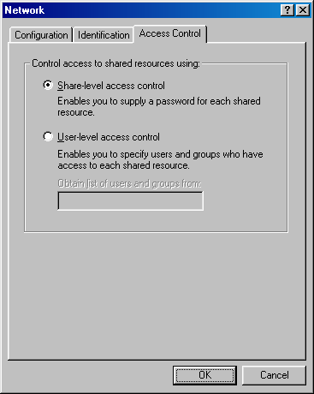
- By default Share-level access control is selected. For user-level sharing, click User-level access control and in Obtain list of users and groups from, type one of the following:
- If you are using the accounts of another computer running Windows XP Professional, Windows 2000, or Windows NT 4.0, type the name of the computer.
- If you are using the accounts of a Windows NT 4.0, Windows 2000, or Windows Server 2003 domain, type the name of the domain.
The computer or domain specified here becomes the source of user accounts that are used by the Windows 98 or Windows Me-based computer when you configure access to a shared folder or printer. In order for a Windows 98 or Windows Me-based computer to read the accounts of the account source or send it credentials of connecting clients to verify, then either the credentials of the user that is logged on to the Windows 98 or Windows Me-based computer must correspond to a user account of the account source or the Guest account of the account source must be enabled.
For example, if you are using a computer running Windows XP Professional on your small office network as the account source, then either the user name and password that you use to log on to the computer running Windows 98 or Windows Me must correspond to a user account on the computer running Windows XP Professional or the Guest account on the computer running Windows XP Professional must be enabled.
- Click OK to save changes.
- Restart the computer if needed.
If you switch between share-level access control and user-level access control, the existing shared resources are no longer shared. You must share them again after restarting the computer and client computers must reconnect.
These two different types are described in the following sections.

Share-Level Access
For share-level access control, the share is protected by optional passwords, which must be submitted by the connecting client computer for access to the shared folder or printer. Any user on any computer that has knowledge of the password can access the shared resource.
The Sharing tab for share-level access to a shared folder is shown in the following figure.
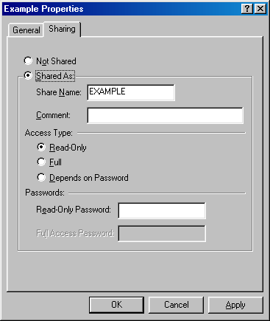
You can specify read-only access with an optional password. You can specify full access with an optional password. You can also specify both read-only and full access, but have different passwords for both types of access.
When configuring a shared printer, you can specify a single password, which allows connecting computers to submit print jobs and view the print queue of the shared printer.

User-Level Access
For user-level access control, the shared folder or printer is protected by a set of specific permissions determined by a set of user or group accounts. A user on a remote computer must be using credentials that can be validated by the computer running Windows 98 or Windows Me and that has access rights granted either explicitly (by account name), or through group membership.
The Sharing tab for user-level access to a shared folder is shown in the following figure.
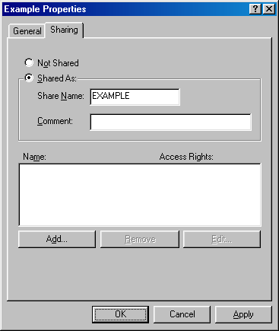
When you click Add, the list of accounts from the account source specified on the Access Control tab is read and displayed. The following figure shows an example.
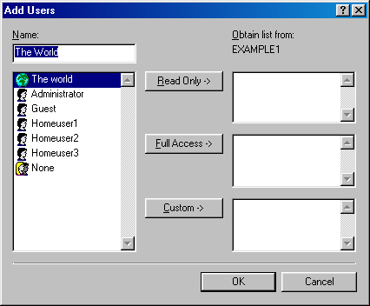
From Add Users, you can specify individual accounts for read-only, full, or custom access.
There are two special group accounts that do not correspond to accounts on the account source:
- The World
Used to specify all credentials. You use The World account when you want to grant access to all users, regardless of whether their credentials can be validated by the account source.
- None
Used to specify no credentials. You use None account when you want to block access to all users, regardless of whether their credentials can be validated by the account source.
When you specify accounts for custom access, you are prompted with a Change Access Rights dialog box, from which you can specify from a list of custom access rights. The following figure shows an example.
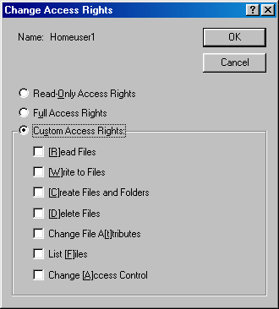
When configuring a shared printer, you can specify which accounts have full access and can submit print jobs and view the print queue of the shared printer.

Connecting to a Windows 98 or Windows Me Shared Folder
The behavior of connecting to a folder or printer that is shared from a computer running Windows 98 or Windows Me depends on whether share-level or user-level access control is configured.

Connecting When Share-Level Access Control is Being Used
If the folder is shared with the read-only access type with no password or the full access type with no password, then anyone using any set of credentials can connect.
If the folder is shared with the read-only access type with a password or the full access type with a password, then the credentials must use a password that matches the read-only or full password set on the shared folder. If the credentials are not using a password that matches the read-only or full password, then the connecting user is prompted to type the proper credentials. The following figure shows an example.
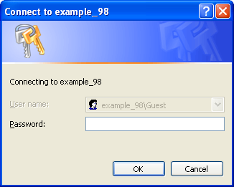
In this case, you only need to specify either the read-only or full access password.
If the shared folder is configured with different passwords for read-only and full access, then the type of access depends on the password sent.

Connecting When User-Level Access Control is Being Used
If user-level access control is being used, then to connect to a Windows 98 or Windows Me shared folder, you must be:
- Using a set of credentials that can be validated via the account source specified on the Access Control tab, and has been granted either explicit access or via The World account, as specified in the permissions of the shared folder.
- Using a set of credentials that cannot be validated via the account source specified on the Access Control tab, but The World account has been granted access, as specified in the permissions of the shared folder.
You can be denied access to a Windows 98 or Windows Me shared folder if the connecting user is:
- Using a set of credentials with a valid user name, but the password is incorrect.
- Using a set of credentials that can be validated via the account source specified on the Access Control tab, however, access has not been granted either explicitly (by account name) or through The World account, as specified in the permissions of the shared folder.
- Using a set of credentials that cannot be validated via the account source specified on the Access Control tab, and The World account has not been granted access, as specified in the permissions of the shared folder.
You can also be denied access if the None account has been granted access, and there are no other permissions.
From the connecting client computer, you can also receive the message "There are currently no logon servers available to service the request." if the account source (a computer or domain) is not available on the network.

Components of File and Printer Sharing
To act as a client computer, a computer running Windows 98 or Windows Me must have the Client for Microsoft Networks component installed. To verify that the Client for Microsoft Networks component is installed, do the following:
- On a computer running Windows 98, right-click Network Neighborhood, and then click Properties. On a computer running Windows Me, right-click My Network Places, and then click Properties.
- On the Configuration tab, under The following network components are installed, verify that the Client for Microsoft Networks component is installed. The following figure shows an example.
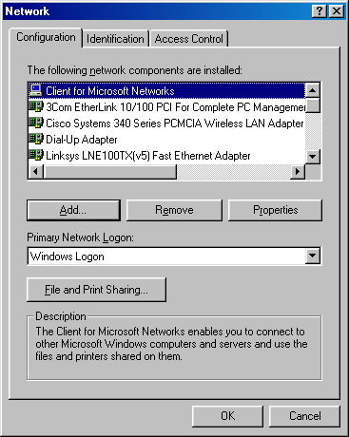
- If it is not installed, click Add.
- In Select Network Component Type, double-click Client.
- In Select Network Client, click Microsoft under Manufacturers, and then double-click Client for Microsoft Networks under Network Clients.
- Click Close.
- Restart the computer if needed.
To act as a server computer, a computer running Windows 98 or Windows Me must have the File and Printer Sharing for Microsoft Networks component installed. To verify that the File and Printer Sharing for Microsoft Windows component is installed, do the following:
- On a computer running Windows 98, right-click Network Neighborhood, and then click Properties. On a computer running Windows Me, right-click My Network Places, and then click Properties.
- On the Configuration tab, under The following network components are installed, verify that the File and Printer Sharing for Microsoft Networks component is installed. The following figure shows an example.
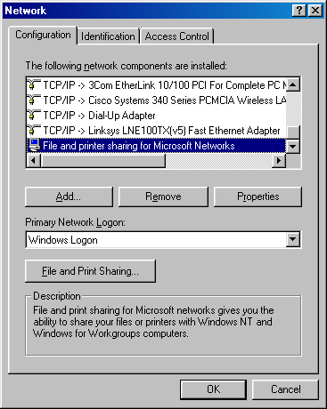
- If it is not installed, click Add.
- In Select Network Component Type, double-click Service.
- In Select Network Service, double-click File and printer sharing for Microsoft Networks.
- In Network, click File and Print Sharing. The following figure shows an example.
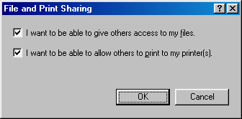
- Ensure that both check boxes are selected, and then click OK.
- In Network, click Close.
- Restart the computer if needed.

Sharing a Folder
To share a folder, right-click the folder in My Computer, and then click Properties. Alternately, you can share a folder from Windows Explorer; right-click the folder name in the tree pane, and then click Sharing.
From the Sharing tab for the folder's properties, click Shared As and do the following:
- Type a share name (the default share name is based on the folder name).
- Type a comment that describes the shared folder (optional).
- For share-level access, select the access type and type the passwords associated with read-only and full access as needed. Setting passwords on shares is optional.
- For user-level access, click Add and select the desired accounts and their access rights.

Connecting to a Shared Folder
There are many ways to connect to a shared folder, including the following:
- Using Start-Run to open a window containing the shared folder contents
- Using Network Neighborhood or My Network Places to open a window containing the shared folder contents
- Mapping a network drive to the shared folder

Using Start-Run
The easiest way to make a connection to a shared folder is by doing the following:
- Click Start, and then click Run.
- In Open, type \\ComputerName\ShareName (in which ComputerName is the name of the computer sharing the folder and ShareName is the name of the share when the folder was shared), and then press ENTER.
For example, to open the share named STUFF on the computer named HOMESRV, you would type \\HOMESRV\STUFF. You can use upper or lowercase letters for the computer and share names. If the share name contains spaces, enclose the entire \\ComputerName\ShareName in quotes. For example, to open the Shared Documents share on the computer named MOMSPC, you would type "\\MOMSPC\Shared Documents".
If you don't remember the name of the share, you can do the following:
- Click Start, and then click Run.
- In Open, type \\ComputerName and then press ENTER.
The window that is displayed contains the shared folders and printers of the specified computer. An example is shown in the following figure.
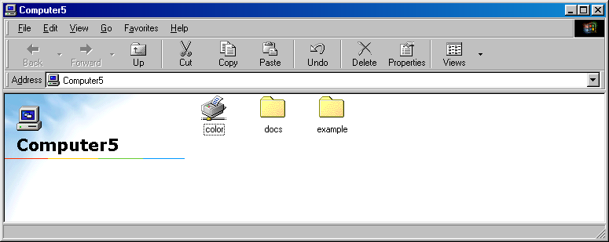
From this window, you can open the shared folders of the computer.

Using Network Neighborhood or My Network Places
To use Network Neighborhood (for Windows 98) or My Network Places (for Windows Me) to display the contents of a shared folder, do the following:
- From the Windows 98 desktop, double-click Network Neighborhood. From the Windows Me desktop, double-click My Network Places.
A window is displayed containing the set of computers in your home or small office workgroup. An example of the Network Neighborhood window is shown in the following figure.
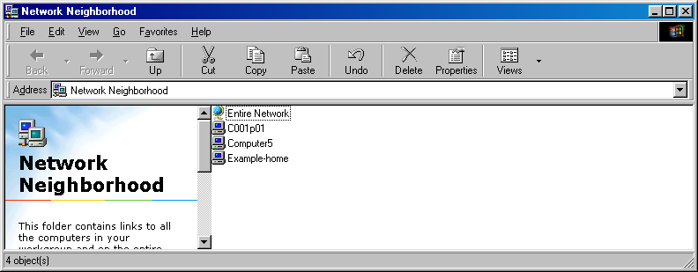
- From the Network Neighborhood window, open the computer containing the shares, and then open the desired shared folder.
- For Windows Me, from the My Network Places window, double-click Entire Network.
- In the Entire Network window, double-click the workgroup to which the computer belongs.
- From the workgroup window, open the computer containing the shares, and then open the desired shared folder.
The contents of the workgroup window depend on the configuration of the workgroup name on all the computers on your network. All of the computers on your network should be configured with the same workgroup name.
To manually change the workgroup name on a computer running Windows 98 or Windows Me, do the following:
Right-click Network Neighborhood (for Windows 98) or My Network Places (for Windows Me), and then click Properties.
In Network, click the Identification tab.
Type the name of the workgroup in Workgroup, and then click OK.
Restart the computer if needed.
If the computers on your network are using different workgroup names, then you can view all the workgroups on your network from the workgroup window by double-clicking Entire Network in the Network Neighborhood or My Network Places window. The resulting window displays all of the workgroups on your network, from which you open the desired workgroup, computer, and shared folder.
The contents of the Network Neighborhood or My Network Places window also depend on the operation of the Windows Computer Browser service. The Computer Browser service operates by collecting periodic announcement messages sent by the computers on your network. Due to timing issues, the workgroup window might not contain all the active computers on your network or might contain computers that are no longer active on your network. If the computer to which you want to connect does not appear in the workgroup window, then try opening a window containing the shared folders and printers of the computer through Start-Run.

Mapping a Network Drive
It is also possible to create a network drive that appears in My Computer as a drive but is actually mapped to a shared folder. To create a network drive, do the following:
For Windows 98, right-click Network Neighborhood, and then click Map Network Drive. For Windows Me, right-click My Network Places, and then click Map Network Drive.
In Map Network Drive, you can specify the following:
- In Drive, the network drive letter. By default, Windows 98 and Windows Me uses the first available drive letter.
- In Path, the folder name, which is the combination of computer and share name using \\ComputerName\ShareName.
- Whether to automatically reconnect the network drive when you log on to the computer.
An example is shown in the following figure.
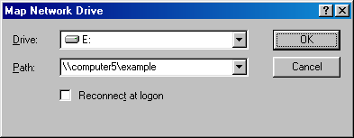
Click OK to map the network drive.
A window appears displaying the contents of the newly mapped network drive. An example is shown in the following figure.
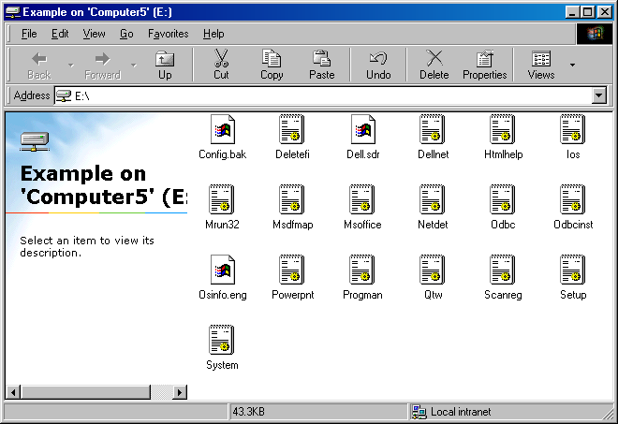
The mapped network drive also appears in My Computer. An example is shown in the following figure.
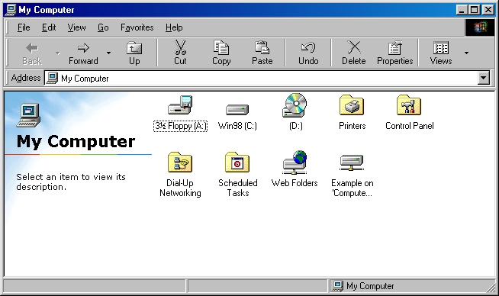

Sharing a Printer
You can share a printer from the Printers folder by doing the following:
Click Start, point to Settings, and click Printers.
From Printers, right-click the printer and then click Sharing.
From the Sharing tab, click Shared as, type the printer name and specify other settings as needed. For share-level access, you can type a password (optional). For user-level access, add the list of groups and accounts that are allowed to use the shared printer.
Click OK.

Connecting to a Shared Printer
There are several ways to connect to a shared printer, including the following:
- From the Add Printer Wizard
- Using Start-Run to open a window containing the shared printer
- Using Network Neighborhood (for Windows 98) or My Network Places (Windows Me) to open a window containing the shared printer

From the Add Printer Wizard
To connect to a shared printer from the Add Printer Wizard, do the following:
Click Start, point to Settings, and then click Printers.
In Printers, double-click Add Printer.
On the first page of the Add Printer Wizard, click Next.
On the second page of the Add Printer Wizard, click Network printer. An example is shown in the following figure.
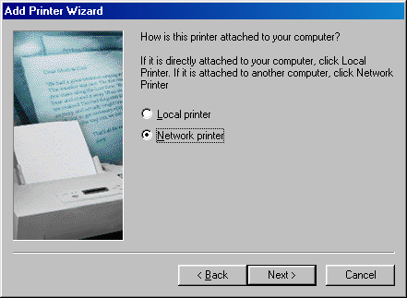
On the third page of the Add Printer Wizard, type the network path of the shared printer as \\ComputerName\SharedPrinterName (in which ComputerName is the name of the computer sharing the printer and SharedPrinterName is the name of the print share). Additionally, specify whether the printer should be made available from Microsoft Disk Operating System (MS-DOS).
An example is shown in the following figure.
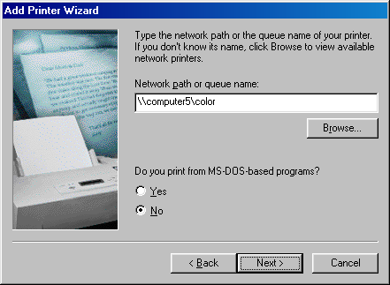
Click Next.
On the fourth page of the Add Printer Wizard, you can type a name for the printer. The printer name is automatically filled out for you. Additionally, you can specify whether this printer is the default printer. An example is shown in the following figure.
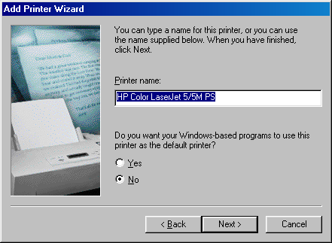
On the fifth page of the Add Printer Wizard, you have the option of printing a test page. Click Next.
The network printer should now appear in your Printers folder. An example is shown in the following figure.
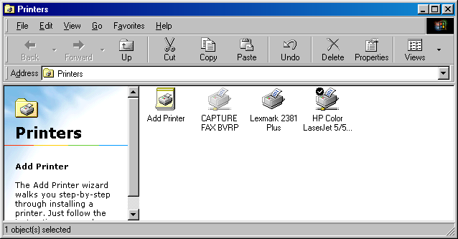

Using Start-Run
Another way to make a connection to a shared printer is by doing the following:
- Click Start, and then click Run.
- In Open, type \\ComputerName\SharedPrinterName, and then press ENTER.
For example, to connect to the shared printer named COLOR on the computer named HOMESRV, you would type \\HOMESRV\COLOR. You can use upper or lowercase letters for the computer and printer share names.
If you don't remember the name of the share, you can do the following:
Click Start, and then click Run.
In Open, type \\ComputerName and then press ENTER.
The window that is displayed contains the file and printer shares of the specified computer. An example is shown in the following figure.
From this window, you can double-click the shared printer icon to create a connection to it and automatically add it to your Printers folder.

Using Network Neighborhood or My Network Places
To use Network Neighborhood or My Network Places to connect to a shared printer, do the following:
- From the Windows 98 desktop, double-click Network Neighborhood. From the Windows Me desktop, double-click My Network Places, then double-click Entire Network, and then double-click the name of your workgroup.
A window is displayed containing the set of computers in your home or small office workgroup. An example is shown in the following figure.
- From the Network Neighborhood or workgroup window, open the computer containing the shared printer, and then double-click the desired shared printer.

Managing Shared Folders
In Windows 98 and Windows Me, you can manage shared folders using the Net Watcher system tool. The Net Watcher system tool is used to view and manage your shared folders, connected computers, and files that are open on your computer by connected computers. To open the Net Watcher system tool, do the following:
- Click Start, point to Programs, point to Accessories, point to System Tools, and then click Net Watcher.
An example is shown in the following figure.
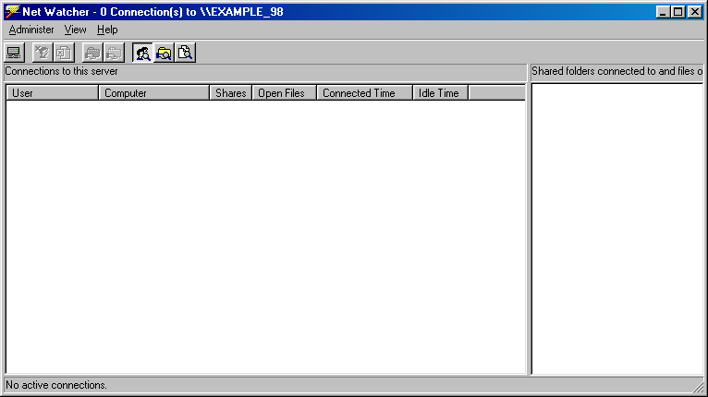
- Click the View menu or the toolbar icons to change the contents of the Net Watcher window.
Using Net Watcher, you can view:
- The set of shared folders shared on the computer (click View-by Shared Folders).
You can also stop the sharing of a shared folder or create a new shared folder.
- The names of the computers that are currently connected to the computer (click View-by Connections).
You can also manually disconnect a computer that is currently connected.
- The files that are open by remote computers (click View-by Open Files).
You can also manually close a file that is open by a connected computer.

Windows NT 4.0
This section describes file and printer sharing support in Windows NT 4.0.

File Sharing in Windows NT 4.0
Windows NT 4.0 supports user-level access to shared folders in a manner similar to Windows 2000 file sharing and Windows XP advanced file sharing.
The Sharing tab for a Windows NT 4.0 shared folder is shown in the following figure.
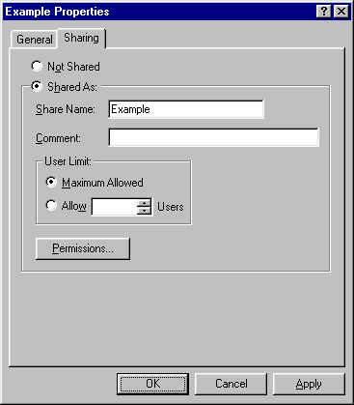
When you click Permissions, the Access Through Share Permissions is displayed, showing you the current set of permissions for connecting to the shared folder. The types of access are: No Access, Read, Change, and Full Control. The default shared folder permissions are shown in the following figure.
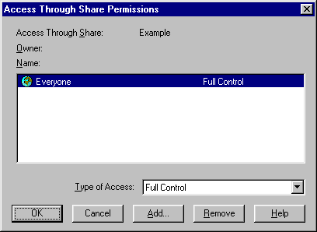
When you click Add, the Add Users and Groups window is displayed, showing the set of user and group accounts that are available from the computer running Windows NT 4.0. If the computer is a member of a workgroup, then only the accounts on the local computer are available. If the computer is a member of a domain, then you can select domain accounts, accounts from domains that are trusted by the domain of the computer, and local computer accounts.
An example of a computer running Windows NT 4.0 that is a member of a workgroup is shown in the following figure.
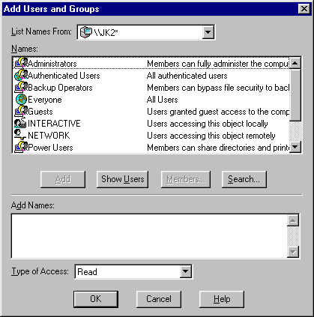

Connecting to a Windows NT 4.0 Shared Folder
In order to connect to a Windows NT 4.0 shared folder, you must be:
- Using a set of credentials that Windows NT 4.0 can validate (it is either a local computer account or a domain account) and has been granted the Read, Change, or Full Control access type either explicitly (the account name) or though group membership, as specified in the permissions of the shared folder.
- Using a set of credentials that Windows NT 4.0 cannot validate, and either the domain Guest account or the local Guest account has been enabled and has been granted the Read, Change, or Full Control access type either explicitly (the Guest account name) or though group membership, as specified in the permissions of the shared folder.
You can be denied access to a Windows NT 4.0 shared folder through the following:
- The account name in the credentials sent by the connecting client is a valid user name, but the password is incorrect.
- Windows NT 4.0 cannot validate the set of credentials and the domain Guest and the local computer Guest accounts are disabled or are not specified via the permissions of the shared folder. The domain Guest and local computer Guest accounts are disabled by default.
- Windows NT 4.0 can validate the set of credentials, but either access has not been granted or the type of access is set to No Access either explicitly (the account name) or though group membership.

Components of File and Printer Sharing
To act as a client computer, a computer running Windows NT 4.0 must have the Workstation network service component installed. To verify that the Workstation network service is installed, do the following:
- From the Windows NT 4,0 desktop, right-click Network Neighborhood, and then click Properties.
- Click the Services tab. Under Network Services, verify that the Workstation service is installed. The following figure shows an example.
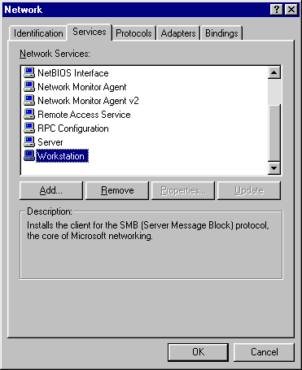
- If it is not installed, click Add.
- In Select Network Service, double-click Workstation.
- Click Close.
- Restart the computer if needed.
To act as a server computer, a computer running Windows NT 4.0 must have the Server service installed. To verify that the Server service is installed, do the following:
Right-click Network Neighborhood, and then click Properties.
Click the Services tab. Under Network Services, verify that the Server component is installed. The following figure shows an example.
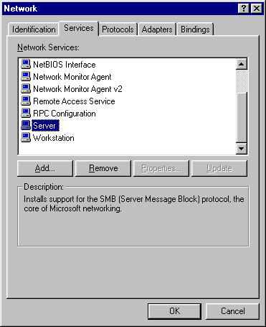
If it is not installed, click Add.
In Select Network Service, double-click Server.
Click Close.
Restart the computer if needed.

Sharing a Folder
To share a folder, right-click the folder in My Computer, and then click Sharing. Alternately, you can share a folder from Windows Explorer; right-click the folder name in the tree pane, and then click Sharing.
From the Sharing tab for the folder's properties, click Shared As and do the following:
- Type a comment that describes the shared folder (optional).
- Specify the maximum number of users that can connect, as needed.
- Click Permissions to configure the accounts that can connect to the shared folder and their level of access. By default, shared folders are shared to the Everyone group with full access.

Connecting to a Shared Folder
There are many ways to connect to a shared folder, including the following:
- Using Start-Run to open a window containing the shared folder contents
- Using Network Neighborhood to open a window containing the shared folder contents
- Mapping a network drive to the shared folder

Using Start-Run
The easiest way to make a connection to a shared folder is by doing the following:
Click Start, and then click Run.
In Open, type \\ComputerName\ShareName (in which ComputerName is the name of the computer sharing the folder and ShareName is the name of the share when the folder was shared), and then press ENTER.
For example, to open the share named STUFF on the computer named HOMESRV, you would type \\HOMESRV\STUFF. You can use upper or lowercase letters for the computer and share names. If the share name contains spaces, enclose the entire \\ComputerName\ShareName in quotes. For example, to open the Shared Documents share on the computer named MOMSPC, you would type "\\MOMSPC\Shared Documents".
If you don't remember the name of the share, you can do the following:
- Click Start, and then click Run.
- In Open, type \\ComputerName and then press ENTER.
The window that is displayed contains the file and printer shares of the specified computer. An example is shown in the following figure.
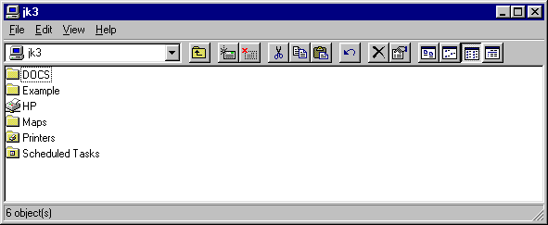
From this window, you can open the shared folders of the computer.

Using Network Neighborhood
To use Network Neighborhood to display the contents of a shared folder, do the following:
- From the Windows NT 4.0 desktop, double-click Network Neighborhood.
A window is displayed containing the set of computers in your home or small office workgroup. An example is shown in the following figure.
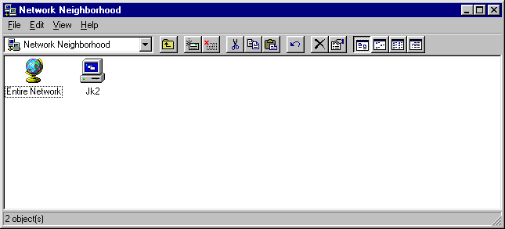
- From the workgroup window, open the computer containing the shares, and then open the desired shared folder.
The contents of the workgroup window depend on the configuration of the workgroup name on all the computers on your network. All of the computers on your network should be configured with the same workgroup name.
To manually change the workgroup name on a computer running Windows NT 4.0, do the following:
- Right-click Network Neighborhood, and then click Properties.
- In Network, on the Identification tab, click Change.
- In Member of, click Workgroup, type the name of the workgroup in Workgroup, and then click OK.
- Restart the computer if needed.
If the computers on your network are using different workgroup names, then you can view all the workgroups on your network from the workgroup window by double-clicking Entire Network in the Network Neighborhood window. In the Entire Network window, double-click Microsoft Windows Network. The resulting window displays all of the workgroups on your network, from which you open the desired workgroup, computer, and shared folder.
The contents of the Network Neighborhood window also depend on the operation of the Windows Computer Browser service. The Computer Browser service operates by collecting periodic announcement messages sent by the computers on your network. Due to timing issues, the workgroup window might not contain all the active computers on your network or might contain computers that are no longer active on your network. If the computer to which you want to connect does not appear in the workgroup window, then try opening a window containing the shared folders and printers of the computer through Start-Run.

Mapping a Network Drive
It is also possible to create a network drive that appears in My Computer as a drive but is actually mapped to a shared folder. To create a network drive, do the following:
- Right-click Network Neighborhood, and then click Map Network Drive.
- In Map Network Drive, you can specify the following:
- In Drive, the network drive letter. By default, Windows NT 4.0 uses the first available drive letter.
- In Path, the folder name, which is the combination of computer and share name using \\ComputerName\ShareName.
- In Connect As, you can specify a different account name than the account name of the current Windows logon session (the currently logged on user account). You can type the name as AccountName or Domain\AccountName.
- Whether to automatically reconnect the network drive when you log on to the computer.
- In Shared Directories, you can browse your network for the shared printer, rather than typing it in Path.
An example is shown in the following figure.
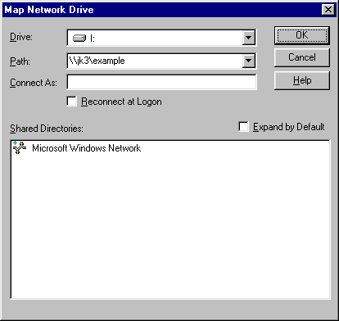
- Click OK to map the network drive.
A window appears displaying the contents of the newly mapped network drive. An example is shown in the following figure.
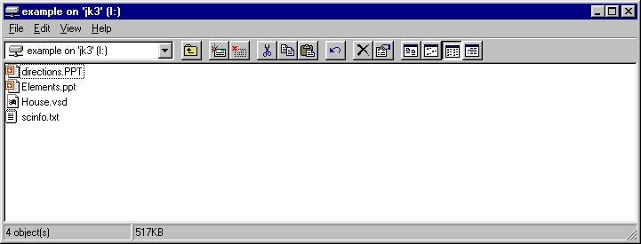
The mapped network drive also appears in My Computer. An example is shown in the following figure.
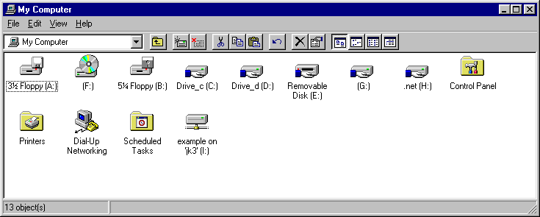

Sharing a Printer
You can share a printer from the Printers folder by doing the following:
- Click Start, point to Settings, and click Printers.
- From Printers, right-click the printer and click Sharing.
- From the Sharing tab, click Shared as, type the printer name and specify other settings as needed, and then click OK.

Connecting to a Shared Printer
There are several ways to connect to a shared printer, including the following:
- From the Add Printer Wizard
- Using Start-Run to open a window containing the shared printer
- Using Network Neighborhood to open a window containing the shared printer

From the Add Printer Wizard
To connect to a shared printer from the Add Printer Wizard, do the following:
- Click Start, point to Settings, and click Printers.
- From Printers, double-click Add Printer.
- On the first page of the Add Printer Wizard, click Next.
- On the second page of the Add Printer Wizard, click Network printer server. An example is shown in the following figure.
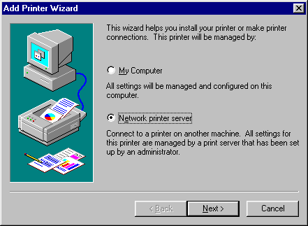
- Click Next.
- In Connect to Printer, type the \\ComputerName\SharedPrinterName (in which ComputerName is the name of the computer sharing the printer and SharedPrinterName is the name of the print share) in Printer. Alternately, you can browse the network using the Shared Printers box. An example is shown in the following figure.
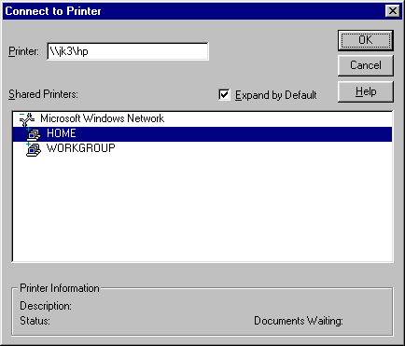
- Click OK.
- On the last page of the Add Printer Wizard, click Finish.
The network printer should now appear in your Printers folder. An example is shown in the following figure.
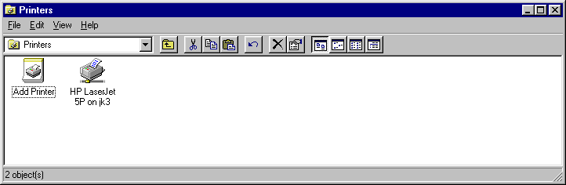

Using Start-Run
Another way to make a connection to a shared printer is by doing the following:
- Click Start, and then click Run.
- In Open, type \\ComputerName\SharedPrinterName, and then press ENTER.
For example, to connect to the shared printer named COLOR on the computer named HOMESRV, you would type \\HOMESRV\COLOR. You can use upper or lowercase letters for the computer and printer share names.
If you don't remember the name of the share, you can do the following:
Click Start, and then click Run.
In Open, type \\ComputerName and then press ENTER.
The window that is displayed contains the file and printer shares of the specified computer. An example is shown in the following figure.
From this window, you can double-click the shared printer icon to create a connection to it. Alternately, you can open the Printers folder and double-click the shared printer icon.

Using Network Neighborhood
To use Network Neighborhood to display the contents of a shared folder, do the following:
- Double-click Network Neighborhood.
A window is displayed containing the set of computers in your home or small office workgroup. An example is shown in the following figure.
- From the workgroup window, open the computer containing the shared printer, and then double-click the desired shared printer.

Summary
Windows file and printer sharing allows you to share folders and locally attached printers with other computers on a network. For each version of Windows (Windows XP, Windows 2000, Windows 98, Windows Me, and Windows NT 4.0), there are different features, components, connection processes, and methods for sharing folders, connecting to shared folders, sharing printers, connecting to shared printers, and managing file sharing.

Related Links
See the following resources for further information:
- Home and Small Office Networking with Windows XP at http://www.microsoft.com/homenet
- Troubleshooting File and Printer Sharing in Microsoft Windows XP at http://www.microsoft.com/downloads/details.aspx?familyid=fd7fd48d-6b4a-448e-a632-076f98a351a2&displaylang=en
- Troubleshooting Home Networking in Windows XP at http://support.microsoft.com/default.aspx?scid=kb;en-us;308007
- Description of File Sharing and Permissions in Windows XP at http://support.microsoft.com/default.aspx?scid=kb;en-us;304040
- How to Troubleshoot Network Printing Problems in Windows XP at http://support.microsoft.com/default.aspx?scid=kb;en-us;314073
- Sharing Files and Folders from the Windows XP Professional Resource Kit at http://www.microsoft.com/technet/treeview/default.asp?url=/technet/prodtechnol/winxppro/reskit/prde_ffs_flez.asp

For the latest information about Windows XP, see the Windows XP Web site at http://www.microsoft.com/windowsxp.

