 | IMAGINE CUP 2010  NEW ZEALAND  SOFTWARE DESIGN  ROUND 1  PROJECT PROPOSAL TEMPLATE
PROJECT PROPOSAL DUE 16 OCT 2009 | EMAIL TO ICNZ@MICROSOFT.COM

Note: Please return soft copy only – hardcopies will not be accepted. Maximum total number of pages – 3

Application Name

Where is my car?

Team Name

Team Sample

Team Members (Name & School)

 | Member 1 | Member 2 | Member 3 | Member 4
Full Name
Phone Contact
Email
Postal Address
Institution
Shirt Size
Gender

Problem

High rates of energy consumption are putting a strain on natural resources leading to different kinds of pollution. With the number of vehicles on the road increasing each day, fuel emissions are also on a significant rise. A measure to solve this problem to some extent is the concept of public transports for example the use of buses. However the system is inefficient because people are not sure of the exact location and time of arrival of the bus.

Solution

‘Where is my car?’ is a mobile phone software that provides the user with real-time information about buses “on the go” in a way which encourages them to use buses instead of private vehicles.

User Scenarios

Scenario 1: Its 10 pm. John came to have coffee with a friend after work and now wishes to go home. He is not sure of the closest bus stop and the next bus home. He also doesn’t have access to the internet or a bus timetable. He can search for a bus route from current location to his house and also see the closest bus stops from that location.

Scenario 2 : Tanya is going to catch a bus to work, however, the bus was involved in an accident. So the software notifies her about the problem and tells her about an alternative bus route or a special service dedicated to this problem.

Discuss Impact of Solution on Community/ Competitive Solutions

- Our software links the major learning techniques of visual aids, audio and written interaction.
- ‘Where is my car’ has been designed as a lightweight template that can be easily translated into other languages and formatted to target a particular age range making it truly effective across national borders.
- The interface is clean and simple so even a first time user can successfully complete a learning module.
- The user is given real time feedback on how they are performing through an audio message.
With the advances in Microsoft’s $100 laptop project we see ‘Where is my car’ as having the scope to reach millions who currently are pre-literate. We have worked alongside local language institutes and Schools in New Zealand to develop the software and see such organizations internationally as our entry point to our target market.

Discuss Business Viability of Application

We are planning a one month trial of our System in the greater Ilam area of Christchurch, New Zealand, which encompasses the University of Canterbury and one of the largest shopping malls in New Zealand. It contains a large student population who seldom travel outside the area.
We have the backing of a local transport company willing to provide vehicles, expertise and other resources. Several organisations, such as the Canterbury Innovation Incubator, have offered to invest in the system. Local and regional councils have also expressed support.
Assuming just 4% of students participate in the trial, our simulations of the trial indicate:
- Waiting times averaging just over 2 minutes
- Travel times just 3 minutes slower than a car, excluding parking
- Profitability when charging just NZ$2 (1€) per trip

Profits from the trial will be used to grow the system to encompass all of Christchurch. Later, it can be implemented in other cities.

Architectural Overview

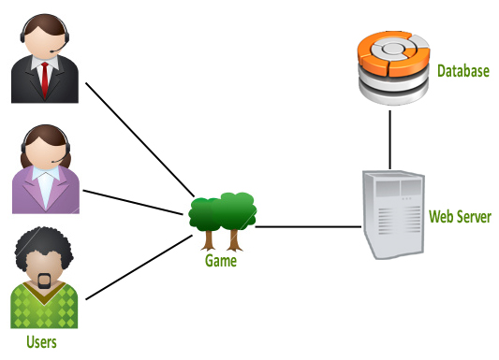

Technologies/Resources Used in the Application

Microsoft .Net 4.0
Microsoft Windows 7
Silverlight 3
Microsoft .Net Compact Framework
Microsoft Visual Studio 2008 Professional Edition
Visual C#
SQL Server
Mobile Device

