# logo-sql08.gif

**Better Together – SQL Server 2008 and SharePoint Products and Technologies**

SQL Server and SharePoint Technical Article

**Writer:** Patrick Gaul, proAxent solutions inc.

**Technical Reviewer:** Jie Li

**Published:** February 2009

**Applies to:** SQL Server 2008 and Microsoft SharePoint

**Summary:** SharePoint Products and Technologies provide enterprise-scale capabilities to meet business-critical needs such as managing content and business processes, simplifying how people find and share information across boundaries, and enabling better informed decisions. A critical element in the architecture of these technologies is Microsoft SQL Server, which provides all of the necessary data services to support the advanced functionality of Windows SharePoint Services 3.0 and Office SharePoint Server 2007. SQL Server enables the data-driven nature of these services, and SharePoint Products and Technologies leverage the advanced management, availability, performance, and security features of SQL Server. Together they provide a reliable, scalable, secure, and manageable foundation for all content, configurations, and shared services data in SharePoint deployments.

Copyright

The information contained in this document represents the current view of Microsoft Corporation on the issues discussed as of the date of publication. Because Microsoft must respond to changing market conditions, it should not be interpreted to be a commitment on the part of Microsoft, and Microsoft cannot guarantee the accuracy of any information presented after the date of publication.

This white paper is for informational purposes only. MICROSOFT MAKES NO WARRANTIES, EXPRESS, IMPLIED, OR STATUTORY, AS TO THE INFORMATION IN THIS DOCUMENT.

Complying with all applicable copyright laws is the responsibility of the user. Without limiting the rights under copyright, no part of this document may be reproduced, stored in, or introduced into a retrieval system, or transmitted in any form or by any means (electronic, mechanical, photocopying, recording, or otherwise), or for any purpose, without the express written permission of Microsoft Corporation.

Microsoft may have patents, patent applications, trademarks, copyrights, or other intellectual property rights covering subject matter in this document. Except as expressly provided in any written license agreement from Microsoft, the furnishing of this document does not give you any license to these patents, trademarks, copyrights, or other intellectual property.

Unless otherwise noted, the example companies, organizations, products, domain names, e-mail addresses, logos, people, places, and events depicted herein are fictitious, and no association with any real company, organization, product, domain name, e-mail address, logo, person, place, or event is intended or should be inferred.

© 2009 Microsoft Corporation. All rights reserved.

Microsoft SQL Server 2008 and SharePoint are trademarks of the Microsoft group of companies.

All other trademarks are property of their respective owners.

Contents

Introduction 4

System Requirements for SQL Server 2008 and SharePoint Products and Technologies 5

Improved Manageability 5

Policy-Based Management 5

Central Management Server Designation 6

Backup Compression (SQL Server 2008 Enterprise) 6

Improved Availability: Data Mirroring Enhancements 7

Log Performance Enhancements 7

Automatic Recovery from Corrupted Pages 8

Increased Security: Transparent Data Encryption (SQL Server 2008 Enterprise Edition) 8

Enhanced Business Intelligence Integration 10

Conclusion 11

# Introduction

SharePoint Products and Technologies provide enterprise-scale capabilities to meet business-critical needs such as managing content and business processes, simplifying how people find and share information across boundaries, and enabling better informed decisions. A critical element in the architecture of these technologies is Microsoft SQL Server, which provides all of the necessary data services to support the advanced functionality of Windows SharePoint Services 3.0 and Office SharePoint Server 2007. SQL Server enables the data-driven nature of these services, and SharePoint Products and Technologies leverage the advanced management, availability, performance, and security features of SQL Server. Together they provide a reliable, scalable, secure, and manageable foundation for all content, configurations, and shared services data in SharePoint deployments.

In general, customers would benefit from the following areas if they use SQL Server 2008 together with SharePoint Products and Technologies:

1. **Manageability**
2. **Availability**
3. **Security**
4. **Business Intelligence**

Continuing a history of innovation in the evolution of SQL Server, the release of SQL Server 2008 introduces a number of new and enhanced advanced capabilities that are especially relevant for deploying SharePoint solutions. These new and enhanced SQL Server 2008 capabilities are particularly important because SharePoint deployments are increasingly at the center of business-critical, data-driven applications for many enterprises. The underlying data schema of the data repositories for SharePoint deployments are abstracted and managed by the application architecture itself; developers who extend SharePoint with their own controls and services work with the SharePoint Object Model and do not need to write programs to access the data elements directly. However, there are a number of changes and enhancements to the SQL Server feature set which are especially beneficial from an architectural viewpoint.

This article outlines the specific enhancements in SQL Server 2008 that benefit the deployment of SharePoint Products and Technologies in three principal areas: Manageability, Availability, and Security. In the governance of enterprise-level web applications, these three areas are critical; enhancements in any of these areas should be of primary importance to the teams responsible for these applications.

It is important to stress that, in terms of the experiences of SharePoint administrators, developers, and end-users, the implementation of SQL Server 2008 is completely transparent. SharePoint Central Administration is unaffected, there are no changes to the SharePoint Object Model, and site users will observe no visual changes as a result of an upgrade of the database version. The new features in SQL Server 2008 affect SharePoint from the perspectives of overall architecture, security, availability, and database management.

## System Requirements for SQL Server 2008 and SharePoint Products and Technologies

The hardware and software requirements for SQL Server 2008 can be found at <http://msdn.microsoft.com/en-us/library/ms143506.aspx>.

For Windows SharePoint Services 3.0 and Office SharePoint Server 2007 support for SQL Server 2008, Windows SharePoint Services 3.0 Service Pack 1 must be installed. To download this Service Pack, go to <http://www.microsoft.com/downloads/details.aspx?FamilyID=875da47e-89d5-4621-a319-a1f5bfedf497&DisplayLang=en>.

It is important to note that some features described here may not be available in all editions of SQL Server 2008. For a matrix of features available within each edition, browse the page titled “[Features Supported by the Editions of SQL Server 2008](http://msdn.microsoft.com/en-us/library/cc645993.aspx)” on MSDN.

## Improved Manageability

The creation of databases for SharePoint configuration, shared services, and site content is handled automatically through SharePoint Central Administration, as well as through the STSADM command-line interface and the Administration namespaces in the SharePoint Object Model. Nonetheless, as is the case with any database, these SharePoint databases require additional management by database administrators.

Depending on organizational requirements, database management can become a complex process, and SQL Server 2008 contains several new features aimed at improving common management tasks. The features relevant to SharePoint deployments are *Policy-Based Management*,*Central Management Server* designation, and *Backup Compression*.

### Policy-Based Management

Defining database management processes to conform to an organization’s policies – for example, in an effort to meet negotiated service level agreements – is a common requirement for many enterprises. Prior to the availability of SQL Server 2008, this requirement gave rise to the need for additional tools and custom processes to determine how closely an organization’s database configuration and management processes conformed to those policies.

SQL Server 2008 has introduced a formal mechanism for this process: **Policy-Based Management** (previously known as the *Declarative Management Framework*). Through the SQL Server Management Studio, database administrators define the policies that are used to manage entities in the database environment; these policies can be automatically monitored and/or enforced.

An example of where Policy-Based Management can be important in a SharePoint deployment is if a Office SharePoint Server 2007 site collection is to be created in conformance with a service level objective that specifies a maximum duration between database log backup and truncate operations (this helps to ensure that the log will not grow excessively large). In SQL Server 2008, a policy can be created that be compares the current time with the database attribute that indicates the date and time that the log was last backed up. In the case that a database exceeds this maximum, the policy can trigger an alert that will in turn trigger a SQL Server job to backup and truncate the log of the database.

Policy-Based Management can also be used to enable a process whereby database administrators can immediately see how the database environment (or a specific entity within it) is in compliance with current policies.

For more information, visit the MSDN page titled [Administering Servers by Using Policy-Based Management](http://msdn.microsoft.com/en-us/library/bb510667.aspx).

### Central Management Server Designation

In an environment that is composed of multiple SQL Server instances, management policies and procedures must be implemented across individual managed instances. With SQL Server 2008, a single instance can be designated as a **Central Management Server**, and can store lists of other instances that comprise one or more **Central Management Server Groups**. Through these groups, actions taken on a particular Central Management Server Group will be taken on all member instances of that group. This simplifies the management process by eliminating the need for database administrators to repeat actions across a group of managed instances.

As SharePoint deployments grow to encompass multiple SQL instances, the Central Management Server designation helps to simplify the implementation of policies and procedures. As described earlier, Policy-based Management enables the creation of policies for the ongoing management of data entities in a SQL Server 2008 environment; through the Central Management Server, defined policies can be evaluated against all registered instances Central Management Server Group if required. All of the results of these evaluations can be viewed through a single results pane on the Central Management Server.

The designation of a Central Management Server and its constituent groups helps to consolidate management processes across a distributed SQL Server 2008 environment. To learn more about this feature, visit the MSDN page entitled [Administering Multiple Servers Using Central Management Servers](http://msdn.microsoft.com/en-us/library/bb895144.aspx).

### Backup Compression (SQL Server 2008 Enterprise)

As the amount of content in SharePoint deployments increases, so too does the amount of physical data stored in the underlying SQL Server databases. As a result of this growth, backup processes tend to take longer to complete, and any features that can improve these processes should be of interest to SharePoint administrators.

The length of time required for a backup process is dependent on the amount of I/O activity required to perform the backup operation. If it is possible to reduce the amount of I/O required in writing the backup data to the backup device, significant improvements can be expected in the speed of the backup, as well as providing greater storage efficiency for backup sets. The **Backup Compression** feature found in SQL Server 2008 Enterprise Edition provides this increased efficiency in the backup process. You can learn more about Backup Compression in SQL Server 2008 Enterprise Edition at <http://msdn.microsoft.com/en-us/library/bb964719.aspx>.

It should also be noted that the Backup Compression feature can increase CPU utilization on the SQL Server 2008 instance that is performing compressed backups. To minimize the impact of these operations on overall server performance, the new **Resource Governor** in SQL Server 2008 can be employed. More information on the Resource Governor may be found at <http://msdn.microsoft.com/en-us/library/bb895232.aspx>.

## Improved Availability: Data Mirroring Enhancements

For business-critical deployments, database mirroring technology increases the availability of SharePoint applications by enabling mirrored instances of data which can take the place of the principal data source in the event of an unplanned event or failure that results that data source becoming unavailable. SQL Server support for database mirroring, introduced in SQL Server 2005, has been considerably enhanced in SQL Server 2008. The value of these enhancements is applicable to any application that uses SQL Server as a database platform and requires failover capability, and is therefore especially relevant to high-profile SharePoint deployments.

The enhancements to database mirroring in SQL Server 2008 are in two principal areas: Log Performance Enhancements and Automatic Recovery from Corrupted Pages.

### Log Performance Enhancements

There are a number of enhancements to logging in SQL Server 2008 which improve the performance of database mirroring which can improve recovery time in a failover event:

* *Compression of stream data* for which at least a 12.5 percent compression ratio can be achieved.
* *Write-ahead on the incoming log stream on the mirror server*: In SQL Server 2008, incoming log records are written on the mirroring server asynchronously, while records which have already been written are concurrently processed to keep the mirrored database up to date with the principal database.
* *Improved use of log send buffers*: In SQL Server 2008, the need for the principal server to reserve a whole database mirroring log send buffer for its log records on each log flush has been removed; if the most recently-used log cache contains enough space for the log records in the next log flush operation, they are appended. If not enough space exists, a new log cache is allocated.
* *Page read-ahead during the undo phase*: Following a failover, the new mirror server must undo changes for which pages were written to disk locally but for which the log record may not have been received by the former mirror server (the new principal server). To undo such changed pages, the mirror server must first request and receive the corresponding pages from the new principal server. Performance of this part of the undo phase is enhanced in SQL Server 2008. Early in the undo phase, the mirror server sends read-ahead hints to the principal server to indicate which pages will be requested later. After receiving a read-ahead hint for a page, the principal server puts that page in its send buffer. On receiving the corresponding page request, the principal server can respond immediately.

### Automatic Recovery from Corrupted Pages

A new feature of SQL Server 2008 improves automatic recovery from corrupted pages. For certain types of errors that prevent reading a data page, the database mirroring partner automatically tries to resolve the error; the partner that is unable to read a page requests a fresh copy from the other partner. If this request succeeds, the unreadable page is replaced by the copy, which usually resolves the error. For more information, see [Automatic Page Repair during a Database Mirroring Session](http://msdn.microsoft.com/en-ca/library/cc645581.aspx) on MSDN.

## Increased Security: Transparent Data Encryption (SQL Server 2008 Enterprise Edition)

In an increasingly security-conscious world, the protection of enterprise data assets is an issue of escalating importance. Indeed, many organizations now face regulatory compliance requirements that not only demand tight controls in accessing data, but may also require physical encryption in the underlying data storage mechanism. Physical encryption of data ensures that sensitive information cannot be accessed even if a database’s underlying physical files are stolen.

From the perspective of enterprise applications in a Windows Server and SQL Server environment, prior to SQL Server 2008 the available options for the physical encryption of data were as follows:

1. **Windows File Encryption,** which (as the name suggests) provides data encryption at the physical file level. Since Windows 2000, this has been available through the **Encrypting File System** (EFS).
2. **BitLocker,** available in the Enterprise and Ultimate versions of Windows Vista and in Windows Server 2008, provides volume-level encryption.
3. **Cell-level encryption** in SQL Server 2005 and later, which is implemented through a combination of built-in functions, a key management hierarchy, and application code to encrypt and decrypt data.

Both Windows File Encryption and BitLocker are automatically handled by the operating system. Encryption and decryption of data happens automatically when dealing with the physical storage of data; these methods require no specific application code to implement. However, it is important to understand that data items encrypted using these methods are not encrypted if cached in memory.

Cell-level encryption provides a very granular approach to the encryption and decryption of data at the cell level in SQL Server database applications. This form of encryption has the advantage that as pages from a SQL Server database are loaded into memory, the encryption remains in place until the data is actually used by the application. Drawbacks of this approach include the fact is that a key hierarchy must be maintained to support this capability and that the applications which access the data must be engineered to access built-in encryption and decryption methods. As well, automatic query optimization methods cannot be used with data encrypted using this method. Nonetheless, this is a very effective mechanism for data encryption when the requirements are distinctly granular in nature.

SQL Server 2008 Enterprise Edition offers a new alternative for the encryption of application data in SQL Server at the database level: **Transparent Data Encryption** (TDE). As its name implies, this method of physical data encryption is designed to be as transparent as possible and requires no changes to the application code which accesses the database, so the user interaction with the data is not changed. (As with any encryption method, there is an associated cost in CPU processing during I/O operations, but the actual impact will vary depending on the specific platform’s typical CPU utilization and I/O activity rates. It is recommended that SharePoint administrators assess these impacts in a test mode before enabling them on a production system to ensure that the impacts will not adversely affect overall performance.)

Perhaps the greatest advantage of TDE is that it can be enabled at the database level without requiring any changes to the applications that access the data. For existing SharePoint deployments, this means that TDE can simply be enabled for those deployments’ content, shared services, and/or configuration databases, and no changes are needed in SharePoint Central Administration, nor in the Windows SharePoint Services 3.0 or Office SharePoint Server 2007 applications that access the data.

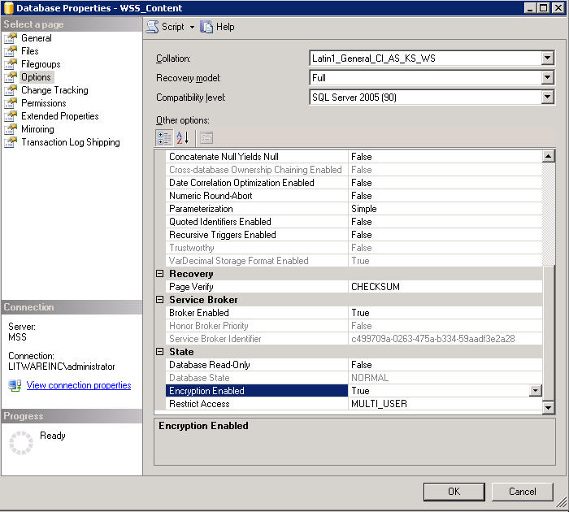

Figure.1 Encryption turned on for Content Databases

A more detailed discussion about TDE, how it compares to alternative encryption methods, and how it is enabled can be found in the article “[Database Encryption in SQL Server 2008 Enterprise Edition](http://msdn.microsoft.com/en-us/library/cc278098.aspx)” on MSDN.

## Enhanced Business Intelligence Integration

SQL Server Reporting Service has a long history integration with SharePoint Products and Technologies. By embedding frequently used reports on SharePoint pages, IT professionals gain a simplified interface to the report server and the power of business intelligence reporting is made accessible to users of the SharePoint environment.

**New Charts**

With increased investment in new visualization capabilities, SQL Server 2008 Reporting Service offers an enhanced charting engine. This new engine brings many possibilities to SharePoint as a report center. Now users can choose in a large variety of chart types, which enable decision makers to view data in a friendlier format that enables them to see the big picture immediately.

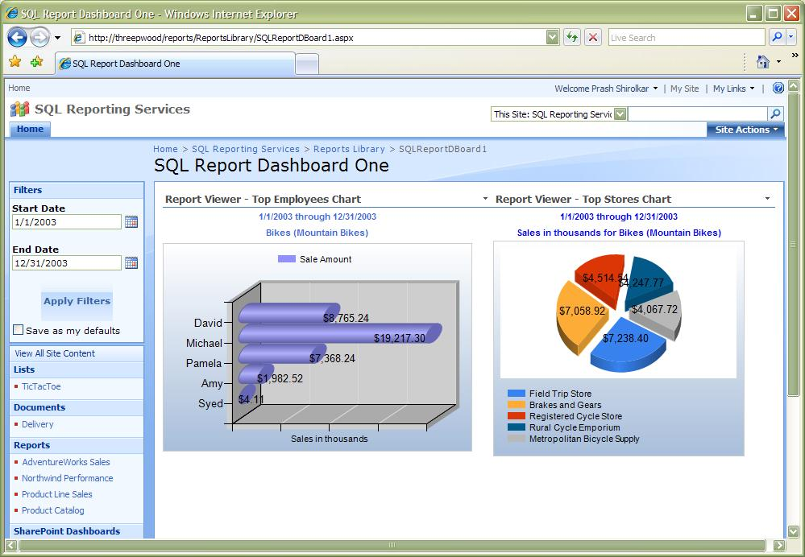

Figure 2. New Graphics Enhancement in Reporting Service on SharePoint

**Report Builder**

For those individuals who are not developers but would like to modify existing reports or build their own, Report Builder is an easy-to-use authoring envoriment with an interface that shares many of the characteristics of Microsoft Office applications. Even a non-technical user can launch Report Builder from a SharePoint page, build reports based on semantic report models from SQL Server 2008 databases, and publish these reports directly to SharePoint sites.

## Conclusion

This article has shown how significant benefits in the areas of manageability, availability, business intelligence and security can be realized by the implementation of SQL Server 2008 in SharePoint deployments (Windows SharePoint Services 3.0 and Office SharePoint Server 2007):

* **Manageability – Policy-Based Management** and **Central Management Server** designation can enhance and simplify administrative processes and allow administrators to exercise better control over the management requirements of SharePoint databases; **Backup Compression** can optimize I/O streams during backup, improving the time required for backups to complete and the amount of storage required for backup sets;
* **Availability** – enhanced **Database Mirroring** functionality improves the recoverability of data in both failover and individual page error scenarios, thereby increasing the availability of SharePoint databases using SQL Server 2008;
* **Security** – SQL Server 2008 Enterprise Edition’s **Transparent Data Encryption** feature allows physical media encryption at the database-level, without requiring any changes to the SharePoint applications that access those databases, and
* **Business Intelligence** – the improved **Reporting Services** in SQL Server 2008 have greatly enhanced the user experience for delivering reports through SharePoint Products and Technologies. The newly-introduced Report Builder allows individuals to design and publish reports to SharePoint sites with greater ease.

**For more information:**

<http://www.microsoft.com/sqlserver/>: SQL Server Web site

<http://technet.microsoft.com/en-us/sqlserver/>: SQL Server TechCenter

<http://msdn.microsoft.com/en-us/sqlserver/>: SQL Server DevCenter

Did this paper help you? Please give us your feedback. Tell us on a scale of 1 (poor) to 5 (excellent), how would you rate this paper and why have you given it this rating? For example:

* Are you rating it high due to having good examples, excellent screen shots, clear writing, or another reason?
* Are you rating it low due to poor examples, fuzzy screen shots, or unclear writing?

This feedback will help us improve the quality of white papers we release.

[Send feedback](mailto:sqlfback@microsoft.com?subject=White%20Paper%20Feedback:%20[Title%20of%20White%20Paper]).