
Service Dispatch

Microsoft Dynamics™ SL

Benefits
- Simplify service and dispatch processes
Automate your service call processing,
dispatching, sales closure, and cost-related
activities efficiently and accurately.
Service Dispatch helps streamline business processes, reduce paperwork, eliminate
duplicate data entry, and provide critical
client historical information.

- Improve customer satisfaction
Service Dispatch gives you all the critical
client contract and historical information
you need to operate your business more
profitably. Focus more time on helping
customers rather than managing multiple
systems, so that your customers can now
rely not only on your service skills but also
on your ability to manage their information.

- Streamline data entry
Enter new customer information quickly,
perform look-ups, and retrieve customer
information more easily than ever before.
From a single screen, you can enter existing or new customer information, service call details, and other information such as preferred technicians and credit card numbers.

- Work proactively
Receive proactive message alerts to notify
you of delinquent accounts and easily
view account information to remind your
customer of an overdue invoice. Other
user-defined messages can alert you to required purchase orders, any active
service contracts, and whether another service call has been assigned to the site.

- Enhance service dispatch
Schedule service calls easily and
electronically, in the same system as
your contract and invoicing information. Manage service calls down to the problem code level, view preventive maintenance
and emergency service calls in the same screen, and adjust schedules with simple drag-and-drop functionality. View detail or summary information with a simple shift between single-day and week-at-a-glance views.

Track and manage every detail of your service organization with Microsoft Dynamics SL Service Dispatch. Flexible capabilities help you manage field technicians efficiently, clarify information about technicians’ profitability, and accurately track customer information, including account status and equipment and service history.

Reschedule
or reassign service calls to a different technician with simple drag-and-drop functionality.

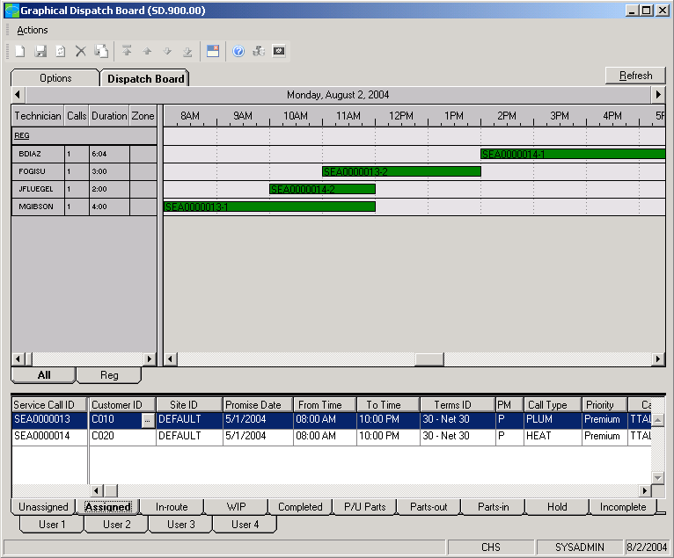

Shift
between single-day and
weekly views.



Microsoft MapPoint integration  features  BENEFITS | Map service call addresses more quickly and accurately — and plan  technicians’ routes accordingly — with integration between Microsoft  MapPoint® and field service for Microsoft Dynamics SL.
Flexible Invoicing | - Process invoices for flat rate or time and materials. Labor hours can be entered and sent into Microsoft Dynamics SL Payroll, eliminating redundant entry.  - Enter parts used versus parts purchased, work hours versus billable hours, billable versus non-billable transactions, and more — on a single transaction.  - Create an invoice while keeping a service call open by using progress  billing capabilities. You can also bill third parties and retain  site-specific history of all services performed.
Integrated Pager Communication | Enable technicians to communicate with headquarters, receive work  assignments, complete work orders, and more with integrated two-way  pager capabilities.
Time/Money Savings | Empower field technicians to send invoice information electronically,  including time and materials, to the Microsoft Dynamics SL accounting  system, thus improving cash flow and cutting billing time from weeks  to days or even hours.
Easy Lookup | Locate an existing customer by searching by name, address, phone number, zip code, customer ID, or equipment serial number.
Faster Data Entry | Save time with the extensive use of default values for fields, including the current date/time, call types, status, and technicians. Default information can be overridden anytime by a user with the proper access rights.
Multiple Location Management | Keep accurate, site-specific service information for every customer, including multiple addresses, contact, phone number, and detailed notes.
Advanced Search Criteria | Search sites rapidly during work order entry to process incoming service  requests using advanced criteria such as name, address, phone number,  equipment ID, and serial number.
Service Call Substantiation | Manage incoming calls better by alerting customer service representatives  (CSRs) of credit issues, unauthorized tenant call requests, and existing open  service calls, and by prompting CSR notes when entering fault codes.
Dispatcher Flexibility | Sort/select service calls by branch, technician, geographic zone, call type,  and status- such as unassigned calls, in-progress calls, and completed  calls.
For more information about Microsoft Dynamics™ SL, visit: http://www.microsoft.com/dynamics/sl

This document is for information purposes only.
MICROSOFT MAKES NO WARRANTIES, EXPRESS, IMPLIED, OR STATUTORY, AS TO THE INFORMATION IN THIS DOCUMENT.

© 2005 Microsoft Corporation. All rights reserved.
Microsoft, The Microsoft Dynamics Logo, are either registered trademarks or trademarks of Microsoft Corporation or Microsoft Business Solutions ApS in the United States and/or other countries. Microsoft Business Solutions ApS is a subsidiary of Microsoft Corporation.

