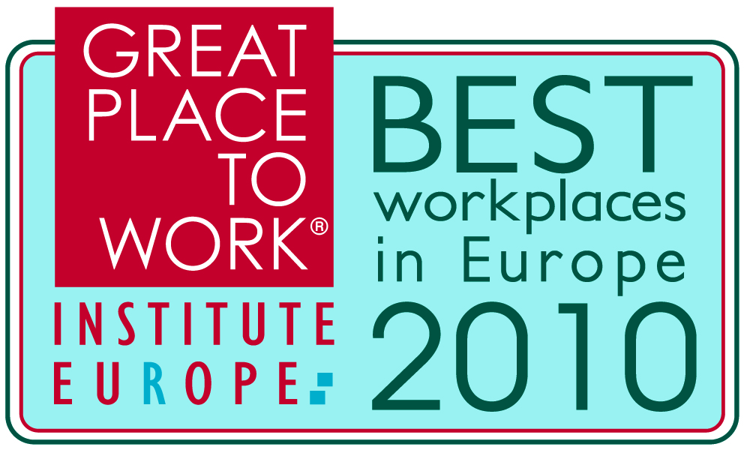
 | Great Place to Work Institute  Palle Ellemann Managing Director of Great Place to Work Institute Europe

What makes a great place to work today, and has this changed as we emerge from recession?
The key element of our understanding of a great place to work is trust and I think that trust is more important now than ever before. So, fundamentally that a great workplace starts with building trust, pride and camaraderie in the relationships within the organization hasn't changed. But we may see differences in what expectations employees will have of employers and what the priorities employees will have in the workplace.

How do you think the new world of business will impact employee’s opinions’ on what makes a great place to work?
We have just conducted a correlation study of close to 300,000 employee surveys from Europe this year and it is interesting to see that the two statements with the strongest correlation to people's perception of a great workplace are the two statements in the survey instrument about reliability - that leaders "walk the talk". This is not surprising taking the insecurity of the labour market into consideration and this reliability and consistency are some of the main drivers for trust these days. Despite the turmoil of the markets during the past couple of years, we actually don't see a lot of change in which companies make the lists of the Best Workplaces. Companies don’t become a Best Workplace for being the first-mover in making changes, but rather for doing exactly what they said they would do yesterday and the day before.

As the millennial generation enters the workforce, how important is it for companies to offer staff flexible working options?
I think this is a key issue for this generation. Not just because they would expect an employer to take advantage of the technologies available, but also because the millennial generation have such high ambitions of succeeding in so many different areas - they want it all at the same time. If you don't manage as an employer to position work in the right way in the lives of the millennial generation, then you may not be attractive to this group.

How important is technology such as cloud computing, unified communications etc. to establishing a great place to work?
There is no doubt that today technology is a hugely important enabler for establishing a great place to work. In particular for the large and dispersed organisations technology is very important to bind together communication and working processes. You can have great camaraderie with your colleagues, but if the technology you work with doesn't work and it prevents you from being successful, then you will be frustrated at the end of the day anyway. Some new technologies are also opening up more flexible work schemes and new ways of collaboration within and across organisations, things that open up new opportunities are highly appreciated by employees.

What do think makes Microsoft a great place to work?
Microsoft has a great track record for consistency - doing what they say - and honouring the values of the organisation. There are excellent development opportunities for employees within the organisation and a great respect for people's needs and priorities. We also see that employees at Microsoft truly appreciate the impact that a company like Microsoft has on society and many employees take an active role in the huge variety of activities that Microsoft organises in the local communities and across the region.

