
Microsoft Enterprise Project Management Solution 2007

Table of Contents

Cover is for
position only

Overview of the Microsoft Enterprise Project Management Solution 2
Efficiently Manage All Types of Work 2
Gain Visibility and Insights 3
Communicate and Collaborate with Ease 3
Evolve with a Scalable and Configurable Platform 4
Efficiently Manage All Types of Work 5
Manage the Simple and the Complex 5
Manage Resources 5
Save Time with Templates 6
Create Your Own Templates 6
Use Predefined Templates 6
Control Project Finances 7
Budget for Financial Control 7
Assign Costs to Tasks with Cost Resources 8
Gain Visibility and Insights 10
Track the Entire Project Life Cycle 10
Create Custom Reports 10
Communicate and Collaborate with Ease 11
Use Enhanced Timesheet Capabilities 11
Access Project Information Through the Web 11
Enhance Knowledge Sharing 12
Use Existing Investments and Knowledge of Desktop Programs 12
Evolve with a Scalable and Configurable Platform 15
Improved Performance 15
Manage the EPM Solution 15
Fully Extensible 16
Architecture 18
Backwards Compatibility, Interoperability, and Migration 19
Summary of the Microsoft EPM Solution Benefits 20
System Requirements 21
Project Server 21
Project Professional 22
Project Web Access 23
Additional Resources 25

Overview of the Microsoft Enterprise Project Management Solution
The Microsoft® Enterprise Project Management (EPM) Solution helps you to effectively manage and prioritize projects and resources across your organization. The EPM Solution consists of the following programs: Microsoft Office Project Professional 2007, Microsoft Office Project Server 2007, and Microsoft Office Project Web Access. Microsoft designed the EPM Solution for organizations needing strong team coordination, standardization across projects and programs, centralized resource management, as well as high-level reporting about projects and resources. Project provides a central repository of project and resource information so that organizations can consistently manage and report across the enterprise.

Project Professional incorporates all the features of Project Standard. Please refer to the Microsoft Office Project Standard 2007 Product Guide for more information.
The EPM Solution empowers organizations to:

Efficiently Manage All Types of Work
Efficiently manage work from simple projects to large programs. A key aspect of management is financial control which the new version provides. Propagate best practices for project work with enterprise templates to improve project management processes throughout your organization.
- New! Assignment Owner
- New! Cost Resources
- New! Deliverables
- New! Import Project Task Lists from Microsoft Windows® SharePoint® Services
- New! Multiple Currencies
- New! Programs
- New! Resource Plans
- New! Team Resource
- Enhanced! Templates
- New! Budget Tracking

Gain Visibility and Insights
Visibility means you can easily find, analyze, and report on all types of information about your projects. In addition to active projects, you can now see the activities before initiation as Proposals and after project completion as Operations Work.
- New! Cube Building Service
- New! Operations Work
- New! Proposals
- New! Reporting Data Service

Communicate and Collaborate with Ease
The EPM Solution enhances information-sharing and coordination among project teams for better participation, progress reporting, and collaboration.

Project provides improved coordination across teams using its automated notifications, integration with other programs, and Web portal access, which enables users to easily view, update, and analyze project information.

The integration of Office Project Server 2007 with Microsoft Windows SharePoint Services (version 3.0) enables you to centrally store, link, and share project-related issues, risks, and documents for collaborative tracking.
- Enhanced! Project Workspaces
- Enhanced! Outlook Integration
- Enhanced! Timesheets

Evolve with a Scalable and Configurable Platform
The Office EPM Solution provides the flexibility to meet your needs as your business requirements evolve. You can customize and integrate Project Server data with existing systems through the new Project Server Interface application programming interface (API) and Microsoft Visual Basic® for Applications object model changes. A redesigned architecture and new features support more users with better performance. The EPM Solution reduces the burden of administration with setup improvements, database partitioning, and more.
- New! Active Cache
- Enhanced! Administration User Interface
- New! Event Model
- New! Project Server Interface
- New! Project Web Access as Web Services
- New! Queuing Service
- New! Server Side Scheduling

Efficiently Manage All Types of Work
The EPM Solution now covers a broader range of work and tracks a wider range of information to provide you better control of your organization’s activities, resources, and investments.

Manage the Simple and the Complex
When you need a one-time project, you can use Windows SharePoint Services as part of the EPM Solution. In Windows SharePoint Services, you can create a project task list that can be imported in Project Web Access to become projects on Project Server. This process increases participation in the EPM Solution while capturing work investments and time commitments that would otherwise not historically have been tracked in Project.
At the high end, Programs enable easy management of multiple sub-projects as a single object. This means you can now generate key performance indicators and analysis at the program rather than just the project level. In order to better display the cross-project dependencies within a program, the new version introduces Deliverables. Deliverables are published as a SharePoint list of committed dates to which other project managers can link their project or tasks.

Manage Resources
The EPM Solution helps you accurately assess needs to effectively deploy resources today and create future Resource Plans for your organization. Resource Plans provide information about high-level resource allocation when detailed resource assignments do not exist, such as in proposed and anticipated projects, task-only projects, and projects where assignments do not accurately reflect resource distribution. These plans help ensure you have the right people on your high-priority projects for optimal delivery, and you hire appropriately skilled resources according to the demands of your projects. With Multiple Currencies, you can set the rates for resources in different currencies and establish a table of exchange rate data in order to generate reports in a single currency. Team Resources enable work to be assigned to an entire team rather than an individual resource. Any member of the team can accept the assignment and report time against it. A Team Resource displays availability based on the team’s aggregate capacity. The Assignment Owner feature enables individuals other than the assigned resource to provide status updates on an assignment. Assignments can also be changed from the current assignment owner to a new individual as necessary. Assignment Owners enable the tracking of utilization of materials (non-human resources) or staff that do not use the EPM Solution themselves.

Save Time with Templates
Office Project provides a wide range of predefined templates to help speed your project management process by establishing repeatable processes and capturing best practices.

Create Your Own Templates
Capitalize on your time and expertise by creating your own custom templates, so you can reuse an existing project as the basis for future projects. A template can capture task and resource information, formatting, macros, and other project-specific settings. Templates give you a quick start by automatically populating a new project with generic information that you can tailor to your specific needs. You can send local templates in e-mail to other users to share best practices for your specific functional area or industry. You can publish them to your whole organization as an enterprise template. Enterprise templates create consistency, which enables roll-up and reporting across projects and programs.

Use Predefined Templates
When creating a new project, you can build from a blank template or choose templates created within your firm, provided from the Project installation, or available on Microsoft Office Online for download. The out-of-the-box templates cover a range of industries, functional areas, and business problems. Templates range from Commercial Construction to New Product Development, all of which are designed to fulfill a specific objective that meets your industry and project management needs. See Figure 1.
Microsoft also provides two templates that you can use in Microsoft Office Excel® to start a new project, create a task list, include resources, and import this information into Project. These templates automatically map fields and information directly into Project. The Microsoft Project Task List Import template helps you build a basic task list. The Microsoft Project Plan Import Export template enables you to create the task list, add resources, and make assignments. This template can be imported into Project and exported back to Excel for revising.
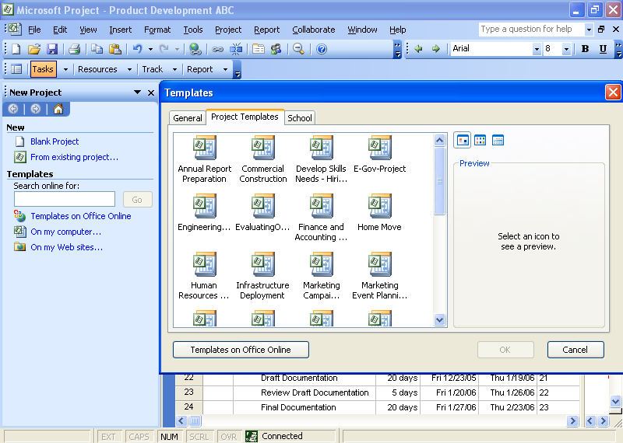
Figure 1: Create a new project based on predefined Project templates.

Control Project Finances
By defining top-down budgets for projects or programs, users gain better financial reporting and analysis, enabling alignment of work with corporate objectives. Project further supports financial control by introducing a new “cost” resource type as well as predefining a number of new project accounting fields.

Budget for Financial Control
Budget Tracking enables Project to support the method many organizations use to allocate budgets to specify the amount of resources each project or program should use. A budget may be specified either as monies (for example, dollar amounts for labor, materials, or other cost types), as work (Full-Time Equivalents), or as materials. This feature enables display of the variances between the budget and the actual roll-up numbers (Work, Cost, Actual Work, and Actual Cost) coming from the detailed plan.

Assign Costs to Tasks with Cost Resources
In the previous version, Project included two types of resources: Work and Material. In the 2007 version, you gain a new type of resource: Cost. Now for each task, you can assign multiple arbitrary costs (not based on work time) and use custom fields to specify cost type or financial code. Cost Resources enable you to more accurately monitor project financials and keep your project in sync with data in your accounting systems. When your project incurs costs, this resource type provides you the ability to apply those costs to tasks, so they affect the overall reported project cost, unlike custom fields.
EPM Scenario: Implementing the EPM Solution to Manage a Growing Business
A team of managers sits in a conference room tossing out ideas for their next year’s operations. To stay competitive, their firm needs to update its existing product lines and develop several new product concepts. These ideas quickly coalesce into a set of proposals, which are entered directly into Project Web Access. The management team reviews the proposals, promoting most of them from proposals to full projects and granting budgets. The vice president of product development has analysts create a best practice template and custom Project Guide for product development. All the teams use the template and Project Guide when adding details to their projects. Project tasks are often assigned to team resources rather than specific resources, which enables the team members to allocate the work themselves. This saves the teams time and creates consistency across all efforts.
The vice president of operations creates a program to retool all of the firm’s manufacturing plants. The program has separate projects for each existing product line and placeholders for new products. Managers on his team use the firm’s manufacturing line conversion template as the basis for quickly creating each project. The managers can start some of their work but are often blocked by dependencies on the product development team’s deliverables. These dependencies appear in a single SharePoint list so the vice president of operations can easily hold discussions with his counterpart in product development and manage expectations of executives if there are schedule slips.

Gain Visibility and Insights
Managing all aspects of the project life cycle gives you greater control over project investments and control of activities around the actual project implementations. Office Project reporting enables you to set realistic expectations with project teams, management, and customers.

Track the Entire Project Life Cycle
Project Web Access Proposals now enable project initiation on the Web. Tracking Proposals will provide better high-plain analysis and will enable the use of business processes to track potential projects as well as use Office Project functionality to perform what-if analysis prior to approval. Further, storing proposal data along with project data should prepare decision-makers with more background for decision-making as they direct the actual projects. Using Resource Plans in conjunction with Proposals will provide a more accurate view for forecasting required resources.

Project Web Access also supports management of Operations Work that often follows completion of a project, so now you can track the full project life cycle.

Create Custom Reports
Extract data from the Project Server Publish, Working, and Version databases with the Reporting Data Service. The Reporting Data Service transforms the data into a format suitable for end-user reporting and Microsoft SQL Server™ Analysis Services cube building and loads it into the Reporting database.

Users can access the Cube Building Service through a flexible user interface to build portfolio analyzer cubes with more data options. Users can also choose what custom fields to include in the cube. The Cube Building Service consumes the Reporting Data Service–generated data and metadata from the Reporting database in order to build cubes for end-user reporting.

Communicate and Collaborate with Ease
Project helps you communicate progress and issues effectively across your enterprise by sharing reports, coordinating on the Web, and integrating with other programs, enabling you to set expectations with project teams, management, and customers. Project itself is localized in 23 languages, enabled in 13 languages, Unicode-enabled, and supports the Multilingual User Interface Pack.

Use Enhanced Timesheet Capabilities
Planning projects relies on knowing which resources are available and which are working. Timesheets provide the basis for this information in Project, but they also extend well beyond the basics to serve as input for financial systems and analyzing progress.
Users can report how they spend their time on project and non-project activities by entering their hours against project tasks, summary tasks, or non-project administrative tasks. For better integration into other timesheet and payment applications, Project includes many predefined project accounting codes such as cost codes. Full auditing will be available and, if enabled, an audit log entry will be created for all changes made when the timesheet is saved or submitted. Timesheets also support billable/non-billable and fiscal periods, and are 100 percent HTML Web-based. Project managers can approve or reject timesheets independently from project status updates. Timesheets will track actual time worked, which can be protected through auditing. Additionally, users can lock tasks and projects against further time tracking.

Access Project Information Through the Web
Partners, executives, and team members can view and interact with role-specific project data through Office Project Web Access—the Web portal in the EPM Solution—just by using a browser. Automatically send updates through e-mail. You can also integrate Project Server Web Parts into a dashboard view with other information for a complete view of your business.

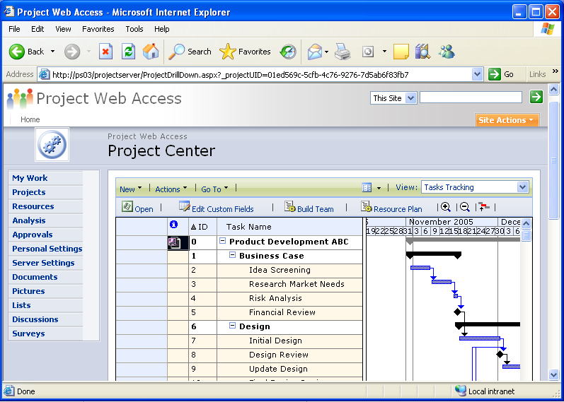
Figure 2: Project Web Access

Enhance Knowledge Sharing
Centralized document management helps users to improve the quality of project deliverables. Integration of Project Server and Windows SharePoint Services enables teams to centrally manage and track project-related documents.

Use Existing Investments and Knowledge of Desktop Programs
With Outlook Integration, team members can view and report progress on tasks—right from their Microsoft Office Outlook® calendar. Team members view project assignments, easily keep track of project tasks alongside other Outlook appointments, and provide project managers with timely updates for accurate reporting.

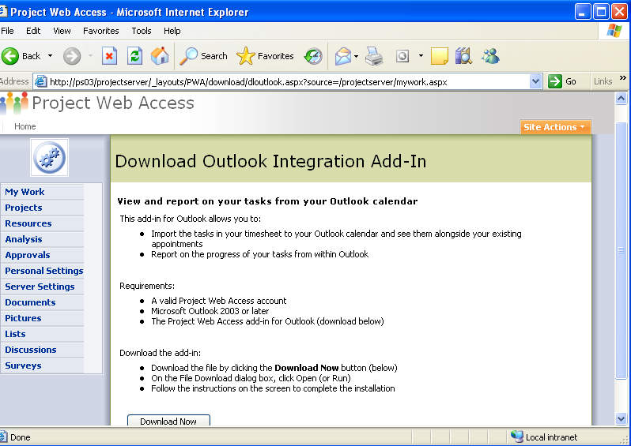
Figure 3: Outlook integration through Project Web Access

EPM Scenario: Communicating Project Progress
Currently, Fabrikam International is working on a large-scale project with two project managers. The project is expected to take two years to complete. Both project managers worked together to promote the proposal to a project and to add all the details required for operational control and reporting of progress. They need several levels of communication to involve team members and to inform executives.
To provide team collaboration, the project managers create user accounts on Project Server for their team members by synching with the Active Directory® directory service. They also select the option for e-mail notification, which will send messages to indicate the assignment of tasks to team members. The team also installs the COM add-in for Outlook integration so they can import Project assignments to their calendar and to-do lists. With this add-in, the people working on these projects can report time and progress for each item in Outlook. For an overall timesheet, their accounts on Project Server grant them access to the complete time reporting function in Project Web Access. Project Web Access offers a range of other collaboration functions for status reporting, sharing issues and risks, and managing documents, because it is built on Windows SharePoint Services.

Evolve with a Scalable and Configurable Platform
The EPM Solution provides enterprise class capabilities for performance and scalability as well as a better foundation for extending and customizing Project as a platform for managing your organization’s work. Project will offer workflow to integrate business processes with project work. Your existing software investments will gain better synergy with Project through an improved API. The new version more readily exposes the administrative functionality through Project Web Access.

Improved Performance
With the Active Cache, a method used to transfer data from client to server, you can provide more data on demand for faster open, save, publish, and other client/server communications, even across WANs and firewalls. It also delivers a smooth online/offline experience.
Developers can also extend the functionality of Project with the server-side Event Model. You can define business processes with Windows Workflow Foundation and trigger the processes with events raised by Project Server. Get greater resiliency and use of server resources with the Queuing Service, which queues work requests pending server availability so users can continue working rather than waiting on the server.

Manage the EPM Solution
To save time and reduce the learning curve for EPM Solution administrators, the new version consolidates security and other management functions on a single, refactored Web Service called Server Settings. Project Server includes a connector that facilitates synchronization from Active Directory to Project Server. This imports Active Directory users to populate the Enterprise Resource Pool and Active Directory security groups, distribution groups, and organization units to Project Server security groups. This means you benefit by not having to implement and manage specific directory services.

Fully Extensible
All Project Server clients and components for integration (Project Web Access, Project Professional, and third-party applications) now interact with Project Server 2007 through the Project Server Interface. The Project Server Interface, along with the Project Server Eventing Service, exposes all of the functionality and data that client applications need to integrate fully with Project Server. The new Server-Side Scheduling moves the scheduling engine from Project Professional to Project Server. This enables you to create an interface without relying on Project Professional for schedule calculations. Now if a third party builds an interface, they no longer have to have Winproj.exe on each client because the server contains the scheduling engine. This reduces license needs from Professional to a Client Access License. Additionally, you have greater ability to customize Project Web Access because it is built on Windows SharePoint Services (version 3.0) and exposes all functions as Web Services. This means you can flexibly format the Project Web Access interface with all of the Windows SharePoint Services tools. The administrative interface has been redesigned for better access and to expose new functions.

EPM Scenario: Extending the Platform to Suit Special Needs
Fabrikam International is undertaking a large-scale initiative with business partners. This initiative requires integration with back-end systems, custom reports, and workflow. The internal IT group has been training developers with the new Project API (the Project Server Interface), .NET Framework 2.0, and the free Windows Workflow Foundation. They have the skills in-house to customize their EPM Solution.
The extensible Project platform allows the IT group to create the necessary custom integration with their timesheet system and to use the free ERP Connector with their SAP system. Fabrikam can develop custom applications to include an extranet portal where suppliers can view what they have committed to deliver, custom workflow to support an approval process for changes to requirements, and a program dashboard in Microsoft Business Scorecard Manager that the executive committee can use to track progress and issues within projects and programs.

Architecture
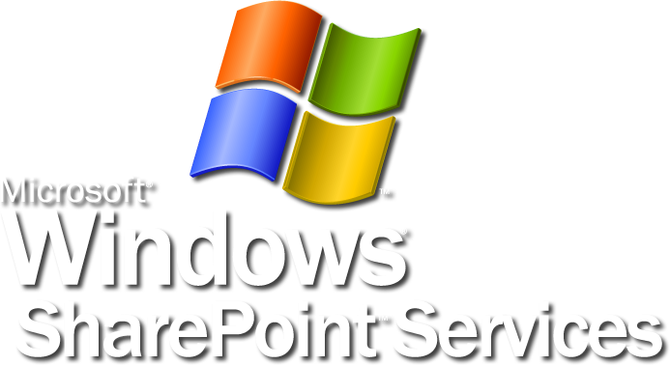
Project Server Interface
Server Business Objects
Timesheet
Reporting
Resource Plans
Data Warehouse
Security
Event/Notifications
Object Linking
Task Assignment
Scheduling
Budgeting
{

The EPM Solution has a three-tiered architecture that consists of:
- A front end: Project Web Access, the thin Microsoft Internet Explorer client, or Project Professional, the Win32 client. In addition to the dedicated Project clients, other applications can also serve as front ends due to integration.
- A middle tier: Project Server, which can be accessed programmatically as described in our software development kit (SDK), and which will be posted on MSDN®.
- A back end: Microsoft SQL Server, Microsoft Windows Server™, and Windows SharePoint Services.
For further details, please refer to the system requirements.

Backwards Compatibility, Interoperability, and Migration
Office Project Professional 2007 can open files created in previous versions of Project. You can save project plans in prior formats, such as Microsoft Office Project 2003, Project 2002, and Project 2000 file formats. Any features that do not map to prior file formats will be discarded when the project is saved in that file format.
Office Project Professional 2007 saves to file formats including XML, CSV (comma separated values), text (tab delimited), Microsoft Excel workbook, Microsoft Excel PivotTable® views, Web page, and Project 2003. It does not support save to Open Database Connectivity (ODBC) data source or .mdb files. Project 2003, Project 2002, and Project 2000 no longer save project plans to the .mpx format.
Office Project Professional 2007 cannot connect to or interoperate with earlier versions of Project Server. Similarly, Office Project Server 2007 does not interoperate with prior versions of Project Professional. Office Project Server 2007 does provide a migration tool that enables certain data (including project and other Project Web Access data such as security settings or Project Web Access views) in Project Server 2003 to be migrated.

Summary of the Microsoft EPM Solution Benefits
The Microsoft Enterprise Project Management (EPM) Solution, based on Office Project Server 2007, addresses the needs of key stakeholders to:
- Align work with strategic business objectives.
- Efficiently manage finances and resources for projects and programs from initiation through end of life.
- Collaborate on and communicate the status of work and investments.
- Exploit integration with Microsoft Office system programs and other existing software infrastructure.
- Customize the EPM Solution to meet your organization’s unique needs.
To evaluate the EPM Solution for your organization, please contact your account manager for a hosted trial.

System Requirements
The Enterprise Project Management (EPM) Solution consists of Microsoft Office Project Server, Microsoft Office Project Professional, and Microsoft Office Project Web Access. Each of these programs has its own system requirements. For complete system requirements, visit www.microsoft.com/office/preview/beta/sysreq.mspx.

Project Server
Microsoft Office Project Server 2007 processor, RAM, and hard disk requirements are highly dependent on the number of services installed on the server computer and the load on the server.
Minimum requirements assume one server on which all Project Server components and supporting technologies (such as Microsoft SQL Server or Windows SharePoint Services) are installed. Additional system requirement information about advanced Project Server configurations is available in the Microsoft Office Project Server 2007 Installation Guide.
Office Project Server 2007 requires the following for use:
- Operating system: Microsoft Windows Server 2003 Standard or Enterprise Edition SP2 or later (32-bit, x 64)
- Processor: Pentium III, 500 MHz or faster
- Memory: 512 MB minimum, 1 GB recommended
- Hard disk: 200 MB of available space
- Display: SVGA (800 x 600) or higher resolution
- Network connection: 10 MB/sec or faster connection
- DVD drive: Required for installation from media
- .NET Framework: Version 2.0 (Whidbey)
- Microsoft Data Access Components (MDAC): 2.8 or later
- Database server: Microsoft SQL Server 2000 SP3 or later; Microsoft SQL Server 2005 (32-bit Intel/AMD processor, 64-bit AMD processor)
Additional items or services required to use certain features:
- Microsoft SQL Server Analysis Services for Portfolio Analyzer and Microsoft SQL Server Reporting Services are optional; versions should be matched with the SQL Server version

Project Professional
Microsoft Office Project Professional 2007 requires the following for use:
- Operating system: Microsoft Windows XP SP2 and later, Windows XP Tablet Edition 2005 (XP SP2), Windows Vista™
- Processor: Pentium III, 500 MHz or faster
- Memory: 128 MB of RAM or more; 500 MB recommended
- Hard disk: 130 MB or more of available hard disk space
- Display: SVGA (800 x 600) or higher resolution
- Network connection: 10 MB/sec or faster connection
Additional items or services required to use certain features:
- Browser: Internet Explorer 6.0 or later. Note: Internet access to Project Server requires dial-up or broadband Internet access (provided separately); local or long-distance charges may apply
- Project Server 2003 is required for enterprise resource and project management capabilities; MAPI compliant messaging software such as Exchange 5.5 for inserting new resources; .NET Framework requires version 2.0 (Whidbey) for use of Resource Substitution Wizard and Desktop Reporting; Windows SharePoint Services (version 2.0) or later required to use Open and Save functions in Windows SharePoint Services; Export to Excel and Copy Picture to Office Wizard require Office 2000 SP3 and later; Visual Reports requires Excel 2003 or later and Office Visio Professional 2007; Outlook 2003 SP2 and later, Office Outlook 2007 (for importing/exporting assignments); Windows Server 2003 SP2 Terminal Services for remote access

Project Web Access
Microsoft Office Project Web Access 2007 is a Web portal used to access the information stored in Microsoft Office Project Server 2007. This also includes the administrative user interface. Using Project Web Access requires an Office Project Server 2007 Client Access License (CAL).
Project Web Access requires the following for use:
- Operating system: Windows 98 SE, Windows 2000 SP4 and later, Windows XP SP2 and later, Windows XP Tablet Edition SP1, Windows Vista
- Processor: Pentium III, 500 MHz or faster
- Memory: 24 MB of additional RAM or more recommended (additional memory may be required depending on operating system requirements)
- Hard disk: 5 MB of available hard disk space
- Display: SVGA (800 x 600) or higher resolution
- Network connection: 256 KB/sec or faster connection required to connect to Office Project Server 2007
- Browser: Internet Explorer 6.0 or later. Note: Internet functionality requires dial-up or broadband Internet access (provided separately); local or long-distance charges may apply
- Office Web Controls: Portfolio Analyzer views require the Office Web Controls version from a valid end-user license for a program from the 2007 Microsoft Office system
Additional items or services required to use certain features:
- Outlook 2003 SP2 and later, Office Outlook 2007 (for importing/exporting assignments)
- Windows SharePoint Services: Windows SharePoint Services (version 3.0) or later, which requires: Microsoft Internet Information Services 6.0 or later, NTFS file system (Microsoft Windows includes a conversion utility (Convert.exe) that you can use to convert an existing file allocation table (FAT) volume to NTFS, without losing data), Microsoft Windows Workflow Foundation

Additional Resources
To learn more about the Microsoft Enterprise Project Management (EPM) Solution, please refer to the following list of related links for additional resources and information.
- Project Home Page
http://office.microsoft.com/project/
- Business Value from the Microsoft Enterprise Project Management Solution
http://www.microsoft.com/business/epm.aspx
- Microsoft Project Association
http://www.mpug.org/default.aspx
- Microsoft Project Communities
http://www.microsoft.com/technet/community/en-us/project/default.mspx
- Microsoft Office Project Developer Center
http://msdn.microsoft.com/office/understanding/project/default.aspx
- Microsoft Office Project TechNet
http://www.microsoft.com/technet/prodtechnol/project/default.mspx
- Microsoft Office Project Support Information
http://support.microsoft.com/default.aspx?pr=offpr2003

This document is developed prior to the product’s release to manufacturing, and as such, we cannot guarantee that all details included herein will be exactly as what is found in the shipping product. The information contained in this document represents the current view of Microsoft Corporation on the issues discussed as of the date of publication. Because Microsoft must respond to changing market conditions, this document should not be interpreted to be a commitment on the part of Microsoft, and Microsoft cannot guarantee the accuracy of any information presented after the date of publication. The information represents the product at the time this document was printed and should be used for planning purposes only. Information is subject to change at any time without prior notice.

This document is for informational purposes only. MICROSOFT MAKES NO WARRANTIES, EXPRESS OR IMPLIED, IN THIS DOCUMENT.

© 2006 Microsoft Corporation. All rights reserved.

Microsoft, Active Directory, Excel, MSDN, the Office logo, Outlook, PivotTable, SharePoint, Visio, Visual Basic, Windows, and Windows Server are either registered trademarks or trademarks of Microsoft Corporation in the United States and/or other countries. All other trademarks are property of their respective owners.

