A Lap Around the Speech Application SDK

by Richard Irving, Program Manager, Microsoft Speech Server Group

Introduction
The Microsoft® Speech Application SDK 1.0 (SASDK) is one of the most fascinating products I’ve had the opportunity to work on. There’s certainly a very high “cool factor” in applications that use speech recognition. Who hasn’t seen HAL or been wowed by the ability of the computer on The Enterprise in “Star Trek”? With Microsoft Speech Server 2004 and the SASDK, we’re not quite at that level yet. But we are closer than we were before.

For a long time, we’ve thought that having a natural interface to the computer--where you can speak your intentions and have the machine operate on those intentions rather than a sequence of verbose commands--is an ideal user interface. Technology is advancing so quickly that it’s time to make speech applications mainstream.

How are we doing this?

First, the SASDK is based on a set of open standards. Microsoft and its partners are driving a set of standards through the World Wide Web Consortium, the SALT Forum, and other standards organizations to create and publicize the basic framework for these applications.

Second, the SASDK leverages the existing infrastructure that you and other businesses have already invested in. The SASDK does not introduce radical new hardware or a new application model.

Third, the SASDK is simple and integrated with the programming environment and technologies that you are familiar with.

Fourth, the applications that you create will make the platform.

Built for the .NET Platform
The SASDK is built for the .NET platform. The core of the SASDK is based on the ASP.NET Web Form architecture. Using ASP.NET, you can build applications that target PCs, mobile devices, telephones, and cell phones, all from one programming model.

The SASDK is integrated with Visual Studio .NET. A suite of tools provides additional functionality to Visual Studio .NET, making it really easy to add speech “artifacts” to your application.

Based on Open Standards
The SASDK is entirely based on open standards. Nearly every API in the SASDK renders XML and script defined in a publicly available specification. This means that as the partner ecosystem evolves, you’ll have even more flexibility in how you deploy your solution, who is deploying it, and where it gets deployed. As an application developer, you get to focus on the core business problems solved by your application.

There are four standards:

- Speech Application Language Tags (SALT) is the core API for the spoken interaction with a user. It provides the core constructs of prompts (questions), listens (answers), and related APIs. This specification is being driven by the SALT Forum: http://www.saltforum.org.

- Speech Recognition Grammar Specification (SRGS) provides a way to define the phrases and phrase combinations that your application recognizes from a user – generally referred to as just “grammar.” It’s important to note that while we have a GUI tool for modeling grammar, what it generates behind the scenes is entirely based on this standard. This specification is driven by the World Wide Web Consortium (W3C): http://www.w3.org/TR/speech-grammar.

- Speech Synthesis Markup Language (SSML) is the text-to-speech specification being driven through the W3C. It’s how you define output (prompts) in the application. The specification is available at: http://www.w3.org/TR/speech-synthesis/.

- ECMAScript (ECMA-262) is commonly seen in its implemented forms as JScript, JScript.NET, and JavaScript. JScript and JScript.NET (depending on the client you’re targeting) are used throughout the SASDK. The specification for ECMAScript is available at http://www.ecma-international.org/publications/files/ECMA-ST/Ecma-262.pdf , and documentation on JScript and JScript.NET is available on MSDN.

Speech Application Concepts
When building a speech application, you need to know about three unique concepts:

- Dialogue is the conversation between the system and the user. This is the presentation logic of your application.
- Prompts are what the system says to the user to ask a question or provide status to the user. In a GUI application, the equivalent is labels and message boxes.
- Grammar is used to define and constrain the user input that the system recognizes. Additionally, the grammar provides a way to associate multiple phrases with a single semantic meaning. For example, the phrases “Help” and “what can I say” would be mapped to a single meaning of “Help.”

The tools and API provided in the SASDK extend Visual Studio .NET to support these concepts. The following sections explore each of them in more detail.

Dialogue Authoring
As mentioned previously, grammar and prompts deal specifically with the input and output of your application. Dialogue is how you weave the two together in the most natural manner possible.

The application that you build is likely to collect data of some sort – whether it’s a user name and password to look up order status, or full-fledged data entry. Allow the user to speak naturally and provide multiple ways for the user to speak or input the data.

What the user hears from your application needs to be dynamic. When the system encounters an error or doesn’t understand the user’s input, it will have to degrade gracefully and coax the right information from the user. Contrast this with an Interactive Voice Response (IVR) system that provides a very rigid menu structure and little or no opportunity for help.

Dialogue Defined
A dialogue is a composition of questions, answers, statements, and digressions. Here are some examples of these components:

Question and Answer
The core construct of a dialogue. The application asks a question; the user answers.
System: What type of coffee would you like?
User: I would like a latte.

Statement
A stand-alone prompt spoken to the user to indicate the current status of the application.
System: Hello, and thanks for calling customer service.
Or:
System: You have $500 left on your credit line.

Digression
User input that causes the system to be diverted from its normal course of action.
System: What type of coffee would you like?
User: What are my choices?
System: You can say latte or mocha.

A dialogue containing all these elements might look something like this:

System: Thanks for calling our coffee service. What type of coffee would you like?
User: I would like a latte.
System: What size?
User: Tall please.
System: What type of milk?
User: What are my choices?
System: You can say whole milk, two percent, nonfat, or soy.
User: I would like whole milk.
System: Your tall, whole-milk latte will be ready in a moment.

Let’s explore what SASDK features make it easy to author dialogues.

Application Architecture
Speech Application Language Tags (SALT) is a great API for managing low-level speech input and output. It even includes a few features for authoring dialogue. What it lacks in features to support dialogue authoring, it makes up in flexibility. It’s because of the flexibility that there are ASP.NET Speech Controls in the SASDK – the primary API for building dialogue-driven speech applications.

Like any other Web-based application, the two major components of your speech application are a client (Web browser) and a Web server. In addition, a component generically referred to as Speech Services comes into play. Note that I’m using it generically because its physical location and the technology being used depend on the type of application you’re building. A telephone application is likely to use the Speech Engine Services feature of Microsoft Speech Server 2004, while a desktop application uses the desktop recognition in combination with the Speech Add-in for Microsoft Internet Explorer.

The Web server stores an ASP.NET application, built with Web Forms and a new type of Web control: Microsoft ASP.NET Speech Controls. These controls use the same framework as the GUI Web controls you’re familiar with. They’re accessible from a toolbox similar to the Web controls that you use today. The difference is that they render speech-specific markup to the client rather than the HTML rendered by other types of Web controls. Grammar files (.GRXML files) and prompt databases (containing the recorded prompts) are also stored on the Web server.

The HTTP request lifecycle in a typical Web application is the same in a speech application. However, during the rendering phase, what is rendered to the client is a document containing SALT, SSML, SRGS, and CSTA tags in addition to the HTML and JScript that a typical Web application generates.

When the client receives this document, two things happen:

- The Speech Services download and parse the grammar in preparation for running it. The Speech Services also download the prompt database (if specified) for playback as prompts are encountered.
- The SALT client and Web browser invoke the <prompt> and <listen> elements as specified in the script. Note that rather than executing elements linearly as a standard HTML client would, elements are executed in their order of invocation as indicated by calling their start() methods.

The Speech Services start listening for input from the user when a <listen> element is invoked. Once it receives the audio (an utterance), it compares its analysis of the audio stream to what is stored in the grammar, looking for a matching pattern. If the recognizer finds a match, a special type of XML document is returned to the client. The document contains markup called Semantic Markup Language (SML) and is used by the client as the interpretation of what the user said – this is effectively what the grammar, or at least its recognized parts, is transformed into. The client then uses this document to determine what to do next (execute a prompt or listen element), and the cycle repeats itself until the application is done collecting data and the session ends.

Microsoft ASP.NET Speech Controls
ASP.NET
JScript
HTML
Client
Application
Controls
Dialog
Controls
Basic
Controls
Grammar
Semantic Map
Prompts
Speech
Services
SML
Dialog
State
Utterance
Web Server
SSML
CSTA
SALT
Four types of controls are available. Basic, Dialog, and Application Speech Controls provide a server-side (Web server control) API that manages the speech interaction of your application. Call Management controls are an abstraction of the Computer Supported Telecommunications Applications (CSTA) messages you’ll use in your application. Each control provides higher-level abstractions on top of the lower-level XML it generates.

Each control has run-time and design-time behavior. You implement the run-time behavior in your application. The design-time behavior is visible through Visual Studio .NET in the Dialog Editing Tool.

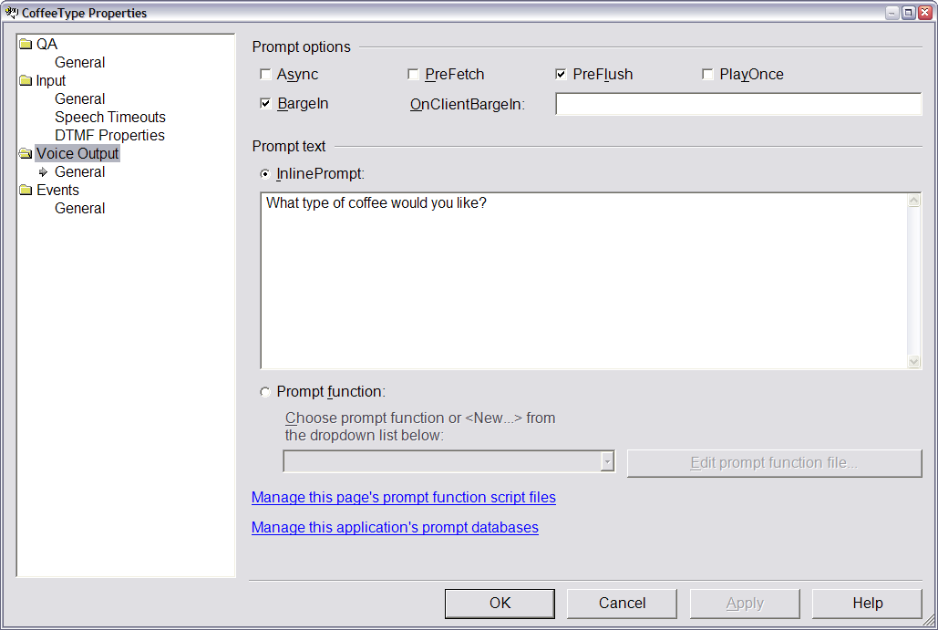

Basic Speech Controls
The Basic Speech Controls are a very basic server-side API for the two core SALT elements, <prompt> and <listen>, as well as the full hierarchy of elements they support. You can think of these in much the way you do the HTML Controls in the ASP.NET control library. They’re server-side representations of the lowest-level elements that you’ll interact with.

These controls preserve consistency of the server-side programming model provided by ASP.NET and the other Speech Controls. They are probably most useful in multimodal applications. However, you can use them any way you see fit.

Note, however, that they are not integrated with the Dialog model provided by the other Speech Controls. So you must provide your own implementation of the features in the Dialog Speech Controls if you want to get the same rich dialogue support.

No introduction to an API would be complete without the obligatory “Hello World” sample. So implementing “Hello World” using the Basic Speech Controls is as simple as this:

<speech:prompt id="GreetingPrompt" runat="server">
<InlineContent>"Hello world!”</InlineContent>
</speech:prompt>

A corresponding Listen control would look something like this:

<speech:listen
id="ListenForResponse"
runat="server"
AutoPostBack="true"
EndSilence="1000"
InitialTimeout="2000"
MaxTimeout="15000"
OnReco=”ListenForResponse_Reco”>

<Grammars>
<speech:Grammar Src=" MyGrammar.grxml" ID="Grammar2"/>
</Grammars>

</speech:listen>

On a technical note, all of the ASP.NET Speech Controls are available in the Microsoft.Speech.Web UI namespace, or in a Web Form, using the ‘speech’ TagPrefix.

Dialog Speech Controls
The Dialog Speech Controls are the building blocks of dialogue in the SASDK. The SALT constructs required to implement the full interaction and management of the dialogue’s state is wrapped up into this API to simplify and limit the code you need to write to wire up your presentation logic. The controller for this functionality is a script called RunSpeech, which manages the execution and state of these controls. It is implemented in both JScript and JScript.NET, and the version rendered depends on the client using the application.

There are three critical controls that provide the fundamental dialogue framework: QA, SemanticItem, and Command.

Microsoft.Speech.Web.UI.QA
The QA control is an abbreviated name for the control’s primary purpose: to ask a question and collect an answer. Its behavior, however, is overloaded in that it can be used as a stand-alone prompt or statement or can supply answers for multiple questions without having to ask them.

The markup for a QA control used for collecting looks like this:

<speech:QA id="CoffeeType" runat="server">

<Prompt InlinePrompt="What type of coffee would you like?"/>

<Answers>
<speech:Answer SemanticItem="siCoffeeType" ID="CoffeeTypeAnswer" XpathTrigger="./CoffeeType"/>
</Answers>

<Reco InitialTimeout="3000" BabbleTimeout="10000" EndSilence="1000" MaxTimeout="30000">
<Grammars>
<speech:Grammar Src="coffeeGrammar.grxml#TypeRule"/>
</Grammars>
</Reco>

</speech:QA>

Most of these properties are straightforward, so I won’t discuss them here. One important property that needs some discussion is the XpathTrigger property. Earlier I mentioned the SML document that the recognition engine returns as the result of processing an utterance. The XpathTrigger property is a reference to XML node path (XPath) in the SML document the SALT interpreter and QA use to determine if there was in fact a recognition result, whether confirmation is needed, and generally what to do next in the dialogue.

If you happen to know XPath syntax, great. The only additional thing you must learn is how to manipulate the structure of the SML document in your grammar. However, if you’re not familiar with XPath syntax, or the precise structure of an SML document, simply enter a recognition phrase as text in the designer for the QA control.

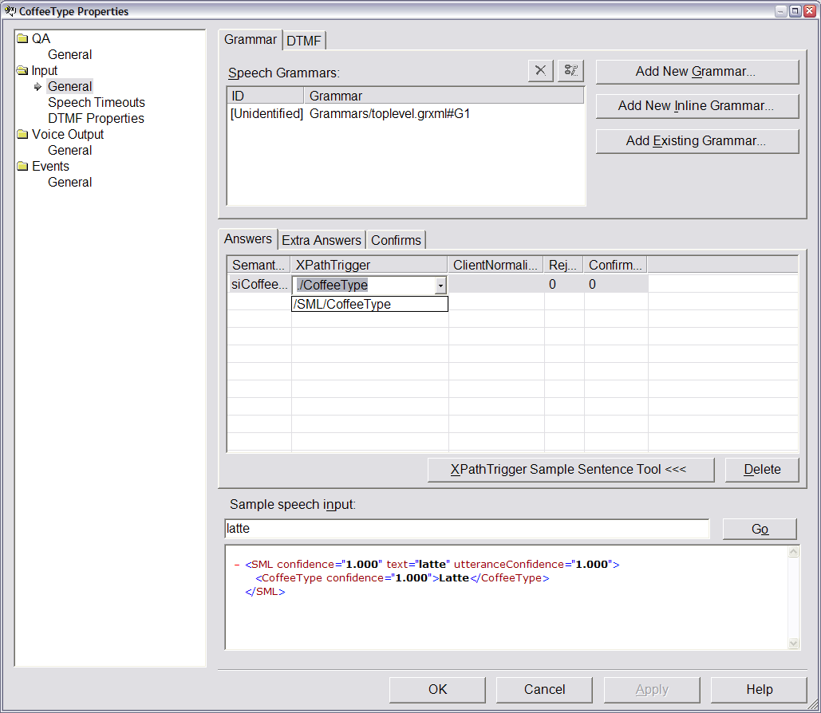

When valid input is recognized – in this case, “latte” – an SML document is returned and the XPathTrigger drop-down list is automatically populated with the XPath corresponding to the node returned in the document.

Microsoft.Speech.Web.UI.SemanticItem
The SemanticMap and SemanticItem controls track the answers and overall state of the dialogue. Each SemanticItem has its own state, such as empty, confirmed, and needs confirmation. The SemanticMap is used to group the SemanticItem controls together.

Note that the while the QA manages the semantics of invoking recognition, the storage of the recognized value is decoupled from the control. This makes it very easy to implement mixed-initiative dialogue in your application (see the section, “Mixed-Initiative Dialogue Support”). It also simplifies state management by centralizing the storage of the state.

The markup for these controls looks like this:

<speech:semanticmap id="TheSemanticMap" runat="server">
<speech:semanticitem id="siSize" runat="server" />
<speech:semanticitem id="siCoffeeType" runat="server"/>
<speech:semanticitem id="siMilk" runat="server" />
</speech:semanticmap>

Microsoft.Speech.Web.UI.Command
The Command control enables you to add out-of-context phrases, such as a digression (mentioned earlier), to each stage of your dialogue. It also provides a way to scope the out-of-context phrases to individual QA controls so that commands such as Help can be responded to differently depending on where the user is in the application.

<speech:command id="HelpCmd" runat="server" scope="CoffeeType" type="Help" xpathtrigger="/SML/Command/Help">

<grammar id="GlobalCmdHelp" runat="server" src=”GlobalCommands.grxml" />

</speech:command>

Note that the designer for the Command control also supports the same automatic discovery feature for the proper XPath as the QA control designer does.

Mixed-Initiative Dialogue Support
Suppose users access your application frequently, or the information you’re asking for has a natural flow to it that a user may already be accustomed to. In these cases, the user should be able to input the information in the order that makes sense, without having to be prompted every step of the way. Otherwise, your application may not be used very often, or worse, it may become a nuisance to frequent users who already know what you’re going to ask for.

Consider the coffee example discussed earlier. Three pieces of information were collected: coffee type, size, and milk type. Remember the last time you went to a café. When the person at the counter asked “What would you like?”, you didn’t wait for him or her to walk through each piece of information. You simply answered, “A tall, nonfat latte, please.”

This scenario is a type of mixed-initiative dialogue. It’s called this because both the user and the system are directing the dialogue. The contrast would be “system-initiative dialogue,” where the system only allows an answer to the immediate question. The Dialog Speech Controls have a significant impact on the design of both the dialogue and the grammar.

As mentioned earlier, the storage of recognized input is decoupled from the QA control in the form of the SemanticItem control. Commensurate with that, each QA control can recognize both primary answers and extra answers. Primary answers are data it must have in order to continue. Extra answers are data it might receive and should process if received. Here is what the markup looks like for such a QA:

<speech:QA id="CoffeeType" runat="server">

<Prompt InlinePrompt="What type of coffee would you like?"/>

<Answers>
<speech:Answer SemanticItem="siCoffeeType" ID="CoffeeTypeAnswer" XpathTrigger="./CoffeeType"/>
</Answers>

<Reco InitialTimeout="3000" BabbleTimeout="10000" EndSilence="1000" MaxTimeout="30000">
<Grammars>
<speech:Grammar Src="coffeeGrammar.grxml#TypeRule"/>
</Grammars>
</Reco>

<ExtraAnswers>
<speech:Answer SemanticItem="siSize" ID="SizeQACoffeeType" XpathTrigger="./Size"/>
<speech:Answer SemanticItem="siMilk" ID="MilkQACoffeeType" XpathTrigger="./Milk"/>

</ExtraAnswers>

</speech:QA>

When this is rendered and executed on the client, the question will be asked and the user must indicate a coffee preference before continuing. If the user happens to list either size or milk preference (or both), that information will be collected as well. This impacts the order in which subsequent questions are asked.

Each Dialog and Application Speech Control can be assigned a SpeechIndex value. This is similar to the tab order of a GUI element in that it determines the default order in which input is collected. Unlike tab order, however, once input is received, the question no longer needs to be asked and, in fact, won’t be.

Assume that the three questions that need to be asked and their SpeechIndex values are specified in this order:

- Coffee Type
- Size
- Milk Type

If the user responds “nonfat latte” to the initial question, only the size question is subsequently asked. Similarly, if the user responds “tall latte,” only the Milk Type question is subsequently asked. It’s easy to mentally model these three simple questions. However, the simplicity or complexity of the model depends on the number of questions you’re asking and how many of them overlap using the Answers/ExtraAnswers collections.

The relationship between the QA controls and their SemanticItem controls is an important consideration when designing your application. You need to support the common scenarios for natural input. However, you don’t want to over-optimize the input such that you accidentally support the utterance, “I would like a tall nonfat charged to my Visa latte ending in digits 0123.” That string is somewhat ridiculous for a user to input, but imagine the hassles you might have debugging an unintentional relationship between QAs.

The Speech Controls Outline tool displays SemanticItem relationships and default control ordering in a hierarchical form, simplifying the modeling of these relationships. This tool also enables you to manipulate the default order by moving controls up and down in the list.

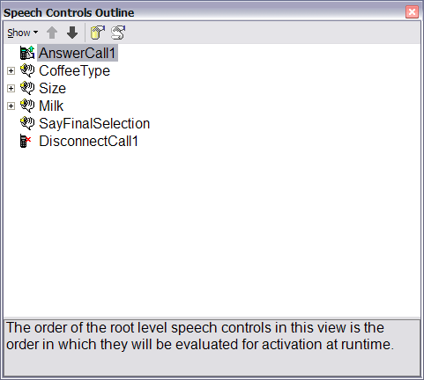

Application Speech Controls
The Application Speech Controls are packaged dialogue components for collecting specific types of information. They accelerate development of common voice-only scenarios such as collecting credit card information. In fact, you can create your own Application Speech Controls for scenarios you might encounter in your applications.

The Application Speech Controls are, in fact, compositions of Dialog Speech Controls. They are configured in the same way as Dialog Speech Controls; however, some of the configuration steps can be omitted since they include more default behavior for things such as confirmation or dynamically generated grammar. Additionally, you can override the default prompts to provide a custom sound to their dialogues.

Prompt Authoring
Prompts are the voice of your application in the conversation with the user. It is the interface to a dialogue-driven application. The same effort you make toward putting a cool UI on your customer Web site must be made when designing the prompts in your application.

The general goal of the prompt is to guide the user through the application. Each prompt must carefully identify the information the application needs to move forward. In fact, the way you prompt the user often has a direct impact on the words the user responds with. For example, the question “What type of coffee would you like?” is likely to evoke a response of “I would like a latte” rather than just “latte.” This means that your prompts are your first line of support in increasing the accuracy and effectiveness of recognition. Similarly, each prompt must prevent or minimize frustration in the event of a misunderstanding.

The prompts in your application must establish a rapport with the user. They also can be used as an extension of your company’s branding. You should give the same effort to implementing the right “voice” for your application that you would give to implementing your company’s logo. After all, the user won’t see anything over the phone, but what you say and the way you say it tells a lot about your company.

During application development, you’ll also want to be able to rapidly prototype your application for proof of concept and usability testing. Parallel development of the dialogue, prompts, and prompt recording is critical, especially since you likely won’t be using the development staff as the voice talent (though you certainly could).

Finally, your prompts must be dynamic. Each prompt must evolve specific to the state of the dialogue. If you didn’t understand the user’s first response, the prompt must be replayed, but probably using a preamble like “I’m sorry, I didn’t get that.” Or, you might be confirming dynamic data that you simply can’t use a static prompt with.

Prompt Implementation
Prompts can be defined statically in the <Prompt> tag of the QA control (see the preceding example) or using the QuestionPrompt property of each application control. This is probably sufficient for the initial prompt of the control. However, as mentioned previously, most of the prompts in your application must be dynamic. This feature is known as Prompt Selection in the SASDK.

Prompt Selection is provided by the Dialog Speech Controls in the form of the PromptSelectFunction property of every Dialog and Application Speech Control and the Prompt Function Editor. The PromptSelectFunction property is essentially a callback function provided by your application for each control and executed on the client side. It returns the prompt (and any related markup to use with that prompt) to use when the control is activated. Each PromptSelectFunction implementation can check and react to the current state of the dialogue. An example of a PromptSelectFunction follows.

function MyPromptSelectFunction() {
var lastCommandOrException = "";
var len = RunSpeech.ActiveQA.History.length;
if(len > 0) {
lastCommandOrException = RunSpeech.ActiveQA.History[len - 1];
}

if (lastCommandOrException == “Silence”) {
return “Sorry I couldn’t hear you. What type of coffee would you like?”;
}
}

In this case, the function is checking the most recent command (such as help) or exception (such as silence) to determine what prompt to play. If the last state of the dialogue was silence (no input was received), the prompt modifies itself just slightly to indicate silence, suggesting the user may need to speak louder or even say anything at all.

Each PromptSelectFunction can be coded inline manually. However, to support one of the features discussed later, Prompt Validation, there’s the Prompt Function Editor tool in Visual Studio .NET. As a source code editor, it’s little more than a colored text editor. What makes it truly useful is how it manages the individual prompts and prompt states, and that it is integrated with the Prompt Validation feature.

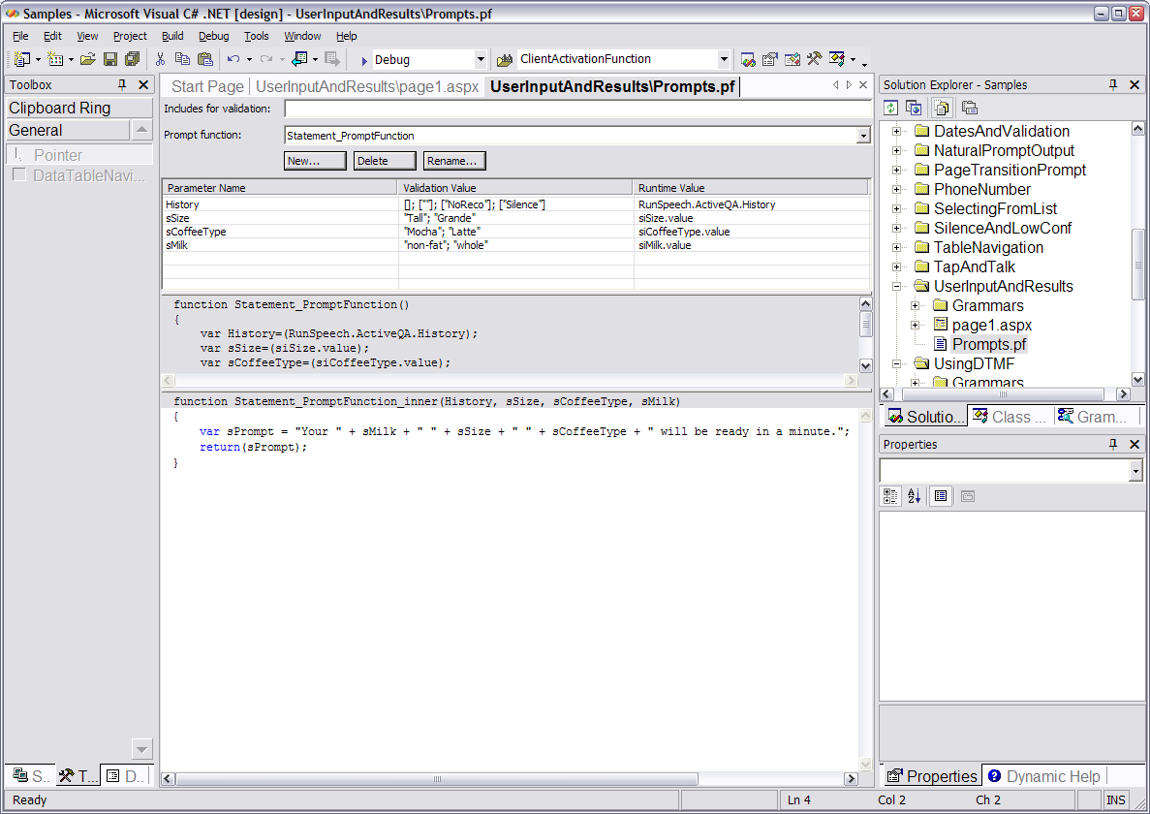

Adding a Custom Voice
You’ve probably heard speech synthesis before (also referred to as text-to-speech, or TTS for short). It’s the computer-generated, mechanical-sounding voice you hear when listening to a screen reader application, reading an eBook, or just playing with the voices in Control Panel. This type of prompt works great for very dynamic data. However, it still doesn’t provide a natural voice to the application.

The SASDK provides a technology that enables you to store pre-recorded prompts, and then dynamically generate and play back these recordings. The best part is that you don’t even have to record every possible variation of prompts in your system. You can extract specific phrases from individual recordings at design-time, and then at run-time they will be dynamically constructed and played back to the user.

For example, you need only record the word “Mocha” once and it can be joined with other phrases dynamically in your application. Best of all, you just need to supply the recording, and the tools will do the rest most of the time. On top of that, the application will still function properly if it does not have a recording in the database. The application will simply default to using synthesized output.

Like the features we’ve talked about this far, this feature has both a run-time and design-time view. During design-time, it surfaces as the prompt database. The prompt database provides a simple way to associate the text of a particular prompt or recording, hints for indicating what sounds to extract, and a way to validate that all the words used in your application do in fact have recordings.

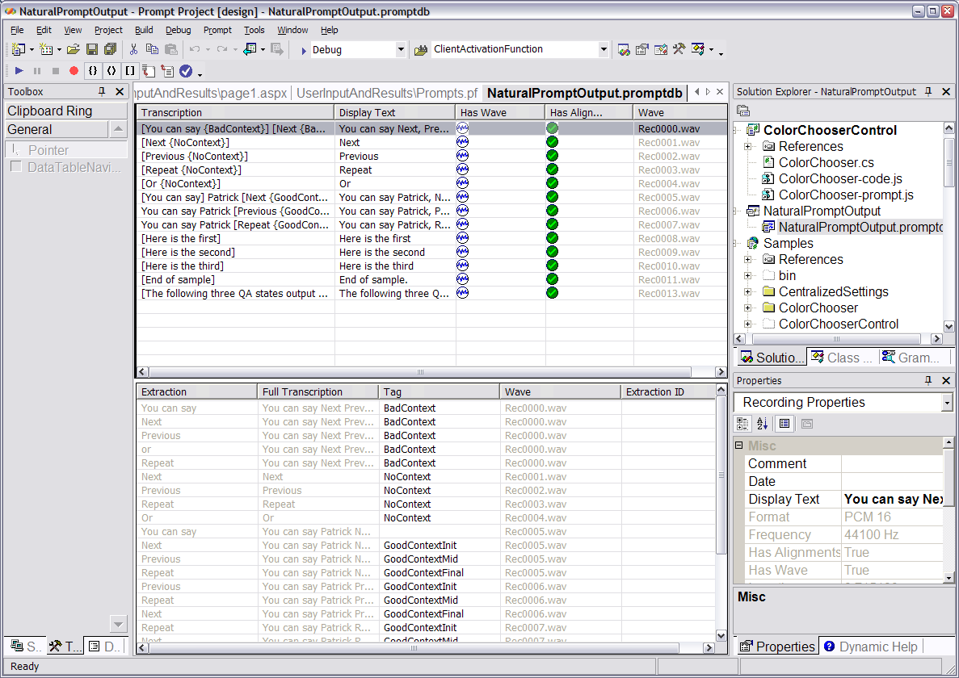

The prompt database automatically attempts to align each word in the transcription with a sound in the audio file you import. However, in some cases you may need to modify these alignments to remove or add dead air, or to make the timing of the extracted sound more precise than the default. Doing this is as easy as double-clicking the entry in the prompt database and realigning the appropriate word(s) in the recording.

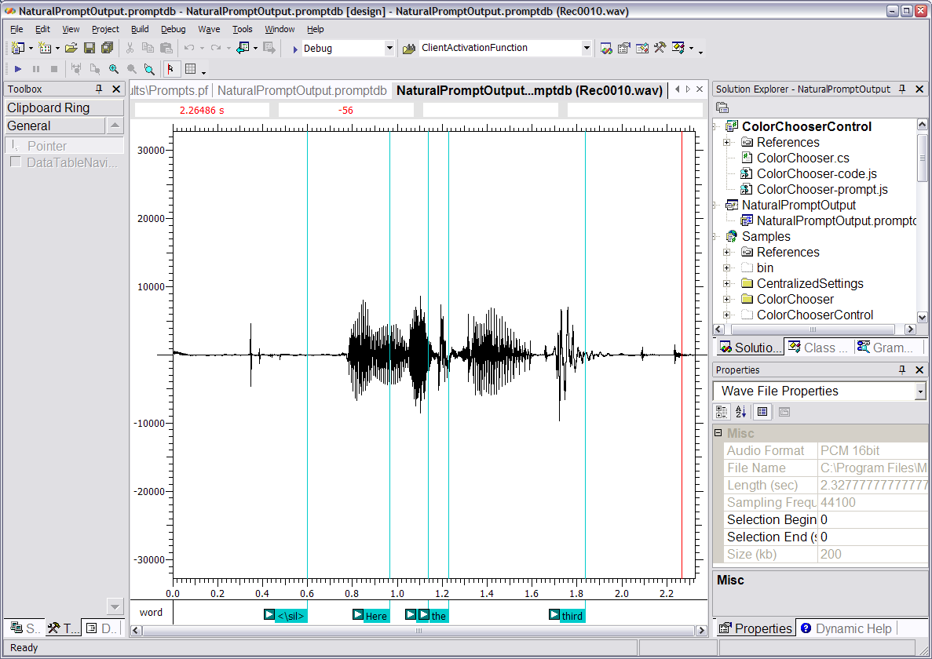

Prompt Validation
The Prompt Validation feature provided by the prompt database is useful when creating prompts. The run-time fall-back strategy for playing synthesized prompts in lieu of a recording is great during development – you can still do work while the voice talent refines the sound of the prompts. However, synthesized output may not be preferable for any number of reasons.

The Prompt Validation feature allows you to validate against a number of sources, including your entire project, files in your project, or specific words you input into the validation window.

In the following example, the NaturalPromptOutput prompt database provided in the SASDK samples was used, and the text “what” was entered as the string to validate. You can easily identify the word that doesn’t exist in the prompt database (bold red text is never a good sign), and if this were a validation result from a Prompt Function file, you could even double-click the text and jump to the exact line containing the prompt text that couldn’t be found. This makes it very easy to identify if there’s an error in the implementation of the prompt, or if the prompt really does need a recording as written.
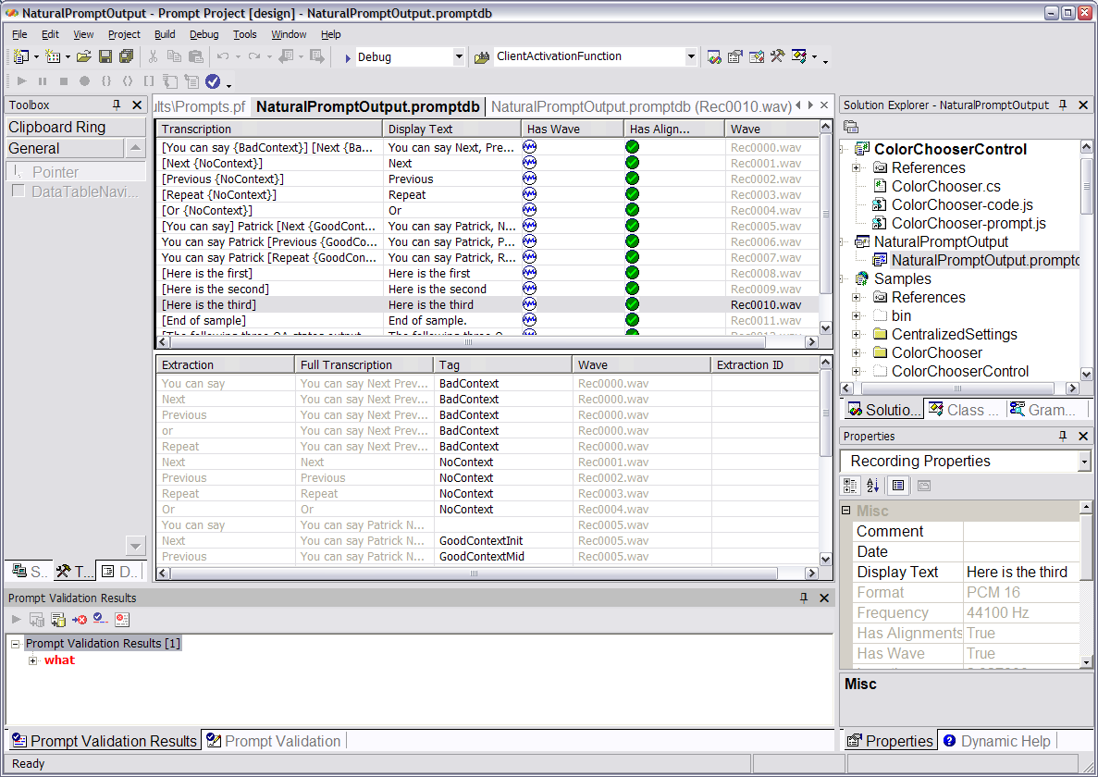

Grammar Authoring
You can think of grammar as a vocabulary of what can be said by the user and what can be understood by the application. This is much like a lookup table in a database that provides a list of options to the user, rather than accepting free-form text for input.

The grammar provides a bit more functionality than that, of course. The grammar doesn’t just define the individual options, but also the additional phrases such as a preamble to a sentence. For example, the grammar corresponding to the question and answer examples earlier must recognize “I would like a” in addition to the options “latte” or “mocha.” So given this, the grammar is essentially a sentence or sequence of phrases broken down into their smallest component parts.

Another job of the grammar is to map multiple similar phrases to a single semantic meaning. Consider all the ways a user can ask for help. The user may say “help” or “huh?”, or in the digression example earlier, “What are my choices?” In all three cases, the user is asking for help. The grammar defines all three phrases and maps them to a single semantic intent, preventing you from having to write the code to handle each individual phrase. So the only code you write in the application is to handle “Help.”

Additionally, as a developer, you need to be able to reuse generic grammar at specific points in your application. This is very similar to reusing a specific database query as a stored procedure. The SRGS specification accounts for this, and the SASDK makes this even easier.

Implementing Grammar
Grammar is arguably going to be the most technically challenging element of a speech application to master. To aid you in this, the SASDK provides a host of grammar-specific features.

Your primary interface to grammar is through the Grammar Editing Tool. This tool provides a graphical layout, left to right view, of the phrases and rules in a particular grammar (.GRXML) file. It’s a visualization of grammar implemented in the SRGS format, though it presents it as a word graph rather than the hierarchical XML document defined in the standard.

The following graphic is a Grammar Editing Tool view of the “Milk” rule used in the earlier examples.

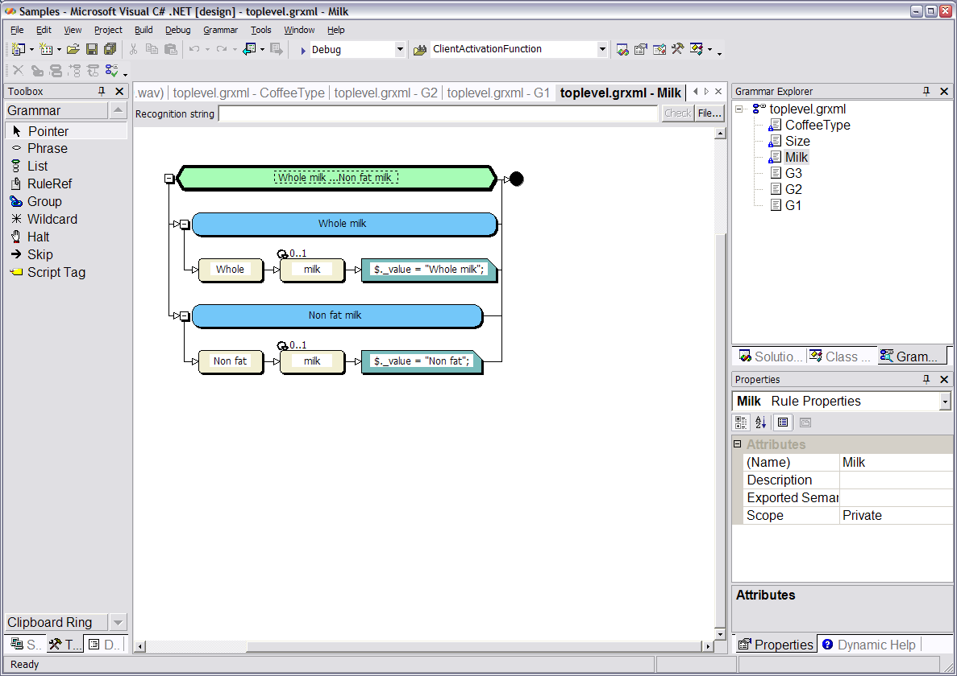

Note that the tool implements all the visual designer metaphors you’re familiar with in Visual Studio .NET. A toolbox on the left provides a list of the grammar features you can implement in that particular rule. The main design canvas occupies most of the window and provides you with a set of shapes that visually represent the SRGS elements in the underlying document. The Grammar Explorer window on the right is similar to the Class Browser, except you navigate grammar rules instead of .NET classes.
Another interesting feature is the Grammar Editing Tool’s ability to show the path a particular utterance would follow through a grammar and the resulting SML document that would be returned by the recognizer. The string “non fat” is entered into the Recognition string text box at the top of the canvas, and the path the recognizer took through the grammar is highlighted. The build output window displays a copy of the SML document returned by the recognizer. These two features help ensure that the grammar does what you think it will, both on input (recognition) and output (SML).

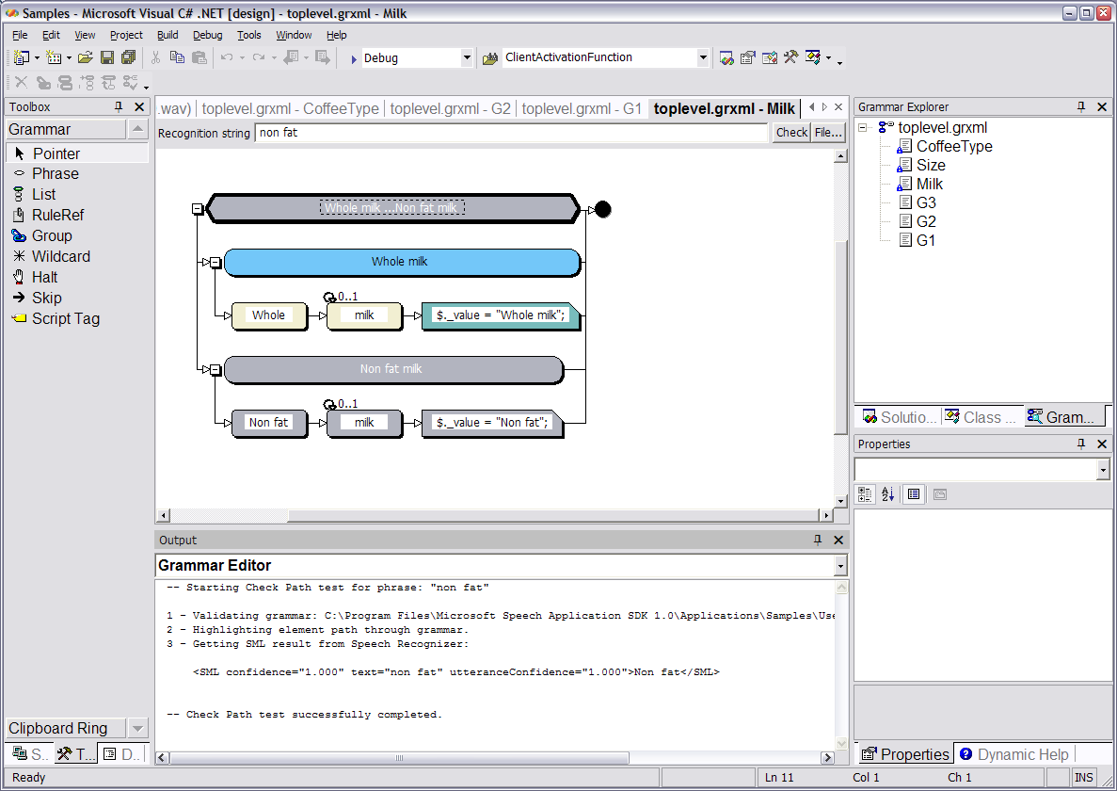

Reusable Grammars
The SASDK also makes it easy to leverage other data for grammar in your application instead of having to manually author it all. The first way is through the Grammar Library. The second is through dynamic, data-driven grammar.

The Grammar Library is a reusable collection of grammar rules, provided in both SRGS and SAPI CFG (context-free grammar) format, for common data types. The Grammar Library includes grammar for recognizing low-level data such as cardinal and ordinal numbers and higher-level data such as mapping holiday names to their actual calendar dates.

Data-driven grammar is a feature provided by three Application Speech Controls. The ListSelector and DataTableNavigator controls enable you to take real SQL Server data, bind it to the control, and automatically make all the data accessible by voice. This means that you do not have to re-create all the data stored in your databases in a grammar file. You can simply configure these two controls to suit your needs. The third control, the AlphaDigit control, isn’t a data-bound control. Rather, it automatically generates a grammar for recognizing a sequence of characters and numbers based on a format mask. For example, the mask DDA would recognize any string following the format digit, digit, character.

The Software Development Lifecycle
The tools and technologies discussed so far have covered the design and development phases of the software development life cycle. However, the SASDK deals with application development holistically, and there are a number of tools to support you during the testing and debugging phases of your project.

Testing and debugging is really an ongoing process throughout the software development cycle. There’s no one point that these processes stop or start; it’s always varying amounts depending on where you are in the project. There are three tools to help during this process:

- The Speech Debugging Console is essentially a trace window that helps track the state of the dialogue in the application. It speeds up unit testing by allowing you to use text as input rather than audio the whole time. Additionally, it enables you to exercise the bounds of the application by injecting custom values into the SML returned by the recognition engine.
- The Telephony Application Simulator is a Microsoft Speech Server simulation environment that runs on your workstation. This means that basic application testing can happen without licensing special versions of Speech Server or telephony hardware for each workstation. The Telephony Application Simulator is fully integrated with the Speech Debugging Console.
- The Log Player allows you or a tester to record a specific path through the application, save it to a log, and replay it at a later time. This helps in producing reproductions of errors or automating the testing of the most common path through the dialogue.

Conclusion
The SASDK provides an integrated, comprehensive platform for building speech-enabled ASP.NET applications. The tool set covers the entire software development life cycle and will help jumpstart your efforts.

The best part about the technology is that it’s built on technologies that you probably already know. The tools and run-time are based on Windows and .NET technologies that you know and continue to invest in. The speech applications you build don’t need to be their own specialized silos of functionality. They can be fully integrated extensions of your existing application infrastructure.

Microsoft Speech Server 2004 and the SASDK present you with a fantastic opportunity. The telephone’s pervasiveness worldwide can’t be overstated, and the technology to support telephone speech applications is here.

