

Installation of Windows Small Business Server 2008

Lab Manual

Information in this document is subject to change without notice. The example companies, organizations, products, people, and events depicted herein are fictitious. No association with any real company, organization, product, person or event is intended or should be inferred. Complying with all applicable copyright laws is the responsibility of the user. Without limiting the rights under copyright, no part of this document may be reproduced, stored in or introduced into a retrieval system, or transmitted in any form or by any means (electronic, mechanical, photocopying, recording, or otherwise), or for any purpose, without the express written permission of Microsoft Corporation.

Microsoft may have patents, patent applications, trademarked, copyrights, or other intellectual property rights covering subject matter in this document. Except as expressly provided in any written license agreement from Microsoft, the furnishing of this document does not give you any license to these patents, trademarks, copyrights, or other intellectual property.

Microsoft Corporation. All rights reserved.

The example companies, organizations, products, domain names, e-mail addresses, logos, people, places, and events depicted herein are fictitious. No association with any real company, organization, product, domain name, e-mail address, logo, person, place, or event is intended or should be inferred.

Microsoft, Hyper-V, OneCare, Windows, Windows Live, the Windows logo, and Windows Server are either registered trademarks or trademarks of Microsoft Corporation in the U.S.A. and/or other countries.

Other product and company names herein may be the trademarks of their respective owners.

Installation of Windows Small Business Server 2008
Scenario
Contoso, a small business of approximately 25 users/devices, is planning and executing their deployment of Windows® Small Business Server (SBS) 2008. Like many organizations this size, Contoso works with a local value-added provider (VAP) to choose and deploy their server solution.
Contoso has decided to make the switch from a peer-to-peer environment with no centralized file server. The new 64-bit server they ordered has just arrived, and it is time for Steve Masters, the IT administrator, to begin installation.

Objectives
This hands-on lab covers the pre-installation checklist, considerations for installation, and a step-by-step walkthrough of the installation process.

Architecture
One virtual machine (VM) is used in this lab: the Windows Small Business Server 2008 VM.

Estimated time to complete this lab:
2 hours

Exercise 0:
Lab Setup—Prepare the Lab Environment
Overview
In this exercise, you will prepare the host server to run the lab.
You need to be running Windows Server 2008 with the Hyper-V™ role enabled. For information on getting started with Hyper-V, click here.
- Task 1: Add a Private virtual network to Hyper-V server
    - On the host server, click Start > Administrative Tools > Hyper-V Manager.
    - In the right column, click Virtual Network Manager.
    - Select Private, and then click Add.
    - Name the new virtual network SBS Network
    - Ensure that Private is selected.
    - Click OK.
- Task 2: Import virtual machines
    - Under the right column, click Import Virtual Machine.
    - Click Browse.
    - Locate your SBS2008 HOL content folder.
    - Double-click the SBS2008--Install folder.
    - Select the SBS2008- Install folder, and then click Select Folder.
    - Click Import.

Exercise 1:
Install the Windows Small Business Server 2008 Operating System
Overview
This section provides step-by-step instructions for installing Windows Small Business Server 2008.
- Task 0: Prepare the virtual machines for this exercise
- From the Hyper-V Manager console, select SBS2008- Install and then click Settings in the actions menu.
- Select DVD Drive in the left column.
- Select Image file: and then click Browse.
- Navigate to the SBS2008 HOL\ISOs\SBS 2008 English content folder.
- Select SBS2008_ Enu_DVD1.iso and then click Open.
- Click OK.
- Click Start in the right column.
- Click Connect in the right column. This brings up the console to the virtual machine.
Task 1: Begin operating system installation
- Leave defaults and click Next.
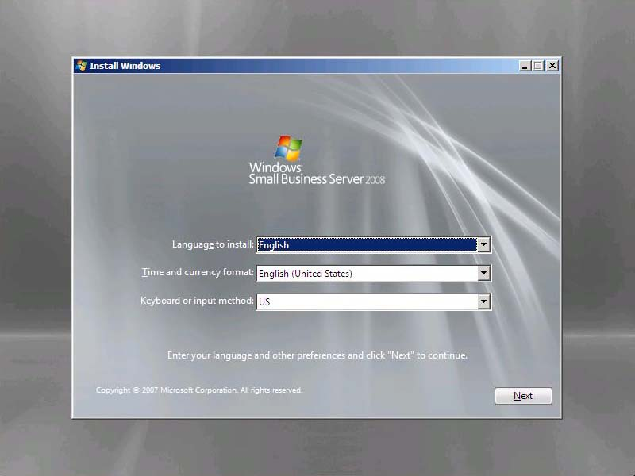
Figure 1 Language selection page
- Click Install Now.
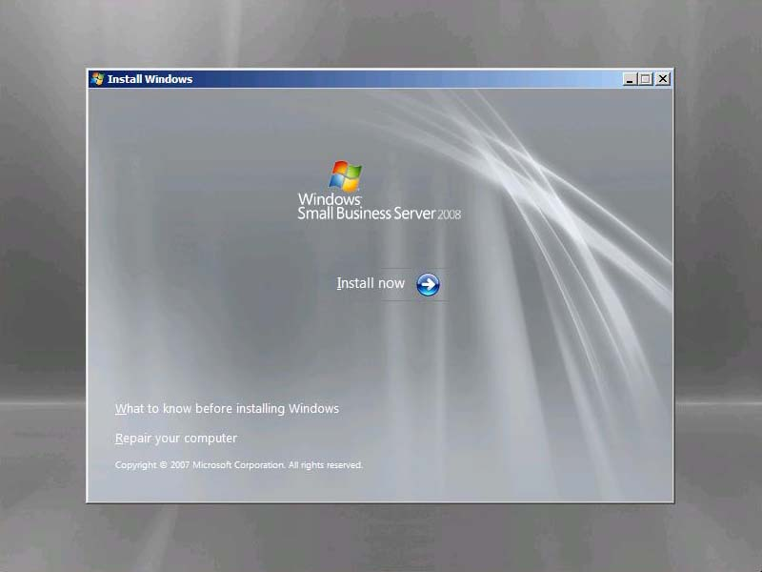
Figure 2 Install now
- Leave the product key field blank.
- Clear Automatically activate Windows when I’m online, and then click Next.

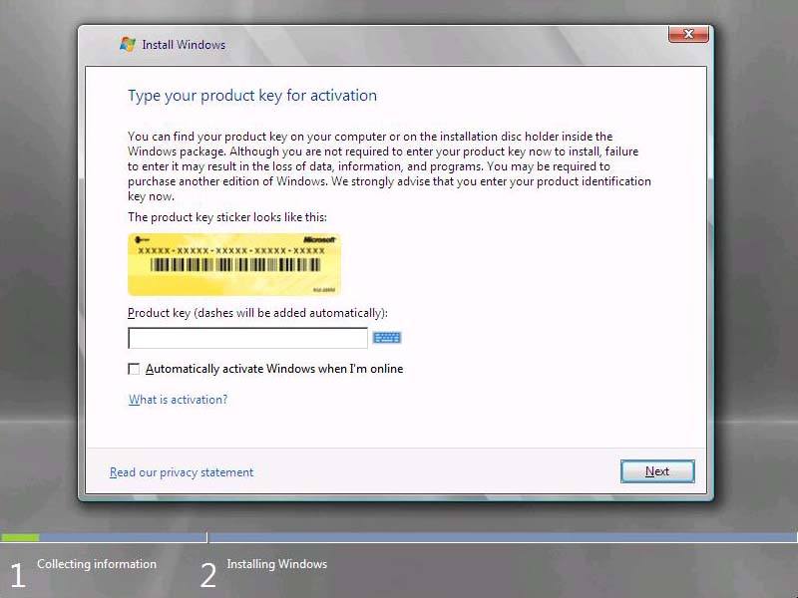
Figure 3 Product key page
- On the Install Windows dialog, click No.
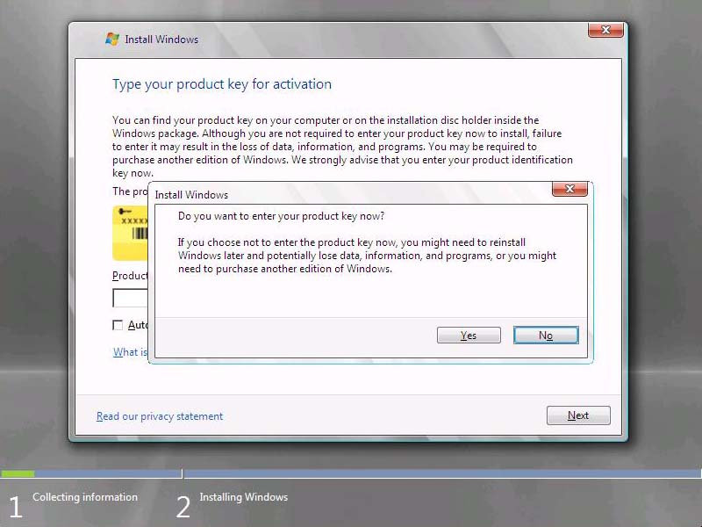
Figure 4 Product key verification page
- Read the license terms. If you accept them, select the I accept the license terms check box, and then click Next.
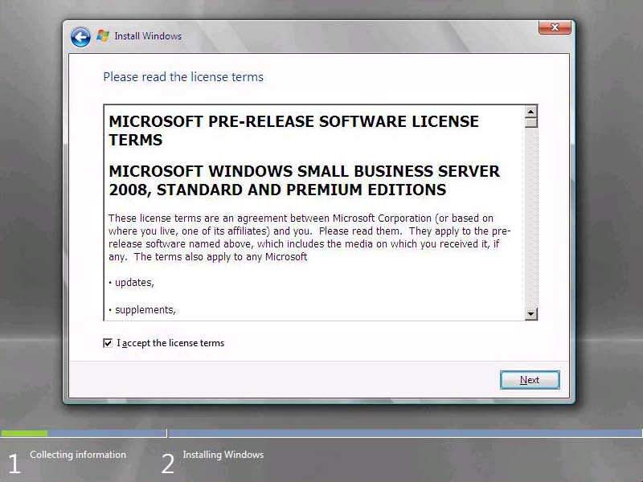
Figure 5 License terms page

                - Note:

If you do not choose to accept the license terms, setup does not continue.

- Click Custom (advanced).
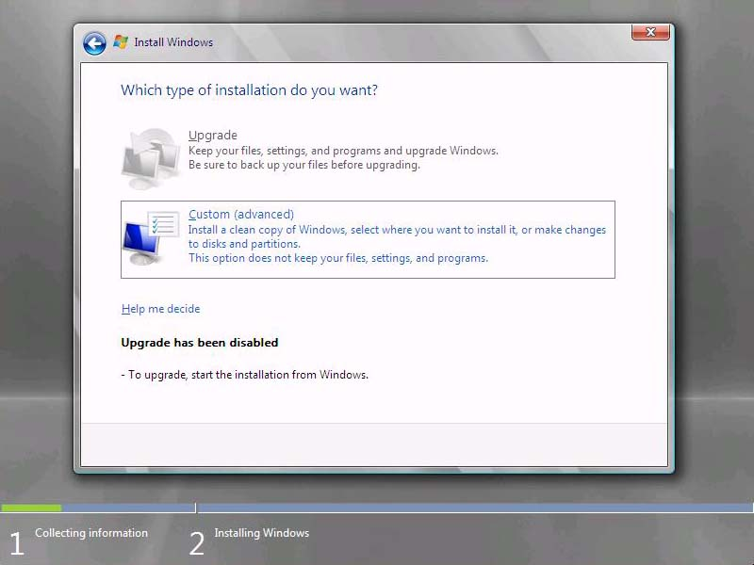
Figure 6 Type of installation page
- Select the Disk 0 location and then choose ‘Drive Options’ using TAB.
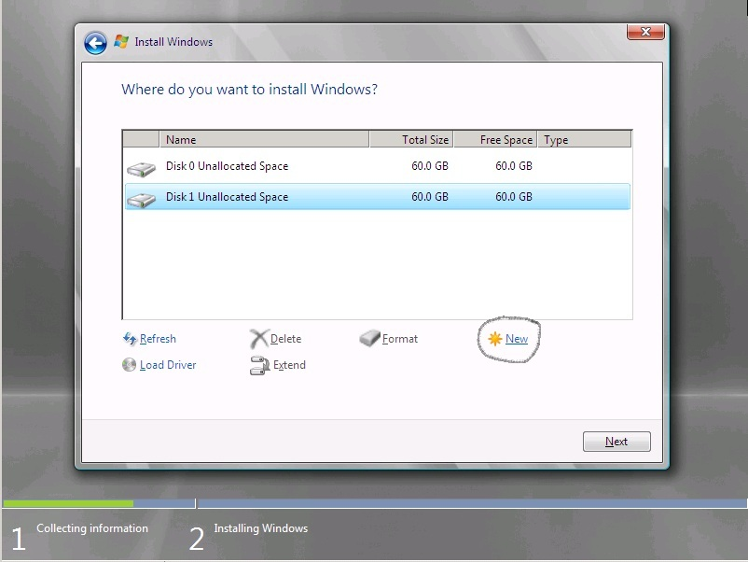
Figure 7 Select Disk 0
- Using the ‘Drive Options’ selection – create a drive volume for both Disk 0 and Disk 1 – APPLY to save
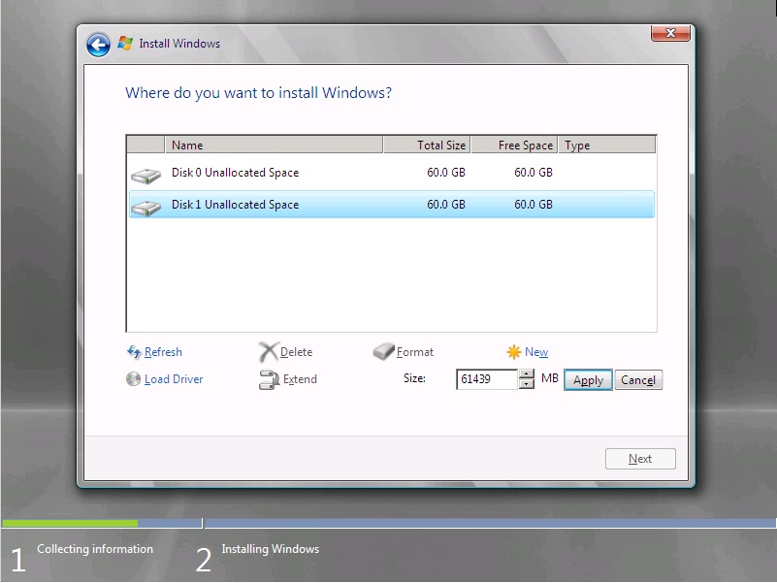
Figure 7 Select partition and create volume

- Choose the ‘FORMAT’ button to create volume on disk 1. Once completed, proceed to install on DISK 0 - NEXT
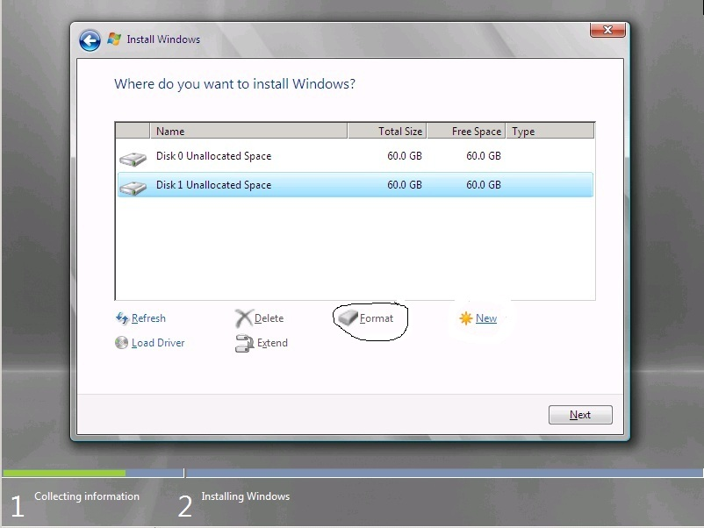
Figure 7 Select

                - Important:

You cannot change the partition that you install the operating system on after you finish this task.

- Task 2: Wait while setup installs the operating system
- Wait while setup proceeds. The time needed for this process varies depending on your specific hardware. This task does not require any input from the user.
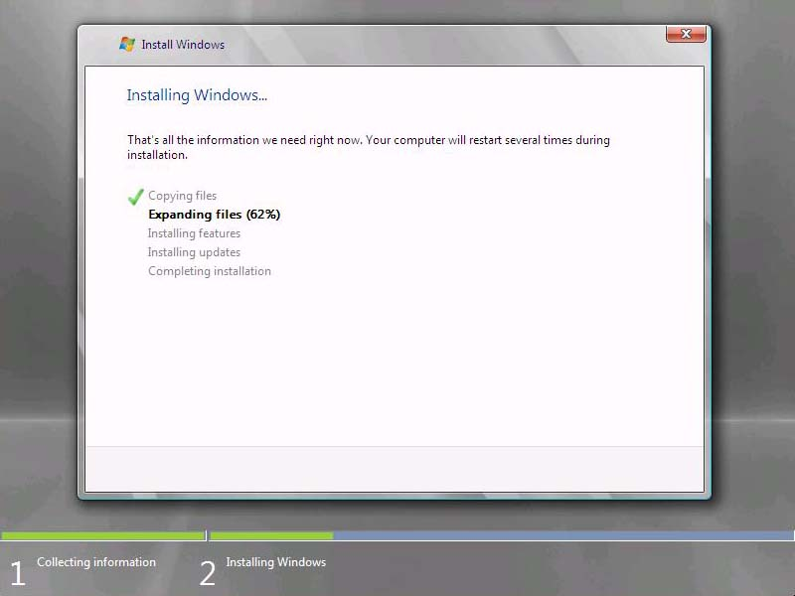
Figure 8 Expanding files page
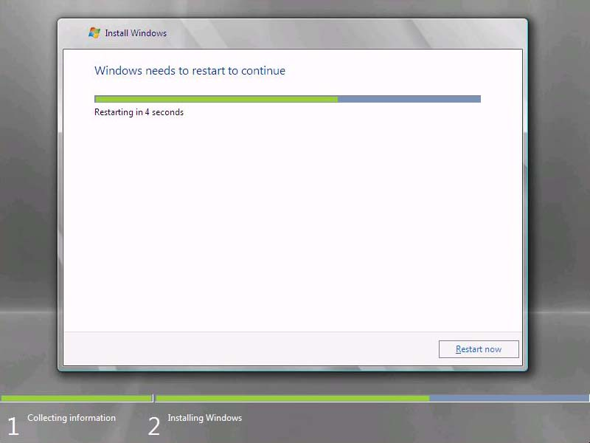
Figure 9 Windows restarting

Exercise 2:
Configure the Operating System
Overview
Setup prompts you to answer a few questions about your organization; it uses this information to configure the operating system.
- Task 1: Continue Installation
- On the Continue Installation page, click Next.
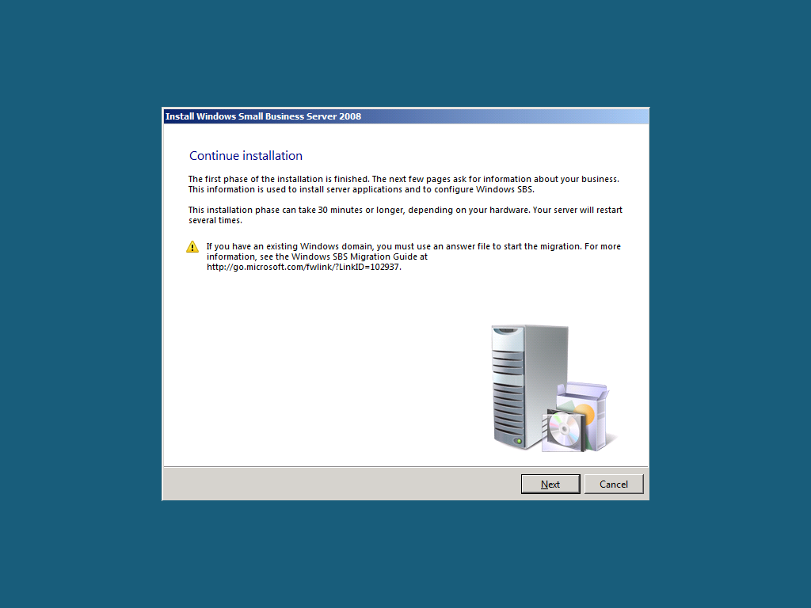
Figure 10 Continue Installation page
- Verify clock and time zone settings, and then click Next.
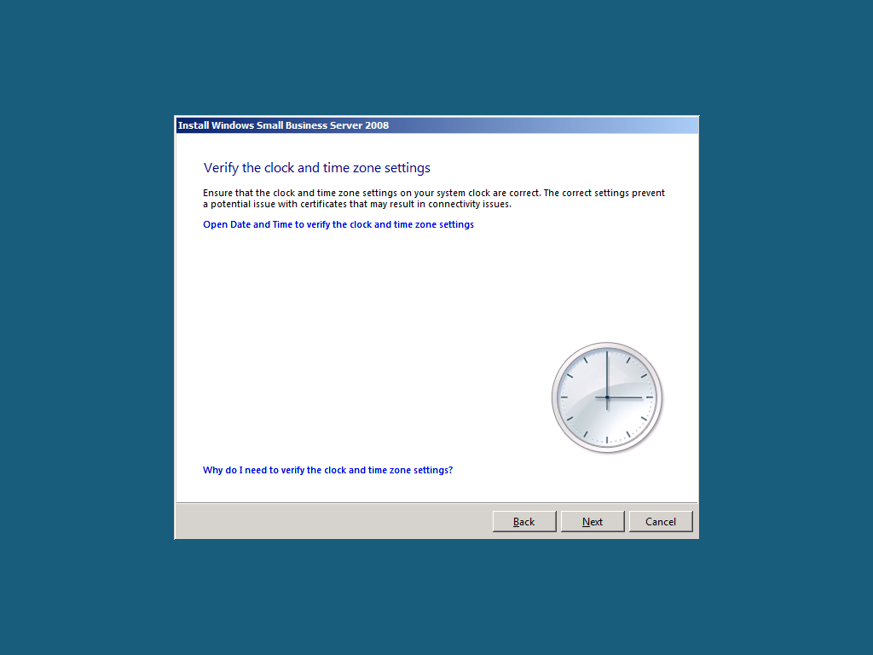
Figure 11 Clock and time zone settings page
- Click Do not get the most recent installation updates.
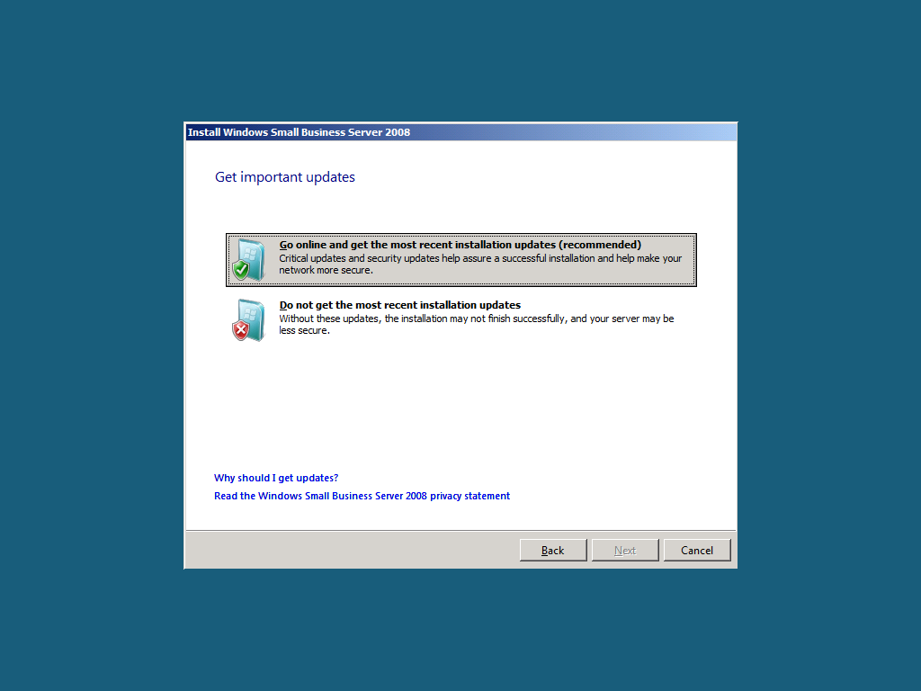
Figure 12 Get important updates page

                - Note:

In a real-world scenario, best practice would be to click Go online and get the most recent installation updates (recommended). Because of the network limitation in the lab, do not get updates.

- Task 2: Enter Company Information
- On the Company information page, type in the following information about Contoso.
Setup stores this information and uses it to configure the server tools, so that you do not have to supply the same information multiple times.
Business name: Contoso
Street address 1: 123 Main Street
City: Yakima
State: WA
Zip/Postal Code: 17927
Country/Region: United States
- Click Next.
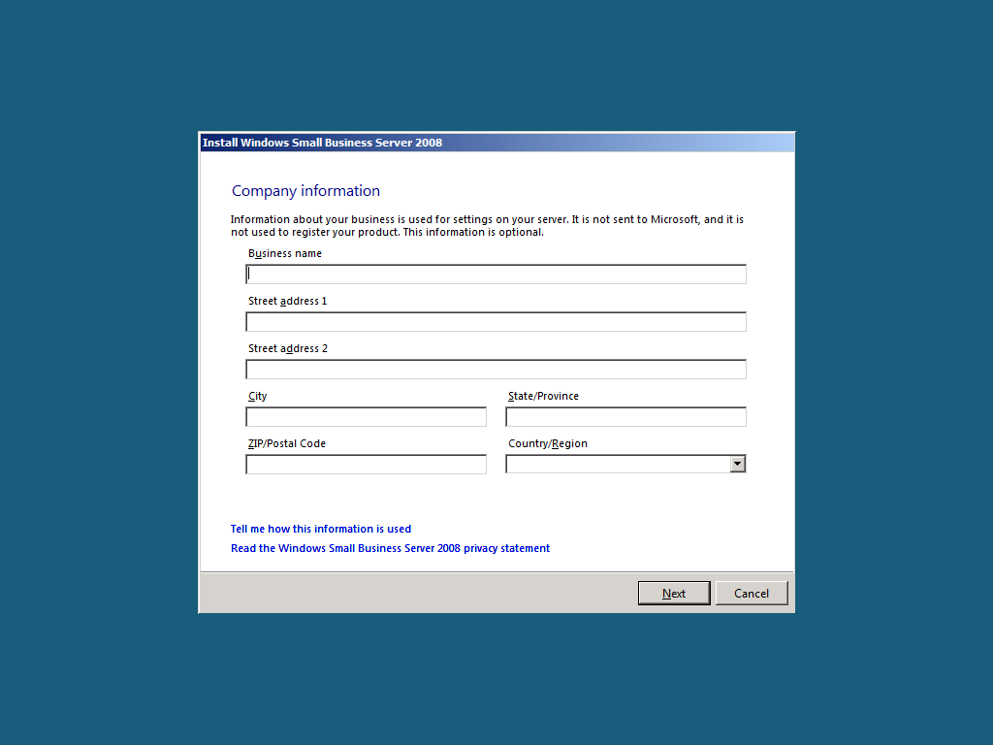
Figure 13 Company information page

- Task 3: Enter server and internal domain names
- On the Personalize your server and network page, type the following name for your server in the Server Name text box.
Server name: SERVER

                - Note:

The server name must be a unique name on your network.

- On the Internal Domain Name text box, type the following name for your internal domain name.
A domain enables you to manage the access to resources on your network (for example, user accounts, client computers, shared folders, or printers).
Setup provides default settings for your internal domain, separating your local (internal) network from the Internet (external network).
Internal domain name CONTOSO

                - Note:

You cannot change the server name or the internal domain name after you finish this task.

- Click Next.
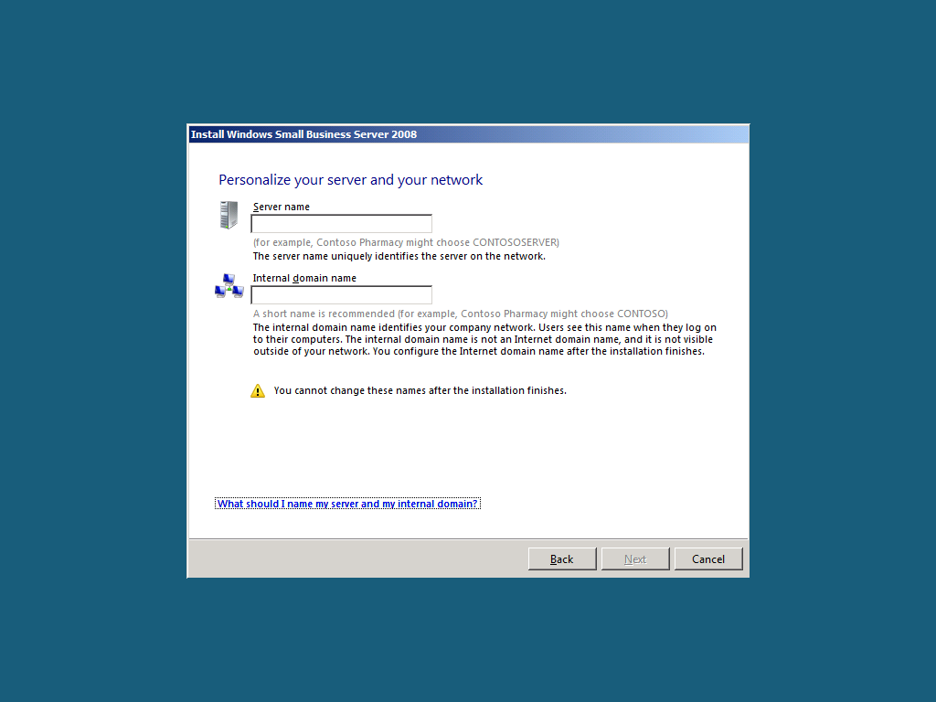
Figure 14 Server and domain names page

- Task 4: Add a Network Administrator Account
- On the Add a network administrator account page, type the information for a new administrator account. This cannot be the same as the built-in Administrator account.
First name: Roland
Last name: Winkler
Administrator user name: RolandW
Administrator password: pass@word1
Confirm administrator password: pass@word1

                - Note:

Specify a strong password for the Network Administrator account. A strong password is between 6 and 127 characters long, and it uses uppercase letters, lowercase letters, numbers, and symbols such as *, ?, and $.

- Click Next.
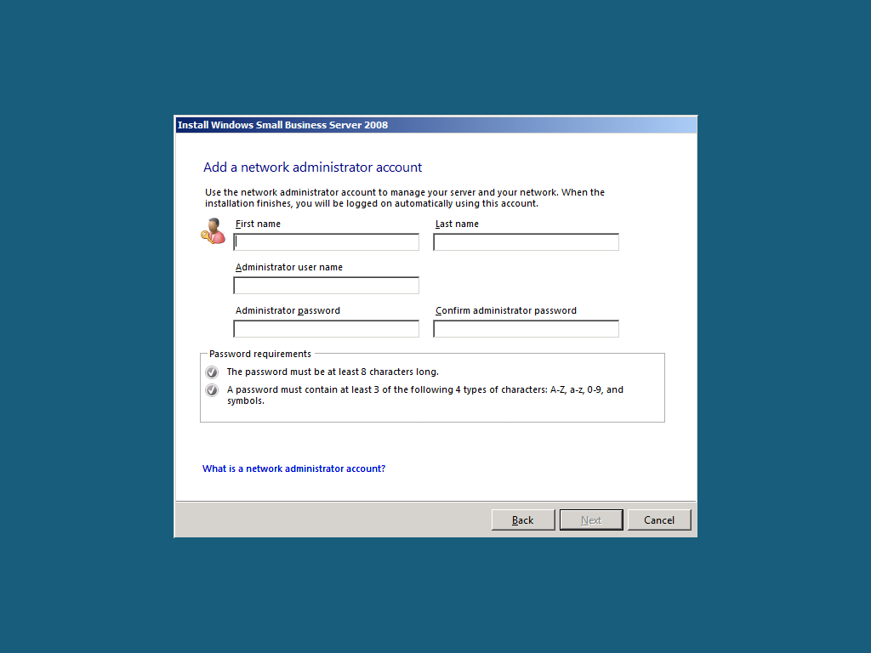
Figure 15 Add a network administrator account page

- Task 5: Finishing up
- Review the settings, and then click Next.
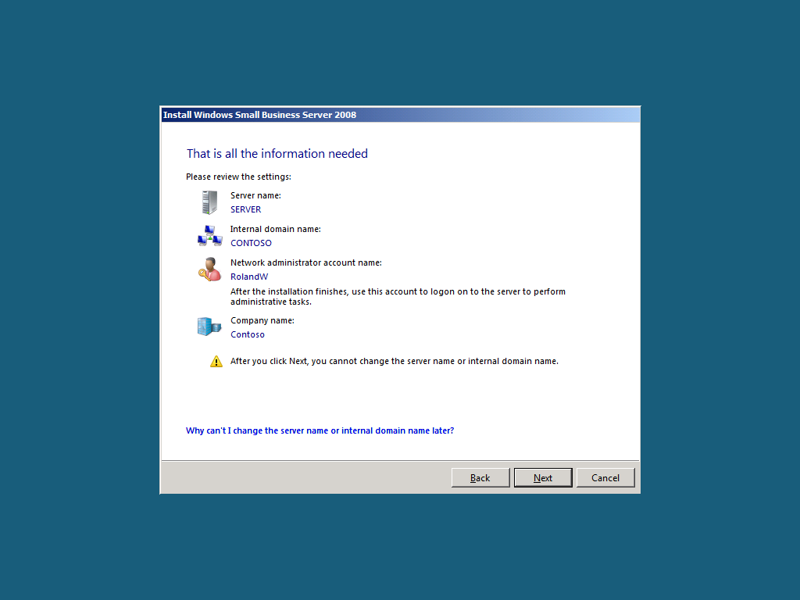
Figure 16 Summary page
- The Expanding and installing files page displays the progress of the final installation process.
- When Windows Small Business Server 2008 setup finishes, the server restarts one more time.
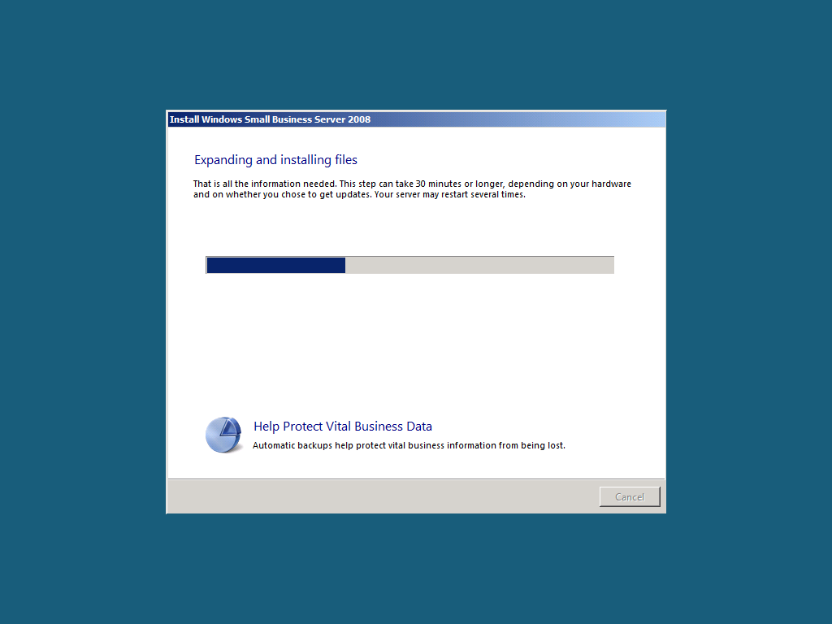
Figure 17 Expanding and installing files page

                - Note:

After installation completes, you are automatically logged on to the new administrator account. The built-in administrator account password is then set to the same password as the new administrator account that was added during installation, and then the built-in administrator account is disabled.

Exercise 3:
Getting Started Tasks
Overview
In this next exercise, you perform post-installation tasks to configure your server. After the server restarts, the Successful Installation window appears. Continue to the Windows SBS Console to walk through the tasks listed in the Getting Started Tasks list.
- Task 1: Connect to the Internet
- Log on as CONTOSO\RolandW, using the password pass@word1.
- Click Start using the server.
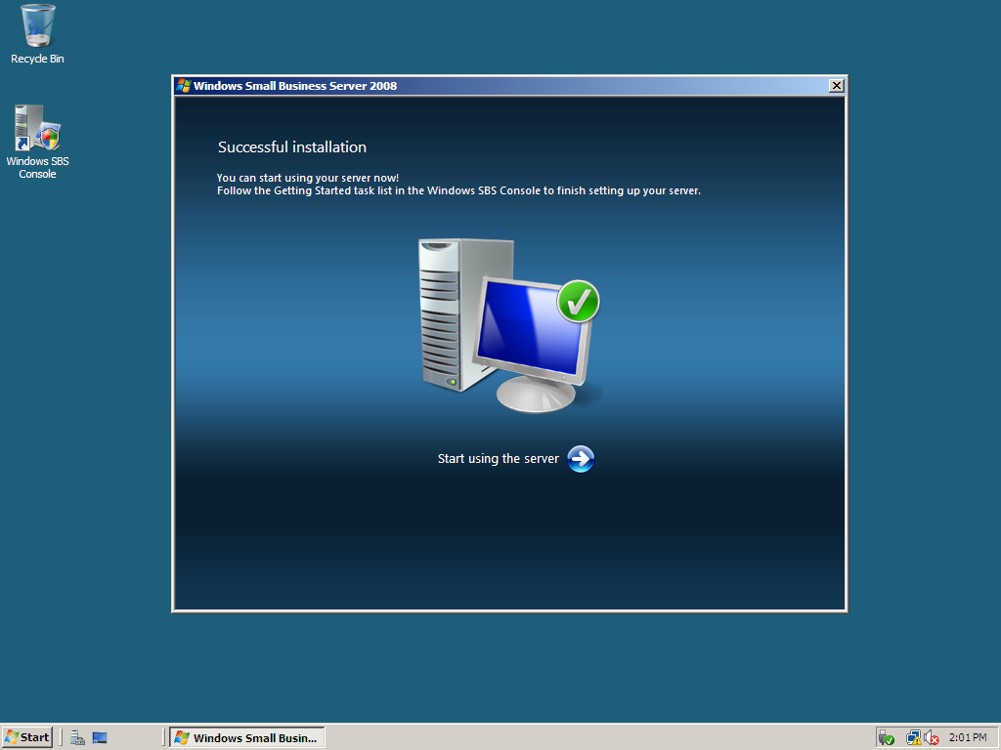
Figure 18 Successful installation page

- If prompted to activate Windows Live™ OneCare™, close message.
- In the Getting Started Tasks section, click Using the Windows SBS console.
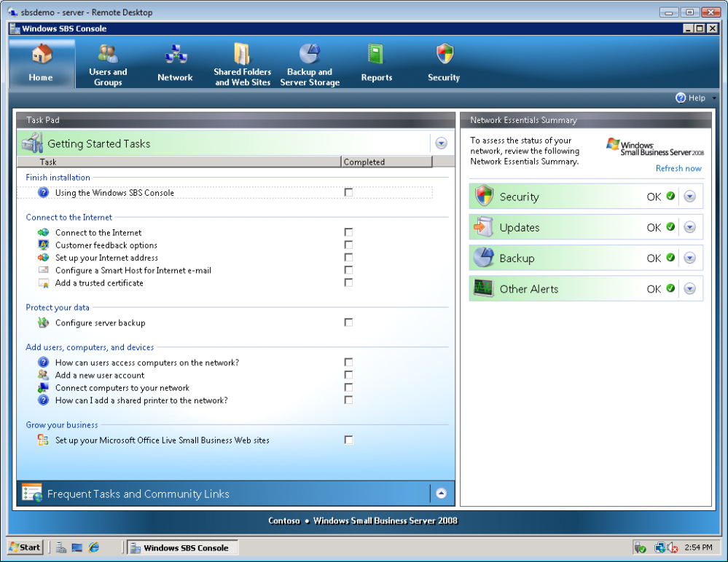
Figure 19 Windows SBS 2008 Console
- From here you can review help for Windows Small Business Server 2008.
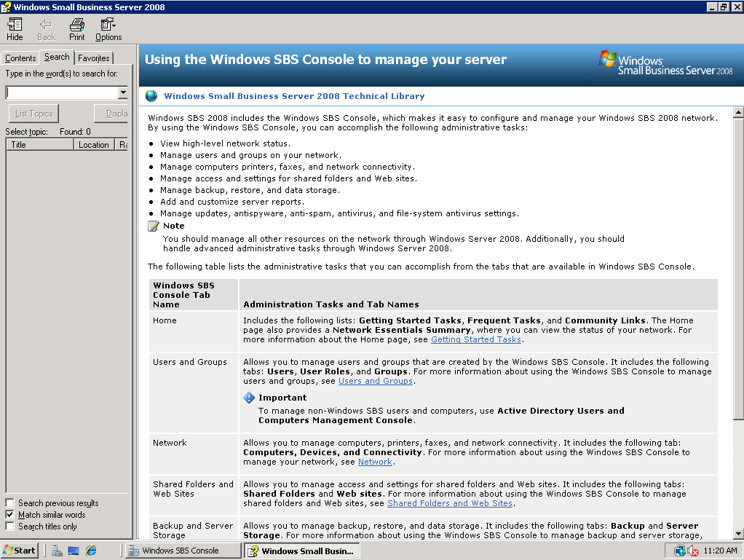
Figure 20 Windows SBS 2008 Help
- Close the help window.
- In the Getting Started Tasks section, click Connect to the Internet.
- On the Before you begin page, click Next.
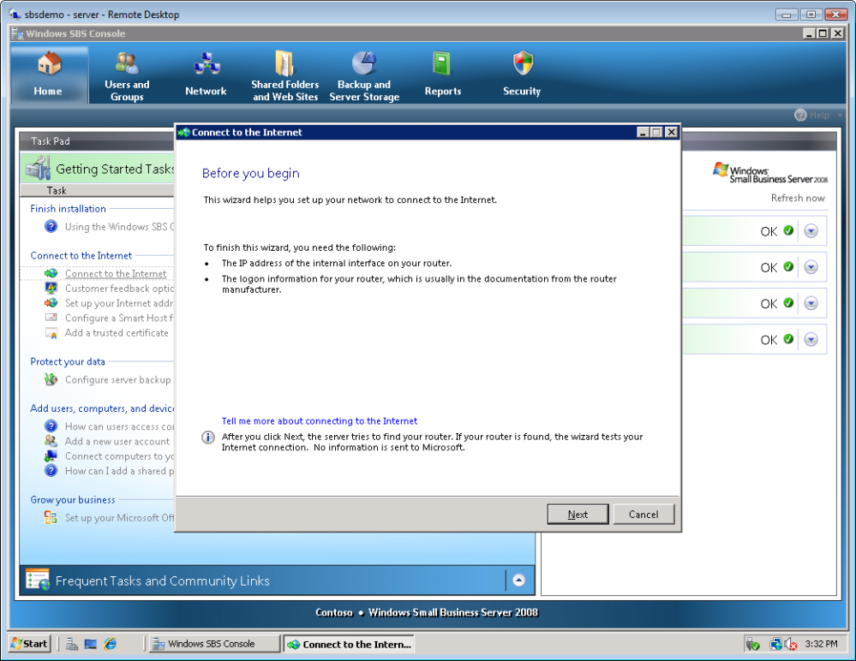
Figure 21 Before you begin page
- Windows attempts to detect an existing network at this point.
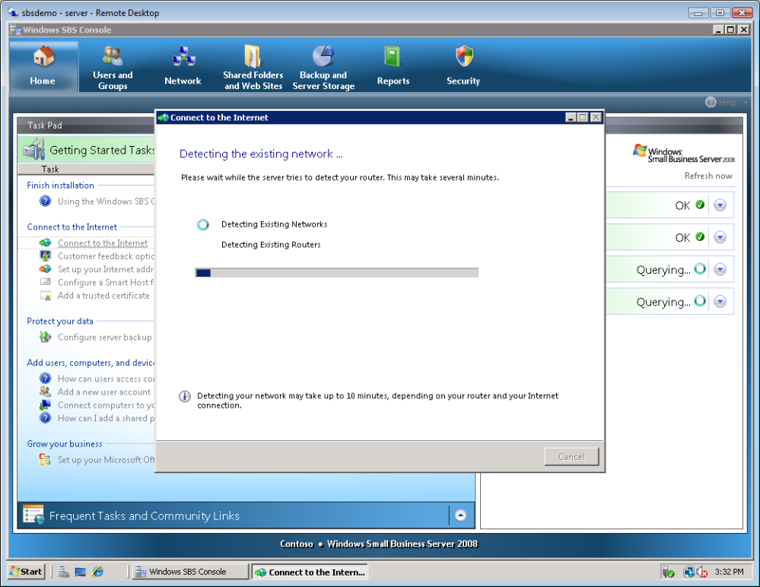
Figure 22 Router IP address page
- At the Connect to the Internet prompt, click Yes.
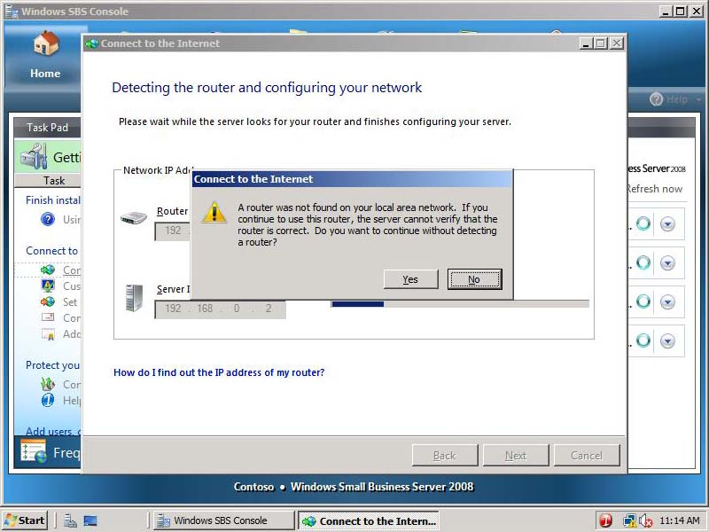
Figure 23 Connect to the Internet prompt
- Type 192.168.0.1 for the IP address of your router.
- Type 192.168.0.2 for the IP address of your server, and then click Next.
- On the Detecting the router and configuring your network page, click Next.
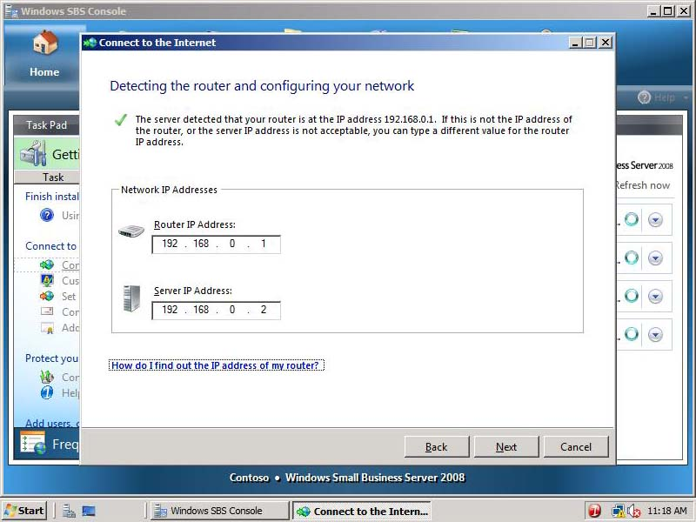
Figure 24 Detecting the router and configuring your network page
- On the Prepare to configure your router page, click Next.
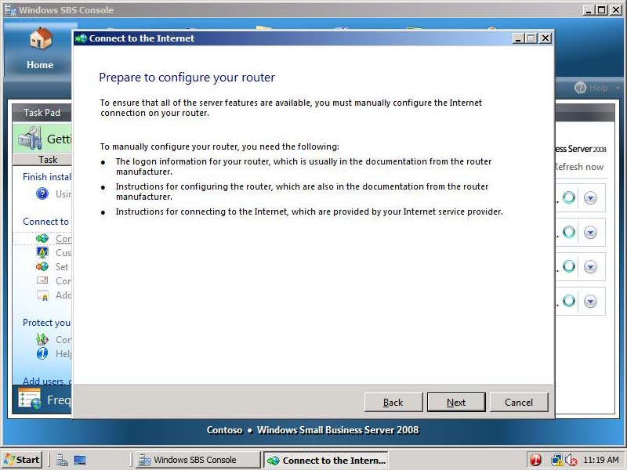
Figure 25 Prepare to configure your router page
- On the Configure your router page, click Test.
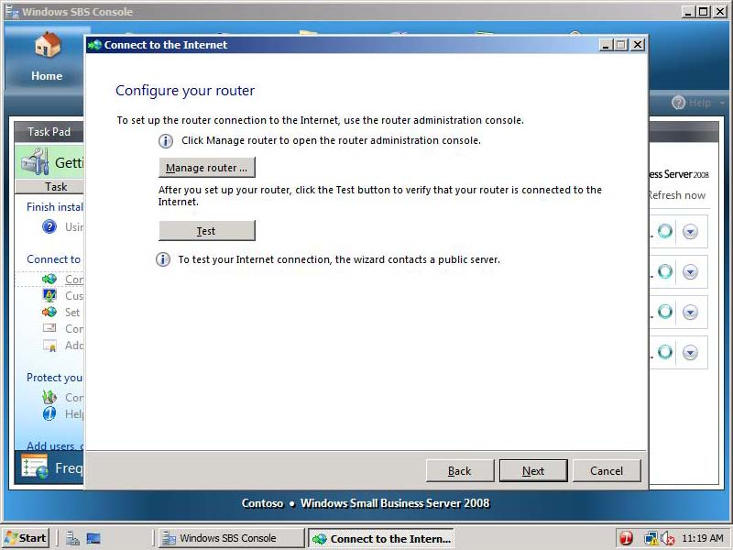
Figure 26 Configure your router page
- Click Skip test.
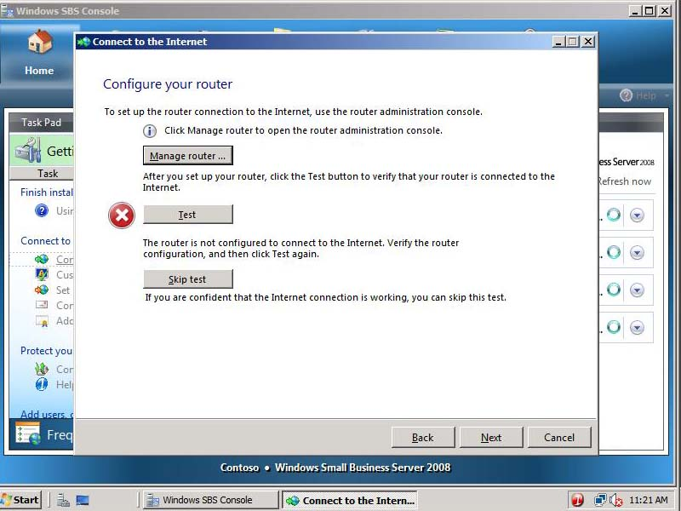
Figure 27 Skip test
- Click Finish.
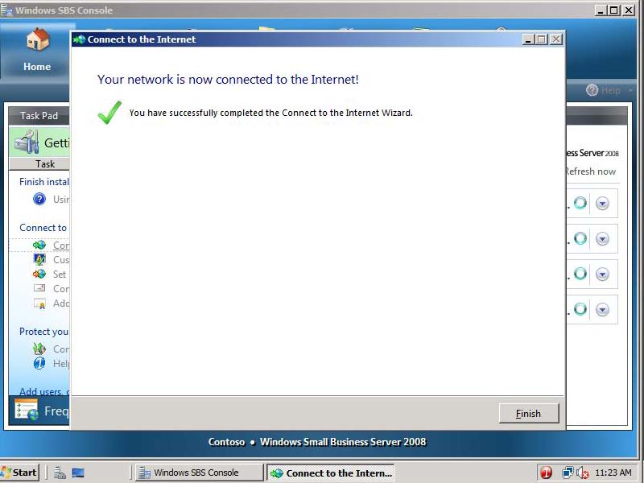
Figure 28 Your network is now connected to the Internet! page

- Task 2: Set up your Internet address
- In the Getting Started Tasks section, click Set up your Internet address.
- On the Before you begin page, click Next.
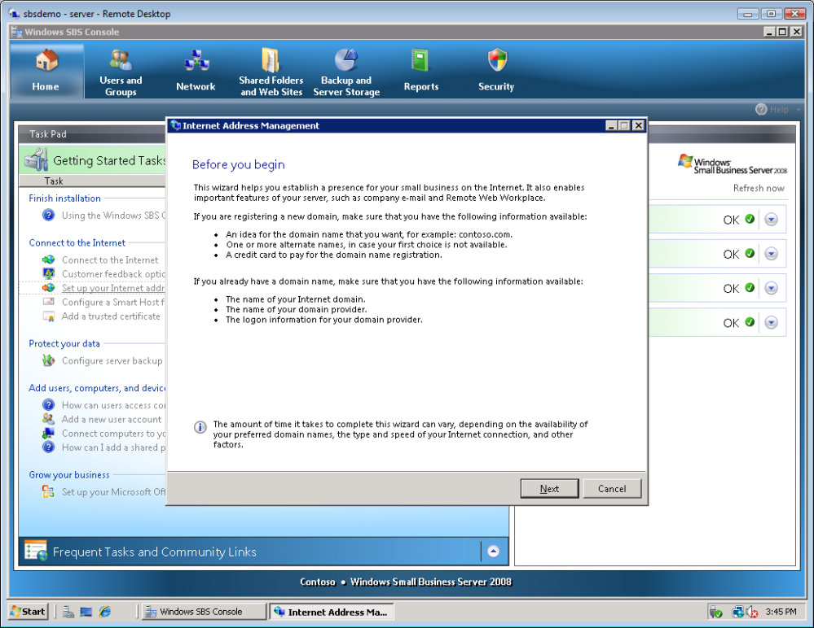
Figure 29 Before you begin
- Select I already have a domain name that I want to use and click Next.
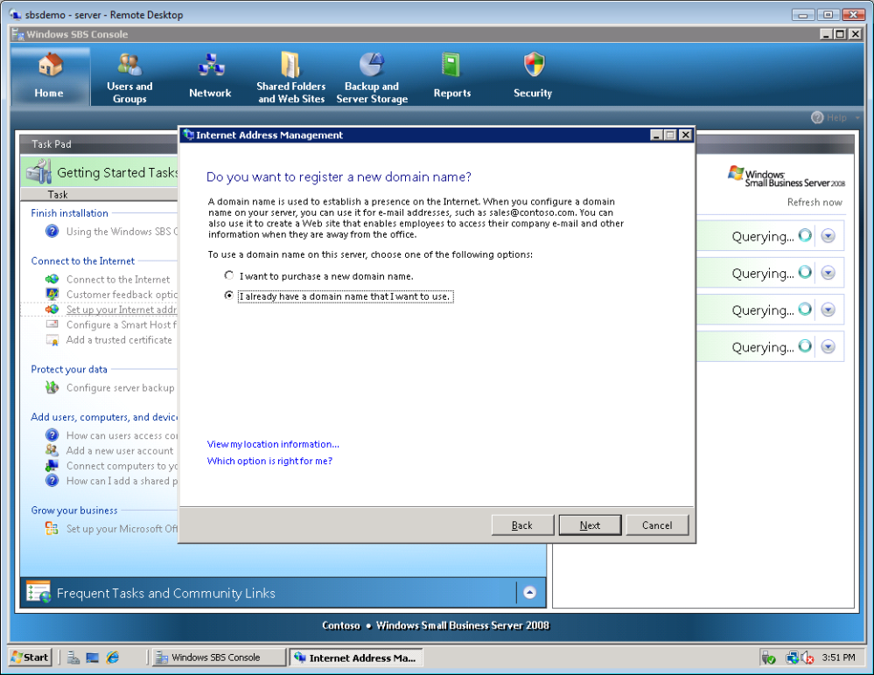
Figure 30 Do you want to register a new domain name? page
- Select I want manage the domain name myself, and then click Next.
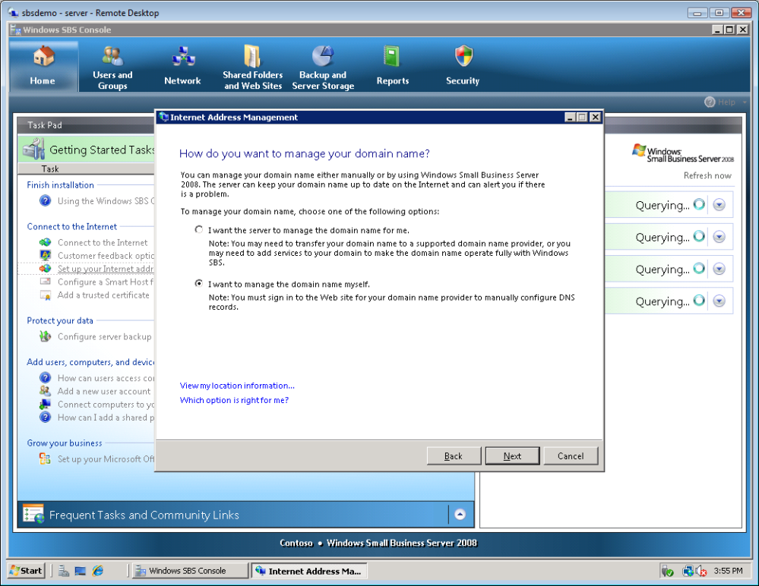
Figure 31 How do you want to manage your domain name? page
- Type Contoso.com and click Configure.
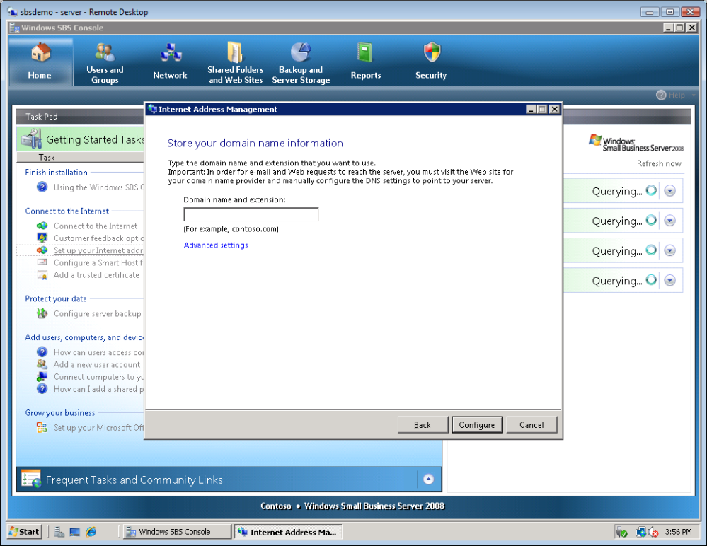
Figure 32 Store your domain name information page
- Your server is now be configured for the contoso.com domain.
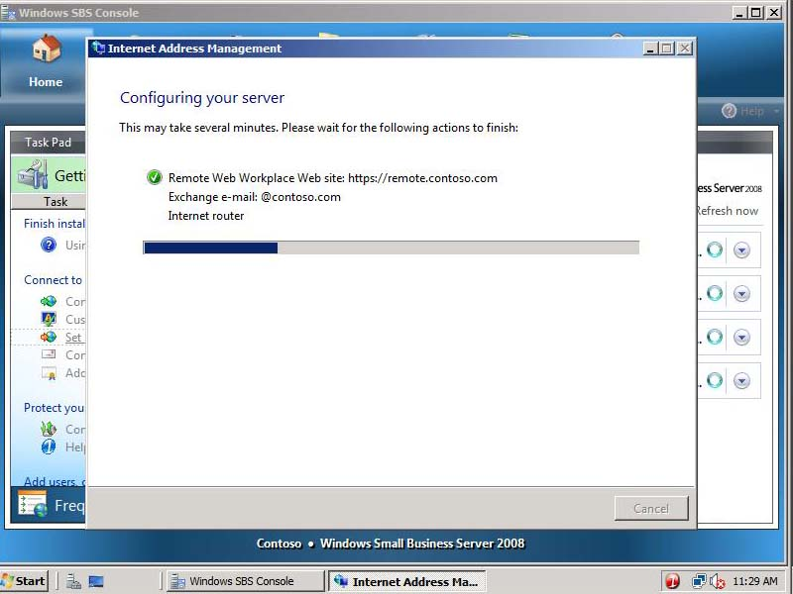
Figure 33 Configuring your server page
- Click Finish.
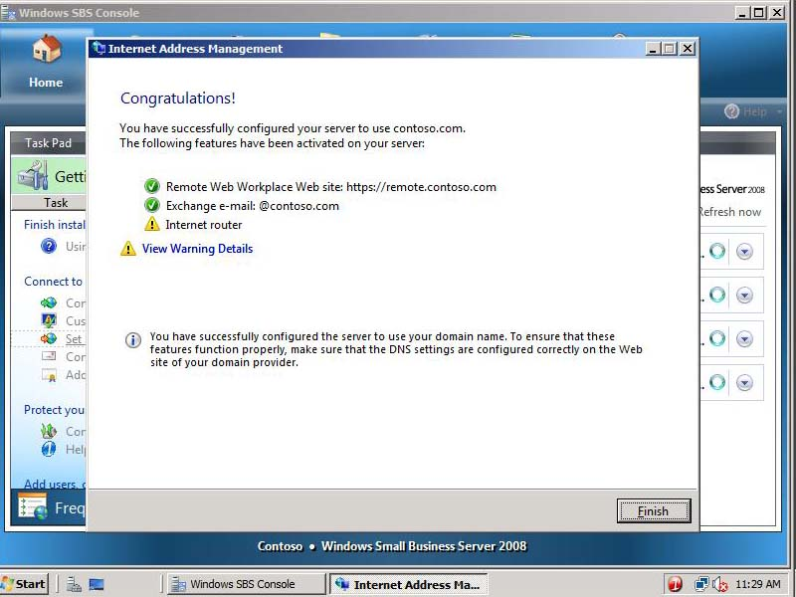
Figure 34 Configuration complete

- Task 3: Configure a Smart Host for Internet e-mail
- In the Getting Started Tasks section, click Configure a Smart Host for Internet e-mail.
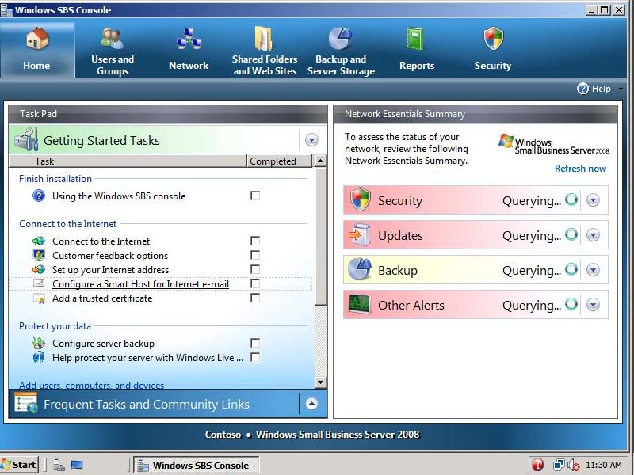
Figure 35 Windows SBS 2008 Console
- On the Before you begin page, click Next.
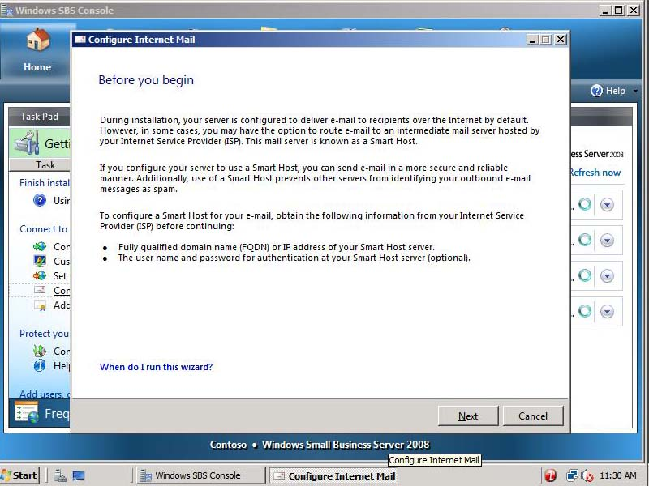
Figure 36 Before you begin page
- Here you can configure a Smart Host server that may be provided by your ISP. Because of network limitations, you cannot set up a smart host at this time.
- Select I do not need to configure a Smart Host server for Internet e-mail, and then click Next.
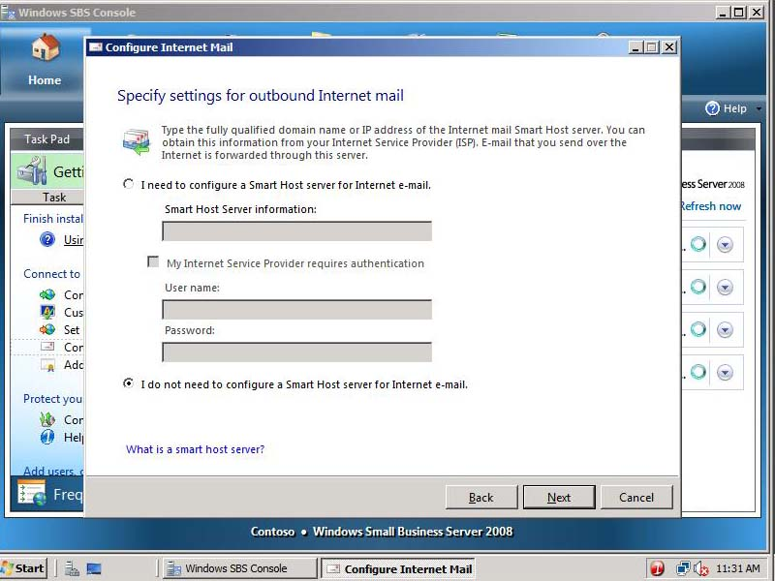
Figure 37 Specify settings for outbound Internet mail page
- On the Configure Internet mail settings is complete page, click Finish.
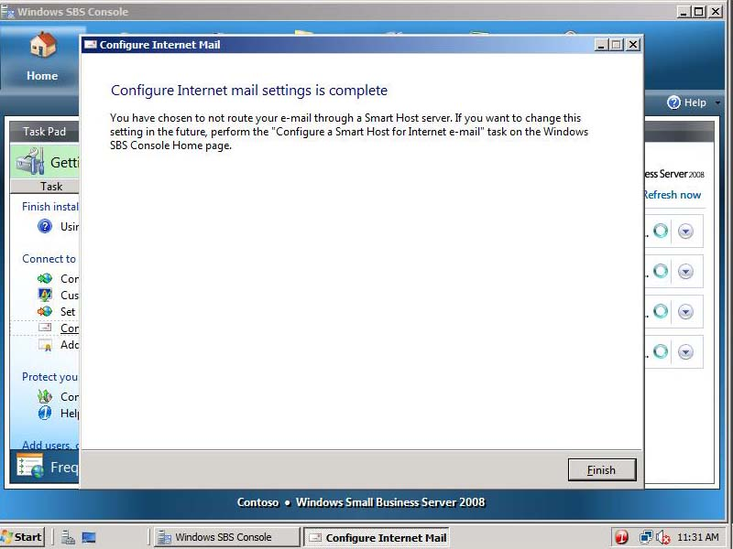
Figure 38 Configure Internet mail settings is complete page

- Task 4: Add a trusted certificate
- In the Getting Started Tasks section, click Add a trusted certificate.
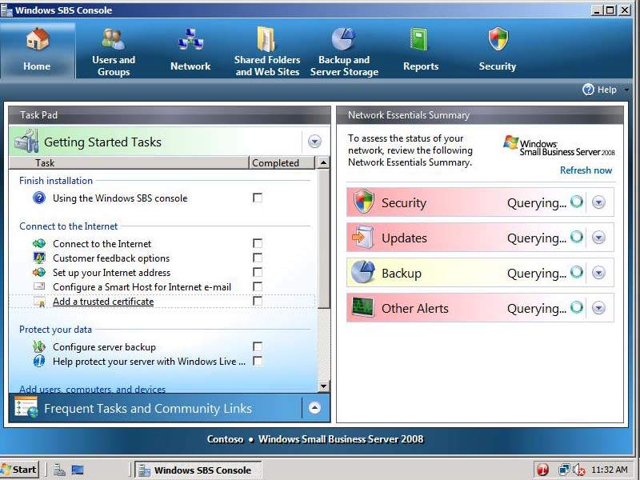
Figure 39 Getting Started Tasks section
- On the Before you begin page, click Next.
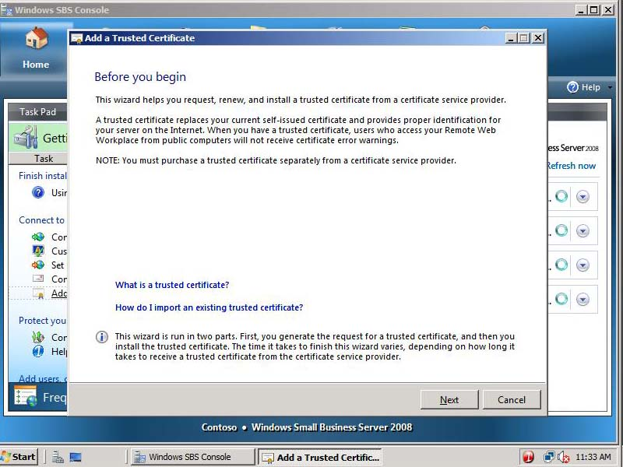
Figure 40 Before you begin page
- Select I want to use a certificate that is already installed on the server and click Next.
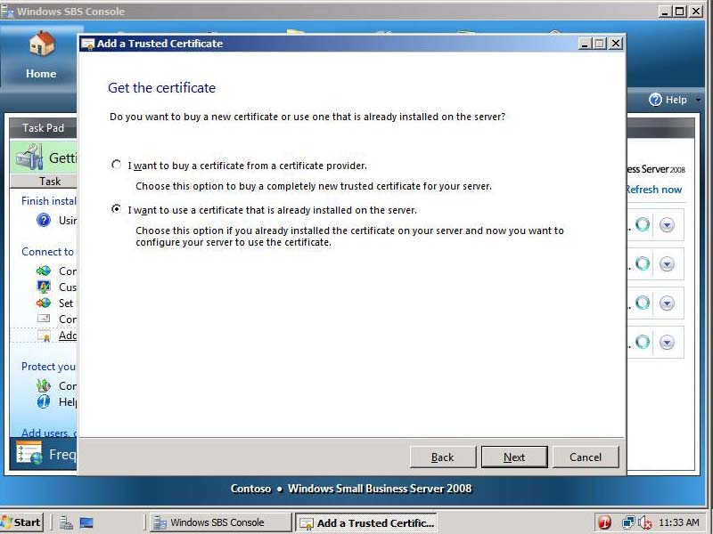
Figure 41 Get the certificate

                - Note:

If you prefer to purchase a certificate from a trusted certificate authority, you can select to do so at this point

- Select remote.contoso.com and click View certificate.
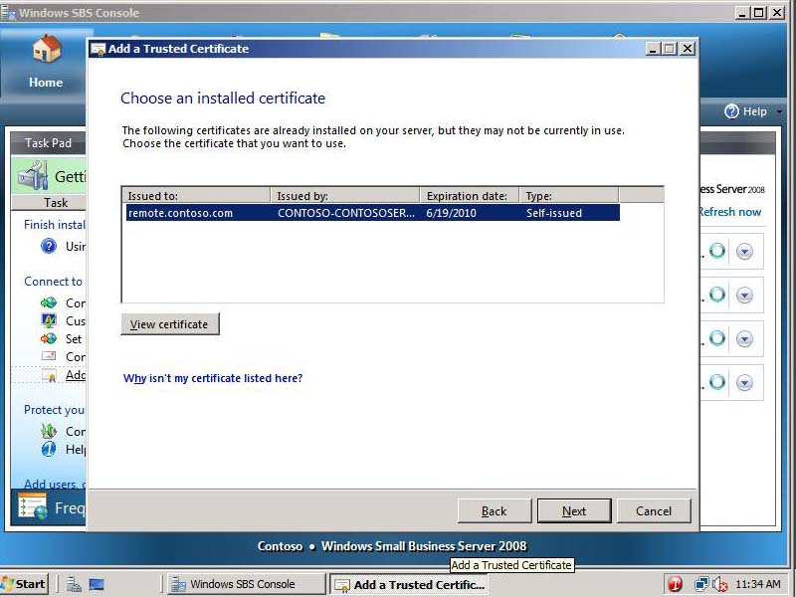
Figure 42 Choose an installed certificate page
- Review the certificate properties, and then click OK.
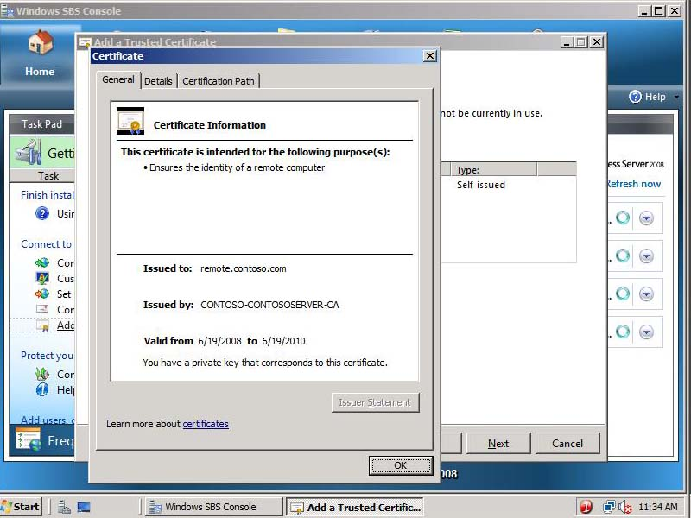
Figure 43 Certificate properties
- Click Next.
- Click Finish.
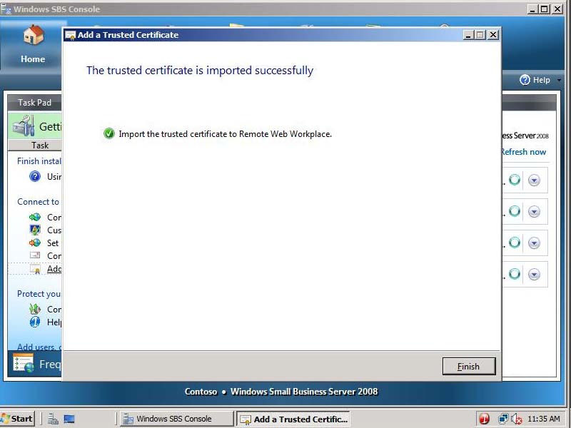
Figure 44 The trusted certificate is imported successfully page
- Task 5: Configure backup and storage
- In the Getting Started Tasks section, click Configure server backup.
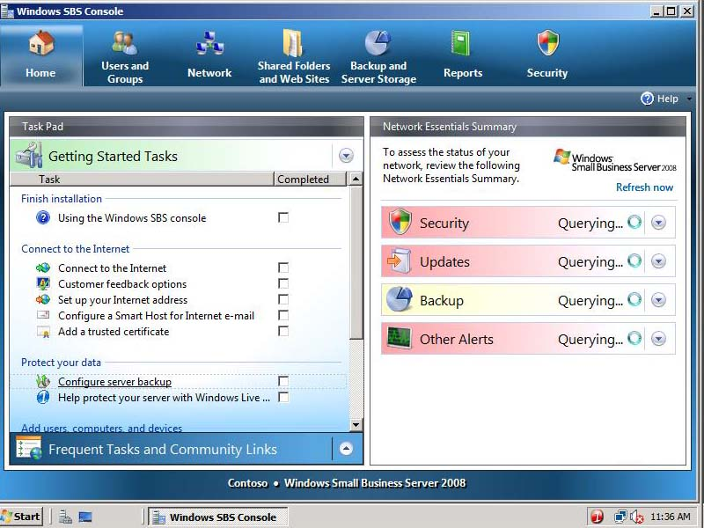
Figure 45 Configure server backup
- In the Getting started window, click Next.
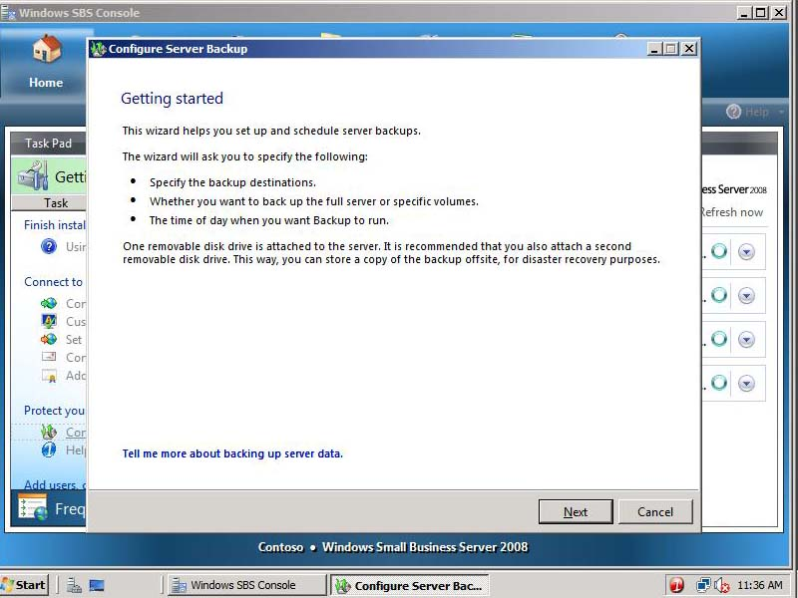
Figure 46 Getting started page
- Select Show all valid internal and external backup destinations.
- Select Disk [1], and then click Next.
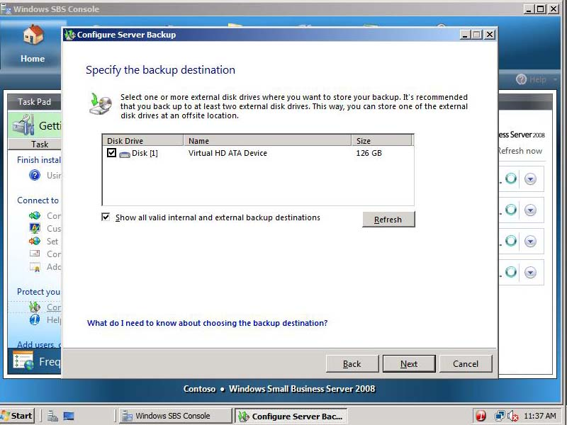
Figure 47 Specify the backup destination page
- Leave Disk1 label, and then click Next.
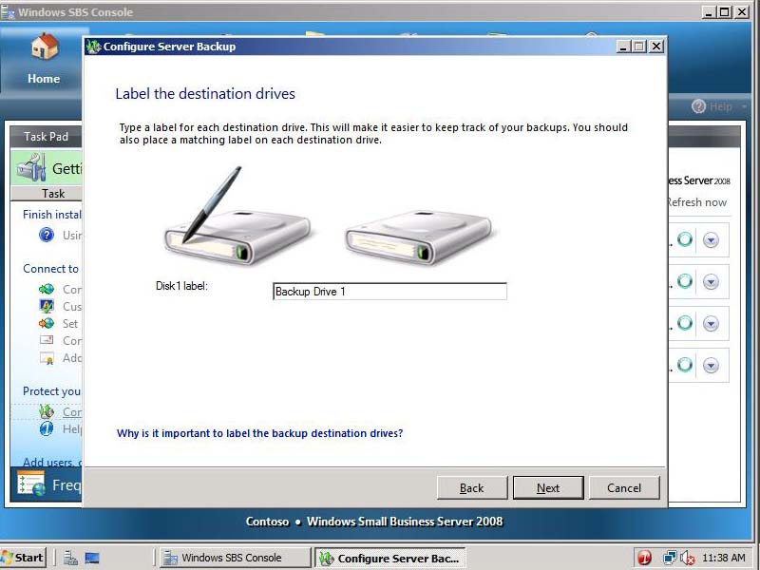
Figure 48 Label the destination drives page
- On the Select drives to back up window, leave defaults, and then click Next.
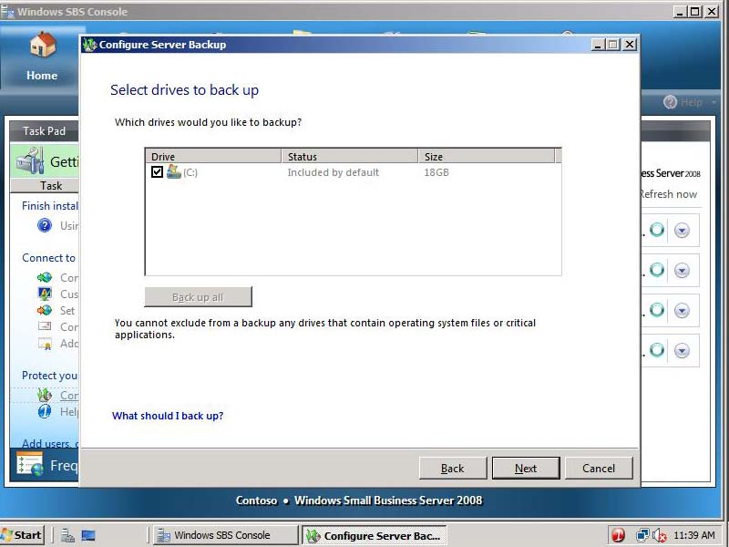
Figure 49 Select drives to back up page
- Review backup schedule, and then click Next.
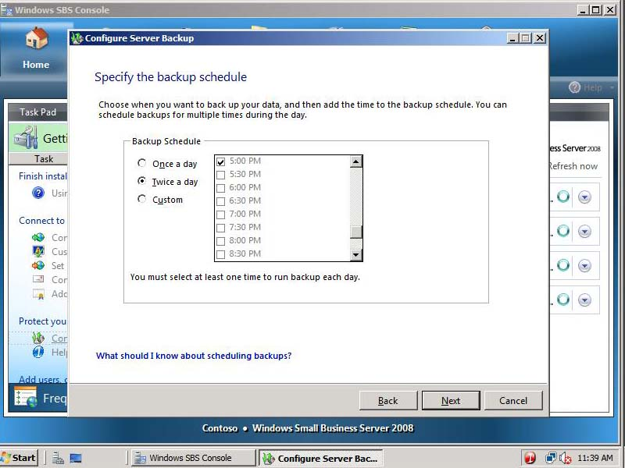
Figure 50 Specify the backup schedule page
- Review backup details, and then click Configure.
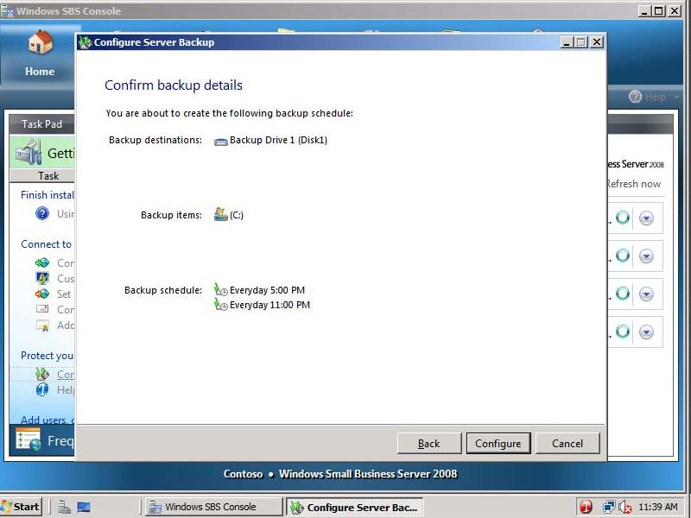
Figure 51 Confirm backup details page
- When prompted to format the selected drives, click Yes.
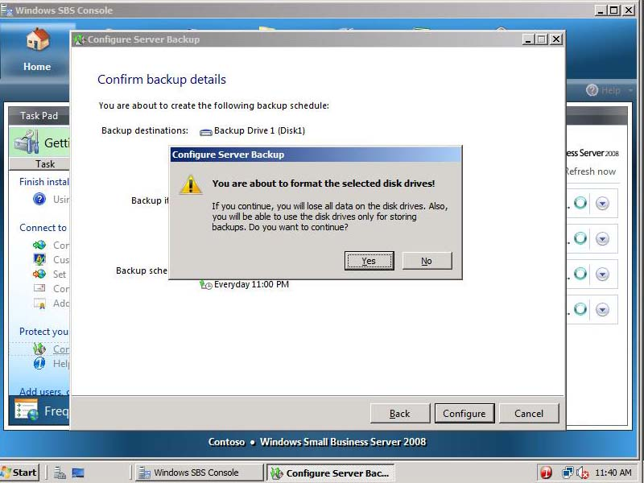
Figure 52 Format drive prompt
- On the Server backup configured page, click Finish.
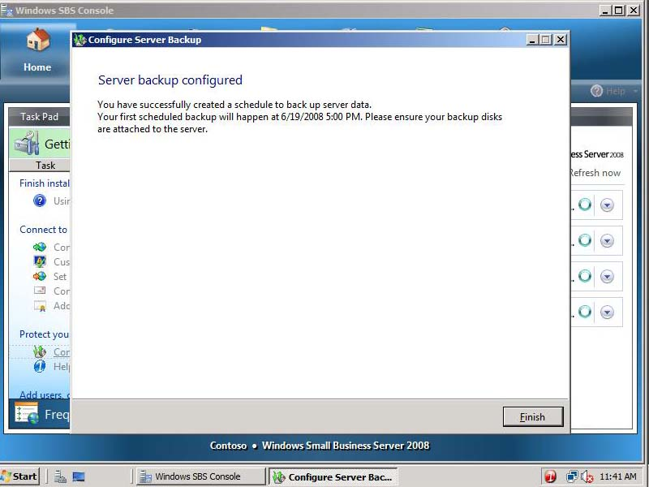
Figure 53 - Server backup configured page

- Task 6: Add a new user
- In the Getting Started Tasks section, click Add a new user account.
Figure 54 Windows SBS 2008 Console
- On the Add a new user account and assign a user role page, enter the following information, and then click Next.
First name: Debra
Last name: Garcia
User name: DebraG
E-mail address: DebraG
Description: Sales
Phone number: 555-555-5555
Choose a user role: Standard User
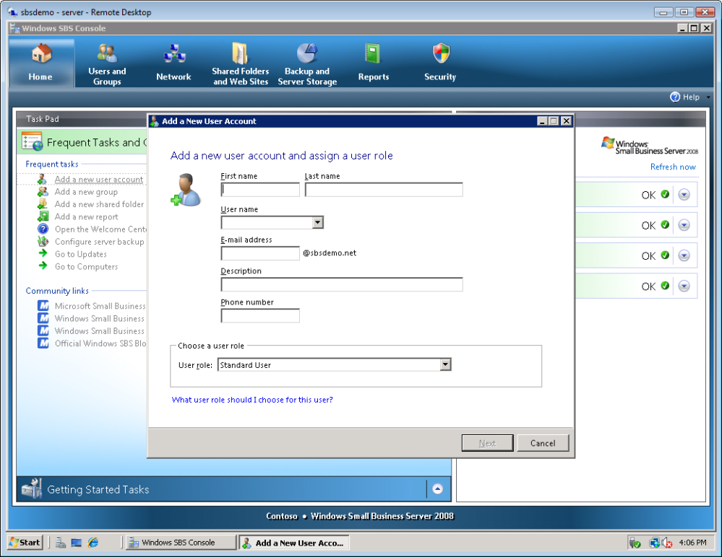
Figure 55 Add a new user account and assign a user role page
- On the Create a password for accessing your network page, enter the following information, and then click Add user account.
Password: pass@word1
Confirm password: pass@word1
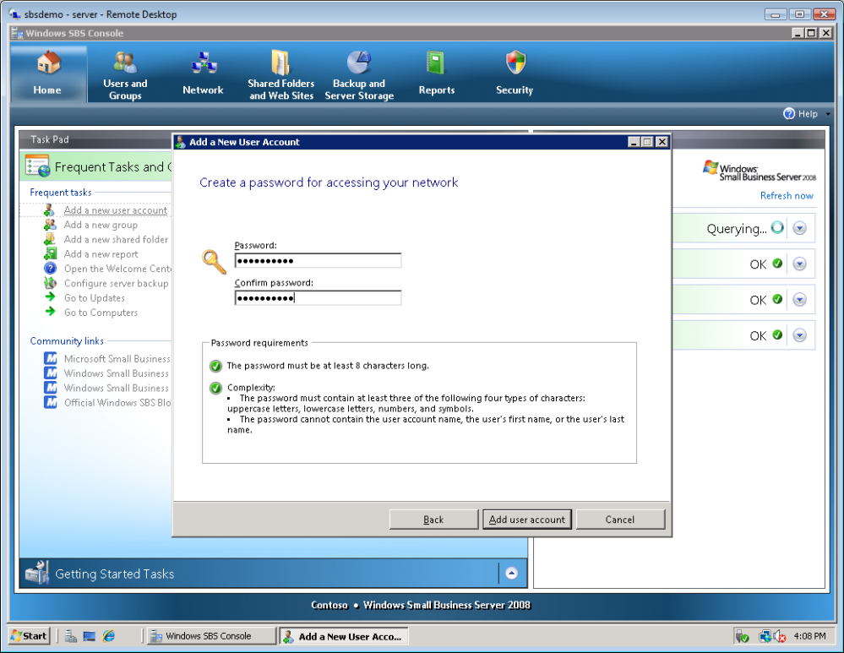
Figure 56 Add user account page
- Click Add a new computer for Don.
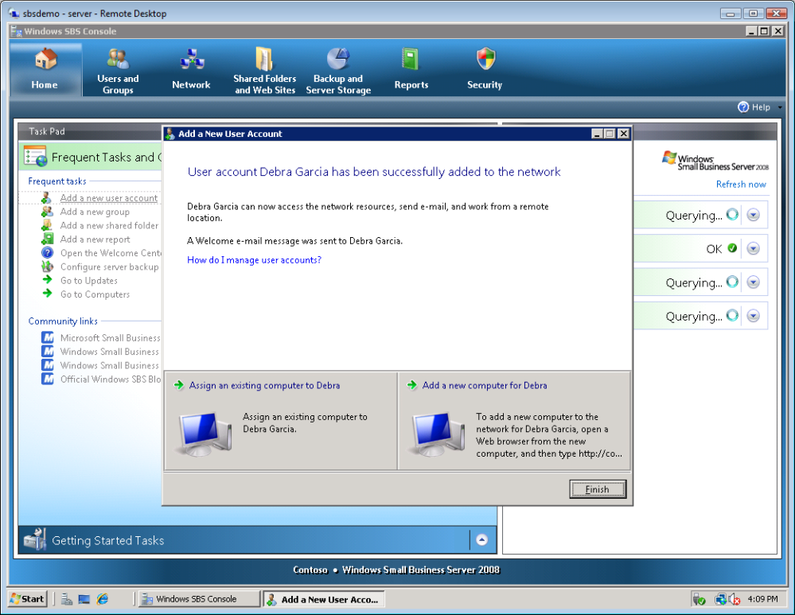
Figure 57 User account added to network
- On the Add user accounts before connecting computers to your network page, click Next.
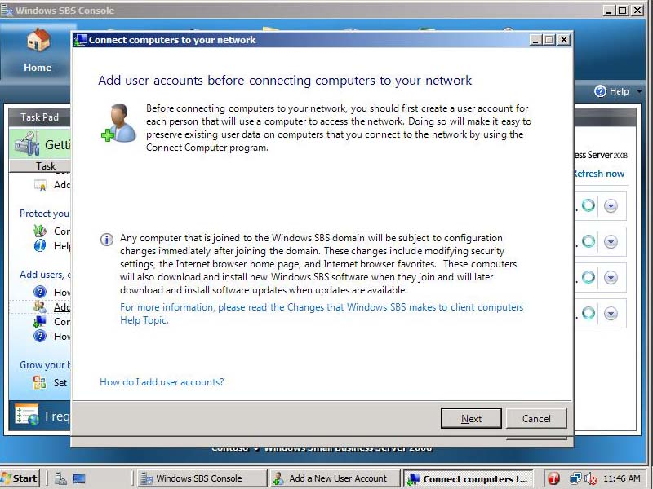
Figure 58 Add user accounts before connecting computers to your network page
- On the Run the Connect Computer program page, click Access the program through a Web browser (recommended).
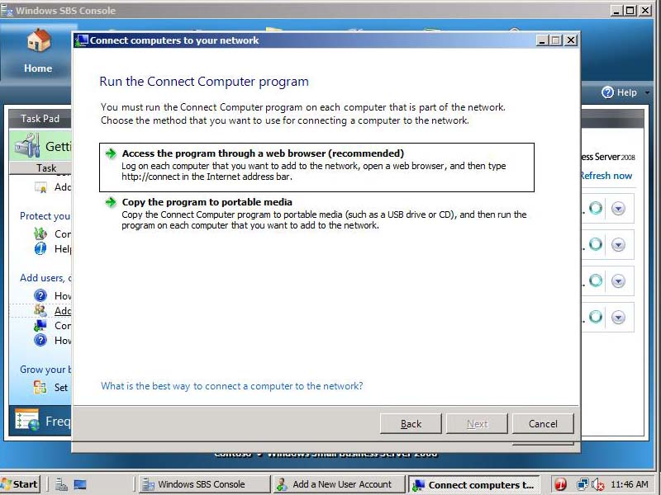
Figure 59 Run the Connect Computer program page
- On the Run the Connect Computer program through a Web browser page, note the Internet address to use to connect to domain: http://connect.
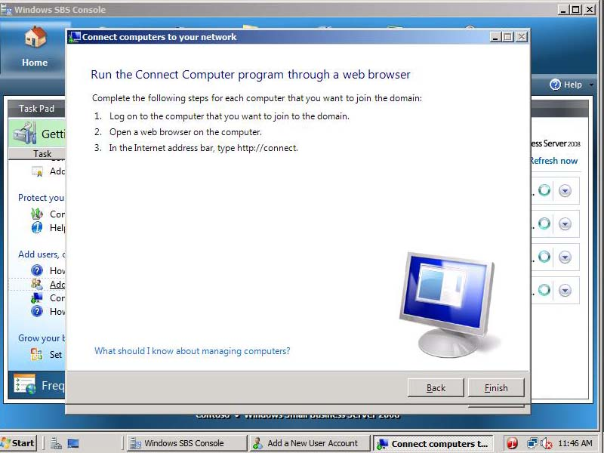
Figure 60 http://connect/
- Click Finish.
- Click Finish.

- Task 7: Set up your Microsoft Office Live Small Business account
    - Click the Home tab.
    - On the Getting Started Tasks, click Set up your Microsoft Office Live Small Business account.
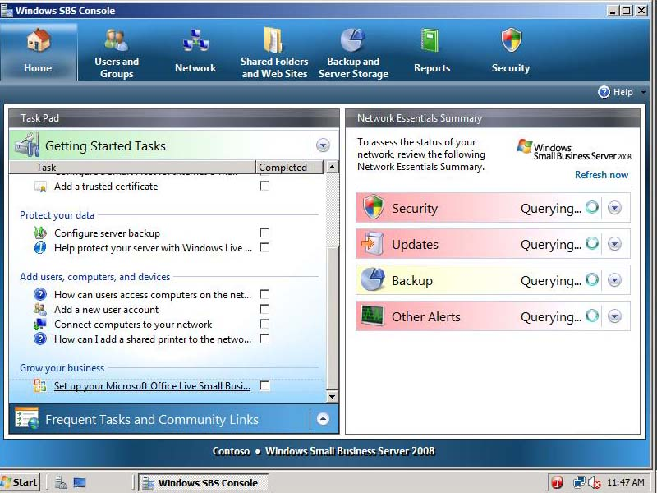
Figure 61 Windows SBS 2008 Console

                - Note:

If you do not have an Internet connection, skip this exercise. You can review the remaining steps to see the steps of the process.

    - On the Getting Started page, click Next.
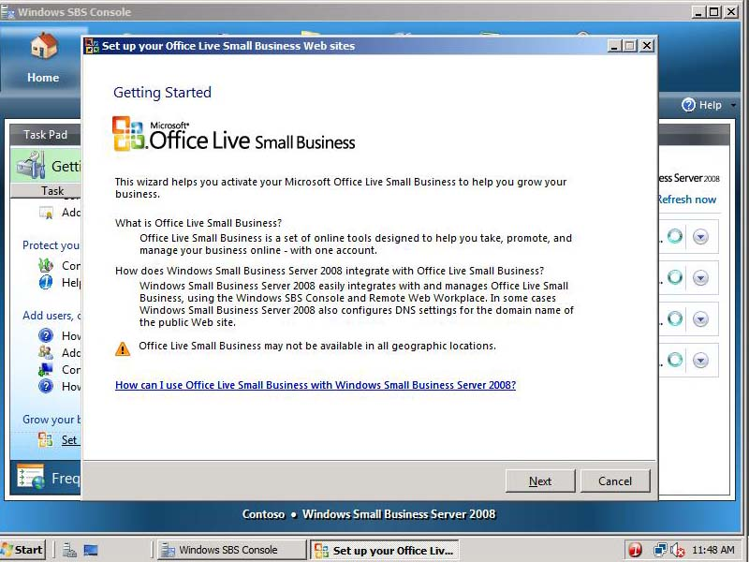
Figure 62 Getting Started page

    - Click Sign up for a new Office Live Small Business account.

                - Note:

If you do not have an Internet connection, click Cancel to exit the wizard. You can review the remaining steps to see the steps of the process.

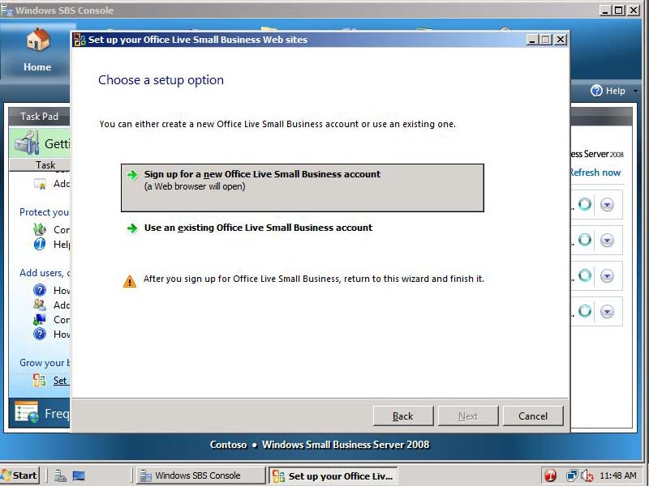
Figure 63 Choose a setup option page

    - A Web browser opens; click Sign Up Free
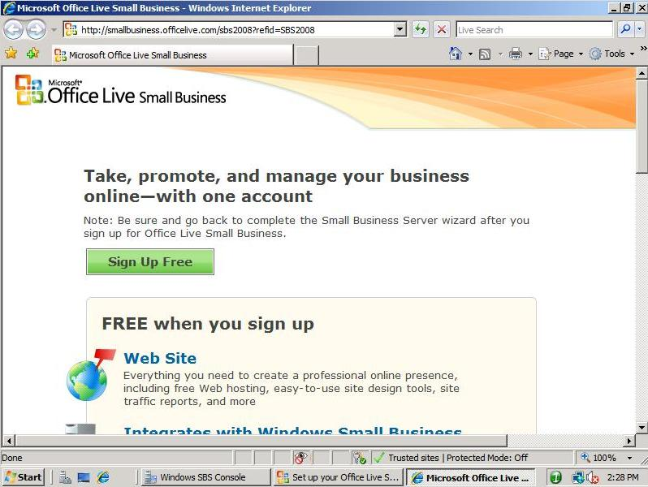
Figure 64 Sign Up Free
    - Click Sign in.
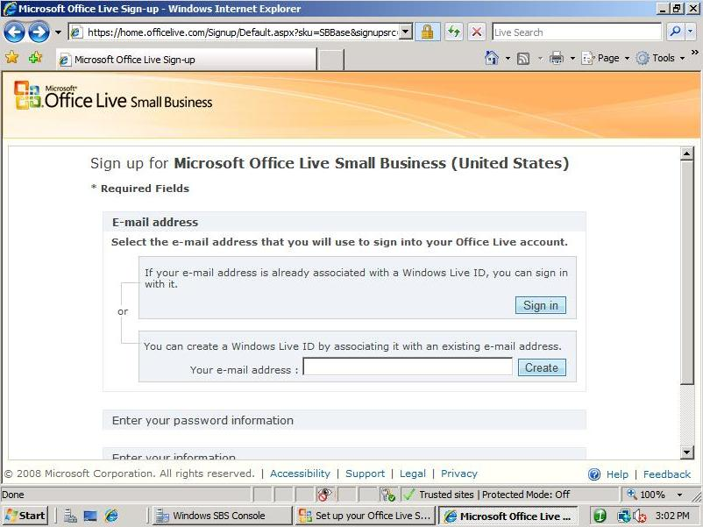
Figure 65 Create a Windows Live ID or Sign in
    - Sign in with your Windows Live ID.
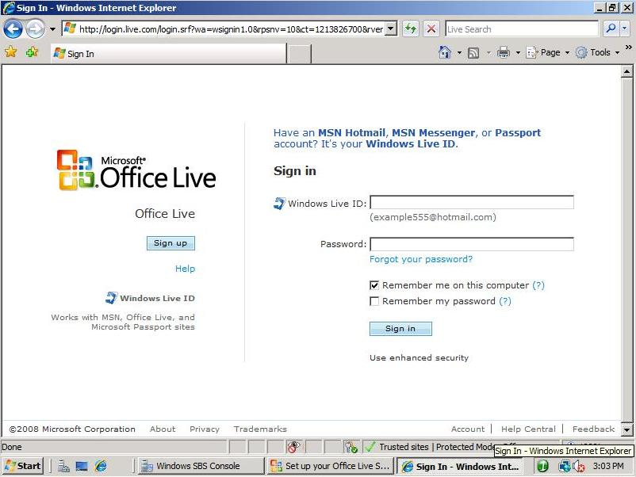
Figure 66 Sign in
    - Enter your information and click Save and continue.
    - Click Go to my account.
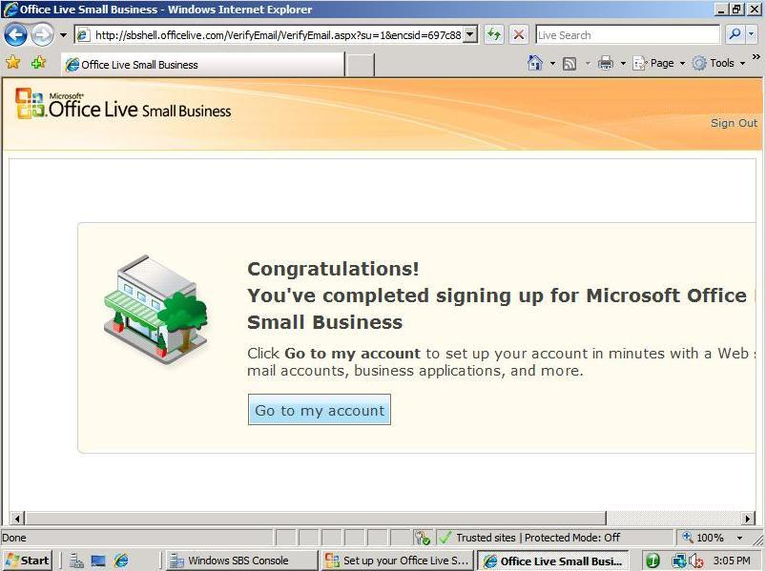
Figure 67 Sign up complete
    - You are now signed up for Microsoft Office Live. Navigate around your account to familiarize yourself with the service.

End of Lab

