Lab 3 Configure Exchange 2003 Messaging Hygiene Features

Objectives
After completing this lab, you will be able to:
- Configure Exchange to Accept/Deny Connection Filtering
- Configure Exchange to using DNS Real-Time Block Lists
- Configure Exchange Sender/Recipient Filtering
- Configure Exchange to handle NDR attack
- Configure Exchange to against Directory Harvest Attack (DHA)
- Configure Exchange to using Intelligence Message Filter (IMF) to filter spam content
- Using Outlook 2003 Anti-Spam Features

Note: Because this lab focuses on concepts, it may not comply with Microsoft security recommendations.

Scenario

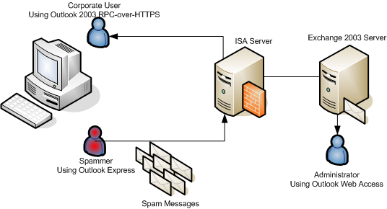

Estimated time to complete this lab: 90 minutes

Exercise 1 Publishing an Exchange Server for SMTP

In this exercise, you will configure server publishing rules on the ISA Server to receive incoming mail from outside (SMTP protocols).

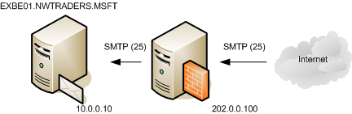

- Switch to ISA Server Log on as Administrator with a password: P@ssw0rd

- Click Start, then point to Programs, then click Microsoft ISA Server, and then click ISA Server Management.

- In the ISA Server console, in the left pane, select Firewall Policy.

- In the right pane, on the Tasks tab, click Publish a Mail Server.

- In the New Mail Server Publishing Rule Wizard, in the Mail Server Publishing Rule name text box, type SMTP Incoming, and then click Next.

- On the select access type page, select: Server-to-server communication: SMTP, NNTP, and then click Next.

- On the select services page, select SMTP and then click Next.

- On the select server page, in the Server IP address text box, type 10.0.0.10 and then click Next.

- On the IP Address page, select External, and then click Next, then click Finish and click Apply to apply the new rules.
Note: Now ISA Server allow SMTP traffic from outside to Exchange 2003 Server.

Exercise 2 Configure Exchange 2003 Connection Filtering

Scenario

Spammer use program/script to generate spam mails traffic to company.

- Switch to RemoteUser Machine VPC Log on as Administrator with a password: P@ssw0rd

- Minimize all active Windows and double click folder name Demo in desktop.

- Explore file name Ex1.cmd, right click and select Edit.

- Review parameter in this file, this file will send spam messages to administrator@nwtraders.msft, close this file.

- Double click Ex1.cmd to generate spam messages to target mailbox.

- Switch to EXBE01 VPC Log on as Administrator with a password: P@ssw0rd.

- Open Internet Explorer and type URL http://exbe01/exchange and click Go.

- The Internet Explorer will open Outlook Web Access and show list of spam messages from outside.

Resolution

Identify sender IP address

- In EXBE01 machine, click Start and Run.

- Type c:\windows\system32\logfiles\SMTPVC1 in Open text box, and click Ok.

- Looking file name ex050929.log and double click this file.

- Consider list of IP address come from same source (202.0.0.200), close this file and close this folder.
Note: In real world scenario, this file will be a large file it may need to import to database to generate a report.

Add Global Deny List

- On EXBE01, click Start, point to Programs, then point to Microsoft Exchange, and then click System Manager.

- Expand Global Settings, right-click Message Delivery, and then click Properties.

- Click the Connection Filtering tab, and in Global Accept and Deny List Configuration, click Deny button.

- In Deny List, click Add.

- In IP Address (Mask), type 202.0.0.200, click Ok, and Ok twice to confirm this change. For waning message click Ok.

- Expand Administrative Groups, First Administrative Group Servers, EXFE01, Protocols, and then SMTP.

- Right-click Default SMTP Virtual Server and then click Properties.

- In the Default SMTP Virtual Server Properties dialog box, on the General tab, click Advanced.

- In the Advanced dialog box, click Edit,

  - Apply Sender Filter: Enable (will be used in next exercise)
  - Apply Recipient Filter: Enable (will be used in next exercise)
  - Apply Connection Filter: Enable
and then click OK.

- To close the Advanced dialog box, click OK.

- To close the Default SMTP Virtual Server Properties dialog box, click OK.

Test the result

- Switch to RemoteUser Machine VPC Log on as Administrator with a password: P@ssw0rd

- Double click Ex1.cmd to generate spam messages to target mailbox, the result will shown “The transport lost its connection to the server”.

Remove Global Deny List

- On EXBE01, click Start, point to Programs, then point to Microsoft Exchange, and then click System Manager.

- Expand Global Settings, right-click Message Delivery, and then click Properties.

- Click the Connection Filtering tab, and in Global Accept and Deny List Configuration, click Deny button.

- In Deny List, select existing list 202.0.0.200, click Remove.

- In IP Address (Mask), click Ok, and Ok twice to confirm this change. For waning message click Ok.

Exercise 3 Configure Exchange 2003 Connection Filtering using DNS Real-Time Block List

Scenario

In real world scenario, the IP addresses deny list is reactive approach to turn to proactive approach in practically way we can subscribe and get update list of IP address direct from database in real-time we call this database as a Real-Time Block List (RBLs).

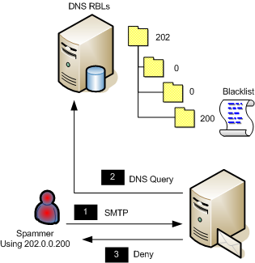

Creating RBLs Provider

In real world scenario, you can subscribe to use RBLs from RBL providers but it would take additional cost per year or per month (depend on condition of each provider).

- In EXBE01 machine, click Start, point to Programs, then point to Administrative Tools, click DNS

- Right-click Forward Lookup Zone, and then click New Zone

- In Welcome to the New Zone Wizard, click Next

- In Zone type, select Primary Zone, click Next

- In Active Directory Zone Replication Scope, select To all DNS servers in the Active Directory domain nwtraders.msft, click Next

- In Zone name, type rbls.local and click Next

- Leave all default configurations, click Next, and Finish.

- In new zone rbls.local, right click and then select New Domain

- In New DNS Domain, type 202 and click Ok.

- Expand zone name rbls.local and zone name 202, in zone name 202 right-click and select New Domain

- In New DNS Domain, type 0 and click Ok.

- Expand zone name rbls.local, zone name 202, and zone name 0, in zone name 0 right-click and select New Domain

- In New DNS Domain, type 0 and click Ok.

- Expand zone name rbls.local, zone name 202, zone name 0, and zone name 0 in zone name 0 right-click and select New Domain

- In New DNS Domain, type 200 and click Ok.

- Expand zone name rbls.local -> 202 -> 0 -> 0 -> 200, right click and then select New Host (A).

- Leave Name as an empty value, and type 127.0.0.1 in IP address, and click Add Host, the record will created in DNS, click Close to close the dialog and close DNS snap-in.
Note: Every RBLs provide will give you a return code translation table e.g. in this example RBLs will return IP address 127.0.0.1 mean IP address 202.0.0.200 is a Relay Server to send a spam traffic.

Add a real-time block list provider

- On EXBE01, click Start, point to Programs, then point to Microsoft Exchange, and then click System Manager.
- Expand Global Settings, right-click Message Delivery, and then click Properties.
- Click the Connection Filtering tab, and then click Add.
- In the Connection Filter Rule window, in the Display Name box, type Real-time Block List Provider
- In the DNS Suffix of Provider box, type rbls.local

- In the Custom Error Message to Return box, type
You are denied permission to submit SMTP messages. Call +66 2 111 1111 for more information.

- In Return Status Code from Provider Service, click Return Status Code.

- In the Return Status Code window, click Match Filter Rule to the Following Mask, type 127.0.0.1 and then click OK.

- Verify that Disable this rule is not selected, and then click OK.

- Click OK to close the Message Delivery Properties window.

- Click OK to the Exchange System Manager warning that Connection, Recipient, and Sender filtering must be manually enabled on specific Simple Mail Transfer Protocol (SMTP) virtual server Internet Protocol (IP) address assignments.

Test the result

- Switch to RemoteUser Machine VPC Log on as Administrator with a password: P@ssw0rd

- Double click Ex1.cmd to generate spam messages to target mailbox, the result will shown “The server response was: 550 5.7.1 You are denied permission to submit SMTP messages. Call +662 111 1111 for more information.”.

Remove a real-time block list provider

- On EXBE01, click Start, point to Programs, then point to Microsoft Exchange, and then click System Manager.

- Expand Global Settings, right-click Message Delivery, and then click Properties.

- Click the Connection Filtering tab, and in Block List Service Configuration, select Real Time Block Lists Providers, click Remove.

- In confirmation click Yes, and Ok to confirm this change. For waning message click Ok.

Exercise 4 Configure Exchange 2003 Sender/Recipient Filtering

Scenario

In real world scenario, event spammer can change IP address every time when they connect to the internet (for example by: ADSL modem, Dial-up Connection). In some spammer that using valid e-mail address (address that user can Reply mail back to sender e.g. Advertising Spam Message). In this case we can filter or block by sender.

In Microsoft IT environment we can filter over 30 Million Messages submitted to domain @microsoft.com a day by set filtering 10 recipients.

Add Sender to Sender Block Lists

- On EXBE01, click Start, point to Programs, then point to Microsoft Exchange, and then click System Manager.
- Expand Global Settings, right-click Message Delivery, and then click Properties.

- Click the Sender Filtering tab, and then click Add.

- In Add Sender text box type: spamer@spam.org, then click Ok.

- Click Ok, to confirm this change, for waning message click Ok.

Test the result

- Switch to RemoteUser Machine VPC Log on as Administrator with a password: P@ssw0rd

- Double click Ex1.cmd to generate spam messages to target mailbox, the result will shown “The transport lost its connection to the server.”.

Exercise 4 Configure Exchange 2003 to handle NDR Attack

Scenario

Non Delivery Reports (NDR) processing takes a significant amount of resources, attacker will send large message by spoofing sender address using non-existing domain, it would make mail server try to send NDR back to non-existing server.

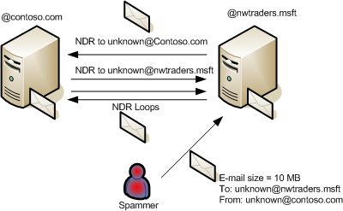

Or attacker will send large message by spoofing sender address to make a recursive NDR between two domains.

- Switch to RemoteUser Machine

- On RemoteUser Machine, click Start, point to All Programs, and then click Outlook Express.

- Browse to Local Folders -> Drafts, open message title “Large File from Spamer – Not in Directory 1”.

- Review the message intensively send to unknown@nwtraders.msft and contain Large File.zip, click Send to summit to SMTP server.

- On EXBE01, click Start, point to Programs, then point to Microsoft Exchange, and then click System Manager.
- Expand Administrative Groups->Servers->EXBE01->Queues, looking queue name spamer.org

- To delete message in pending queue, right-click queue name spamer.org and select Find messages.

- In Find Messages – spamer.org click Find Now button.

- Explore the result in Search Results; right click in message and select Delete (no NDR), and confirm to delete this message.

- Close Find Messages dialog.

Add Sender to Sender Block Lists

- In Exchange System Manager, Expand Global Settings, right-click Message Delivery, and then click Properties.

- Click the Recipient Filtering tab, and enable “Filter recipients who are not in the Directory”, and click Ok. For waning message click Ok.

Test the result

- Switch to RemoteUser Machine VPC

- On RemoteUser Machine, click Start, point to All Programs, and then click Outlook Express.

- Browse to Local Folders -> Drafts, open message title “Large File from Spamer – Not in Directory 2”.

- Review the message intensively send to unknown@nwtraders.msft and contain Large File.zip, click Send to summit to SMTP server.

- The Outlook Express will show error message “Server Response: 550.5.1.1 User unknown”.

Exercise 5 Configure Exchange to against Directory Harvest Attack (DHA)

Scenario

In exercise 4, recipient lookup feature validates recipients before accepting message. But it increasing the possibility of rapid alias enumeration, called Directory Harvest Attack (DHA).
Note: In test environment it does take 20 minutes to harvest all valid 4 character aliases within a domain.

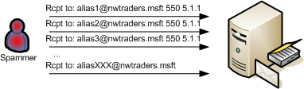

- Switch to RemoteUser Machine

- Minimize all active Windows and double click folder name Demo in desktop.

- Explore file name Ex2.cmd, right click and select Edit.

- Review parameter in this file, this file will send spam messages to administrator@nwtraders.msft, close this file.

- Double click Ex2.cmd to start Directory Harvest Attack to target domain.

- Explore the result in console windows, the DHA will finish in short period.

Delay 550 responses for n seconds

Delay the 550 response for n seconds will slow down the attacker significantly. With 5 second delay it takes months to enumerate all 4 character alias combinations (compare with 20 minutes with no delay 550 response).
- Switch to EXBE01 VPC

- Click Start, click Run, type regedit in the open box, and then click Ok.

- Locate and then click to select the following registry subkey:
HKEY_LOCAL_MACHINE\SYSTEM\CurrentControlSet\Services\
SMTPVC\Parameters

- On the Edit menu, point to New, then click DWORD Value.

- Type TarpitTime as the registry entry name, and then press ENTER.

- On the Edit menu, click Modify.

- Click Decimal.

- In the Value data box, type 5, click Ok.
Note: The value is a number of seconds that you want to delay SMTP address verification responses (505 5.1.1 User unknown)

- Quit Registry Editor

- Click Start, click Run, type Cmd and then click Ok

- Type net stop “Simple Mail Transfer Protocol (SMTP)”, and wait until the service has been stopped.

- Type net start “Simple Mail Transfer Protocol (SMTP)”, and wait until the service has been started.

Test the result

- Switch to RemoteUser Machine

- Minimize all active Windows and double click folder name Demo in desktop.

- Explore file name Ex2.cmd, right click and select Edit.

- Review parameter in this file, this file will send spam messages to administrator@nwtraders.msft, close this file.

- Double click Ex2.cmd to start Directory Harvest Attack to target domain.

- Explore the result in console windows, the DHA will finish in 50 seconds (10 addresses with 5 second delay).
Exercise 6 Configure Exchange to using Intelligence Message Filter (IMF) to filter spam content

Scenario

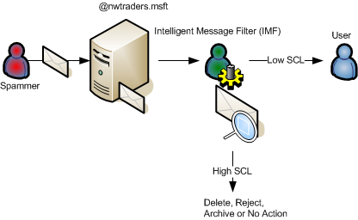

Intelligent Message Filter (IMF) examines message and give each an Spam Confident Level (SCL) value [0-9], two level threshold at Gateway and Store. If SCL > Gateway threshold, administrator can define action (Delete, Reject, Archive or No Action). If SCL in message pass the Gateway threshold but > Store level it will deliver new mail into Junk Mail folder.

- Switch to EXBE01 VPC

- On EXBE01, click Start, point to Programs, then point to Microsoft Exchange, and then click System Manager.
- In Exchange System Manager, Expand Global Settings, right-click Message Delivery, and then click Properties.

- Click the Intelligent Message Filtering tab,

  - Gateway Blocking Configuration: 8
  - When blocking messages: Delete
  - Store Junk E-mail Configuration: 4

Click Ok

- Expand Administrative Groups, First Administrative Group Servers, EXFE01, Protocols, and then SMTP.

- Right-click Intelligent Message Filtering and then click Properties.

- Enable Virtual Server name, Default SMTP Virtual Server, and click Ok.

- Switch to RemoteUser Machine VPC

- On RemoteUser Machine, click Start, point to All Programs, and then click Outlook Express.

- Browse to Local Folders -> Drafts, open message title “Save up to 75% on Inkjet Cartridges”.

- In To text box: type remoteuser@nwtraders.msft, and click Send.

- Browse to Local Folders -> Drafts, open message title “Billion dollar arena,…”.

- In To text box: type remoteuser@nwtraders.msft, and click Send.

- Switch to Microsoft Outlook 2003, click Send/Receive button.

- Review one new message come to Inbox and another new mail come to Junk E-mail.

Review SCL value in message

- In Remote User VPC, minimize all opened Windows.

- Open folder name Demo in Desktop.

- Copy file SCL.CFG to folder c:\program files\Microsoft office\office11\forms\1033

- Open Microsoft Outlook 2003, right click Junk E-mail folder and select Properties.

- Select Forms Tab, click Manage button.

- In Forms Manager, click Install button.

- Browse the file c:\program files\Microsoft office\office11\forms\1033\SCL.CFG and click Ok.

- Click Close button to close Forms Manager, and click Ok to close Junk Folder properties.

- Back to Junk Mail Item, right click title: Arranged By: Date, and then Select Custom item

- In Customize View, click Fields button

- In Show Fields, select available fields form: SCL Extension Form

- In Available fields, select SCL and click Add -> button.

- Click Move Up SCL until SCL move into first order.

- Click Ok button twice.

- You will able to see SCL score in message header.

Exercise 6 Outlook 2003 Anti-Spam Features

Scenario

Many out of the box security features come with Microsoft Outlook 2003

- Attachment blocking for Outlook/Outlook Web Access
- Web beacon blocking
- Junk mail filtering

- In Remote User VPC, minimize all opened Windows

- Open Microsoft Office Outlook 2003, right click mail from Spamer, and select Junk E-mail, and then select Add Sender to Blocked Senders List. Click Ok to confirm.

- Switch to EXBE01 VPC

- On EXBE01, click Start, point to Programs, then point to Microsoft Exchange, and then click System Manager.
- Expand Administrative Groups, First Administrative Group Servers, EXFE01, Protocols, and then SMTP.

- Right-click Intelligent Message Filtering and then click Properties.

- Disable Virtual Server name, Default SMTP Virtual Server, and click Ok.

- In Remote User VPC, Switch to Outlook Express, Browse to Local Folders -> Drafts, open message title “Celebrated of Labour Day!...”.

- In To text box: type remoteuser@nwtraders.msft, and click Send. In any security warning message click Ok to accept.

- Switch to Microsoft Outlook 2003, click Send/Receive button.

- Review one new message come to Junk E-mail folder, with SCL in header. And notice all HTML picture link is not download by default to prevent mail beacon attack.

Bringing It All Together

However “No silver bullet for Spam”, At Microsoft, we are committed to promoting a safe online experience to help empower individuals and organizations worldwide to confidently rely upon the Internet to interact, to communicate, and to conduct business.

We believe achieving that goal requires a coordinated approach that includes technology solutions, industry collaboration, user education and enablement, effective legislation, and targeted enforcement. Through our industry and government partnerships, we are working to improve online safety and to put the spammers and scammers out of business, read more information from http://www.microsoft.com/spam.

With the release of Exchange 2003 Server SP2 Microsoft and the Exchange Server Product Unit are taking another big step in helping alleviate the Unsolicited Commercial Email (spam) problem. Announced a year ago, the Coordinated Spam Reduction Initiative clearly outlined the plan for drastically reducing the amount of spam customers may experience through the introduction of new technology solutions. A year later, Exchange 2003 SP2 delivers exactly that - new technology that significantly helps combat spam.

With the introduction of Exchange 2003 Server, Microsoft built a framework that included a number of features intended to reduce the volume of spam. The framework called for a solution based on a multi-layered approach around the idea that most if not all spam should be stopped at the gateway, and before reaching the final recipient's mailbox. The adoption of this approach has proven to be very successful and highly effective, and with the release of SP2 the framework will be refined even further to include the following steps of which I'll summarize below:

1. Connection Filtering
2. SMTP Filtering
3. Content Filtering
4. Inbound mail processing rules (this will be covered separately)
This is an example of typical mailflow:
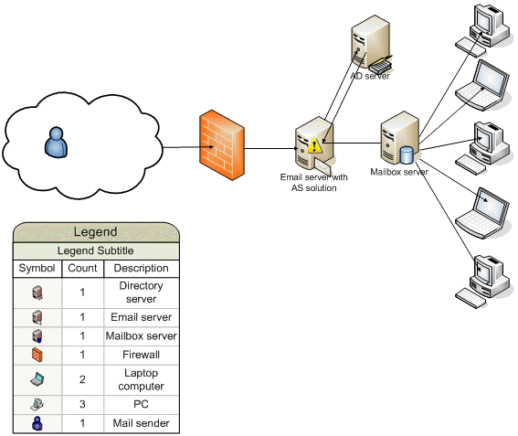

At a point during mail transmission from the origination point to the final destination (recipient), a mail item enters the Exchange organization. There it goes through the extensive anti-spam processing framework and the following anti-spam layers:
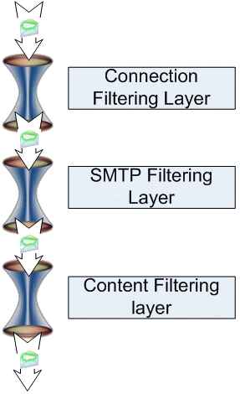
Layer 1 - Connection Filtering
The first step in spam verification process is to establish an understanding where the mail is coming from. Highly effective, this method accounts for roughly 25% of all blocked mail inside of Microsoft Corporation. Exchange 2003 Server SP2 provides the following framework to achieve this functionality:

1. Support for multiple Real Time Block List (also known as DNS Block List) providers (including paid subscriptions)

2. Customized rule-based Block List service configuration
3. Custom-tailored server response (DSN) based on provider and connection initiation source (i.e. open relay, known source of spam)
4. Global Accept and Deny Lists
5. Configurable exception list that override the block list

If enabled, Connection Filtering will snap the IP address on the incoming connection from the winsock and send a DNS query to verify whether the connecting identity has been listed as an open relay or if it is a known source of spam. If the returned DNS query contains the connecting IP address on the DNS block list, Connection Filtering will close the connection down and trigger a customized server response back to the sender. If the sender was legitimate and got onto the block list by mistake, s/he can implement corrective actions based on the custom NDR received. Connection Filtering also allows the remote user from the blocked IP to submit mail to the postmaster or administrator of the Exchange organization for implementing corrective actions if the sending identity was put on the block list in error. Connection Filtering is very useful as it is capable of defending Exchange deployments from spam without generating additional resource consumption (CPU cycles, further load on the downstream servers, extra mail processing and NDR handling, etc.). Exchange 2003 Server can also perform reverse DNS lookup on incoming messages to resolve originating IP to a host name through the DNS.



The majority of Exchange 2003 Servers have been deployed behind the perimeter and do not face the Internet directly. This renders Connection Filtering less useful as the feature relies on getting the original sender's IP to run the DNS query on.
With the release of SP2 this deficiency has been addressed by introducing a new headers parsing algorithm for originating IP retrieval. Now, Exchange 2003 Server SP2 with Connection Filter deployed can be positioned anywhere in the organization and perform filtering as it would on the perimeter.

Layer 2 - SMTP Filtering

If the incoming connection passed through the Connection Filtering layer, the next in line is SMTP Filtering. Exchange 2003 Server SP2 makes extensive use of SMTP protocol filtering and this feature contributes to 35% of all blocked messages in Microsoft Corporation (MSIT department). SMTP Filtering has been implemented to monitor live SMTP sessions and functions as a real-time filter.
SMTP Filtering has been complemented by comprehensive SMTP session RFC compliance enforcement and starts with the first RFC2821 HELO/EHLO command. The SMTP implementation in Exchange 2003 Server SP2 will monitor and examine the session for potential violations and will not accept mail when the sending identity does not conform to or severely violates SMTP governing RFCs. I.e. no mail transaction will be allowed if the remote party does not begin the SMTP session with an appropriately constructed greeting that contains an RFC2821 compliant domain part. Similarly, RFC compliance will be enforced on MAIL FROM: and RCPT TO: commands to ensure that malicious users can not get around SMTP Filtering by providing, for example, 8-bit characters in the RFC2821 stream. Another common tactic deployed by spam senders is to confuse anti-spam solutions by changing the order of commands in an SMTP session. Exchange 2003 SP2 enforces RFC compliance in this area, preventing spam senders from executing an attack this way.

To prevent dictionary attacks and valid e-mail address harvesting, Exchange 2003 Server SP2 will respond to the VRFY command, but will not release the directory information to the remote party. Exchange 2003 Server SP2 by default does not support the EXPN command.
SMTP Filtering is based on rules configured by the administrator and consists of Sender Filtering and Recipient Filtering. Sender Filtering starts with the first RFC2821 MAIL FROM: command.
Sender Filtering:

1. Sender Filtering allows a list of senders to be specified that are prohibited from sending messages to a particular Exchange organization.
2. Sender Filtering can be easily configured to reject messages originating from certain domains or email addresses.
3. Sender Filtering filters messages with blank sender information and provides a mechanism for spoof detection (e.g. if the message coming from outside the organization claims to be sent from the CEO of organization where Exchange is deployed).
4. Based on the administrator-configurable actions the filter can drop the incoming connection if the Sender's address matches the filter.
5. To minimize information disclosure to malicious users, Sender Filtering can silently accept mail and delete it without notifying the sender.
6. Sender Filtering provides an option for archiving filtered messages for a forensic analysis as needed.
Once a mail item gets through Sender Filtering it faces Recipient Filtering. Recipient Filtering starts with the first RFC2821 RCPT TO: command.

Recipient Filtering:

1. Recipient Filtering enables inbound mail filtering for a particular recipient in the Exchange organization.
2. Recipient Filtering supports blocking mail based on wildcards. This enables administrators to use patterns to block entire ranges of recipients.
3. Recipient Filtering filters messages sent to non-existent recipients, rejecting them at the protocol level. By rejecting non- existent recipients at the protocol level (on RFC2821 RCPT TO: command), the Exchange server is protected from doing expensive NDR generation work and clogging the Badmail directory.

4. Enabling filtering of the Recipients who are not in the Directory potentially allows spam senders to discover internal directory information (valid e-mail addresses in the Exchange organization). A malicious user can execute address book mining by monitoring/parsing the server responses to RCPT TO: commands. To mitigate this threat Exchange 2003 Server SP2 supports SMTP command tarpitting. An administrator can configure Exchange to implement an n-seconds delay of the server response to the RCPT TO: command if a DHA attack is encountered or if the remote party violates SMTP RFC conformance. When a malicious user tries to harvest responses the Exchange server significantly slows down its responses (to an admin-defined delay interval) and the attack becomes infeasible.
5. Ability to restrict Distribution List mail submissions to authenticated users only contributes to the Recipient Filtering Framework.
6. Recipient Filtering applies only to anonymous connections so all authenticated identities bypass Recipient Filtering rules.

Layer 3 - Content Filtering

If a mail item gets through Recipient Filtering it faces Content Filtering. Content Filtering in Exchange relies on Microsoft Research SmartScreen machine learning technology incorporated into the Intelligent Message Filter (IMF).

Intelligent Message Filter:

Messages from the Internet arrive at the Exchange SMTP gateway and enter the Exchange 2003 Server anti-spam framework. Previous layers of the Exchange 2003 SP2 anti-spam solution (connection, sender and recipient filtering) block message submission before message data is sent. If a message passes all of these then the message body is received. A custom event sink (msgfilter.dll) is invoked when the SMTP End of Data event occurs. The sink passes the message to the Intelligent Message Filter SmartScreen DLL. The SmartScreen technology determines the Spam Confidence Level (SCL) rating of the message which is returned to the sink for comparison against the gateway SCL threshold. The Administrator defined action is applied if the message SCL is greater than the gateway threshold. Otherwise, the SCL rating is added to messages for transmission to the recipient's inbox.

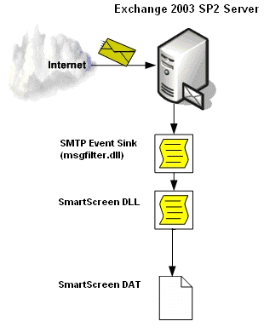

As of today, the SmartScreen technology deployed by the Microsoft IT department blocks 40% of remaining messages that passed through the previous anti-spam layers (Connection and SMTP filtering).

Anti-Phishing:

With the introduction of Exchange 2003 Server SP2 Intelligent Message Filter extends the anti-spam functionality to support anti-phishing. The new SmartScreen anti-phishing technology will impact the SCL ratings and also expose an independent Phishing Confidence Level (PCL) value as an output of the filter. The new anti-phishing functionality is totally transparent to administors and includes the following features:
1. Anti-phishing heuristics
2. Anti-phishing consistency list
3. Anti-phishing block list
4. Anti-phishing allow list
5. PCL values map to weights within the DAT file that allow for non-
deterministic SCL adjustment

Anti-phishing technology relies on heuristics, the consistency list, and the allow list to detect phishing scams. These lists are not exposed for administration and are updated during regular IMF updates (frequency of updates will be determined later). The PCL score is one of the factors that trigger final SCL assignments.

Custom Message Weight:

Custom Weighting (also known as Bad Words List) is a file-based implementation with no supporting UI. Within the file specific words/phrases can be added along with their relative text part location (Subject or Body) and their associated modifier value. The supported modifier values can include positive and negative increments, as well as MAX and MIN values. During anti-spam mail processing the IMF will look into the file and search inside the mail item for a string/word/phrase match. If a match is found the weight of the SCL will be adjusted according to the modifier value. If MAX or MIN values are specified for particular word or phrase, they will move the SCL towards MAX or MIN. The Custom Message Weight feature allows administrators to custom tailor the filter to account for specific words or phrases and adjust it on the fly to act on particular message content as needed.

Custom Server Response when IMF is configured in 'Reject' mode:

To mitigate False Positives, a problem common to all types of automated anti-spam technologies, IMF can be configured to work in "Reject" mode. This allows for False Positives investigations if the mail was submitted by a legitimate sender and rejected by the filter. SP2 allows customization of the server response string that is generated and appended to the NDR sent back to the sender. The default response "550 5.7.1 Requested action not taken: message refused" can be altered to provide blocked legitimate users with meaningful explanation as to why their message was blocked. This will alleviate investigation of False Positives and decrease support costs associated with the anti-spam processing.

Sender ID Filtering:

Sender ID is an industry standard framework created to counter e-mail domain spoofing. Sender ID is aimed at removing the ambiguity associated with the sender identity by verifying that each e-mail message originates from the Internet domain from which it claims to come based on the sending server's IP address. Eliminating domain spoofing will help legitimate senders protect their domain names and reputations, and help recipients more effectively identify and filter junk e-mail and phishing scams.

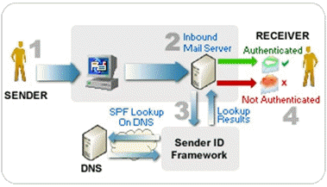

The steps in the process are:
1. The Sender sends an e-mail message to the Receiver.
2. The Receiver's inbound mail server receives the mail.
3. The Receiver's server checks for the SPF record of the sending domain published in the Domain Name System (DNS) record.
4. The Receiver's e-mail server determines if the sending e-mail server's IP address matches the IP address that is published in the DNS record.
Sender ID defines an algorithm for detecting the email address of the entity that is most recently responsible for injecting a message into the email system by extracting the Purported Responsible Address (PRA). The extraction of the PRA ensures Sender ID verifies the appropriate sender against the correct IP addresses as email systems can legitimately forward mail on behalf of other mail servers.

The Sender ID feature has 3 modes:

1. Delete (silent delete - no NDR generated)
2. Reject (the mail will be rejected at the protocol level)
3. Accept (the mail item will be stamped with the Sender ID result for IMF consumption).

The first and second mode will delete or reject mail that failed the Sender ID verification (i.e. a clear case of spoofing), the rest of the mail items will be stamped with the Sender ID status and passed along. The last option will just stamp the Sender ID status onto the mail item (even in the case of spoofing). This status will be passed to the new Intelligent Message Filter and trigger appropriate Spam Confidence Level (SCL) score modification.
Reference: Microsoft Exchange Team Blog http://blogs.technet.com/exchange/articles/407836.aspx

Additional Information:

- Microsoft IT Showcase: Messaging Hygiene At Microsoft http://www.microsoft.com/technet/itsolutions/msit/valuecard/
msghygiene.mspx
- Microsoft Safety Home Page
http://www.microsoft.com/mscorp/safety/default.mspx
- Sender ID Home Page
http://www.microsoft.com/mscorp/safety/technologies/senderid/default.mspx
- Free vs. Subscription-Based RBLs
http://www.spamcop.net, http://www.dsbl.org, http://www.maildeflector.net, http://www.mail-abuse.org, http://www.postfixgate.com.
- SMTP tar pit feature for Microsoft Windows Server 2003
http://support.microsoft.com/kb/256986
- Microsoft Exchange Server: Exchange Intelligent Message Filter download http://www.microsoft.com/exchange/downloads/2003/imf/default.mspx
- Microsoft Anti-Phishing Technologies http://www.microsoft.com/mscorp/safety/technologies/antiphishing/default.mspx
- Sybari Advanced Spam Manager for Messaging & Collaboration Systems http://www.sybari.com/asm

