Lab 2: Configuring Exchange/Outlook RPC over HTTP Communication

Objectives

After completing this lab, you will be able to:
- Install remote procedure call (RPC) over Hypertext Transfer Protocol (HTTP) on Microsoft® Windows® Server 2003 and then configure it to proxy requests to Exchange back-end server.
- Test Microsoft Outlook® over a secure Hypertext Transfer Protocol (HTTP) connection.

Note This scenario using internal Enterprise CA, it will require additional step to export/import Trust Root CA.

Scenario

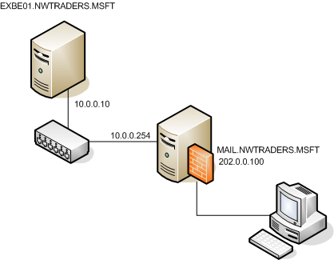

Estimated time to complete this lab: 90 minutes
Exercise 1 Starting Virtual PCs
In this exercise, you will start the Virtual PCs (VPCs) required for this lab.
Start Microsoft Virtual PC 2004 and start VPCs

- On the host computer, click Start, point to Programs, and then click Microsoft Virtual PC.

- Click VPC image name ISA Server and then click Start.

- Verify that all VPCs start with no error messages. If error messages appear, consult a lab proctor.

- Click VPC image name RemoteUser Machine and then click Start.

- Verify that all VPCs start with no error messages. If error messages appear, consult a lab proctor.

- To log on to a VPC, press RIGHT-ALT+DELETE. All machines (EXBE01, ISA Server and RemoteUser Machine) using same password: P@ssw0rd.

- In case you have not finish the Lab 1: Co-exist Exchange 2003 Mailboxes with IMAP4 Server, this is mandatory step to perform, In System Tray on server EXBE01, right click IMAP4 Network Connection select Disable.
Warning Do not ignore this step, because it will take an effect for further exercise.

Exercise 2 Prepare SSL on Exchange Server for Secure Access (OWA, RPC-over-HTTP)

In this exercise, you will prepare SSL on Exchange Server to support clients that use Outlook Web Access (OWA), RPC-over-HTTP with the SSL protocol (HTTPS).

- On EXBE01 computer, on the Start menu, click Administrative Tools, and then click Internet Information Services (IIS) Manager.

- In the IIS Manager console, expand EXBE01 (local computer), expand Web Sites, right-click Default Web Site, and then click Properties.

- In the Default Web Site Properties dialog box, on the Directory Security tab, click Server Certificate.

- In the Welcome to the Web Server Certificate Wizard dialog box, click Next.

- On the Server Certificate page, select Create a new certificate, and then click Next.

- On the Delayed or Immediate Request, select Send the request immediately to an online certification authority, click Next.

- On the Name and Security Settings, leave all default values and click Next

- On the Organization Information, leave all default values and click Next

- On Your Site’s Common Name, ensure Common name are equal EXBE01, click Next
Warning: If common name for certificate is not match with the name in request URL, it will show certificate warning and will make RPC-over-HTTP not working.

- On Geographical Information, leave all default values and click Next.

- On SSL Port, type 443 and then click Next

- On the Certification Authority, choose Nwtraders CA, and click Next
Note: In this scenario, we use internal CA by using Windows 2003 Certificate of Authority Service (Enterprise CA mode). In real world scenario we may need to create certificate request and send to CA provider.

- On the certificate summary page, click Next

- On the completing the web serve certificate wizard page, click Finish

Exercise 3 Install and Configure RPC Proxy on Exchange Server

In this exercise, you will install and configure RPC Proxy on Exchange Server to support RPC request from Outlook 2003

Note: In this exercise we running Exchange 2003 Back-end, RPC Proxy, Domain Controller and Global Catalog in same server, in real world scenario you may need to run Exchange 2003 (Front-end/Back-end) on separate machine and you may have more than one Domain Controller and Global Catalog Servers.

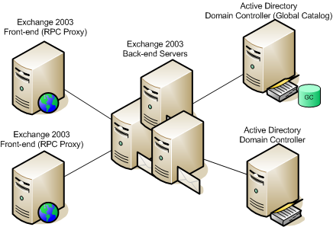

Real world scenario in complex environment

This part is for RPC Proxy

- On EXBE01 computer, on the Start menu, click Control Panel, and then click Add or Remove Programs.

- In the Add or Remove Programs windows, click Add/Remove Windows Components.

- On the Windows Components page, select the Networking Services component (do NOT select the check box), and then click Details.

- In the Network Services dialog box, select the RPC over HTTP Proxy check box, and then click OK.

- On the Windows Components page, click Next.
Note: You will get a dialog to request to access Windows Server 2003 Service Pack 1 CD, in this dialog put the location from following text c:\InstallationCD\sp1\i386.

- On the Completing the Windows Components Wizard page, click Finish.

- Close the Add or Remove Programs window.

- On the Start menu, click Administrative Tools, and then click Internet Information Services (IIS) Manager.

- In the IIS Manager console, expand EXBE01 (local computer), and then in the left pane, select Web Service Extensions.

- A new Web Service Extension is installed (RPC Proxy Server Extension). Ensure the status of the extension is Allowed.

- In the IIS Manager console, expand Web Sites, expand Default Web Site, and then in the left pane, select Rpc

- Right-click Rpc, and then click Properties.

- In the Rpc Properties dialog box, on the Directory Security tab, in the Authentication and access control box, click Edit.

- In the Authentication Methods dialog box, complete the following information:
• Enable anonymous access: disable
• Integrated Windows authentication: disable
• Basic authentication: enable
and then click OK.
Note: You may receive warning message from IIS Manager, this is expected behavior, click Yes to confirm that you want to continue.

- On the Directory Security tab, in the Secure communications box, click Edit.

- In the Secure communications box, enable Require secure channel (SSL), and then click OK, Click OK to close the Certificate dialog box, Click OK to close the Rpc Properties dialog box.

- Close the IIS Manager console.

- Verify current RPC Proxy Using Ports to communicate to Directory Service, open a Command Prompt Windows, click Start, and select Run and type “cmd” and click Ok.

- Type reg.exe query HKLM\System\CurrentControlSet\Services\MSExchangeIS\ParametersSystem and press Enter, ensure the result shown Rpc/HTTP Port = 0x1771 (Decimal 6001).

- Type reg.exe query HKLM\System\CurrentControlSet\Services\MSExchangeSA\Parameters and press Enter, ensure the result shown HTTP Port = 0x1772 (Decimal 6002) and Rpc/HTTP NSPI Port = 0x1774 (Decimal 6004).

- Configure the RPC Proxy network service to communicate with the Exchange Server, on the Start menu, click Run.

- In the Run dialog box, type regedit.exe, and then click OK.

- In the Registry Editor window, select the HKEY_LOCAL_MACHINE\SOFTWARE\Microsoft\Rpc\RpcProxy key.

- In the right pane, right-click ValidPorts, and then click Modify

- Remove all the information from the value data, then type the following information:
EXBE01:6001-6002;exbe01.nwtraders.msft:6001-6002;
EXBE01:6004;exbe01.nwtraders.msft:6004
Note: In your environment, you may need to replace EXBE01 by NetBIOS name of your Exchange Back-end Server. Replace exbe01.nwtraders.msft by the fully qualified domain name (FQDN) of your server in Active Directory.

This part is for Global Catalog Server

- Configure the Global Catalog Server to accept communication from RPC Proxy on port 6004, In the Registry Editor window, select the HKEY_LOCAL_MACHINE
\SYSTEM\CurrentControlSet\Services\NTDS\Parameters key.

- Right-click the Parameters key, click New, and then click Multi-String Value.

- In the New Value #1 text box, replace the text by typing NSPI interface protocol sequences, and then press Enter.

- Right-click the NSPI interface protocol sequences value, and then click Modify.

- In the Edit Multi-String dialog box, type ncacn_http:6004, and then click OK, and close the Registry Editor window.

- Manual Shutdown Exchange Service, click Start and select Run and type Cmd then press Enter

- Type net stop MSExchangeSA then press Enter, for confirmation prompt press Y and Enter to confirm service stopping.
Warning: Do not skip this step, because it would take long time to shutdown Windows.

- After Microsoft Exchange System Attendant service was stopped, go to Start menu, click Restart.

Exercise 4 Prepare ISA Server to publish Secure Exchange OWA and RPC-over-HTTPS

In this exercise, you will prepare ISA Server to publish Secure Exchange OWA and RPC-over-HTTPS, by import internal Root CA into machine certificate. In part may not required for real world deployment, it is depend on CA you decision to use in your environment.

- On the ISA Server computer, click Start and in Start Menu select ISA Server Management snap-in.

- In the ISA Server console (TH-HL-ISA2004), select Firewall Policy (ITALY).

- In the task pane, on the Tasks tab, click Create New Access Rule

- In the New Access Rule Wizard dialog box, in the Access rule name text box, type Allow Access from Firewall to Internal, and then click Next.
- On the Rule Action page, select Allow, and then click Next.

- On the Protocols page, in the This rule applies to list box, select All outbound traffic, and then click Next.

- On the Access Rule Sources page, click Add.

- In the Add Network Entities dialog box, click Networks, click Local Host, and click Add, and then click Close to close the Add Network Entities dialog box.

- On the Access Rule Sources page, click Next.

- On the Access Rule Destinations page, click Add.

- In the Add Network Entities dialog box, click Networks, click Internal, and click Add, and then click Close to close the Add Network Entities dialog box.

- On the Access Rule Destinations page, click Next.

- On the User Sets page, click Next.

- On the Completing the New Access Rule Wizard page, click Finish.

- Click Apply to apply the new rule, and then click OK. Wait until the configurations were successfully applied.

- On the ISA Server, open Internet Explorer. In the Address box, type https://exbe01/certsrv, and then press Enter.
Note: The Security Alert dialog will prompt in the screen, this is expected behavior because the certificate was issued by local CA is not trusted CA. We need to manual import trust root CA to fix this issue before enable RPC-over-HTTPS.
Click Ok, to accept this certificate.

- Log on credential will prompt, type User name Administrator and Password: P@ssw0rd then click Ok.

- In Nwtraders CA welcome screen, click Download a CA certificate, certificate chain, or CRL link.

- In Nwtraders CA, Download a CA Certificate, Certificate Chain, or CRL, click Download CA certificate.

- In File Download – Security Warning, click Save button.

- Save As certnew.cer file into Desktop, click Save. And click Close dialog.
Warning: If you click Open this file and select Install Certificate. The certificate will store in Personal Store, we need to store this certificate in Machine store see more detail in following steps.

- On the Start menu, click Run.

- In the Run dialog box, type mmc.exe, and then click OK.

- A new empty Microsoft Management Console (MMC) opens.

- In the Console1 window, on the File menu, click Add/Remove Snap in.

- In the Add/Remove Snap-in dialog box, click Add.

- In the Add Standalone Snap-in dialog box, select Certificates, and then click Add.

- In the Certificates snap-in dialog box, select Computer account, and then click Next.

- In the Select Computer dialog box, select Local computer, and then click Finish.

- Click Close to close the Add Standalone Snap-in dialog box.

- Click OK to close the Add/Remove Snap-in dialog box.

- In the left pane, expand Certificates (Local Computer), and then select Trusted Root Certification Authorities, and then clicks Import.

- In the Certificate Import Wizard dialog box, click Next.

- On the File to Import page, in the File name text box, browse to file certnew.cer in Desktop, and click Open, then click Next.

- Verify the certificate will keep in Trusted Root Certification Authorities, click Next, and click Finish to import certificate to machine store.

- Close MMC Console, you do not need to save this snap-in.

Exercise 5 Publishing Secure Exchange OWA and RPC-over-HTTPS

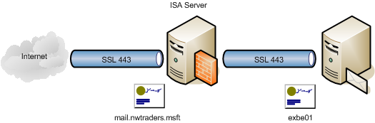

- Open Internet Explorer. In the Address box, type https://exbe01/certsrv, and then press Enter.

- Log on credential will prompt, type User name Administrator and Password: P@ssw0rd then click Ok.
Note: The Security Alert dialog will not prompt in the screen, because your just import trust root CA who issue this certificate to machine store.

- On the Welcome page, click Request a certificate.

- On the Request a Certificate page, click advanced certificate request.

- On the Advanced Certificate Request page, click Create and submit a request to this CA.

- On Certificate Template, select Web Server template.

- On the next Advanced Certificate Request page, complete the following information:
• Name: mail.nwtraders.msft
• Store certificate in the local computer certificate store: enable
• Leave all other settings as default
and then click Submit.

- In the Potential Scripting Violation message box, click Yes to confirm that you want to request a certificate now.

- If a message box appears, warning you that it might be possible for others to see the information when you send this to the Internet, then click Yes to confirm that you want to continue.

- On the Certificate Issued page, click Install this certificate.

- In the next Potential Scripting Violation message box, click Yes to confirm that you want to add the certificate.

- Close Internet Explorer.

- In the ISA Server console, in the left pane, in the left pane, select Firewall Policy.

- In the task pane, on the Toolbox tab, in the Network Objects section, right-click Web Listeners, and then click New Web Listener.

- In the New Web Listener Definition Wizard dialog box, in the Web listener name text box, type External Web 443, and then click Next.

- On the IP Addresses page, select External, and then click Next.

- On the Port Specification page, complete the following information:
• Enable HTTP: disable
• Enable SSL: enable
• SSL port: 443 (is default)
and then click Select.

- In the Select Certificate dialog box, select the mail.nwtraders.msft certificate, and then click OK.

- On the Port Specification page, click Next.

- On the Completing the New Web Listener Wizard page, click Finish.

- In the right pane, select the first rule to indicate where the new rule is added to the rule list.

- In the task pane, on the Tasks tab, click Publish a Mail Server.

- In the New Mail Server Publishing Rule Wizard dialog box, in the Mail Server Publishing rule name text box, type Secure Exchange OWA and RPC-over-HTTPS, and then click Next.

- On the Select Access Type page, select Web client access: Outlook Web Access (OWA), Outlook Mobile Access, Exchange Server ActiveSync and then click Next.

- On the Select Services page, complete the following information:
• Outlook Web Access: enable (is default)
• Outlook Mobile Access: disable (is default)
• Exchange ActiveSync: disable (is default)
• Enable high bit characters used by non-English character sets: enable (is default)
and then click Next.
Note: You may need to enable OMA, EAS if you need to enable your perform ActiveSync to your Exchange from outside.

- On the Bridging Mode tab, click each of the three options, to see the different OWA publishing scenarios.

- On the Bridging Mode tab, select Secure connection to clients and mail server, and then click Next.

- On the Specify the Web Mail Server page, in the Web mail server text box, type exbe01, and then click Next.

- On the Public Name Details page, complete the following information:
• Accept requests for: This domain name (type below):
• Public name: mail.nwtraders.msft
and then click Next.

- On the Select Web Listener page, in the Web listener list box, select External Web 443, and then click Next.

- On the User Sets page, click Next.

- On the Completing the New Mail Server Publishing Rule Wizard, click Finish.

- In the right pane, right-click Secure Exchange OWA and RPC-over-HTTPS, and then click Properties.

- In the Paths Tab, click Add.

- In Path mapping, type /rpc/* and click Ok

- Click Ok to close the Secure Exchange OWA and RPC-over-HTTPS Properties dialog box.

- Click Apply to apply the new rule, and then click OK. Wait until the configurations were successfully applied.

Exercise 5 Configure Client Access Using RPC-over-HTTPS

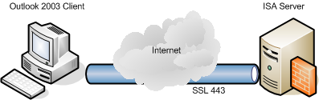

- Switch to RemoteUser Machine VPC.

- Open Internet Explorer. In the Address box, type https://mail.nwtraders.msft/exchange, and then press Enter.

- Log on credential will prompt, type User name RemoteUser and Password: P@ssw0rd then click Ok.
Note: The Security Alert dialog will not prompt in the screen, because your just import trust root CA who issue this certificate to machine store. If you receive any warning messages related to certificate issue, your machine will not able to use Outlook RPC-over-HTTPS.

Sending Root CA via E-mail

- Switch to ISA Server VPC, minimize all active Windows.

- You will see Root CA file name certnew.cer (the result from Exercise 4), right click and select Send To -> Compressed (zipped) Folder.

- In ISA Server VPC, Open Internet Explorer. In the Address box, type https://exbe01/exchange, and then press Enter.

- In Outlook Web Access, click New button.

- In To text box: type remoteuser

- In Subject text box: type: Internal Root CA

- Click Attachments button.
Note: For security prompt in IE click Close,

- The High Security Setting on IE will block pop-up Windows, click Pop-up blocked. To see this pop-up or additional options click here…

- Select Temporarily Allow Pop-ups, then click Attachments button again.

- In Choose a file to attach, click Browse button and point to certnew.zip in Desktop.

- Click Attach button, and click Close button.

- Click Send button.

Importing CA to Machine Store

- Switch to RemoteUser Machine VPC.

- Open Internet Explorer (in case you have close this Windows), otherwise type URL https://mail.nwtraders.msft/exchange using user account: RemoteUser and password: P@ssw0rd

- Press F5 to refresh IE.

- You will see new mail come from Administrator, on right pane click certnew.zip

- On File Download dialog, click Save button

- Save file certnew.zip on Desktop, and click Close dialog.

- Minimize all Windows, right click on file name certnew.zip. select menu Extract All…

- Click Next and Extraction Wizard screen.

- Leave default target directory and click Next, and then click Finish.

- On the Start menu, click Run.

- In the Run dialog box, type mmc.exe, and then click OK.

- A new empty Microsoft Management Console (MMC) opens.

- In the Console1 window, on the File menu, click Add/Remove Snap in.

- In the Add/Remove Snap-in dialog box, click Add.

- In the Add Standalone Snap-in dialog box, select Certificates, and then click Add.

- In the Certificates snap-in dialog box, select Computer account, and then click Next.

- In the Select Computer dialog box, select Local computer, and then click Finish.

- Click Close to close the Add Standalone Snap-in dialog box.

- Click OK to close the Add/Remove Snap-in dialog box.

- In the left pane, expand Certificates (Local Computer), and then select Trusted Root Certification Authorities, and then clicks Import.

- In the Certificate Import Wizard dialog box, click Next.

- On the File to Import page, in the File name text box, browse to file certnew.cer in Desktop\certnew, and click Open, then click Next.

- Verify the certificate will keep in Trusted Root Certification Authorities, click Next, and click Finish to import certificate to machine store.

- Close MMC Console, you do not need to save this snap-in.

- Close all opened Internet Explore Windows.

Create Outlook Profile to use RPC-over-HTTP

- Click Start -> All Programs -> Microsoft Office -> Microsoft Office Outlook 2003.

- In Outlook 2003 Startup, click Next

- In E-mail Upgrade Options screen, choose Do not upgrade and then click Next.
Note: Outlook Express Profile will use in next lab.

- In E-mail Account screen, click Yes to configure e-mail account now, click Next.

- In the E-mail accounts, Server type windows, select Microsoft Exchange Server and click Next.

- In the E-mail accounts, Exchange Server settings window, in the Microsoft Exchange Server field, type EXBE01.

- Verify that the Use Cached Exchange Mode box is checked.

- In the User Name field, type RemoteUser.
Warning: Do not click Next in this time, otherwise you may need to reconfigure it on Control Panel -> Mail.

- Click More Settings.

- Click the Connection tab.

- Click Connect to my Exchange mailbox using HTTP.

- Click the Exchange Proxy Settings button.

- In the https:// box, type mail.nwtraders.msft

- In the Connections settings box, select the Connect using SSL only check box.

- Click Mutually authenticate the session when connecting with SSL.

- In the Principal name for proxy server box, type msstd:mail.nwtraders.msft

- In the Connections settings box, select the On fast networks, connect using HTTP first, then connect using TCP/IP check box and select On slow networks, connect using HTTP first, then connect using TCP/IP check box.

- For Proxy Authentication settings, select Basic Authentication, and then click OK.
Note: This configuration must match with /RPC authentication method in Exercise 3.

- Click OK to close the More Settings dialog box and then click Next.

- If prompted, in the Connect to mail.nwtraders.msft windows type nwtraders\remoteuser for the user name and P@ssw0rd for the password.

- Click Finish.

- Click OK to close the Mail dialog box.

- After Outlook 2003 starts, hold the CTRL key down, right-click the Outlook icon in the Application tray in the lower right corner of the screen, and then click Connection Status.

- Verify that the connection is set to HTTPS.

- Click Close to close the Exchange Server Connection Status dialog box.

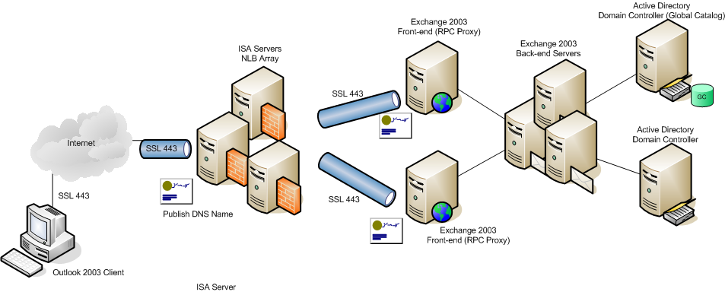

Architecture guide line for High Availability and Enterprise Scale Secure Remote Access

Additional Information:

- Exchange Server 2003 Technical Documentation Library
http://www.microsoft.com/technet/prodtechnol/exchange/2003/library/default.mspx
- How to Configure Exchange to Forward Messages to a Foreign Messaging System That Shares the Same SMTP Domain Name Space
http://support.microsoft.com/default.aspx?scid=kb;en-us;319759

- DNS MX Records and CNAMEs
http://support.microsoft.com/default.aspx?scid=kb;en-us;153001

- Troubleshooting SSL Certificates in ISA Server 2004 Publishing
http://www.microsoft.com/technet/prodtechnol/isa/2004/plan/tscerts.mspx

- Outlook Web Access Server Publishing in ISA Server 2004
http://www.microsoft.com/technet/prodtechnol/isa/2004/plan/owapublishing.mspx

- Exchange Server 2003 RPC over HTTP Deployment Scenarios
http://www.microsoft.com/technet/prodtechnol/exchange/2003/library/ex2k3rpc.mspx

- How to configure RPC over HTTP on a single server in Exchange Server 2003
http://support.microsoft.com/default.aspx?scid=kb;en-us;833401

