Lab 1: Co-exist Exchange 2003 Mailboxes with IMAP4 Server

Objectives
After completing this lab, you will be able to:
- Configure Exchange to co-exist with IMAP4 Server
- Migrate Mailboxes from IMAP4 Server to Exchange 2003

Note Because this lab focuses on how to migrate and co-exist between Exchange 2003 and Existing IMAP4 Server, IMAP4 client will run in Exchange 2003 server.

Scenario

Existing Environment

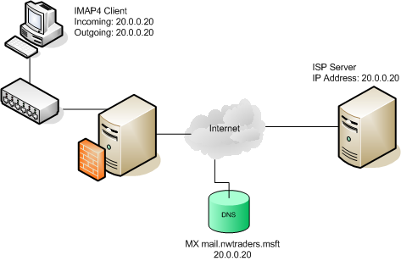

New Proposed Environment

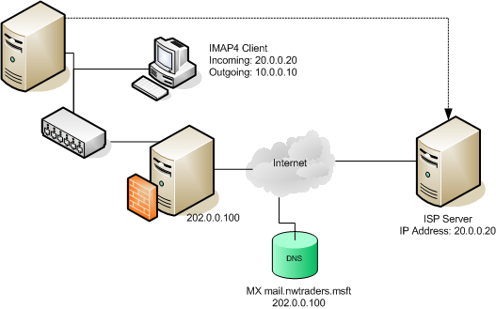

Estimated time to complete this lab: 30 minutes

Exercise 1 Starting Virtual PCs

In this exercise, you will start the Virtual PCs (VPCs) required for this lab.
Start Microsoft Virtual PC 2004 and start VPCs

- On the host computer, click Start, point to Programs, and then click Microsoft Virtual PC.

- Click VPC image name EXBE01 and then click Start.

- Click VPC image name IMAP4 Server and then click Start.

- Verify that all VPCs start with no error messages. If error messages appear, consult a lab proctor.

- To log on to a VPC, press RIGHT-ALT+DELETE.

Exercise 2 Testing IMAP4 client connectivity

In this exercise, you will need to check client connectivity between user mailbox user1@nwtraders.msft to user2@nwtraders.msft

- Switch to EXBE01 Log on as Administrator with a password of P@ssw0rd

- Click Start, then point to Programs, then click Outlook Express

Note: You may receive error message folders was not polled for its unread count, this is expected behavior just click “Hide” button and click “Send/Recv” button in toolbar and you will receive warning message “No connection to the Internet is currently available” click “Try Again”.

- Explore Outgoing mail (SMTP) configuration, click Tools and select Accounts, then in All tab select Account name 20.0.0.20 click Properties button. In Account Properties select Servers tab explore Outgoing mail (SMTP) verify server address.
Note: Current configuration Outlook Express will download user1 mailbox from ISP Server and also submit outgoing mail to this server too.

- Click “Create Mail” button to start to compose new message, New Message dialog will appear, type following information
To: user1@nwtraders.msft;user2@nwtraders.msft
Subject: First Message from User1
And then click Send button

- Click Send/Recv button to retrieve new mail from ISP Server
- Ensure you got new mail from ISP Server shown in Outlook Express Inbox, and close Outlook Express.

Exercise 3 Configure Smart Host Forwarding to support new MX record

In this exercise, you will have experience to setup Exchange SMTP Virtual Server to verify incoming mail and forward to ISP Server if destination mailbox is not host in Exchange Organization.

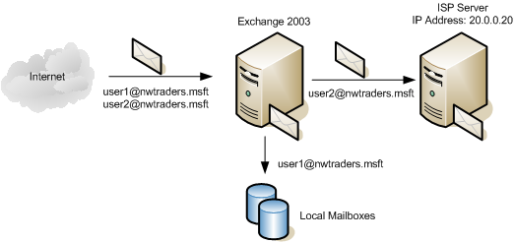

- On EXBE01, click Start, point to Programs, then point to Microsoft Exchange, and then click System Manager.

- Expand Administrative Groups -> First Administrative Group -> Servers -> EXBE01 -> Protocols -> SMTP -> Default SMTP Virtual, and then right-click and select Properties.

- Select Messages Tab, and in Forward all mail with unresolved recipients to host type [20.0.0.20].

- Click Ok and close this dialog.

Exercise 4 Configure new outgoing address to using Exchange Server SMTP

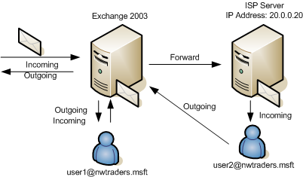

- Click Start, then point to Programs, then click Outlook Express

- Change Outgoing mail (SMTP) configuration, click Tools and select Accounts, then in All tab select Account name 20.0.0.20 click Properties button. In Account Properties select Servers tab change Outgoing mail (SMTP) from 20.0.0.20 to 10.0.0.10, and then Click Ok and click Close button.

- Switch Account Identity from User1 to User2, in Outlook Express menu click File -> Switch Identify

- In Switch Identities Dialog box, select User2 @ NWTraders.MSFT then click Ok button.

- Change Outgoing mail (SMTP) configuration of User2, click Tools and select Accounts, then in All tab select Account name 20.0.0.20 click Properties button. In Account Properties select Servers tab change Outgoing mail (SMTP) from 20.0.0.20 to 10.0.0.10, and then click Ok and click Close button.
Warning: In real world scenario, you may need to finish updating all of the clients to send outgoing mail to Exchange 2003 before start migration users from IMAP4 Server to Exchange. Otherwise users in Exchange 2003 will not receive mails from internal.

Exercise 5 Change MX record on public DNS and point to Exchange Server

Note This part will not cover in this lab, in real world practice you may need to send change request of your domain MX record to your DNS provider e.g. in this scenario @nwtraders.msft currently use address 20.0.0.20, the new MX record will use IP address 202.0.0.100 (Public IP of this environment). Please always reminded it would take at lease 6 hours (depend on DNS provider and zone transfer scheduling) consult your DNS provider and check for the effective date & time before migration your mailboxes.

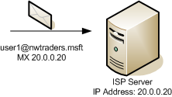 | 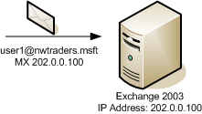

Exercise 6 Prepare List of mailboxes and passwords needed to access to mailboxes in ISP Server

- On EXBE01 desktop, double click Shortcut to Tools

- Looking parameter file name IMAP Import List.csv then double click to open this file.
Note: This file contains information about target mailboxes, password, SMTP address and target server in csv format with following header
“IMAP_Mailbox,IMAP_Password,SMTP_Address,IMAP_Server”
For security reason, ISP Admin will decline to give you a list of user password. You may need to reset password of target mailboxes.

- Explore information inside this file, and close.

Exercise 7 Migrate users from IMAP4 Mailbox on ISP Server to Exchange 2003

- Open Exchange Migration Wizard, click Start, point to Programs, then point to Microsoft Exchange->Deployment and click Migration Wizard.

- In Exchange Server Migration Wizard dialog, click Next button.

- In Select the migration function, choose Migrate from Internet Mail (IMAP4) and click Next twice.

- Select One step migration option, and type c:\temp in Path to migration files text box.

- In Destination server, select destination server (EXBE01) and destination information store (Mailbox Store), click Next.
Note: Some organization may have more than one Exchange server or may have more than one information store.

- Specify the user list file, type c:\tools\IMAP Import List.csv, and click Next.

- Review information to migrate, Information to create mailboxes and Personal e-mail messages, and click Next.

- Migration Wizard will compile user list file and show the accounts to migrate, select user1 then click Next.

- In Container For New Windows Accounts, expand nwtraders.msft select OU name mail users, click Options button to change advanced account creation. Explore the way of password generation: To Use Windows account name for password, Generate random password. Click Ok to accept change and click Next.
- Windows Account Creation And Association dialog will show list of mail account, ensure user1 mail account was shown in this screen, click Next to perform mailbox migration.

- Wait for the migration process, Exchange will create new mailbox in Active Directory and logon to target mailbox using user name and password from user list file and download message from IMAP4 Server and import into mailbox. The Migration Progress screen will show the migration result. Click Finish then click Ok button to finish migration process.

Exercise 8 Test migrated account in Exchange 2003

- Open Active Directory Users and Computers, click Start, point to Programs, then point to Microsoft Exchange-> and click Active Directory Users and Computers

- Expand nwtraders.msft select OU name mail users, right click new created user name user1 then select Reset Password, assign New password and Confirm (e.g. P@ssw0rd), then click Ok and close the snap-in.

- Force update Recipient information in Active Directory, click Start, point to Programs, then point to Microsoft Exchange-> and click System Manager

- Expand Recipients -> Recipient Update Services -> right click and select Update Now on both Recipient Update Service (Enterprise) and Recipient Update Service (NWTRADERS), close System Manager Snap-in.

- Open Outlook Express which User2 Identity (the result from Exercise 3), click “Create Mail” button to start to compose new message, New Message dialog will appear, type following information
To: user1@nwtraders.msft;user2@nwtraders.msft
Subject: Second Message from User2
And then click Send button

- Open Internet Explorer type following URL in address field: http://exbe/exchange/user1 and click Go, when the user authentication prompt dialog shown. Type User name: user1, Password: P@ssw0rd.

- Close Outlook Express, Internet Explorer on EXBE01.

- In System Tray on server EXBE01, right click IMAP4 Network Connection select Disable.
Warning Do not ignore this step, because it will take an effect for further exercise.

- Close IMAP4 Server VPC to release system resources for next exercise, for VPC warning message choose Turn off and delete changes.

