



Microsoft ISA Server 2006 Evaluation Guide
June 2006

ISA Server 2006 is the integrated edge security gateway that helps protect your IT environment from Internet-based threats while providing your users with fast and secure remote access to applications and data.

For more information, press only, contact:

Rapid Response Team
Waggener Edstrom
(503) 443-7070
rrt@wagged.com

This document supports a preliminary release of a software product that may be changed substantially prior to final commercial release. This document is provided for informational purposes only and Microsoft makes no warranties, either express or implied, in this document. Information in this document, including URL and other Internet Web site references, is subject to change without notice. The entire risk of the use or the results from the use of this document remains with the user. Unless otherwise noted, the companies, organizations, products, domain names, e-mail addresses, logos, people, places, and events depicted in examples herein are fictitious. No association with any real company, organization, product, domain name, e-mail address, logo, person, place, or event is intended or should be inferred. Complying with all applicable copyright laws is the responsibility of the user. Without limiting the rights under copyright, no part of this document may be reproduced, stored in or introduced into a retrieval system, or transmitted in any form or by any means (electronic, mechanical, photocopying, recording, or otherwise), or for any purpose, without the express written permission of Microsoft Corporation.

Microsoft may have patents, patent applications, trademarks, copyrights, or other intellectual property rights covering subject matter in this document. Except as expressly provided in any written license agreement from Microsoft, the furnishing of this document does not give you any license to these patents, trademarks, copyrights, or other intellectual property.

© 2006 Microsoft Corporation. All rights reserved.

Microsoft, Active Directory, ActiveSync, ActiveX, Hotmail, Outlook, PowerPoint, SharePoint, Windows, Windows NT, Windows Media, Windows Server, and Windows Server System are either registered trademarks or trademarks of Microsoft Corporation in the United States and/or other countries.

INTRODUCTION 5
Key Trends 7
Using This Guide 8
New Features of ISA Server 2006 9
ISA Server 2006 Appliances 10
Secure Application Publishing 12
Key Data Points 12
Typical Environment and Customer 12
Customer Needs, Pain Points and the ISA Server 2006 Solution 12
Secure Server Publishing 14
Secure Web Publishing 15
Web Listener Wizard 15
Server Farms 18
Web Publishing Load Balancing 19
SharePoint Portal Server Publishing 20
SSL Bridging 21
Link Translation 21
Cross Array Link Translation 23
Microsoft Exchange Server Publishing 24
Enhanced Certificate Management 25
Authentication 27
Session Management 31
Enhanced HTML Form Support 32
Integrated Virtual Private Networking 33
VPN Quarantine 35
Monitoring and Manageability 36
Summary: Key Differentiators of ISA Server 2006 Secure Application Publishing 37
Branch Office Gateway 39
Key Data Points 39
Typical Target Environment and Customer 39
Customer Needs, Pain Points, and the ISA Server 2006 Solution 39
Multi-Network Architecture 41
Branch Office Configuration (VPN Site-to-Site) 42
Centralized Management (Enterprise and Array-Level Policies) 44
Fast Propagation of Enterprise-Wide Policies 45
BITS Caching 45
HTTP Compression 46
Traffic Prioritization Using DiffServ 48
Performance and High Availability 49
Summary: Key Differentiators of ISA Server 2006 for Branch Office Gateways 52
Web Access Protection 54
Key Data Points 54
Typical Environment and Customer 54
Customer Needs, Pain Points and the ISA Server 2006 Solution 54
Ease of Use 56
Multilayer Firewall 57
Application Layer Filtering (Deep Packet Inspection) 59
Customizable Protocol Definitions 62
Flood Resiliency 62
Product Extensibility 64
Summary: Key Differentiators of ISA Server 2006 Web Access Protection 66
Appendix A: General Concepts and Features 68
Proxy (Internet Access Control) 68
ISA Server 2006 Clients 68
Easy-to-Use Wizards 69
Configuration Export and Import to XML 70
Intrusion Detection 70
Architectural Enhancements 70
Forward Caching 71
Reverse Caching 72
Appendix B: ISA Server 2006 Feature List 73
Appendix C: Getting Started with ISA Server 2006 85
System Requirements for ISA Server 2006 85
Network Requirements for ISA Server 2006 86
Upgrade Paths from ISA Server 2004 86
Appendix D: ISA Server 2006 Architecture 87
ISA Server VPN Performance 87
Appendix E: Links to Useful Information 89

INTRODUCTION

Welcome to the Reviewers Guide for Microsoft® Internet Security and Acceleration (ISA) Server 2006. ISA Server 2006 is a fully integrated application layer firewall, virtual private network (VPN), and Web caching solution. A member of the Microsoft Windows Server System™, ISA Server 2006 is a highly secure, easy-to-use and cost-effective solution that helps IT professionals combat new and emerging threats against Internet-facing organizations.

Enterprises are facing an onslaught of increasingly targeted and sophisticated attacks on their networks. Protecting corporate resources at corporate headquarters as well as at branch offices, while providing seamless access for legitimate business functions, requires a sophisticated and multi-functional edge gateway.

ISA Server 2006 is the integrated edge gateway that provides:

- Integrated security ISA Server 2006 secures your environment and protects your partners and users from malicious programs. ISA Server 2006 provides improved security through integration with Microsoft application infrastructure and Microsoft Windows® services such as NTLM and Kerberos authentication, the Active Directory® directory service, VPN, Routing and Remote Access, Network Load Balancing (NLB), and more. ISA Server 2006 is built on the Windows Server™ 2003 platform, which has fewer vulnerabilities then any Linux-based operating system.

- Efficient management ISA Server 2006 makes it easy to enable new usage scenarios with your existing infrastructure. ISA Server 2006 provides reduced Total Cost of Ownership (TCO) and simplified deployment and management through easy-to-use user interface, tools, flexible software development kit (SDK), remote management, and strong logging and reporting capabilities.

- Fast and secure access ISA Server 2006 ensures your data and applications are safe and users are productive. With its compression, caching, single sign on, and link translation features, ISA Server 2006 provides secure, high speed, and seamless user access to corporate applications and data.

ISA Server 2006 is intended to meet customer demand for a single, integrated solution that is flexible enough to be used in a variety of different scenarios. Some scenarios include:

- Protect internal network resources by screening all incoming and outgoing Internet traffic.
- Ensure network access and network reliability.
- Manage secured traffic across different sections of the network.
- Authenticate users to make them more accountable and to control access based on users and groups.
- Provide useful reports and detailed logging information for both inbound and outbound traffic.
- Provide fast, secure access to internal servers.
- Implement technologies to allow for collaboration.
- Maintain confidentiality and integrity of information being transferred.
- Cost-effectively enable remote user connectivity to the corporate network.
- Cost-effectively create a secure and fault tolerant site-to-site VPN between offices.

Key Trends

Hacking incidents against companies have risen exponentially over the last few years with hackers targeting the point of least resistance in a network. Because traditional network firewalls are not designed to detect and prevent intrusions to the application layer, the vast majority of Internet-based attacks now target applications such as e-mail, Web server, and on-line collaboration software. In addition, today’s workforce is becoming ever-increasingly mobile, bringing additional challenges to providing secure access to corporate resources.

A key trend concerns the increase of new and emerging threats that bypass traditional stateful packet inspection-only firewalls through protocols such as Hypertext Transfer Protocol (HTTP) and Simple Mail Transfer Protocol (SMTP). Traditional packet inspection firewalls have done a satisfactory job of blocking attacks that take place at the network layer, but have done little to contend with application-based threats. Companies are demanding solutions that offer deeper inspection of Web-based content.

Identity theft, Web site defacement, unauthorized network access, theft of proprietary information, and service disruption—all possible manifestations of application layer attacks—can result in significant loss of productivity and hurt an organization’s bottom line.

IT professionals are under pressure to do more with less in securing their environments.

The need to simplify administration by consolidating security devices and products is taking on greater importance.

Regulatory pressures are increasing and becoming more complex. Compliance with legislation, such as the Sarbanes Oxley Act, Gramm Leach Bliley, the US Patriot Act, the Health Insurance Portability and Accountability (HIPAA) Act of 1996, the Basel II Accord, the EU Data Protection Directive, and California’s new Privacy Act, present challenging requirements. These regulatory requirements vary from country to country, bring greater complexity to compliance for companies that operate internationally. Organizations must now weigh the regulatory implications of network intrusions and failure to implement adequate security infrastructure. Liability and the threat of lawsuits must also be a consideration for any company doing business over the Internet, particularly in the areas of privacy, file sharing, human resources, health, and investor relations.

In this environment, hackers pose not only a risk to data but to a company’s ability to properly comply with these requirements. Even the company’s own user community can pose compliancy problems, for example, if they are illegally sharing copyrighted files over a corporate network.

Customers are calling for easier to use solutions, particularly for small or mid-sized businesses without a great deal of IT personnel resources. Larger organizations require increasing levels of cost-justification for IT expenditure, but still require state-of-the-art security and enterprise-level high availability, monitoring, and performance. Customers demand security options that allow them to maximize network security without sacrificing fast connectivity or performance. They need sophisticated application layer protection, simplified management, security, and performance, plus the scalability and extensibility that will enable them to expand their security solution as business needs dictate.

Using This Guide

This guide highlights the important features of ISA Server 2006 and is intended to make the review process simple.

The sections of this guide are intended to highlight the most important features of ISA Server 2006. These discussions are grouped as follows:

- Secure Application Publishing ISA Server 2006 enables greater control over intranet resources, yet provides increased productivity by making them available to remote users. ISA Server 2006 helps protect your corporate applications, services and data across all network layers with stateful packet inspection, application-layer filtering and comprehensive publishing tools.

- Branch Office Gateway ISA Server 2006 helps enable you to simplify your administrator and user experiences through a unified firewall and VPN architecture, with web caching and bandwidth management, an optimized firewall and filtering engine and comprehensive access control.

- Web Access Protection ISA Server 2006 helps provide web access protection with its hybrid proxy-firewall architecture, granular policies, deep content inspection, comprehensive alerts and monitoring capabilities.

- Appendix A This section includes general concepts and discussions not directly related to the three primary scenarios presented in the document.

- Appendix B This section provides a list of ISA Server 2006 features with brief descriptions and whether each feature is new, improved, or similar to a feature existing in ISA Server 2004.

- Appendix C This section describes how to get started with ISA Server 2006, including system requirements, network requirements, and upgrade paths from ISA Server 2004.

- Appendix D This section describes the ISA Server 2006 architecture.

- Appendix E This section provides links to additional useful ISA Server information.

For walkthroughs of key features of ISA Server 2006, see the Microsoft ISA Server 2006 Reviewers Guide Walkthroughs.

New Features of ISA Server 2006

ISA Server 2006 provides the following new features.

Integrated security
Improved security through tight integration with applications and with Microsoft infrastructure such as Active Directory, Windows Internet Name Service (WINS), Dynamic Host Configuration Protocol (DHCP), NLB, and VPN Quarantine.
- Increase security and deployment flexibility for Web application servers through enhanced multi-factor authentication (smart cards and one-time passwords), flexible integration with Active Directory (LDAP), and customizable forms-based authentication for almost any Web application and client device.
- Easily integrate ISA Server with your existing authentication infrastructure through enhanced authentication delegation (including NTLM, Kerberos, and SecurID), and gain more access control with improved session management that detects non-user traffic through automatic idle-based time-outs.
- Maintain secure branch office infrastructure using Background Intelligent Transfer Service (BITS) caching to accelerate the deployment of software updates and keep remote computers protected.
- Help defend your network with Enhanced Flood Resiliency features for event handling and monitoring that provide better resistance to denial of service and distributed denial of service attacks.
- Mitigate the effects infected computers have on your network with enhanced worm resiliency through simplified client Internet Protocol (IP) alert pooling and connection quotas.
- Enhance attack remediation through comprehensive alert triggers and responses to quickly notify administrators of network problems.
Efficient management
Reduced TCO through simplified deployment and management, cost, and server consolidation.
- Simplify the process of securely publishing Exchange, Windows SharePoint Services, and other Web servers with easy-to-use wizards for multiple sites, and enhanced certificate administration to avoid configuration errors.
- Easily deploy entire farms of Web servers behind ISA Server using session-based and IP-based affinity with automatic out-of-service detection using Web Publishing Load Balancing.
- Easily deploy and configure ISA Server computers in branch offices by using answer files on removable media for unattended installation, and with easy-to-use VPN wizards to streamline connectivity.
- Manage remote ISA Server computers more effectively with faster propagation of enterprise policies, reduced server requirements, and low-bandwidth optimizations.
- Provide enhanced resource control by log throttling and control of memory consumption and pending DNS queries.
- Unify management and monitoring across your ISA Server infrastructure with the Management Pack for Microsoft Operations Manager 2005, and use enterprise-level and array-level policies to easily control security and access rules across your organization.
Fast and secure access
Secure and seamless user access to resources with added speed through caching.
- Enable a smoother user experience for published Web applications, document libraries, and content through single sign on and comprehensive link translation to help ensure secure and consistent access.
- Improve Web page load times and reduce WAN costs for users in branch offices with HTTP traffic compression and caching.
- Help ensure that the highest priority applications get precedence over other network traffic through Diffserv IP settings, providing better bandwidth utilization and response times for critical Web resources.

ISA Server 2006 Appliances


There are two deployment options for ISA Server 2006. You can install the software on separately purchased server hardware, or you can purchase an ISA Server 2006 appliance from leading hardware vendors.

Microsoft has joined with key original equipment manufacturers (OEMs) to bring pre-installed ISA Server 2006–based security appliances to market. These solutions combine the best of ISA Server 2006 with a hardened version of Windows Server 2003 and optimized hardware so they are ready to deploy right out of the box.

Several hardware vendors have also added additional components and technology to their products, such as protocol accelerators, antivirus gateways, and content filtering software to extend the value of ISA Server 2006 for your infrastructure. Examples of ISA Server add-ons include antivirus, anti-spam, URL filtering, advanced NLB and high availability, and advanced Web filtering

Some hardware vendors have created security appliances that you can quickly deploy to automatically update your management tools and Web-based user interfaces for remote management and RDP sessions.

With ISA Server 2004, only Standard Edition was available on an appliance form-factor. Both Standard Edition and Enterprise Edition of ISA Server 2006 will be available on ISA Server appliances. When Enterprise Edition is installed on an appliance, it will provide extended ISA Server capabilities with respect to scalability and high availability through enhancements to NLB and improved caching through Cache Array Routing Protocol (CARP). A multi-server monitoring console will allow for enterprise-level management and support for array and enterprise-level policies. Separate configuration using a dedicated Configuration Storage server will also be supported.

ISA Server 2006 appliances will support fully unattended deployment using a USB flash drive. The new Branch Office Deployment Wizard will also be able to be launched, making the ISA Server 2006 appliance a great choice for branch offices.
Key benefits of deploying an ISA Server 2006 appliance are the following:
- Easy to deploy and set up.
- Cost-effective.
- Hardware comes pre-loaded and pre-tested, saving time and providing a greater level of security.
- Configuration is hardened, providing greater security through a reduced attack surface.
- Richer package provides better value (ISA Server 2006 add-ins).
- Out-of-the-box configuration tools and Web-based administration tools are available (on some models from some OEMs).
- Comprehensive warranty and support provided by the OEM.

Secure Application Publishing

Secure Application Publishing with ISA Server 2006 enables greater control over intranet resources, yet provides increased productivity by making them available to remote users. ISA Server 2006 helps protect your corporate applications, services and data across all network layers with stateful packet inspection, application-layer filtering and comprehensive publishing tools.

Key Data Points

According to external research studies (CSI/FBI 2005 Report) more than 35 percent of companies face issues with unauthorized access to computer resources while the number of security incidents originating from inside the organization (including VPN access) is equal to the number of incidents originating from outside the organization.

Typical Environment and Customer

More and more business processes require the ability to provide global, on-demand access to internal corporate applications and data exposing the business to a variety of risks. A key differentiator of ISA Server 2006 is its high level of integration with other key business applications and services, for example, Microsoft Exchange Server, Microsoft SharePoint Portal Server®, Active Directory, and Terminal Services. Any organization that has the need to provide secure access to these types of internal resources should utilize ISA Server 2006.

Customer Needs, Pain Points and the ISA Server 2006 Solution

The following table describes customer needs, pain points, and how ISA Server 2006 meets those needs.

Customer Need | Pain Points | ISA Server Meets the Need
Easily administer and manage access to different corporate resources through different devices.  “It’s too cumbersome to configure URL mappings; I don’t know if my certificates are valid.” | - Administrative interfaces are often complicated, which often leads to misconfiguration. | New  Simplify the process of securely publishing Exchange, Windows SharePoint Services, and other Web servers with easy-to-use wizards for multiple sites, and enhanced certificate administration to avoid configuration errors.
Maintain confidentiality of communications.  “Attacks are being cloaked in encrypted content.” | - Confidentiality requires encryption, which defeats traffic inspection at the firewall.  - Attackers may gain access to the network even though a firewall is installed. | Secure Sockets Layer (SSL) bridging provides inspection of encrypted content, better application scalability through offloading SSL processing to ISA Server, and lower latency through support for SSL hardware accelerators.
Ensure resources are always available and served up quickly when accessed remotely.  “I have a large number of Web and application servers to publish.” | - Providing a scalable load-balanced solution is complicated and costly. | New  Web Publishing Load Balancing makes it easy to deploy entire farms of Web servers behind ISA Server using session-based and IP-based affinity with automatic out-of-service detection.
Provide remote users seamless interaction with corporate resources with good user experience.  “Users can’t access internal sites linked in e-mail; Users have to authenticate repeatedly.” | - Users need to authenticate multiple times.  - Broken links lead to diminished user experience.  - Translating links to internal sites and resources is time consuming and costly. | New  Enable a smoother user experience for published Web applications, document libraries, and content through single sign on and comprehensive automatic link translation to help ensure secure and consistent access.
Provide complete security for every instance of a user remotely accessing a corporate resource.  “I want to customize my logon pages; I need to make better use of Active Directory.” | - Providing better compatibility with existing authentication infrastructure is needed. | New  Increase security and deployment flexibility for Web application servers through enhanced multi-factor authentication (smart cards and one-time passwords), flexible integration with Active Directory (LDAP), and customizable forms-based authentication for almost any Web application and client device.
Accommodate needs of increasingly mobile workforce using different devices.  “Business rules dictate stronger authentication methods; Users walk away without logging off.” | - Setting up all types of access is complicated.  - Troubleshooting is difficult. | New  Easily integrate ISA Server with your existing authentication infrastructure through enhanced authentication delegation (including NTLM, Kerberos, and SecurID), and gain more access control with improved session management that detects non-user traffic through automatic idle-based time-outs.
Protect internal corporate resources while providing secure access to authenticated users.  “Hackers are launching attacks on my network by exploiting the connections my remote users are making to my corporate network.” | - Providing remote access to users involves exposing the application servers to the Internet.  - Internal servers are exposed to attacks that threaten business resources. | More easily secure inbound traffic and protect your network from inside attacks through VPN client connections through unified firewall and VPN policy management, deep content inspection, and VPN Quarantine integration.
Track user resource access.  “I want better visibility into what users are accessing and when, so I can identify attacks better.” | - Tracking user access is difficult and time consuming. | Strong logging and reporting capabilities provide enhanced monitoring of clients accessing corporate resources.

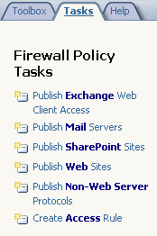
Secure Server Publishing

In today’s business environment, organizations regularly need to make Web servers, e-mail servers and e-commerce applications available to external users and customers, while protecting those resources from a variety of threats. Unfortunately, with traditional firewall products it is often difficult, if not impossible, to configure them for these purposes. This often leads to misconfigurations, which can cause breaches in corporate network security.

ISA Server 2006 can impersonate internal servers through a reverse proxy process known as publishing to add a layer of security at the network edge. In addition, security breaches due to misconfigurations are limited by a variety of new and improved wizards that make it easy for administrators to publish these resources. These wizards are discussed throughout this section of the document.

Secure Web Publishing

Web Server Publishing allows administrators to securely make internal Web applications available to users outside of the corporate network, including remote employees and partners.

Traditional Web publishing involves sending all traffic that uses TCP port 80 to an internal Web server. An additional limitation of traditional Web publishing is that you can only publish one server for each IP address, unless nonstandard ports are used, which is cumbersome and often impractical.

Web publishing with ISA Server 2006 is more secure and flexible than traditional Web publishing. Because ISA Server 2006 inspects HTTP content before it reaches the Web servers, it provides one element of a defense-in-depth strategy. It can also be used as a central location to block disallowed Web requests, which is much easier than configuring each Web server individually. ISA Server 2006 processes only allowed URLs and blocks any disallowed or invalid HTTP syntax. It can also block based on signatures in the HTTP request or response.

ISA Server 2006 provides additional flexibility because it can make Web forwarding decisions based on the content of the request. For example, requests for www.contoso.com and www.fabrikam.com can be forwarded to different internal Web servers. This means that organizations can easily publish multiple Web sites, and that multiple Web sites behind ISA Server 2006 can appear like a single Web site to the Internet.

ISA Server 2006 builds upon the functionality of ISA Server 2004 to enable and optimize secure Web publishing scenarios, including Windows SharePoint Services publishing, Microsoft Outlook® Web Access publishing, publishing of multiple Web sites, and publishing of Web server farms.

Web Listener Wizard

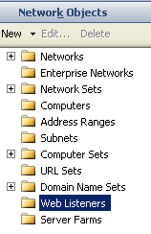
When a Web publishing rule is created, a Web listener is specified to be used when applying the rule. Web listeners are network objects that can be used by more than one Web publishing rule.

The Web listener properties determine the following:

- Which IP addresses and ports on the specified networks will listen for Web requests.
- Which authentication method will be used (when authentication is required).
- The number of connections that are permitted.

Changes to the ISA Server 2006 Web Listener Wizard reflect new capabilities with respect to authentication (single sign on), Certificate Management, and HTTP compression:

- Multiple certificates can now be assigned to a single Web listener. For example, three separate certificates can be assigned to three different Web sites using a single Web listener.
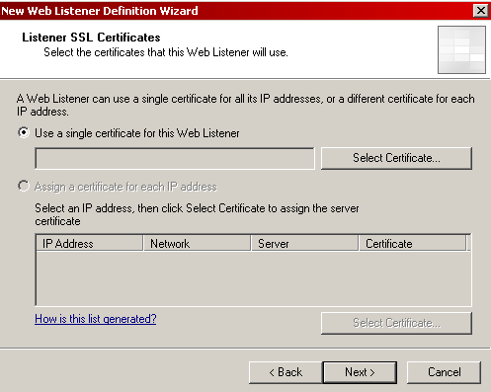

- A certificate can be selected for each server in the array, and it no longer has to be the same thumbprint certificate.

Note: In ISA Server 2004, each listener was associated with a single certificate. In ISA Server 2006, a listener can have more than one certificate. This is important because it enables the administrator to specify a single set of authentication settings for multiple sites without requiring a wildcard certificate. Wildcard certificates are considered less secure and more expensive than standard certificates.
Note: Improvements to Certificate Management are discussed later in this section of the document.

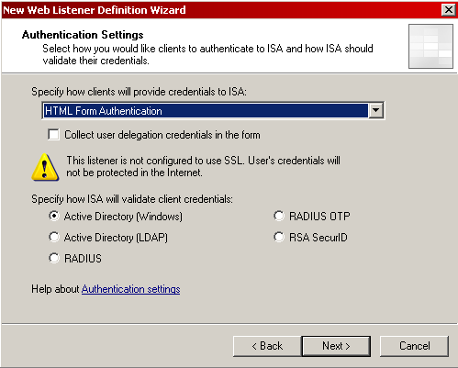
- Authentication settings are now a mandatory part of the Web Listener Wizard. Options include:

  - HTML Form, which allows you to tell ISA Server to collect user delegation credentials in the form (that is, RADIUS OTP, RSA SecurID)
  - HTTP Authentication, along with sub-authentication sites
  - SSL client certificate authentication
  - No authentication

Note: The list will be expanded if third-party authentication mechanisms are installed on ISA Server 2006.
Note: Enhanced integration and implementation of authentication mechanisms are discussed later in this section of the document.

- A check box in the wizard enables single sign on for the Web listener. When enabled, single sign on occurs automatically between all applications that are published on a single listener.
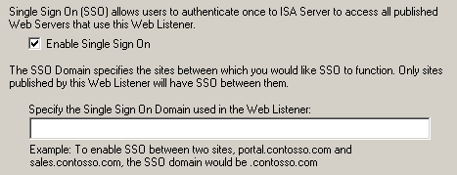

- A check box in the wizard enables HTTP compression for the Web listener, resulting in savings on upstream bandwidth.
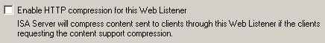

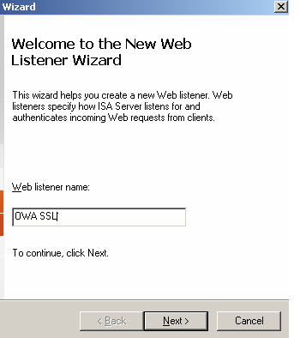
Note: Single sign on is discussed later in this section of the document. For more information about HTTP compression, see the Branch Office Gateway section of this document.

For a demonstration of the Web Listener Wizard, see "Walkthrough C" of the Microsoft ISA Server 2006 Reviewers Guide Walkthroughs.

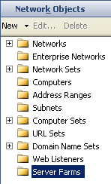
Server Farms

Configuring access and security to a large number of Web sites can be time consuming. Server farms make it possible to ensure that resources are always available and served up when accessed remotely.

ISA Server 2006 approaches the concept of server farms in much the same way as it does Web listeners. A farm of servers can be defined as a network object, and then used in as many different publishing rules as desired.

The Server Farm Wizard allows administrators to define which servers belong to the farm. It includes a connectivity verifier option that allows for verification of connectivity to the individual servers through any of the following methods:
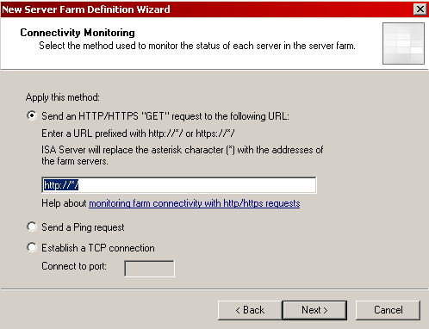
- Send an HTTP/HTTPS “Get” request to specific URLs that do not require authentication

- Send a Ping request

- Establish a TCP connection to any specified port

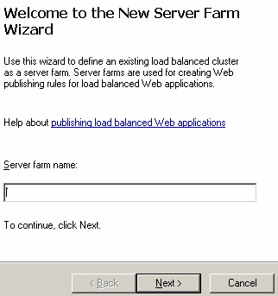

For a demonstration of the Server Farm Wizard, see "Walkthrough D" of the Microsoft ISA Server 2006 Reviewers Guide Walkthroughs.

Web Publishing Load Balancing

Web applications and sites are often hosted by an array of servers. This is done to increase availability and scale the performance. To derive the full benefit of such a configuration, the incoming client traffic needs to be distributed, as evenly as possible, among the available servers. You want to be able to easily configure a full Microsoft solution where ISA Server 2006 effectively publishes an array of servers.

With its new Web Publishing Load Balancing feature, ISA Server 2006 will balance the request stream coming from a remote user to an array of published servers. All the requests from the same client session are relayed to the same server, thus maintaining the application context and potentially saving the need to deploy NLB on the published array.
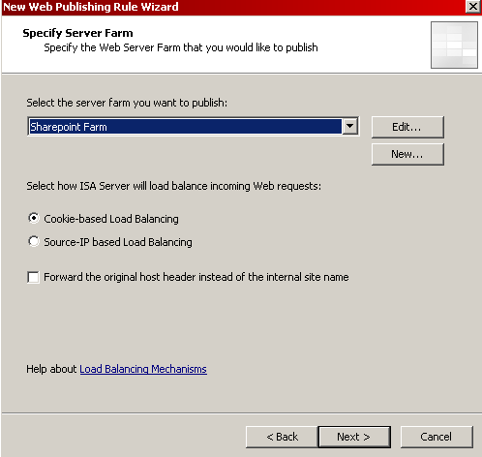
When creating a new server farm, an administrator will be able to specify whether to use cookie-based or source-IP based load balancing. However, when publishing Exchange through Outlook Web Access and RPC/HTTP, the new Web load balancing features are automatically implemented.

- When publishing Outlook Web Access, a rule is automatically created that uses cookie-based load balancing.

- When publishing RPC/HTTP, a rule is automatically created that uses source-IP based load balancing.

Web Publishing Load Balancing is implemented on a per-rule basis and provides for the following:

- Effective load balancing ISA Server will implement an effective load balancing algorithm that will distribute the traffic on all of the servers in the published array.

- Session mode support of session affinity All requests that originate from the same browser session on the same remote client will be relayed to the same server in the published array.

- Detection of target server change of status ISA Server 2006 will detect changes in the availability of members of the published server array. For example, ISA Server will detect when a published server becomes unavailable, and when it becomes available again. The following states are tracked:

- Active When an administrator adds a server to the list of load balanced published servers associated with a Web publishing rule, the server is in an Active state. This means that this published server is ready to accept and process requests.

- Draining An administrator can configure the published server to the Draining state. In this state, the server continues to process requests that belong to the already active sessions that were previously relayed to that published server. ISA Server 2006 does not relay new client sessions to a published server that is in the Draining state.

- Out of Service (OOS) A published server is placed in the OOS state when ISA Server 2006 detects that it does not respond to requests and is not available to serve clients.

- Removed The administrator can remove a published server from the list of published servers. In that case, the server is in the Removed state. It is not displayed by the UI and no requests are relayed to this server.

- Recovery from server failure When ISA Server 2006 detects that a target server is unavailable, it will select an alternate server from the target array and relay the requests to the alternate server. An administrator may add or remove a target server to or from the published array, and ISA Server 2006 will maximize service availability under these circumstances. The return to service of a failed published server will not affect existing client sessions. Sessions that should have been served by the recovering published server but, in its absence, were assigned to alternate published servers, will be relayed to the same server as before the recovery. The rationale is that the session context is already maintained on the application server, hence moving the session to the recovered server (where it should have resided had it been active) will break the application session.

SharePoint Portal Server Publishing

Many customers use Windows SharePoint Services technologies for internal collaboration. A new SharePoint Publishing Wizard makes it easy to provide that same functionality to external audiences, such as remote employees and business partners. With this wizard, publishing multiple sites simultaneously is quick and easy, with link translation being implemented automatically.

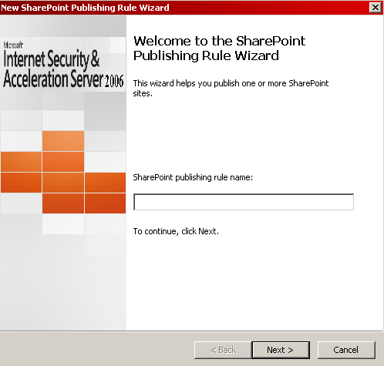
For a demonstration of the SharePoint Publishing Wizard, see "Walkthrough F" of the Microsoft ISA Server 2006 Reviewers Guide Walkthroughs.

SSL Bridging

The nature of business in today’s world demands that organizations enable their employees to communicate across the Internet to a variety of resources and sites. Maintaining confidentiality of that traffic requires encryption.

Secure Sockets Layer (SSL) is the protocol used to validate the identities of two computers involved in a connection across a public network, and to ensure that the data sent between the two parties cannot be read by anyone else on the network. All network traffic, including the confidential parts of the authentication process, is sent using an encrypted SSL connection called a tunnel that is created between the client and server. In addition, the client and server will automatically detect if the data sent over an encrypted SSL connection has been altered in transit. SSL is used extensively to protect Web-related communications. Unfortunately, this same protection mechanism will defeat traditional firewalls because they cannot inspect the traffic. The result is that exploits enter a network through this secure tunnel.

For Web servers requiring authenticated and encrypted client access, ISA Server 2006 can provide end-to-end security and application layer filtering using SSL-to-SSL bridging. Unlike most firewalls, encrypted data can be inspected before reaching the Web server. The ISA Server 2006 firewall decrypts the SSL stream, performs stateful inspection, and then re-encrypts the data and forwards it to the published Web server.

Link Translation

Providing simultaneous internal and external access to Web resources can be problematic. There are a number of problems that occur when you want to make internal Web resources available to both internal and external clients at the same time.

Access can be denied when a published server returns a link that cannot be resolved. Absolute links to the internal Web server are the most common example of this access denial. In the following diagram, an external client requests the home page for www.contoso.com. The server returns the home page that contains a link to the Sales page on the internal Teams server. The external client receives the link to the Sales page on the Teams server. The external client then tries to resolve the name Teams to an IP address. Because this is an internal name, the external client cannot resolve it, and the request fails.

www.contoso.com
http://www.contoso.com/default.htm
External
Client
HREF=http://teams/sales
teams
Web
Page
Internet
The following diagram illustrates how ISA Server implements link translation when a client requests the home page for www.contoso.com. This page contains the same reference to the Teams server. Because ISA Server 2006 publishes the Web site, it can inspect the Web response, and it replaces the link to the internal server with a link that contains a name that is externally accessible, in this example, teams.contoso.com. The client can resolve the name and can retrieve the linked page through ISA Server.

www.contoso.com
http://www.contoso.com/default.htm
External
Client
HREF=http://teams/sales
teams
Web
Page
Internet
HREF=http://teams.contoso.com/sales
http://teams.contoso.com/sales/

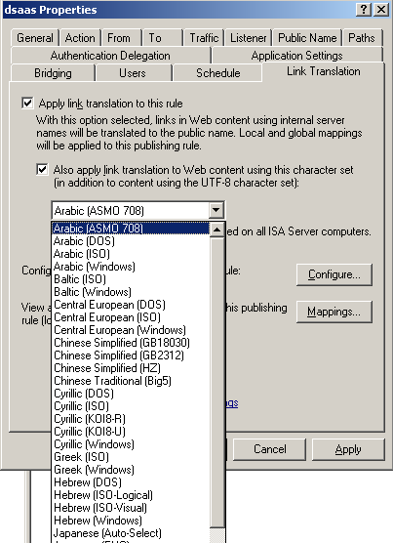
Link translation is a unique feature of both ISA Server 2006 and ISA Server 2004. It addresses issues of confidentiality and availability. Internal network details are not revealed to unauthorized external users, and external users can connect to resources that the hypertext links point to by using public fully qualified domain names (FQDNs). A significant return on investment (ROI) can be achieved because link translations remove the need to rewrite the underlying Hypertext Markup Language (HTML) code for these Web pages.

ISA Server 2006 brings several improvements to link translation:

- Automatic implementation Link translation is built in and enabled automatically during the Web publishing process.

- New translation engine Completely rewritten, with an improved Search and Replace algorithm to increase performance and scalability.

- Globalization Various multi-language character sets are now supported.

Cross Array Link Translation
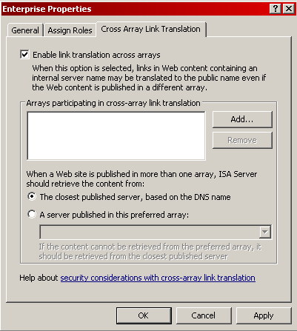
When enabled, Cross Array Link Translation allows links in Web content containing an internal server name to be translated to the public name even if the Web content is published in a different array. This ensures that resources are always available and served up quickly when accessed remotely.

Microsoft Exchange Server Publishing

A key goal in the design of ISA Server 2006 is to provide added security for Microsoft Exchange Server, including support for Microsoft Outlook Mobile Access and Microsoft Exchange ActiveSync® for PocketPC. Exchange Server publishing allows administrators to provide secure access to internal Exchange servers:

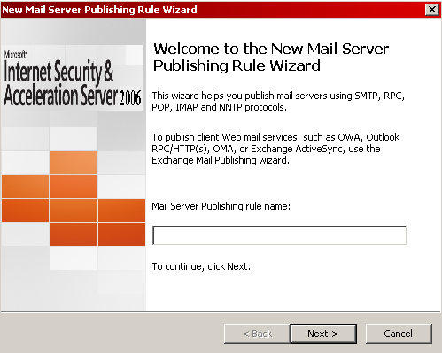
- Publish mail servers The New Mail Server Publishing Rule Wizard is designed to make it easy for administrators to publish e-mail servers using RPC, IMAP, POP3, and SMTP for client access. It also allows for server-to-server communications using SMTP and Network News Transfer Protocol (NNTP). ISA Server 2006 allows remote users to connect to Exchange using the fully functional Outlook MAPI client over the Internet. The Outlook client may be configured to use secure RPC so that the connection is encrypted and the ISA Server 2006 firewall can be configured to require only encrypted communications from the full Outlook MAPI client.

- Publish Exchange Web client access ISA Server 2006 is integrated with Outlook Web Access. A new publishing wizard makes it easy to allow secure remote access to Outlook Web Access Web sites. The wizard begins by asking you if you are publishing Exchange through traditional protocols, Web client access (including Outlook Web Access, Outlook Mobile Access, and Exchange ActiveSync), or server-to-server communication. Subsequently, there are new choices added to the wizard in ISA Server 2006:

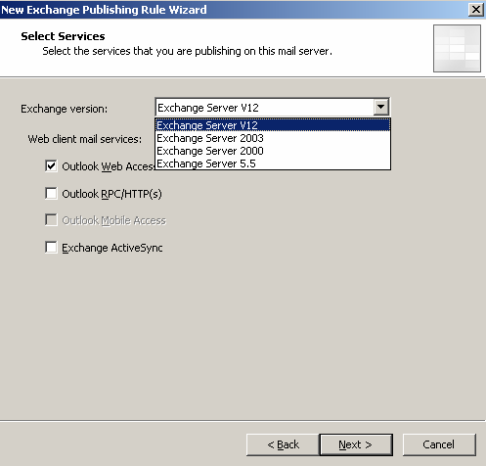
- You can now choose the exact version of Exchange to be published (including Exchange "12", Exchange Server 2003, Exchange 2000 Server, and Exchange Server 5.5) and the remainder of the wizard is fitted to that choice.

- When choosing to publish Outlook Web Access, you can choose to include one or all of these methods: Outlook Web Access, Outlook RPC over HTTP, Outlook Mobile Access, and Exchange ActiveSync.

- You can choose to publish a single server or a server farm.

Note: Exchange "12" integration provides:
- Read only access to:
    - Windows SharePoint Services document libraries.
    - Files on internal Windows SharePoint Services sites.
    - Internal network shares.
- Full Access to:
    - Internal Windows SharePoint Services document libraries.
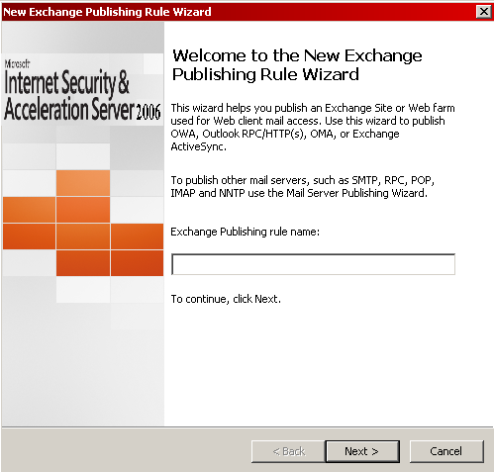
    - Files on internal Windows SharePoint Services sites.
    - Non-Windows SharePoint Services sites.

For a demonstration of the New Exchange Publishing Rule Wizard, see "Walkthrough E" of the Microsoft ISA Server 2006 Reviewers Guide Walkthroughs.

Enhanced Certificate Management

Because they provide stronger security for authentication, certificates are often used instead of other authentication mechanisms. However, as with all public key infrastructure components, management can be challenging. According to Microsoft Product Support Services, “Public Key Infrastructure and especially SSL certificates are the most commonly misunderstood security features among our customers.” In addition, certificate-related support calls are the most frequent and costly support issue for ISA Server Product Support Services.

ISA Server 2006 is designed to make this process easier. As discussed earlier, it is now possible to utilize multiple certificates per Web listener and to use different certificates per array member (used in conjunction with SSL accelerators). In addition, ISA Server 2006 has been improved to simplify Certificate Management and reduce the total cost of ownership associated with using certificates when publishing Web sites by helping to:

- Avoid problems when installing SSL certificates on ISA Server 2006.
- Troubleshoot problems that arise with already installed certificates on ISA Server or any of the servers it publishes.

ISA Server 2006 supports four types of certificates, by location:

- Front-End Certificates on ISA Server 2006 are used to establish SSL connections with the remote client.
- Back-End Certificates on the published server are used to establish SSL connections with ISA Server 2006.
- ISA Server Client Certificates on ISA Server are used to authenticate ISA Server to the published server (optional).
- Remote Client Certificates on the remote clients are used to authenticate the remote client to ISA Server (optional).

Improvements in both the ISA Server 2006 user interface and alerting capabilities will save you time and effort by making certificate configuration and troubleshooting more visible and intuitive:

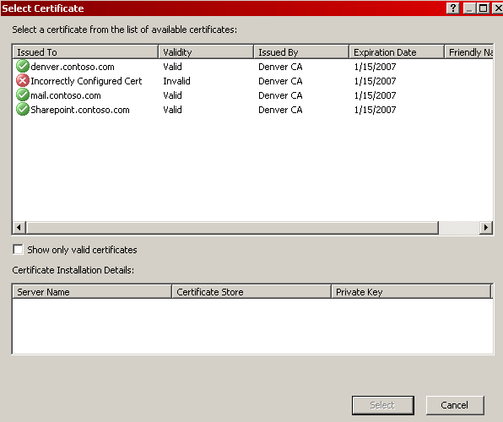
- User interface improvements:
    - Shows incorrectly installed certificates:
      - Certificates installed in current user store.
      - Certificates without a private key.
    - Shows certificate state on each array member.
    - Shows expired certificates with a warning.

Note: The incorrectly configured certificate in the preceding figure is showing an error because it has been installed into the current user store instead of the local store, which is a requirement under ISA Server 2006.
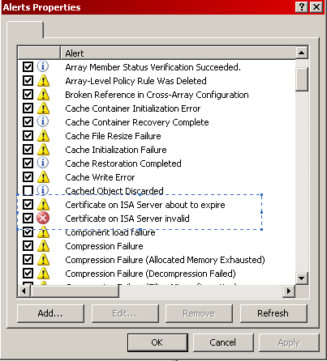

- Administrative alerts In ISA Server 2004, problems with certificates resulted in a general HTTP 500 error message being generated and were difficult to troubleshoot. In ISA Server 2006, alerts are raised when certificates are about to expire or when they are invalid.

Authentication

Over the years, many different types of authentication methods have been developed, some more secure than others. An administrator chooses which methods to use based upon which methods are supported by the client software being used and by the level of security desired. For example, Basic authentication is supported by virtually all Web browsers, but integrated Windows authentication is only available to Microsoft Internet Explorer 6 or Internet Explorer 5. Client certificates are more secure than the simple user name and password required by Basic authentication.

Many organizations have challenges in addressing user compliance with corporate security policies. By authenticating users and therefore ensuring the user names are logged according to their activities, organizations can achieve a higher degree of user accountability and corresponding increase in compliance. Also, because users can be authenticated, access can be allowed or denied on the basis of user name and group membership. ISA Server 2006 provides granular control over access by allowing access based not only on user name and group membership, but on protocol usage and schedule.

Authentication can be configured to be performed at the ISA Server computer, the published server, or both:

- Authentication flow When a client requests a published Web site, ISA Server 2006 must determine whether to authenticate the user. A listener can be configured to require authentication. In this case, ISA Server 2006 authenticates the user before access is granted to any published Web site:

- If a listener is not configured to require authentication, ISA Server 2006 determines whether or not to authenticate the user based on the rules that are associated with the listener. When the client sends an HTTP request, ISA Server 2006 attempts to find a matching publishing rule. During this process, if ISA Server 2006 reaches a rule that requires authentication (the rule’s users definition specifies anything other than All Users), the user is required to authenticate.

- When ISA Server 2006 matches a rule that is allowed for All Users, it does not require the user to authenticate. Instead, it passes the request to the published server. The session is considered unauthenticated because ISA Server 2006 does not know the identity of the user.

- At any stage, if the back-end server requires authentication, and the delegation is set to pass-through or the session is not authenticated yet, the user is asked to authenticate. If ISA Server 2006 is unable to authenticate to the server due to an incorrect configuration, the client receives a 403 Forbidden response.

ISA Server 2006 enables companies to authenticate users through four methods (Front End, Gateway, Back End, and Enhanced Delegation of Authority).

- Front End The method ISA Server 2006 uses to receive user’s authentication information before the user can access internal resources:
- HTTP Authentication (Basic, Digest, and Negotiate)

- SSL Client Certificates ISA Server 2006 now allows for per-rule client certificate settings. Each rule has the following options:

    - Ignore client certificates ISA Server 2006 does not request a certificate.
    - Accept client certificates ISA Server 2006 asks for a certificate and falls back to the listener’s authentication scheme if a certificate is not provided.
    - Require client certificates ISA Server 2006 asks for a certificate and the rule is not matched if a certificate is not provided. When this option is selected, the administrator can specify if the user is also required to provide credentials. The administrator can specify if two-factor authentication is required. Note that the second factor (“what you know”) is requested according to the listener’s authentication scheme.

Note: With ISA Server 2006, two-factor authentication is achieved by combining forms-based authentication with either a client certificate or a SecurID token.

- Forms-based authentication ISA Server 2006 extends the use of forms-based authentication through enhanced HTML forms, customizable through HTML editing. Multiple form sets are available in 26 different languages and can be selected for use on a per listener or per-rule basis:

    - Different forms are based on specific authentication combinations:
      - User name, password.
      - User name, passcode.
      - User name, passcode, password.
      - Non-browser clients (including Microsoft Office, RPC over HTTP, Exchange ActiveSync, and Acrobat) utilize Basic authentication.

- Gateway The method ISA Server uses to validate user identity:

- Active Directory (Windows) When ISA Server 2006 is a domain member, this method supports Windows-based authentication to Active Directory for domains composed of Windows Server 2003, Windows 2000 Server, and Windows NT® Server 4.0 domain controllers in all modes (mixed or native).

- Active Directory (LDAP) This method is similar to Windows authentication, however, ISA Server 2006 does not need to be a domain member. In this case, ISA Server supports authentication for domains composed of Windows Server 2003, Windows 2000 Server, and Windows NT Server 4.0 domain controllers in all modes (mixed or native).

- Remote Authentication Dial-In User Service (RADIUS) An industry-standard protocol used to provide authentication in heterogeneous environments. An important benefit of using RADIUS for ISA Server authentication is that you can authenticate users based on their Active Directory user names without requiring that the ISA Server computer be a member of the Active Directory domain.

ISA Server 2006 provides the same level of RADIUS support as ISA Server 2004, except for the load balancing and failover algorithm, which is now the same one used for LDAP. All RADIUS servers are supported, including Internet Authentication Service (IAS) for Windows Server 2003, IAS for Windows 2000 Server, IAS for Windows NT Server 4.0, FreeRADIUS, and GNU RADIUS.

- RADIUS OTP A RADIUS OTP solution is a RADIUS server where the password changes are based on time or an authentication request counter. ISA Server 2006 supports RADIUS OTP by avoiding re-authentication when a client arrives with a cookie that can be successfully decrypted. All RADIUS OTP solutions are supported, including Aladdin, Vasco, Secure Computing, and ActivCard.

- RSA SecurID

- Back End The method ISA Server 2006 uses to authenticate the session on behalf of the user with the internal resource using a variety of authentication methods:

- No Authentication (Block)

- No Authentication (Pass-through)

- HTTP authentication:

    - Basic
    - Negotiate This provides for negotiation between NTLM and Kerberos. Negotiate selects Kerberos unless it cannot be used by one of the systems that is involved in the authentication process, or the calling application does not provide sufficient information to use Kerberos.

- Kerberos constrained delegation This enables a trust relationship between ISA and a published server. This way the published server will serve any user requests for content coming through ISA because it trusts ISA to have independently authenticated the user. This functionality is especially useful when ISA is unable to provide the published server with a username and password but instead has validated the user’s identity through other authentication means such as SSL client certificate authentication. Smartcard based authentication, when not used in conjunction with some other authentication mechanism such as Forms-based authentication, is one such example when one would need to use Kerberos Constrained Delegation. Another example is when publishing an Exchange server for Exchange ActiveSync access over a smartphone while using SSL client certificate authentication.
- Enhanced Authentication Delegation The ability to transform some front-end authentication method into a back-end authentication method:

- ISA Server 2006 will use information obtained from front-end authentication to authenticate the session to the published Web site on behalf of the user.

- The back-end method may be different from the front-end method, for example:

    - HTML Form to Basic
    - Client Certificates to Kerberos delegation

- Back-end authentication methods are limited by the selected front-end method. The following table specifies which combinations of client authentication and back-end delegation are possible. (Every row in the following table is a possible combination.)

Front-end interface | Authentication provider | Back-end delegation | Comments
Forms-based authentication Password  Basic | - Active Directory (Windows)  - Active Directory (LDAP)  - RADIUS | - No authentication (pass-through)  - No authentication (block)  - Basic  - NTLM  - Negotiate | - Single sign on (SSO) is supported for forms-based authentication Password and Basic  - An additional client certificate can be required (two-factor authentication).
- Digest  - Integrated | Active Directory (Windows) | - No authentication (pass-through)  - No authentication (Block) | None
Forms-based authentication PC | SecurID | - No authentication (pass-through)  No authentication (block)  - SecurID | Single sign on is supported.
Forms-based authentication PCPW | SecurID | - No authentication (pass-through)  - No authentication (block)  - Basic  - NTLM  - Negotiate  - SecurID | Single sign on is supported.
Client certificates | Active Directory (Windows) | None | Two-factor authentication when combined with: SecurID  RSA Token

- Single sign on (SSO) support Allows users to access a group of published Web sites without being required to authenticate with each Web site.

Note: It is important to understand SSO. In the broadest interpretation, the meaning of SSO is that the user only needs to authenticate once to ISA Server 2006 for each session. ISA Server 2006 does not ask the user to authenticate for each Web site. Even if SSO is enabled, the published servers may also require authentication. (Delegation of authority is necessary to improve the user’s experience, but has nothing to do with SSO. SSO only relates to the relationship between the client and ISA Server 2006.)

- Scope SSO covers multiple published Web sites. All of the Web sites that participate in a single SSO experience are covered by an SSO scope.
- DNS Suffix ISA Server 2006 supports SSO between sites that share a common Domain Name System (DNS) suffix. Examples include portal.contoso.com, mail.contoso.com, and hr.contoso.com. (The SSO domain in this instance is “contoso.com.”) ISA Server cannot provide SSO between www.msn.com and www.microsoft.com, even if both sites are published with listeners that share the same authentication profile, and that profile has SSO turned on.
- Validation ISA Server 2006 performs a validation on the SSO scope entries. It makes sure that there are at least two dots (for example, “*.microsoft.com” is valid, but “*.com” is not).

Session Management

During client authentication, a session is established between the client and the authenticating server. The way in which these sessions are handled has a large impact on the security of the session. ISA Server 2006 handles session management as follows:

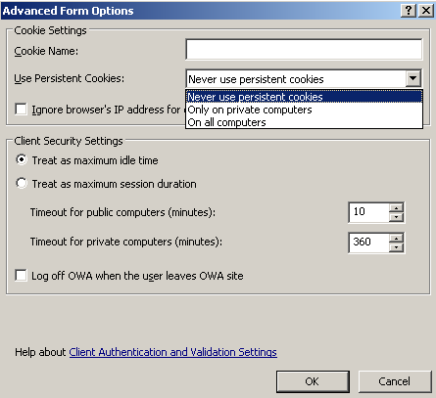
- Cookies ISA Server 2006 supports both session and persistent cookies. Although persistent cookies may offer a better user experience, they are considered less secure. An administrator can choose to use persistent cookies on private or public computers.

- Time-outs An administrator can configure different time-outs for public and private computers. The client computer is considered public unless the user specifically selects the private option in the logon form:

    - The administrator can choose the mode of the time-out: idle or absolute. When idle is selected with a time-out of x seconds, a session is timed out when no user activity is detected for x seconds. When absolute is selected with a time-out of x seconds, a session is timed out exactly x seconds after the user logged on.
    - All time is specified in seconds. This means that the administrator should specify 120 seconds for a 2 minute session time-out.

- Logoff ISA Server 2006 enhances the logoff functionality that existed in ISA Server 2004. A logoff URL can now be configured for each Web publishing rule. When ISA Server 2006 receives a request to log off a URL, it deletes the cookie and adds it to the list of revoked cookies. This provides additional security for remote access from public computers. In addition, ISA Server logs the identity of remote users, which can later be used for forensic purposes.

Enhanced HTML Form Support

HTML forms are used to collect information from clients during forms-based authentication, which ISA Server 2006 supports for use with any published Web site (not just Outlook Web Access). ISA Server 2006 supports three classes of HTML forms:

- Premium Intended for browsers that support advanced features.
- Basic Intended for browsers that have limited capabilities.
- Mobile Intended for browsers that are limited in resolution.

Each of the previous classes contains various forms:
- Logon form
- Logoff form
- SecurID forms

The logon form is available in the following formats:

- Forms-based authentication PW The user enters a user name and password.
- Forms-based authentication PC The user enters a user name and passcode.
- Forms-based authentication PCPW The user enters a user name (for SecurID or RADIUS OTP), passcode, user name (for delegation), and password (for delegation). ISA Server 2006 only validates the user name (for SecurID or RADIUS OTP) and passcode. The additional set of credentials is used for delegation to back-end servers.

ISA Server 2006 can provide localized forms based on the language settings of the user’s browser. While this feature is enabled by default, an administrator can decide to use only forms in a specific language (unlike Microsoft Office Outlook Web Access 2003, which uses automatic language selection).

ISA Server 2006 ships with two predefined form sets:

- ISA The default form set with the logo of ISA Server 2006.
- Exchange A form set that stresses the enhanced protection for Exchange.

Note: The forms in the ISA Server form set feature the logo of ISA Server 2006, and the forms in the Exchange form set feature the logo of Exchange as part of the better-together message. When an administrator successfully completes the Exchange wizard (and the listener’s current form set is ISA), ISA Server 2006 offers to switch the form set to ISA. The administrator can accept or reject this proposal.

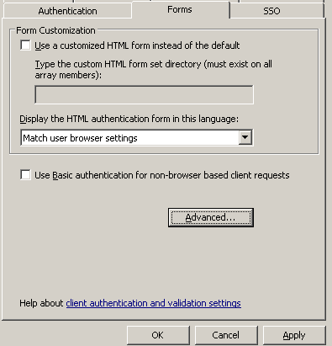
In some cases, an administrator might want to provide a different look and feel for the logon forms of some published Web sites. Each such look and feel is defined by a custom form set:

- Each listener can be configured by the administrator to support one of the form sets. All listeners use the Default set by default. However, an administrator can explicitly select a different form set.
- A specific Web publishing rule can override the form set of its listener. A rule can be configured with one of the following settings:
    - Use the listener’s form set.
    - Use a different form set.

Integrated Virtual Private Networking

VPN functionality is fully integrated into the firewall architecture of ISA Server 2006, which enables fast and secure remote access to corporate network resources.

In a traditional VPN infrastructure, a VPN gateway is used to allow connections from the Internet. This device is separate from the firewall, which controls other inbound and outbound traffic. In this type of product, the purpose of the VPN gateway is to provide connectivity, but not to control network traffic based on security policies. The result is that VPN clients get full access to the Internal network. If corporate policies require control over what VPN clients can access on the Internal network, a separate firewall may implement this restriction. Administrators in such a scenario must configure and maintain multiple devices, each of which uses different configuration tools and can be costly.

Internal Network
Firewall
VPN Gateway
Internet

ISA Server 2006 is both a VPN gateway and a firewall, which means that ISA Server 2006 can provide network access for VPN clients and control and help protect this access at the same time. Administrators have full control over what types of network traffic are allowed between VPN clients and internal resources.
Internal Network
ISA Server 2006
Internet

ISA Server provides the following:

- Comprehensive filtering The ISA Server application layer firewall provides improved protection to all network traffic. The same filtering and control that applies to all network traffic also applies to VPN clients. The firewall rule engine discriminately checks requests from VPN clients, statefully filtering and inspecting these requests and dynamically opening connections based on the access policy.

- Multi-network support The multi-network support capability in ISA Server 2006 extends to VPN traffic, allowing administrators to define different areas of the Internal network and control which areas users can access when connected through a VPN. This access can be more restrictive than the access allowed while users are directly connected to the corporate network.

- Broad support for VPN protocols ISA Server 2006 supports Point-to-Point Tunneling Protocol (PPTP) and Layer Two Tunneling Protocol (L2TP) over Internet Protocol security (IPsec) (L2TP over IPsec). ISA Server 2006, running on Windows Server 2003, also supports IPsec NAT Traversal (NAT-T) to allow client computers to connect by using a VPN, even if client and server communicate across one or more devices that perform network address translation (NAT). Traditionally, such a configuration has prevented IPsec connections.

- Broad range of authentication and encryption ISA Server 2006 supports a wide range of authentication methods and their corresponding encryption mechanisms, including Active Directory, LDAP, RADIUS, certificates, and RSA SecurID.

- SecureNAT client support for VPN clients ISA Server 2006 expands VPN client support by allowing SecureNAT clients to access the Internet through the ISA Server firewall. Administrators can also enhance corporate network security by forcing user-based and group-based firewall policy on VPN SecureNAT clients.

VPN Quarantine

A common problem with remote clients is that they are often unmanaged (for example, employees’ home computers or public computers). These unmanaged computers create a security risk to the organization when they are used to connect remotely through a VPN connection. An attacker may even be able to remotely control a client computer while connected to the corporate network over a VPN, and use this control to gain access to corporate resources. Therefore, administrators are seeking a solution that would inspect the configuration of remote computers and update security configurations before allowing full access to employees working remotely. It would also constrain remote employee access to destinations within the corporate network and to required resources, and inspect all traffic from and to the remote client.

ISA Server 2006 helps administrators quarantine VPN clients on a separate network until they meet a predefined set of security requirements (such as having the latest A/V signatures). These clients are represented in the ISA Server user interface as a separate network, making them easy to identify. VPN clients passing security tests are allowed network access based on VPN client firewall policies. VPN clients who fail security testing may be provided limited access to specific servers that will help them meet network security requirements.

Note: Implementation of quarantine requires components from the Windows Server 2003 Resource Kit or Windows Server 2003 Service Pack 1, as well as customized scripts.

Monitoring and Manageability

Customers today require security solutions that are easy to monitor and manage. As customers deploy large mission critical environments, they are looking for ways to spend less time and resources on deploying and managing solutions that support these environments. Therefore, they are looking for solutions that they can configure and manage centrally. Doing this allows them to have fewer resources, while saving time that can be better spent on other projects. With ISA Server 2006 Enterprise Edition, customers can take advantage of centralized management of firewall policy, monitoring, and logging:
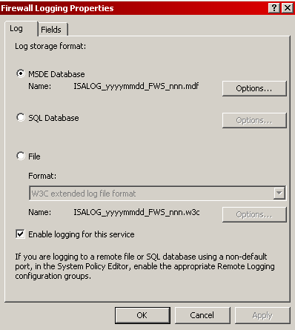
- Logging ISA Server 2006 provides detailed logs for inbound and outbound access. When combined with authentication, the logs will contain information about activity by user name, which greatly increases the accountability of users. ISA Server 2006 offers three log files formats—text-based logging, MSDE logging (default), and SQL logging. Regardless of log file format, all log information can be viewed in real time for troubleshooting or other purposes.

- Reporting ISA Server 2006 has the ability to automatically generate several standard reports for viewing by management and others. Report capabilities can be easily extended by third-party tools or by developers.

- Real-time monitoring and log filtering ISA Server 2006 allows administrators to view all active connections to and through the firewall. From a session view, they can sort or disconnect individual or groups of sessions. In addition, they can filter entries in the session’s interface to focus on sessions of interest using the built-in sessions filtering facility. ISA Server 2006 also allows administrators to see firewall, Web Proxy, and SMTP Message Screener logs in real time. The ISA Server Management snap-in displays log entries as they are recorded in the firewall’s log file.
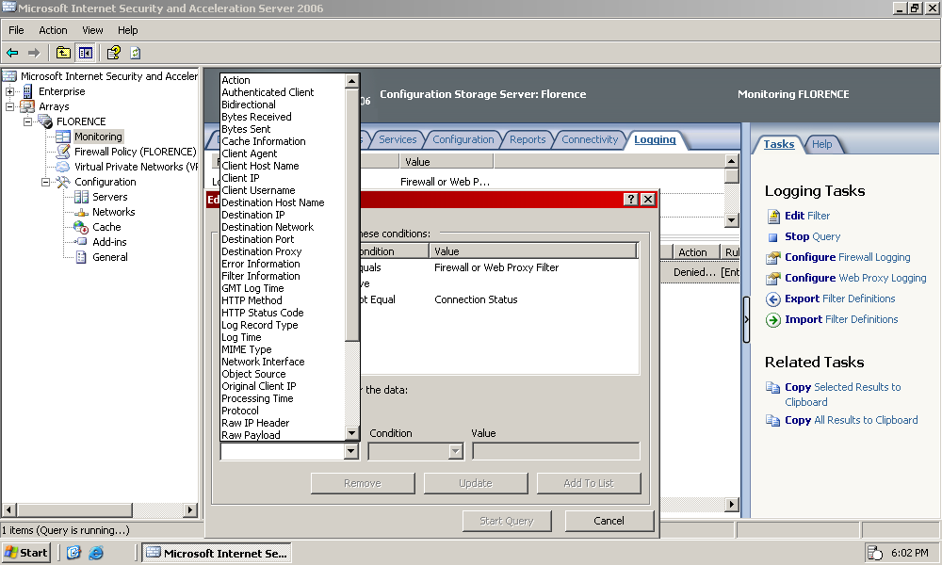

- Connection verifiers Administrators can verify connectivity by regularly monitoring connections to a specific computer or URL from the ISA Server 2006 computer using connection verifiers. They can configure which method to use to determine connectivity: Ping, Transmission Control Protocol (TCP) connect to a specific port, or HTTP GET. Administrators can select which connection to monitor by specifying an IP address, computer name, or URL.

- Enhanced troubleshooting ISA Server 2006 offers a monitoring dashboard with enhanced, real-time log viewer that presents a summarized version of key ISA Server status information across the enterprise. The centralized view includes data on session state, connectivity, performance, alerts, events, reports, logs, and more.

Summary: Key Differentiators of ISA Server 2006 Secure Application Publishing

The following table describes the ISA Server 2006 features related to secure application publishing.

Integrated security
Improved security through tight integration with applications and with Microsoft infrastructure such as Active Directory, WINS, DHCP, NLB, and VPN Quarantine.
ISA Server 2006 features | Meet these needs
SSL bridging provides inspection of encrypted content, better application scalability through offloading SSL processing to ISA Server, and lower latency through support for SSL hardware accelerators. | Maintain confidentiality of communications.
New  Increased security and deployment flexibility for Web application servers through enhanced multi-factor authentication (smart cards and one-time passwords), flexible integration with Active Directory (LDAP), and customizable forms-based authentication for almost any Web application and client device. | Provide complete security for every instance that a user remotely accesses a corporate resource.
New  Easily integrate ISA Server with your existing authentication infrastructure through enhanced authentication delegation (including NTLM, Kerberos, and SecurID), and gain more access control with improved session management that detects non-user traffic through automatic idle-based time-outs. | Accommodate needs of increasingly mobile workforce using different devices.
More easily secure inbound traffic and protect your network from inside attacks through VPN client connections through unified firewall and VPN policy management, deep content inspection, and VPN Quarantine integration. | Protect internal corporate resources while providing secure access to authenticated users.

Efficient management
Reduced TCO through simplified deployment and management, cost, and server consolidation.
ISA Server 2006 features | Meet these needs
New  Simplifies the process of securely publishing Exchange, Windows SharePoint Services, and other Web servers with easy-to-use wizards for multiple sites, and enhanced certificate administration to avoid configuration errors. | Easily administer and manage access to different corporate resources through different devices.
New  Web Publishing Load Balancing makes it easy to deploy entire farms of Web servers behind ISA Server using session-based and IP-based affinity with automatic out-of-service detection. | Ensure resources are always available and served up quickly when accessed remotely.
Strong logging and reporting capabilities provides enhanced monitoring of clients accessing corporate resources. | Track user resource access.

Fast and secure access
Secure and seamless user access to resources with added speed through caching.
ISA Server 2006 features | Meet these needs
New  Enable a smoother user experience for published Web applications, document libraries, and content through single sign on and comprehensive automatic link translation to help ensure secure and consistent access. | Provide remote users seamless interaction with corporate resources with good user experience.

Branch Office Gateway

With ISA Server 2006 as your Branch Office Gateway, you will be able to simplify your administrator and user experiences through a unified firewall and VPN architecture, with web caching and bandwidth management, an optimized firewall and filtering engine and comprehensive access control.

Key Data Points

External research studies (Harte-Hanks 2004 and AMI Partners 2003) indicate that 30 percent of businesses have remote offices and that these branches consume nearly 33 percent of IT budgets. (Larger organizations of more than 1,000 employees spent US $25 billion on WANs in 2003.) Fifty-five percent of large organizations have more than 1,000 employees at branch locations, but often have no IT professionals on site. These statistics drove improvements to branch office connectivity in ISA Server 2006.

Typical Target Environment and Customer

Companies with branch offices distributed locally, across a continent, or around the world, want to ensure secure, safe, and efficient communication between those offices and corporate headquarters, as well as between the various branch offices. IT professionals who are responsible for centralized or distributed branch offices face a host of challenges around management, security, and efficient bandwidth utilization.

For these types of organizations, ISA Server 2006 offers a unique and compelling branch office solution by integrating firewall, VPN, and caching into a single easy-to-use solution that provides branch offices with advanced protection and fast and secure access.

Customer Needs, Pain Points, and the ISA Server 2006 Solution

The following table describes customer needs and pain points, and how ISA Server 2006 meets these needs.

Customer needs | Pain points | ISA Server meets the needs
Efficiently and cost effectively manage policy across geographically dispersed offices.  “I want to leverage my existing infrastructure as much as possible without altering it.” | - Managing policy across a large number of branch offices is difficult. | A multi-network architecture, network templates and configuration wizards, and stateful IP routing and inspection makes it easy to deploy ISA Server into existing IT environments as an edge, departmental, or branch office firewall without changing your network architecture.
Easily and cost-effectively integrate new branch offices into the WAN infrastructure.  “I don’t have local IT at each site to set up and configure a firewall/VPN.” | - Deploying to large numbers of branches is costly.  - Branch-office connections must be established across an insecure network and confidentiality of corporate information may be compromised.  - Equipment from multiple vendors may not work together.  - Site-to-site connectivity can be difficult to configure. | New  Easily deploy and configure ISA Server computers in branch offices by using answer files on removable media for unattended installation, and with automated VPN wizards to streamline connectivity.
Respond quickly to new threats and manage branches effectively  “I want a central place where I can manage branch office connectivity.” | - Employees at branch offices may access inappropriate content.  - Managing remote sites and policies is difficult because no local IT is present at branches. Additional hardware requirements prove costly. | Centrally manage branch office security and connectivity and prevent network access downtime by allowing administrators to securely and remotely manage firewall and Web cache services.
Manage deployment of policy between offices while optimizing available bandwidth.  “Branch offices consume 33 percent of my IT budget.” | - Keeping branch office devices synchronized with configuration updates can be time consuming and costly. | New  Manage remote ISA Server computers more effectively with faster propagation of enterprise policies, reduced server requirements, and low-bandwidth optimizations.
Remedy insufficient security on WAN connections and protect branches from attacks.  “Remote desktops don’t get software updates as fast as they should.” | - Keeping branch office computers up to date and resilient to security breaches while minimizing bandwidth consumption is difficult.  - Employee access at branch offices may expose the network to worms, viruses, and hacker attacks.  - Maintaining a consistent configuration is difficult. | New  Maintain secure branch office infrastructure using BITS caching to accelerate the deployment of software updates and keep remote computers protected.
Improve slow, unreliable Web access for branch offices. Utilize limited bandwidth at the branch office efficiently.  “WAN links are expensive and poorly utilized.” | - Large bandwidth demand on main office links makes it difficult to optimize bandwidth usage and increase speed.  - Branch office pipe may not be enough to allow for efficient Internet access. Branch offices use slow links, with a speed of 56–64 kilobits per second (Kbps). | New  Improve Web page load times and reduce WAN costs for users in branch offices with HTTP traffic compression and caching.
Ensure that applications with higher business priority always have enough bandwidth.  “Low priority traffic is overriding my application functionality.” | - Important business needs may be impacted by low bandwidth. | New  Help ensure that the highest priority applications get precedence over other network traffic through Diffserv IP settings, providing better bandwidth utilization and response times for critical Web resources.
Provide fast access while combating the high cost of WAN connectivity.  “I want to minimize the use of bandwidth and provide fast access to my users at the same time.” | - It can be hard to reduce bandwidth usage.  - Bandwidth used for Internet access can slow access to corporate networks. | Enhance network performance and reduce bandwidth costs with integrated Web caching in corporate data centers (using cache server arrays in ISA Server Enterprise Edition). Optimize branch office content delivery with distributed hierarchical caching (Enterprise Edition only).

Multi-Network Architecture
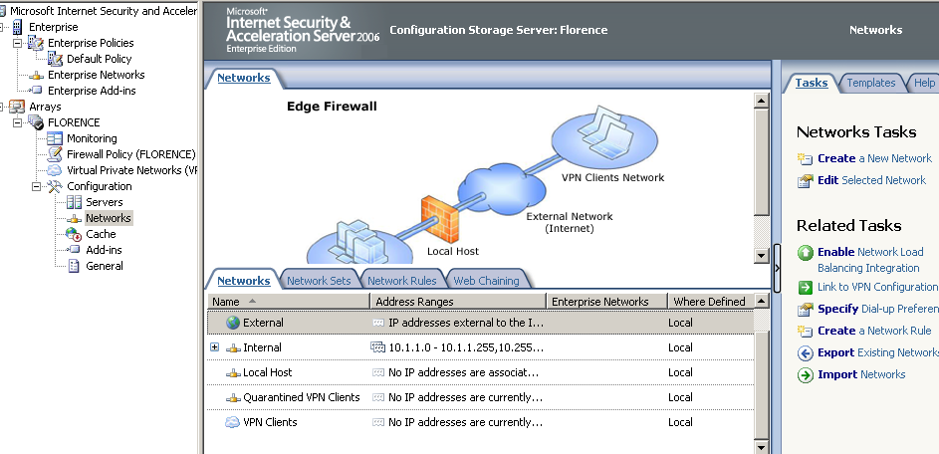
Multi-network architecture makes deployment and management of the Microsoft Firewall service easier. In ISA Server 2000, all traffic was inspected relative to a local address table (LAT), which included only address ranges on the Internal network. Beginning with ISA Server 2004, Microsoft added support for the more likely scenario in which a customer has numerous network types or definitions and needs a centralized and simple way of configuring and managing security policy.

With multi-network architecture, customers can configure one or more networks, each with distinct relationships to other networks. Access policies are defined relative to the networks and not necessarily relative to a specific internal network. VPN clients are treated as a separate network entity, which allows ISA Server 2006 to extend its firewall and security features to apply to traffic between the VPN clients and any other network or network object. This makes it possible to protect a network against internal or external security threats by limiting communication between clients, even across organizational boundaries.

Branch Office Configuration (VPN Site-to-Site)

Many corporations have multiple sites that require communication, for example, a corporate office in New York and a sales office in Washington. The two offices can be connected securely over the Internet using a site-to-site virtual private network (VPN). ISA Server 2006 provides the following protocols for VPN site-to-site connections:

- PPTP or L2TP over IPsec Administrators can use PPTP or L2TP over IPsec when a Windows Server 2003 system is being used as the VPN server, and the site being connected to is using Windows Server 2003 or Windows 2000 Server, and any version of ISA Server (including ISA Server 2006, ISA Server 2004, and ISA Server 2000) as a VPN server. ISA Server 2006 uses Routing and Remote Access to establish the L2TP over IPsec VPN connection.

- IPsec tunnel mode When the branch office is running one of several third-party VPN servers, IPsec tunnel mode will be used, which makes it easy to connect ISA Server 2006 to branch office VPN providers, or from a branch office to a central corporate VPN concentrator. This support greatly increases ISA Server 2006 interoperability with a wide array of third-party VPN solutions, because it has been verified against leading VPN solutions in the market today.

Because many organizations do not have local IT professionals available at branch offices, administrators need an easy and cost-effective way to integrate new branch offices into the existing WAN infrastructure. To meet this need, ISA Server 2006 provides a new Branch Office VPN Connectivity Wizard for configuring a site-to-site VPN connection between a headquarters and a branch office.

The Branch Office VPN Connectivity Wizard (AppCfgWzd.exe) provides for both manual, real-time configuration and automated configuration and is executed under three scenarios:

- Creating an answer file For headquarters administrators, the wizard is run using a special switch, which results in the generation of an answer file, based on the choices the administrator makes during the execution of the wizard. This answer file is then utilized again at the branch office under one of the other two scenarios.

- ISA Server software implementation After first installing ISA Server Enterprise Edition in a stand-alone mode (ISA Server and the Configuration Storage server are installed on the same computer), the wizard is then executed during which the following occurs:

    - A VPN site-to-site connection to the headquarters office is established.

    - The branch office ISA Server computer is associated with an existing Configuration Storage server at the headquarters and synchronized.

    - The branch office ISA Server computer is joined to a specific ISA Server array.

- ISA Server hardware implementation The wizard can be used to configure an ISA Server Enterprise Edition appliance and will appear when the appliance is turned on for the first time. The individual executing the wizard can either walk through the steps manually, or point to an answer file. When the answer file is placed on a USB flash drive and connected to the appliance before it is powered on, the configuration will run automatically in the background doing everything it was set to do. It will:

    - Establish a site-to-site VPN connection to the headquarters. (This is optional, and is performed if a VPN is not already in existence.)

    - Select the correct Configuration Storage server. (This is optional. The default is the local Configuration Storage server that comes with the appliance.)

    - Join the branch office ISA Server computer to an ISA Server array. (This is optional. The default is a local array on the local Configuration Storage server.)

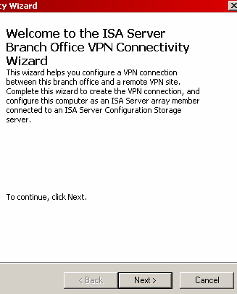

For a demonstration of the Branch Office VPN Connectivity Wizard, see "Walkthrough M" of the Microsoft ISA Server 2006 Reviewers Guide Walkthroughs.

Centralized Management (Enterprise and Array-Level Policies)

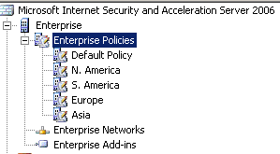
Establishing and maintaining security devices at branch offices is a challenge for administrators, particularly when IT professionals are not located at those offices and bandwidth is at a premium. With ISA Server 2006 Enterprise Edition, corporate office administrators can create flexible enterprise-level policies and configure their placement among array-level policies, which can be controlled by branch office administrators. Continuing remote management is provided through the ISA Server Management snap-in:

- Configuration Storage server (Enterprise Edition) While configuration settings for ISA Server Standard Edition are stored in an encrypted portion of the local computer registry on the local computer, in an enterprise environment there must be a centralized storage mechanism to continually and efficiently keep all ISA Server computers synchronized with the latest configuration settings. ISA Server 2006 configuration is stored in one or more Configuration Storage servers.

- Like ISA Server 2004, the Configuration Storage server in ISA Server 2006 uses an instance of Active Directory Application Mode (ADAM) to store its configuration data. ADAM is an LDAP directory service based on Active Directory. However, unlike Active Directory, it does not require DNS or domains, but it does support multi-master replication and sites. Use of the Configuration Storage server for configuration storage removes all ISA Server 2006 dependency on Active Directory.

- The Configuration Storage server provides for flexible deployment options for ISA Server 2006 Enterprise Edition. For example, it is not necessary for ISA Server 2006 to be a member of a domain. Also, the Configuration Storage server can be located on the ISA Server computer, on a separate domain member server, or on a separate workgroup server. A single Configuration Storage server can be used to store configuration information for multiple arrays, or multiple instances of a Configuration Storage server can be used to store configuration information for multiple arrays.

- Multi-master replication of the Configuration Storage server provides fault tolerance when ISA Server is a domain member. The Configuration Storage server is managed through the ISA Server Management snap-in. However, standard Active Directory and LDAP tools, such as ADSIEdit and LDP, can be used against the directory service to provide further management capability.

Fast Propagation of Enterprise-Wide Policies

When managing enterprise policy across WAN connections, administrators are looking for ways to optimize available bandwidth. In addition, it is important from a security standpoint that changes in policy be propagated throughout the enterprise as quickly as possible.

In ISA Server 2006, Microsoft has changed the way in which configuration is read from the Configuration Storage server. In general, configuration is now read in chunks instead of property by property. This reduces the number of calls that the firewall makes to the Configuration Storage server, which dramatically increases performance in connection with large round-trip time. In addition, downloading the entire configuration, which happens during setup or in a Configuration Storage server failover, will now take approximately 20–30 minutes instead of several hours. A simple configuration change will take less then a minute to propagate instead of several minutes.

BITS Caching

The Background Intelligent Transfer Service (BITS) helps you transfer large amounts of data without degrading network performance. It does this by transferring data in small chunks, utilizing unused bandwidth as it becomes available, and reassembling the data at the destination. ISA Server 2006 provides the caching mechanism for data received through BITS. Any cache rule that you create can be enabled to cache BITS data.

Updating the Microsoft Windows operating system and other Microsoft products on corporate computers from Microsoft Update can use a large portion of the available bandwidth. This problem is exacerbated in a low-bandwidth connection scenario, but can be an issue in higher bandwidth conditions as well. Updating Windows and other Microsoft software is an important security function, and should be expedited.

ISA Server 2006 provides a Microsoft Update caching feature that uses the BITS caching feature to efficiently cache the updates, so that the ISA Server cache can serve the requests. The update request can be completed over the Internet connection once, and then can be applied through the corporate network.

ISA Server caching uses HTTP range requests to make the caching process even more efficient. Microsoft Update uses a mechanism that enables computers that use a specific version of Windows to request and receive only the ranges that contain the update information they need. Because ISA Server can cache those range requests, additional efficiency can result. For example, in a branch office where all of the client computers run Windows XP, only the Windows XP ranges of an update will be requested and cached. This results in quicker updates with lower bandwidth use and a more secure operating environment.

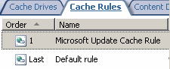
Note: For more information about how Microsoft Update enables computers to request and receive only specific ranges, see Using Binary Delta Compression (BDC) Technology to Update Windows Operating Systems at the Microsoft Download Center.

For information about BITS configuration and the built-in Microsoft Update Caching Rule, see "Walkthrough J" of the Microsoft ISA Server 2006 Reviewers Guide Walkthroughs.

HTTP Compression

HTTP compression reduces file size by using algorithms to eliminate redundant data. Most common Web-related file types can safely be compressed. HTTP compression uses the industry standard GZIP and Deflate algorithms, which are built into Windows Server 2003 and Windows 2000 Server operating systems and Internet Explorer 6, Internet Explorer 5, and Internet Explorer 4. These same algorithms are again used to decompress the static files and dynamic responses on an HTTP 1.1 supported client. A client that is configured to use HTTP 1.1 will request compressed content from a Web server. Web servers indicate in their responses whether they support compression.

Note: In Internet Explorer, configure the use of HTTP 1.1 on the Advanced tab of Internet Options, by selecting Use HTTP 1.1 through proxy connections.

HTTP compression in ISA Server is a global HTTP policy setting. It applies to all HTTP traffic that passes through ISA Server to or from a specified network or network object, rather than to traffic handled by a specific rule. However, HTTP compression can also be implemented on a per-listener basis through a check box selection in the Web Listener Wizard.

Note the following:

- Compression filter This filter is responsible for compression and decompression of HTTP requests and responses. This filter has a high priority, and is high in the ordered list of Web filters. This is because the filter is responsible for decompression. If you choose to enable inspection of compressed content, decompression must take place before any other Web filters inspect the content.

- Range compression HTTP compression also provides a range compression capability feature, which is the compression of a specific portion of Web content. Range compression is required to support legacy Portable Document Format (PDF) file readers that do not have built-in compression support.

Because Internet Information Services (IIS) does not support range compression, do not allow range compression on the network that includes a server running IIS. However, because ISA Server 2006 does support range compression, an administrator might want to enable it between two ISA Server 2006 computers. For example, if there is a Web server in the main office, range compression could be disabled on the Internal network for the main office, but enabled on both the External network for the main office and the branch offices. This would result in compression taking place between the offices.

By default, ISA Server does not compress a range request. To support compression of range requests, ISA Server uses a new property per network element that indicates if range compression is allowed. If range compression is enabled, ISA Server requests range compression. When receiving a compressed range response, ISA Server always decompresses it. When returning a range response to the client that asked for compression, ISA Server compresses the data before transferring it to the client.

Note: HTTPS is not compressed.

- Compression caching ISA Server cache and compression work together to provide more efficient serving of compression requests. Content is cached in one of three formats:

    - Compressed Content is requested in compressed format and cached in compressed format.
    - Uncompressed Content is requested in uncompressed format and cached in uncompressed format.
    - Uncompressed and incompressible If a client requests compressed content, and it arrives at the cache uncompressed, it is stored in the cache as incompressible. The next time the request for the same compressed content is received, ISA Server recognizes that the content is incompressible, and serves it from the cache uncompressed rather than from the Internet. Content that is inspected is also stored as uncompressed and incompressible.

After content is cached, it will continue to be served from the cache even if you change the compression status in the cache rule. For example, if you initially enable content inspection of compressed content, that content is stored in the cache as uncompressed and incompressible. ISA Server compresses the content before serving it to the client (if the client requested compressed content). If you disable content inspection, the content will still be served from the cache. In this case, ISA Server will continue to compress the content for clients that requested compressed content, rather than storing compressed content in the cache and serving it to clients. This can affect ISA Server performance in serving the requests. If you want compression configuration changes to be reflected in the cached content, you must first clear the cache.

Note: To clear the cache, disable the cache through ISA Server Management, and then delete the cache storage file, such as Dir1.cdat (the default name of the ISA Server cache file). There is a cache file in the Urlcache folder on each drive that is configured for caching. After deleting the cache file, caching can be enabled again.
There is also a sample script that describes how to clear the cache programmatically. For information, see the document "Deleting Cache Contents" at the Microsoft TechNet Web site.

- Content types and compression In general, some Web servers, when responding to a request, do not accurately provide the content type in the response header. For example, a response may include a Microsoft Office PowerPoint® 2003 (.ppt) file, but the response header may indicate that the content is plain text. When an Internet Explorer client receives this type of response in compressed format, it cannot interpret the response, and the user will see meaningless characters on the monitor. If the response is received uncompressed, Internet Explorer can interpret it, and the user can open and view the content. However, if the client requests compression and the Web server replies with uncompressed content, ISA Server 2006 compresses the content, and Internet Explorer cannot interpret it. In this case, the client must request uncompressed content (by changing the compression setting in the browser) to view it.

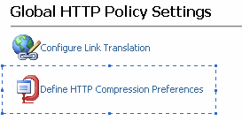
For information about the global HTTP compression configuration settings, see "Walkthrough G" of the Microsoft ISA Server 2006 Reviewers Guide Walkthroughs.

Traffic Prioritization Using DiffServ

Packet prioritization is a global HTTP policy setting that applies to all browser traffic that passes through ISA Server 2006, rather than to traffic handled by a specific rule. The packet prioritization functionality is provided by the DiffServ Web filter, which scans the URL or domain and assigns the packet priority using DiffServ bits. Administrators can create priorities in ISA Server 2006 whose DiffServ bits match those of the priorities on the corporate routers, thereby enabling the corporate routers to transmit the packets according to their priority.

This filter has a high priority, and is high in the ordered list of Web filters. This is because the filter has to be aware of the size of the request or response that is actually being sent, and therefore has to inspect the data at the point that it is sent or received by ISA Server 2006.

Note: ISA Server does not add DiffServ bits to traffic on protocols other than HTTP or secure HTTP (HTTPS). ISA Server may not transmit existing DiffServ bits for traffic on other protocols. (That information may be removed from the packets.)
Note: First packet priority is not assigned for responses served from the cache. Packet prioritization does not take into account the size of the first chunk when assigning first packet priority, so the first packet priority could be assigned to a large chunk.

For configuring DiffServ preferences, see "Walkthrough H" of the Microsoft ISA Server 2006 Reviewers Guide Walkthroughs.
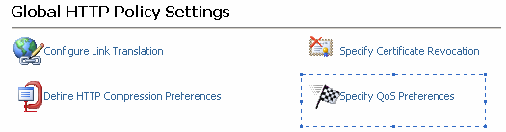

Performance and High Availability

ISA Server 2006 Enterprise Edition includes all the features and functionality included in ISA Server 2006 Standard Edition and builds on that feature set with additional capabilities targeted at the performance, high availability, and management requirements for large, geographically dispersed enterprises:

- Enterprise Web caching Many customers have branch offices that may be separated geographically within the United States or worldwide. It is costly for them to have multiple systems for access, caching, and firewalls. Multiple setups are more expensive to acquire and manage, and are more vulnerable to configuration errors, possibly leading to compromise. In addition, it is costly to be connected through the Internet, because bandwidth is expensive. A caching solution would help cut costs.

- Distributed caching ISA Server 2006 Enterprise Edition supports the Cache Array Routing Protocol (CARP). CARP enables the enterprise organization to create Web caching server farms that accelerate Web performance both for users on the corporate network and Internet users accessing Web content hosted by the enterprise. CARP presents the Web caching array as a single logical cache where content is never duplicated, enhancing both performance and reducing storage costs. CARP-enabled Web caching arrays also provide fault tolerance and load balancing for inbound and outbound Web requests, which ensure that users have access to the content they require in a high availability enterprise environment.

- Hierarchical caching Hierarchical caching, called Web chaining in ISA Server, works differently. ISA Server 2006 supports chaining multiple servers running ISA Server together to provide flexible Web proxy services. These servers can be chained in a hierarchical manner so that one ISA Server computer routes Internet requests to another ISA Server computer rather than routing the request directly to the Internet. In this scenario, caching servers are placed at different levels on the network. Upstream caching servers communicate with downstream proxies using CARP. For example:

- A client makes a request for a Web page, which is sent to the caching server at the branch office.
- The branch caching server communicates with the caching array at the main office.
- The array services the request first from the local cache, and then from a centralized cache.
- If the data is not in the array’s cache, it will then go to the Internet server for the request.
- The main office server returns the requested data to the branch office caching server and places it in its cache.
- The branch office caching server returns the requested data to the client.

An administrator might use Web chaining when the organization has multiple branch office locations, but all Internet requests are routed through one Internet connection at the main office. In this scenario, ISA Server can be installed in each office, and then configured at the branch offices to route all Internet requests to the server running ISA Server at the main office.

Flexible rules for conditionally routing Internet requests can be configured, depending on the destination server. For example, if one of the branch offices has a direct Internet connection and many of the sites requested by users in that branch office are in the same country as the branch office, ISA Server can be configured to route all requests for specific domain names directly to the Internet. The branch office ISA Server computer can still route all other requests to the main office ISA Server computer.

One of the benefits of using Web chaining is the accumulated caching on the ISA Server computer. If all the servers running ISA Server in the branch offices are configured to forward their requests to the main office ISA Server computer, that ISA Server computer will develop a large cache that contains many requested items. The combination of caching at the local branch office and at the main office increases the chances that the Internet content can be delivered to the client with the least use of network bandwidth.

Note: Another benefit of Web chaining is for configuring a test lab. Many organizations run a test lab that needs to be isolated from the production environment but may also need access to the Internet. By configuring the ISA Server computer at the edge of the test lab network, and configuring it to forward all Internet requests to the production ISA Server computer, an administrator can accomplish both goals.
Note: Hierarchical caching is more efficient in terms of bandwidth usage, but distributed caching is more efficient in terms of disk space usage.

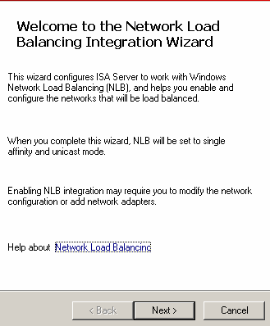
- Integrated support for Network Load Balancing Integrated support for Network Load Balancing (NLB) enables ISA Server 2006 Enterprise Edition to provide high performance and high availability to enterprises deploying arrays of fault tolerant ISA Server 2006 firewalls. When one or more servers in the ISA Server 2006 Enterprise Edition NLB array become unavailable, remaining online NLB array members take over connections for the unavailable firewalls. In addition, ISA Server 2006 Enterprise Edition integrated NLB support improves performance on all NLB array members by evenly distributing connections through the array using the smart NLB load balancing algorithm.

Summary: Key Differentiators of ISA Server 2006 for Branch Office Gateways

The following table describes the ISA Server 2006 features related to branch office gateways.

Integrated security
Improved security through tight integration with applications and with Microsoft infrastructure such as Active Directory, WINS, DHCP, NLB, and VPN Quarantine.
ISA Server 2006 features | Meet these needs
A multi-network architecture, network templates and configuration wizards, and stateful IP routing and inspection makes it easy to deploy ISA Server into existing IT environments as an edge, departmental, or branch office firewall without changing your network architecture. | Efficiently and cost effectively manage policy across geographically dispersed offices.
New  Maintain secure branch office infrastructure using BITS caching to accelerate the deployment of software updates and keep remote computers protected. | Remedy insufficient security on WAN connections and protect branches from attacks.
Enhance network performance and reduce bandwidth costs with integrated Web caching in corporate data centers (using cache server arrays in ISA Server Enterprise Edition). Optimize branch office content delivery with distributed hierarchical caching (Enterprise Edition only). | Provide fast access while combating the high cost of WAN connectivity.

Efficient management
Reduced TCO through simplified deployment and management, cost, and server consolidation.
ISA Server 2006 features | Meet these needs
New  Easily deploy and configure ISA Server computers in branch offices by using answer files on removable media for unattended installation, and with automated VPN wizards to streamline connectivity. | Easily and cost-effectively integrate new branch offices into the WAN infrastructure.
Centrally manage branch office security and connectivity and prevent network access downtime by allowing administrators to securely and remotely manage firewall and Web cache services. | Respond quickly to new threats and manage branches effectively.
New  Manage remote ISA Server computers more effectively with faster propagation of enterprise policies, reduced server requirements, and low-bandwidth optimizations. | Manage deployment of policy between offices while optimizing available bandwidth.

Fast and secure access
Secure and seamless user access to resources with added speed through caching.
ISA Server 2006 features | Meet these needs
New  Improve Web page load times and reduce WAN costs for users in branch offices with HTTP traffic compression and caching. | Improve slow, unreliable Web access for branch offices. Utilize limited bandwidth at the branch office efficiently.
New  Help ensure that the highest priority applications get precedence over other network traffic through Diffserv IP settings, providing better bandwidth utilization and response times for critical Web resources. | Ensure that applications with higher business priority always have enough bandwidth.

Web Access Protection

ISA Server 2006 helps provide Web Access Protection with its hybrid proxy-firewall architecture, granular policies, deep content inspection, comprehensive alerts and monitoring capabilities.

Key Data Points

According to studies approximately 70 percent of all Web attacks occur at the application layer. Hackers and malicious program developers have financial motive. They are more targeted, sophisticated, and harder to detect than ever before. However, 95 percent of all breaches would be avoidable with an alternative configuration.

Typical Environment and Customer

Any organization that requires network edge security will benefit from ISA Server 2006, regardless of its size. The need for deep content filtering of network traffic, especially HTTP and SMTP, is universal.

All organizations desire greater flexibility in leveraging and maximizing their existing IT investments, while also improving network security and performance. For this reason, ISA Server 2006 is designed to work in organizations as the primary edge security device, or to be part of a broader defense-in-depth strategy as a second-layer firewall, providing application layer filtering and better protection against attacks that originate from both outside and inside the corporate network.

Customer Needs, Pain Points and the ISA Server 2006 Solution

The following table describes customer needs and pain points, and how ISA Server 2006 meets these needs.

Customer needs | Pain points | ISA Server meets the needs
Configures effective network edge security.  “Configuring and managing Web access is a time-consuming and specialized task.” | - Difficult configuration may lead to mistakes that threaten security.  - Complex security products are difficult for administrators to learn quickly. | Simple, easy to learn and use management tools shorten ramp-up time for new security administrators while making it easier to avoid security breaches due to firewall misconfiguration.
Protects internal network resources by screening all incoming and outgoing Internet traffic and protecting against advanced attacks.  Provides controlled user access to resources (both internal and external).  “Internet-based attacks are becoming increasingly sophisticated and are hidden deep within applications.” | - There is a need for stronger protection than provided by traditional firewalls.  - Limited application layer filtering prevents meaningful access control. Users may inadvertently access insecure content.  - Users may access inappropriate Web sites and content.  - Peer-to-peer applications (such as instant messaging) may reveal corporate secrets.  - Illegal downloads may expose company to lawsuits.  - User access to personal e-mail may bypass corporate e-mail protection. Attacks can bypass traditional firewalls by using the same protocols as legitimate traffic. | Multi-layer deep content inspection helps protect IT assets and corporate intellectual property such as data stored in IIS, Exchange Server, Windows SharePoint Services, and other network infrastructure resources from attackers, viruses, and unauthorized use with comprehensive and flexible policies, customizable protocol filters, and network routing relationships.
Responds to continually evolving threats quickly and cost-effectively.  “I want flexibility so I can tailor protection to meet my unique needs and keep up with changing threats.” | - Threats are continually changing and evolving.  - Replacing systems when a new threat occurs is expensive and time consuming. | A flexible SDK allows for development of ISA Server add-ins for a wide range of protection such as antivirus and Web filtering, and allows for scripting of all ISA administrative tasks.
Provides resiliency against externally originated attacks.  “The more applications I publish, the more exposed I am.” | - Network is susceptible to flood attacks, resulting in denial of network services. | New  Help defend your network with enhanced flood resiliency features for event handling and monitoring that provide better resistance to denial of service attacks and distributed denial of service attacks.
Provides resiliency against internally originated attacks.  “Not only do propagating worms hurt my organization, but they hurt my customers and partners, too.” | - Recurrent worm outbreaks are common. | New  Mitigate the effects infected computers have on your network with enhanced worm resiliency through simplified client IP alert pooling and connection quotas.
Provides mitigation measures when a network is under attack and minimizes performance impact on the network.  “When I’m under attack, there’s too much information to sort through to stop it.” | - Network downtime results in loss of efficiency and revenue. | New  Log throttling and control of memory consumption and pending DNS queries provide enhanced resource control.
Provides remediation during attacks.  “I need better ways to detect attacks when they occur, and take appropriate action.” | - Quick identification is needed to help resolution.  - Logs that are difficult to view may prevent administrators from discovering problems. | New  Enhanced attack remediation through comprehensive alert triggers and responses can quickly notify administrators of network problems.
Provides cost-effective centralized management.  “I don’t have sufficient control of or reporting from remote gateways.” | - Monitoring on a large scale is difficult.  - Lack in reporting capabilities prevents management from evaluating use of Internet by employees. | New  Unify management and monitoring across your ISA Server infrastructure with the Management Pack for Microsoft Operations Manager 2005, and use enterprise-level and array-level policies to easily control security and access rules across your organization.

Ease of Use

Some firewalls require an in-depth understanding of a command-line interface. Others might use a GUI, but in many cases, the GUI is non-intuitive and difficult to use. The harder the interface is to use, the greater the costs associated with the firewall management (for example, training) and the greater the risk of configuration error.

The Microsoft goal is to help reduce security breaches resulting from misconfiguration, and to provide a cost-effective solution for businesses with few IT resources. To meet this requirement, ISA Server 2006 has a user interface based on studies of the way people do security administration and the kinds of tools with which they are familiar. Numerous usability enhancements such as easy-to-use wizards and network templates will help administrators understand firewall configuration and easily change it to meet network use policy.

The ISA Server 2006 user interface utilizes the standard Microsoft Management Console (MMC) snap-in with a comprehensive and easy-to-use interface, including real-time monitoring, collapsible task pads and toolboxes, context-sensitive Help and tasks, and more.
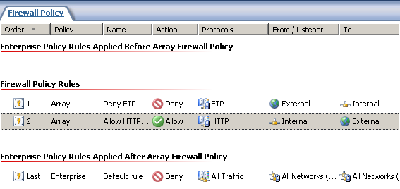
Rules are implemented with clear color-coded graphic icons (such as allow and deny, and user groups) so that the administrator can quickly surmise the ISA Server configuration state. This new rule administration mechanism makes it easy to understand how the policy executes, and under what conditions it applies.

Consider the following:

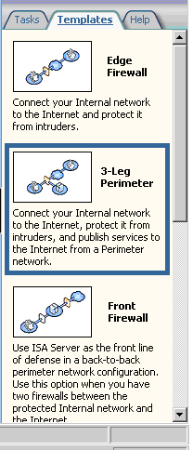
- Single ordered rule base Firewall policy rules represent an ordered list in which connection parameters are first compared to the top listed rule. ISA Server moves down the list of rules until it finds a rule matching the connection parameters and enforces the matching rule's policy. This approach to firewall policy makes it easier to determine why a specific connection is allowed or denied. The user interface now supports selection of multiple rules for deletion.

- Network templates ISA Server 2006 provides five network templates corresponding to some of the most common network topologies (Edge Firewall, 3-Leg Perimeter, Front Firewall, Back Firewall, and Single Network Adapter). Administrators can then customize topologies for more sophisticated perimeter security scenarios. The templates enable administrators to easily and automatically configure routing relationships and firewall policy for traffic between multiple perimeter, VPN, internal, and external networks.

Multilayer Firewall

Application security includes both client and server applications. Client applications typically run on end-user computers while server applications are usually hosted on dedicated servers.

Attackers may try to attack applications in several different ways. One type of attack is a denial of service attack, in which the attacker might bombard an application with so many service or data requests that legitimate use is impossible. The attacker may also attempt to crash the application to make its functionality unavailable.

An attacker may attempt to exploit a weakness in an application to run malicious code on the system. This malicious code may then be used to access data on the system or launch attacks on other systems. An attacker might also attempt to use an existing application to perform unintended and undesirable tasks such as routing e-mail.

To protect against these threats, ISA Server 2006 provides three types of firewall functionality: packet filtering (also called circuit-layer), stateful filtering, and application layer filtering.

- Packet filtering This type of filtering examines the header information for each network packet arriving at the firewall. Packet filtering provides application-transparent circuit gateways for multiplatform access to Telnet, RealAudio, Microsoft Windows Media® technologies, Internet Relay Chat (IRC), and many other Internet protocols and services. The firewall checks for information such as source and destination address or source and destination port and compares this information against a list of allowed packets. If the packet is allowed, the packet is passed through the firewall. If the packet is not explicitly allowed, the packet is dropped.

- Stateful filtering This type of filtering is based on a more thorough examination of the network packet. Stateful inspection examines information about the state of a packet within the context of several packets, and dynamically opens ports only as needed and then closes the ports when the communication ends. So if the packet arriving at the firewall is in response to a packet that was first sent from inside the firewall, the firewall will forward the packet. A packet from outside the firewall that is trying to initiate a session with a host inside the firewall will be dropped unless it is explicitly permitted.

- Application layer filtering This type of filtering examines the actual content of a packet to determine whether the packet will be forwarded through the firewall. An application filter can use almost any information within the packet to block or forward the packet.

- Network rules Network rules define how network packets will be passed between networks or between computers. They determine whether there is a relationship between two network entities and what type of relationship is defined. There are two types of relationships:

  - Route When this type of connection is specified, client requests from the source network are directly routed to the destination without address translation. This relationship is bidirectional.

  - Network Address Translation When this type of relationship is specified, ISA Server 2006 replaces the IP address of the client on the source network with its own IP address. This relationship is directional.

Application Layer Filtering (Deep Packet Inspection)

Most of today’s attacks are directed against applications. Common examples of this are attacks against mail clients, such as worms or Trojan horse attacks. There are also many attacks against Web browsers, such as malicious Java applets. All of these attacks enter the computer using the same methods as legitimate e-mail or legitimate Web browsing.

Increasingly, applications encapsulate their traffic in HTTP. Examples for this are peer-to-peer applications and instant messaging. The reason for the encapsulation is that firewalls often block the native protocols that these applications use. HTTP encapsulation is a convenient method to bypass such restrictions. Traditional firewalls cannot determine what type of traffic is sent or received by using a specific protocol. They forward all HTTP traffic without examining whether it consists of regular Web traffic or other, disallowed traffic.

Some applications use dynamic ports. This means that the application will sometimes use one port for data transmission, and another port at other times. Examples for this are File Transfer Protocol (FTP), which may use nonstandard ports, and remote procedure calls (RPCs), which always uses dynamic ports. Traditional firewalls cannot securely allow this type of traffic.

ISA Server 2006 provides superior application layer protection for corporate clients. Administrators can configure ISA Server 2006 to enforce corporate policies. The firewall can limit access to only those sites that users should be permitted to access. Administrators can also restrict the use of protocols so that users are only allowed to use those protocols that match your corporate security policy. Finally, firewall rules can be implemented according to schedules.

ISA Server 2006 features a security architecture that has been designed to protect Microsoft application infrastructure against external and internal threats. By understanding complex application protocols and inspecting traffic in a way that is more granular and intelligent than what a basic packet inspection firewall can do, ISA Server 2006 catches many threats and attacks that other firewalls miss.

Malicious code, such as worms and viruses looks legitimate to the packet-filtering firewall because the network layer headers of the packets are identical in format to those of legitimate traffic. It is the payload that is malicious. Only when all the packets are put together can the worm be identified as malicious code. ISA Server 2006 uses advanced, configurable application-specific filters that can deeply inspect the payload itself.

When a traditional firewall examines a packet, it only inspects the packet headers. In the following figure, the IP header is shown in the left box. It contains a source address and destination address, a Time to Live (TTL), and a checksum, which is used to ensure packet integrity.

Application Layer Content:
???????????????????????????????
???????????????????????????????
???????????????????????????????
IP Header:
Source Address,
Dest. Address,
TTL,
Checksum
TCP Header:
Sequence Number
Source Port,
Destination Port,
Checksum

A TCP header, shown in middle box of the figure, (or a similar User Datagram Protocol (UDP) header) contains additional information. In the case of a TCP header, this is a sequence number, a source port, a destination port, and a checksum. The application layer content, such as the content of an e-mail message or a Web request, is shown in the right box. Traditional firewalls do not inspect that part of a packet.

Instead, the firewall makes forwarding decisions based on port numbers only. For example, traffic to a Web server is sent to port 80 on that server. This traffic may include expected HTTP traffic, such as Web requests, but it may also contain unexpected HTTP traffic, such as disallowed commands or attacks. In addition, traffic that is addressed to port 80 may contain non-HTTP traffic that is sent through that port to bypass firewall restrictions.
Web Server
Expected HTTP Traffic
Unexpected HTTP Traffic
Web Server Attacks
Incoming Traffic
Non-HTTP Traffic
Internet

ISA Server 2006 handles a packet differently. It inspects both the packet headers and the application content.

Application Layer Content:
GET www.contoso.com/partners/default.htm
IP Header:
Source Address,
Dest. Address,
TTL,
Checksum
TCP Header:
Sequence Number
Source Port,
Destination Port,
Checksum

The right box in the preceding figure shows the beginning of an example home page of Contoso.com. ISA Server 2006 can make forwarding decisions based on this type of content, so that only legitimate and allowed traffic is processed. For example, to disallow traffic that uses a certain character set, ISA Server 2006 can be directed to block all Web pages that contain this character set. The result is that only allowed HTTP traffic is permitted to flow between the Internet and the corporate network, as reflected in the following figure.
Web Server
Expected HTTP Traffic
Unexpected HTTP Traffic
Web Server Attacks
Incoming Traffic
Non-HTTP Traffic
Internet

ISA Server 2006 includes a wizard, the Access Rule Wizard (firewall rules), that makes it easier to create access policy. Unlike traditional firewalls, ISA Server 2006 in addition to stateful packet inspection, controls application-specific traffic with application command and data-aware filters, which provide stronger protection. Traffic can be accepted, rejected, redirected, and modified based upon its contents through intelligent filtering of VPN, HTTP, FTP, SMTP, POP3, DNS, H.323 conferencing, streaming media, and RPC traffic. Important examples include:
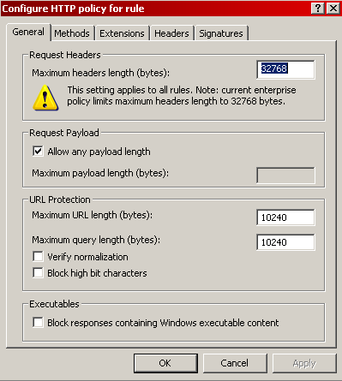
- HTTP filtering on a per-rule basis ISA Server 2006 policy allows the firewall to perform deep HTTP stateful inspection, configured on a per-rule basis for both inbound and outbound access, on a full variety of constraints.

- Block access to executable content Administrators can configure HTTP policy to block connection attempts to Windows executable content, regardless of the file extension. In addition to blocking all Windows executables, policies can include “allow all file extensions,” “allow all except a specified group of extensions,” or “block all extensions except for a specified group.”

- Filter on HTTP signatures Deep content inspection allows administrators to search traffic for HTTP signatures (in any byte range) in the Request URL, Request headers, Request body, Response headers, and Response body. This allows precise control over what content internal and external users can access, as well as blocks unwanted application traffic.

- Control allowed HTTP methods Administrators can control what HTTP methods are allowed through the firewall by setting access controls. For example, administrators can limit the HTTP POST method to prevent users from sending data to Web sites.

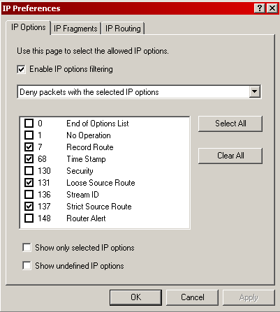
- Granular control over IP options Administrators may want to enable some IP options and not others for network management and troubleshooting. ISA Server 2006 allows administrators to configure IP options on a granular basis.

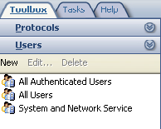
- Control based on firewall user groups ISA Server 2006 builds on its support for Active Directory users and groups to allow administrators to create custom firewall groups comprised of pre-existing groups in the local accounts database, an Active Directory domain, and LDAP directory, or through RADIUS. This increases the administrator’s flexibility to control access, and removes the requirement that the firewall administrator be a domain administrator to create custom security groups for inbound or outbound access control through the firewall.

Customizable Protocol Definitions
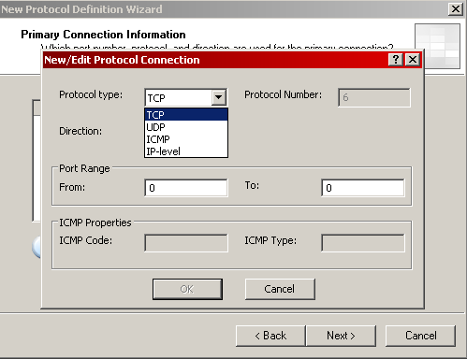
ISA Server 2006 allows administrators to control the source and destination port number for any protocol for which a firewall rule is created. This allows the ISA Server 2006 firewall administrator a high level of control over what packets are allowed inbound and outbound through and to the firewall.

Flood Resiliency

Distributed denial of service attacks are attacks on computer systems or networks that cause a loss of service to users, typically the loss of network connectivity and Web sites. The principal aim of these organized attacks is to overload or flood the various services so that access becomes impossible.

A worm is a malicious program that self propagates across a network, exploiting security or policy flaws in widely used services. A worm is different from viruses and other denial of service attacks, in that they self-propagate automatically, without need for user input, and they do not require people to open e-mail attachments or take other actions to function. In most cases, worms are propagated to clients. In other cases they can propagate through network shares, FTP, or exploits that automatically trigger the attack. Worms can also propagate to servers utilizing protocols used by the server’s services (such as HTTP, SMTP, or RPC). Examples of well-known worms are Sasser, SQL Slammer, and MS Blaster.

Worms produce flood attacks after they propagate themselves across the network and potentially later after a signal triggers a distributed denial of service attack against the victim. A good example is the Blaster attack that tried to initiate a distributed denial of service attack against the Microsoft Windows Update Web site. Worm propagation is characterized by infected clients arbitrarily scanning the network looking for other vulnerable hosts and, after they are found, trying to copy the worm binaries. To find other vulnerable hosts, a client sends many small TCP or non-TCP requests, first to IP addresses within the same subnet and later to external network IP addresses behind the firewall. For most worms, the scanning client will have a low success rate (approximately 1 percent). The greater problem is that worm attacks, along with denial of service attacks and distributed denial of service attacks, may flood the network with data that can slow legitimate services (for example, firewalls) or even shut them down. This is especially true in the case of a gateway (proxy) like ISA Server 2006.

While the ISA Server 2004 connection quota capability helped to mitigate some flooding attacks, it was not a satisfactory solution and suffered from a variety of limitations. There was no easy way to determine at any specific time if ISA Server was under attack, what type of attack ISA Server was dealing with, what port or network protocol an attack was based on, and other parameters that would simplify an investigation while an attack was still active. The architecture of ISA Server 2006 has been modified to provide resiliency against common attacks and to provide for remediation and control of resources through a new Flood Resiliency feature that provides better denial of service and distributed denial of service protection.

The main goal of ISA Server 2006 Flood Resiliency is to protect ISA Server from being permanently unavailable, compromised, or unmanageable during a flood attack.

Flood Resiliency protects against the following:

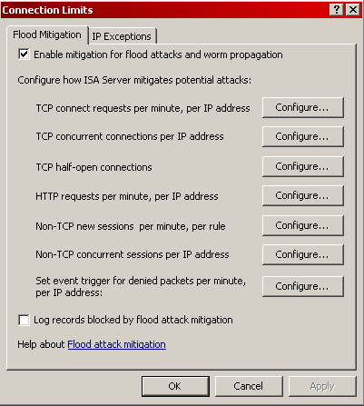
- Worm propagation attacks
- Syn attacks
- Denial of service attacks
- Distributed denial of service attacks
- HTTP bombing (denial of service) attacks

ISA Server 2006 can detect the offending IP address, validate that it is a non-spoofed address, and then mitigate the effect of the attack through a variety of techniques:

- Limit TCP connection requests per minute per IP address
- Limit TCP concurrent connections per IP address
- Limit TCP half-open connections per IP address
- Limit HTTP requests per minute, per IP address
- Limit non-TCP concurrent sessions per IP address
- Limit non-TCP new sessions per minute, per rule
- Limit TCP and non-TCP denied messages

The Flood Resiliency feature also provides resource control to avoid denial of service attacks to the ISA Server 2006 system through:

- Log throttling This mechanism measures the volume of denied records being written to the log. If the volume exceeds a specified threshold, ISA Server 2006 will stop logging denied records.

- Control of memory consumption ISA Server 2006 monitors the amount of consumed non-paged pool (NPP) memory and, if it is close to being full, will reject new connections but will continue to service existing connections. When enough NPP memory is again available, ISA Server 2006 will once again service new requests. This is a fully automated mechanism and only a sophisticated massive attack would cause ISA Server 2006 to activate it.

- Control of pending DNS queries This mechanism makes sure that clients cannot cause a denial of service attack by causing ISA Server 2006 to manage too many pending DNS queries. There are two scenarios where ISA Server 2006 sends a DNS request:

    - A firewall client asks ISA Server 2006 to resolve a DNS name on its behalf.
    - ISA Server sends a reverse DNS query to find the host name, and then uses a policy to allow or block the request based on a list of allowed or denied hosts.

Flood Resiliency provides remediation through the quick identification of potential attacks and infected clients. When an attack is detected, an alert is triggered notifying administrators of the IP address involved and providing remediation instructions. This leads to many attacks being identified and blocked before they can cause damage. This feature allows for exceptions to be made, based on IP address.

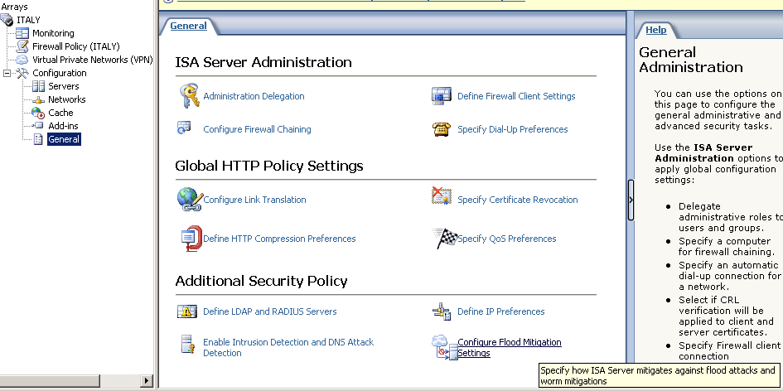
Note: Flood and worm mitigation features are configured from the General Configuration node of an array. For a detailed look at flood resiliency configuration, see "Walkthrough I" of the Microsoft ISA Server 2006 Reviewers Guide Walkthroughs.

Product Extensibility

Consider the following product extensibility features of ISA Server 2006:

- Extensive SDK ISA Server 2006 includes a comprehensive SDK for developing tools that build on ISA Server 2006 firewall, caching, and management features. Full API documentation and step-by-step samples are provided to build additional Web filters, application filters, MMC snap-ins, reporting tools, scriptable commands, alert management, and more.

- Broad vendor support Independent vendors offer products, such as virus detection, management tools, and content filtering and reporting, that build on and integrate with ISA Server 2006. With ISA Server 2006, organizations can use third-party filters to prevent the latest viruses, Java scripts, or Microsoft ActiveX® controls from being downloaded into their secured networks.
There is a list of partner solutions for ISA Server 2006 that is expected to grow significantly within the first few months of ISA Server 2006 availability. The following table provides a current listing of partners.

Category | Partner
Antivirus | McAfee, GFI, Panda
URL filtering | Websense, SurfControl, FilterLogix, Cerberian, Wavecrest
Application filtering | Cornerpost, Forum Systems
User authentication | RSA, Authenex, Everywhere Networks
Load balancing | Rainfinity, Radware
Cache acceleration | Venation
Reporting | WebSpy
Intrusion detection | ISS
SSL acceleration | AEP

For the latest information, see the Partners Web site.

- Microsoft Operations Manager (MOM) 2005 MOM utilizes management packs to provide intelligent operations management for a wide variety of server applications, including ISA Server 2006. Management packs monitor a wide array of server health indicators, which enable them to call attention—often preemptively—to many critical events that require administrator intervention. This powerful monitoring is augmented by in-depth knowledge base content associated directly with the relevant alerts included in the Management Pack module, providing prescriptive guidance for the administrator to quickly resolve outstanding alerts. Administrators can then act to prevent or correct situations such as degraded performance or service interruption, maintaining service availability with greater ease and reliability.

- Centralized management and reporting ISA Server 2006 Enterprise Edition allows you to manage arrays of ISA Server 2006 firewall servers located anywhere in the world from a single location using the ISA Server Management snap-in. Enterprise firewall policy is created once and automatically distributed to hundreds of array firewall servers throughout the enterprise. In addition, ISA Server 2006 Enterprise Edition consolidates log file information gathered from each array member in the organization and uses that information to generate network usage reports from a single location.

ISA Server 2006 is the Microsoft response to the need for companies to establish safe connectivity with branch offices, and to make communication more efficient, even where bandwidth is limited and latency is high.

Summary: Key Differentiators of ISA Server 2006 Web Access Protection

The following tables describe the ISA Server 2006 features related to Web Access Protection.

Integrated security
Improved security through tight integration with applications and with Microsoft infrastructure such as Active Directory, WINS, DHCP, NLB, and VPN Quarantine.
ISA Server 2006 features | Meet these needs
Multi-layer deep content inspection helps protect IT assets and corporate intellectual property such as data stored in IIS, Exchange Server, Windows SharePoint Services, and other network infrastructure resources from attackers, viruses, and unauthorized use with comprehensive and flexible policies, customizable protocol filters, and network routing relationships. | Protect internal network resources by screening all incoming and outgoing Internet traffic and protecting against advanced attacks. Provide controlled user access to resources (both internal and external).
New  Enhanced Flood Resiliency features for event handling and monitoring help defend your network and provide better resistance to denial of service attacks and distributed denial of service attacks. | Provide resiliency against externally originated attacks.
New  The effects infected computers have on your network is mitigated with enhanced worm resiliency through simplified client IP alert pooling and connection quotas. | Provide resiliency against internally originated attacks.
New  Enhanced attack remediation through comprehensive alert triggers and responses can quickly notify administrators of network problems. | Provide remediation during attacks.

Efficient management
Reduced TCO through simplified deployment and management, cost, and server consolidation.
ISA Server 2006 features | Meet these needs
A flexible SDK allows for development of ISA Server add-ins for wide range of protection such as antivirus and Web filtering, and allows for scripting of all ISA Server administration tasks. | Respond to continually evolving threats quickly and cost-effectively.
New  Log throttling and control of memory consumption and pending DNS queries provide enhanced resource control. | Provide mitigation measures when a network is under attack and minimize performance impact on the network.
New  Management and monitoring can be unified across your ISA Server infrastructure with the Management Pack for Microsoft Operations Manager 2005, and enterprise-level and array-level policies can be used to easily control security and access rules across your organization. | Provide cost-effective centralized management.

Fast and secure access
Secure and seamless user access to resources with added speed through caching.
ISA Server 2006 features | Meet these needs
Simple, easy to learn and use management tools shorten ramp-up time for new security administrators while making it easier to avoid security breaches due to firewall misconfiguration. | Configure effective network edge security.

Appendix A: General Concepts and Features

This section includes general concepts and discussions not directly related to the three primary scenarios presented earlier in this document.

Proxy (Internet Access Control)

Because businesses are routinely providing Internet access to their employees, there are increasing concerns about possible negative implications and the potential exposure to malicious traffic. However, one of the most common business needs is to enable users to access information on the Internet. ISA Server 2006 provides added protection through monitoring and control of traffic. Through its proxy capabilities, ISA Server 2006 allows companies to control Internet access and help protect clients from malicious traffic. To take advantage of ISA Server 2006 integrated proxy capabilities, client computers should be configured as Web Proxy clients.

ISA Server 2006 Clients

An ISA Server client is a client computer that connects to resources on another network by going through ISA Server. ISA Server 2006 supports three different types of clients:

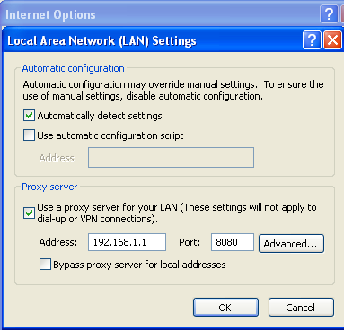
- Web Proxy clients Any computers that run CERN-compatible Web applications such as Web browsers. Requests from Web Proxy clients are directed to the Microsoft Firewall service on the ISA Server computer to determine if access is allowed. Web Proxy clients do not require any special software to be installed. However, the Web application must be configured to use ISA Server as a proxy.

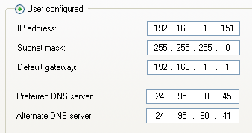
- SecureNAT Clients Computers that are configured to route all requests for resources on other networks to an internal IP address on the computer running ISA Server (TCP/IP gateway and router address). Again, no separate software is required.

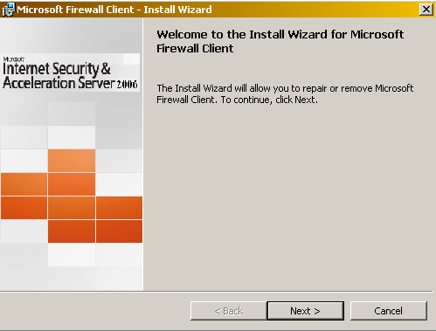
- Firewall clients Windows-based computers that have Firewall Client software installed and enabled. When a computer with the Firewall Client installed makes a request for resources on the Internet, the request is directed to the Firewall service on the ISA Server 2006 computer. The Firewall service will authenticate and authorize the user and filter the request base on firewall rules and application filters or other add-ins.

Easy-to-Use Wizards

Graphical user interfaces and configuration wizards simplify navigation and configuration of common firewall tasks. For example, wizards can configure the firewall to be a VPN server or gateway, or create a new firewall rule. A number of new wizards focus on making it easier to publish Windows SharePoint Services sites or an Exchange Server to the Web, including enhanced wizards for automating the procedure for publishing an Exchange server, whether it uses RPC over HTTP or Outlook Web Access.

ISA Server 2006 provides a delegated permissions wizard for firewall administrator roles. The Administration Delegation Wizard helps assign administrative roles to users and groups. These predefined roles delegate the level of administrative control users are allowed over specified ISA Server 2006 services.

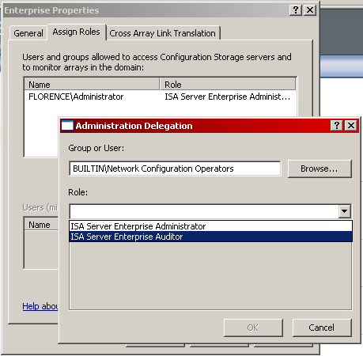

Configuration Export and Import to XML

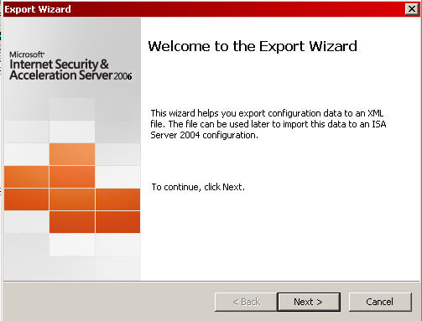
ISA Server 2006 includes the ability to export and import configuration information. Administrators can copy the entire firewall configuration to an XML file. This configuration can be copied to removable media or sent through secure e-mail to other firewall administrators to create a standardized firewall configuration through an organization. Selected elements of the firewall configuration can be copied to an XML file and imported as well. This allows administrators to prepare for disaster recovery and to easily clone ISA Server computers.

Intrusion Detection
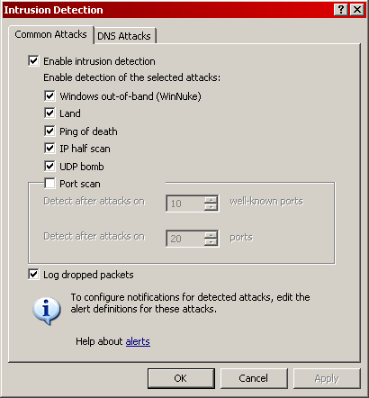
Computer networks are susceptible to a variety of intrusions. ISA Server 2006 can detect a number of specific types of attacks, including:
- Windows out-of-band (WinNuke)
- Land
- Ping of death
- IP half scan
- UDP bomb
- Port scans
In addition, it can filter incoming traffic to check for DNS host name overflow, DNS length overflow, and DNS zone transfer traffic.

Architectural Enhancements

Beginning with ISA Server 2004, important improvements were made to the firewall architecture so that performing application filtering and inspection does not slow down the firewall. That trend continues in ISA Server 2006:

- Web Proxy application filter The Web proxy is implemented as an application filter that sits on top of the firewall engine, rather than as a Windows service application. This change eliminates inter-process communication overhead that can create a performance issue. It also provides additional security to the system, because all traffic, including Web proxy traffic, goes through the firewall inspection engine as opposed to going straight through the Web proxy. These enhancements have increased performance so that transparent Web proxy traffic runs 3.5 times faster under ISA Server 2006 and ISA Server 2004 than it did in ISA Server 2000.

- Kernel mode data pump Some application traffic that has been authorized to pass through the firewall, such as an FTP file transfer, streaming media content, or other traffic that does not need additional application layer inspection can be automatically fed through the kernel mode data pump. This feature enables such traffic to bypass the individual application filters and be passed directly across the IP stack, resulting in a significant performance boost.

Performance has been increased by extending the kernel mode data pump to support more scenarios. This provides administrators with granular per-rule control of the tradeoff between performance and security. In addition, stateful packet inspection (as opposed to application layer inspection) is done using the kernel mode data pump, and ISA Server 2006 supports kernel mode policy checks that boost connection-establishment performance in stateful packet inspection. These enhancements increase performance of SecureNAT stateful inspection in ISA Server 2006 and ISA Server 2004 up to 2.5 times faster than ISA Server 2000.

Note: For more information about ISA Server 2006 architecture, see Appendix D: ISA Server 2006 Architecture in this document.

Forward Caching

Caching is widely used as a method of improving network performance by serving content locally instead of retrieving it from the Internet with every request. The architecture of ISA Server has been enhanced to improve the cache performance, which improves a user’s perceived experience on the Internet.

ISA Server can be deployed as a forward caching server that provides internal clients with faster access to requested content.

ISA Server maintains a centralized cache of frequently requested objects that can be accessed by any Web browser client. In addition, ISA Server 2006 Web cache can preload offline content that is stored on CD or DVD media. Objects served from the cache require significantly less processing than objects served from another network. This improves client browser performance, decreases user response time, and reduces bandwidth consumption on an Internet connection.

By default, when ISA Server 2006 is installed, caching is effectively disabled. This is because no space on any disk drive on the ISA Server computer has been specified to be used for caching. When an administrator specifies how much space to use on a drive, caching is effectively enabled. An administrator can configure cache rules that will determine whether content from specified sites should be stored or retrieved from the ISA Server 2006 cache. A cache rule applies to requested sites, regardless of the source network.

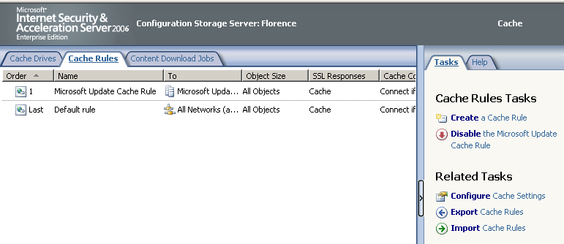

Organizations can preload the cache with entire Web sites on a defined schedule. Scheduled downloads ensure the freshest cache content for every user and make content on offline Web servers available to users.

Reverse Caching

With ISA Server 2006, you can use Web publishing rules to make Web content hosted on networks behind the firewall available to Internet users. Reverse caching takes place when Internet users request such Web content. When the Internet user sends a request for content located on a corporate Web server, ISA Server 2006 intercepts the request and checks whether the requested content is contained in its in-memory or disk-based cache. If the content is not in the cache or has expired (if its header information indicates that it should no longer be served from the cache), ISA Server 2006 forwards the request to the published Web server on the corporate network, which returns the requested information to ISA Server 2006. ISA Server 2006 places the Web content in its in-memory Web cache, where it stores the most popular and frequently requested content for rapid retrieval, after which it returns the content to the Internet user who requested it. ISA Server 2006 will service subsequent Internet user requests for corporate Web resources from either its in-memory or disk-based Web cache.

Note: After a period of time (determined by the caching algorithm), if the content is no longer being requested regularly, ISA Server 2006 copies the content to its disk-based cache and flushes it from RAM. At this point, the only copy of the content resides in the disk-based cache. If another user requests content stored in the disk-based cache, ISA Server 2006 will return it to the in-memory cache.

In addition to speeding up Internet users’ access to Web resources hosted on corporate Web servers, reverse caching also reduces the amount of bandwidth used to meet Internet users’ requests for content from these servers.

Appendix B: ISA Server 2006 Feature List

This section provides a list of ISA Server 2006 features with brief descriptions and whether each feature is new, improved, or similar to a feature existing in ISA Server 2004.

Integrated Security

The following table describes the ISA Server 2006 features related to integrated security.

Secure remote access to internal Microsoft servers
ISA Server 2006 | Feature | Description
Same | Firewall generated forms for forms-based authentication. | ISA Server 2006 can generate the forms used by Outlook Web Access sites for forms-based authentication. This enhances security for remote access to Outlook Web Access sites by preventing unauthenticated users from contacting the Outlook Web Access server.
Same | Remote access to Terminal Services using SSL. | Computers running the Windows Server 2003 operating system support RDP over SSL to allow an SSL connection to Windows Server 2003 Terminal Services. With ISA Server 2006, you can more securely publish Windows Server 2003 Terminal Server using SSL technology.
Same | Enforce Microsoft Exchange RPC connections from full Microsoft Outlook messaging and collaboration MAPI clients. | ISA Server 2006 secure Exchange Server publishing rules give remote users connection to Exchange Server using the fully functional Outlook MAPI client over the Internet. However, the Outlook client must be configured to use secure RPC so that the connection is encrypted. With the ISA Server 2006 RPC policy, you can block all non-encrypted Outlook MAPI client connections.
Improved | Outlook Web Access Publishing Wizard. | Clientless remote access through SSL connections form the core of SSL VPNs. The ISA Server 2006 Outlook Web Access Publishing Wizard walks you through creating a firewall rule and creates the Outlook Web Access SSL connection to your Exchange server. All network elements can be created in the wizard, and you never need to leave the wizard to create a policy element.
New | SharePoint Server Publishing Wizard. | A new wizard publishes multiple Windows SharePoint Services sites simultaneously and provides for automatic link translation.
New | Integrated support for Exchange "12." | Support for the Exchange "12" feature set is built-in to ISA Server 2006.

Virtual Private Networking

The following table describes the ISA Server 2006 features related to virtual private networking.

Virtual private networking
ISA Server 2006 | Feature | Description
New | Branch Office VPN Connectivity Wizard | This wizard automatically configures a site-to-site VPN connection between two separate offices.
Same | Full integration of VPN with the Microsoft Firewall service | ISA Server 2006 includes a more fully integrated virtual private networking mechanism, which is based on the Windows Server 2003 and Windows 2000 Server functionality.
Same | Stateful filtering and inspection for VPN | VPN clients are configured as a separate network zone. Therefore, you can create distinct policies for VPN clients. The firewall rule engine discriminately checks requests from VPN clients The engine statefully filters and inspects these requests and dynamically opens connections based on the access policy.
Same | SecureNAT client support for VPN clients connected to ISA Server 2006 VPN server | ISA Server 2006 expands VPN client support by allowing SecureNAT clients to access the Internet without the Firewall Client installed on the client system. You can also enhance corporate network security by forcing user-based or group-based firewall policy on VPN SecureNAT clients.
Same | Stateful filtering and inspection for communications moving through a site-to-site VPN tunnel | ISA Server 2006 introduces stateful filtering and inspection for all communications moving through a site-to-site VPN connection. As a result, you can control the resources that specific hosts or networks can access on the opposite side of the link. User-based or group-based access policies can be used to gain granular control over resource use with the link.
Same | VPN Quarantine | ISA Server 2006 uses Windows Server 2003 VPN quarantine tools for deep VPN client inspection and integration of your firewall policy.
Same | Publishing VPN servers | ISA Server 2006 server publishing rules can be used to publish IP protocols and PPTP servers. The ISA Server 2006 smart PPTP application filter performs complex connection management. In addition, you can publish the Windows Server 2003 NAT-T L2TP over IPsec VPN server using ISA Server 2006 server publishing.
Same | IPsec tunnel mode support for site-to-site VPN links | ISA Server 2006 improves site-to-site link support using IPsec tunnel mode as the VPN protocol. IPsec tunnel mode support greatly increases ISA Server 2006 interoperability with a wide array of third-party VPN solutions.

Efficient Management

The following table describes the ISA Server 2006 features related to efficient management.

Management
ISA Server 2006 | Feature | Description
Same | Ease of use management features | ISA Server 2006 includes management features that make it easier to improve security of networks by avoiding misconfigurations. User interface features include task panes, context-sensitive Help panes, and a Getting Started Wizard.
Improved | Easy-to-use wizards | New configuration wizards exist for publishing Windows SharePoint Services, Exchange, and general Web sites. A new Branch Office VPN Connectivity Wizard exists for configuring site-to-site VPN connections.
Same | Export and import of configuration data | ISA Server 2006 provides the ability to export and import configuration information. You can use this feature to save configuration parameters to an .xml file, and then import the information from the file to another server.
Same | Delegated permissions wizard for firewall administrator roles | The Administration Delegation Wizard helps you assign administrative roles to users and groups. These predefined roles delegate the level of administrative control users have over specified ISA Server 2006 services.
Same | Centralized logging and reporting | ISA Server 2006 Enterprise Edition logs and reports traffic moving through all members of an enterprise array. There is never a need to collect log file information from each firewall and organize it to create unified report information.
Same | Centralized storage of firewall policy (Configuration Storage server) | ISA Server 2006 Enterprise Edition uses Active Directory Application Mode (ADAM) for firewall policy storage. ADAM storage enables you to place policy storage containers anywhere in the organization, allowing enhanced flexibility and availability for firewall policy redundancy and facilitated access.
Same | Enterprise policy | Consistent control over security standards throughout your geographically diverse organization is available by setting security policies at the enterprise level, with application of array-level policy and local policy, as appropriate.
Same | Automatic array configuration | New servers can be dynamically added to your enterprise and arrays with a simple wizard. ISA Server automatically reads the ADAM database for configuration and policy details.
Same | ISA Server 2006 Microsoft Operations Manager (MOM) Management Pack | A newly designed MOM Management Pack for ISA Server 2006 enables enterprise-level event monitoring and consolidation of common firewall activities.
Improved | Certificate Management | It is now possible to utilize multiple certificates per Web listener and to use different certificates per array member. ISA Server 2006 is improved to simplify certificate management and reduce the total cost of ownership associated with using certificates when publishing Web sites.
Same | Extensive SDK | ISA Server 2006 includes a comprehensive SDK for developing tools that build on ISA Server 2006 firewall, caching, and management features.
Same | Broad vendor support | Independent vendors offer products, such as virus detection, management tools, and content filtering and reporting, that build on and integrate with ISA Server 2006.
Improved | Hardware-based ISA Server appliances | ISA Server 2006 Standard Edition and Enterprise Edition are now available in preconfigured hardware.
Improved | Propagation of enterprise-wide policy | Underlying architecture is improved to provide for more efficiency.

Monitoring and Reporting

The following table describes the ISA Server 2006 features related to monitoring and reporting.

Monitoring and reporting
ISA Server 2006 | Feature | Description
Same | Real-time monitoring of log entries | With ISA Server 2006, you can view firewall, Web Proxy, and SMTP Message Screener logs in real time. The ISA Server Management snap-in displays the log entries as they are recorded in the firewall’s log file.
Same | Built-in log query facility | You can query the log files using the built-in log query facility. Logs can be queried for information contained in any field recorded in the logs. You can limit the scope of the query to a specific time frame. The results appear in the ISA Server Management snap-in and can be copied to the Clipboard and pasted into another application for more detailed analysis.
Same | Real-time monitoring and filtering of firewall sessions | With ISA Server 2006, you can view all active connections to the firewall. From a session view, you can sort or disconnect individual or groups of sessions. In addition, you can filter the entries in the session’s interface to focus on the sessions of interest using the built-in session filtering facility.
Same | Connection verifiers | You can verify connectivity by regularly monitoring connections to a specific computer or URL from the ISA Server 2006 computer using connection verifiers. You can configure which method to use to determine connectivity: Ping, TCP connect to a specific port, or HTTP GET. You can select which connection to monitor by specifying an IP address, computer name, or URL.
Same | Customizing ISA Server 2006 reports | ISA Server 2006 includes an enhanced report customization feature for adding more information in the firewall reports.
Same | Report publishing | You can configure ISA Server 2006 report jobs to automatically save a copy of a report to a local folder or network file share. The folder or file share the reports are saved in can be mapped to a Web site virtual directory so that other users can view the report. You can also manually publish reports that have not been configured to automatically publish after report creation.
Same | E-mail notification after report creation | You can configure a report job to send you an e-mail message after a report job is completed.
Same | Customized time for log summary creation | ISA Server 2006 is designed to create log summaries at 00:30 (12:30 A.M.). Reports are based on information contained in log summaries. You can easily customize the time when log summaries are created with ISA Server 2006. This gives you increased flexibility in determining the time of day reports are created.
Same | Log to an MSDE database | In addition to .txt files and Microsoft SQL Server™ databases, logs can now be stored in an .mdb file. Logging to a local database enhances query speed and flexibility.
Same | Enhanced SQL Server logging | You can log to a computer running a SQL Server database located on another computer on the Internal network. ISA Server 2006 SQL Server logging has been optimized to provide much higher performance.

Multi-Networking

The following table describes the ISA Server 2006 features related to multi-networking.

Multi-Networking
ISA Server 2006 | Feature | Description
Same | Multiple network configuration | You can configure one or more networks, each with distinct relationships to other networks. Access policies are defined relative to the networks and not necessarily relative to a specific internal network. ISA Server 2006 extends the firewall and security features to apply to traffic between any networks or network objects.
Same | Unique per-network policies | The new multi-networking features of ISA Server 2006 enable you to better protect your network against internal and external security threats by limiting communication between clients even within your own organization. Multi-networking functionality supports sophisticated perimeter networks, also known as demilitarized zone (DMZ) or screened subnet scenarios, helping you to configure how clients in different networks access the perimeter network. Access policies between networks can then be based on the unique security zone represented by each network.
Same | Route and NAT network relationships | You can use ISA Server 2006 to define routing relationships between networks, depending on the type of access and communication required between the networks. In some cases, you may want more secure, less transparent communication between the networks. For these scenarios, you can define a NAT relationship. In other situations, you want to simply route traffic through ISA Server. In these cases, you can define a route relationship. Packets moving between routed networks are fully exposed to ISA Server 2006 stateful filtering and inspection mechanisms.
Same | Network Load Balancing | NLB provides real-time failover and load balancing of connections made through an ISA Server 2006 Enterprise Edition array. Real-time failover enables high availability for enterprise arrays, while load balancing evenly distributes connections across firewall array servers to prevent network slow downs related to impacted firewalls.

Fast and Secure Access

The following table describes the ISA Server 2006 features related to advanced firewall protection.

Advanced firewall protection
ISA Server 2006 | Feature | Description
Same | Multi-layer firewall | ISA Server 2006 provides three types of firewall functionality: packet filtering (also called circuit-layer), stateful filtering, and application layer filtering.
Same | Application layer filtering | ISA Server provides deep content filtering through built-in application filters.
Same | HTTP filtering on a per-rule basis | ISA Server 2006 HTTP policy allows the firewall to perform deep HTTP stateful inspection (application layer filtering). The extent of the inspection is configured on a per-rule basis. With this capability, you can configure custom constraints for HTTP inbound and outbound access.
Same | Block access to all executable content | You can configure ISA Server 2006 HTTP policy to block all connection attempts to the Microsoft Windows operating system executable content, regardless of the file extension used on the resource.
Same | Control HTTP file downloads through file extension | The ISA Server 2006 HTTP policy enables you to define policy based on file extension, including ”allow all except a specified group of extensions” or “block all extensions except for a specified group.”
Same | HTTP filtering is applied to all ISA Server 2006 client connections | With the ISA Server 2006 HTTP policy, you can control HTTP access for all ISA Server 2006 client connections.
Same | Control HTTP access based on “HTTP Signatures” | ISA Server 2006 deep HTTP inspection can help you create “HTTP Signatures” that can be compared to the Request URL, Request headers, Request body, and Response body. This gives you precise control over what content internal and external users can access through the ISA Server 2006 firewall.
Same | Control allowed HTTP methods | You can control what HTTP methods are allowed through the firewall by setting access controls on user access to various methods. For example, you can limit the HTTP POST method to prevent users from sending data to Web sites using the HTTP POST method.
Same | Extensive protocol support | ISA Server 2006 gives you control over accessing and using any protocol, including IP-level protocols. Users can then use applications such as Ping and Tracert and can create VPN connections using PPTP. In addition, IPsec traffic can be enabled through ISA Server.
Same | Support for complex protocols requiring multiple primary connections | Many streaming media and voice or video applications require that the firewall manage complex protocols. ISA Server 2006 can manage these protocols and has an easy-to-use New Protocol Wizard you can use to create protocol definitions.
Same | Customizable protocol definitions | With ISA Server 2006, you can control the source and destination port number for any protocol for which you create a firewall rule. This gives the ISA Server 2006 firewall administrator a high level of control over what packets are allowed inbound and outbound through the firewall.
Same | FTP policy | The ISA Server 2006 FTP policy can be configured to let users upload and download through FTP, or you can limit user FTP access to download only.
Same | Granular control over IP options | With ISA Server 2006, you can configure IP options on a granular basis and only allow the IP options you require while blocking all others.
Same | Firewall user groups | You can use ISA Server 2006 to create custom firewall groups that are comprised of pre-existing groups in the local accounts database or the Active Directory directory service domain. This increases your flexibility to control access based on user or group membership, because the firewall administrator can create custom security groups from these existing groups. This removes the requirement that the firewall administrator be a domain administrator to create custom security groups for inbound and outbound access control.
Same | Microsoft Hotmail® Web-based e-mail access through the firewall | ISA Server 2006 improved HTTP filter enables users to access Hotmail through an easy-to-configure firewall rule without the need for special configuration on the client or firewall.
Same | Network objects | With ISA Server 2006, you can greatly expand your ability to define network objects by creating computers, networks, network sets, address ranges, subnets, computer sets, and domain name sets. These network objects are used to define source and destination settings for firewall rules.
Improved | Firewall Rule wizards | ISA Server 2006 includes a new set of rule wizards that make it easier to create access policy. ISA Server 2006 access policy can be created by a sophisticated firewall rule that you can use to configure any required policy element. You do not need to leave the rule wizard to create a network object. Any network object or relationship can be created within the new wizard.
Same | Firewall rules represent an ordered list | ISA Server 2006 firewall rules are represented in an ordered list in which connection parameters are first compared to the top listed rule. ISA Server 2006 moves down the list of rules until it finds a rule matching the connection parameters and enforces the matching rule’s policy. This approach to firewall policy makes it easier to determine why a specific connection is allowed or denied.
Same | User-based or group-based access policy | With the ISA Server 2006 enhanced firewall rules, you can define the source and destination for each protocol a user or group is able to access. This greatly increases flexibility for inbound and outbound access control.
Same | FTP support | ISA Server 2006 gives you access to Internet FTP servers, listening on alternate port numbers without requiring special configuration on the client or ISA Server 2006 firewall. The FTP server publishing on alternate port numbers requires nothing more than a simple FTP server publishing rule.
Same | Port redirection for FTP server publishing rules | Using ISA Server 2006, you can receive a connection on one port number and redirect the request to a different port number on the published server.
New | Flood Resiliency | A new Flood Resiliency feature protects ISA Server 2006 from being permanently unavailable, compromised, or unmanageable during a flooding attack.
New | Enhanced remediation during attack | Flood Resiliency provides enhanced remediation during attacks through log throttling, control of memory consumption, and control of pending DNS queries.

Authentication

The following table describes the ISA Server 2006 features related to authentication.

Authentication
ISA Server 2006 | Feature | Description
Improved | Authentication | Users can be authenticated using built-in Windows, LDAP, RADIUS, or RSA SecurID authentication. Front-end and back-end configuration has been separated, providing for more flexibility and granularity. Single sign on is supported for authentication to Web sites. Rules can be applied to users or user groups in any namespace. Third-party vendors can use the SDK to extend these built-in authentication mechanisms.
Same | Firewall client credentials forwarded to the Web proxy service | ISA Server 2006 allows Firewall clients to access the Web cache with the HTTP filter without requiring separate authentication with the Web proxy service.
Same | RADIUS support for Web Proxy client authentication | With ISA Server 2006, you can authenticate users in Active Directory and other authentication databases by using RADIUS to query Active Directory. Web publishing rules can also use RADIUS to authenticate remote access connections.
Same | Delegation of Basic authentication | Published Web sites are protected from unauthenticated access by requiring the ISA Server 2006 firewall to authenticate the user before the connection is forwarded to the published Web site. This prevents exploits from unauthenticated users from reaching the published Web server.
Same | SecurID authentication for Web Proxy clients | ISA Server 2006 can authenticate remote connections using SecurID two-factor authentication. This provides a high level of authentication security because a user must know something and have something to gain access to the published Web server.
New | Single sign on | Single sign on allows users to access a group of published Web sites without being required to authenticate with each Web site.
Improved | Forms-based authentication | Forms-based authentication is now available for all published Web sites, and not just for Outlook Web Access.
Improved | Session management | ISA Server 2006 includes improved control of cookie-based sessions to provide for better security.
New | Support for LDAP authentication | LDAP authentication allows ISA Server to authenticate to Active Directory without being a member of the domain.

Server Publishing

The following table describes the ISA Server 2006 features related to server publishing.

Server publishing
ISA Server 2006 | Feature | Description
Same | Secure Web publishing | With ISA Server, you can place servers behind the firewall, either on the corporate network or on a perimeter network, and publish their services. With the improved secure Web Publishing Wizard, you can create a rule that lets users have SSL remote access to published Web servers.
Same | Path mapping for Web publishing rules | ISA Server 2006 significantly improves the flexibility of Web publishing because you can redirect the path sent to the firewall by the user to any path of choice on the published Web server.
Same | Preservation of source IP address in Web publishing rules | ISA Server 2006 gives you a choice on a per-rule basis whether the firewall should replace the original IP address with its own or forward the original IP address of the remote client to the Web server.
Improved | Link translation | Some published Web sites may include references to internal names of computers. Because only the ISA Server 2006 firewall and external namespace, and not the internal network namespace, are available to external clients, these references appear as broken links. ISA Server 2006 includes a link translation feature that you can use to create a dictionary of definitions for internal computer names that map to publicly known names.  ISA Server 2006 implements link translation automatically during Web publishing.
New | Cross-Array Link Translation | This feature allows links in Web content containing an internal server name to be translated to the public name even if the Web content is published in a different array.
Same | SSL bridging support | To guard against embedded attacks in HTTP traffic, SSL bridging allows SSL protected packets to be decrypted by ISA Server 2006, inspected, and re-encrypted.

Performance

The following table describes the ISA Server 2006 features related to performance.

Performance
ISA Server 2006 | Feature | Description
Same | Cache rules | With the centralized cache rule mechanism of ISA Server, you can configure how objects stored in the cache are retrieved and served from the cache.
New | BITS caching | ISA Server 2006 provides the caching mechanism for data received through BITS. Any cache rule that you create can be enabled to cache BITS data.
Same | CARP-enabled Web caching arrays | ISA Server 2006 Enterprise Edition Cache Array Routing Protocol (CARP)-enabled Web caching arrays significantly extend the bandwidth saving and performance-enhancing Web cache included in all versions of ISA Server 2006. Web caching arrays provide load balancing and failover for Web access from any Web browser.
New | Web Publishing Load Balancing | ISA Server 2006 will automatically balance the request stream coming from a remote user to an array of published servers.
New | HTTP compression | HTTP compression reduces file size by using algorithms to eliminate redundant data during transmission of HTTP packets.
New | Diffserv (Quality of Service) | ISA Server 2006 includes a new packet prioritization functionality (provided by the Diffserv Web filter), which scans the URL or domain and assigns a packet priority using Diffserv bits.

Appendix C: Getting Started with ISA Server 2006

This section describes how to get started with ISA Server 2006, including system requirements, network requirements, and upgrade paths from ISA Server 2004.

System Requirements for ISA Server 2006

To use Microsoft ISA Server 2006, you need:

- Computer with a 550 megahertz (MHz) Pentium II or faster processor.

- Microsoft Windows Server 2003 operating system.

- 256 megabytes (MB) of memory.

- NTFS formatted local partition with 150 MB of available hard-disk space. Additional space required for Web cache content.

- One network adapter that is compatible with the computer's operating system for communication with the Internal network.

- An additional network adapter, modem, or ISDN adapter for each additional network connected to the ISA Server computer.

- One additional network adapter required for ISA Server 2006 Enterprise Edition integrated NLB for intra-array communications.

Note: You can use ISA Server on a computer that has only one network adapter. Typically, you will do so when another firewall is located on the edge of the network, connecting your corporate resources to the Internet. In this single adapter scenario, ISA Server typically functions to provide an additional layer of application filtering protection to published servers, or to cache content from the Internet.
Note: If you intend to set up and configure your own ISA Server computer for the walkthroughs associated with the Microsoft ISA Server 2006 Reviewers Guide Walkthroughs, you will need to install three network adapters.

- CD-ROM or DVD-ROM drive.

- VGA or higher resolution monitor.

- Keyboard and Microsoft mouse or compatible pointing device.

Warning: Do not install ISA Server 2006 Standard Edition on a multi-processor computer with more than four processors.
Note: We recommend that all customers deploy current security implementation best practices as outlined at the Microsoft Security Web site. Additional hotfixes may be recommended.
Note: Actual system requirements will vary based on your deployment configuration, expected load, and the features you choose to install.

Network Requirements for ISA Server 2006

Before installing ISA Server 2006, make sure that DNS or WINS (name resolution) and routing are properly configured and functioning in your environment. If these basic networking services are not functioning properly before you install ISA Server 2006, you will not be able to determine if your problem is related to ISA Server, name resolution, or routing.

Upgrade Paths from ISA Server 2004

Consider the following upgrade paths:

- Stand-alone ISA Server 2004 (Standard Edition or Enterprise Edition):

    - The firewall is disabled for the upgrade period.

- Upgrade of an ISA Server 2004 Enterprise Edition array:

    - All array members must be upgraded to the same release.

    - The array is operational during the upgrade.

    - You need the ISA Server 2006 Configuration Storage server and ISA Server 2004 Configuration Storage server during the upgrade.

- Running mixed environment:

    - An organization can use both ISA Server 2006 arrays and ISA Server 2004 arrays.

    - You need both ISA Server 2006 Configuration Storage server and ISA Server 2004 Configuration Storage server.

    - Management is through separate snap-ins (ISA Server 2006 MMC and ISA Server 2004 MMC).

To build your own ISA Server 2006 Enterprise Edition computer, see "Walkthrough A" of the Microsoft ISA Server 2006 Reviewers Guide Walkthroughs.

Appendix D: ISA Server 2006 Architecture

ISA Server architecture improves efficiency.
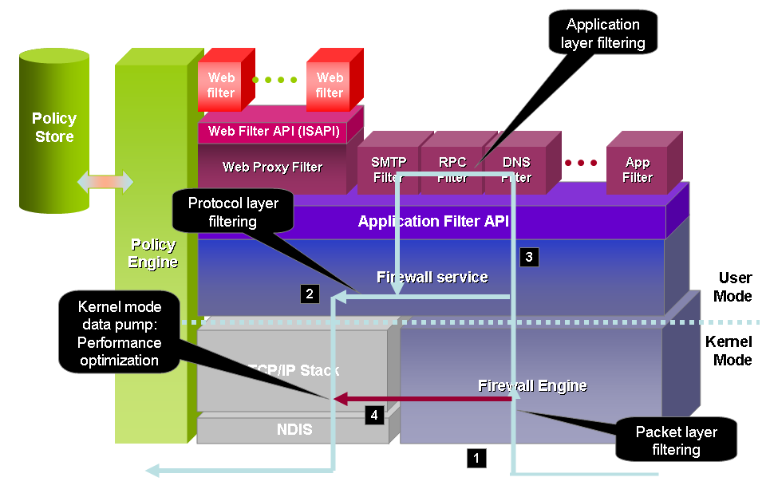
Consider a detailed look at the ISA Server architecture:

- The core firewall engine operates in efficient kernel mode and integrates with the TCP/IP stack.

- The policy engine, on the left side of the figure, retrieves ISA Server policies from the policy store, and enforces them both in kernel mode, as part of the firewall engine, and in user mode, where the Microsoft Firewall service performs advanced functions, such as user authentication.

- An application filter API allows included protocol filters and third-party protocol filters to provide advanced services that integrate with ISA Server. For example, the SMTP filter is such a protocol filter.

- A special case is the Web Proxy Filter. It processes HTTP requests and performs application filtering on these requests. A Web filter API allows third-party Web filters to plug into the Web Proxy Filter for more advanced HTTP processing.

When network traffic enters ISA Server (on the right side of the previous figure), the firewall engine performs packet layer filtering. In most cases, ISA Server has to perform protocol layer filtering. If this is necessary, the incoming packets are passed to the Firewall service, which then performs further processing. The traffic is directed to the appropriate application layer filter for granular inspection of that particular protocol. If the request is allowed, ISA Server then forwards the packet, or a modified packet, through the TCP/IP stack back to the network.

ISA Server includes a unique performance optimization feature. After ISA Server has performed the initial protocol layer filtering for a connection, and no application layer filtering is required, the kernel mode data pump can process packets entirely in kernel mode, without the firewall engine to pass the traffic on to the Firewall service.

ISA Server VPN Performance

The following table indicates the maximum number of concurrent VPN remote access connections supported by each hardware platform. These figures assume out-of-the-box ISA Server setup incorporating Web Proxy filtering, MSDE logging, and compression for both PPTP and L2TP over IPsec protocols.

Protocol | Connections  and bandwidth | Single Pentium III  550-megahertz (MHz) processor | Single Pentium 4  3-gigahertz (GHz) processor | Dual Xeon  3-GHz processors
PPTP | Connections | 150 | 600 | 760
PPTP | Bandwidth | 2.25 megabits per second (Mbps) | 9 Mbps | 11.4 Mbps
L2TP over IPsec | Connections | 150 | 700 | 850
L2TP over IPsec | Bandwidth | 2.25 Mbps | 10.5 Mbps | 12.75 Mbps

The following applies to the preceding table:

- Bandwidth Bandwidth figures are the required Internet link bandwidth. The actual bandwidth is twice the amount shown in the preceding table, due to compression. The bandwidth figures assume an average throughput of 30 kilobits per second (Kbps) per connection, approximately equivalent to a 56- kilobyte (KB) dial-up connection.

In deployments where VPN clients can be trusted to a higher degree, application-level filtering may be disabled, improving total capacity on the account of loosening the security level. The following table states the same figures for the case where the Web Proxy Filter is disabled.

Protocol | Connections  and bandwidth | Single Pentium III  550-MHz processor | Single Pentium 4  3-GHz processor
PPTP | Connections | 375 | 1,000
PPTP | Bandwidth | 5.6 Mbps | 15 Mbps
L2TP over IPsec | Connections | 330 | 1,000
L2TP over IPsec | Bandwidth | 5 Mbps | 15 Mbps

The following applies to the preceding table:

- Connections The single Pentium 4 3-GHz processor is capable of reaching the maximum number of concurrent connections shown in the preceding table.

Appendix E: Links to Useful Information

This section provides links to additional useful ISA Server information.

Product information and community resources

ISA Server product information
ISA Server 2006 http://www.microsoft.com/isaserver
Partner ecosystem http://www.microsoft.com/isaserver/partners/default.asp
Support http://www.microsoft.com/isaserver/support/default.asp
Appliances http://www.microsoft.com/isaserver/hardware/default.mspx

Related product Web sites
Exchange Server 2003 http://www.microsoft.com/exchange
Windows Server 2003 http://www.microsoft.com/windowsserver2003/default.mspx
Windows SharePoint Services http://www.microsoft.com/sharepoint

General content sites
Microsoft security http://www.microsoft.com/security
Windows Server System http://www.microsoft.com/windowsserversystem/default.mspx

Communities
ISA Server newsgroups http://www.microsoft.com/isaserver/community/default.mspx
ISAServer.org http://www.isaserver.org
ISA Server Tools Repository http://www.isatools.org

