


Setting Up Virtual Private Network Enforcement for Network Access Protection in a Test Lab

Microsoft Corporation
Published: June 2006

Abstract

Network Access Protection (NAP) is a health policy creation, enforcement, and remediation technology that is included in Microsoft® Windows Vista™ (now in beta testing) and Windows Server® Code Name "Longhorn" (now in beta testing). With NAP, system administrators can enforce health requirements, which can include software requirements, security update requirements, required computer configurations, and other settings. This paper describes how to create a test lab for NAP with the virtual private network (VPN) enforcement method using the Beta 2 releases of Windows Vista and Windows Server "Longhorn."

This is a preliminary document and may be changed substantially prior to final commercial release of the software described herein.
The information contained in this document represents the current view of Microsoft Corporation on the issues discussed as of the date of publication. Because Microsoft must respond to changing market conditions, it should not be interpreted to be a commitment on the part of Microsoft, and Microsoft cannot guarantee the accuracy of any information presented after the date of publication.
This White Paper is for informational purposes only. MICROSOFT MAKES NO WARRANTIES, EXPRESS, IMPLIED OR STATUTORY, AS TO THE INFORMATION IN THIS DOCUMENT.
Complying with all applicable copyright laws is the responsibility of the user. Without limiting the rights under copyright, no part of this document may be reproduced, stored in or introduced into a retrieval system, or transmitted in any form or by any means (electronic, mechanical, photocopying, recording, or otherwise), or for any purpose, without the express written permission of Microsoft Corporation.
Microsoft may have patents, patent applications, trademarks, copyrights, or other intellectual property rights covering subject matter in this document. Except as expressly provided in any written license agreement from Microsoft, the furnishing of this document does not give you any license to these patents, trademarks, copyrights, or other intellectual property.
Unless otherwise noted, the example companies, organizations, products, domain names, e-mail addresses, logos, people, places, and events depicted herein are fictitious, and no association with any real company, organization, product, domain name, email address, logo, person, place, or event is intended or should be inferred.
© 2006 Microsoft Corporation. All rights reserved.
Microsoft, Active Directory, Windows, Windows Server, and Windows Vista are either registered trademarks or trademarks of Microsoft Corporation in the United States and/or other countries.
All other trademarks are property of their respective owners.
Contents
Introduction 1
In this guide 1
Hardware and software requirements 1
Introduction to NAP 3
Client computer health 3
Custom solutions 4
Important aspects of NAP 4
Who should use NAP? 5
Benefits of NAP 5
Configuring the test lab 6
Configuring DC1 7
Install the operating system 7
Configure TCP/IP 7
Install Active Directory and DNS 8
Install Certificate Services 8
Create a user account and group in Active Directory 10
Configuring NPS1 10
Install the operating system 11
Configure TCP/IP 11
Join the computer to the domain 12
Install the NPS server role 12
Install and configure NPS 12
Configure VPN1 as a RADIUS client 18
Configuring VPN1 19
Install the operating system 19
Configure TCP/IP 19
Join the computer to the domain 20
Configure Routing and Remote Access 20
Configuring CLIENT1 22
Connect CLIENT1 to the intranet subnet 22
Install the operating system 22
Configure TCP/IP 22
Join the computer to the domain 23
Enable Security Center in Group Policy 24
Enable the Network Access Protection service 24
Connect CLIENT1 to the Internet subnet 25
Configure TCP/IP 25
Configure and test a VPN connection 25
Verifying NAP functionality 27
Verification of NAP autoremediation 27
Verification of health policy enforcement 28
Summary 30
Related links 31

Introduction
Network Access Protection (NAP) is a new technology introduced in Windows Vista and Windows Server "Longhorn." NAP includes client components and server components that allow you to create and enforce health requirement policies that define the required software and system configurations for computers that connect to your network. NAP enforces health requirements by inspecting and assessing the health of client computers, limiting network access when client computers are deemed noncompliant, and remediating noncompliant client computers for unlimited network access. NAP enforces health requirements on client computers that are attempting to connect to a network. NAP also provides ongoing health compliance enforcement while a compliant client computer is connected to a network.
In addition, NAP provides an application programming interface (API) set that allows third party software vendors to integrate their solutions into the NAP framework.
NAP enforcement occurs at the moment when client computers attempt to access the network through network access servers, such as a VPN server running Routing and Remote Access, or when clients attempt to communicate with other network resources. The way that NAP is enforced depends upon the enforcement method you choose.
NAP enforces health requirements for the following:
- Internet Protocol security (IPsec)-protected communications
- Institute of Electrical and Electronics Engineers (IEEE) 802.1X-authenticated connections
- Virtual private network (VPN) connections
- Dynamic Host Configuration Protocol (DHCP) configuration
This paper provides instructions on how to deploy a VPN enforcement test lab so that you can gain a greater understanding of VPN enforcement and how it works.

In this guide
This paper contains an introduction to NAP and instructions on how to set up a test lab and deploy NAP with the VPN enforcement method using two server computers and one client computer. The test lab lets you create and enforce client health requirements using NAP and VPN.

Hardware and software requirements
The following are required components of the test lab:
- The product discs for Windows Server "Longhorn" Beta 2 and Windows Vista Beta 2.
- The product disc for Windows Server 2003, Enterprise Edition with Service Pack 1 (SP1).
- One computer that meets the minimum hardware requirements for Windows Server 2003, Enterprise Edition with Service Pack 1 (SP1).
- Two computers that meet the minimum hardware requirements for Windows Server "Longhorn."
- One computer that meets the minimum hardware requirements for Windows Vista.
- Two Ethernet hubs or layer 2 switches.
Software installation notes:
- You cannot upgrade from a previous version of Windows to Windows Server "Longhorn." You must perform a clean install of Windows Server "Longhorn."
- You cannot upgrade from a previous version of Windows to Windows Vista. You must perform a clean install of Windows Vista.

Introduction to NAP
Most organizations create network policies that dictate the type of hardware and software that can be deployed on the organization network. These policies frequently include rules for how client computers can and cannot be configured before connecting to the network. For example, many organizations require that client computers run antivirus software with recent antivirus updates installed, and that client computers have a host-based firewall installed and enabled before connecting to the organization network. A client computer that is configured according to the organization network policy is compliant with policy (healthy). A computer that is not configured according to the organization network policy is noncompliant with policy (unhealthy).
NAP allows you to use Network Policy Server (NPS), the replacement for Internet Authentication Service (IAS) in Windows Server "Longhorn," to create policies that define client computer health requirements. NAP also allows you to enforce the client health policies you create, and to automatically update, or remediate, NAP-capable client computers to bring them into compliance with client health requirements. NAP provides continuous detection of client computer health to guard against circumstances where a client computer is compliant when it connects to the organization network but becomes noncompliant while connected.
NAP provides complementary client computer and organization network protection by ensuring that computers connecting to the network comply with organization network and client health policies. This protects the network from harmful elements introduced by client computers, such as computer viruses, and it also protects client computers from harmful elements that could be introduced by the network to which it is connecting.
In addition, NAP autoremediation reduces the amount of time that noncompliant client computers are prevented from accessing organization network resources. When autoremediation is configured and clients are in a noncompliant state, NAP client components can rapidly update the computer using resources you supply on a restricted network, allowing the now-compliant client to validate its corrected health state and obtain unlimited access to the network.

Client computer health
For NAP, health is defined as information about a client computer that NAP uses to determine whether to grant unlimited or limited access to a network. The client computer's health status is compared to the heath state that is required by health policy.
Example measurements of health include:
- The operational status of Windows Firewall. Is the firewall enabled or disabled?
- The update status of antivirus signatures. Are the antivirus signatures the most recent ones available?
- The installation status of security updates. Are the most recent security updates installed on the client?
The client computer's health status is encapsulated in a list of statements of health (SoHs), which are determined by NAP client components. NAP client components send their list of SoHs to an NPS for evaluation to determine whether the client is compliant and can be granted unlimited network access.
NAP allows administrators to ensure ongoing compliance with health policies, and, optionally, to limit the access of noncompliant computers until their health state can be brought into compliance with health policy.
In NAP terminology, verifying that a computer meets your defined health requirements is called health policy validation. NPS performs health policy validation for NAP.

Custom solutions
NAP is an extensible platform that provides an infrastructure and an API set for adding components that verify and amend a computer’s health and that enforce health requirements. By itself, NAP does not provide components to verify or correct a computer's health. Other components, known as system health agents (SHAs) and system health validators (SHVs), provide network policy validation and compliance. Windows Vista includes the Windows Security Health Agent to monitor the computer health services of the Windows Security Center. Windows Server “Longhorn” includes the corresponding Windows Security Health Validator. By using the NAP API, third-party vendors can also develop SHAs and SHVs to integrate with NAP.
Developers and administrators can create solutions for validating computers that connect to their networks, provide needed updates or access to needed resources (called remediation resources), and restrict the network access of computers that do not comply. The enforcement features of NAP can be integrated with software from other vendors or with custom programs. Administrators can customize the systems they develop and deploy, whether for monitoring the computers accessing the network for policy compliance, automatically updating computers with software updates to meet policy requirements, or isolating computers that do not meet policy requirements to a restricted network.
NAP is not designed to secure a network from malicious users. It is designed to help administrators maintain the health of the computers on the network, which in turns helps maintain the network’s overall integrity.

Important aspects of NAP
Network Access Protection has three important and distinct aspects:
- Network policy validation When a user attempts to connect to the network, the computer’s health state is validated against the health policies as defined by the administrator. Administrators can then choose what to do if a computer is not compliant. In a monitoring-only environment, all authorized computers are granted access to the network even if some do not comply with health policies, but the compliance state of each computer is logged. In an isolation environment, computers that comply with the network access policies are allowed access to the network, but computers that do not comply with health policies or that are not compatible with NAP are isolated to a restricted network. In both environments, administrators can define exceptions to the validation process. NAP will also include migration tools to make it easier for administrators to define exceptions that best suit their network needs.
- Network policy compliance Administrators can help ensure compliance with health policies by choosing to automatically update noncompliant computers with the missing requirements through management software, such as Microsoft Systems Management Server (SMS). In a monitoring-only environment, computers will have access to the network even before they are updated with required software or configuration changes. In an isolation environment, computers that do not comply with health policies are isolated until the software and configuration updates are completed. Again, in both environments, the administrator can define policy exceptions.
- Network isolation Administrators can protect network assets by isolating computers that do not comply with health requirements. Computers that do not comply will have their network access restricted as defined by the administrator, whether that access is limited to a restricted network, to a single resource, or to no internal resources at all. If an administrator does not configure health update resources, the network isolation will last for the duration of the connection. If an administrator configures health update resources, the network isolation will last only until the computer is brought into compliance.
Note The NAP platform is not the same as Network Access Quarantine Control, which is a feature included with Windows Server 2003 to provide limited health policy enforcement only for remote access (dial-up and virtual private network [VPN]) connections. For more information, see Network Access Quarantine Control at http://www.microsoft.com/technet/itsolutions/network/vpn/quarantine.mspx.

Who should use NAP?
NAP helps large and medium organizations reduce the risk of infection or attack from viruses, worms, and malicious software (malware) by enforcing health requirements. NAP is particularly useful for organizations that allow employees to connect desktop or mobile computers to the corporate network from home, through a public network (such as the Internet), or both. NAP is also useful for organizations that allow employees to connect computers to unknown or hostile network environments, such as the Internet, and then connect to the corporate network. NAP can help protect the network in these situations by inspecting client computers and ensuring health compliance before allowing them to connect to or communication on the organization network. NAP is typically implemented by the networking, security, and desktop IT administration staff.

Benefits of NAP
NAP's health policy enforcement provides an additional layer of protection against malware and mitigates risks to business processes. As an end-to-end solution, NAP integrates with existing network infrastructure, minimizing costly infrastructure upgrades and effectively leveraging infrastructure investments that may have already been made. In addition, NAP is a network infrastructure solution that has an open and extensible architecture.

Configuring the test lab
This test lab includes the following components:
- One domain controller running Windows Server 2003. This computer is named DC1.
- Two member servers running Windows Server "Longhorn." One computer is named NPS1. The other computer is named VPN1.
- One client computer running Windows Vista. This computer is named CLIENT1.
There are two subnets in this test lab network:
- An intranet subnet, which contains private network resources and uses the private address prefix 192.168.0.0/24.
- An Internet subnet, which contains a VPN server and client and uses the public address prefix 131.107.0.0/24.
Figure 1 shows the VPN enforcement test lab configuration, including the names of each computer and their assigned IP addresses.
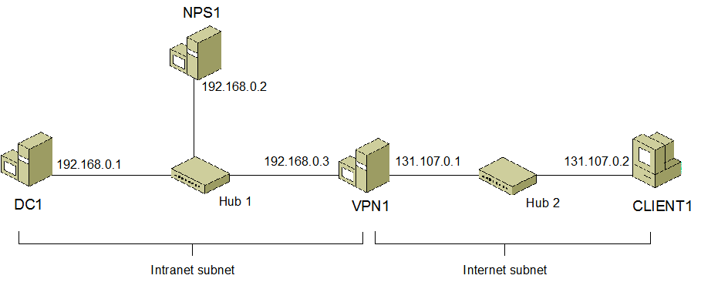
Figure 1 Configuration of the VPN enforcement test lab
Important The procedures described in this guide are based on the default Start menu configuration in Windows Server 2003, Windows Server "Longhorn," and Windows Vista. If your computer is configured to use the default Start menu configuration, the procedures described in this guide might not work properly.
There are four overall stages required to set up this test lab, one stage for each computer.
- Configuring DC1
DC1 is a server computer running Windows Server 2003. DC1 is configured as a domain controller with the Active Directory® directory service and the primary DNS server for the intranet subnet.
- Configuring NPS1
NPS1 is a server computer running Windows Server "Longhorn." NPS1 is configured with Network Policy Server (NPS), which is a NAP policy server and a Remote Authentication Dial-in User Service (RADIUS) server.
- Configuring VPN1
VPN1 is a server computer running Windows Server "Longhorn." VPN1 is configured with Routing and Remote Access as a VPN server. VPN1 has two network adapters installed and is connected to both subnets.
- Configuring CLIENT1
CLIENT1 is a client computer running the Windows Vista operating system.
Note You must be logged on as a member of the Domain Admins group or a member of the Administrators group on each computer to complete the tasks described in this guide. If you cannot complete a task while you are logged on with an account that is a member of the Administrators group, try performing the task while you are logged on with an account that is a member of the Domain Admins group.

Configuring DC1
DC1 configuration consists of the following steps:
- Install the operating system
- Configure TCP/IP
- Install Active Directory and DNS
- Install Certificate Services
- Create a user account and group in Active Directory
The following sections explain these steps in detail.

Install the operating system
Install Windows Server 2003 as a stand-alone server.
To install Windows Server 2003 on DC1
- Start your computer using the Windows Server 2003 product disc.
- Follow the instructions that appear on your screen. When prompted for a computer name, type DC1.

Configure TCP/IP
Configure TCP/IP properties so that DC1 has a static IP address of 192.168.0.1 with the subnet mask 255.255.255.0 and a default gateway of 192.168.0.3.
To configure TCP/IP properties on DC1
- Click Start, point to Control Panel, point to Network Connections, right-click Local Area Connection, and then click Properties.
- On the Local Area Connection Properties dialog box, on the Configure tab, click Internet Protocol Version 4 (TCP/IPv4), and then click Properties.
- Click Use the following IP address. In IP address, type 192.168.0.1. In Subnet mask, type 255.255.255.0. In Default gateway, type 191.168.0.3.
- Click OK, and then click Close to close the Local Area Connection Properties dialog box.
- Close the Network Connections window.

Install Active Directory and DNS
Configure the computer as a domain controller for the Contoso.com domain. This will be the first and only domain controller in this network.
To configure DC1 as a domain controller
- Click Start, and then click Run. In Open, type dcpromo, and then click OK.
- On the Welcome page of the Active Directory Installation wizard, click Next, and then click Next again.
- Click Domain controller for a new domain, and then click Next.
- Click Domain in a new forest, and then click Next.
- In Full DNS name for new domain, type contoso.com, and then click Next.
- In NetBIOS Domain name, type CONTOSO, and then click Next.
- Click Next twice, click Install and Configure the DNS server on this computer, and set this computer to use this DNS server as its preferred DNS server, and then click Next.
- Click Permissions compatible only with Windows 2000 or Windows Server 2003 operating systems, and then click Next.
- In Restore Mode Password, type a password. In Confirm password, type the password again, and then click Next.
- Click Next.
- The Active Directory Installation Wizard will begin configuring Active Directory. When the Active Directory Installation Wizard is done, click Finish.
Note You must restart the computer after you complete this procedure.

Install Certificate Services
VPN NAP requires the use of a computer certificate on the VPN server to perform Protected EAP (PEAP) authentication with VPN clients. The root certificate authority for the public key infrastructure (PKI) will be installed as an enterprise root CA running on DC1. Install and configure the CA.
To install an enterprise root CA on DC1
- Click Start, point to Control Panel, and then click Add or Remove Programs.
- Click Add/Remove Windows Components.
- In the Windows Components Wizard dialog box, select the Certificate Services check box.
- If a Microsoft Certificate Services dialog box appears warning you that the domain name and computer name cannot be changed, click Yes.
- In the Windows Components Wizard dialog box, click Next.
- Click Enterprise Root CA, and then click Next.
- In Common name for this CA, type Root CA. The following figure shows an example.
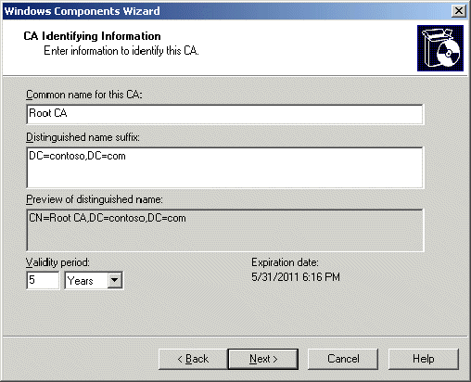
- Click Next twice.
- If a Microsoft Certificate Services dialog box appears warning you that Internet Information Services (IIS) is not installed, click OK. You do not need to install Internet Information Services (IIS) on DC1 to support Web enrollment of certificates.
- Click Finish.
- Close the Add or Remove Programs window.
The CA needs to be configured to issue certificates automatically unless directed otherwise by the certificate template. This allows the health certificates be distributed automatically at the time they are requested.
To configure root CA properties for DC1
- Click Start, point to Administrative Tools, and then click Certification Authority.
- In the left side tree, right-click Root CA, and click Properties.
- In the Root CA Properties dialog box, on the Policy Module tab, click Properties.
- Click Follow the settings in the certificate template, if applicable. Otherwise, automatically issue the certificate.
- Click OK.
- If a Windows default dialog box appears warning you that Certificate Services must be restarted, click OK.
- Click OK.
Restart the Certificate Services service so that the changes you made to Root CA properties take effect.
To restart the Certificate Services
- In the Certification Authority tree, right-click Root CA, point to All Tasks, and then click Stop Service.
- Wait for the service to stop.
- In the Certification Authority tree, right-click Root CA, point to All Tasks, and then click Start Service.
- Wait for the certificate service to start. Close the Certification Authority window.

Create a user account and group in Active Directory
Create a user account and add it to the Domain Admins group. You will be instructed to log on using this user account later in this paper.
To create a user account in Active Directory
- Click Start, point to Administrative Tools, and then click Active Directory Users and Computers.
- In the left side tree, expand contoso.com, right-click Users, point to New, and then click User.
- In Full name, type User1 User, and in User logon name, type User1.
- Click Next.
- In Password, type the password that you want to use for this account, and in Confirm password, type the password again.
- Clear the User must change password at next logon check box, and then select the following check boxes:
- User cannot change password
- Password never expires
- Click Next, and then click Finish.
Add the user to the Domain Admins group so this user can be used for all configuration activities.
To add a user to the Domain Admins group
- In the Active Directory Users and Computers tree, open contoso.com, and then click Users.
- In the details pane, double-click Domain Admins.
- On the Members tab, click Add.
- In Enter the object names to select (examples), type User1, the user name that you created in the procedure above, and then click OK twice.
- Close the Active Directory Users and Computers window.

Configuring NPS1
For the test lab, NPS1 will be using Windows Server "Longhorn" and will host the Network Policy Server (NPS).
NPS1 configuration consists of the following steps:
- Install the operating system
- Configure TCP/IP
- Join the computer to the domain
- Configure NPS
The following sections provide details on how to perform these tasks.

Install the operating system
Install Windows Server “Longhorn” on the computer.
To install Windows Server “Longhorn”
- Start your computer using the Windows Server "Longhorn" product discs.
- When prompted for the installation type, choose Custom.
- When prompted for the computer name, type NPS1.
- Follow the rest of the instructions that appear on your screen to finish the installation.

Configure TCP/IP
Configure TCP/IP properties so that NPS1 has a static IP address of 192.168.0.2 with a subnet mask of 255.255.255.0, the default gateway of 192.168.0.3, and the DNS server address of 192.168.0.1.
To configure TCP/IP properties on NPS1
- Click Start, point to Administrative Tools, and click Server Manager.
- Under Server Summary, click View Network Connections.
- In the Network Connections dialog box, right-click Local Area Connection, and then click Properties.
- On the Local Area Connection Properties dialog box, on the Configure tab, click Internet Protocol Version 4 (TCP/IPv4), and then click Properties.
- Click Use the following IP address. In IP address, type 192.168.0.2. In Subnet mask, type 255.255.255.0. In Default gateway, type 191.168.0.3.
- Click Use the following DNS server addresses. In Preferred DNS server, type 192.168.0.1.
- Click OK, and then click Close to close the Local Area Connection Properties dialog box.
- Close the Network Connections window.
Check to ensure that network communication between NPS1 and DC1 is working by running the Ping command from NPS1.
To use the ping command to check network connectivity
- Click Start, click Run, in the Open box, type cmd, and then click OK.
- In the command window, type ping DC1.
- Verify that the response displays “Reply from 192.168.0.1".
- Close the command window.

Join the computer to the domain
Join NPS1 to the Contoso.com domain.
To join NPS1 to the Contoso.com domain
- In Server Manager, under Server Summary, click Change system properties.
- In the System Properties dialog box, on the Computer Name tab, click Change.
- In Computer name type NPS1.
- In the Computer Name Changes dialog box, in Member of, click Domain, and then type contoso.com.
- Click More. In Primary DNS suffix of this computer, type contoso.com, and then click OK twice.
- When prompted for a user name and password, type User1 and password for the user account that you added to the Domain Admins group, and then click Submit.
- When you see a dialog box welcoming you to the contoso.com domain. Click OK.
- When you see a dialog box telling you to restart the computer, click OK.
- On the System Properties dialog box, click Close.
- Restart the computer.

Install the NPS server role
NPS1 is a member server that provides NAP-related functionality through the Network Policy Server (NPS) service. To configure NPS1, you must do the following:
- Install and configure NPS.
- Create a remediation server.
- Configure system health validator (SHV) templates.
- Configure authorization policies.
- Configure VPN1 as a RADIUS client.

Install and configure NPS
NPS is installed from the Server Manager tool.
To install NPS on NPS1
- On NPS1, click Start, point to Administrative Tools, and then click Server Manager.
- In Roles Summary, click Add Role, and then click Next.
- Select Network Access Services, click Next three times, and then click Install.
- Click Close.
- In the Roles Summary window, verify that the Network Access Services is listed as installed.
The Network Policy Server will validate the system health of clients against the configured network health policies. Network health requirements are defined by system health validators. Therefore, the system health validator needs to be configured. For the test lab, the system health policy will only require that Windows Firewall be enabled.
To configure the Network Policy Server for the Windows System Health Validator
- On NPS1, click Start, click Run, type mmc, and then click OK.
- In the MMC console, click File, click Add/Remove Snap-in, click Network Policy Server, and then click Add.
- Click Local Computer, click Finish, and then click OK.
- In the console tree, open NPS (Local), then Network Access Protection, and then System Health Validators.
- In the contents pane, right-click Windows Security Health Validator, and then click Properties.
- Click Configure.
- Select the A Firewall is enabled for all network connections check box and clear all other check boxes. The following figure shows an example.
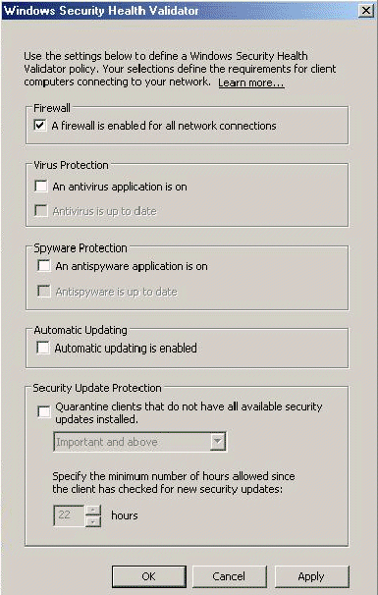
- Click OK twice.
The Network Policy Server SHV Templates must be configured. These templates define the SHV validation results that are interpreted by the NPS server and are used when creating the health enforcement policies.
To configure the Network Policy Server SHV templates
- In the Network Policy Server console tree, open NPS (Local), then Network Access Protection, and then System Health Validator Templates.
- On the Actions menu, click New.
- In the Create New SHV Template window, type Compliant in the Name field.
- In Template Type, click Client passes all SHV checks.
- In Select which SHVs must pass, select Windows Security Health Validator. The following figure shows an example.
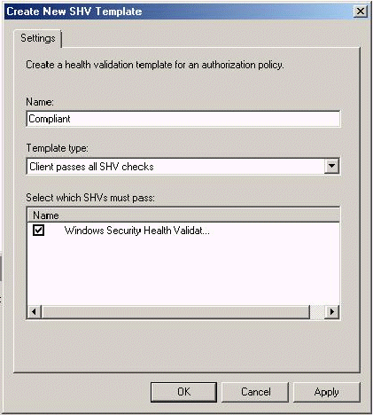
- Click OK to save the template.
- In the Actions menu, click New.
- In the Create New SHV Template window, type Noncompliant in the Name field.
- In Template type, click Client fails one or more SHV checks.
- In Select which SHVs must pass, select Windows Security Health Validator.
- Click OK to save the template.
The health authorization policies are used to enforce the network health policy. There needs to be an authorization policy that will be applied to computers that are compliant with the health policy, and there needs to be an authorization policy that will be applied to computers that are not compliant with the health policy. You will also create a default policy that will apply to all computers that do not match either of the other policies.
To configure the compliant authorization policy
- In the Network Policy Server console tree, open NPS (Local), then Network Access Protection, and then Authorization Policies.
- From the Actions menu, click New, and then Custom.
- In Policy name, type Compliant-Full-Access.
- In Policy Type, click Grant access. Note that this does not mean that full network access it granted to compliant computers; it means only that all requests coming to this policy are allowed to be processed further. See the following figure for an example.
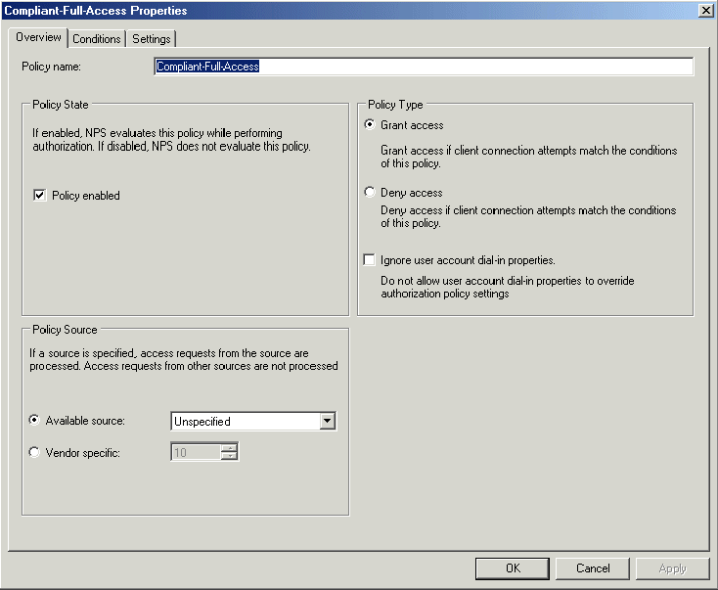
- Click the Conditions tab.
- In the Available Conditions tree, open Network Access Protection, and then click SHV Templates.
- In the Existing templates list, click Compliant and click Add. See the following figure for an example.
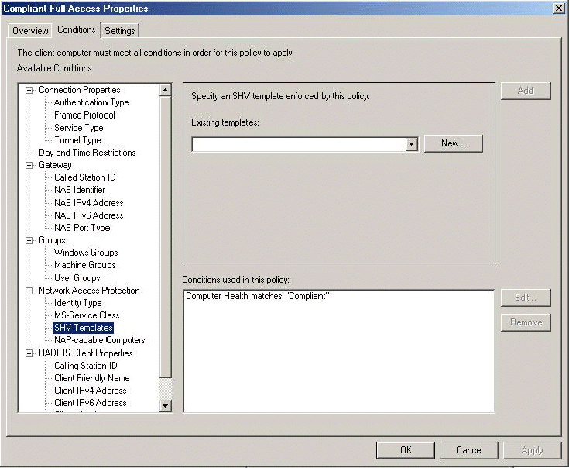
- Click the Settings tab.
- In the Available Settings tree, open Network Access Protection, and then click NAP Enforcement.
- Click Do not enforce. This indicates that the network restrictions will not be applied to computers that match the conditions for this policy. See the following figure for an example.
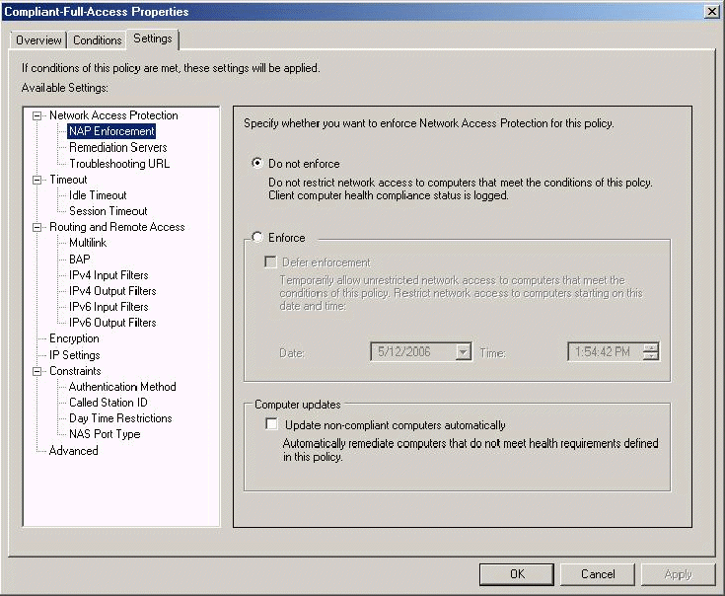
- Click OK to save the template.
To configure the noncompliant authorization policy
- In the Network Policy Server console tree, open NPS (Local), then Network Access Protection, and then Authorization Policies.
- From the Actions menu, click New, and then Custom.
- In Policy name, type noncompliant-Restricted.
- In Policy Type, click Grant access. Note that this does not mean that unlimited network access is granted to compliant computers; it means only that all requests coming to this policy are allowed to be processed further.
- Click the Conditions tab.
- In the Available Conditions tree, open Network Access Protection, and then click SHV Templates
- From the Existing Templates list, click Noncompliant, and then click Add.
- Click the Settings tab.
- In Available Settings, open Network Access Protection, and then select NAP Enforcement.
- Click Enforce, and select Update non-compliant computers automatically. The following figure shows an example.
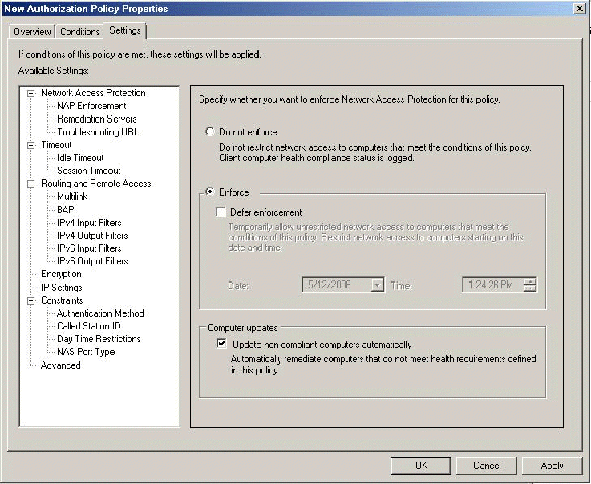
- In Available Settings, open Routing and Remote Access, and then click IPv4 Input Filters.
- Click Input filters, click New, select Destination Network, type 192.168.0.1 as IP address, type 255.255.255.255 as Subnet Mask, click Any for Protocol, and then click OK twice. This step ensures that traffic from noncompliant clients can only reach DC1, a remediation server.
- In Available Settings, click IPv4 Output Filters.
- Click Output filters, click New, select Source Network, type 192.168.0.1 as IP address, type 255.255.255.255 as Subnet Mask, click Any for Protocol, and then click OK twice. This step ensures that only traffic from DC1 can be sent to noncompliant clients.
- Click OK to save the template.
An authentication policy is used to authenticate the client. You need to create a default authentication policy that will be applied to all computers authenticating against this NPS server.
To configure the Network Policy Server authentication policy
- In the Network Policy Server console tree, open NPS (Local), then Network Access Protection, and then Authentication Policies.
- From the Actions menu, click New, and then click Custom.
- For Policy name, type VPN connections.
- On the Policy Properties page, click Policy enabled in Policy state. In Policy source, click Available Source, and then click Remote Access Server (VPN-Dialup).
- Click the Settings tab.
- In Available Settings, open Authentication, and then click Authentication Method. Clear all check boxes. Select the Override authentication settings from authorization policy check box.
- Select the EAP check box. Click EAP Methods, click Add, click Protected EAP (PEAP), click Add, click EAP-MSCHAPv2, click Add, and then click OK. This will add PEAP-MSCHAPv2 to the list of authentication methods allowed for this policy.
- Click Protected EAP (PEAP), and then click Edit. Ensure that Enable Quarantine checks is selected. Click OK.
- Click OK to save the template.

Configure VPN1 as a RADIUS client
Because NPS1 and VPN1 are separate computers and VPN1 will be sending NPS1 RADIUS messages to authentication and authorize VPN connection, VPN1 must be configured as a RADIUS client on NPS1.
To configure VPN1 as a RADIUS client
- On NPS1, in the console tree, open NPS (Local), and then RADIUS Clients.
- Right-click RADIUS clients, and then click New Radius Client.
- In the New Radius Client Wizard, type VPN1 in Friendly Name, type 192.168.0.3 in Client Address, and then click Next.
- In the Additional Information page, click Radius-Standard in Client Vendor, type NAPDemo in Shared Secret, type NAPDemo in Confirm Shared Secret, select The Client is NAP capable check box, and then click Finish.

Configuring VPN1
For the test lab, VPN1 will be using Windows Server "Longhorn" and will host the Routing and Remote Access service. VPN1 has two network adapters.
VPN1 configuration consists of the following steps:
- Install the operating system
- Configure TCP/IP
- Join the computer to the domain
- Configure Routing and Remote Access
The following sections provide details on how to perform these tasks.

Install the operating system
Install Windows Server “Longhorn” on the computer.
To install Windows Server “Longhorn”
- Start your computer using the Windows Server "Longhorn" product discs.
- When prompted for the installation type, choose Custom.
- When prompted for the computer name, type VPN1.
- Follow the rest of the instructions that appear on your screen to finish the installation.

Configure TCP/IP
Configure TCP/IP properties so that VPN1 has the following:
- For the network adapter attached to the intranet subnet (Hub 1), a static IP address of 192.168.0.3 with a subnet mask of 255.255.255.0, and the DNS server address of 192.168.0.1.
- For the network adapter attached to the Internet subnet (Hub 2), a static IP address of 131.107.0.1 with a subnet mask of 255.255.255.0.
To configure TCP/IP properties on VPN1
- Click Start, point to Administrative Tools, and click Server Manager.
- Under Server Summary, click View Network Connections.
- In the Network Connections dialog box, right-click the network adapter attached to the intranet subnet (Hub 1), and then click Properties.
- On the properties dialog box, on the Configure tab, click Internet Protocol Version 4 (TCP/IPv4), and then click Properties.
- Click Use the following IP address. In IP address, type 192.168.0.3. In Subnet mask, type 255.255.255.0.
- Click Use the following DNS server addresses. In Preferred DNS server, type 192.168.0.1.
- Click OK, and then click Close to close the properties dialog box.
- In the Network Connections dialog box, right-click the network adapter attached to the Internet subnet (Hub 2), and then click Properties.
- On the properties dialog box, on the Configure tab, click Internet Protocol Version 4 (TCP/IPv4), and then click Properties.
- Click Use the following IP address. In IP address, type 131.107.0.1. In Subnet mask, type 255.255.255.0.
- Click OK, and then click Close to close the properties dialog box.
- Close the Network Connections window.
Check to ensure that network communication between VPN1 and DC1 is working by running the Ping command from VPN1.
To use the ping command to check network connectivity
- Click Start, click Run, type cmd, and then click OK.
- In the command window, type ping DC1.
- Verify that the response displays “Reply from 192.168.0.1".
- Close the command window.

Join the computer to the domain
Join VPN1 to the Contoso.com domain.
To join VPN1 to the Contoso.com domain
- In Server Manager, under Server Summary, click Change system properties.
- In the System Properties dialog box, on the Computer Name tab, click Change.
- In Computer name type VPN1.
- In the Computer Name Changes dialog box, in Member of, click Domain, and then type contoso.com.
- Click More. In Primary DNS suffix of this computer, type contoso.com, and then click OK twice.
- When prompted for a user name and password, type User1 and password for the user account that you added to the Domain Admins group, and then click Submit.
- When you see a dialog box welcoming you to the contoso.com domain. Click OK.
- When you see a dialog box telling you to restart the computer, click OK.
- On the System Properties dialog box, click Close.
- Restart the computer and login with the CONTOSO/User1 account.

Configure Routing and Remote Access
Install Routing and Remote Access from the Server Manager tool.
To install Routing and Remote Access on VPN1
- On VPN1, click Start, point to Administrative Tools, and then click Server Manager.
- In Roles Summary, click Add Role, and then click Next.
- Select Network Access Services, click Next two times, select Routing and remote access server, and then select Remote access service.
- Click Next three times, and then click Install.
- Click Close.
- For Roles Summary, verify that the Routing and Remote Access Services is listed as installed.
The Routing and Remote Access service provides VPN server services to the VPN clients connected to the Internet subnet. VPN1 must be configured as a VPN server and as a RADIUS client to NPS1.
To configure the Routing and Remote Access as a VPN server
- On VPN1, click Start, click Run, type mmc, and then click OK.
- In the MMC console, click File, click Add/Remove Snap-in, click Network and Remote Access, and then click Add.
- Click Finish, and then click OK.
- In the console tree, right-click VPN1, and then click Configure and Enable Routing and Remote Access. This runs the Routing and Remote Access Server Setup wizard.
- Click Next, click Remote Access (dialup or VPN), and then click Next.
- Select VPN, and then click Next.
- Select the LAN interface connected to the Internet subnet (Hub 2). Clear the Enable security on the selected interface by setting up static packet filters check box. This step ensures that CLIENT1 will be able to ping VPN1 when attached to the Internet subnet without having to configure additional packet filters for the ping traffic.
- Click Next.
- Click From a specified address, and then click Next.
- Click New. Type 192.168.0.100 in the Start IP address and 192.168.0.110 in the End IP address, and then click OK. Click Next.
- Click Yes, setup this server to work with a RADIUS server, and then click Next.
- Type 192.168.0.2 in Primary RADIUS server. Type NAPDemo in Shared secret.
- Click Next and then Finish. Click OK for the two messages that subsequently appear.
VPN1 needs to be configured to use the PEAP-MS-CHAP v2 authentication method.
To configure the Routing and Remote Access for the PEAP-MS-CHAP v2 authentication method
- On VPN1, in the console tree of the Routing and Remote Access snap-in, right-click VPN1, and then click Properties.
- Click the Security tab. Select Authentication Methods and add the Protected EAP (PEAP) EAP type.

Configuring CLIENT1
CLIENT1 is a client computer that you will use to demonstrate how NAP can be used with VPN to help protect a network from noncompliant client computers. CLIENT1 must be configured as a domain member while connected to the intranet subnet and then configured as a VPN client while connected to the Internet subnet.
CLIENT1 configuration for the intranet subnet consists of the following steps:
- Connect CLIENT1 to the intranet subnet
- Install the operating system
- Configure TCP/IP
- Join the computer to the domain
- Enable Security Center in Group Policy
- Enable the Network Access Protection service
The following sections explain these steps in detail.

Connect CLIENT1 to the intranet subnet
Connect CLIENT1 to Hub 1 and the intranet subnet.

Install the operating system
Install Windows Vista as a workgroup client.
To Install Windows Vista on CLIENT1
- Start your computer using the product discs for Windows Vista.
- When prompted for the installation type, choose Custom Installation.
- When prompted for a computer name, type CLIENT1.
- Follow the rest of the instructions that appear on your screen to finish the installation.

Configure TCP/IP
Configure TCP/IP properties for CLIENT1’s static IP address on the intranet subnet.
To configure TCP/IP properties on CLIENT1
- Click Start, and then click Control Panel.
- Click Network and Internet, click Network Center, and then click Manage network connections.
- Right-click Local Area Connection, and then click Properties. If you receive a dialog asking for permissions to perform this operation, click Continue.
- In the Local Area Connection Properties dialog box, clear the Internet Protocol Version 6 (TCP/IPv6) check box. This is simply for ease of use for those who are not familiar with IPv6.
- Click Internet Protocol Version 4 (TCP/IPv4), and then click Properties.
- Click Use the following IP address. In IP address, type 192.168.0.4. In Subnet mask, type 255.255.255.0.
- Click Use the following DNS server addresses. In Preferred DNS server, type 192.168.0.1.
- Click OK, and then click Close to close the Local Area Connection Properties dialog box.
- Close the Network Connections window.
Check to ensure that network communication between CLIENT1 and DC1 is working by running the Ping command from CLIENT1.
To use the ping command to check network connectivity
- Click Start, click Run, in the Open box, type cmd, and then click OK.
- In the command window, type ping DC1.
- Verify that the response displays “Reply from 192.168.0.1".
- Close the command window.

Join the computer to the domain
CLIENT1 needs to be joined to the Contoso.com domain.
To join CLIENT1 to the Contoso.com domain
- Click Start, right-click Computer, and then click Properties.
- In Computer name, domain, and workgroup settings, click Change.
- In the Computer name, domain, and workgroup settings click Change Settings. If you receive a dialog asking for permissions to perform this operation, click Continue.
- In the System Properties dialog box, click Change,
- In the Computer Name Changes dialog, click Domain, and then type contoso.com.
- Click More, and in Primary DNS suffix of this computer, type contoso.com.
- Click OK twice.
- When prompted for a user name and password, type the user name and password for the User1 account, and then click OK.
- When you see a dialog box welcoming you to the contoso.com domain, click OK.
- When you see a dialog box telling you to restart the computer, click OK.
- On the System Properties dialog box, click Close.
- Restart the computer.

Enable Security Center in Group Policy
On clients running Windows Vista, Security Center is disabled by default when the computer is joined to a domain. Security Center needs to be turned on. To do this, Security Center will be enabled through local Group Policy.
To configure CLIENT1 so that Security Center is always enabled
- Click Start, point to All Programs, click Accessories, and then click Run.
- Type mmc, and then click OK.
- On the File menu, click Add/Remove Snap-in.
- In the Add or Remove Snap-ins dialog box, under Available snap-ins, click Group Policy Object Editor, and then click Add.
- In the Select Group Policy Object dialog box, click Finish, and then click OK.
- In the console tree, open Local Computer Policy/Computer Configuration/Administrative Templates/Windows Components/Security Center. Note that the entries in the list may not be in alphabetical order.
- Double-click Turn on Security Center (Domain PCs only), click Enabled, and then click OK.

Enable the Network Access Protection service
By default, the Network Access Protection service on computers running Windows Vista is configured for manual start. CLIENT1 needs to be configured so that the Network Access Protection service starts automatically.
To configure CLIENT1 so that the NAP service is started automatically
- On CLIENT1, click Start, click Control Panel, click System and Maintenance, and then click Administrative Tools.
- Double-click Services.
- In the services list, double-click Network Access Protection.
- In the Network Access Protection Agent Properties dialog, change the Startup Type to Automatic, and then click OK.
- Close the Services dialog, and then close Control Panel.
Enable the VPN NAP enforcement client.
To enable the VPN NAP enforcement client
- Click Start, click All Programs, click Accessories, and then click Run.
- Type napclcfg.msc in Open, and then click OK.
- In the console tree, click Enforcement Clients.
- In the details pane, right-click Remote Access Quarantine Enforcement Client, and then click Enable.
- Close the NAP Client Configuration window.
Restart CLIENT1 to force those changes to be applied.
CLIENT1 configuration for the Internet subnet consists of the following steps:
- Connect CLIENT1 to the Internet subnet
- Configure TCP/IP
- Configure a VPN connection
The following sections explain these steps in detail.

Connect CLIENT1 to the Internet subnet
Disconnect CLIENT1 from Hub 1 and the intranet subnet and connect it to Hub 2 and the Internet subnet.

Configure TCP/IP
Configure TCP/IP properties for CLIENT1’s static IP address on the Internet subnet.
To configure TCP/IP properties on CLIENT1
- Click Start, and then click Control Panel.
- Click Network and Internet, click Network Center, and then click Manage network connections.
- Right-click Local Area Connection, and then click Properties.
- Click Internet Protocol Version 4 (TCP/IPv4), and then click Properties.
- Click Use the following IP address. In IP address, type 131.107.0.2. In Subnet mask, type 255.255.255.0.
- In Preferred DNS server, remove 192.168.0.1.
- Click OK, and then click Close to close the Local Area Connection Properties dialog box.
- Close the Network Connections window.
- Restart CLIENT1.
Ensure that network communication between CLIENT1 and VPN1 is working by running the Ping command from CLIENT1.
To use the ping command to check network connectivity
- Click Start, click All Programs, click Accessories, and then click Run.
- In Open, type cmd, and then click OK.
- In the command window, type ping 131.107.0.1.
- Verify that the response displays “Reply from 131.107.0.1".
- Close the command window.

Configure and test a VPN connection
CLIENT1 needs be configured with a VPN connection to VPN1 to access the intranet subnet.
To configure a VPN Connection on CLIENT1
- Click Start, click Control Panel, click Network and Internet, and then click Network Center.
- Click Set up a connection or network.
- On the Set up a connection or network page, click Set up a virtual private network (VPN) connection.
- On the Set up a virtual private network (VPN) connection page, type 131.107.0.1 in Internet address, type Contoso in Destination Name, select the Allow other people to use this connection check box, and then click Next.
- Type the user name and password of the User1 account in Name and Password, select the Remember this password check box, type contoso in Domain, and then click Create.
- Click Close.
- In the Network Center window, click Manage Network Connections.
- Right-click on the Contoso connection under Virtual Private Network, click Properties, and then click the Security tab.
- Click Advanced (custom settings), and then click Settings.
- In Logon security, select Use Extensible Authentication Protocol (EAP), and then click Protected EAP (PEAP) (encryption enabled).
- Click Properties.
- Select the Validate server certificate check box, clear the Connect to these servers check box, select Secured Password (EAP-MSCHAP v2) from the Select Authentication Method, clear the Enable Fast Reconnect check box and select the Enable Quarantine checks check box.
- Click OK three times.
The new VPN connection needs to be tested.
To test the VPN Connection on CLIENT1
- From the Network Connections window, double-click on the Contoso connection.
- Allow the VPN connection to complete. Because CLIENT1 is compliant, it should have unlimited access to the intranet subnet.
- Click Start, click All Programs, click Accessories, and then click Run.
- In Open, type cmd, and then click OK.
- In the command window, type ping 192.168.0.1.
- Verify that the response displays “Reply from 192.168.0.1".
- In the command window, type ping 192.168.0.2.
- Verify that the response displays “Reply from 192.168.0.2".
- Close the command window.
- In the Network Connections window, right-click on the Contoso connection, and then click Disconnect.

Verifying NAP functionality
The following procedures verify that the NAP infrastructure is functioning correctly:
- Verification of NAP autoremediation CLIENT1 is automatically remediated when Windows Firewall is disabled.
- Verification of health policy enforcement Health policy is revised to be more restrictive, causing CLIENT1 to be noncompliant with policy.

Verification of NAP autoremediation
Because the noncompliant-Restricted authorization policy specifies that noncompliant computers should be automatically remediated, the autoremediation of CLIENT1 when Windows Firewall is disabled will be verified.
To verify that CLIENT1 is autoremediated when Windows Firewall is disabled
- Logon to CLIENT1 as CONTOSO/User1.
- Click Start, and then click Control Panel.
- Click Security, click Security Center, and then click Windows Firewall.
- In the Windows Firewall dialog box, click Off (not recommended), and then click OK.
- Click Start, click Control Panel, click Network and Internet, and then click Network Center.
- In the Network Center window, click Manage Network Connections.
- Double-click on the Contoso connection.
- Allow the VPN connection to complete.
- You may see a message in the notification area of the desktop showing the computer does not meet health requirements. This is displayed because Windows Firewall has been disabled. The following figure shows an example.
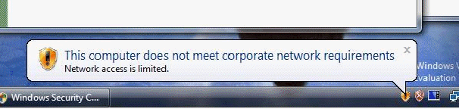
- You may then see a message showing that the computer does meet health requirements. This is displayed when the NAP client automatically enables Windows Firewall and is compliant with the heath policy. The following figure shows an example.
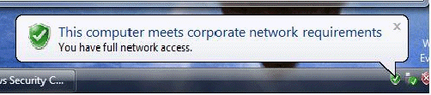
- In the Manage Network Connections window, right-click on the Contoso connection, and then click Disconnect.

Verification of health policy enforcement
Configure NPS1 so that antivirus software is a requirement for system health. Because no antivirus program is installed on CLIENT1 and the NAP client components cannot remediate its health, CLIENT1 will be noncompliant.
To configure the system health validator policy to require antivirus software
- On NPS1, in the Network Policy Server console tree, open NPS (Local), then Network Access Protection, then System Health Validator Templates.
- In the details pane, double-click Windows Security Health Validator.
- In the Windows Security Health Validator Properties dialog box, click Configure.
- In the Windows Security Health Validator dialog box, clear all of the check boxes except those for Firewall is enabled and An antivirus application is on.
- Click Apply.
Connect to VPN1 from CLIENT1. This will cause the CLIENT1 to validate its system health. Because an antivirus program is not installed, the health requirement for an antivirus program cannot be autoremediated. Therefore, CLIENT1 will remain in a noncompliant state and will be placed on the restricted network.
To verify that CLIENT1 is placed on the restricted network
- Logon to CLIENT1 as CONTOSO/User1.
- Click Start, click Control Panel, click Network and Internet, and then click Network Center.
- In the Network Center window, click Manage Network Connections.
- Double-click on the Contoso connection.
- Allow the VPN connection to complete.
- You may see a message in the notification area of the desktop indicating that the computer does not meet health requirements. This is displayed because antivirus software has not been installed.
- Click Start, click All Programs, click Accessories, and then click Run.
- In Open, type cmd, and then click OK.
- In the command window, type ping 192.168.0.1.
- Verify that the response displays “Reply from 192.168.0.1".
- In the command window, type ping 192.168.0.2.
- Verify that there is no response from 192.168.0.2.
You can also check the Network Access Protection state of the computer using a NAP netsh command.
To use a Netsh command to show the NAP client's health state
- On CLIENT1, at the command prompt, type netsh nap client show state.
- Scroll the command window up to display the Client state section. In the Client state section, the Restriction state should be "Restricted".
- In the Manage Network Connections window, right-click on the Contoso connection, and then click Disconnect.
Configure NPS1 to remove the antivirus health requirement so that CLIENT1 can be compliant.
To configure NPS1 health requirements to allow CLIENT1 to be compliant
- On NPS1, in the Network Policy Server console tree, open NPS (Local), then Network Access Protection, and then System Health Validator Templates.
- In the details pane, double click Windows Security Health Validator.
- In the Windows Security Health Validator Properties dialog box, click Configure.
- In the Windows Security Health Validator dialog box, clear all of the check boxes except the Firewall is enabled check box.
- Click Apply.
Reconnect to VPN1 with CLIENT1 and ensure that CLIENT1 is compliant.
To reconnect to VPN1
- In the Manage Network Connections window, double-click the Contoso connection.
- Verify that you are compliant by pinging 192.168.0.1 and 192.168.0.2.

Summary
This white paper described how to configure and demonstrate VPN enforcement with Network Access Protection using four computers in a test lab.

Related links
See the following resources for further information:
- Microsoft Network Access Protection Web page at http://www.microsoft.com/nap
- Introduction to Network Access Protection at http://go.microsoft.com/fwlink/?LinkId=49884
- Network Access Protection Platform Architecture at http://go.microsoft.com/fwlink/?LinkId=49885
- Network Access Protection Frequently Asked Questions at http://go.microsoft.com/fwlink/?LinkId=49886.
For ongoing discussions of NAP from members of the NAP product team at Microsoft, see the NAP blog at http://blogs.msdn.com/nap/.
If you have questions about NAP, you want to provide feedback about NAP, or you want to request a feature for NAP, you can send mail to asknap@microsoft.com.

For the latest information about Windows Server System, see the Windows Server System Web site at http://www.microsoft.com/windowsserversystem.

