Microsoft Office Basic 2007

September 2006

Table of Contents

Cover is for   
position only

Overview of Microsoft Office Basic 2007 1

Create High-Quality Documents 2

Work with Enhanced Reliability and Security Features 2

Find Commands and Help More Easily 3

Organize Your Time and Communications 3

Create High-Quality Documents 4

Microsoft Office Fluent User Interface 4

Improved Advanced Formatting 6

SmartArt Diagramming and Enhanced Charting Capabilities 7

Improved Templates and New Fonts 8

Improved Themes 8

Live Preview and Galleries 10

Save as PDF or XPS 11

Work with Enhanced Reliability and Security Features 11

Improved Outlook Junk E-Mail Filter 11

New Anti-Phishing Tools 13

Improved Document Recovery Tool 13

New Document Inspector 14

Find Commands and Help More Easily 15

New Command Tabs 15

Improved Tutorials 17

Improved and Easy-to-Use Help 17

Enhanced ScreenTips 17

Organize Your Time and Communications 18

New Ways to Organize Appointments and Tasks Easily 18

Improved Instant Search Helps You Find What You Need 21

New Inbox Autoconfiguration 22

New RSS (Really Simple Syndication) Aggregator 23

Summary 24

Resources 25

System Requirements 26

# Overview of Microsoft Office Basic 2007

Welcome to Microsoft® Office Basic 2007, the exciting new release of the familiar and widely used productivity software. Office Basic 2007 provides office software essentials to homes and small businesses with new personal computers so that users can quickly and easily create great-looking documents and spreadsheets, and manage e-mail. The Microsoft Office Fluent™ user interface, enhanced graphics and formatting capabilities, new time-management tools, and more reliability and security makes it easier and more enjoyable for you to get things done.

Office Basic 2007—consisting of Microsoft Office Word 2007, Microsoft Office Excel® 2007 spreadsheet software, and the Microsoft Office Outlook® 2007 messaging and collaboration program—offers easy access to a comprehensive set of powerful tools and resources. The Office Fluent user interface, one of the most significant visual makeovers in the history of Microsoft Office, helps you access the commands you need while you work.

This guide provides an overview of new and improved features in Office Basic 2007. You will also see examples of Office Basic 2007 in action that demonstrate its powerful new capabilities.

Office Basic 2007 in Action

Francisco Chaves owns the Coho Winery in Northern California. His small sales and marketing staff has a very basic understanding of computers. He finds that the simplicity and functionality of Office Basic 2007 not only meets all of his sales and marketing needs, but also improves his staff’s efficiency and productivity. Office Outlook 2007 helps his staff store and track contacts and minimizes junk e-mail messages, enabling employees to focus on important e-mail messages. Office Excel 2007 helps staff track product and customer data as well as make projections for their annual output. For all correspondences and press releases, the staff relies on Office Word 2007.

## Create High-Quality Documents

Office Basic 2007 simplifies the way home and small business users work with documents. The Office Fluent user interface enables you to quickly and easily create high-quality documents and spreadsheets. Enhanced graphics and formatting capabilities help make your user experience more enjoyable and productive.

* **New! The Microsoft Office Fluent user interface** makes it more straightforward to find and use the product features you use most to get the results you want.
* **Improved! Enhanced formatting** capabilities make it easier to consistently format documents.
* **New! Text effects** **and diagram and graphics galleries** enable you to preview and format items.
* **Improved! Document Themes** create a consistent appearance across Word documents and Excel spreadsheets.
* **New! Save as Portable Document Format (PDF) or an XML Paper Specification (XPS) file[1]** option gives you the ability to share your documents, spreadsheets and presentations with people who may not have Word, Excel or PowerPoint.

## Work with Enhanced Reliability and Security Features

Powerful new security features help homes and small businesses stay operational so that users can work with confidence.

* **Improved! A junk e-mail filter** reduces spam e-mail messages in inboxes and helps protect against potentially harmful e-mail attachments.
* **New! Anti-phishing tools** alert users to suspicious and potentially fraudulent e-mail messages so that they do not divulge private information unnecessarily.
* **Improved! Automatic** **document recovery** helps retrieve Microsoft Office documents after a system stops responding.
* **New! Document Inspector** helps protect private information by automatically removing personally identifiable information, comments, and tracked changes from documents.

## Find Commands and Help More Easily

Office Basic 2007 offers the Office Fluent user interface that significantly simplifies how home and small business users access commands. Commonly used commands appear on the results-oriented Ribbon instead of in drop-down menus. In addition, an enhanced Help system, including tutorials with step-by-step instructions, enables you to quickly find answers to your questions.

* **New! Command tabs** on the results-oriented Ribbon reveal commonly used commands that previously appeared only in lengthy drop-down menus.
* **Improved!** **Tutorials** provide you with step-by-step instructions for common tasks.
* **Improved! The easy-to-use Help system** offers a smooth transition between Help in the Microsoft Office system and Help on the Internet.
* **Improved! Enhanced ScreenTips** provide quick access to information about a command directly from the command’s location.

## Organize Your Time and Communications

New features and enhancements in Office Outlook 2007 help home and small business users organize their daily schedules, tasks, and communications.

* **New! Organizational tools** such as the To-Do bar bring tasks, calendar information, and flagged e-mail messages together into one location.
* **Improved! Instant Search** enables you to quickly find information in any of the Outlook modules.
* **New! Inbox autoconfiguration** sets up and configures all of your e-mail accounts automatically.
* **New! RSS (Really Simple Syndication) Aggregator** sends headlines and Web content to you, rather than having you go look for it (an additional RSS fee-based subscription is required).

Create High-Quality Documents

Microsoft Office Basic 2007 makes it easier than ever to format your documents and spreadsheets. New and improved features such as enhanced graphics and advanced formatting capabilities help you deliver high-quality documents in lightning-fast time, providing a more enjoyable experience.

## Microsoft Office Fluent User Interface

The richer Microsoft Office Fluent user interface reflects an overall effort by Microsoft to deliver a more user-driven product. Rather than rethinking Office Basic 2007 from a *feature-oriented* viewpoint, Microsoft focused on the user’s *results-oriented* perspective. The end product delivers one of the most significant makeovers in the history of Microsoft Office. The Office Fluent user interface is more intuitive and offers more easily accessible features that are less about commands and more about results. At the same time, although the look is very new, its evolution from previous releases of Microsoft Office makes it extremely familiar.

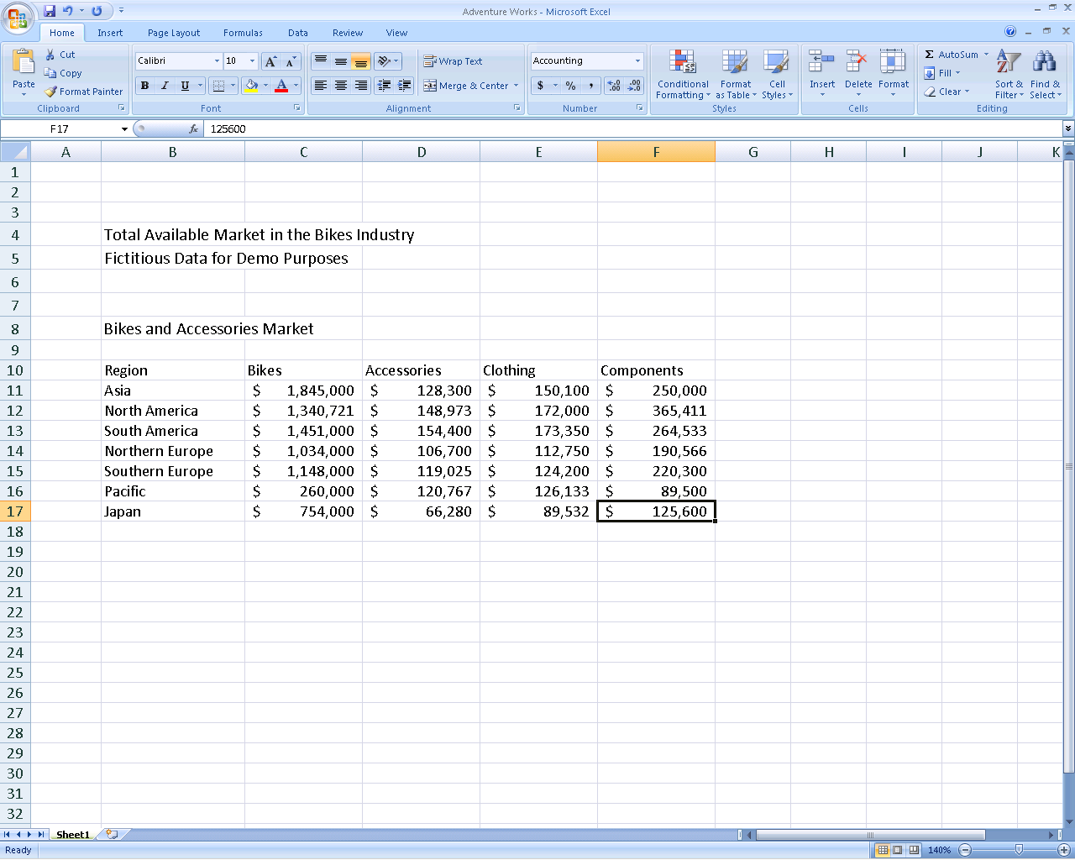

Figure 1: Office Excel 2007 task-based Office Fluent user interface

The Office Fluent user interface significantly simplifies how you author documents by:

* Making the experience more predictable, with fewer complicated features and less guesswork.
* Maximizing your workspace and being less intrusive by not popping up images and dialog boxes on top of your work.
* Putting a majority of the most commonly used commands on the first tab, so you do not have to dig for commands in lengthy drop-down menus.

Office Basic 2007 in Action

Michelle Alexander serves on the board of her child’s school’s Parent Teacher Association (PTA) and volunteers at the zoo. She uses Office Basic 2007 to write letters to parents and design zoo flyers. Although comfortable with the menus in previous versions of Microsoft Office, she was frustrated with having to hunt down commands in the drop-down menus. With the Office Fluent user interface in Office Basic 2007, all of the tools she needs become available automatically when and where she needs them. As a result, she can spend less time formatting documents and more time doing what is important to her.

## Improved Advanced Formatting

With the addition of more consistent numbering, bullet, and table features in Office Basic 2007, home and small business users no longer have to waste time formatting and reformatting their Word documents. Office Basic 2007 simplifies document formatting by:

* Enabling you to create and apply Quick Styles to text and tables with a single click.
* Providing previews of your formatting changes.
* Maintaining formatting across Microsoft Office programs when you copy text or tables from one program to another.
* Providing more consistent and stable bullet and numbering formatting.

## SmartArt Diagramming and Enhanced Charting Capabilities

The new SmartArt™ diagramming and enhanced charting capabilities in Office Basic 2007 applications make it easy to create great-looking diagrams and charts. Just choose the chart type, the layout, and the format from visual galleries of predefined options. Or take a bulleted list and convert it to a compelling diagram with just a couple of clicks. You can also reuse content by saving your favorite charts as chart templates. In addition, the SmartArt graphics capabilities have been enhanced so you can easily use professional effects such as shading, reflections, glow, transparency, and other 3-D effects.

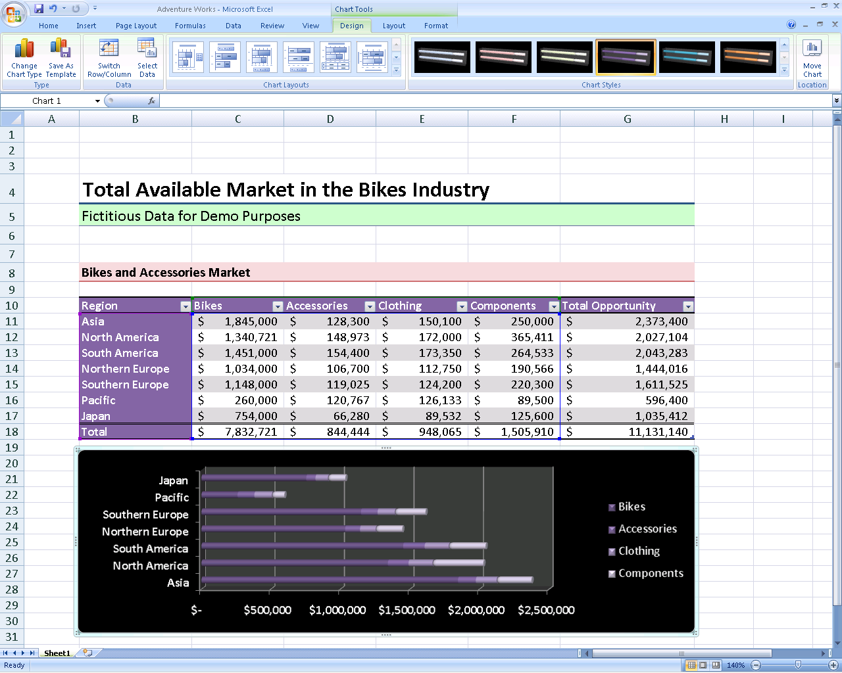

**Figure** **2: New charting tools in Office Excel 2007**

Office Basic 2007 in Action

Jonas Hasselberg owns a small business, Trey Research, which specializes in analyzing industry trends. The company relies heavily on charts and graphs as a means of supplementing its reports. Jonas finds that Office Basic 2007 offers many opportunities to spice up his documents. He uses the selection of diagram types to create variety within his reports, and takes advantage of effects such as shadows and glows. Designing reports has become one of the most interesting aspects of his job.

## Improved Templates and New Fonts

New and improved out-of-the-box templates in Office Basic 2007 enable home and small business users to create professional-looking documents more quickly and easily. You can either get started with included templates or search the preformatted templates available at Microsoft Office Online at [www.microsoft.com/office](http://office.microsoft.com/). In addition, Office Basic 2007 includes new and improved fonts that make on-screen reading easier.

## Improved Themes

Themes is an improvement that helps home and small business users maintain a consistent look between Word documents and Excel spreadsheets. This predictability means that when you copy tables and objects between programs, the items maintain their appearance. As a result, working simultaneously with multiple programs becomes more consistent and less frustrating.

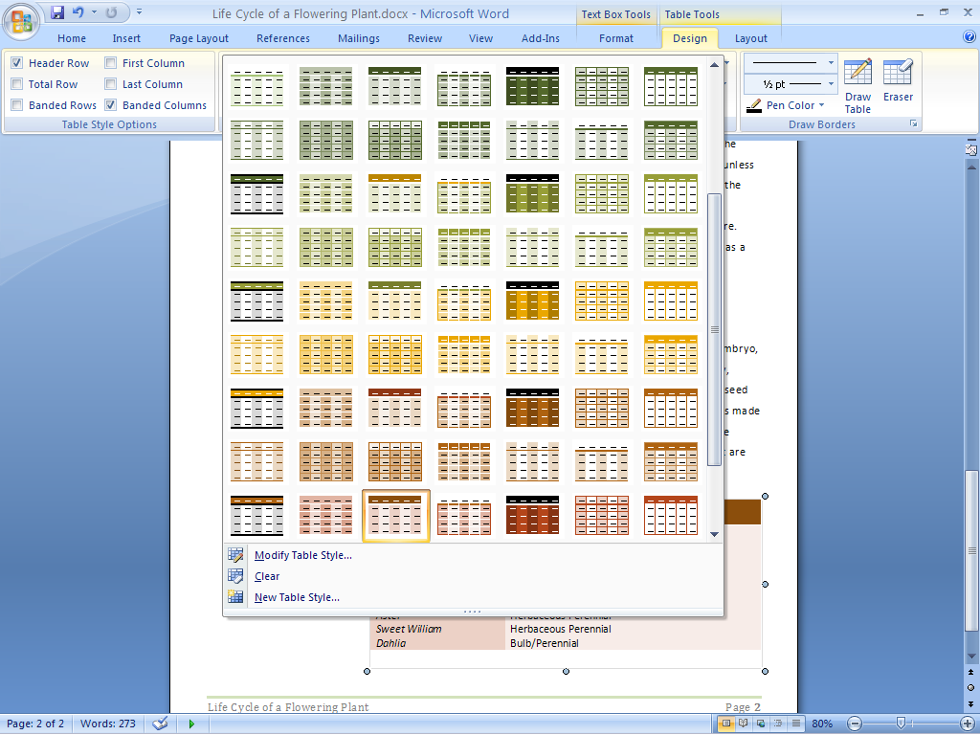

**Figure 3: Table styles in Office Word 2007**

Office Basic 2007 in Action

Joanna and Artur Rybka are considering building an addition to their house. They use Office Excel 2007 to analyze and track the projected costs. They also use Word documents to record their design ideas and logistics. The Themes feature in Office Basic 2007 helps ensure that all transferred information between programs maintains its appearance. As a result, Joanna and Artur can quickly shuffle information between different programs, which helps them plan more efficiently and with greater confidence.

## Live Preview and Galleries

Everyone wants to create the highest-quality documents possible in the shortest amount of time. Accomplishing this often requires experimenting with different styles and formats. Office Basic 2007 enables you to quickly preview proposed changes to your document. With Live Preview or when in one of the galleries, you can actually view formatting choices right inside your document while you’re working on it, without having to repeatedly search through drop-down menus. By test-driving your proposed formatting, you can save time and experiment more easily. The end result is a quickly created document that looks the way you want it to look. These galleries can be found in Office Word 2007, Office Excel 2007, and Office PowerPoint 2007.

## Save as PDF or XPS

Ensure broader distribution of your documents and presentations. New support for Portable Document Format (PDF) and XML Paper Specification (XPS) file formats helps ensure broader distribution of your documents with others.[2]* Now you can post your documents on the Internet or share them with others, knowing that users can view them regardless of the type of computer or programs they are using.

Office Basic 2007 in Action

Monica Brink wants to design a baby shower invitation for her sister. She knows the details of the event, but cannot decide on the design. With Live Preview in Office Basic 2007, she can preview different fonts simultaneously within her document before making a decision. For help with margins, she can quickly preview visual images of multiple options. She finds that this new preview feature makes her feel more comfortable experimenting with different looks.

# Work with Enhanced Reliability and Security Features

Microsoft Office Basic 2007 offers new and improved features to home and small business users that can help increase security by reducing junk e-mail and “phishing” attacks. In addition, tools such as automatic document recovery and the Document Inspector give you peace of mind by automatically recovering documents after a system stops responding and giving you the option to remove personally identifiable information from your documents before you share them with others.

## Improved Outlook Junk E-Mail Filter

Junk e-mail is time-consuming, annoying, and potentially dangerous for home and small business users. To address the flood of junk e-mail messages, Office Outlook 2007 offers an enhanced junk e-mail filter that helps reduce the amount of spam sent to inboxes and better protects your computer against viruses sent through e-mail. This security feature applies to both e-mail messages and their attachments.

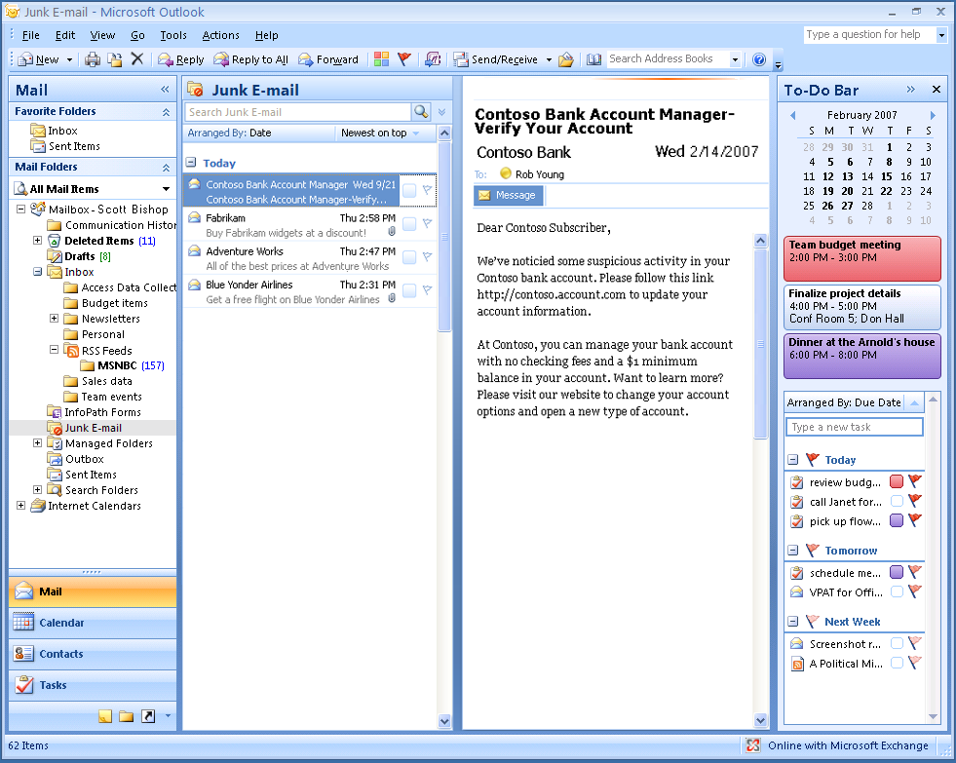

**Figure 4: Junk e-mail filter in Office Outlook 2007**

Office Basic 2007 in Action

David Barber used to feel like he never had enough time to sort through and separate junk e-mail messages from his important messages while checking his inbox at home. With the enhanced Office Outlook 2007 junk e-mail filter, the sorting is done for him. David also gets peace of mind knowing that when his kids are surfing the Internet, the family computer is better protected from viruses. Even with a powerful computer firewall, he knows that he can never have enough security.

## New Anti-Phishing Tools

Office Outlook 2007 provides new enhancements that help protect personal information by alerting home and small business users to potentially fraudulent e-mail messages sent to their inboxes. Fraudelent e-mail communication, known as “phishing,” attempts to trick you into providing bank, credit card, or other personal information. To provide more security, Office Outlook 2007 displays suspected phishing e-mail messages in plain text (no HTML or images), disables the hyperlinks, and provides a warning alert across the top of the message.

## Improved Document Recovery Tool

Automatic document recovery in Office Basic 2007 better protects home and small business users’ documents when their system suddenly stops responding. If a Microsoft Office program encounters a problem or stops responding, you can now close the program in a controlled manner. The files you had open are analyzed for errors, and whenever possible, recovered. You can then view any repairs that were made to the files.

## New Document Inspector

The Office Basic 2007 Document Inspector provides an easy and efficient way for home and small business uers to protect information. This tool automatically searches documents for comments, revisions, tracked changes, headers and footers, and hidden text. You can delete your choice of personal information in a matter of seconds. When you distribute your documents, you can be confident that no unwanted personally identifiable or other information is accidentally included.

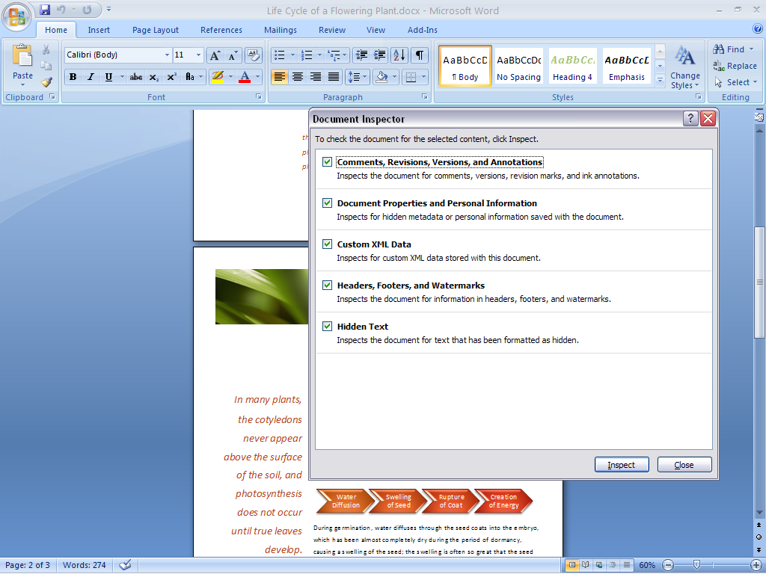

**Figure 5: Document Inspector in Office Word 2007**

Office Basic 2007 in Action

Martin Lotz is the Chief Financial Officer of A. Datum Corporation, a small software company situated in Boulder, Colorado. He has access to almost all personal company information. He uses the Document Inspector in Office Basic 2007 to search his documents and automatically remove any personal information before sending the documents out. This helps ensure that his correspondence is free of any unwanted comments, hidden text, or personally identifiable information that he does not want to share with others.

# Find Commands and Help More Easily

Office Basic 2007 offers the Office Fluent user interface, which makes document creation easier, faster, and more intuitive. The design emphasizes user efficiency and feature discoverability, enabling the home and small business user to quickly find relevant help for questions. Tutorials and templates help you get started and understand more about the software’s capabilities.

## New Command Tabs

Most home and small business users employ only a small percentage of all of the commands available in Microsoft Office programs. With the Office Fluent user interface in Office Basic 2007, you can learn more about the capabilities of Microsoft Office through an offering of command tabs that replaces the previous drop-down menus. Commonly used commands, once buried, are now available at your fingertips. You get access to the right tools when you need them, so you can learn more and get the results you want.

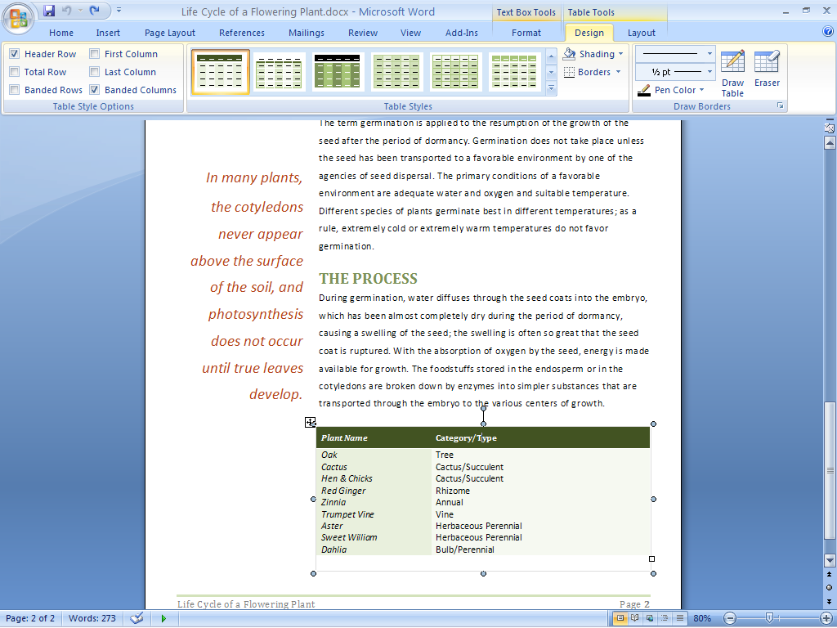

**Figure** **6: Formatting commands in Office Word 2007**

Certain sets of commands are relevant only when editing objects of a particular type. These sets are known as *contextual command tabs*. The tabs automatically change depending on the task that you are trying to complete.

Office Basic 2007 in Action

Even as a multitasker, Naoki Sato never has enough time to finish everything she wants to do on her home computer. As a result, she has never taken the time to discover all the functionality available in Microsoft Office. With hundreds of commands in Word alone, this means she has not benefited from capabilities that could simplify and improve her experience. With contextual command tabs in Office Basic 2007, she can get fast access to commands that relate to what she is doing at the moment. As a result, she can complete whatever she is working on faster than before.

## Improved Tutorials

An improved Getting Started experience in Office Basic 2007 significantly reduces the learning curve for new home and small business users. Tutorials offer step-by-step instructions for using Microsoft Office software. Getting Started brings to the surface additional Help options, such as Office Online integration.

## Improved and Easy-to-Use Help

Many home and small business users are tired of wasting time trying to find answers to functionality questions. Office Basic 2007 provides more direct links to Help content than ever before. Take advantage of the smooth transition between Help in a program and Help on the Internet (when connected).

## Enhanced ScreenTips

Office Basic 2007 offers larger, more informative ScreenTips than previous releases of Microsoft Office. ScreenTips provide quick access to information about a command directly from the command’s location. By popping up when you rest your mouse pointer on any command, the enhanced ScreenTip often gives you enough information about a feature to enable you to use it immediately without further assistance. This capability gives you easy access to all of the functionality of the Office Fluent user interface. As a result, you can save time and become more productive.

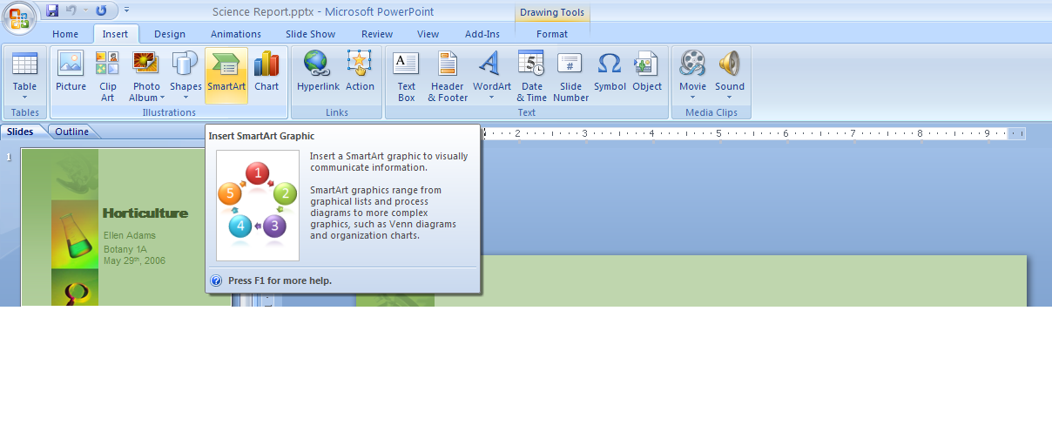

**Figure** **7: Enhanced ScreenTips in Microsoft Office Basic 2007**

# Organize Your Time and Communications

Office Outlook 2007 provides tools that help home and small business users organize their time and communications. Using Instant Search capabilities and Color Categories, you can easily locate the information you want and need. Through new calendar viewing, publishing, and sharing capabilities, you can safely share calendars stored in Office Outlook 2007 with coworkers, friends, and family, no matter where they are located.[3] A new To-Do Bar makes it easier for you to prioritize and control your time, so you can focus on more important matters.

## New Ways to Organize Appointments and Tasks Easily

Office Outlook 2007 provides an effective and efficient way to organize information in one location. All of the tools home and small business users need to manage, prioritize, and sort tasks are integrated directly into Outlook. Some of the new and improved organizational features include the following:

* **Color Categories** help you quickly differentiate e-mail messages.
* **New calendar views** enable you to compare two calendars side by side or one on top of the other.
* **A new To-Do Bar** brings together tasks, calendar information, and flagged e-mail messages in one place. Tasks completed on a particular day “stick” to that day and appear as part of a record of what you did on that day. Tasks not completed roll over to the next day and accumulate until you complete them.

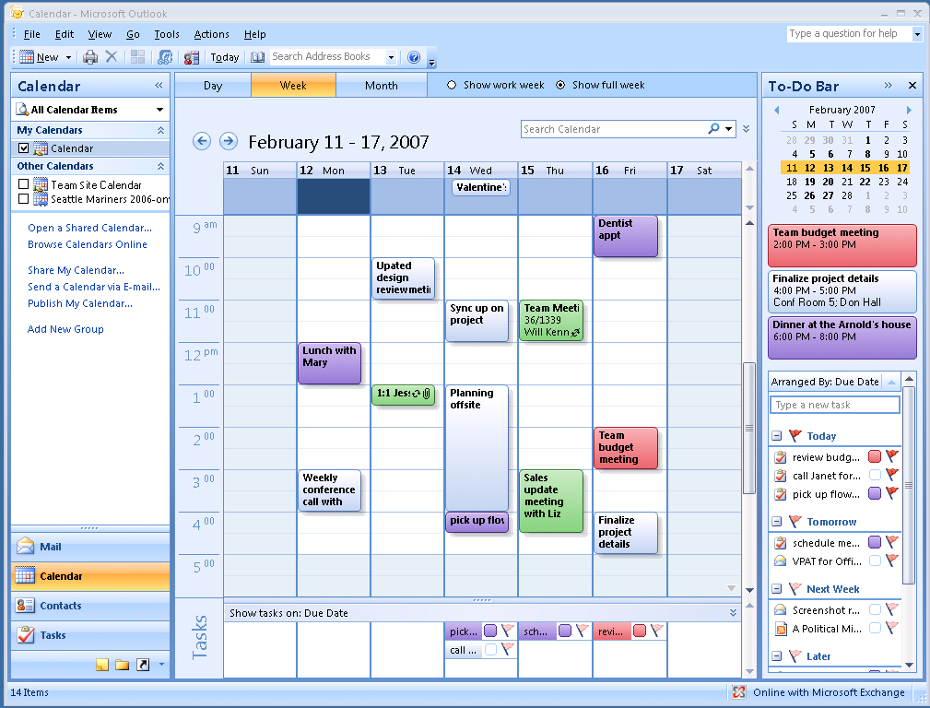

**Figure 8: Calendar view in Office Outlook 2007**

Office Basic 2007 in Action

Jay Jamison is the Schedule Coordinator at Adventure Works, a small outdoor tourist company. Jay relies on Office Outlook 2007 to help him manage trip dates, reservation deadlines, and meetings. He uses the Office Outlook 2007 To-Do Bar to help ensure that he never misses an appointment or deadline. He uses the new Color Categories feature to differentiate his personal e-mail messages from work-related ones. New calendar publishing and sharing capabilities enable everyone in the company to stay aware of important deadlines, trip dates, and schedules.

## Improved Instant Search Helps You Find What You Need

Office Outlook 2007 provides Instant Search that enables home and small business users to quickly find information in any of the Outlook modules such as e-mail messages, calendars, and tasks. The search capability also includes the following:

* **Search folders** where you can save common searches and their results.
* **Advanced search capabilities** that save you the time and hassle of finding important e-mail messages.
* **New calendar publishing and sharing capabilities** that enable you to safely share any Outlook data with friends and family, no matter where they are located.[4]

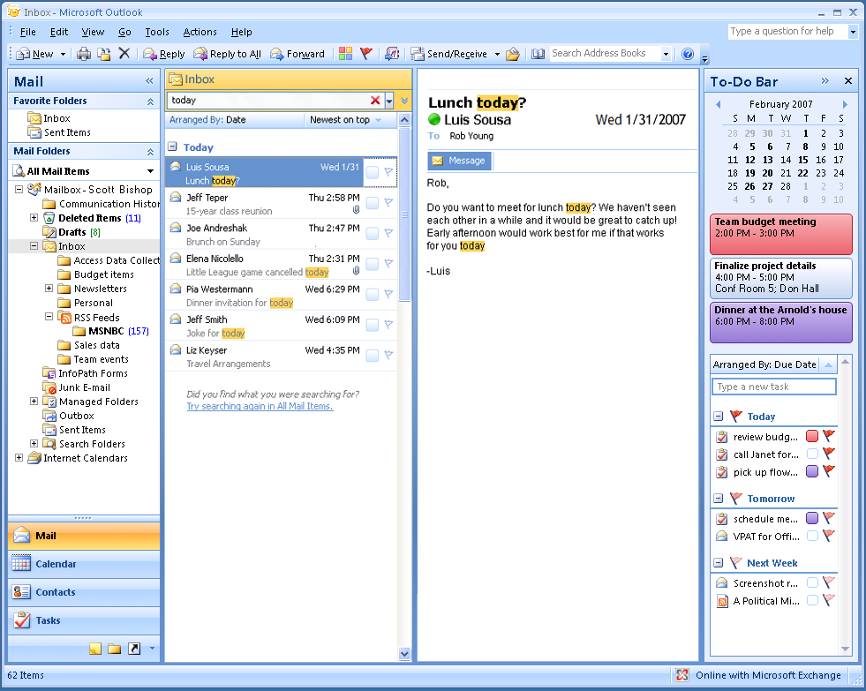

**Figure 9: Instant Search in Office Outlook 2007**

## New Inbox Autoconfiguration

A new feature in Microsoft Office Outlook 2007 enables users of Post Office Protocol (POP), Internet Message Access Protocol (IMAP), and other types of e-mail accounts to simply enter their account name and password, and then Office Outlook 2007 configures the account automatically. For example, if you enter your MSN® network of Internet services or Microsoft Hotmail® Web-based e-mail service address and password, Office Outlook 2007 automatically sets up that account for use in Outlook.

## New RSS (Really Simple Syndication) Aggregator

Many Web sites offer RSS as a way for home and small business users to have headlines delivered directly to them. RSS aggregation is a new technology that provides you with an easy way to monitor multiple sources of news, blogs, and other Web-based content. Office Basic 2007 adds RSS reading and subscriptions directly into Outlook. As a result, you can have a “news” folder that captures all of the RSS feeds that you subscribe to. This folder automatically updates periodically, bringing in new posts and information. (Please note: A separate fee-based RSS subscription is required.)

# Summary

Microsoft Office Basic 2007 is a new and exciting office software suite for new personal computers that provides home and small business users with all the essential tools they need to quickly and easily create great-looking documents and spreadsheets. Focusing its efforts more on results than on features, Microsoft has developed a suite that makes it easier and more enjoyable for you to get things done. You get the tools you need to quickly deliver the quality outcome you want. You can also coordinate your time and communications in a simpler, more efficient manner. The end result is that your computer tasks are a lot easier and more fun.

# Resources

For more information about Office Basic 2007, please visit <http://www.microsoft.com/office/suites/basic>.  
  
Additional information about Office Basic 2007 can be found at Office Online at <http://www.microsoft.com/office>. Office Online is your one-stop location on the Internet for everything related to Microsoft Office, including product information, support, updates, trials, and more.

# System Requirements

For complete system requirements, visit <http://www.microsoft.com/office/suites/basic>.

This document is developed prior to the product’s release to manufacturing, and as such, we cannot guarantee that all details included herein will be exactly as what is found in the shipping product. The information contained in this document represents the current view of Microsoft Corporation on the issues discussed as of the date of publication. Because Microsoft must respond to changing market conditions, it should not be interpreted to be a commitment on the part of Microsoft, and Microsoft cannot guarantee the accuracy of any information presented after the date of publication. The information represents the product at the time this document was printed and should be used for planning purposes only. Information is subject to change at any time without prior notice.

This document is for informational purposes only. MICROSOFT MAKES NO WARRANTIES, EXPRESS OR IMPLIED, IN THIS DOCUMENT.

© 2006 Microsoft Corporation. All rights reserved. Microsoft, Excel, Hotmail, MSN, the Office logo, Outlook, Fluent, and SmartArt are either registered trademarks or trademarks of Microsoft Corporation in the United States and/or other countries. All other trademarks are property of their respective owners. The example companies, organizations, products, domain names, e-mail addresses, logos, people, places, and events depicted herein are fictitious. No association with any real company, organization, product, domain name, e-mail address, logo, person, places, or events is intended or should be inferred.

1. The Save as PDF or XPS functionality is available as a free download from Office Online.
2. * You can save as a PDF or XPS file from a 2007 Microsoft Office system program only after you install an add-in. For more information, see [Install and use a PDF or XPS add-in](http://r.office.microsoft.com/r/rlidOOPDFXPSAddin?clid=1033)**.**
3. Additional service fees may apply for sharing calendars online.
4. 5 Additional service fees may apply for sharing calendars online.