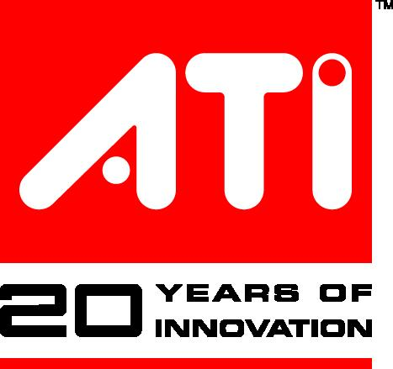
ATI TECHNOLOGIES INC. 1 Commerce Valley Drive East Telephone: (905) 882-2600
Markham, Ontario Canada Facsimile: (905) 882-2620
L3T 7X6 www.ati.com

For media inquiries:
John Swinimer, Public Relations Manager
Consumer Products Division
(905) 882-2600, Ext. 8456 or swinimer@ati.com

ATI Shows Groundbreaking High Definition Digital Cable PC Receiver
2006 International CES demonstration heralds new era in media PCs

MARKHAM, Ontario – January 5, 2006 – ATI Technologies Inc. (TSX: ATY, NASDAQ: ATYT) today announced a preview of the revolutionary (HD) digital cable PC receiver. Available later this year, the ATI OCUR (open cable uni-directional receiver) product will allow Media Center PCs that run on the forthcoming Microsoft Windows Vista operating system, to receive High Definition premium digital cable TV content on the PC, ushering in the next level in functionality and opening new avenues for PC entertainment. The new device will also offer traditional analog TV and free-to-air HD broadcast reception to the PC. ATI demonstrated this new technology at the 2006 International Consumer Electronics Show in Las Vegas, January 5 to 8, 2006.

The ATI OCUR product opens a crucial barrier to making the PC ubiquitous for the ultimate entertainment PC. According to the Consumer Electronics Association, almost 68 per cent of the North America market is served by cable operators, and now these end users will be able to access premium content. This new OCUR product is designed to support any cable
television system in North America on the PC.

“We’re working with Microsoft and other industry leaders to drive Media Center PCs to be more intuitive, powerful and robust than standalone consumer electronics devices,” said Godfrey Cheng, directory of marketing, multimedia business unit, ATI Technologies Inc. “The forthcoming OCUR PC receiver is powered by ATI’s Avivo™ technologies which means that not only will the Media Center PC have a new level of functionality but also the highest available video quality. ATI is proud to work with Microsoft to demonstrate this new OCUR PC receiver for a new era of media PCs.”

“Microsoft strives to provide our customers with the most compelling TV experience possible on Windows Media Center,” said Dave Mendlen, director of Windows Consumer Marketing at Microsoft Corp. “We’re excited to work with ATI on this project, based on the company’s industry-leading expertise in both multimedia PC solutions and the digital TV marketplace.”

ATI will exhibit its solutions at International CES 2005 at booth 30779 at the South Hall, Upper Level, Las Vegas Convention Center, January 5 to 8, 2006.

Microsoft Windows Media Center delivers advanced computing plus easy-to-use integrated digital entertainment, including live and recorded television, movies, music, photos and radio, that consumers can enjoy when and how they want. It provides a central hub for digital entertainment and productivity, accessible on either a PC monitor or TV display, using a single remote control.

About ATI Technologies
ATI Technologies Inc. is a world leader in the design and manufacture of innovative 3D graphics and digital media silicon solutions. An industry pioneer since 1985, ATI is the world’s foremost graphics processor unit (GPU) provider and is dedicated to deliver leading-edge performance solutions for the full range of PC and Mac desktop and notebook platforms, workstation, set-top and digital television, game console and handheld device markets. With 2005 revenues of US $2.22 billion, ATI has more than 3,400 employees in the Americas, Europe and Asia. ATI common shares trade on NASDAQ (ATYT) and the Toronto Stock Exchange (ATY).
-30-

Important Information Regarding Forward-looking Statements
Forward-looking statements look into the future and provide an opinion as to the effect of certain events and trends on the business. Forward-looking statements may include words such as “plans,” “intends,” “anticipates,” “should,” “estimates,” “expects,” “believes,” “indicates,” “targeting,” “suggests” and similar expressions.
This news release contains forward-looking statements about ATI’s objectives, strategies, financial condition and results. These “forward-looking” statements are based on current expectations and entail various risks and uncertainties. Our actual results may materially differ from our expectations if known and unknown risks or uncertainties affect our business, or if our estimates or assumptions prove inaccurate. Therefore we cannot provide any assurance that forward-looking statements will materialize. We assume no obligation to update or revise any forward-looking statement, whether as a result of new information, future events or any other reason. Additional information concerning risks and uncertainties affecting our business and other factors that could cause our financial results to fluctuate is contained in our filings with Canadian and U.S. securities regulatory authorities, including our 2005 Annual Information Form and 2004 Annual Report filed on SEDAR at www.sedar.com.
Copyright 2006 ATI Technologies Inc. All rights reserved. ATI and ATI product and product feature names are trademarks and/or registered trademarks of ATI Technologies Inc. All other company and product names are trademarks and/or registered trademarks of their respective owners. Features, pricing, availability and specifications are subject to change without notice.
For media or industry analyst support, visit our Web site at http://www.ati.com

Other ATI Contacts:

Briana D’Archi, Manager, Porter Novelli Canada, at (416) 422-7166 or briana.d’archi@porternovelli.com

For investor relations support, please contact:

Zev Korman, Investor Relations, ATI Technologies Inc., at (905) 882-2600, Ext. 3670 or zev@ati.com

Consumer Electronics Association press release, May 11, 2005. http://www.ce.org/Press/CurrentNews/press_release_detail.asp?id=10746

