Role-Based Template for SharePoint My Sites: IT Manager
Technical Overview for
IT Professionals
Template Data and Integration
Role-Based Templates for SharePoint® My Sites are pre-configured to display, in a common environment, role-relevant data from sources such as line of business systems, desktop tools, and portals. The templates make use of Microsoft® Office SharePoint Server 2007 capabilities, such as audience targeting, key performance indicators (KPIs), workflows, Excel® services, Business Data Catalog (BDC), and others. IT departments can integrate the Role-Based Templates for SharePoint My Sites with existing systems, as well as customize, extend and even replicate them. This enables quick deployment of role-based portals and provides cost-effective and easy-to-use solutions that integrate with important IT investments.
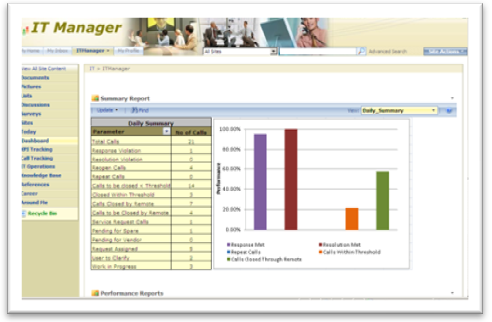
The templates are built using existing out-of-the-box SharePoint Web parts, and are flexible, providing a starting point for custom development. They come with a sample SQL Server™ 2005 database, a BDC application file and a SQL Server 2005 Analysis Services (SSAS) cube to show sample data. This datasheet describes the web parts and functionality Microsoft used when designing the templates. The role-based My Site template Setup Guide explains in detail how to configure them for your own data.

Description of Template
The IT Manager role-based template for SharePoint My Sites focuses on the IT Manager in a maintenance division handling location support. The services rendered by the support team are governed by the Service Level Agreement (SLA), where service level is defined by response, resolution and threshold. IT Managers oversee the support services provided by the team of IT engineers for SLA adherence and coordinate with the team for backups and updates. They also oversee the incident calls and escalations being logged in the help desk. At a product level, IT Managers track license renewal and their respective roadmaps and updates.

Customized Pages and Web Parts Utilized in this Role-Based My Site Template

The following is a list of all the custom pages that make up the IT Manager role-based My Site template. Also included is a description of the web parts utilized on each page.

Today: Provides a quick glance into the user’s personal inbox, calendar and task list. It also displays user tasks assigned to them on SharePoint sites.
- My Inbox, My Calendar, and My Tasks utilize Outlook® Web Access web parts to fetch data from the Microsoft Exchange Server and display the user’s personal inbox, calendar and task list. These web parts are configured with the mail server address and take in the user context by default to display their data from Exchange Server.
- User Tasks web part displays the tasks assigned to the user in SharePoint tasks lists, enabling them to view and update the SharePoint tasks.

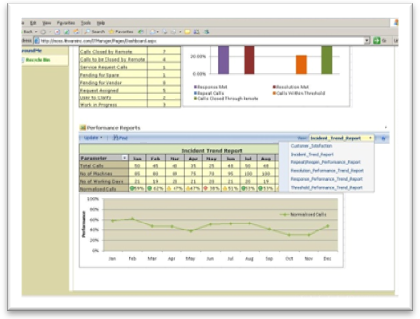
Dashboard: Displays a summary report of calls received and performance reports showing trends and satisfaction levels. Data is shown in a pivot table and charts with information pulled from a backend SQL Server database.
- Summary Report and Performance Reports use Excel® Web Access web parts with a pivot table and charts to display information on the Dashboard page. They are configured to fetch data that resides in the backend SQL Server database. The data is pulled into the workbook through an Office Data Connection (.odc) file and published using Excel services. Summary Report shows a summary chart of daily and monthly calls and lists the common call parameters with the number of calls. Performance Reports shows response, resolution, and threshold performance for logged calls, helping to indicate trends and satisfaction levels.

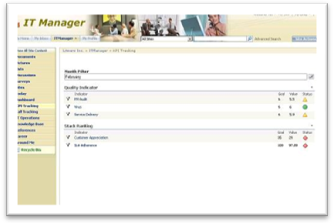
KPI Tracking: Provides quality and stack ranking details and shows Key Performance Indicators (KPIs) defined against a set of goals and filtered by month.
- The Month filter is an SQL Server Analysis (SSAS) Filter web part that enables the IT Manager to select a month to view corresponding KPIs.
- Quality Indicators and Stack Ranking are KPI web parts connected to the SSAS Filter web part to receive the selected month and filter the details accordingly. The SSAS Filter web part is connected to the SSAS cube through an Office Data Connection file (.odc) residing in the Data Connections library. Quality Indicators and Stack Ranking show values for KPIs such as PM Audit, Virus, Service Delivery, Customer Appreciation and SLA Adherence.

Call Tracking: Displays calendar list, contacts, certification details for team members, and pulls information from BDC to view all calls that are logged for the day. The calls can be filtered based on their status.
- Scheduled Backups uses a Calendar List View web part to keep track of the backup schedule. An Alert workflow is attached to trigger an email one hour before the backup.
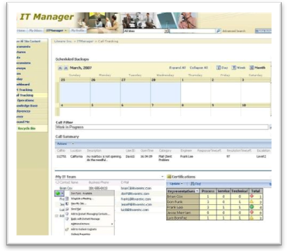
- Call Filter is a List Filter web part that displays Call Status and enables the IT Manager to select a status to view corresponding calls logged for the day.
- Call Summary uses a Business Data List web part to display call details. It is configured to a Call Summary entity defined in the BDC application metadata file. Call Summary shows data based on the status set in the Call Filter.
- My IT Team is a List View web part with contact details for team members. It is enabled with the presence icon.
- Certifications use an Excel Web Access web part with pivot table and shows certification stats and sections completed for team members. It is configured to fetch data that resides in the backend SQL Server database, which is pulled into the workbook through the Office Data Connection File(.odc). The spreadsheet containing the chart is published using Excel Services and conditional formatting has been applied.
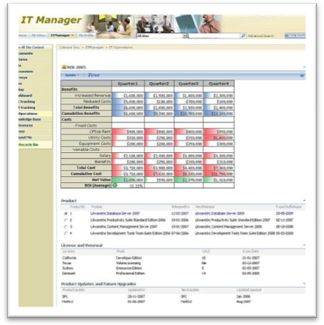

IT Operations: Pulls information from BDC and creates dynamic data views of IT team operations.
- ROI uses an Excel Web Access web part to display a Return on Investment chart. The Excel spreadsheet containing the chart is published with Excel Services.
- Product List uses a Business Data List web part to display product information. It is configured to an entity, Product, defined in the BDC application metadata file for this template.
- License and Renewal and Product Updates and Future Upgrades use Business Data Related List web parts to dynamically display information based on the product selected in Product List web part. License and Renewal displays product renewal details. Product Updates and Future Upgrades shows roadmap and update details.

Knowledge Base: Provides a repository for frequently referenced case studies and knowledge base articles.
- Case Studies and Knowledge Base are Library View web parts. Case Studies is attached to the Case Studies document library, a repository for frequently referenced case studies and customer implementations. Knowledge Base is attached to the Knowledge Base Wiki Page document library and stores articles.

References: Provides links, contacts, and a repository with frequently used documents and presentations.
- Recent Meeting Outcomes, References and Presentations are Library View web parts. Recent Meeting Outcomes is attached to the Meeting Outcomes form library which has a Microsoft Office InfoPath® form template attached and is used to store meeting notes and items. References is attached to the References document library, a repository for documents relating to the organization or business unit. Presentations is attached to the Presentation document library which has an Approval workflow attached.
- Contacts and Links are List View web parts. The two Contacts lists (Vendor and Business Support) display frequently used contacts. The two Links lists (Internal and External) display links to other systems and websites.

Around Me and Career: Around Me provides one page to keep track of news, announcement and events relevant to the IT Manager to keep them informed and in touch with the company. The Career page helps facilitate career planning by providing a place to keep track of objectives and performance.
- Around Me: Corporate News and Technology News are RSS Feed Viewer web parts and display news feeds from external web sites. Corporate and System Downtime Announcements are List View web parts displaying announcement details by the administrator. Team Announcements is a List View web part displaying announcements created by the IT Manager. Corporate and Industry Events are List View web parts that display corresponding events. An Alerts workflow is attached to these lists.
- Career: Training, Awards and Rewards, and Organization Objectives are List View web parts that help keep track of one’s career. With personalized views, only items created or modified by the logged in IT Manager are visible.

Technical Dependencies
To use the Customer Service Manager template, you must have a server running the following:
- Microsoft Office SharePoint Server 2007
- Microsoft Office SharePoint Server 2007 Client Access License, Enterprise Edition
For more information on additional dependencies, please review the Setup Guide.
Licensing information can be found at: http://go.microsoft.com/fwlink/?LinkId=86927

More Information
For more information on the technologies described in this article, please visit:

Microsoft Office SharePoint Server 2007:  http://www.microsoft.com/sharepoint | Role-Based Templates for SharePoint My Sites:  http://go.microsoft.com/?linkid=6060804
Business Intelligence with Office SharePoint Server 2007:
http://go.microsoft.com/fwlink/?LinkId=86668

